Product Dashboard based on the Exposure Draft (example only)
XYZ MySuper
Net return target | CPI plus 4% per year (after investment and administration fees, costs and taxes, excluding activity fees and insurance costs) over a 10 year period.
Net return performance | 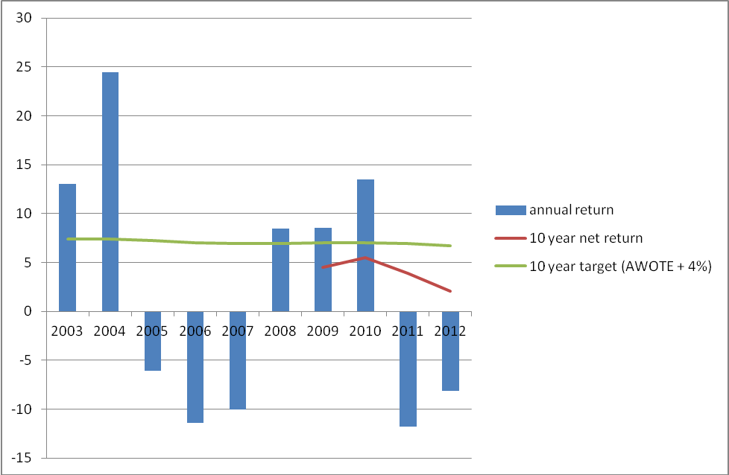  Actual annual net return  Moving average actual net return over 10 years  Target net return over 10 years  Note: Net return performance commenced in 2000 for this product.
Level of investment risk | Negative returns expected in 5 to 6 out of every 20 years.
Statement of fees and other costs for a representative member (with a $50,000 balance and contributions of $5,000 per year) | $437

Explanation of items
Product Name
Target net investment return | A per annum estimate of the expected return after investment and administration fees, costs and taxes, excluding activity and insurance fees and costs in excess of CPI over 10 years.  Investment and administration fees, costs and taxes, activity and insurance fees and costs are defined in APRA’s reporting standards.
Net return performance | A graphical representation of the annual net return for each year of the last ten years. The chart must also show a line plotting the 10 year moving average return that was achieved and a line plotting the realised value of the 10 year moving average return target using realised CPI for the relevant years.  Net return target and net return are to be measured after investment and administration fees, costs and taxes, excluding activity and insurance fees and costs.  Where a product has less than 10 years’ investment history, each annual return must be displayed but no moving average return can be displayed until there is ten years of data.  Investment and administration fees, costs and taxes and activity fees and costs are defined in APRA’s reporting standards.
Investment risk | Negative returns expected in [x] out of every 20 years.  This is to be calculated consistent with the guidelines provided in the ASFA/FSC Guidance on Standard Risk Measure
Measure of fees and other costs | Annual investment and administration fees, costs and taxes reported as whole dollars, excluding activity and insurance fees and costs, for a member with $50,000 balance and $5,000 in contributions.  Investment and administration fees, costs and taxes and activity fees and costs are defined in APRA’s reporting standards

