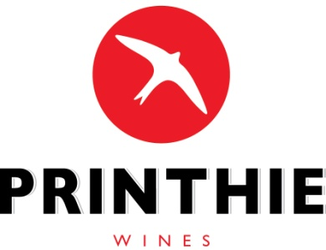
Manager
Indirect Tax and Not-for-profit Unit
Individuals and Indirect Tax Division
The Treasury
Langton Crescent
PARKES ACT 2600
Wine Equalisation Tax Rebate Submission
We would like to take this opportunity to formally submit our position on the exposure draft legislation to amend the A New Tax System (Wine Equalisation Tax) Act 1999.
In relation to the exposure draft we generally agree with the Winemakers Federation of Australia submission dated 28 April 2017, however we make the following comments on areas where we feel more information is required or we have a differing opinion.

- Changes to Eligibility
  - Ownership must be established prior to crushing. Proof of this ownership would be provided by payment to the grower or supporting documents relating to the ownership or lease of the vineyard.
  - Concerns relating to areas with phylloxera, have, we understand prompted the proposed change, however this opens the door to NZ eligibility again as all of NZ is a phylloxera zone.
- Product branded and packaged for retail sale
  - The trademark clauses will put many legitimate wine businesses in a position where they are unable to sell wine they have a legitimate claim over. We do not support this change as we believe other measures of tightening eligibility deal with this sufficiently.
  - The volume per packaged container should be increased to 50 litres in capacity to fall in line with cider producers but also as it is now more common practise and has both social and environmental advantages.
- Reduction in the WET producer rebate cap from $500,000 to $350,000
  - We do not support the reduction in the cap
  - We support the tightening of eligibility as a means to reduce rorting.
  - Tightening the associated producers rule is a must to ensure the removal of multiple claimants and we agree strongly with the amendment.
- Penalties
  - There seems to be nothing in the way of penalties for individuals or companies that abuse the eligibility and ownership rules. Legislation should look towards penalties being imposed on all parties found to be involved in abusing the system.
- Cider and related wine products
  - Should be treated exactly the same as grape wine products in respect of ownership and eligibility.

Jim Swift

Printhie Wines
489 Yuranigh Road, Molong, NSW

