Document 6

Page 1-6 section 22
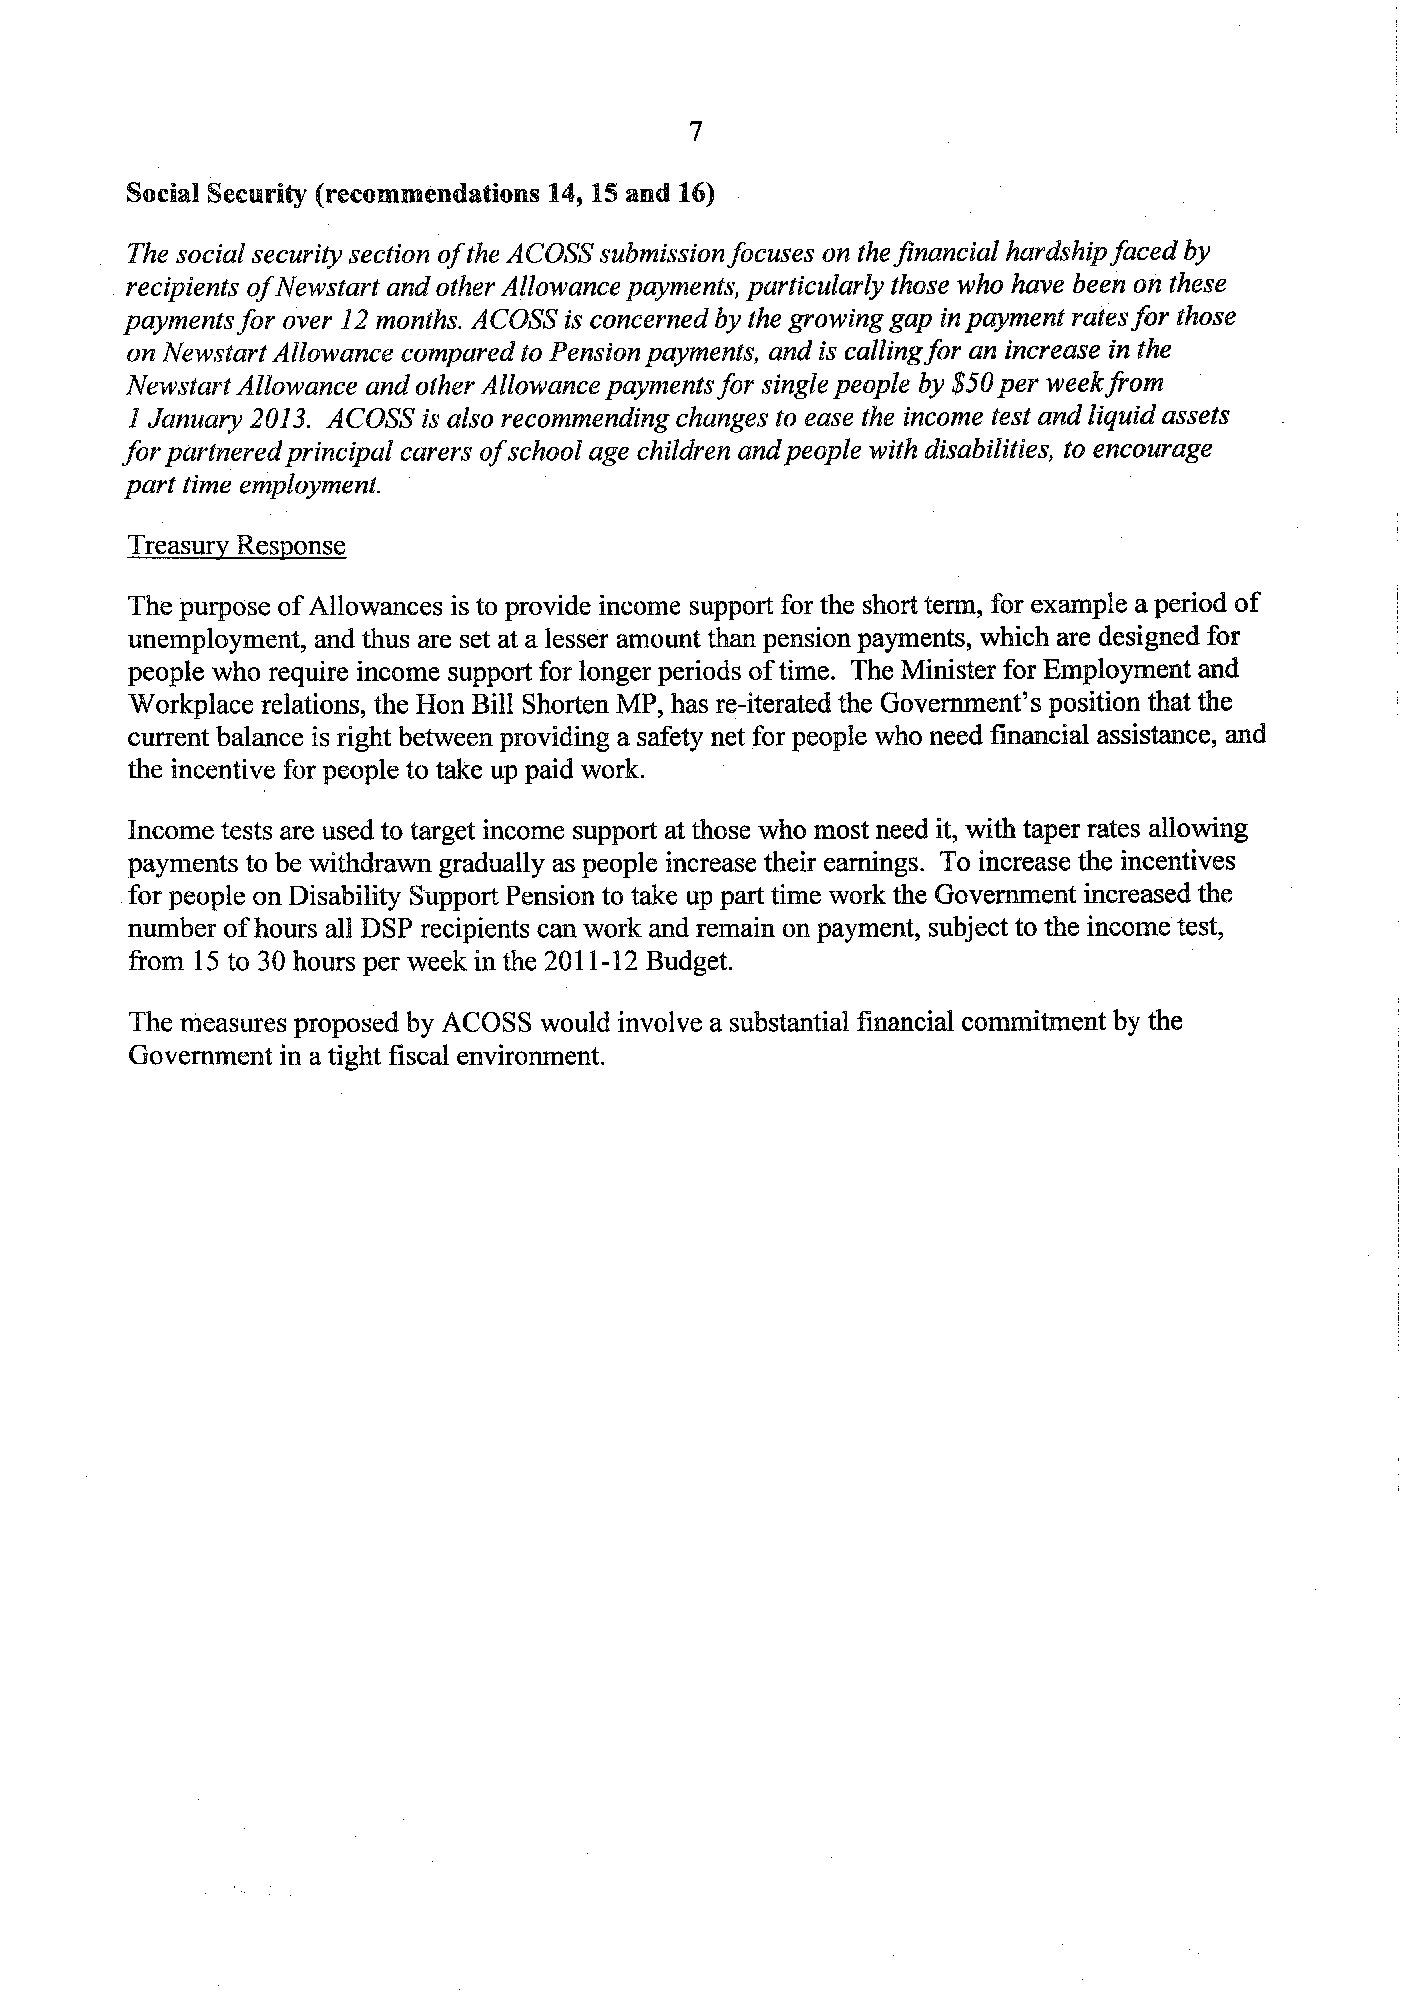

Section 22
Page 8-12 section 22


