**National Tertiary Education Union (NTEU)**

***2017-18 Pre-Budget Submission***

**Overview**

Despite many false starts and missteps, the Government’s plans for higher education remain largely unchanged from the plans announced in the 2014 Budget, where the policy agenda was, and continues to be, primarily motivated by the goal of saving $2.5billion of public investment over four years. Unfortunately, these savings seem to be viewed solely through the lens of further shifting the funding burden away from the public and onto the shoulders of students and their families by making undergraduate domestic students pay more for their degrees. This is despite the fact that Australia already has one of the lowest levels of public investment in tertiary education in the world while conversely, our students pay amongst the highest fees in the OECD. Furthermore, international and post graduate coursework students already pay very high upfront fees, which can be significantly higher than $100,000. The Government also seems insistent upon pursuing their policy of opening up public funding to private, including for-profit, providers, despite the demonstrable failure of such a policy framework in relation to VET, which the Government has now addressed in legislation in late 2016.

While the NTEU welcomes the Government’s decision to abandon full fee deregulation, we remain opposed, for the reasons outlined below, to a number of the Government’s specific plans, including:

* a 20% cut to funding per Commonwealth supported place (CSPs) and any increase in student contributions,
* the expansion of the demand driven system to private providers,
* the partial fee deregulation through the introduction of flagship courses,
* the introduction of a universal HELP loan fee for all students, and
* the repurposing of $3.7bilion balance of Education Investment Fund (EIF).

The NTEU’s alternative approach (initially outlined in the [NTEU’s 2015 Pre-Budget Budget submission](http://www.nteu.org.au/library/view/id/6652)) which proposes a better planned and managed higher education framework through the use of Public Accountability Agreements (PAAs) is given some support by the findings of a L.H Martin Institute paper entitled [*Domestic Student Load and Financing*](http://www.lhmartininstitute.edu.au/insights-blog/2016/06/229-domestic-student-load-and-financing-trends-for-the-deregulated-demand-driven-australian-universities)*.* The NTEU’s proposed framework would help provide a way of resolving some very important policy questions raised in this paper, including:

* *Are universities adequately accountable for demonstrating that their quest for growth is in the national interest and has not been at the expense of quality?*
* *Is it in the public interest that teaching and learning funding continue to be allocated exclusively on the basis of student load?*
* *What policy measures might Government contemplate to strengthen capability across the sector?*

**Background**

As part of the 2016-17 Federal Budget, the Turnbull Government announced that it was:

* abandoning plans to “fully” deregulate university fees; and
* delaying the implementation of their higher education policy package by yet another year to allow for further consultation.

To facilitate further consultation, the Minister for Education and Training, Senator Simon Birmingham, released a discussion paper entitled, *Driving Innovation, Fairness and Excellence in Higher Education*. The discussion paper proposed a series of policy options on specific policy issues, including:

* the coverage of the demand driven system;
* equity support and funding;
* the provision of higher education for regional Australia;
* partial fee deregulation;
* government and student contribution amounts; and
* reining in the costs of the Higher Education Loans Programme (HELP).

Crucially, however, all of the policy options are *“subject to the financial sustainability savings outlined in the budget”.* NTEU understands that the sustainability measures outlined in the Federal Budget equate to a total saving of $2.5billion in cash balance terms over the next four years.

The NTEU’s immediate response to the Government’s budget announcements and the release of the *Driving Innovation* paper was that they amounted to little more than an overtly political manoeuvre, primarily designed to remove criticism of the Coalition’s plans to deregulate fees and extract higher education funding from the 2016 election policy debate.

**The Government’s plan for higher education**

While the Government has indicated that they are prepared to consider tinkering with details of individual policies, the fundamental goals remain:

* to cut public investment in higher education;
* to make students pay more; and
* to introduce a fully contestable market model into higher education by allowing private for-profit providers to access Commonwealth Supported Places (CSPs).

The NTEU remains fundamentally opposed to this plan because:

* Australia’s level of public investment in tertiary education is already amongst the lowest in the OECD (see Figure 1);
* Australian students already pay amongst the highest fees in the world to study at a public university (see Figure 2); and
* the fully contestable market policy framework in vocational education and training (VET) has been a complete failure for students, the community, industry and Governments.

The only substantial policy change announced in the 2016-17 Budget was to abandon the policy to “fully” deregulate domestic undergraduate fees because of public concerns “*about the perceived cost of potential higher education fees*”. However, the NTEU’s latest analysis shows that the proposal to introduce so-called “flagship” courses, for which universities could charge higher fees, would create the perfect environment for even higher fees. The Government even recognises this danger by acknowledging that any such proposal might need to be accompanied by some mechanism or regulation to limit the scope of fee increases.

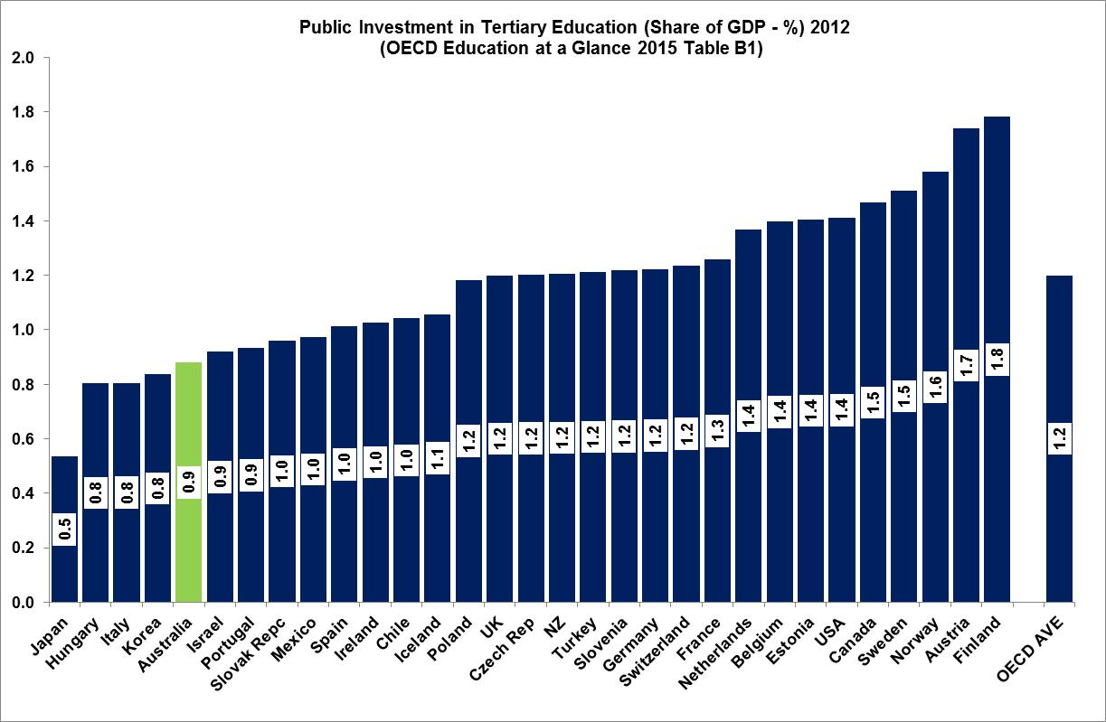

Figure A

**Figure B**

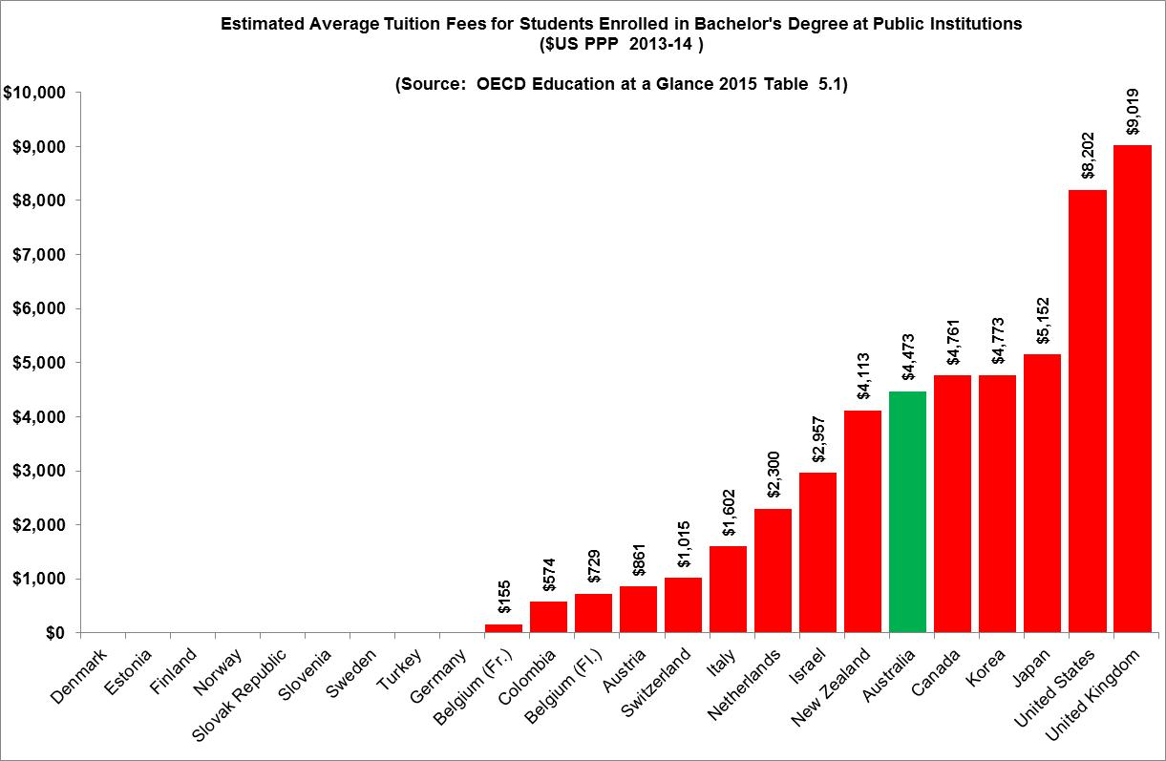

**An alternative framework**

While agreeing that individuals derive a direct benefit from participating in higher education, the NTEU believes that higher education, like all other forms of education, essentially remains a public good from which the whole of society benefits economically, socially and culturally.

As recent experience in vocational education and training (VET) has shown, education is far too important to be left to the market. The Government’s plans for a market driven framework for higher education must be abandoned. Australia needs a well-planned and managed higher education system. This could be achieved through the use of a Public Accountability Agreement (PAA) framework, as outlined in the NTEU’s 2015 Budget Submission entitled: [*Towards a sustainable policy framework for Australian higher education*](http://www.nteu.org.au/library/view/id/6652).

The complete and utter failure of the market driven approach to the funding and regulation of VET was explicitly acknowledged by the Government’s decision in October 2016 to abandon the VET FEE HELP scheme and replace it with a new VET Student Loan Fee scheme.

Interestingly, the new VET scheme is more prescriptive than the NTEU’s alternative framework for higher education. The new VET arrangements place strict limits on the number of students entitled to Government loans based on past levels of enrolments and student attrition rates. Under the NTEU’s proposed PAA framework, there would not be any caps on the number of students an individual university could enrol. Each university would be able to enrol as many students as it likes, but in doing so it would have to demonstrate that it has the physical, staffing and support resources to ensure that every student enrolled has the opportunity to succeed in graduating and finding employment.

The release of the latest analysis of higher education completion rates on 18 January 2017 (See Attachment A)provides further evidence of a need for a policy framework which is capable of adapting to a diverse range of institutions with very different missions and student cohorts.

Completion rates also provide a good example of where the Government’s new VET scheme is more prescriptive than the NTEU’s alternative framework can be illustrated in relation to the relationship between completion rates and eligibility of students to access income contingent Government loans to cover tuition fees. Under the new VET Student Loan scheme, the number of students eligible for new loans can be directly tied to student completion rates in preceding years. The NTEU believes that such an approach would be far too blunt if applied to higher education because its fails to take into account the different circumstances and student cohorts of different universities.

# The NTEU is concerned that the adoption of universal completion rates, as is being applied to the VET sector would not only fail to capture these important differences, but would also provide a perverse incentive for universities to put pressure on staff to improve student completion rates, for purely financial reasons rather than pedagogy. Such an approach will lead to flawed outcomes; the NTEU’s proposed PAA’s would allow the individual circumstances of each institution to be taken into account in determining if, and how, completion rates would be used to demonstrate how an institution was achieving its objectives.

# As pointed out in the NTEU 2015 Budget Submission*,* if the demand driven system is extended to sub-degree and postgraduate qualifications and to non-university providers, it is unsustainable. As the experience in VET has clearly demonstrated, a fully contestable funding and regulatory framework will quickly become fiscally, institutionally and individually unsustainable. As has been the experience in VET, the NTEU’s analysis shows that such an expansion of the system would lead to budget blowouts, which in turn would most likely result in cuts to funding per student and further cost shifts to students through increased contributions.

The Government must learn heed its own experience of full market contestability in VET. We propose an alternative funding and regulatory framework designed to mitigate the risks of a market driven approach, without losing the flexibility and capacity to respond to changing circumstances.

In summary the framework being proposed by the NTEU would:

* maintain the cap on fees universities can charge for Commonwealth Supported places (CSPs);
* restrict eligibility for CSPs to public higher education providers;
* use Public Accountability Agreements (PAAs) as the basis of flexible and coordinated oversight for the allocation of CSPs; and
* establish an independent agency or council with statutory planning and funding responsibilities to negotiate and administer PAAs.

It is important to emphasise that under the proposed framework hard caps would not be placed on the number of students each university would be allowed to enrol. The independent council would be responsible for coordinating and moderating PAAs. Unlike the old system where the number of places would be allocated by the Commonwealth, the NTEU’s proposal would be a system of planned and managed soft caps which would take into account not only the capacity of the system to provide all students with a high quality educational experience, but also ensure that they graduate with the appropriate skills to make them employable.

A better planned and managed system, as proposed by the NTEU, would not only ensure that all students enrolling in university were given the opportunity to succeed, it would also give the Commonwealth greater certainty over the level of public expenditure on higher education (unlike the current situation which effectively gives universities a blank cheque) and gives industry and the public greater confidence in our universities.

**Specific policy issues**

The following is the NTEU’s response to each of the policy issues which remain to be resolved in relation to higher education policy and funding as outlined in the Government’s *Driving Innovation* discussion paper.

**Expansion of the demand driven system**

The Government’s plans are for the demand driven system to be expanded to include:

* all registered higher education providers, including for-profit private providers:
* sub-bachelor level higher education qualifications; and/or
* postgraduate course work qualifications.

The overwhelming evidence from the vocational education and training (VET) sector shows that, even with the regulation in place, a fully contestable market in tertiary education fails to plan for, or deliver adequately, qualified graduates into areas of skills shortage. The focus of many providers is upon marketing the most profitable courses to students prepared to sign on, without verifiable assurances of course quality or career outcomes.

The risks associated with opening up the demand driven system to all higher education providers are too great and should not proceed. It would also be unsustainably expensive and wasteful, as public funds are drained for private provider profits while the level of student debt would grow at an accelerating rate. The results of the latest higher education student completion rates also provide further evidence that completion rates for students enrolled with non-university higher education providers have significantly lower completion rates than public universities. The data (see Attachment A) shows that four years after enrolling 79.5% of student that enrolled in public university in 2011 had either completed their degree or where still enrolled compared to only 58.3% for non-university providers. Perhaps the most disturbing finding was that only one-in-three (33.5%) students who enrolled in an external course with a non-university provider in 2011 had either completed their degree or was still enrolled. In other words, two-in-three such students had dropped out.

While the NTEU understands that current funding arrangements might be providing a perverse incentive for universities to enrol academically under-prepared students in bachelor level qualifications, the solution to this issue is not to expand the demand driven system to include all sub-degree higher education qualifications.

The way to deal with this issue is to strengthen and expand existing alternative or enabling programmes offered by universities. The big advantage of enabling programmes is that they are generally free or low cost to students. Expanding the demand driven system to sub-degree qualifications would mean that students who are currently enrolled in low or no fee enabling programmes would be incurring substantial HELP debts. The success and importance of free enabling programmes, especially for disadvantaged students, is highlighted in a recent National Centre for Student Equity Centre report entitled: *Pathways to Higher Education: The efficacy of enabling and sub-bachelor pathways for disadvantaged students.*

The expansion of enabling programmes could be funded by savings achieved by not expanding the demand driven system to private providers.

In order to avoid gaming and price gouging by providers, the only circumstances in which the demand driven system should be expanded to postgraduate course work qualifications is where:

1. such a qualification is the equivalent of an undergraduate qualification that is the recognised entry standard into a given profession; and
2. the fees for such professional postgraduate qualifications are capped at the same rate as for equivalent undergraduate qualifications. To illustrate an example, a postgraduate Masters qualification in law would be capped at 2017 values, currently $10,596.

**Better targeted equity funding and support**

The NTEU agrees that equity funding and support programs need to be better funded and targeted. Public Accountability Agreements (PAAs) could be used to ensure that individual universities clearly articulate particular initiatives as well as specify targets for the participation and success rates for specific equity groups.

**Regional universities**

The NTEU agrees with the establishment of a specific fund for the development and support of regional universities and campuses. Regional campuses have a very student cohort of students when compared to those based in capital cities and as the evidence presented in the *Completion rates of domestic bachelor students 2006-2014: A cohort analysis* released on 18 January 2017 (Attachment A) shows, this is a major influence on student completion rates. Again PAAs could be used to allow each eligible university to negotiate how any such additional funding would be best used to suit their particular circumstances.

In addition to supporting regional universities, the NTEU encourages the Government to develop policies which provide better student income support to students from regional and remote Australia.

**Partial deregulation of fees – “flagship” courses**

The proposal to establish flagship courses would create the perfect environment for $100,000 degrees and is recognised across much of the sector as well as publicly as a cynical policy wedge which would inevitably lead to further deregulation. The irony is that the Government recognises this problem and has indicated that some form of market intervention would be needed to restrain excessive prices rises.

The introduction of flagship courses should be rejected on a several grounds, including:

* it would establish a tiered system of standard and superior (flagship) programs, where entry into the superior programs will be determined by willingness and ability to pay, rather than merit;
* many students will end up paying significantly more, in some cases more than $100,000 for a flagship degree; and
* any attempts to “indirectly” intervene in price setting will distort the way such places are allocated.

**Student – Government contribution amounts**

As noted above, the primary rationale for Government’s higher education plans is driven by the objective of reducing the level of public investment per student and make students pay more for their education. As the NTEU has argued above, this position cannot be justified on the basis that Australia already has one of the lowest levels of public investment and that Australian students pay amongst the highest fees to attend a public university in the OECD (Figures 1 and 2).

While the NTEU will continue to strongly oppose any cuts to the current average Government contribution per student (approximately 60%) we agree that there is a need to review current cluster funding arrangements. The need for such a review was identified by the Lomax-Smith Base funding review (2011) which highlighted a significant misalignment between funding rates and costs of delivery. The NTEU also supports the Lomax-Smith recommended that cluster funding should cover the costs of both teaching and basic research capability.

**Student information**

Students deserve access to more consistent and reliable information to help them make informed choices about what and where they want to study, the mode of delivery, their eligibility and career outcomes. While we support efforts to provide students with better and more accurate objective information on employability and earnings, we have serious concerns about the inclusion of any subjective information such as student and/or employer satisfaction surveys. The information provided to students should be factual and verifiable, and not be a quasi-marketing exercise on behalf of individual universities.

**Financially sustainable Higher Education Loans Programme (HELP)**

The *Driving Innovation* paper outlines a number of policy options aimed at improving the fairness and financial sustainability of HELP including:

* the introduction of consistent loan fee arrangements for all students;
* changes to repayment thresholds and rules; and
* the introduction of renewable lifetime limits for FEE HELP loans.

However before addressing these proposals, the NTEU emphasises that the best and most obvious way to ensure the financial sustainability of the HELP scheme is to limit the level of fees students are charged. Lower fees reduce average HELP debts. The lower the average HELP debt, the lower the proportion of that debt that may not be repaid. This would significantly lower the costs to the Budget of operating HELP which recent analyses by both the Parliamentary Budget Office and the Grattan Institute (see below) have shown to be increasing at an unsustainable rate.

***HELP Loan Fees***

The NTEU supports the Government’s current policy to abolish 20% or 25% loan fees charged to different categories of students in receipt of VET-FEE HELP and FEE HELP loans. We agree that it is not fair that a student be asked to pay a quasi-interest payment on their student loans simply because they choose to study somewhere other than at a public Australian university.

The NTEU, however, strongly opposes the suggestion that this situation is made fairer by charging all students loan fees including the 15% fee proposed by Grattan Institute’s [*Shared Interest: A Universal Loan Fee*](https://grattan.edu.au/report/shared-interest-a-universal-loan-fee-for-help/) for HELP report published in December 2016.

The imposition of any such loan fee existence of an administrative loan fee would increase the cost of a university for education for most students (that is, for those who cannot afford to pay upfront) without providing the university without one additional cent to improve the quality of that student’s learning experience. This also has equity implications by effectively providing a discount for someone who is in a position to pay their fees upfront. If you pay upfront, you don’t incur a HELP debt and therefore do not have to pay the loan fee.

***Removal of lifetime limits of loans***

The NTEU is also strongly opposed to the proposition that the existing lifetime limits on FEE HELP loans of $99,389 (or $124,238 for medical related courses) be abolished or be able to be topped up (renewed) once it had been paid down. The removal or renewal of these limits together with the operation of the income contingent nature of HELP loans would provide a strong incentive for fees to rise for full fee qualifications.

***Household liability***

Suggestions that HELP debts be made a household liability and/or paid from a deceased estate are also strongly opposed by the NTEU. Such suggestions violate the fundamental nature of HELP, in that only those who directly benefit from higher education should be asked to pay for it. Therefore, if a person does not earn sufficient income over their working lives to repay their HELP debts, the debt should not be inherited.

***Limiting courses***

The NTEU is also strongly opposed to the denial of any access to HELP for university studies being undertaken by a student, based on their choice of course, age and/or perceived working capacity. The complexities of determining which courses should or should not be eligible for public funding has already arisen in relation to radical changes proposed for VET. Leaving aside the problems of determining what makes a university level course ‘recreational’, there are serious issues around discrimination and access. The NTEU is of the view that the best way to ensure the legitimacy of any course offered by a university would through the use of PAAs .

**Education Investment Fund**

The NTEU notes with some concern that decision included in the 2106-17 MYEFO to re-purpose the $3.7billion balance of Education Investment Fund (EIF) to the funding of the National Disability Insurance Scheme (NDIS). Pitching the NDIS against the EIF is a cynical exercise and is viewed as such by education and disability advocates. The funds in the EIF should be used for the purposes of supporting education and research including the provision of national research infrastructure, as outlined in the 2016 National Research Infrastructure Roadmap.

**Conclusion**

Virtually everyone involved in the sector agrees that Australia’s current higher education policies are unsustainable. However, the Government’s attempts to use a market based approach to address the challenges facing higher education, first introduced in 2014 Federal Budget and which include giving non-university, for-profit providers access to public funding and allowing universities and others to charge whatever they wish for degrees, have not only been shattered by its experiences of such a policy framework in VET but have also been soundly rejected by the Parliament.

Given that the Government’s market based policies have been proven to be too risky for the quality and reputation of Australia’s higher education system, the question remains as to what policy framework should be followed.

The NTEU has and will continue to advocate for a policy and funding framework which is well planned and well managed (as opposed to the chaos of the market) as well as being sufficiently flexible and adaptable to respond to changing business, societal and student demands. Such a framework could be achieved through the use of Public Accountability Agreements (PAA’s) as first proposed in our [2015 Pre-Budget Budget submission](http://www.nteu.org.au/library/view/id/6064).

**ATTACHMENT A**

**Completion Rates**

# The following provides an overview of the results contained in the Department of Education and Training’s latest analysis of higher education completion rates released on 18 January 2017, entitled [*Completion rates of domestic bachelor students 2005-2014: A cohort analysis*](https://docs.education.gov.au/node/36817).

# Nine Year Completion Rates at Public Universities (2006-2014)

# Figures A and B shows the proportion of students that enrolled in a public university (Table A provider) in 2006 who in 2014 had either completed their qualifications or who were still enrolled.

# *Student Characteristics*

# Figure A shows that the following student characteristics had a significant influence on student completion rates:

# mode of study - external students significantly to have completed or still be enrolled when compared to internal (campus based) or mixed mode students

# type of attendance - part-time much lower rates than full-time,

# age - older students much less likely to complete or still be enrolled,

# Indigenous students – far less likely to complete than non-Indigenous students

# Socio-economic status (SES) – student with higher ATARs more likely to be enrolled or have completed,

# geographic background – student from regional and remote areas far less likely to have completed or still be enrolled.

# Figure B show the proportion of students who had completed or were still enrolled after nine years (2006-2014) by different entry score (ATAR) and by broad field of study. The data show that having completed or still being enrolled increases with ATAR as well variations between fields of study.

# *Institutional Variations*

Given the very different students cohorts of different universities one would expect that there to be significant variation in nine year completion rates between institutions as the data in Figure C clearly shows. Four universities (Melbourne, Sydney, UWA and ANU) had completion rates above 85% compared to two universities with completion rates below 50% (CQU and USQ).

**Public Universities vs Non-University Higher Education Providers**

# Figure D compares the proportion of student that had completed or were still enrolled in 2014 after initially enrolling in 2011 (four year rates[1]) between public universities (Table A) and non-university higher education providers by different student characteristics. The data clearly shows that completions and on-going enrolments after four years for non-university providers are significantly lower than for public universities across virtually every criteria including: domestic and overseas students; mode of delivery; type of attendance; age; and SES status.

# In summary a student who enrolled with a non-university provider in 2011 was for more likely to have dropped out by 2014 when compared to someone enrolling at public university.

# 

Figure A

# 

Figure B

# 

Figure C

# 

Figure D

# 

1. Nine year rates not published for non-university providers