PO Box 400, Emerald Vic 3782
T: 03 5968 2996 E: info@geneethics.org

January 19, 2017

Minister for Small Business

Michael McCormack

Dear Minister:

Following is our brief contribution to your department’s pre-budget deliberations. Please favourably consider our proposals to improve the allocation of government resources, to achieve budget savings yet increase community benefit through more targeted and effective spending. As relevant 2016/17 budget documents are persistently unavailable online, it is not possible to provide detailed costings to our recommendations.

Recommendations:

1. We support government adopting the following recommendations of JSCOT’s TPP report:
- (JSCOT recommendation 1) “changing its approach to free trade agreement negotiations to permit security cleared representatives from business and civil society to see the Australian Government positions being put as part of those negotiations.” However, we advocate full transparency for all interested persons and parties.
- (JSCOT recommendation 2) “implementing a process through which independent modelling and analysis of a proposed trade agreement is undertaken by the Productivity Commission, or equivalent organisation to improve assessment of the agreement.” Without the text in advance, such modeling and analysis was impossible, yet essential to informed public and parliamentary discourse on the TPP.
- (JSCOT recommendation 3) “using the single set of documentary procedures and the paperless trading provisions of the TPP to measure the agreement’s benefits.” The claimed benefits and the undoubted social costs of the TPP even now remain uncertain and such an information vacuum leaves the public uninformed and policy-makers flying blind.

2. We strongly reject the National Farmer’s Federation’s recommendation 6 in their pre-budget submission, that the government formulate an alternative approach to the TPP if the US walks away from it, viz. implement the TPP without the US or make bilateral trade agreements based on the TPP text.

The TPP model is unacceptable as it has few demonstrated benefits for farmers – sugar, dairy, grain and red meat - and several provisions would greatly disadvantage the rest of the Australian community. In particular, the TPP’s ISDS provisions are unacceptable as our governments must be able to freely legislate in the public interest without prejudice; the capacity to deliver affordable healthcare would be compromised, especially through extended IP provisions on bioogics and other health care innovations; and the precautionary regulation of Genetically Manipulated organisms and agrichemicals would be compromised.

For instance, an annex to the TPP would require parties to negotiate permission for the 'Low Level Presence' (LLP), at unspecified levels, of unapproved Genetically Manipulated (GM) contaminants in imported food commodities. The TPP says: “products of modern biotechnology means agricultural goods, as well as fish and fish products, developed using modern biotechnology, …” LLP means: “The inadvertent low level presence in a shipment of plants or plant products, except for a plant or plant product that is a medicine or medical product, of rDNA plant material that is authorised for use in at least one country, but not in the importing country, and if authorized for food use, a food safety assessment has been done.”

Thus, the TPP would require Australia to negotiate the acceptance of an unspecified level of GM contaminants, even though overseas assessments and approvals did not meet our Food Standards. We raised this view with DFAT, the Minister, and in a leaflet for all delegates to TPP Negotiations in Melbourne from 1-9 March 2012, without a discernible response. In departmental briefings we were misleadingly advised that these matters were “not on the table” in the TPP negotiations.

The TPP annex reflects the US Biotechnology Industry Organisation’s (BIO) brief which argued for LLP of GM if a GM food is ‘approved in any country’, based on a Codex Alimentarius Annex on Food Safety Assessment in Situations of Low-Level Presence of Recombinant-DNA Plant material in Food. But the Annex actually says: “This guidance is not intended for a recombinant-DNA (GM) plant that was not authorized in an importing country as a result of food safety assessment by that country.”

So the USA’s hands-off, self-regulatory, non-assessment process could become the basis for accepting the LLP of GM contaminants in traded food commodities everywhere. This is unacceptable in the Australian regulatory context where applicants are rightly required to give a full account of the foods they propose to release into the Australian food supply.

3. We support the NFF’s pre-budget recommendation 22, that the Government recommit at least $1 billion to the next 5-year phase of the National Landcare Program.

We propose that this commitment be made in favour of investment in sustainable agriculture, based on the agro-ecological systems approach well documented in the International Assessment of Agricultural Knowledge, Science and Technology for Development (IAASTD) report. The report was launched as an intergovernmental process, with a multi-stakeholder Bureau, under the co-sponsorship of the FAO, GEF, UNDP, UNEP, UNESCO, the World Bank and WHO.

The Australian Government did not adopt the report, its recommendations and methods, when it was published as most other countries did. This lapse in judgement should now be redressed the IAASTD report’s sensible recommendations adopted and implemented as the blueprint for future farming.

Policy decisions taken now must ensure Australians are always well fed, now and into the future. We must not be complacent or take food security for granted. The Food and Agriculture Organisation (FAO) has called for a “paradigm shift” towards sustainable agriculture. Instead of squandering more on the GM fantasy, so public R&D funds should be allocated to refining the ecological farming systems essential for our transition to a secure, sustainable and soil-friendly food & farming future.

The UN's IAASTD report could serve as a working template for this work. It confirms that GM crops and foods are past their use by date and have no useful role to play in the next wave of farm innovations.

4. We recommend that the NFF funding proposal for its engagement with key kindred organisations and their processes be extended to other civil society groups on agriculture and food. We propose that the Government establish a fund to assist groups such as Gene Ethics and other Australian civil society groups – e.g. Sustain Organic Federation of Australia Regenerative Agriculture and others - to be active members and full participants in policy-making and implementation processes and activities in various national and international fora, such as: The Cartagena Biosafety Protocol GMO-free Europe La Via Campesina the International Federation of Organic Agriculture Movements and Slow Food International, and in Australian food policy-making processes too.

These engagements would help build permanently sustainable Australian food systems, with a focus on ensuring every present and future Australian citizen is adequately well fed, ensuring their right to food as the United Nations has mandated since 1948.

5. We recommend that Government commission an inquiry into the increasingly concentrated ownership and control of agricultural inputs - seed, fertilizer, agricultural and veterinary chemicals, and farm machinery – as it will drive up the costs of farm production and food.

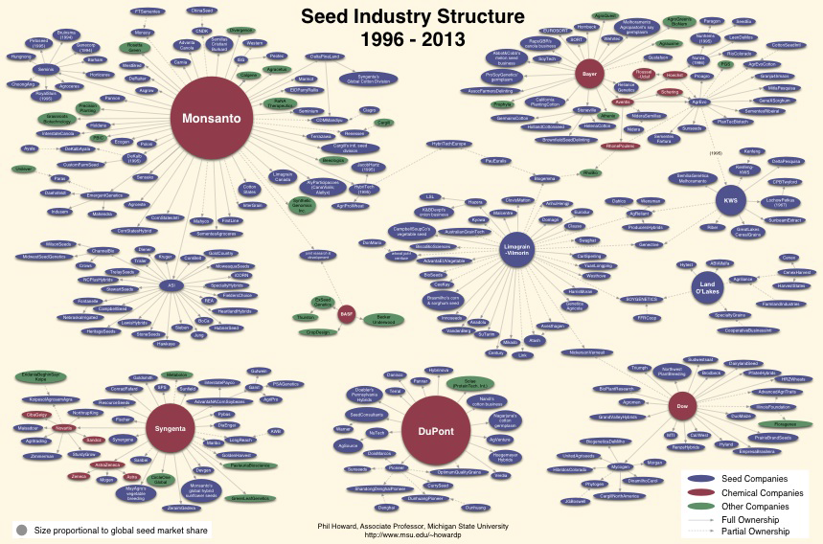

If the present round of mergers and takeovers among companies are concluded, just four global corporations will own and control a majority of the world’s commercial seed and agrichemicals.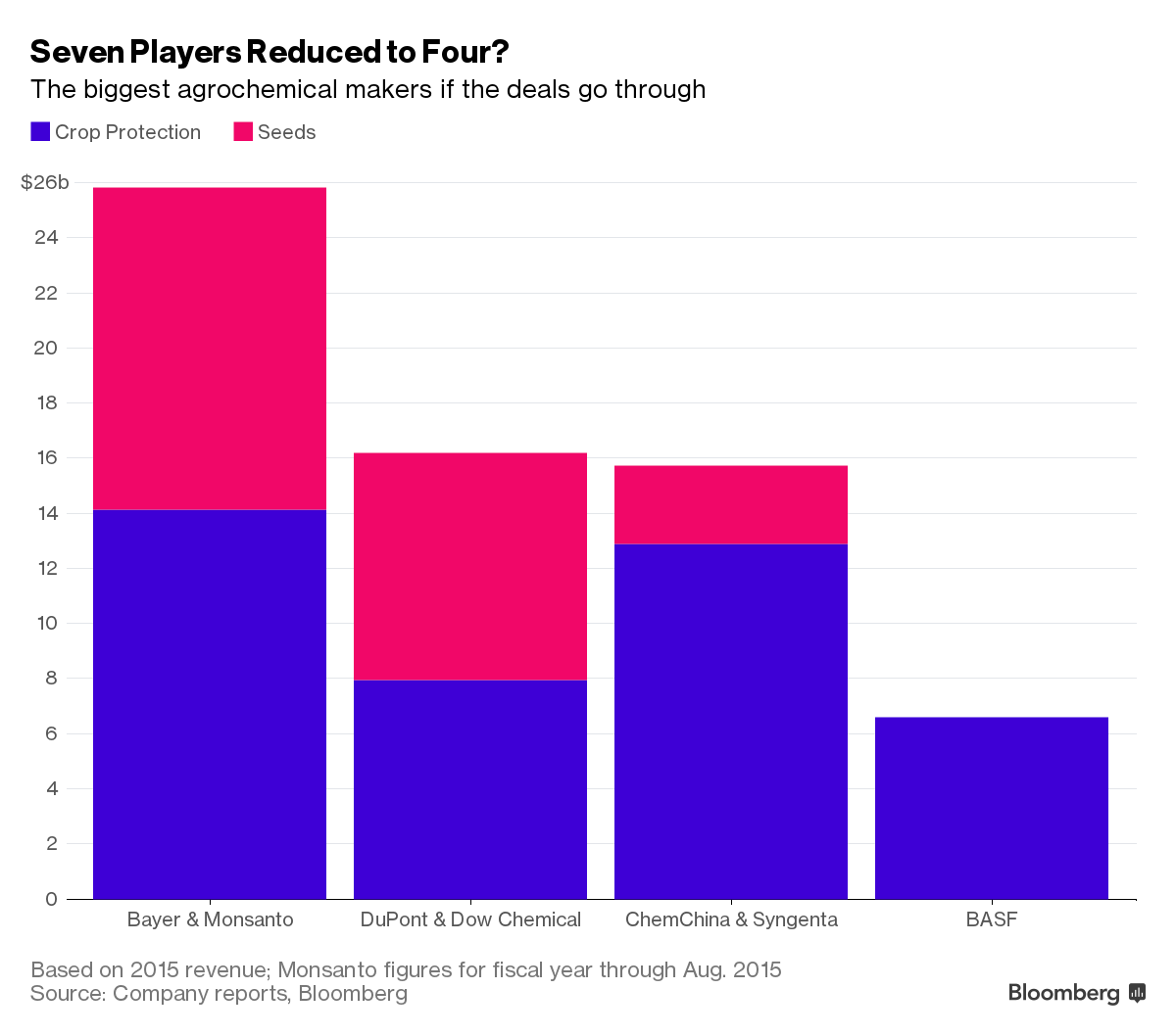
Through cross-licensing and other agreements, these few companies are already operating as price and supply cartels in some sectors. This is not in the public interest.

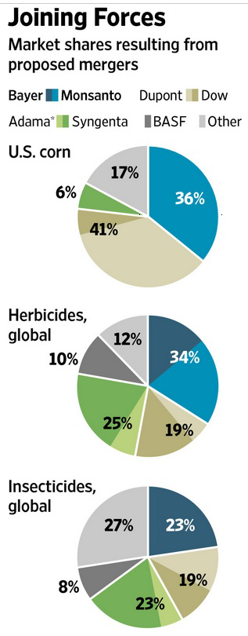

We therefore share the NFF’s concerns over some aspects of agency and distribution agreements in supply chains and support the NFF’s Recommendation 21 that a market study be conducted, into various types of agency/distribution agreements used in the supply of agricultural inputs.

The inquiry’s Terms of Reference should include the fixed price and margin agreements that suppliers of agricultural inputs increasingly use to create virtual cartels over the prices and supplies available to farmers, of seeds, chemicals, pharmaceuticals, fertilisers and machinery.

We share the NFF’s concerns over this unsatisfactory state of affairs which it details as:

“Under an agency agreement, a product is sold to a farmer with the reseller/distributor acting as an agent for the company that owns the product. The reseller/distributor gets a guaranteed margin but has to sell the product at the price specified by the company that produces the product. This effectively stops resellers/distributors reducing the price (by reducing the margin they receive) to compete with other reseller/distributors.

Examples are:
- Monsanto biotechnology – where the reseller is a Monsanto agent and the price is set by Monsanto as is the margin the reseller/distributor gets for making the sale. You will never see any discounting of a Monsanto license to a grower who purchases 10,000 ha vs a grower who buys 200 ha, the price is the price.
- Certain planting seeds (such as cotton) are now controlled by an agency agreement. Hence there are no discounts offered by resellers/distributors based on volume or sales of other products, again this price is the price.”

Such price fixing, which affects the profitability and viability of farmers, amounts to price fixing and market manipulation that fully justifies a thorough investigation. Such abuses are even more unacceptable as Australian scientists and organisations incorporate Monsanto’s patented Bt and Roundup Ready traits into local cotton varieties at grower and public expense. Yet the company dictates the terms of sale and fixes the returns to itself.

We propose that a selection process be employed to choose an organization to do the study as the ACCC may not be best suited to this inquiry. We agree that whoever conducts the inquiry should be adequately resourced for the purpose and have the power to call witnesses.

6. We recommend that the government again develop a National Food Plan as a matter of urgency. However, this plan should be based on the concepts inherent in the People’s Food Plan not the assumptions and biases of the previous plan. The new plan must avoid mimicking the last National Food Plan which was developed in a closed shop of self-interested lobbyists, with its focus primarily on corporate interests, industrial farming, agribusiness profits, and export markets.

A new National Food Plan should be developed with the full participation of all sectors of society. It must be in touch with the real needs of all ordinary citizens and future generations of Australians, for sustainably produced, environmentally and health friendly, local, fresh foods. We cannot rely on imports to feed us. We need local agricultural systems designed to sustainably feed, clothe and house the human population, far into the future.

A recent global survey found 87% of people want to eat GM-free food and will pay a premium for it. And in response to customer demand, most of Australia's 132,000 growers, 160 countries and 550 million farm families around the world also remain GM-free. Squandering growers' hard-earned levies and taxpayer funds on more GM research that is unacceptable and doomed to fail is just unacceptable.

Even Monsanto agrees that farms of the future must be researched, retrofitted and resourced before multiple catastrophes hit. Climates are changing fast, there are many more mouths to feed, and the oil and phosphates on which industrial farm chemicals, fertilisers and fuels depend are running out.

Innovation is the key to food security but the new suite of agricultural solutions to problems like climate change, unreliable water supply and soil loss will not include Genetically Manipulated (GM) seeds and more pesticides as GM cannot deliver on its promises.

In 1996, four commercial GM broad-acre crops with two single gene traits were first grown in the USA. They are still the GM industry's main products - GM soy, corn, canola, and cottonseed, with Roundup tolerance and built-in toxins to kill the caterpillars of some insects. Yet over thirty years of research and development have cost tens of billions of public and private dollars.

Monsanto and others promised to 'feed the world' with GM crops with many new traits including drought and salt tolerance, nitrogen fixation in grains, faster growth rates, higher yields, greater nutrient efficiency, longer shelf-life food, and healthier foods fortified with micro-nutrients. Most of the promised varieties will never be commercially available as many reputable scientists now agree that seeds with complex multi-gene traits, like those promised, cannot be genetically engineered with GM's simple cut-and-paste techniques.

For instance, Dr Richard Richards of CSIRO Plant Industry says: “… breeding combines many traits and most are controlled by many genes, including performance in dry environments, grain yield, tolerance to high temperatures, and once the wheat is turned into flour, improved baking quality. GM technologies are generally only suitable for the single gene traits, not complex multigenic ones.”

Australian Bureau of Resource Sciences notes: "Most complex phenological traits such as water-use efficiency and heat tolerance have multi-genic inheritance patterns and, therefore, plants genetically modified for these traits have not progressed far down the product development pipeline."

Let’s get a National Food Plan that thinks outside the square, does not rely on failed approaches and concepts, and puts the public interest first.

The Plan should include a national Food Ombudsman, to provide a One Stop Shop for shopper access to all food-related issues. The inclusion of every level of government from national, to state, to local, in the various different aspects of food policy and implementation, leads to unmanageable fragmentation from a public access perspective. As the biggest industry in the world, the Plan must ensure that food is produced, regulated and delivered through an integrated system that empowers people to engage with it simply and positively to meet their personal and communal needs.

7. We recommend that the Australian Government become a Party to the Cartagena Protocol on Biosafety - the first treaty negotiated under the Convention on Biological Diversity – as soon as possible. The Biosafety Protocol has 170 States Parties, but Australia is not among them.

Australia has been an active member of the Biodiversity Convention since ratifying it on June 18, 1993 and is also party to the Nagoya Protocol on Access to Genetic Resources and the Fair and Equitable Sharing of Benefits Arising from their Utilization, a 2010 supplementary agreement to the Convention.

Important reasons for the Australian Government to join the Biosafety Protocol include:
- It provides a precautionary framework and processes for the safe and orderly international transfer, handling and use of all Living Modified Organisms (LMOs), especially in trade where a transgression can see a shipment rejected or market lost;
- As an importer as well as exporter of food and fibre products, Australia should exercise caution and care to ensure that GM organisms in international trade do no harm;
- Traded organisms may soon include the products of new Genetically Manipulation (GM) techniques such as CRISPR, which appear able to modify any living organism (including humans) – animals, plants, insects, microbes, fungi, etc.
- Australia’s biosecurity failures are legion and our continent is host to a cornucopia of invasive alien organisms that harm our environment, commerce and way of life;
- We must not keep failing on invasive species incursions through trade, that threaten markets;
- The Biosafety Clearing-House (BCH) facilitates information exchange on LMOs and assists Parties to better comply with the Protocol’s safety requirements;
- BCH also assists with global access to a variety of scientific, technical, environmental, legal and capacity building information in six official UN languages.

8. We recommend the government commission a public review to reality check the commercial benefits and the full costs of Agricultural R&D programs over the past 25 years, with particular reference to GM R&D. R&D was focused on developing broad-acre production for export and many other areas of were defunded or aborted.

This one-track approach had high opportunity costs including reduced capacity to feed Australians from our own resources. A Sunday Age investigation found a: “fundamental shift in Australia's ability to process its own food, raising concerns about dependence on foreign supply chains and pressure on regional communities, as processors, many owned by multinational companies, move their operations offshore to use cheaper labour in low-cost factories.” It reported:

- “Almost one in five processed fruit and vegetable imports now comes from New Zealand, where cheaper labour and lower input costs make it attractive to multinational processors.
- Cheap prawns and fish from Vietnam, China and Thailand have turned Australia into a net seafood importer, with local fish making up only 45 per cent of the market.
- According to recent evidence given to a Senate inquiry on the food processing sector, 80 per cent of the processed pork sold in Australia - such as ham, bacon and smallgoods - is made from imported pig meat; the juice industry, which once imported 70,000 tonnes of fresh fruit, now imports 600,000 tonnes each year; and imports of processed chicken have risen six-fold since 2006-07 from $5 million to $32 million.”

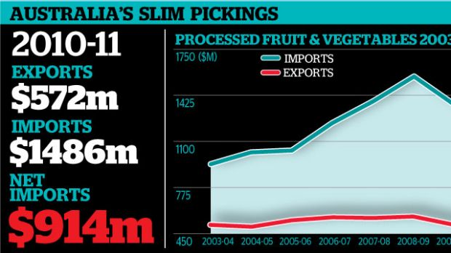

All non-performing R&D should be halted, including the GM projects that have failed to live up to their promises. Increase the R&D for organic and agro-ecological systems.

Fund more projects with a preventative rather than curative focus, to maximise public benefit and minimise the costs of treatment and cure that result from environmental and public health impacts.

Establish an assessment process for new and emerging techniques and their products, such as CRISPR, to further minimise their risks and trim budgets for cleanups and recalls later.

Conclusions:

Innovation is the key to food security and sovereignty for all Australians. A new suite of agricultural solutions to problems like climate change, unreliable water supply and soil loss should not include GM seeds and more pesticides. Governments must take back ownership and control of the global seed supply - GM and conventional - now owned by a small corporate cartel.

Ideally, production of the whole Australian food supply would shift to post-organic systems, with biodynamic the nearest to the ideal. This model would take a holistic approach to every aspect of production - people, animals, seed, soil, animal manures, composting, recycling urban organic material, and more.

As the oil and phosphates on which industrial agriculture depends sharply decline over the next century, and the climate even more radically changes, a well-planned and timely transition to agro-ecological systems of post-organic production is essential. R&D resources must be invested in the transition to the ecological agriculture systems that will feed us. The UN’s IAASTD report offers one guide to more sustainable, secure and safe eco-agricultural systems for the future.

Australian agriculture must aim to be better, not bigger! Australia's population is about 25 million and our agriculture typically produces enough to feed 70 million people. So we have a modest amount of surplus primary produce to export. 'Better' ensures quality and continuity but bigger implies continuation of the mass production of bulk commodities, mostly exported without value-adding.

We will never be a big agricultural player. So we should focus on being smarter, to enhance our reputation and the value of our food and fiber. Australian-owned and run family businesses should be encouraged to do top quality production and processing, and to value-add here in Australia. Then we can find more valuable markets, both domestically and overseas.

Feed all Australians well must be the first priority, as everyone has the right to good food. A well-fed, healthy, well-paid population here will maintain a stable society and create a sound basis for successful food businesses to prosper and grow. This foundation can be a firm basis for exporting our surpluses. Thinking of local markets as mere add-ons to exports is counter-productive and dangerous.

Plans to produce and promote quality foods cannot include processes and ingredients prohibited in organics - GM, food irradiation (exposing 'fresh' fruits and vegetables to energy equal to 10 million x-rays), nanomaterials (ingredients smaller than a human cell) in processing and packaging, synthetic biology (synthetic organisms that never existed before), synthetic chemical residues (such as Roundup) synthetic bovine growth hormones, veterinary medicines, processing aids and additives.

SA and Tasmania have set the ball rolling with excellent food production and marketing programs. SA companies KI Pure Grain, Temple Bruer Wines, Paris Creek dairy, and many more are leading the way. Others should be encouraged to follow.

Most of the biggest GM crops, soy and corn, produced in North and South America, go into animal feed and biofuels. Feedlots are not the direction that Australia should go. Open range, grass fed animals are a plus for us.

So are GM-free crops for which European shoppers have paid premiums since 2006, before any GM canola was grown here. They did not want North America’s GM products, and GM crop production has peaked globally, with shopper demand for GM‐free foods growing faster than any other segment in the USA.

Unmanageable weeds, created by the repeated spraying of Roundup Ready crops, have served as a lesson to more than 95% of the world’s farmers who remain GM-free.

Yours sincerely,

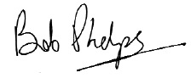

Executive Director

PARLIAMENT OF THE COMMONWEALTH OF AUSTRALIA, Joint Standing Committee on Treaties, Report 165, Trans-Pacific Partnership Agreement, November 2016. http://parlinfo.aph.gov.au/parlInfo/download/committees/reportjnt/024012/toc_pdf/Report165.pdf;fileType=application%2Fpdf
IAASTD Report: http://www.unep.org/dewa/Assessments/Ecosystems/IAASTD/tabid/105853/Defa
Sustain: the Australian Food Network: http://www.circlesoffood.org/
OFA: https://www.facebook.com/OrganicFederationAustralia/
Regenerative Agriculture: http://regenag.com/web/
Cartagena Biosafety Protocol: https://bch.cbd.int/protocol/
GMO-free Europe: http://www.gmo-free-regions.org/gmo-free-regions.html
La Via Campesina: https://viacampesina.org/en/index.php/organisation-mainmenu-44
IFOAM: https://www.ifoam.bio/
Slow Food International: http://www.slowfood.com/our-network/
UN Right to Food: http://www.fao.org/righttofood/about-right-to-food/en/
Howard, Philip H. Concentration and Power in the Food System: Who Controls What We Eat? London: Bloomsbury Academic (February 25, 2016) and https://msu.edu/~howardp/
ETC Group (2016) The Industrial Food Chain’s Recipe for a Box Lunch: Briefing Note, 31/5/16 http://www.etcgroup.org/sites/www.etcgroup.org/files/files/etc_briefing_160530_agmergers_-final.pdf
Bunge, J. (2016) Bayer-Monsanto Deal Would Forge New Agricultural Force, Wall Street Journal, 14/9/16, http://www.wsj.com/articles/bayer-and-monsanto-expected-to-announce-takeover-1473839357
The People’s Food Plan: http://www.australianfoodsovereigntyalliance.org/peoples-food-plan/
87% of consumers globally think non-GMO is ‘healthier’. Food Navigator, Elaine Watson, August 13 2015. http://www.foodnavigator-usa.com/Manufacturers/87-of-consumers-globally-think-non-GMO-is-healthier
Richard Richards, Top five myths about genetic modification. http://theconversation.edu.au/top-five-myths-about-genetic-modification-2664
Australia's crops and pastures in a changing climate - can biotechnology help? Julie Glover, Hilary Johnson, Jacqueline Lizzio, Varsha Wesley, Paul Hattersley and Catherine Knight, Bureau of Rural Sciences, 2008, Page 43. http://www.daff.gov.au/SiteCollectionDocuments/ag-food/biotech/climate-change-and-biotechnology.pdf
Parties to the Cartagena Biosafety Protocol: https://bch.cbd.int/protocol/parties/
CRISPR explainer: https://www.youtube.com/watch?v=MnYppmstxIs
Scale of CRISPR use: http://emergingtech.foe.org.au/wp-content/uploads/2016/05/GM-2.0-Fact-Sheet.pdf
Department of Environment, Invasives. https://www.environment.gov.au/biodiversity/invasive-species
Invasive Species Council. https://invasives.org.au/
Biosafety Clearing-House (BCH): https://bch.cbd.int/
Surge in imports sends Australian farms to brink, Melissa Fyfe and Royce Millar, Sydney Morning Herald, May 27 2012 http://www.smh.com.au/national/surge-in-imports-sends-australian-farms-to-brink-20120526-1zc2u.html

