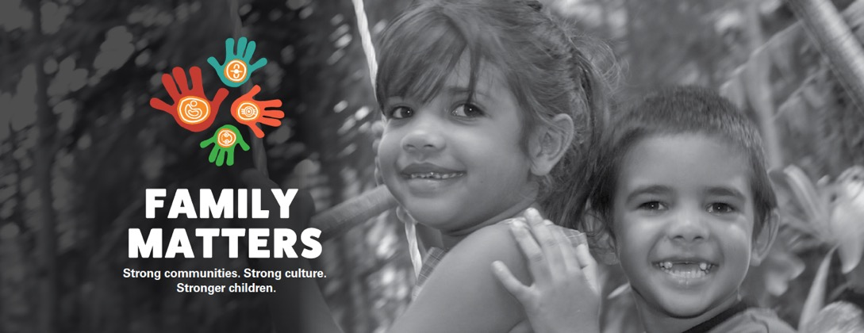

Family Matters
SUBMISSION
TO THE 2017-18 FEDERAL BUDGET

About Family Matters

Family Matters – Strong Communities. Strong Culture. Stronger Children. is Australia’s national campaign to ensure Aboriginal and Torres Strait Islander children and young people grow up safe and cared for in family, community and culture.
Family Matters aims to eliminate the over-representation of Aboriginal and Torres Strait Islander children in out-of-home care by 2040.
Family Matters is led by SNAICC – National Voice for our Children (SNAICC) and is supported by a Strategic Alliance of over 150 Aboriginal and Torres Strait Islander and non-Indigenous organisations, leading academics and prominent educational institutions.

ACKNOWLEDGEMENTS

The Family Matters Submission to the 2017-18 Federal Budget was developed with leadership from SNAICC – National Voice for our Children and Save the Children Australia, in close consultation with the campaign’s national Policy & Advocacy Working Group.
SNAICC and the Family Matters Co-Chairs would like to acknowledge the depth of knowledge, research expertise and strategic advice contributed to this submission by all members of the Family Matters Policy & Advocacy Working Group and by members of the campaign’s national steering committee, the Champions Group.
Front Cover Photography: Wayne Quilliam
For further information, please contact:
Family Matters, c/o SNAICC – National Voice for our Children
familymatters@snaicc.org.au

Introduction
Family Matters – Strong Communities. Strong Culture. Stronger Children. brings together the collective voice of Australian organisations, academics and leaders who are distressed at the persistent and escalating poor outcomes for Aboriginal and Torres Strait Islander children across our country. The failure to promote and protect the rights of Aboriginal and Torres Strait Islander children is highlighted starkly in their 9.5 times and growing over-representation in Australia’s child protection systems. This over-representation reflects broader realities of poverty, discrimination and inter-generational trauma that are impacting our children and the families and communities that care for them. Systems, services and available supports are failing our children as evidenced by a context where young Aboriginal and Torres Strait Islander children are twice as likely to be developmentally vulnerable as non-Indigenous children and far less likely to access universal and preventive services that could address issues and support their potential.
Aboriginal and Torres Strait Islander children have the right to grow up in nurturing and safe environments with the love and support of their families and communities, grounded in and proud of their cultural identity and rich cultural heritage. All the evidence suggests that to achieve this we need to address the root causes of child protection intervention for Aboriginal and Torres Strait Islander children by taking action to heal and strengthen families and communities. Family Matters has completed a review of the evidence and extensive consultation with Aboriginal and Torres Strait Islander people, governments and the non-government sector to create a Roadmap for change that could provide our children with the opportunity to thrive. The Family Matters Roadmap calls for action to progress four evidence-based building blocks for change:
- All families enjoy access to quality, culturally safe, universal and targeted services necessary for Aboriginal and Torres Strait Islander children to thrive
- Aboriginal and Torres Strait Islander people and organisations participate in and have control over decisions that affect their children
- Law, policy and practice in child and family welfare are culturally safe and responsive
- Governments and services are accountable to Aboriginal and Torres Strait Islander people
The budget proposals in this submission call for substantial short to medium-term investment to implement these priorities – to strengthen our families and communities, support our children, and arrest the escalating over-representation of Aboriginal and Torres Strait Islander children in out-of-home care. We call for national and accountable strategies to be implemented by the federal government in partnership with states and territories and Aboriginal and Torres Strait Islander people. Though the initial investment required is significant, this submission argues strongly and presents the evidence that the future benefits for our society and cost savings from the reduced provision of lifelong remedial services are far greater than the costs – there is both a moral and economic imperative to act now.

Budget Proposals

1. A COAG target and national strategy to address over-representation

The persistent, escalating rate of removal of Aboriginal and Torres Strait Islander children into out-of-home care is a national crisis that requires a clear and concerted national response. While child protection is primarily a state responsibility, the federal government has responsibility and capacity to support efforts to address the root causes of child removal. The federal government also bears significant costs of later life health and well-being issues associated with child abuse, neglect and experiences of out-of-home care. The Coalition of Australian Governments (COAG) has already taken a strong role in child protection with preventive focus through its carriage of the National Framework for Protecting Australia’s Children 2009-2020.
When the ground-breaking Bringing Them Home report into the Stolen Generations was released in 1997, nearly 20 years ago, mainstream Australia was shocked to learn that Aboriginal and Torres Strait Islander children represented 20 per cent of children living in out-of-home care. Now, in 2016, they are over 35 per cent. Despite numerous legal and policy frameworks designed to advance safety, and family and cultural connections for children, the rate of Aboriginal and Torres Strait Islander children in out-of-home care is now almost ten times that of other children, and continues to grow. Projections developed by the University of Melbourne in 2016 (Figure 1) show that the population of Aboriginal and Torres Strait Islander children in out-of-home care will triple in the next 20 years if nothing is done to interrupt current trajectories.

Figure 1: Population growth trajectories of children in out-of-home care in Australia by Indigenous status

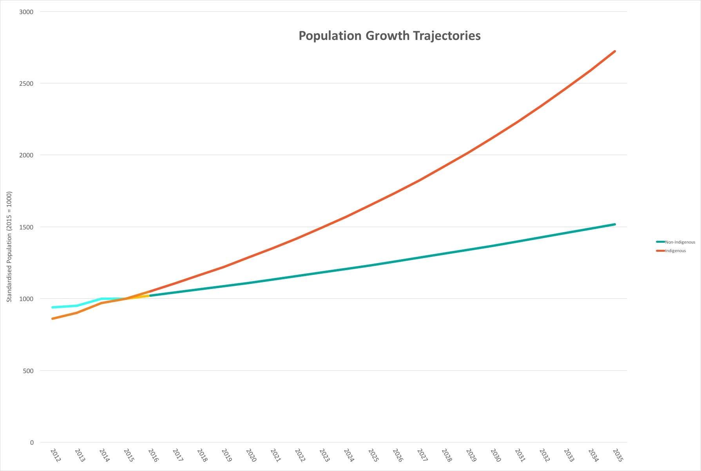

The outcomes delivered by child protection systems across Australia are alarmingly poor for children and families, and are achieved at significant and increasing financial and social cost. Recurrent expenditure on child protection and family support services in Australia has reached $4.3 billion, of which $3.6 billion is spent on statutory child protection and out-of-home care. This expenditure has increased by an average of 3.8 per cent per year, and a total of $472 million over the last 4 years. The costs of this system are much greater however, with children in out-of-home care much more likely to experience poorer health, depression, violence and suicide over their lives; be imprisoned; suffer from alcohol abuse and gambling addiction, and are less likely to have trusting relationships, healthy parenting models, and access to education and economic opportunities. Impacts also ricochet through families through our health, education, welfare and justice systems. Cost benefit analyses demonstrate that improving child safety and rectifying these increasing and unsustainable government costs are best achieved through redressing the causes of child removal, and investing early to better support at-risk children and their families.

Political recognition of and commitment to the urgent need to redress this over-representation has grown significantly at both state, territory, federal and COAG levels over recent times. In June 2016 state and territory Child and Families Ministers from across Australia met and signaled their intent to take national action and seek COAG support, stating in their communiqué of 24 June, “Children and Families Ministers agreed to pursue national action to address the over-representation of Aboriginal and Torres Strait Islander children in out-of-home care…Ministers will work through First Ministers to seek consideration of these issues at COAG as a priority for national reform.” The December 2016 meeting of COAG addressed the issue directly, with its communiqué stating that, “Leaders discussed the critical importance of early intervention efforts to reduce the flow of children into the system as well as the benefits of better information sharing and identifying opportunities to reduce the over-representation of Indigenous children.” Throughout 2016, the Family Matters Statement of Commitment to work towards eliminating over-representation of Aboriginal and Torres Strait Islander children in out-of-home care was signed by 29 state and federal politicians, 88 non-government organisations, and 6 children’s commissioners or child guardians. Politicians signing the statement included federal government ministers, federal government and opposition MPs and senators, state children and families ministers and federal cross-bench senators – demonstrating broad, non-partisan support for action on this issue.

Evidence calls for an integrated strategy that redresses the causes of Indigenous child removal. These cover areas of both federal and state powers, including: family support; inadequate housing and homelessness; social security; family violence; drug and alcohol misuse; health and mental health; early childhood education and care; and child protection. Strategies must include public measures of accountability, which are essential tools to drive intra and inter-government focus, resourcing and monitoring of outcomes. While a significant component of implementation for the strategy will need to be led by states and territories, federal leadership and investment in a range of new or sustained initiatives across these areas will be critical. Recommendations for a federal early intervention, prevention and reunification initiative are included separately in proposal 2 below.
To implement a COAG target and strategy to eliminate the over-representation of Aboriginal and Torres Strait Islander children in out-of-home care resources will be required at the federal level for:
- the development of the target, strategy, and outcomes measures;
- national coordination of implementation efforts by the Australian Government with Secretariat support provided by the Department of Prime Minister and Cabinet and the Department of Social Services;
- ongoing consultation with Aboriginal and Torres Strait Islander leaders and peak organisations on the development and delivery of the strategy;
- public reporting of progress and outcomes;
- additional resources for targeted family and community strengthening initiatives as referenced in proposal 2 below.

Recommendation 1:
Develop and implement a comprehensive, adequately resourced national strategy and target, developed in partnership with Aboriginal and Torres Strait Islander peoples, to eliminate the over-representation of Aboriginal and Torres Strait Islander children in out-of-home care.

Budget impact:
The Commonwealth commit to provide $40 million over four years to fund a new National Partnership Agreement between all States and Territories to eliminate the over-representation of Aboriginal and Torres Strait Islander children in out-of-home care.

2. A national Aboriginal and Torres Strait Islander early intervention, prevention and reunification program

Australian and international evidence has demonstrated the enormous potential downstream social and economic cost benefits of early intervention supports that prevent family breakdown and ensure children can stay safely in the care of their families. Health and well-being benefits of preventive service delivery cut across a broad range of federal and state portfolios. In 2015 the Australian Research Alliance for Children and Youth (ARACY) completed a comprehensive review of evidence on cost benefits of early intervention, concluding that,

“In addition to being crucial to children’s developmental trajectories, it is clear that investments in the early years and in prevention and early intervention more broadly yield significant financial returns. The return on investment for prevention and early intervention is consistently greater than costly remedial responses; preventative investment reduces downstream expenditure on remedial education, school failure, poor health, mental illness, welfare recipiency, substance misuse and criminal justice.”

The ARACY (2015) study cites multiple cost/benefit analyses with findings including that a 7.35 per cent increase in GDP could be achieved over 60 years by reducing child vulnerability; and that Australia incurs a cost of $245,000 per child at 2011 rates for each new substantiation of child maltreatment. A 2006 study of a cohort of 1150 Australians who were in out-of-home care found total costs to government of just over $2 billion across their lifetimes with the highest cost areas including family services ($190m), income support ($76m) and housing support ($67m). Studies of the economic benefits of early intervention programs are more advanced internationally, where, for example, in the United States a study has shown that the implementation of four evidence-based family support programs yields a benefit to cost ratio of 4.31 to 1.

While an effective universal service system addressing core services – including health, education and early childhood – is critical to support vulnerable families, research describes that the most vulnerable families are least likely to access available services. To respond to needs for vulnerable families, targeted approaches that address their specific and complex needs and targeted client engagement strategies are critical. Evidence is also clear that the greatest economic and social returns on investment come from programs targeted to vulnerable populations, especially those targeted early in the life cycle. For Aboriginal and Torres Strait Islander families, service access issues are compounded by the lack of services that are culturally appropriate or adapted to their specific circumstances – reflected in their under-utilisation of mainstream preventive services.

Despite Australia-wide endorsement of a public health model for child safety that would increase the use of preventive approaches, 83 per cent of the $4.34 billion child protection budget remains targeted at the tertiary end of the spectrum, child protection and out-of-home care. Australia is in fact moving backwards with investment in family support services for vulnerable families decreasing from 19.2 per cent to 16.6 per cent of total child protection expenditure over 2011-12 to 2014-15. As illustrated in Figure 2, we are investing in responding to incidents that place children at risk, rather than preventing them from happening in the first place.

Figure 2 – Real recurrent expenditure on child protection in Australia, 2014-15
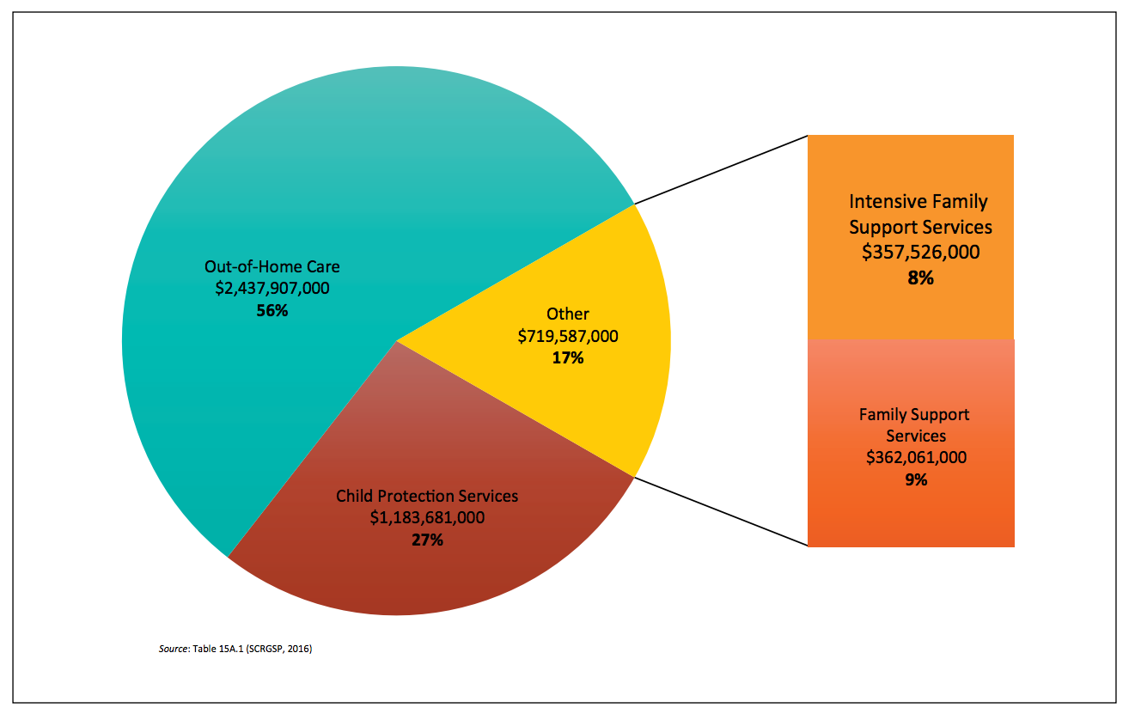

Given widespread failures to invest adequately in early intervention and the lack of culturally appropriate services, it is unsurprising that only 1.4 per cent of Aboriginal and Torres Strait Islander children on average accessed an intensive family support service across Australia in 2012-14 (Figure 3), as compared to 14.6 per cent of Aboriginal and Torres Strait Islander children who received a child protection service in 2014-15, as illustrated in Figure 3.

Figure 3 – Percentage of Aboriginal and Torres Strait Islander children commencing an Intensive Family Support Service, 2012-14
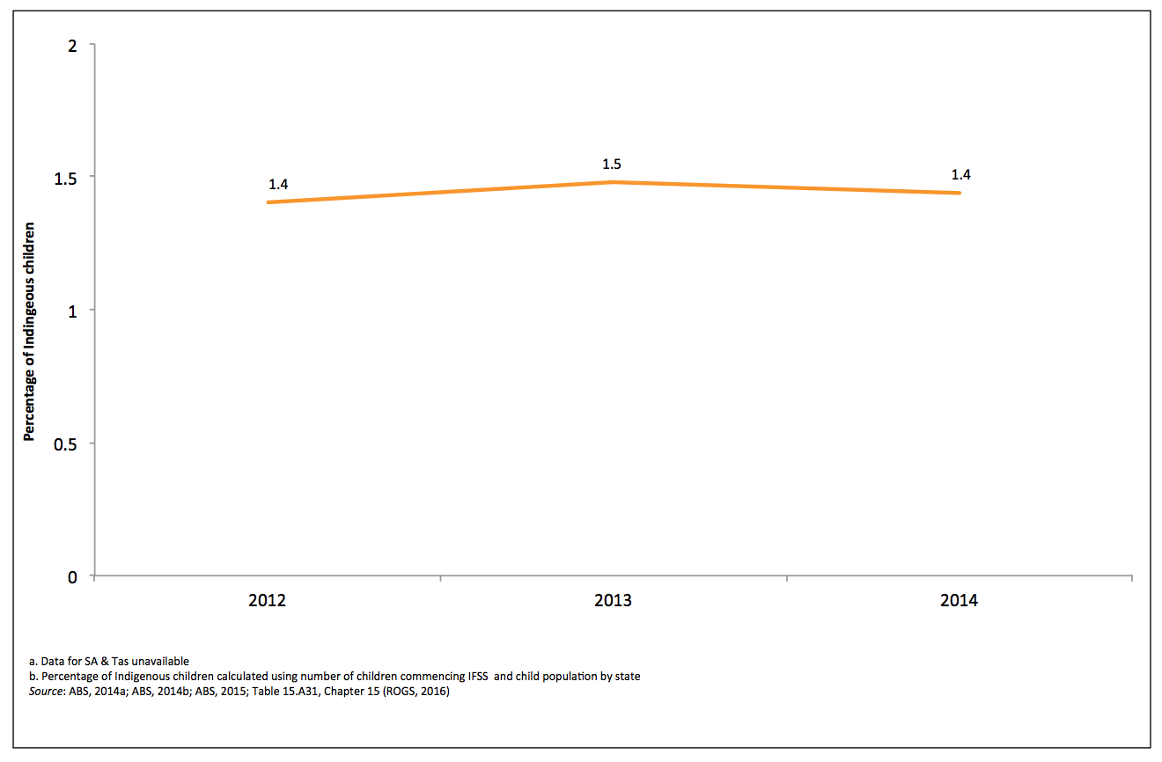
Together this evidence clearly indicates that at the core of a response to Aboriginal and Torres Strait Islander over-representation is the increased provision of targeted and culturally appropriate family services that intervene early. International research has determined conclusively that a range of evidence-based early intervention and prevention programs deliver significant social and cost benefit returns on investment and show strong potential to inform Australian family support approaches. For example, the SafeCare parenting support program has been implemented and extensively researched in the United States, with a study in Los Angeles showing that 85 per cent of families had no further reports of child abuse 36 months following the intervention. In New York, the New York Foundling is implementing Family Functional Therapy through Child Welfare (FFT-CW), a program that extends the strongly evidence-based Family Functional Therapy model to provide targeted support for families to address issues that lead to child protection intervention. A pilot study of FFT-CW in New York in 2010-11 found that 71 per cent of high risk families met all treatment goals, 55 per cent of high risk cases were closed within 6 months and only 2 per cent of families required an out-of-home care placement. If these kinds of results could be replicated in Australia, the social benefits and cost savings for our society would be enormous.

However, International evidence-based programs will still fail to engage and meet the needs of Aboriginal and Torres Strait Islander families where they are not adapted to local culture and context. SNAICC – National Voice for our Children (SNAICC) has undertaken research supported by the Australian Government Department of Social Services under the National Research Agenda for Protecting Australia’s Children with Aboriginal and Torres Strait Islander service providers delivering intensive and targeted family support programs which has shown the elements of support programs that are being adapted to meet the needs of Aboriginal and Torres Strait Islander children and families. The 2-year research project across four jurisdictions conducted in collaboration with Griffith University found that the Aboriginal and Torres Strait Islander services were effectively engaging Aboriginal and Torres Strait Islander families and operating at a high level of quality with “skilled and experienced staff supported by good supervision and management, with strong team functioning.” Services in the study were engaging families in helpful and constructive ways to develop clear goals that addressed the underlying causes of child protection intervention. Importantly, the research found that adaptation of evidence-based family support approaches for Aboriginal and Torres Strait Islander communities was showing success and that Indigenous leadership was integral to that success – concluding that:

“The research demonstrates the capacity of services to adapt the core elements of best practice for Aboriginal and Torres Strait Islander families. Providing services in culturally competent and respectful ways was intrinsic to the services. Their standing as Aboriginal and Torres Strait Islander community services was important to engagement and take-up… The value lies in the services being delivered by Aboriginal community-controlled agencies as these entities are framed by the philosophy that community owns the service, that ‘it is our service, for our community.’”

Further funding is essential across the child protection spectrum, however, the rate of removal of Aboriginal and Torres Strait Islander children into out-of-home care cannot change without a focus on intervening early to support, strengthen and heal families. What is most urgent is nation-wide emphasis on Aboriginal and Torres Strait Islander led holistic, best practice, intensive family support, preservation and reunification services tailored to vulnerable Aboriginal and Torres Strait Islander families, provided at the earliest possible point.

Therefore, Family Matters calls for federal intervention to drive increased investment in Aboriginal and Torres Strait Islander family support services that prevent child protection intervention and its long-term social and economic costs, including incarceration, welfare dependency, poor health and mental illness. This program could be delivered by creating a dedicated family support component within the Safety and Wellbeing stream of the federal government’s Indigenous Advancement Strategy. Elements of the program would include:
- drawing on proven successful local and international evidence-based family support programs;
- consultation with Aboriginal and Torres Strait Islander communities to determine local and cultural adaptations of evidence-based programs;
- resourcing family support services through Aboriginal and Torres Strait Islander organisations to drive community capacity development, local employment and culturally safe services; and
- targeting supports to family preservation and reunification to both prevent entry to out-of-home care and safely reunify children to the care of their families.

Recommendation 2:
Invest in a national Aboriginal and Torres Strait Islander family support program for early intervention, prevention and family reunification.

Budget impact:
Reallocation of funding within the Community Safety stream of the Commonwealth Government’s Indigenous Advancement Strategy, accompanied by a $60m p.a. new investment to establish a nation-wide program for intensive family support with a total additional cost of $240m over 4 years.

3. Dedicated funding for early childhood education and care services to effectively address Aboriginal and Torres Strait Islander children’s educational disadvantage

Currently, Aboriginal and Torres Strait Islander Children are twice as likely to be developmentally vulnerable early in life, and only half as likely to access early education as non-Indigenous children. The Productivity Commission has identified a 15,000 place gap in early learning places for Aboriginal and Torres Strait Islander children. The Commonwealth has a clear responsibility to ensure that the inequality that exists between Aboriginal and Torres Strait Islander children and non-Indigenous children in accessing early childhood services is redressed, through continued and increased support for quality and culturally safe service delivery driven by Aboriginal and Torres Strait Islander peoples. The current reform process being undertaken through the Jobs for Families Child Care package offers a key opportunity to directly invest in the safety and well-being of our children, however, SNAICC has repeatedly raised concerns about the devastating and inadvertent impact these reforms could have without a direct and specific consideration of the needs of Aboriginal and Torres Strait Islander children. The proposed amendments to this package are minimal: firstly for a dedicated funding stream for Aboriginal and Torres Strait Islander services, and secondly an increase in the number of subsidised hours Aboriginal and Torres Strait Islander families can access.
Early education and care (ECEC) is recognised extensively in Australia and internationally as the most effective intervention to support vulnerable children and families. Early investment in strengthening families can provide long-term social and economic benefits by interrupting trajectories that lead to health problems, criminalisation, and child protection intervention. It is well known that efforts to strengthen families need to target whole communities to address situations of poverty, disadvantage, trauma and housing instability for communities that are dealing with the inter-generational impacts of colonisation, racism and dispossession. The evidence shows that Aboriginal and Torres Strait Islander peoples are grossly over-represented on measures of disadvantage that contribute to child protection risks, and similarly under-represented in participation in services that could respond and prevent entry to out-of-home care.
The government has declared a commitment to increasing the participation of Aboriginal and Torres Strait Islander children through the new child care system. All research indicates that the extreme gaps in utilisation between Aboriginal and Torres Strait Islander people and non-Indigenous people of universal services – including early childhood education and care – are a product of the historical, cultural and social factors intertwined in mainstream service delivery which generate experiences of discrimination and then, in turn, disengagement.

Aboriginal and Torres Strait Islander ECEC services are an essential part of the Australian child care system. Aboriginal and Torres Strait Islander organisations have been identified as best placed to provide culturally competent services that are attuned to the needs of their communities, and evidence confirms that these services are more likely to be used. Research describes that Indigenous specific services offer Indigenous families a safe, comfortable, culturally appropriate environment that is easier to access and engage with.
Aboriginal and Torres Strait Islander ECEC services have a different purpose to other services. Their aim is to support the well-being of the most vulnerable children and families in our community by reducing the service access barriers that many Aboriginal and Torres Strait Islander families experience in the mainstream system. Evidence strongly supports Aboriginal and Torres Strait Islander ECEC services as the most successful organisations in engaging successfully with Aboriginal and Torres Strait Islander children because:
- they actively access vulnerable children who are not accessing services – particularly due to the discrimination families experience in mainstream services;
- they engage with the most vulnerable and isolated families in our community and are a key entry point for vulnerable families to engage with a broad range of support services that can enhance the safety and well-being of children; and
- they support parents who may be experiencing long-term or entrenched unemployment to access support in their transition into the workforce and provide an incentive to transition into the workforce. They often offer culturally safe options for training and a stepping stone into paid local work, some being among the larger employers in their communities.
Adequately understanding and accommodating for the ECEC service needs of Aboriginal and Torres Strait Islander children and families experiencing vulnerability can only occur when specific consideration is given to the increased costs services face when delivering culturally informed and integrated education and care. The increase in comparative delivery costs for Aboriginal and Torres Strait Islander services is particularly notable for services operating in remote or rural areas where there is no market for childcare and all services incur higher costs. However, there are key funding considerations that extend much further than remoteness – notably the additional costs of engaging with a higher number of high risk children and families and providing effective trauma-informed culturally based services. Aboriginal and Torres Strait Islander ECEC services are faced with highly complex and diverse demands on staff and programs, and these demands can only be met with:
- higher staffing levels;
- increased and varied forms of training for staff (e.g. family violence, drug and alcohol, mental health);
- funding for cultural programming and effective engagement with community boards and governance structures to ensure community buy in; and
- funding to remedy higher levels of administration for children experiencing vulnerability and the need for a more diverse and comprehensive range of support programs for parents and families.
If the federal government is to close the gap in access to ECEC for Aboriginal and Torres Strait Islander children, these additional funding needs that are critical to engagement with and support of families will need to be met.
The Family Assistance Legislation Amendment (Jobs for Families Child Care Package) Bill 2016 proposes dramatic reform of the early childhood education and care sector. As identified by a large range of organisations including SNAICC, the package will have devastating consequences for Aboriginal and Torres Strait Islander ECEC services without reform. The two key areas of concern are the abolishment of the Budget Based Funding (BBF) program and the reduction in the minimum subsidised hours available to families. The impact of these changes will be reduced income for services and higher costs for families, the combination of which will have a devastating impact on Aboriginal and Torres Strait Islander children and families by reducing the ability for families to access services, and reducing the capacity of services to offer a broad range of holistic services.
For Aboriginal and Torres Strait Islander families experiencing vulnerability or hardship, a reduction in support to access ECEC services has a significant impact on their children. This is particularly true for families with multiple children, who will now face significantly higher costs and a reduction in subsidised hours. The reduction in the minimum child care entitlement for low income families from 24 to 12 hours of subsided care per week will result in either higher out-of-pocket costs or reduced attendance for families who are in the lowest income bracket and do not meet the activity test. Given the high proportion of low-income and vulnerable families serviced by Aboriginal and Torres Strait Islander child care centres, this is expected to have a significant impact on service revenue.
By placing Aboriginal and Torres Strait Islander ECEC services in competition for funding with other mainstream providers under the Community Child Care Fund, the Commonwealth is generating a system that has the potential to marginalise small-scale community organisations and support larger, established organisations to secure more funding, thus eroding local community and cultural leadership in service delivery. This was the experience of the implementation of the Indigenous Advancement Strategy by the Department of the Prime Minister and Cabinet (PM&C) which saw many small and under-resourced Aboriginal and Torres Strait Islander organisations struggling to compete for funding against large and well-established mainstream non-government organisations. We have been encouraged by the recent advice to sector organisations provided by the Minister for Education and Training, Senator the Hon. Simon Birmingham, that a discretionary component of funding within the Community Child Care Fund will assist to ensure that Aboriginal and Torres Strait Islander services are not unfairly disadvantaged through the competitive funding process. However, we strongly believe that a sustainable approach that meets the government’s responsibility to address the inequities in service access and outcomes for Aboriginal and Torres Strait Islander children requires a dedicated Aboriginal and Torres Strait Islander service stream.

The proposed remedy for these impacts is in two parts:

- An Aboriginal and Torres Strait Islander specific program within the Child Care Safety Net and an attuned funding model for other rural and remote services.
The objective of the Aboriginal and Torres Strait Islander program would be to provide repeated three year grants to top-up the income to Aboriginal and Torres Strait Islander services to enable them to continue flexible service provision to the most disadvantaged children within their communities. Savings from the delayed roll-out of the Jobs for Families Childcare Package could be drawn upon to provide the estimated additional $100m p.a. required to implement this program on top of funds reallocated from the proposed Community Child Care Fund.

Funding agreements under this stream of funding would be provided on a long-term basis to ensure the sustainability of services and enable effective programming to support the needs of families in light of best-practice models for intervention surrounding family violence, drug and alcohol misuse and community violence.

- Provision of at least two full days (20 hours) of subsidised quality early learning to all children to support their development, regardless of their parents’ activities.
This is a compromised position from the full 24 hours provided now, offered in the spirit of compromise as a part of a package of recommendations. This requires an amendment to the Bill to ensure that families on incomes less than $100,000 per annum receive two full days (20 hours) of subsidised care per week. This could taper down between the current proposed $65,700 and $100,000 p.a. This proposal would require, specifically, an amendment of Schedule 1, Clause 13 1) of the Bill to state that “The low income result is 48” so that families on incomes less than the lower income threshold ($100,000) per annum receive two full days (up to 20 hours) of subsidised care per week or an amendment reflecting the tapering component. This removes unfair cuts in subsidy caused by the cliff at $65,710 which would mean children have to drop out of early learning or have a significant increase in their fees if their estimated income goes above $65,710. It also retains workforce incentives for families with incomes over $65,710 because subsidy for working families will be paid at a higher Child Care Subsidy (CCS) percentage as well as including additional CCS hours. It finally ensures families in the bottom two quintiles who do not meet the activity test are not worse off moving to CCS.

Given the budget ask for shifting the number of subsidized hours for all children to 20 hours is significant, a potential option would be to implement a special measure to enable a specific provision for 20 subsidised hours for all Aboriginal and Torres Strait Islander children in recognition of the need to close the gap in early childhood services access and outcomes for Aboriginal and Torres Strait Islander children.
Cost saving measures
There are a series of cost savings that could be made to redress any increased costs through these recommendations. The sector has been working on identifying some potential measures that range from reducing the income threshold for the cap from $185,000 to reallocating underspends from the Nanny Pilot and redirecting some of the $1.1 billion of budget savings the Government will achieve in 2017-18 from the delay in the commencement of the Child Care Subsidy.

Recommendation 3:
Establish an Aboriginal and Torres Strait Islander specific program within the Child Care Safety Net of the Federal Government’s Jobs for Families Package.

Budget impact:
$100m per annum additional cost drawing on savings from the delayed implementation of the Jobs for Families package.

Recommendation 4:
Provide at least 20hrs of subsidised quality early learning to all children to support their development, regardless of their parents’ activities.

Budget impact:
Family Matters is yet to develop a clear costing on the proposed increase in minimum subsidised hours. We would be prepared to work with the Government to fully detail costs and potential savings.

4. National data sets for child protection aligned with gaps identified in the 2016 Family Matters Report

In 2016, Family Matters formed a partnership between the University of Melbourne, the Centre for Evidence and Implementation, SNAICC and Save the Children to research and produce a report on available data reflecting:
- a benchmarking of the current over-representation of Aboriginal and Torres Strait Islander children in out-of-home care;
- measures of the economic, community and social factors that drive over-representation and service responses; and
- measures of progress towards enabling Aboriginal and Torres Strait Islander participation and cultural respect in the response to over-representation.
These efforts led to the November 2016 publication of the Family Matters Report. While the report provided a valuable baseline on current issues and trends to promote Aboriginal and Torres Strait Islander child safety and well-being, it also revealed extensive gaps in available data.

The lack of comprehensive and detailed data relevant to the situation of, causes and responses to Aboriginal and Torres Strait Islander children’s over-representation in out-of-home care (OOHC) should be of great concern to governments. Effective policy making is guided by accurate data and information, and data is also essential to monitor and evaluate the impact and cost effectiveness of policies designed to improve and address the safety and well-being of Aboriginal and Torres Strait Islander children. The substantial gaps in data relevant to Aboriginal and Torres Strait Islander children’s experience of child welfare systems highlights the potential for serious risks to children including: governments and authorities not being aware of elevated risks to children’s safety; the rights of children to access health, education and justice being compromised; and the inadequate and delayed investment of governments in targeted and evidence-based solutions to address the chronic situation we are facing today.
A significant investment in data development is needed to ensure access to a range of relevant data that would inform a better understanding of the current situation of over-representation, the progress towards reform and the targeting of future efforts. Data development should take account of identified gaps throughout the 2016 Family Matters Report that have been mapped against the evidence-based building blocks to addressing over-representation outlined in the Family Matters Roadmap. In particular, there should be a priority to ensure the following priority data gaps are redressed and reported against in the Productivity Commission’s annual Report on Government Service, the AIHW Child Protection Australia Report, and/or the Overcoming Indigenous Disadvantage Report:
- Reunification rates of Aboriginal and Torres Strait Islander children in OOHC;
- Aboriginal and Torres Strait Islander child entry and re-entry to OOHC;
- Inclusion of access to long day care under the Budget Based Funding Program in early childhood education and care data;
- Expenditure in child protection and family support both provided to Aboriginal and Torres Strait Islander children and provided by community-controlled services;
- Aboriginal and Torres Strait Islander access to family support and intensive family support services;
- The rate of domestic and family violence reports and substantiations across all jurisdictions and by remoteness for Aboriginal and Torres Strait Islander women and children;
- Nationally consistent measures of compliance with the Aboriginal and Torres Strait Islander Child Placement Principle aligned with its intent and five distinct elements;
- Housing tenure type and quality of housing amongst Aboriginal and Torres Strait Islander families with children; and
- Homelessness and issues relating to housing and overcrowding experienced by Aboriginal and Torres Strait Islander children and their families involved with child protection.

Recommendation 5:
Development and publication of data to better measure the situation of, causes and responses to over-representation of Aboriginal and Torres Strait Islander children. A data development project could be led by either the Productivity Commission or the Australian Institute of Health and Welfare which both report annually on a number of relevant existing data sets.

Budget impact:
Nil – This measure could be implemented through reallocation of priorities of the agency completing the data development project.

5. Community participation in child protection decision making trials
Shifting practice – from service delivery responses that echo historical government interventions, to the empowerment of Aboriginal and Torres Strait Islander people to drive the agenda through community-led approaches – is critical to sustainable change for child safety and well-being. Many of the challenges communities face in providing safe care for their children have their roots in the historical loss of culture and control, and the resulting experiences of trauma and disadvantage that are passed from one generation to the next. As such, these issues can only be addressed by returning responsibility and leadership to Aboriginal and Torres Strait Islander people to create and provide safe and nurturing families and communities for their children. To enable this to occur the Australian Government needs to foster community leadership on matters of child safety and well-being. While other sections of the submission call for services that address immediate support needs for families, this section calls for the community empowerment that will make family changes sustainable in the context of supportive and thriving communities.

A strong base of capacity to care for and support children remains the dominant paradigm in Aboriginal and Torres Strait Islander culture and communities, indicating a clear pathway for community and culturally based safe care. The cultural strengths of Aboriginal and Torres Strait Islander child rearing practices contribute to create safe and nurturing environments for children – indeed, the literature has recognised the value of Indigenous kin and community systems that provide holistic care for children. Also, despite the over-representation of Aboriginal and Torres Strait Islander children in out-of-home care, almost 95 per cent of Aboriginal and Torres Strait Islander children are cared for by their families and communities, and of those in care, just over half are cared for by Aboriginal and Torres Strait Islander carers, indicating the enormous degree of successful care provided by Aboriginal and Torres Strait Islander people.

Australian and international evidence has confirmed the effectiveness of Indigenous leadership to identify needs and shape responses that consistently produce better results, and has linked Indigenous community empowerment to broadly positive social and emotional well-being outcomes for community members. Community-driven solutions have the potential to meet communities’ specific needs with realistic and culturally appropriate approaches. As a result of the community participation, involvement and delivery of these solutions, a sense of control, trust, and awareness can be created within communities. Community values and beliefs are also promoted through these processes, reinforcing a positive sense of cultural identity and knowledge. Children are the direct beneficiaries of strong functioning communities that exercise self-governance.

A framework for genuinely enabling such participation requires the development and recognition of community representative structures that can participate in decision-making, and good faith negotiations with those community representatives to obtain their free, prior and informed consent for decisions made. Enabling community leadership on matters of child safety and well-being is a complex task that confronts a broad range of barriers, including:
- Disparate systems of governance and leadership through service organisations, reference groups and committees that are often aligned to siloed government service responses – rather than holistic, community-led safety and well-being approaches;
- Reluctance to engage because of the failure to follow-through or achieve outcomes through previous government or mainstream led responses;
- Fractured communities where inter-generational disadvantage and struggle have contributed to community divisions, and competition for resources and authority;
- Damaged relationships between government and mainstream services and communities that require support for rebuilding trust and genuine partnership; and
- Persistent discriminatory, racist and/or paternalistic attitudes of some non-Indigenous service organisations and staff.

What is needed to address these barriers and support community empowerment is the facilitated development of community leadership for ensuring child safety and well-being. Enabling such leadership would necessarily draw and build on the strengths of existing community leadership and cultural strengths in providing for the safe care of Aboriginal and Torres Strait Islander children. Family Matters proposes a trial of a facilitated approach to working with Aboriginal and Torres Strait Islander communities to develop child safety and well-being leadership. The trial would include elements such as:
- Facilitating the formation of a leadership group with appropriate representation and drawing on existing community governance structures;
- Supporting community representatives to define their aspirations, needs and strengths for ensuring the safety and well-being of their children;
- Supporting the development of community strategies to address child abuse and neglect;
- Facilitating the development of relationships and engagement protocols between community representative and government and community services; and
- Providing community education on child protection processes and services.

The proposal of a trial recognises that community-driven mechanisms can take many shapes – both formal and informal – and that the form of community organisation cannot be prescribed. The process involves governments trusting and strengthening community knowledge and expertise through building community capacity and confidence and ultimately allowing community control over local responses.

It is proposed that the trial would commence by appointing an Aboriginal or Torres Strait Islander facilitator to work with communities to determine the most appropriate community structure for enabling participation. Key objectives of capacity strengthening within the context of child and family welfare include the strengthening of identity and sense of belonging of community members, strengthening the community’s nurturance and protection of children and families, and creating a collaborative and supportive network to assist a families.

Case Study: Grandmothers Against Removals (GMAR)

GMAR is a key community-driven solution to the escalating numbers of Aboriginal and Torres Strait Islander children in care. Formed in 2014 in response to the high levels of Aboriginal children in out-of-home care in New South Wales, GMAR has been led by concerned grandparents who have advocated for stronger relationships between child protection services and communities and agreed on a Guiding Principles document with the New South Wales Government. The Guiding Principles highlight the role of local Aboriginal communities and their organisations in decision-making, inputting into child protection and out-of-home care service delivery, and ensuring compliance with various requirements including the Aboriginal and Torres Strait Islander Child Placement Principle and cultural care planning.

Recommendation 6:
Undertake a trial of local Aboriginal and Torres Strait Islander community strategies to strengthen families, redress local risks of abuse and neglect for children, oversee child safety and well-being, and input to decision-making on the care and safety of Aboriginal and Torres Strait Islander children. The trial could be conducted in 6-7 locations in urban, regional and remote locations to establish a firm base of evidence to inform the consideration of broader implementation.

Budget impact:
$8 million over 4 years

6. A national peak body for Aboriginal and Torres Strait Islander children

Effectively engaging with Aboriginal and Torres Strait Islander families experiencing vulnerability and strengthening the safety and well-being of children requires a high level of knowledge and experience to understand and respond to their needs. The over-representation of Aboriginal and Torres Strait Islander children in out-of-home care is symptomatic of a child and family service sector that broadly fails to respond to and prioritise the specific needs, circumstances and experiences of Aboriginal and Torres Strait Islander children and families. Addressing this gap requires the active engagement of government with Aboriginal and Torres Strait Islander communities that have the best knowledge about their own unique needs and the responses required.

Governments have increasingly recognised the need to engage in productive policy partnerships with Aboriginal and Torres Strait Islander peoples to address the chronic gaps in access, engagement and outcomes from child and family interventions. The principle of active participation of, and engagement with, Aboriginal and Torres Strait Islander communities is recognised within the National Indigenous Reform Agreement (NIRA) as fundamental in designing programs to effectively overcome disadvantage. The NIRA identifies that “strong relationship/partnerships between government, community and service providers increase the capacity to achieve identified outcomes.”

The efforts of government to engage with and be informed by Aboriginal and Torres Strait Islander communities are often hampered by multiple engagement challenges including:
- Overcoming distrust of Aboriginal and Torres Strait Islander people and communities of government due to past discriminatory policies and persistent poor outcomes;
- Difficulty in clearly determining the priorities of Aboriginal and Torres Strait Islander people due to multiple and disparate voice reflecting a large diversity of cultures and perspectives;
- Identifying collective needs and interests versus local, individual and organisational needs and interests; and
- Inadequate capacity for culturally competent engagement practice.

To function effectively government requires mechanisms for engaging with Aboriginal and Torres Strait Islander leadership and community-controlled organisations to ensure that the relevant expertise, knowledge and community connections are embedded in policy approaches to addressing the disadvantage experienced by Aboriginal and Torres Strait Islander peoples. Engaging with Aboriginal and Torres Strait Islander peak organisations provides a key platform for overcoming engagement barriers and translating community knowledge and the collective voices of Aboriginal and Torres Strait Islander peoples to inform government policy. Key functions of Aboriginal and Torres Strait Islander peaks that benefit government include:
- Providing a cost effective conduit to garner the perspectives of disadvantaged or marginalised groups, which contributes to improve the development of social policy and programs;
- Bringing cultural expertise and connections to communicate effectively with Aboriginal and Torres Strait Islander people;
- Overcoming distrust of government through Aboriginal and Torres Strait Islander leadership and decades of engagement with Aboriginal and Torres Strait Islander people and representation of their needs and priorities;
- Acting as a repository of sector knowledge and expertise in relation to the needs and circumstances of Aboriginal and Torres Strait Islander people, through specialist knowledge and consultation with members;
- Instigating and promoting public debate which assists in fostering participatory democracy while contributing to sound social policy development;
- Providing a low-cost mechanism by which governments can access the knowledge and expertise of the sector to improve the quality, efficiency and relevance of their programs and services; and
- Assisting in facilitating dialogue and information sharing amongst community sector organisations.

Additionally, and critically, Aboriginal and Torres Strait Islander peak bodies, because they are governed by representative groups of Aboriginal and Torres Strait Islander leaders, provide a platform for self-determination. They serve as vehicles for the empowerment of both the Aboriginal and Torres Strait Islander people who operate them and the communities that they represent and serve. They are a key mechanism through which government can enable Indigenous leadership, in line with compelling international evidence that “the best outcomes in community well-being and development for Indigenous peoples are achieved where those peoples have control over their own lives and are empowered to respond to and address the problems facing their own communities.”

In the child and family services sector, SNAICC has a unique role as the only national body providing a representative voice for Aboriginal and Torres Strait Islander community members and organisations. SNAICC is strongly recognised by government and non-government stakeholders as a leading representative voice on Aboriginal and Torres Strait Islander child and family issues. Established in 1983, SNAICC is an Aboriginal and Torres Strait Islander community-controlled organisation governed by a national board and council of Aboriginal and Torres Strait Islander community and service leaders from across the country. In partnership with its board and council members, SNAICC undertakes strong, participatory and ongoing consultation with Aboriginal and Torres Strait Islander communities and organisations across the country. SNAICC’s deep connection to, understanding of and accountability to Aboriginal and Torres Strait Islander communities is grounded in its Indigenous-controlled and national representative governance structure, and its long history representing the interests of Aboriginal and Torres Strait Islander children and families. SNAICC represents the voices of Aboriginal and Torres Strait Islander communities in processes that affect them, including government reviews, inquiries, and consultative processes.

Since the introduction of the Indigenous Advancement Strategy (IAS) in 2014, SNAICC has not received funding to fulfil peak body functions – including to consult with Aboriginal and Torres Strait Islander communities and services and draw on their knowledge and perspectives to inform policy and program development. SNAICC currently primarily receives funding through the Department of Prime Minister and Cabinet for conducting training programs, providing resources and coordinating National Aboriginal and Torres Strait Islander Children’s Day.

Despite limitations of its current funding arrangements, SNAICC continues – to a more limited extent – to provide policy advice to government, extending its strong track record of playing an active facilitation role between Aboriginal and Torres Strait Islander community-controlled organisations and governments. SNAICC is engaged in a range of partnerships with governments to share expertise and knowledge, and inform best-practice approaches to safety and well-being for Aboriginal and Torres Strait Islander children. A recent example has been the work of SNAICC to coordinate the Family Maters campaign, bringing together over 150 Aboriginal and Torres Strait Islander and mainstream sector organisations to provide advice and direction to government on the strategies to overcome the persistent and rising over-representation of Aboriginal and Torres Strait Islander children in out-of-home care. SNAICC recently worked with Family Matters partners to produce and publish an evidence-based roadmap for reform and an extensive overview of baseline data on outcomes and progress to address over-representation. The report and roadmap have been recognised as quality and informative guiding documents by a broad range of government and non-government stakeholders – reflected in the over 88 non-government organisations, 29 state and federal politicians and 6 children’s commissioners who have signed the Family Matters Statement of Commitment.

Though SNAICC has been able to sustain a small scope of peak body operation with non-government and philanthropic support, to fully and sustainably provide peak functions, it requires a government re-investment in SNAICC as a peak body. SNAICC estimates that an additional $700,000 p.a. dedicated to peak functions – including community and sector consultation, policy development, and advising government – would enable it to fulfil its peak body functions, including:

- Key consultation forums to continually document and track emerging evidence around effective approaches to service delivery for Aboriginal and Torres Strait Islander children and families;
- Maintenance of networks and relationships between Aboriginal and Torres Strait Islander community-controlled organisations to build organisational capacity, enable the exchange of knowledge and expertise, and to provide a platform for Aboriginal and Torres Strait Islander leadership to communicate and share the experiences of their communities;
- The facilitation of advice, knowledge and mentoring for governments engaged in addressing the vulnerability and disadvantage experienced by Aboriginal and Torres Strait Islander families;
- The contribution of in-depth policy analysis and advice to a broad range of government policy, legislation and sector development and review processes; and
- The facilitation of best practice advice and mentoring for non-government organisations in engaging in effective service delivery approaches; and
- The convening of national policy development spaces such as the biennial SNAICC National Conference.

Recommendation 7:
Adequate resourcing is provided to SNAICC – National Voice for Our Children to fulfil its role as the national peak body representing the interests of Aboriginal and Torres Strait Islander children.

Budget impact:
$2.8m over 4 years

TOTAL Budget IMPACT and OFFSETS

Costs

Recommendation | Cost over 4 years
A COAG target and national strategy to address over-representation | $40 million
A national Aboriginal and Torres Strait Islander early intervention, prevention and reunification program | $240 million
An Aboriginal and Torres Strait Islander specific program within the Child Care Safety Net of the Federal Government’s Jobs for Families Package | $400 million reduced to Nil by savings within the existing package
At least 20hrs of subsidised quality early learning to all children to support their development, regardless of their parents’ activities | Not costed in this submission
National data sets for child protection aligned with gaps identified in the 2016 Family Matters Report | Nil
Community participation in children protection decision-making trials | $8 million
Adequate resourcing is provided to SNAICC – National Voice for Our Children to fulfil its role as the national peak body representing the interests of Aboriginal and Torres Strait Islander children | $2.8 million
TOTAL | $290.8 million

Offsets

SNAICC understands the need for structural reform to return the budget to surplus. However, in recent years significant funds have been stripped from the services that are critically needed to improve outcomes Aboriginal and Torres Strait Islander children. This included $534 million that was cut from existing programs within the Indigenous Affairs budget in 2014 and the discontinuation of the Aboriginal Children and Family Centres program in the same year. The continuing failure to advance the closing the gap agenda across a broad range of outcomes reflects persistent failures to achieve adequate service reach, quality and accessibility for Aboriginal and Torres Strait Islander people, and reflects the need for targeted investments. The continuing escalation in over-representation of Aboriginal and Torres Strait Islander children in child protection systems and the long-term social and economic returns of early intervention investment detailed in this submission compellingly inform the case to increase overall funding for Indigenous child safety and well-being initiatives.
Our recommendation is that the total of $290.8 million in additional expenditures identified in this submission are offset against a decline in the Government’s planned increase in defence expenditures, as outlined in Save the Children Australia’s federal budget submission which incorporates the majority of Family Matters budget proposals.

SNAICC – National Voice for our Children (2016), Family Matters Report, Melbourne.
Australian Institute of Health and Welfare (2016) Child Protection Australia 2014-15, Child welfare series no. 63. Cat. no. CWS 57. Canberra.
SNAICC – National Voice for our Children (2016), Family Matters Report, Melbourne.
Australian Institute of Family Studies (2016), The economic costs of child abuse and neglect, CFCA Resource Sheet, available at: https://aifs.gov.au/cfca/publications/economic-costs-child-abuse-and-neglect.
Fox, S., Southwell, A., Stafford, N., Goodhue, R., Jackson, D. and Smith, C. (2015). Better Systems, Better Chances: A Review of Research and Practice for Prevention and Early Intervention. Canberra: Australian Research Alliance for Children and Youth.
Children and Families Ministers, Communique, 24 June 2016.
Council of Australian Governments, COAG Meeting Communique, 9 December 2016, available at: https://www.coag.gov.au/meeting-outcomes/coag-meeting-communiqu%C3%A9-9-december-2016.
Available at: http://www.familymatters.org.au/wp-content/uploads/2016/11/Family-Matters-Statement-of-Commitment-website.pdf
Fox, S., Southwell, A., Stafford, N., Goodhue, R., Jackson, D. and Smith, C. (2015). Better Systems, Better Chances: A Review of Research and Practice for Prevention and Early Intervention. Canberra: Australian Research Alliance for Children and Youth. ARACY (2014) cited in Fox et al (2015), p36.
ARACY (2014) cited in Fox et al (2015), p36
Segal, Dalziel, and Papandrea (2013, p623) cited in Fox et al (2015), p36.
Morgan Disney & Associates Pty Ltd and Applied Economics Pty Ltd (2006), Transition from care: Avoidable costs to governments of alternative pathways of young people exiting the formal child protection system in Australia, available at: https://www.dss.gov.au/sites/default/files/documents/05_2012/vol1_transition_care_0.rtf.
Lee, Aos and Miller (2008) cited in Fox et al (2015), p47.
Heckman, J. (2008) The Case for Investing in Disadvantaged Young Children, available at: http://www.heckmanequation.org/content/resource/case-investing-disadvantaged-young-children; Allen, K. (2013). Value for Everyone: Understanding the social and economic benefits of family support services. Canberra: Family Relationships Services Australia, p49-50.
SNAICC – National Voice for our Children (2016), Family Matters Report, Melbourne, p46.
Steering Committee for the Review of Government Service Provision (2016) Report on Government Services 2016. Productivity Commission: Melbourne.
Steering Committee for the Review of Government Service Provision (2013) Report on Government Services (2012). Productivity Commission: Melbourne; Steering Committee for the Review of Government Service Provision (2016) Report on Government Services 2016. Productivity Commission: Melbourne.
SNAICC – National Voice for our Children (2016), Family Matters Report, Melbourne.
Steering Committee for the Review of Government Service Provision (2016) Report on Government Services 2016. Productivity Commission: Melbourne.
Australian Institute of Health and Welfare (2016) Child Protection Australia 2014-15, Child welfare series no. 63. Cat. no. CWS 57. Canberra, table A45.
SNAICC – National Voice for our Children (2016), Family Matters Report, Melbourne.
Lutzker, J. and Edwards, A. (2009). Safe Care: Towards wide-scale implementation of a child maltreatment prevention program, International Journal of Child Health and Human Development, Volume 2, Issue 1, 7-15.
Robins and Rowlands (2012) cited in ‘FFT Evidence Studies Implementation’, p14, available at: http://www.fftllc.com/documents/FFT-CW-Model-Effectiveness.pdf.
SNAICC (2010). Towards Aboriginal and Torres Strait Islander access and engagement: Overcoming barriers to child and family services; Flaxman, S., Muir, K., and Oprea, I. (2009). Indigenous families and children: coordination and provision of services. Occasional Paper No 23. Canberra: FaHCSIA, p.23;
Tilbury, C (2015) Moving to Prevention: Intensive family support services for Aboriginal and Torres Strait Islander children. Melbourne: SNAICC.
Tilbury, C (2015) Moving to Prevention: Intensive family support services for Aboriginal and Torres Strait Islander children. Melbourne: SNAICC, p28
Tilbury, C (2015) Moving to Prevention: Intensive family support services for Aboriginal and Torres Strait Islander children. Melbourne: SNAICC, p28-29
Tilbury, C (2015) Moving to Prevention: Intensive family support services for Aboriginal and Torres Strait Islander children. Melbourne: SNAICC, p29.
Productivity Commission. (2014). Child Care and Early Childhood Learning. Productivity Commission Inquiry Report Volume 2.No. 73. Australian Government, p. 526
Australian Government (2013). A Snapshot of Early Childhood Development in Australia 2012 – AEDI National Report. Re-issue November 2013. Australian Government, Canberra, p.13
Productivity Commission. (2014). Child Care and Early Childhood Learning. Productivity Commission Inquiry Report Volume 2.No. 73. Australian Government, p. 644.
SNAICC – National Voice for our Children (2016), Family Matters Report, Melbourne, p.8.
Australian Government 2016). ‘Minister Morrison: Better start for Indigenous children’, media release, 19 August 2015, available: http://www.indigenous.gov.au/news-and-media/announcements/minister-morrison-better-startindigenous-children.
Flaxman, S., Muir, K., and Oprea, I. (2009). Indigenous families and children: coordination and provision of services, Occasional Paper No 23. Canberra: Department of Families, Housing, Community Services, and Indigenous Affairs (FaHCSIA), p23; See also: SNAICC. (2010). Towards Aboriginal and Torres Strait Islander access and engagement: overcoming barriers to child and family services, Melbourne: Author.
Senate Finance and Public Administration References Committee (2016), Commonwealth Indigenous Advancement Strategy tendering processes, Australian Government, Canberra, p.16.
SNAICC - National Voice for our Children (2016), Submission into the Inquiry into the provisions of the Family Assistance Legislation Amendment Jobs for Families Child Care Package Bill 2015, Melbourne.
Department of Families, Housing, Community Services and Indigenous Affairs (FaHCSIA) (2009). Footprints in Time: The Longitudinal Study of Indigenous Children—Key Summary Report from Wave 1, Canberra: Author, p42; SNAICC (2004). Indigenous Parenting Project: Final Report, Melbourne: Author, p.40; Yeo, S. (2003). Bonding and attachment of Australian Aboriginal children. Child Abuse Review, 12, 299; Taylor, J. (2011). Coming, ready or not: Aboriginal children’s transition to school in urban Australia and the policy push. International Journal of Early Years Education, 19(2), 145, p.148; Armstrong, S, Buckley, S., Lonsdale, M., Milgate, G., Kneebone, L., Cook, L., and Skelton, F. (2012). Starting school: a strengths-based approach towards Aboriginal and Torres Strait Islander children, pp.11-12.
Australian Institute of Health and Welfare (2016), Child Protection Australia 2014-15, Child welfare series no. 63. Cat. no. CWS 57. Canberra.
Australian National Audit Office. (2012). Capacity development for Indigenous service delivery, No 26, Canberra, p17; Cornell, S., and Taylor J. (2000). Sovereignty, devolution, and the future of tribal-state relations, Cambridge: Harvard University, pp6-7 available at: http://hpaied.org/sites/default/files/ publications/PRS00-4.pdf; Denato, R., and Segal, L. (2013). ‘Does Australia have the appropriate health reform agenda to close the gap in Indigenous health?’, Australian Health Review, 37(2), May, 232.
Chandler, M., and Lalonde, C. (1998). Cultural continuity as a hedge against suicide in Canada’s First Nations; Lavoie, J. et al. (2010). ‘Have investments in on-reserve health services and initiatives promoting community control improved First Nations’ health in Manitoba?’, Social Science and Medicine, 71(4), August, 717.
Lohar, S., Price-Robertson, R., & Nair, L. (2013). Applying community capacity building approaches to child and welfare practice and policy. Child, Family and Community Australia, 13.
SNAICC. (2013). Whose voice counts: Aboriginal and Torres Strait Islander participation in child protection decision-making, Melbourne.
Grandmothers Against Removals (2016), ‘About Us’, available at: http://stopstolengenerations.com.au/.
Council of Australian Governments, National Indigenous Reform Agreement (Closing the Gap), 2008, available at: http://www.coag.gov.au/intergov_agreements/federal_financial_relations/index.cfm, p. D-67.
Harvard Project on American Indian Economic Development, available at: http://hpaied.org/about-hpaied/overview.

