21 December 2016
Budget Policy Division
Department of the Treasury
Langton Crescent
PARKES ACT 2600

cc Hon Christian Porter MP Minister for Social Services

Dear Sir/Madam,
CSSA is the Catholic Church’s peak national body for social services.

CSSA envisages a fairer, more inclusive Australian society that reflects and supports the dignity, equality and participation of all people.

For 60 years we have assisted member agencies to promote a fairer, more inclusive society that reflects and supports the dignity, equality and participation of all people.

Our 52 member agencies operating from 650 sites across Australia employ around 10,000 people, with 6,000 voluntary contributors to this work.

The network provides community services to 450,000 Australians each year.

CSSA partners with a range of government and non-government organisations to pursue our mission and contributes to social policy development based on the experience and expertise of the CSSA member network.
This submission provides Catholic Social Services Australia’s (CSSA) recommendations for the 2017-18 Australian Government Budget. In making our pre-Budget submission, CSSA is cognisant of the Government’s stated priority to bring the Budget back to surplus. While CSSA accepts the importance of this, we believe that it should not be done at the expense of services and welfare payments for the vulnerable and disadvantaged in our communities. As such we urge the Government to adopt equity as its chief guiding principle, in order to ensure vulnerable families and individuals are not unfairly disadvantaged by expenditure cuts.
CSSA regards the Budget as the primary vehicle for the Government to communicate its commitment to supporting all members of our community and providing a safety net for the most vulnerable. It also serves as signal to the community of the government’s commitment to the 2030 Agenda for Sustainable Development which the Government is a signatory, and in particular Sustainable Development Goals for Ending Poverty, Reducing Inequality and Sustainable Cities and Communities.
In summary we ask that the Government consider the following recommendations:
- Fund trials in communities and regions experiencing entrenched poverty and disadvantage;
- Prioritise support for rural and remote communities;
- Ensure adequate income support for low income and welfare dependent households;
- Increase investment and certainty in affordable housing and services for homeless people; and
- Increase investment in support for vulnerable children and families.

Unfortunately, the rate of poverty is growing in Australia, with an estimated 2.5million people or 13.9% of all people living below the internationally accepted poverty line. Disturbingly 600,000 children now live below the poverty line. 160 000 people are long term unemployed (over 12 months) and just over a million people want to work more but can’t get the extra hours.
CSSA member organisations are seeing first-hand the negative impacts of previous Budget decisions on the people they serve – people whose hopes for breaking the poverty cycle, getting a job or securing affordable accommodation have suffered a serious set-back. We implore Government not to make the same decision this year, and seek assurance that Budget decisions will not further increase the risk of social and economic disadvantage, especially for low income families and households.
Addressing this disadvantage should be a primary consideration of the 2017-18 Budget. A Budget which enables social and economic participation of the vulnerable and disadvantaged in our society not only brings about social justice and fairness, it also enhances economic growth. The success of the 2017-18 Budget will be judged by the measures within it which address the needs of the poorest and most vulnerable in our society.
In this regard, we urge the Government to focus on investment for long-term benefit rather than expenditure cuts for short-term savings. Sound investment in families and children, especially through the funding of preventative measure in the lives of those at risk, has demonstrated longer term economic and social benefits to the whole community. Increased economic and social participation of all Australians including access to employment, training and community participation needs to be a priority for this Budget. Similarly measures which seek to reduce income and support services available to vulnerable Australians should be abandoned as they will not deliver increases in employment, economic and social participation so critical to the functioning of our society and the economy.
CSSA would also like to take this opportunity to stress the importance of the Not-for-Profit sector in delivering social services across Australia. These services effect a critical difference in the lives of people served, helping them to realise greater independence and self-determination in life. Cuts to services and programs only reduce the capacity of people to move from a situation of social and financial dependence to independence.
These services deliver clear social and economic benefit, assisting people to participate fully in their communities, supporting transition back into the workforce often after long periods of absence, helping families navigate critical periods in the lifecycle, and supporting people with complex physical, social and mental health needs with the day to day activities of life. Member agencies focus on improving the lives of individuals and families experiencing disadvantage and creating social change in the communities within which they work. Social services and social impact go hand in hand to break cycles of entrenched disadvantage. As such at a time of increasing inequality and disadvantage we would encourage the Government to use this budget to increase funding of social programs delivered by the charity sector to the levels pre-2014.

CSSA’s Budget recommendations focus on the areas that have the greatest potential to improve the lives of people and the communities who are most disadvantaged.
- Fund trials in communities and regions experiencing entrenched poverty and disadvantage
Dropping off the Edge 2015 released by CSSA and Jesuit Social Services found that a small number of communities experience persistent and complex entrenched disadvantage. Previous reports in this series show that many of the same communities continue to experience entrenched disadvantage. While the current approach to support services may work for the majority of communities, it is clear that the mainstream approach is failing communities at the edge.
High levels of unemployment, low levels of income and education, housing stress, and high incidences of family violence and criminal offending are consistently present in these communities. These factors coalesce to form a web of disadvantage severely limiting the life opportunities of individuals over successive generations, and accruing significant social and economic costs to the broader community.
Similar to the Try, Test and Learn trials which are focussing on three cohort groups, CSSA recommends that trials are also undertaken in communities that experience entrenched disadvantage. These trials should co design programs with the local community that identify and meet its needs. This would also require better co-ordination of government funded services to ensure the expenditure was making improvements to the lives of the people in these most disadvantaged communities and especially young people.
- Prioritise support for rural and remote communities
In the 2015-16 Budget, the Department of Agriculture ceased funding of a highly successful community mental health and family and relationship counseling services program in drought affected communities and which was administered by the Department of Social Services. CSSA is concerned about the long term support for farming communities and families affected by drought and other economic and social challenges. Our members have been supporting local communities in 52 drought affected Local Government areas across Australia with wellbeing and community mental health programs. CSSA has developed a proposal (link here) to continue this successful rural resilience program which would require a modest $20 million per year for a three year commitment.
This program had begun to break through the challenges of providing individual and family relationship support services to rural families in an innovative way. Activities such as men’s sheds, morning teas, toy library visits to remote farms and provided opportunities to start conversations and develop support networks. We have evidence that this approach has provided support for individuals and farmers’ facing difficult challenges such as economic stress, drought and isolation.
Traditional mental health services such as one on one counselling and telephone crisis lines are ineffective in rural areas due to farmers’ reluctance to seek help and support for various reasons. We are concerned that the Primary Health Networks (funded by Department of Health) will focus on clinical mental health counselling. Our preferred approach is a community mental health model (through the Department of Social Services) that develops support networks in the community and builds resilience so rural communities can withstand the ups and downs of rural living.

We also recommend funding to significantly strengthen social support services and community connections in rural and remote communities. The majority of communities identified in the Dropping off the Edge 2015 research are located in rural and remote areas. Funding for community development and support must acknowledge the greater costs for service delivery related to locational disadvantage. These costs include travel, housing and attracting skilled workforce. These costs are currently met by member agencies at the expense of actual service delivery. CSSA calls on the Government to ensure that funding is commensurate with the true costs of service delivery in these areas.
- Ensure adequate income support for low income and welfare dependent households
The recently released Mid-Year Economic and Fiscal Outlook (MYEFO) 2016‑17 showed that the Australian economy is “soft” with slow wages and employment growth contributing to the deficit budgetary position of the Government. Subdued wages growth is acting as a buffer against increased unemployment but in doing so is also limiting the growth, and indeed potentially reducing tax receipts. However, this is also contributing to an increase in the number of people underemployed and the general income stress many households are feeling today.
The 2017-18 Budget provides the Government the opportunity to continue down the path of ongoing cuts to spending or strategically increasing government spending in social capital and infrastructure aimed at stimulating the economy and private spending. Since 2014 the Government has and continues to pursue a path of fiscal constraint, however in doing so has focussed on those in our society least able to deal with the withdrawal of government funded services or a reduction in payments. MYEFO still maintains a raft of “zombie” measures which if implemented will further reduce the income of low income and working class families which in turn will impact on economic spending and growth. Reducing government payments at a time of low wages growth will in our view only exacerbate the impacts of a soft economy which is neither socially or economically sensible. We would therefore encourage the Government to abandon budgetary measures such further cuts to family tax benefits and instead look to defer cuts to the corporate tax rates until such time as the Budget position has stabilised.
CSSA believes that the current system for determining the level of income support is in need of a significant overhaul and as such recommends that an Independent Commission be established to develop evidence-based benchmarks of adequacy for income support payments to people of working age. CSSA has been asking for greater transparency, through the public release of government economic modelling of all budgetary measures which impact on the economic wellbeing of Australians, especially the poorest and vulnerable in our society.
Placing the burden of budget repair on those who can least afford it, is wrong morally and economically. We know from our own research, through the Dropping off the Edge 2015 report, that there are many factors which contribute to poverty and disadvantage and it would be of no surprise that one of these is low income.

- Increase investment and certainty in affordable housing and services for homeless people
CSSA is concerned that Australia has not had a national strategy to address affordable housing and homelessness for some time. We support the adoption of a national housing strategy that commits all governments to devise appropriate mechanisms to increase the supply of affordable housing and address homelessness. Housing affordability is one of the key concerns for many Australians, and there is a growing number of people experiencing homelessness and those at risk of becoming homeless, especially older single women and women with families fleeing domestic violence.
We are encouraged by the Government’s recent announcement to establish an affordable housing taskforce that will examine innovative financing models for the development of social and affordable housing.
We are also encouraged by the 12 month extension to the National Partnership Agreement on Homelessness but want this commitment to extend for five years to provide long term certainty of funding for homelessness and associated services.
While we commend the Government’s move to prioritise emergency housing for women with young children fleeing family violence, this prioritisation must be matched with additional funding for emergency housing services. Australia’s welcome response to eliminating family violence will only succeed when it is supported by requisite funding for emergency housing and support services.
- Increase investment in support for vulnerable children and families
CSSA supports those budget initiatives that focus on early intervention and prevention strategies to assist children and families experiencing poverty and vulnerability. There is substantial evidence that intensive investment in family support at an early stage, before problems become entrenched, results in marked social and economic benefits for the whole community. Any new package of support for families needs to prioritise funding for the most vulnerable people, and those communities of most disadvantage.
CSSA calls on the Government to prioritise those projects that form part of the National Framework for Protecting Australia’s Children, which recognises the economic and social benefits of investing in stronger universal and early intervention services to assist vulnerable children and families at critical stages of their development and life.
The Second Action Plan 2015-18 developed under The National Plan to Reduce Violence against Women and their Children 2010 – 2022 should also be fully funded to address the current shortfall of services for women and their children experiencing domestic violence.

- Support the not-for-profit sector
The recently released Australian Charities Report 2014 highlights the significant role that the charity sector plays in the Australian economy. According to the report the charity sector employs more than a million people and had a total income in 2014 in excess of $103 billion, which included some $42 billion by way of government grants. The relationship between the government and charities is both significant and interdependent and as such we caution the government from introducing measures which would undermine the sustainability of the sector in delivering vital services to the poor and vulnerable in our society.

CSSA will remain vigilant in advocating for fair and balanced policy responses that enable equity of opportunity for all Australians and outcomes that ensure that the most vulnerable in our community have access to their share of Australia’s common good.
I would be pleased to elaborate further on our recommendations on the contact details provided below or alternatively you can contact the Director Social Policy, Liz de Chastel on Telephone: 02 6188 6943.
Sincerely,
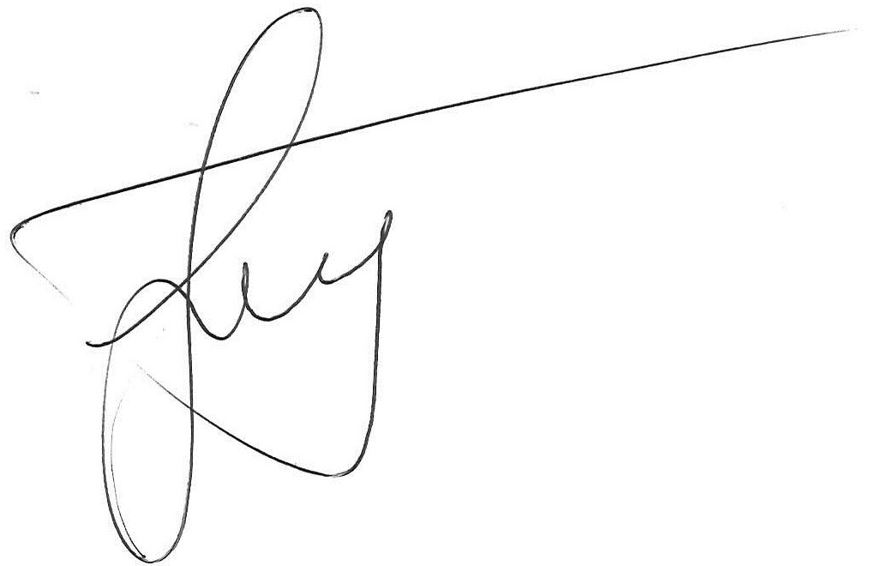
Graham West
Interim Chief Executive Officer

http://dfat.gov.au/aid/topics/development-issues/global-development-agenda/Pages/global-development-agenda.aspx accessed on 11th January 2016
ACOSS 2014 Poverty in Australia Report
ibid
ABS July 2016
A New System for Better Employment and Social Outcomes - Interim Report of the Reference Group on Welfare Reform to the Minister for Social Services P85
The Dropping off the Edge Report, State Fact Sheets and further relevant material can be found at http://www.dote.org.au/
http://www.theage.com.au/comment/housing-affordability-crisis-brought-on-by-government-policy-failures-20150610-ghkh5w.html accessed 12th January 2016
http://www.abs.gov.au/ausstats/abs@.nsf/latestProducts/2049.0Media%20Release12011
The evidence base underpinning family and community policy, summarised by the Australian Institute of Family Studies in http://www.aifs.org.au/sf/pubs/bull1/bulletin1.pdf , was used to support FAHCSIA’s Stronger Families and Communities Strategy, a pre-curser to the Family Support Program.
Cortis, N., Lee, I., Powell, A., Simnett, R. and Reeve, R. (2015) Australian Charities Report 2014.Centre for Social Impact and Social Policy Research Centre, UNSW Australia.

