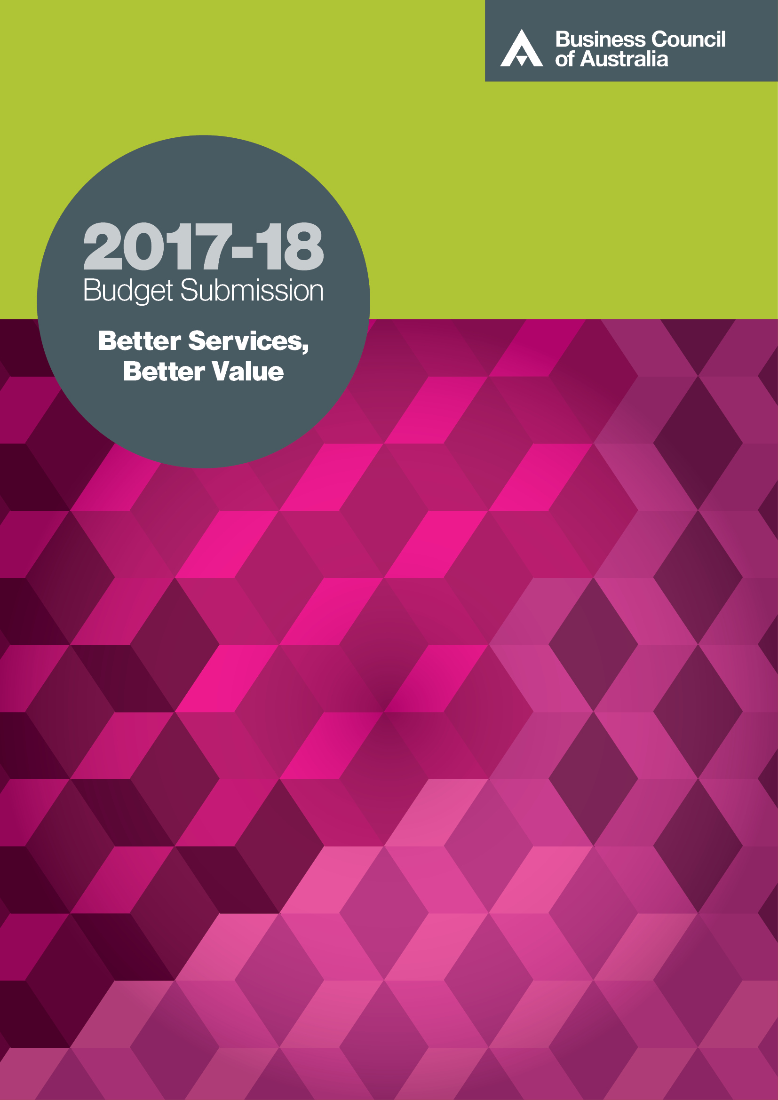
Business Council 2017-18 Budget Submission: Better Services, Better Value
March 2017

Contents
Key messages 3
Recommendations for a stronger budget 7
1 a strong budget is needed for a prosperous Australia 12
2 A perfect storm is looming 15
3 an Architecture for strengthening the Budget 24
4 The immediate task 29
5 improving the quality and sustainability of spending 31
5.1 Delivering better health care 35
5.2 Driving a better return on education investment 41
5.3 Fit-for-purpose social security 46
6 managing risks and building capacity 48
7 investing for growth 52

The Business Council of Australia is a forum for the chief executives of Australia’s largest companies to promote economic and social progress in the national interest.

Key messages

It’s time to break the gridlock and act
- The Business Council is calling on the Australian Parliament to break the gridlock to get Australia’s budget back in order.
- Continuing opposition to savings measures and the absence of an agreed systematic strategy are just leaving the tab for the deficit and growing debt burden for future generations of Australians to pay.
- Households will face blunt cuts in services, higher taxes and a weaker, less resilient economy.
- Those opposing savings measures have a responsibility to the community to set out alternatives that will deliver a stronger budget and economic growth.

Action is needed on three fronts
- To slow the 3 per cent annual real spending growth projected from 2020 onwards.
  - A strong, affordable budget position is needed first and foremost to safeguard critical services and investments and the social safety net that are the hallmarks of the prosperous and fair society we all want.
- To deliver more effective and better-targeted services that give the community better value for the $440 billion spent each year.
  - Each and every dollar spent should promote overall community wellbeing. Spending without regard to the costs, or benefits, is in no-one’s interests.
- Policies to promote investment and economic growth.
  - A dual strategy of strengthening the budget will build capacity for investing in economic growth while economic growth will improve the budget. This is win-win.

The problem is spending growth – and poor spending outcomes
- The numbers are stark. From 2020 onwards, annual real spending growth is expected to ramp up to 3 per cent on the back of new programs and population ageing, outpacing projected economic growth.
- As a result, federal government spending will climb to more than 30 per cent of GDP by 2055 compared with just over 25 per cent today.
- Real spending growth of 3 per cent a year would lock in structural deficits of at least 3 per cent of GDP, doubling to 6 per cent of GDP by mid-century according to the most recent Intergenerational Report.
- This is unsustainable. Ongoing deficits of even 3 per cent of GDP would create (in today’s terms) some $50 billion additional debt each year.

Key messages (cont’d)

Australian households will bear the costs of inaction
- Let’s be clear what this would mean for Australian households.
  - Taxes would need to rise by more than $5000 per household per year or by $2000 per person to close the deficit, and by much more to pay off debt.
  - Relying on bracket creep to close the deficit would see 1.5 million more workers paying the top marginal rate of tax of 47 per cent.
  - Alternatively, if we make budget cuts, services would have to be slashed. Saving $50 billion requires cutting the equivalent of one-third of today’s social security budget or almost the entire education and defence budgets combined.
  - Burgeoning debt would leave no buffer to respond to economic shocks – a ‘perfect storm scenario’ – or any capacity for substantial investments in physical and social infrastructure. Other policies, including a more competitive tax system, which are urgently needed to deliver stronger economic growth, would languish.
- None of these options is acceptable but, without intervention, they are inevitable.
- We are in a vicious circle. The only way to break free from this negative sum game is for the Parliament to act in the interests of the community and remedy the structural spending pressures that are driving it.
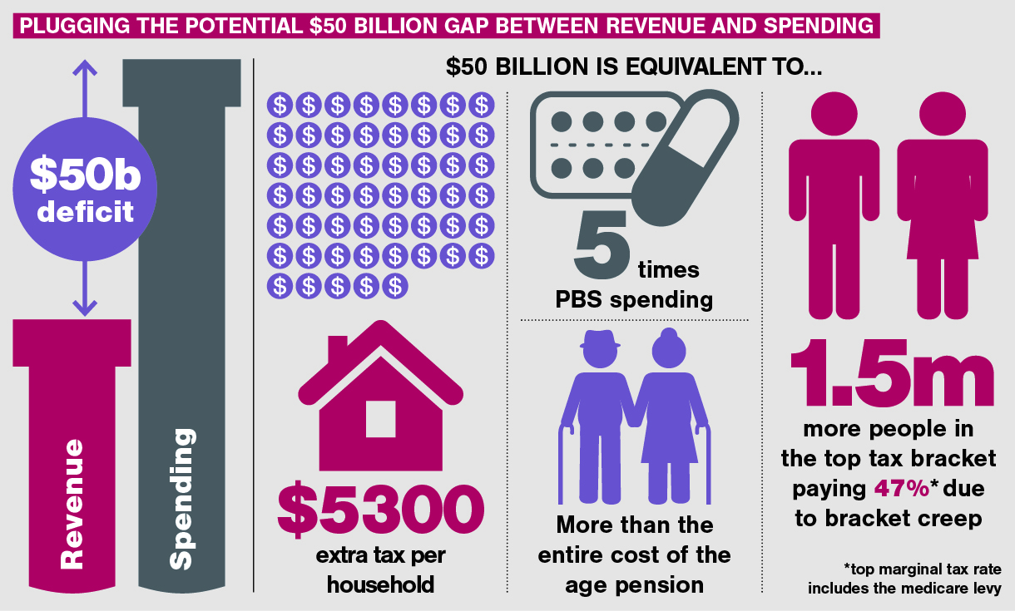
Key messages (cont’d)

Higher tax rates or new taxes will not solve the budget problem but comprehensive tax reform would underpin economic growth and a stronger revenue base
- Low revenues have not created the deficit and higher tax rates or new taxes are not the answer to budget repair.
- Tax hikes are not budget savings. They just underwrite even higher spending.
- Higher taxes would do nothing to improve service outcomes and value for money.
- Higher overall taxation will only dampen growth and incomes and diminish the revenue base over time.
  - Higher taxes cripple living standards by discouraging people and businesses from working, investing and innovating. These are the key ingredients for higher growth, higher wages and sustainable tax revenues.
- There is a compelling need for a more efficient and less complex tax system, including more competitive business taxes, to relieve the growth-sapping effects of the existing tax mix.
- Higher economic growth and revenue dividends flowing from a more competitive tax system would give greater capacity to provide government services. But revenue dividends should never be frittered away on poorly targeted spending.

A budget strategy to support prosperity
- This submission sets out a five-pronged strategy to promote stronger growth, better services and value from government spending and, ultimately, higher community living standards:
  - an architecture for embedding a systematic approach to improving program outcomes and delivering sustainable budgets, guided and supported by overarching fiscal goals and rules to contain spending and revenue growth and the overall size of government
  - measures to prevent budget slippage in the immediate term including the passage of several blocked savings measures and continued functional and efficiency reviews
  - actions over the medium term across several program areas, including healthcare and education, that would contain growth in outlays at the same time as improving program effectiveness and service quality through better targeting and productivity improvements
  - management of emerging spending risks
  - a suite of policies to promote stronger growth including infrastructure, comprehensive tax and regulatory reforms that should be implemented in tandem with budget repair.
- The 10-year window to contain spending growth is rapidly closing. Lacklustre economic growth and still-languishing business investment, coupled with heightened global uncertainty, make taking action more, not less, urgent.

Key messages (cont’d)

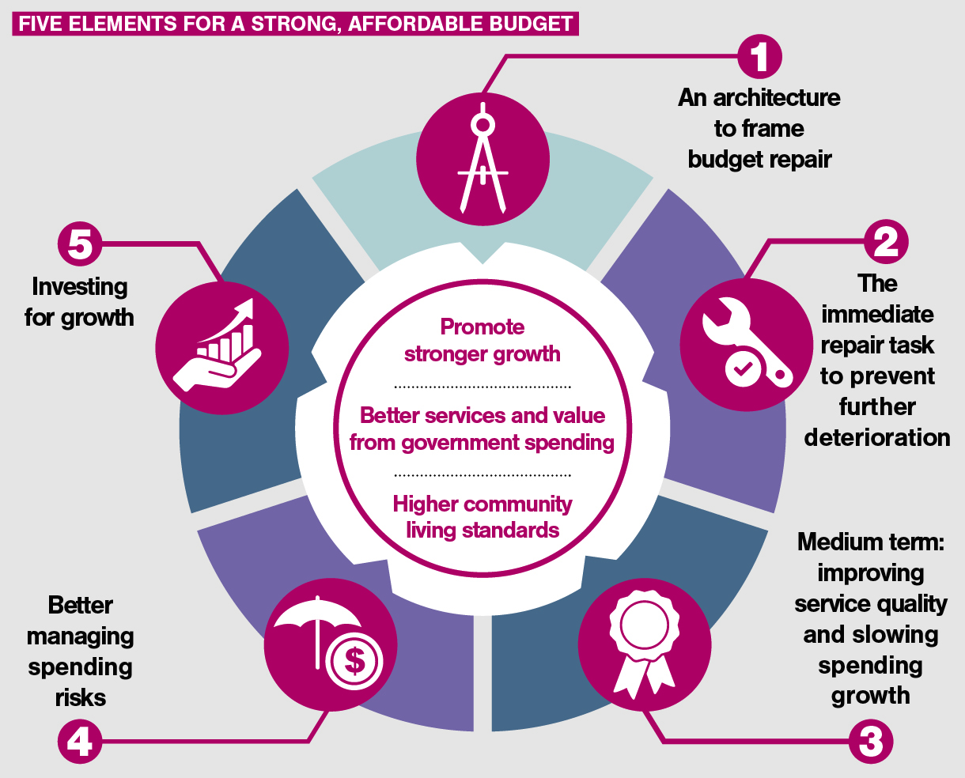

Recommendations for a stronger budget

Promoting fiscal discipline

Recommendation 1
- Adopt and legislate fiscal rules to:
  - limit the overall level of taxation: There should be no increase in the overall level of taxation as a proportion of the economy. That is, it should not exceed maximum levels envisaged in the current forward estimates (around 22 per cent of GDP)
  - reduce spending growth: Real spending growth in any one year should not exceed 2 per cent until budget surplus is achieved. Two per cent should be an outer boundary for real spending growth in any given year. As long as the economy grows in excess of 2 per cent, this would progressively reduce the overall share of government spending
    - This will require a strategy to slow the rate of spending growth in fast-growing areas such as health and aged care
  - as far as possible, in collaboration with the states, develop measures of and benchmarks to assess government sector productivity performance
  - contain the overall size of government: The Parliamentary Budget Office should be given the task of reporting on the overall size of government and identifying major trends and risks.

Independent budget oversight and assessment

Recommendation 2
- The Parliamentary Budget Office should have greater autonomy to:
  - deliver an independent assessment of the state of the budget at regular intervals
  - provide an independent assessment of progress against the government’s fiscal strategy and rules on an annual basis.

Immediate actions to stem the tide

Recommendation 3
- The Senate should, as a matter of priority, pass the government’s omnibus bill.
- The government should continue to undertake functional and efficiency reviews of government departments.
- The rationale for and performance of more than 1200 federal bodies should be reviewed with a view to rationalisation and removing duplication.
- Any new spending proposals should be offset, but savings preferably should be used as much as possible to contribute to fiscal repair.
- Any tax measures should contribute to broader tax reform, not fund extra spending.
- The government should lay the ground-work for appropriate governance, funding arrangements and allocation of responsibilities across the federation to incentivise improved efficiency and better program outcomes, through reinvigorating the Council of Australian Governments (COAG) reform process.

Embedding systematic program evaluation

Recommendation 4
- Embed a strategic approach to designing major programs through regular and disciplined evaluation, underpinned by more effective collection and analysis of performance data. This should be achieved through:
  - requiring budget bids for new or continued funding to demonstrate that a thorough whole-of-program evaluation has been undertaken.
  - requiring program evaluations to assess public and private sector models of innovative service delivery and incorporate into the program design where relevant.

Consumer-centred health care

Recommendation 5
- By the end of 2017, COAG should formulate and agree to a 10-year program for reorienting the health system in line with a vision of how consumer-centred health care will be delivered in decades to come.
- As a starting point for comprehensive redesign of health spending, the COAG Health Council should enhance transparency of health price and performance data to increase accountability, drive better value for money and bring safety into line with other industries. This includes immediate steps to:
  - publish institution-level hospital and health agency performance data for the full suite of indicators agreed and reflected in the National Health Performance Authority’s Performance and Accountability Framework 2012
  - mandate that all Australian hospitals report specific data to clinical-quality registries under the National Safety and Quality Health Service Standards
  - share existing hospital cost data, including condition-level costs, among public hospitals as a means of identifying and improving on poor performance
  - explore options for adopting better payments systems in line with commercial practice to support more timely information on cash flows of the sector, patterns of activity and costs.

Improving education outcomes

Recommendation 6
- Through the COAG Education Council, develop a strong reform agenda focused on teaching quality and work with the states and territories to introduce an outcomes-based performance incentive that would provide a supplement to growth.

Recommendation 7
- Work with the states and territories to reach agreement on how schools funding can be redistributed using a needs-based funding model in light of a true assessment of the needs of student and schools. As part of this, ensure that schools are held to account for delivering the required outcomes associated with government funding.

A seamless national tertiary system

Recommendation 8
- Design a broad tertiary system covering the Vocational Education and Training (VET) and higher education (HE) systems to deliver high-quality skills development to people across all stages of their lives – ranging from literacy and numeracy through to higher-level research qualifications.
  - Move away from the current siloed approach to VET and HE, towards a single seamless national tertiary education system. Such a system should be built on an entitlement to post-school education, making it available to all Australians, regardless of their financial circumstances.

Recommendation 9
- As a condition of access to government funding, require providers to publish course-level data on price, quality of delivery, and labour market outcomes so there is clear and transparent market information across tertiary education.

A fit-for-purpose social security system

Recommendation 10
- Adopt the McClure review objectives for a social security system with a stronger focus on providing incentives to work for those able to, providing adequate support for those who are unable to work, supporting participation in the workforce through measures that build capability and being affordable and sustainable now, in the future and through economic cycles.
- Continue to progress the investment approach to reduce long-term welfare dependence and support people’s transitions as outlined in the McClure review.
- Continue to invest in digital technologies, including through the Digital Transformation Office, particularly in support of programs and projects, such as an access card, that would enhance the efficiency of government service delivery and reduce fraud.

Managing risks

Recommendation 11
- Emerging spending risks should be planned for including the rising cost of caring for an ageing population and new programs such as the National Disability Insurance Scheme (NDIS).
- To lock in the sustainability of the NDIS and insulate against unforeseen cost pressures and poor outcomes, the Productivity Commission’s inquiry into NDIS costs should:
  - explore options for a clear and transparent expenditure envelope for the NDIS, for inclusion in the 2017-18 budget across the forward estimates
  - examine the demand profiles by region and market capacity to meet demand within the required cost and quality parameters
  - examine the key risk areas for inappropriate behaviour by providers within the scheme as it rolls out.

Providing efficient infrastructure

Recommendation 12
- Improve the efficient provision and use of infrastructure through initiating an intergovernmental reform agenda based on the recommendations in Infrastructure Australia’s infrastructure plan, with priority given to:
  - improved long-term infrastructure planning and project prioritisation
  - more streamlined and efficient planning approvals regimes
  - implementing road policy reforms to link cost-reflective pricing models with road funding
  - ‘asset recycling’ initiatives that incentivise state and territory governments to privatise infrastructure assets and reinvest the proceeds into new infrastructure.

Recommendation 13
- Maintain public infrastructure funding as a priority in the federal budget and roll out a regular pipeline of infrastructure projects by:
  - adequately resourcing Infrastructure Australia to advise on infrastructure priorities
  - bringing forward ‘ready-to-go’ projects from Infrastructure Australia’s priority project list
  - attaching performance-based conditions to federal funding of infrastructure
  - speeding up planning approvals and maximising opportunities for private investment
  - maximising funding from user charges and the appropriate use of ‘value-capture’ mechanisms.

Reducing the regulatory burden

Recommendation 14
- Federal government should establish and prioritise a clear and transparent regulatory reform agenda, with a pipeline of reform priorities, overseen by a minister with accountability for reducing the regulatory burden.
- Strengthen the Australian Government’s Regulator Performance Framework and introduce similar regimes in the states and territories.

A competitive tax system

Recommendation 15
- The Enterprise Tax Plan Bill should be passed in full to ensure that Australia is not left stranded in the global contest for investment.
- Broader tax reform to reduce the overall deadweight burden should be kept on the policy agenda.

Future-oriented workplace relations

Recommendation 16
- Implement the Productivity Commission’s recommended workplace reforms.
- Implement additional reforms including to clarify allowable contents of agreements, streamline awards to their core purpose and create greater enterprise flexibility.

Promoting an open, dynamic economy

Recommendation 17
- Progress reforms from the 2015 Competition Policy Review in agreement with state and territory governments, to streamline planning approval processes, remove restrictions on retail trading hours and increase mutual recognition of occupational licensing, among other potential reforms.

Recommendation 18
- The government’s changes to section 46 (‘misuse of market power’) of the Competition and Consumer Act 2010 should minimise unintended consequences for innovation and competition and be reviewed within five years.

1 a strong budget is needed for a prosperous Australia

Budget improvement is crucial for safeguarding the prosperity of current and future generations
A prosperous society is one that helps create better conditions for its citizens now and in future including good health, world-class education, better living conditions and improved quality of life and economic opportunity.
What a prosperous society looks like
- High GDP per capita and high living standards by world standards that are widely shared across the community
- Meaningful, well-paid jobs and low unemployment
- Access to world-class health care and improved quality of life and life expectancy for all
- Access to lifelong learning and world-class education
- Liveable and affordable cities and regions
- A healthy natural environment.
Debate about the budget all too often loses sight of this main game.
The ultimate goal of government spending must be to improve community living standards through the provision of crucial services such as education and health care, public infrastructure, national defence and a social safety net to protect the most vulnerable.
These services are essential ingredients of the prosperous, caring – and just – society the Business Council, and all Australians, want and expect.
Put simply, our continuing poor budget position undermines capacity to improve living standards.

Inefficient and ineffective government programs leading to higher debt and higher taxes cannot promote prosperity
But for government spending to promote prosperity it must deliver good outcomes for recipients and the benefits must exceed the costs. It must be affordable.
The federal government already spends more than $440 billion each year. This is 25.2 per cent of GDP compared with a 30-year average of just under 25 per cent. It would seem unarguable that such a large part of our economy should perform as well as possible.
Spending without regard to the costs, or benefits, is in no-one’s interests. Yet all too often programs are ineffective or inefficient. There is duplication and overlap and sometimes inconsistency. Despite the best intentions, some programs have unintended consequences that may actually make things worse.
- Wasteful, unnecessarily costly or ineffective spending does not promote community benefits or provide value for taxpayers’ dollars.
- Continued deficits and debt accumulation – net debt is already more than $300 billion or more than $30,000 per household – crowd out the capacity to provide valuable services and infrastructure and a fair and fit-for-purpose social safety net into the future. Future generations are left to pick up the tab.
- Without budget repair and debt reduction, the economy will become more vulnerable to external shocks that would blow out the deficit and trigger blunt cuts to programs and tax hikes. High debt also weakens economic growth by crowding out investment.
- Higher spending inevitably means higher taxes, eventually. High taxes discourage investment, individual effort and economic growth. Higher taxes chasing higher spending is a negative sum game for the economy and the community.

The community deserves value for its hard-earned money
We need to fundamentally rethink our approach to government spending to ensure that it delivers desired outcomes in the most efficient, prioritised and targeted way. This should be an overarching objective for all governments, regardless of their budget situation. Waste is waste, poor outcomes are poor outcomes.
Providing value for money, as a matter of course, is the only sure way of safeguarding the services that underpin fairness and economic opportunity.

Delivering value for money will require a new approach
Value for money is unlikely to be achieved through ad hoc cuts and knee-jerk budget ‘fixes’ that diminish critical capacity and capability and create bigger problems down the track.
- It demands systematic processes and fundamental cultural change with a view to delivering sustainable outcomes over time. In some cases, achieving cost-effective outcomes will require upfront investments – in systems, infrastructure and, importantly, in people.
- It will require embedding institutions for transparent and rigorous program review, and ongoing monitoring and assessment, to ensure that programs are effective and deliver net community benefits.
- It will also require an open and direct conversation about the appropriate role of government provision and funding versus the role and responsibility of individuals, families and businesses. The trade-offs between spending and taxing need to be better explained.
- Last, but certainly not least, services need to be delivered more efficiently to improve the value obtained from every dollar of tax raised.
  - Waste, duplication and overlap must be reduced, including through clear assignment of responsibilities across the federation.
  - Governments need to find ways to innovate and improve their productivity, in the same way we expect private enterprises to continually improve their performance to deliver real income gains to the community.
  - Competition and market mechanisms should be used where possible to encourage more efficient, innovative service delivery.
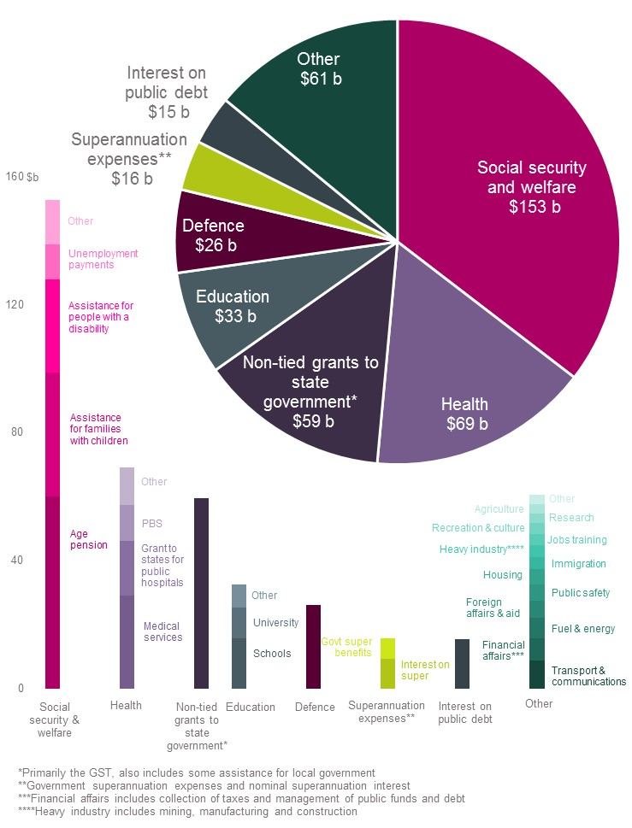
- Where the federal government budget goes
Source: Australian Government, Budget 2016-17

2 A perfect storm is looming

The forecast return to a small surplus in 2020-21 is becoming increasingly shaky
In 2015 the Business Council said that Australia had a 10-year window in which to make the transition to sustainable spending levels in a deliberate and inclusive way.
We consider that this time horizon remains appropriate, but two years have already elapsed. The longer action is delayed, the worse the problem will become and the more abrupt and blunt the adjustment will eventually be.
The government has made some welcome headway towards fiscal consolidation, including a number of measures in last year’s omnibus legislation that gained bipartisan support. These measures combined should save around $22 billion over four years.
But $22 billion is 1 per cent of total forecast spending of $2 trillion over the same period and falls well short of the task of returning the budget to enduring surplus.
The razor-thin budget surplus projected by 2020-21 assumes stronger economic and revenue growth as well as the implementation of residual savings measures blocked in the Senate. There are many reasons why this is unlikely to be realised.
The global economy remains fragile and global trade intensity continues to decline. Mooted policy changes in the US could have hugely disruptive impacts on global trade and investment. World interest rates are beginning to edge up, which will only add to the $12 billion annual net interest bill on Australia’s $317 billion net debt.
At home, worryingly weak business investment (notwithstanding the most recent positive quarter), soft nominal wages growth and subdued hours worked do not augur well for future economic or revenue growth. The one bright spot of higher commodity prices will improve revenues but is likely to be transitory.

Population ageing and new programs are driving higher spending
Of even greater concern, structural spending pressures continue to build rather than abate. These pressures come principally from an ageing population, which will significantly increase demand for pensions, health and aged care services, and new programs such as the NDIS.

Spending pressures are set to intensify not abate
- Looking further ahead, demographic pressures on the budget will greatly intensify.
  - The most recent Intergenerational Report projects that without intervention, spending will persistently outpace economic growth leading to a structural deficit of 6 per cent of GDP (around $100 billion in today’s terms) for the federal government by 2055.
- Over the next decade, federal government spending on child care is projected to double in real terms and aged care spending will grow by 60 per cent.
- Public hospital spending will be 40 per cent higher over the 12 years to 2026.
- The annual cost of the NDIS across all governments is expected to reach $22 billion in 2019-20 and up to $32 billion by 2028-29.

A growing fiscal gap will lead to a debt blow out and much higher taxes or blunt program cuts
This is why the Mid-Year Economic and Fiscal Outlook (MYEFO) foreshadows that real spending growth will blow out to 3 per cent a year over 2020-21 to 2026-27, compared with an average 1.8 per cent forecast across the current forward estimates. So even if the forecast small surplus eventuated in 2020-21, it would be a one-off event.
Three per cent real spending growth exceeds projected economic growth from 2023 onwards. Put simply, this means that spending growth will outpace the economy’s capacity to pay.
The most recent Intergenerational Report projects real spending growth of 3.1 per cent per year over the next 40 years, with spending rising to more than 31 per cent of GDP by 2054-55, generating a structural deficit of as much as 6 per cent by 2055 and net debt of almost 60 per cent of GDP.
We are facing a structural spending and deficit problem that will not correct itself. Without action, the fiscal gap will grow ever wider – until it provokes a painful economic correction involving both cuts to services and higher taxes.

- The long-term budget outlook is unsustainable
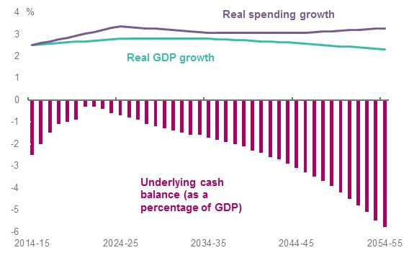
Source: Business Council calculations using 2015 Intergenerational Report ‘currently legislated’ data.
NB. The data for real spending and GDP growth have been smoothed to illustrate the underlying trends in the data.
Left unchecked, this imbalance will generate an ever-growing and unsustainable fiscal gap and debt build-up. Structural deficits of at least 3 per cent are being locked in, creating (in today’s terms) some $50 billion additional debt each year.
The consequences are inevitable and unpalatable:
- Closing this gap would require taxes to rise by $5300 per household per year or $2000 per person. Paying off accumulated debt would require even higher taxes.
- Relying on bracket creep to close the deficit would see 1.5 million more workers paying the top marginal rate of tax of 47 per cent.
- Alternatively, services would have to be slashed. Saving $50 billion requires cutting the equivalent of one-third of today’s social security budget or almost the entire education and defence budgets combined.
- Burgeoning debt would leave no buffer to respond to economic shocks – a ‘perfect storm scenario’ – or any capacity for substantial investments in physical and social infrastructure.
- Other policies, including a more competitive tax system, which are urgently needed to deliver stronger economic growth, would languish.
The Intergenerational Report goes further, projecting a deficit of 6 per cent of GDP by 2054-55 without further action to slow the rate of growth of spending.
The projected debt burden would be the equivalent of 60 per cent of GDP (more than $900 billion in today’s terms).
These numbers are not just bookkeeping entries. They have real consequences for Australian households who will face severe cutbacks in services, higher taxes and lower economic growth and living standards.
This is unacceptable and must not be allowed to happen. It is ultimately the Parliament’s responsibility to ensure it does not happen.
Repairing the budget will require systematic, careful and purposeful review and assessment of major spending programs to target them better and improve their effectiveness and efficiency.
With the federal government spending of more than $440 billion a year, it is inconceivable that that there isn’t scope for significant productivity improvements.

Spending has to be paid for by taxing productive activities
Government spending cannot increase unchecked without impairing economic growth and living standards.
This is because the money has to come from taxes on productive activities. Taxes inevitably deter private investment, individual effort, risk-taking, innovation and entrepreneurship, the core ingredients of economic growth. This trade-off cannot be avoided, although the impact of some taxes on growth is lower than others.
The trouble with taxing more
- Taxes are a means to an end, used to pay for a range of important government services.
- But taxes influence virtually all our economic decisions. This is because they inevitably distort prices, incentives and rewards, all of which change people’s behaviour.
- Higher taxes discourage productive activities by businesses and individuals.
- Australia’s 30 per cent company tax rate discourages businesses from investing and innovating in Australia, reducing growth and wages.
- High personal tax rates reduce the rewards for effort and discourage people from working and being entrepreneurial.
- Economic growth and living standards and capacity to raise revenue are lower as a result.
- Of course, these costs must be balanced against the benefits of government spending. But the distorting effects and costs of taxes increase disproportionately with the tax rate. In other words, if tax rates keep rising to match higher spending, the impact on growth becomes disproportionately higher.

Borrowing just kicks the day of reckoning down the road
Deficits are not an escape route. They are just a credit card – in Australia’s case, one issued by foreign lenders. The debt has to be repaid in the future by taxpayers or by cutting services.
Federal net debt is already almost $320 billion with an annual interest bill of $12 billion (or more than half of the projected full annual cost of the NDIS to all governments).
Net federal debt is approaching 20 per cent of GDP, its highest level for 45 years and is forecast to increase further. State and local government debt represents another 3 per cent of GDP.
- An unprecedented peace-time rise in net debt
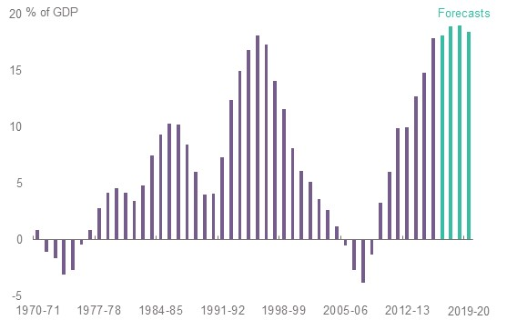
Source: Australian Government, MYEFO 2016-17
High debt exposure is impairing our capacity to respond to economic shocks and threatening Australia’s AAA credit rating.
Although Australia’s government debt clearly is not as large as many other countries, it is largely owed abroad. This matters because we are highly exposed to shifts in sentiment in global capital markets. And this is why ratings agencies are concerned.
Why Australia’s AAA credit rating is worth keeping
Australia currently is one of only 10 countries with a AAA credit rating from all three ratings houses.
Loss of the AAA rating would affect lending rates for other levels of government, as well as businesses and consumers, given higher borrowing costs in the wholesale market. This may not be of great significance in a relatively low interest rate environment, but an economic shock could quickly lead to much higher rates as credit is squeezed. This would be especially problematic for Australia because of its reliance on foreign borrowings.
As in other countries with higher debt, further debt build-up in Australia would weaken the economy’s fiscal resilience, while higher borrowing costs would put greater pressure on the budget. It will crowd out our capacity to invest in people and infrastructure with negative implications for future economic growth – a negative sum game.

Imposing higher taxes to match higher spending is not a viable solution either
Low revenues have not created the deficit. Total revenue of over 23 per cent of GDP is close to its 30-year average share and revenue growth is being relied on to do the heavy lifting to deliver the small surplus projected by 2020-21.
By 2019-20 total receipts will be almost $500 billion or a quarter of GDP. Much of the revenue growth will come from increasing average taxes on middle-income households through future bracket creep, notwithstanding recent welcome intervention to slow it.
- Spending and revenue are set to exceed their 30-year averages
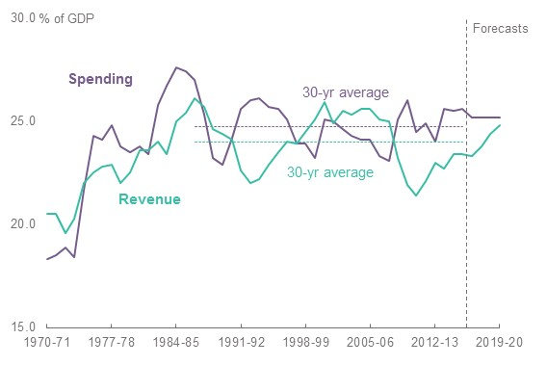
Source: Australian Government, MYEFO 2016-17
We are kidding ourselves if we think we can keep raising taxes on income generated from private enterprise to chase higher government spending with impunity.
Higher taxes on productive activities by individuals and businesses would seriously impair the capacity of the economy to grow and generate jobs, incomes and revenues in the first place. Personal income tax rates are already high for middle-income earners and Australia’s 30 per cent company tax rate is becoming less competitive by the day as one country after another reduces its rate.
Tax hikes are not budget savings. They might reduce the deficit in the immediate term but they won’t fix inefficient spending and they will inevitably impair income growth – and revenues for essential services – over the medium to longer term.
This will only serve to diminish economic opportunities, rather than deliver the fairer, inclusive outcomes often claimed.

A more competitive tax system is needed to promote growth and generate higher revenues but will not address inefficient or ineffective spending
There is an urgent need for a more efficient and less complex tax system, including more competitive business taxes, to relieve the growth-sapping effects of the current tax system. Stronger economic growth will also improve budget sustainability through building a more stable and reliable revenue base.
Growth and revenue dividends from a more competitive tax system would provide room to reduce taxes and give greater capacity to provide government services. But revenue dividends should never be frittered away on poorly targeted spending.
Although tax reform and other policies that promote stronger growth can obviously ease budget pressures, they do not eliminate the need to ensure that we get the best value for money possible for the community from government spending.
The Business Council’s plan for comprehensive tax reform
- Lower personal income tax rates and address bracket creep to reward effort, and encourage participation and entrepreneurship
- Lower the company tax rate to give businesses a better chance to transition to a competitive global economy and incentives to invest, innovate and create jobs
- Rebalance the tax mix away from narrow and volatile taxes (such as the company tax and stamp duties) to more stable, broader tax bases
- More neutral and fairer treatment of savings income to promote efficient investment and lifetime consumption choices
- Build trust in the tax system to ensure everyone pays their fair share through integrity measures and streamlining
- Simplify the system to reduce time, effort and administrative costs for taxpayers.
Source: Business Council of Australia, ‘Realising Our Full Potential: Tax Directions for a Transitioning Economy’, March 2016

The window for action is rapidly closing
Consistent with its 2015-16 budget submission, the Business Council believes that Australia has a medium-term window – until 2025 – within which to put the budget on a sustainable footing.
Importantly, though, this does not mean that measures to repair the budget can be postponed until 2025.
Budget repair will require both immediate measures to prevent deterioration or slippage in the budget position and deeper structural reforms of major areas of expenditure over the medium term to shore up budget sustainability well ahead of 2025.
Australia’s recent economic growth figures have been uninspiring. To sustain higher economic growth levels, it will be essential that the bounce in private investment growth seen in late 2016 continues. This domestic underperformance, coupled with heightened uncertainty throughout the world economy, makes taking action more, not less, urgent.

- Recent economic data have been uninspiring
Moderate real GDP growth | New business investment remains weak | Slow growth in hours worked | Nominal wages growth is at record lows
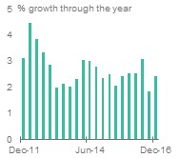 | 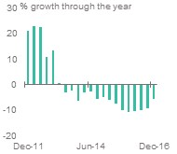 | 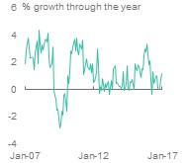 | 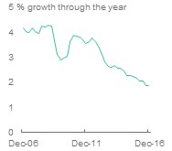
Source: ABS, 5206.0; ABS, 6202.0; ABS, 6345.0
The economy’s capacity to fund spending is diminishing just as the risk of global economic upheaval is increasing. As former Reserve Bank Governor Glenn Stevens previously observed, a downturn could blow out the deficit to 5 or 6 per cent of GDP ‘in a heartbeat’.
The budget position is also constraining capacity to undertake taxation reforms and public investments that would boost growth and living standards.
We are in a vicious circle and the only way to break free is to address the structural spending pressures that have created it.

3 an Architecture for strengthening the Budget
The Business Council continues to advocate for a fiscal strategy to 2025 to achieve sustainable fiscal reform. This strategy was first outlined in our 2015-16 Budget Submission recommendations.
Budget repair ultimately will require careful improvements in individual programs, but this task should be guided by overarching fiscal goals. Fiscal rules are a means of achieving these goals by providing discipline and benchmarks for assessing progress (or identifying backsliding).

Four fiscal goals
The Business Council proposes four goals that go to the heart of competent and prudent fiscal management in the interests of the Australian community now and in the future.

1. Ensure the sustainability of priority services, including an adequate safety net, which are integral to community living standards and the functioning of our society.
The prime fiscal objective should be to support the sustainable and effective provision of services that deliver net community benefits and which only governments can provide.

2. Ensure capacity for investments in infrastructure and human capital, vital for innovation and productivity growth and higher incomes.
While spending growth restraint is vital for returning the budget to surplus, investment in human capital and infrastructure and other policies including taxation reform that can improve productive capacity and growth are equally important.
Redesigning major spending programs will free up capacity to deliver these essential investments in future growth without undermining fiscal capacity and resilience.

3. Progressively return the budget to surplus to build resilience and flexibility for dealing with economic shocks and volatility, and for underpinning business confidence and investment.
The government budget position has significant implications for macroeconomic stability and resilience.
In 2016-17, Australia will record its ninth consecutive budget deficit. Persistent deficits undermine our ability to respond to economic shocks and volatility.
Australia was in surplus by $20 billion and had zero debt when the GFC hit in 2008, providing the capacity to deploy funds to see through the economic impact. Today, the budget is in deficit by $37 billion with net debt of over $300 billion, a significantly weaker starting point. This leaves Australia far more exposed to turbulence in the global economy.
This vulnerability will only worsen the longer deficits continue and debt accumulates.

4. Preserve Australia’s AAA credit rating to retain financial capacity and maintain investor confidence.
Maintaining the AAA credit rating is not an end in itself, but losing it would have real economic consequences.

An overarching strategy to achieve the four goals
Ultimately, budget repair will require improvements in individual programs. However, rules and benchmarks can provide an overarching framework for assessing progress.
The Charter of Budget Honesty commits the federal government to producing a medium-term fiscal strategy that outlines principles-based fiscal objectives and the steps that will be taken to secure them.
These strategies are not binding and – consistent with international experience – have often not been fully executed, therefore failing to ensure meaningful fiscal discipline.
The Business Council supports the central tenets of the government’s fiscal strategy including:
- maintaining strong fiscal discipline by controlling expenditure to reduce the government’s share of the economy over time in order to free up resources for private investment to drive jobs and economic growth
- a clear path back to surplus being underpinned by decisions that build over time
- new spending measures being more than offset by reductions in spending elsewhere within the budget.
However, the Business Council believes that there is a strong case for adherence to fiscal rules that are subject to independent oversight and potentially legislated. The NSW Fiscal Responsibility Act 2012 provides one model.

Clear fiscal ground rules would provide discipline and consistency
There is international evidence that fiscal rules – which can take the harder form of numerical limits relating to debt, spending and taxes – can be useful to anchor fiscal strategies and budget repair goals. The number of countries with fiscal rules has grown from six in 1985 to 85 in 2014.
Fiscal rules provide signposts for each year’s budget in progressing towards longer-term goals such as those outlined by the Business Council.
They also provide discipline. Without them, longer-term goals can more easily be deferred or fiscal discipline can be inconsistent.
The adoption of fiscal rules would not prevent government having the flexibility to change course in the event that an extraordinary economic shock, natural disaster or other emergency situation result in a significant and unexpected call on budget resources.
Rules should also be relatively simple to understand. For example, the 1985-86 budget included three commitments to:
- not raise tax as a proportion of GDP over the life of the Parliament (three years)
- not raise spending as a proportion of GDP over the life of the Parliament
- reduce the deficit in dollar and share of GDP terms.
In order to underpin fiscal discipline the Business Council recommends that the government adopt the following fiscal rules.

1 Overall level of taxation should not increase above its current GDP share
There should be no increase in the overall level of tax revenue as a proportion of the economy. That is, it should not exceed maximum levels envisaged in the current forward estimates (around 22 per cent of GDP). This is in line with the 30-year average.
This rule ensures that the problem of spending, as the government has rightly emphasised, is addressed as opposed to increasing taxes to fund increasing expenditure.
It also recognises that stronger economic growth will be the most sustainable means of increasing revenues.

2 Annual real spending growth should not exceed 2 per cent in any one year until a sustainable surplus is achieved
As long as the economy grows in excess of 2 per cent, this rule would gradually reduce the overall size of government spending to bring it into line with receipts and bring the budget back to balance and, in time, a sustainable surplus.
Two per cent should be an outer boundary for real spending growth in any given year, not a target. Barring an economic shock or reduced receipts, it would ensure steady, if slow, improvement in the budget bottom line each year.
Indeed, if we are dealing with a structural deficit of 3 per cent of GDP, real spending growth at the upper bound of 2 per cent would still take close to two decades to balance the budget, based on current projections for economic growth.
Yet real spending growth at or below 2 per cent has only occurred four times in the last decade.
The Business Council notes that real spending growth is projected to be 1.8 per cent a year on average over the forward estimates, but that this is underpinned in part by measures that are yet to be legislated. Beyond the forward estimates real spending growth is projected to rise to 3 per cent per annum, above projected GDP growth.

3 The productivity of government spending must be monitored and improved
Ideally government sector productivity should also be monitored and a target set for improvement. Unfortunately, government sector productivity is not measured well, if at all, because of the difficulty in measuring outputs.
However, where possible, productivity measures and benchmarks should be developed to enable greater performance monitoring and assessment.
The Harper review provides a road map for increasing competition in the delivery of key social services. The federal and state governments should work together to develop benchmarks including private sector comparators.

4 Expenditure by all governments must be contained
The federal government accounts for the lion’s share of government spending and debt but state and local governments also raise revenues and spend taxpayer funds. Total spending for all governments currently exceeds $600 billion a year. In 2016-17 the total size of government (federal, state, local) is estimated to be 38.3 per cent of GDP (including public non-financial corporations).
- Spending by all governments has edged up
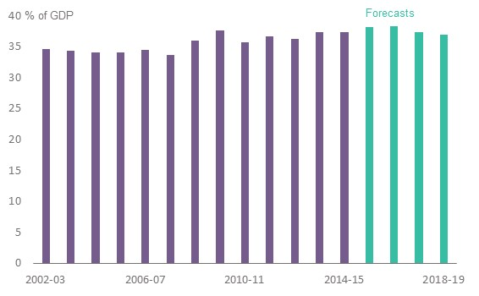
Source: Australian Government, Budget 2016-17
It is important that there is a benchmark for the size of government to ensure discipline over time, particularly as health absorbs increasing funding across the federation and major new government programs commence.
An overall benchmark would also guard against shifting of costs across jurisdictions and to off-budget entities.
The Business Council believes that the Parliamentary Budget Office (PBO) should be given responsibility for reporting on the overall size of government and identifying major trends and risks.

Recommendation 1
- Adopt and legislate fiscal rules to:
  - limit the overall level of taxation: There should be no increase in the overall level of taxation as a proportion of the economy. That is, it should not exceed maximum levels envisaged in the current forward estimates (around 22 per cent of GDP)
  - reduce spending growth: Real spending growth in any one year should not exceed 2 per cent until budget surplus is achieved. Two per cent should be an outer boundary for real spending growth in any given year. As long as the economy grows in excess of 2 per cent, this would progressively reduce the overall share of government spending.
    - This will require a strategy to slow the rate of spending growth in fast-growing areas such as health and aged care
  - as far as possible, in collaboration with the states, develop measures of and benchmarks to assess government sector productivity performance
  - contain the overall size of government: The Parliamentary Budget Office (PBO) should be given responsibility for reporting on the overall size of government and identifying major trends and risks.

Independent budgetary oversight will be essential
Since the global financial crisis, a number of countries have established an independent, non-partisan fiscal watchdog to report on government performance against fiscal rules and strategies. In Australia, the PBO was created in 2012 to provide independent advice on the budget cycle, fiscal policy and spending proposals. The PBO is not required to report on the government’s fiscal performance at this stage.
Over 75 per cent of fiscal councils established since 2004 have an explicit role in monitoring fiscal policy rules; this has been found to be a key role of effective fiscal councils.
The National Commission of Audit has previously recommended that the PBO report on government fiscal performance (as opposed to fiscal rules per se) after the release of the annual Final Budget Outcome.
The Business Council recommends that the PBO be given the annual task of publishing an assessment of the government’s progress against its fiscal strategy. For example, this could occur after the release of the government’s Final Budget Outcome but before the release of MYEFO each year.
Recommendation 2
- The Parliamentary Budget Office should have greater autonomy to:
  - deliver an independent assessment of the state of the budget at regular intervals
  - provide an independent assessment of progress against the government’s fiscal strategy and rules on an annual basis.

4 The immediate task
Budget repair is ultimately a task for Parliament. The Business Council has supported the government’s efforts to achieve savings to date. Unfortunately, these efforts have too often been stymied by the Parliament.
The Business Council also acknowledges that new spending measures in recent budgets have been more than offset by savings measures or increases in revenue.
However, changes at the margin will be inadequate for the task of fiscal repair. The approach of offsetting spending increases also perpetuates expectations for new spending measures and only makes more challenging the task of finding other savings measures to contribute to improving the budget bottom line.
While deeper spending reforms are needed over the medium term, in the immediate term, the government should seek, at a minimum, to prevent slippage in budget outcomes and as far as possible identify savings measures to contribute to fiscal repair.
The government should resist temporary or one-off tax measures to address the fiscal repair task. Such measures can cause economic harm and underwrite higher spending, creating greater budget problems down the track. Higher revenues from any tax measures should be used to fund tax reform.

The Parliament should pass the omnibus bill
The Senate should agree to pass a number of measures already before it including changes to parental leave payments and family tax benefits, as contained in the government’s omnibus proposal.

Functional and efficiency reviews should continue
Functional and efficiency reviews comprehensively assess all aspects of a federal government department or agency to ensure that resources align with government policy objectives.
A recent efficiency review for the Department of Health identified net savings of $96 million through changes to contracting, corporate, staffing and property costs. A review of the Education and Training portfolio found an initial $131 million worth of savings by ceasing or redesigning programs, including $8 million in the operations of the department, with further savings to be considered at a later date.

Reviews should extend to more than 1200 federal bodies
The reviews should encompass the rationale for and performance of more than 1200 federal government bodies with a view to reducing duplication and identifying scope for rationalisation.

Reform of the federation must be reinvigorated
Addressing major spending pressures in areas such as health care and education and the NDIS will require the federal and state governments to work together.
The abandonment of the white paper on reform of the federation does not mean that the issues have gone away.
The government should reinvigorate the COAG process to lay the groundwork for improving spending outcomes and slowing the rate of growth for major spending areas such as health care, education and the NDIS, through appropriate assignment of responsibilities and governance and funding arrangements across the federation.
Recommendation 3
- The Senate should, as a matter of priority, pass the government’s omnibus bill.
- The government should continue to undertake functional and efficiency reviews of government departments
- The rationale for and performance of more than 1200 federal bodies should be reviewed with a view to rationalisation and removing duplication.
- Any new spending proposals should be offset, but savings preferably should be used as much as possible to contribute to fiscal repair.
- Any tax measures should contribute to broader tax reform, not fund extra spending.
- The government should lay the ground-work for appropriate governance, funding arrangements and allocation of responsibilities across the federation to incentivise improved efficiency and better program outcomes, through reinvigorating the COAG reform process.

5 improving the quality and sustainability of spending
The focus on reducing the budget deficit is very important, but how the deficit is reduced is equally, if not more critical. We must not lose sight of why governments spend – and tax.
One of the fundamental roles of government, why it exists, is to provide critical public services that would be underprovided by private markets, for reasons such as free-riding and ‘spillovers’.
These services include public goods such as defence, universal access to health care and education because of the social spillover benefits they bring, and public infrastructure including roads and urban transport. Governments also redistribute income, principally to provide an adequate safety net for those unable to support themselves.
Providing these services is the hallmark of our prosperous and compassionate society. Education, health care, national security and infrastructure also build critical capabilities and a supporting environment for the efficient functioning of markets and private enterprise. They provide a platform for prosperity.
But spending must be affordable and sustainable, otherwise prosperity will be undermined not enhanced.

The rate of spending growth must be slowed
Services in health and aged care, together with pensions, are among the largest and fastest-growing areas of government spending, with many of these subject to the forces of demographic change.
As noted earlier, from 2020 real spending growth is projected to rise to 3 per cent per year, above projected economic growth and revenue growth. In short, spending is projected to rise beyond the capacity of the economy to pay.
Without staged reform, continued deficits and higher debt-servicing costs risk inequitable rationing of services and cuts in these base entitlements. This will inevitably fall disproportionately on the most disadvantaged in society. Shifting debt obligations onto future generations is also inequitable.
This is why the government should set out to systematically review and redesign major spending programs between now and 2025.
Systematic review and redesign of major spending programs must be an ongoing process, with the impacts brought together in the budget process. Policy actions to support enduring fiscal reform should not be confined to an annual budget event.
A comprehensive plan along with careful and detailed implementation paths should underpin this strategy.

All government spending means giving up something else
Governments can only spend what is earned elsewhere in the economy. When consumers of government services do not pay directly for them, governments must raise revenues from taxes or borrow. Borrowing can only defer the need to raise tax revenues.
Government spending will deliver net community benefits when the value of government spending exceeds the opportunity cost (foregone value) of the activities in the market sector that must be given up. The cost includes the direct cost of provision plus the deadweight cost imposed by taxation – that is, the value of investment, effort and transactions discouraged by taxes.
This trade-off between benefits and costs is an unavoidable reality. It is of critical importance for determining the net impact of government spending on community living standards.
More spending will not improve community wellbeing if the costs exceed the benefits. Inefficient and ineffective spending imposes costs without delivering benefits.
Getting the best value from the community’s scarce resources
Higher per capita incomes and living standards come from getting more value from what we produce with our labour, capital and natural resources.
What we produce includes the services and income support governments provide which, at $600 billion for all levels of government combined, account for more than one-third of the Australian economy.
Getting better value from government spending means ensuring that the social benefits exceed the social costs of the scarce resources drawn away from other valuable uses. In practice, this means that the benefits of programs should exceed all costs, including the economic costs of raising taxes to pay for them.
All else constant, the higher the burden of taxation on productive activities, the greater the deadweight imposed on the capacity of the economy to grow and generate income. The increasing costs of raising extra revenue mean that additional spending needs to pass an ever-higher benefit test. Higher costs require higher benefits to ensure that additional spending is worthwhile for the community.
The Business Council acknowledges that evaluating many government programs is not straightforward. Benefits are often subjective and judgement is required. Transparency and community consultation are essential.
But these challenges do not excuse an absence of monitoring, assessment and review.

We must embed a culture of program evaluation
It is incumbent on governments to ensure that what they spend does deliver net community benefits. Assessing this is not an easy task because often community benefits are hard to measure. But the challenges do not excuse not even trying.
Australia does not have an embedded culture of program evaluation. This has to change. We need to:
- deliver maximum value for the more than $440 billion of taxpayers’ money being spent by the federal government each year
- ensure that programs achieve what they set out to achieve
- ensure that wasteful spending is not crowding out potentially valuable spending.
New Zealand has recast its approach to spending to promote better outcomes and value for money through better evaluation and innovation. It provides a valuable model for Australia to follow.
New Zealand’s Better Public Services Program
The New Zealand Government is driving public sector reform under their Better Public Services Program. The goal of the program is to achieve improved services for the community while ensuring that taxpayers get value for money.
Government agencies are tasked with finding innovative ways of delivering public services using technology and digital channels, working together more effectively, improving responsiveness to community needs and better measuring and reporting their performance.
There are 10 central targets across five different themes:
- reducing long-term welfare dependency
- supporting vulnerable children
- boosting skills and employment
- reducing crime
- improving interaction with government.
The program was launched in 2012 and already the government has reported good progress against their targets. For example, since the targets were introduced:
- the proportion of 25–34 year olds with advanced trade qualifications, diplomas and degrees has risen from 51.3 per cent to 56.5 per cent
- the proportion of 8 month olds who are immunised has increased from 86.0 per cent to 92.8 per cent
- 49.7 per cent of government service transactions with citizens are now completed digitally, up from 29.9 per cent in 2012.
Source: B. English and P. Bennett, ‘Public Service working hard to Meet Challenging Targets’, media release, New Zealand Government, 14 March 2016 and ‘Better Public Services Programme’, State Services Commission website, accessed 6 March 2017.

Embedding an evaluation culture supported by better use of data and evidence
To be successful in highly competitive markets, enterprises must continually seek to improve their productivity performance to ensure that they deliver goods and services that consumers want to buy at the lowest cost. But government services and programs generally do not face these same market and consumer pressures.
Other mechanisms and approaches are required to promote public sector productivity.
For some services, greater competition and contestability can promote more effective service delivery. Greater transparency about outcomes would allow programs to be evaluated.
- An evaluation culture is important – knowing what works and why is essential in designing successful policies for the future. One evaluation method will not be suitable for all policies.
- Transparency of outcomes is essential – this can raise awareness in the wider community, convey any lessons learnt and help hold government accountable for the success or otherwise of policy decisions.
- The data that is currently available needs to be better used – this could be by adding procedural, evaluation-focused targets into policy design.
Robust evaluations are necessary at both the system and policy-detail level. Doing either one without the other risks making decisions on incomplete information.
A strategic approach to major program redesign can be embedded through regular and disciplined evaluation of programs, underpinned by more effective collection and analysis of performance data.
Budget bids for new or continued funding and even savings measures should be able to demonstrate that a thorough whole-of-program evaluation has been undertaken. They should also be able to demonstrate that comparative public and private sector models of innovative service delivery have been evaluated and incorporated into the program design where relevant.

Recommendation 4
- Embed a strategic approach to designing major programs through regular and disciplined evaluation, underpinned by more effective collection and analysis of performance data. This should be achieved through:
  - requiring budget bids for new or continued funding to demonstrate that a thorough whole-of-program evaluation has been undertaken
  - requiring program evaluations to assess public and private sector models of innovative service delivery and incorporate into the program design where relevant.

5.1 Delivering better health care
The performance of Australia’s health system is critical to our wellbeing and prosperity. Our health system has performed relatively well by international standards in the past and is an important reason that we have enjoyed increasing quality of life and life expectancy.
But the system is coming under increasing strain from increased demand for health care, accelerated by factors such as high rates of chronic disease and an ageing population.
Government expenditure on health across the federation has grown at a compound annual growth rate of 7 per cent over the last decade, reaching $108 billion. This amount is equivalent to almost 60 per cent of personal income tax.
At the same time the core architecture behind the delivery of health care has largely stood still. Acute care in hospitals remains the core focus of the system and operational innovations in areas like electronic health records and payments have not been realised.
This means that our system is less efficient that it should be. It does not achieve the results for consumers that it could with existing resources.
This means that there is capacity to liberate and redeploy funds through the progressive redesign of Australia’s health system so that we can afford high-quality health care without higher taxes or increased debt.

The size of the task
The Productivity Commission has projected government expenditure on health over the next 45 years. These projections suggest that government health expenditure will grow from around 6.7 per cent of GDP today ($108 billion) to almost 11 per cent of GDP by 2060 ($174 billion in today’s terms). The projections take into account Australia’s ageing population as well as non-demographic factors driving demand.
- Future government spending on health as percentage of GDP
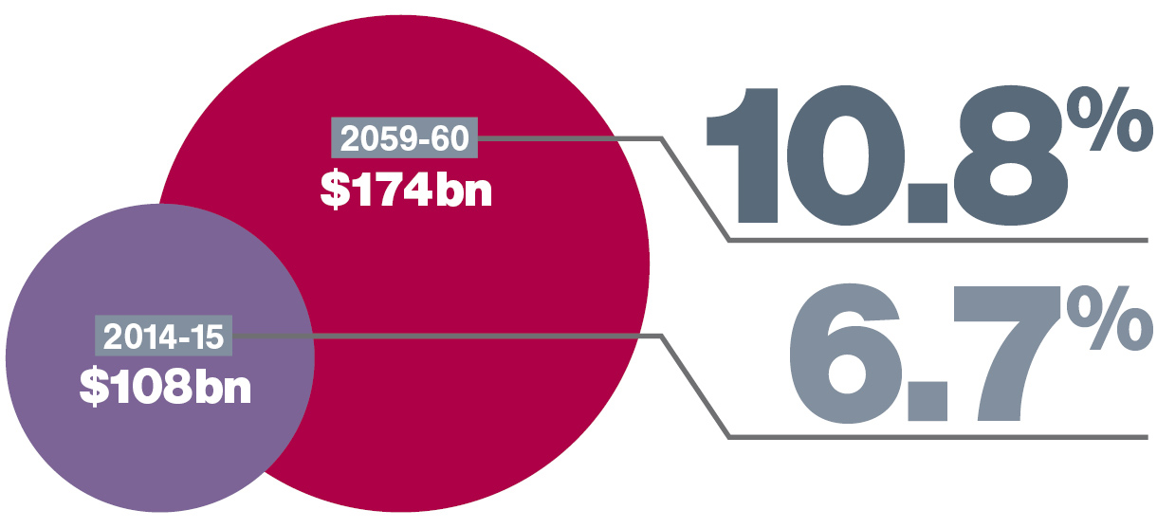
Source: Productivity Commission, An Ageing Australia: Preparing for the Future, 2013
To put the growth in spending between now and 2060 into perspective, in today’s terms it is the equivalent of:
- doubling the federal government’s current levels of spending in health
- adding another two Queensland health systems.
To fund this spending growth in today’s terms would be equivalent to the combined tax revenues of New South Wales, Queensland, Victoria and Western Australia.
It is therefore unsurprising that the New South Wales Government is forecasting combined annual budget deficits by 2030 of $45 billion, of which $35 billion would be generated by health.

Opportunities for improvement
While the size of the task may well be substantial, there are considerable opportunities for improvement flowing from the current operation of the health system.
Even small changes to the rate of growth over the next decade through efficiency savings can add up. For example, if the rate of growth is 0.5 per cent lower at 6.5 per cent a year over the next decade, then expenditure on health in 10 years’ time will be $10 billion a year less than if it continued growing at its current 7.0 per cent rate.
First, there is substantial waste and inefficiency in the system.
Governments, individuals and insurers spend a considerable amount of money on health interventions that are irrelevant, duplicative or excessive, provide low or no benefits, or arise from missed opportunities for earlier interventions.
In addition, quality and safety issues in our health system lead to relatively high rates of preventable adverse events in hospitals and preventable hospital admissions. The Australian Commission on Safety and Quality in Health Care estimates that preventable adverse events in Australia add between 6 and 10 per cent to the costs of the system.
Second, the current system is centred around providers.
Compared to most other markets, the health system places consumers in a weak position relative to providers. This remains the case despite a general trend in the government provision of human services like disability and aged care services towards consumer-driven models. By not asking consumers what they want, proactively sharing information or tailoring services to their preferences, we end up with health care that is often inconvenient, unnecessary or unexpectedly expensive.
Third, the system focuses on sickness rather than preventative health and wellbeing.
More than 80 per cent of Australians are estimated to have at least one chronic condition or risk factor. Despite the rise of chronic disease and an ageing population, much of governments’ efforts to date have focused on reform of the institutional arrangements for acute care in hospitals.
Almost one-third of chronic health conditions could be prevented, yet Australia devotes just 1.5 per cent of health spending to prevention.
Finally, the sector’s operating model is in need of innovation.
Much of the rise in life expectancy can be attributed to clinical innovation with advancements in pharmaceuticals, diagnostic technologies and methods of care. Despite this, the business systems and service delivery that underpin clinical care have remained stagnant.
For example, Medicare reimbursements remain weighted towards in-person medical consultations. This prevents us benefitting from digital innovations like telehealth, which would enhance consumer convenience and increase efficiency. Consumers must also navigate a myriad of payment and reimbursement systems that are often paper-based to pay for one procedure.

The way forward
The most sustainable way of funding a high-quality health system into the future that improves our wellbeing without sapping growth through crippling taxation or diverting resources from other critical spending areas is through progressive redesign of the system. This has the potential to slow the trajectory in spending growth while also improving the quality of care.
If it is to meet the future challenges and be financially sustainable, work must begin now on progressing its redesign.
The benefits of the reforms will accumulate and compound over time to ease the fiscal pressures on the system. The sooner we begin to redesign the system, the better the result will be in decades to come as the ageing of our population reaches its peak.
For this reason by the end of 2017, COAG should formulate and agree to a 10-year program for redesigning the health system in line with a vision of how consumer-centred health care will be delivered in decades to come. The intergenerational nature of the problem requires a long-term enduring solution to avoid higher taxes and unaffordable health care for future generations.
The Business Council recommends that this plan incorporate the key redesign priorities outlined in this paper as these will be critical to delivering better outcomes more efficiently.
The cost of continuing to avoid the task of redesigning the health system is growing, but there is still time to fix it if Australian governments move purposefully in collaboration with the health sector.

The vision for a redesigned health system
The Business Council envisages a redesigned future health system that is responsive and innovative so that it is constantly improving without the need for continual policy intervention. In order to achieve this it will be:
- consumer-driven, with consumers at the centre of the health system using technology and information to work in collaboration with providers to get the best possible care
- data-driven, with patient, system and cost data all readily accessible and utilised to ensure effective and convenient care. With almost 70 cents of each dollar spent in health funded by government, data must also be used to hold key players in the sector accountable for performance
- connected, with all the segments of the health system working in an integrated way and providing connectivity into complementary sectors like aged care and disability
- focused on maintaining wellness, with more and more care provided outside of hospitals to prevent and manage chronic disease while people get on with their lives
- value for money, with high-quality care delivered across the system without an unreasonable burden placed on consumers and taxpayers to support unnecessary waste and inefficiency.

Key priorities for redesign of the health system
In order to realise this vision, we need to activate a number of critical elements in the health system to better empower consumers and increase competitive pressures for health providers to improve their performance.
This requires five key priorities for redesign:
- Better information on the price and performance of providers so that consumers can make better decisions and health care providers have stronger incentives and accountability for improving their performance.
- Greater payment for quality rather than just quantity of services, so that providers are increasingly rewarded for high-quality, integrated care across different parts of the system.
- Digitally-enabled care so that Australia’s health system can finally take proper advantage of technologies like eHealth records and telehealth to improve the convenience, efficiency and precision of care, while maintaining privacy and safety for consumers.
- Better consumer choice in the health system so that once greater information is available to consumers they can use it to exercise meaningful choices across a vast array of decisions.
- Locking in a durable role for private sector service provision in health, which is vital to driving private sector disciplines and efficiency in the sector, providing increased choice for consumers and taking pressure off the public health system.
The Business Council will outline further details on the necessary reform actions under each of these priorities in its upcoming Health Reform Road Map publication. Exhibit 1 provides further details on the importance of better information in Australia’s health system and the key actions necessary to achieve this.
Recommendation 5
- By the end of 2017, COAG should formulate and agree to a 10-year program for reorienting the health system in line with a vision of how consumer-centred health care will be delivered in decades to come.
- As a starting point for comprehensive redesign of health spending, the COAG Health Council should enhance transparency of health price and performance data to increase accountability, drive better value for money and bring safety into line with other industries. This includes immediate steps to:
  - publish institution-level hospital and health agency performance data for the full suite of indicators agreed and reflected in the National Health Performance Authority’s Performance and Accountability Framework 2012
  - mandate that all Australian hospitals report specific data to clinical-quality registries under the National Safety and Quality Health Service Standards
  - share existing hospital cost data, including condition-level costs, among public hospitals as a means of identifying and improving on poor performance
  - explore options for adopting better payments systems in line with commercial practice to support more timely information on cash flows of the sector, patterns of activity and costs.

Exhibit 1: Better information in Australia’s health system

Why?
Information transparency is a key feature of well-functioning markets. Across the economy, businesses continually measure and analyse their own production and performance data to drive improvement. Consumers also typically know what they will pay for a product or service before purchasing it, and have a strong sense of the outcomes it will deliver.
However, this is rarely the case in health care where transparency is limited. At present, clinicians have limited access to information on their patient outcomes relative to those of other providers. This inhibits their ability to compare themselves to high-performing peers, and improve their care.
The United Kingdom, the United States and Canada outperform Australia in collecting and releasing data on areas of health care delivery. A 2015 analysis of publicly available metrics on nation-wide hospital performance found four in Australia compared to 94 in the UK and 115 in the United States.

What?
- Better utilise existing data on price and performance by disseminating it more widely to drive performance improvement.
- Extend the collection of data for performance reporting more widely across the health system, with an initial focus on sharing between clinicians before eventually making such data public.

How?
- Publish the full suite of hospital and health agency performance data in the former National Health Performance Authority’s Performance and Accountability Framework 2012.
- Require all hospitals to report data to clinical quality registries so that they can use these registries to identify performance concerns and rectify them.
- Publish hospital cost data, including condition-level costs among public hospitals.
- Extend performance reporting to hospital unit level and clinician level, sharing this data with providers to inform care improvement, and over time with the public.
- Publicly report clinician-level price data for a range of procedures, including out-of-pocket costs.
Source: Business Council of Australia, 'Overview of megatrends in health and their implications for Australia’, October 2015

5.2 Driving a better return on education investment
Education spending has increased significantly over the past decade, driven primarily by schools and higher education (HE) funding. In 2014-15 federal expenditure on education was around $29 billion, including $15 billion on schools, $10 billion on HE and $4 billion on vocational education and training (VET). This includes annual expenditure on income-contingent loans provided to students, but excludes funding provided for research.
The Business Council strongly supports government investment in the development of human capital, but investment needs to generate benefits in excess of its costs.
Evidence suggests the increased investment in recent years has not delivered better student outcomes or more efficient delivery. Australian school students are slipping behind on international comparisons. Employers and learners raise concerns about the quality and relevance of VET and HE teaching and learning.
In the coming years, human capital will be key to economic growth and innovation, and one of Australia’s comparative advantages. The government will spend more upfront on skills development to ensure that all Australians have a broad base of skills that enables them to adapt to changing conditions and be resilient in the global labour market. In this way, education expenditure will also decrease over generations, as the skill level of the Australian workforce increases.
Government investment across schools, VET and HE is significant. Advocates in these sectors argue that additional investment is needed. We cannot have a debate about whether additional government investment is needed in our education systems when the current investment is not delivering value for money.
Now is the time to redesign our education systems so they are effective and efficient. This means increasing the schools system’s focus on the quality of what we teach, how we teach, and who teaches it and ensuring its funding is used efficiently. It also means redesigning the VET and HE systems so they are fit for purpose and can transition from a tertiary system for a small percentage of the population, to one that is able to effectively service the majority of Australians.

Schools system redesign

Funding
Since 2014, the schools system has been funded using a needs-based funding model. The Business Council supports the concept of a needs-based funding model, initially proposed by David Gonski AC, in recognition of the role it can play in increasing both the equity and transparency of the system.
However, the implementation of the Gonski funding reforms has not been based on a true needs-based model because of the commitment to maintain all schools’ funding levels. This has limited the model’s capacity to deliver its objective of creating a simpler and more transparent approach to funding disadvantaged students and schools, and it has created a situation where the model will not be sustainable in the future.
Given this, the Business Council believes it is time to reconsider how the needs-based model should operate. The government must take concrete steps to redistribute funding using the needs-based model in light of a true assessment of the needs of students and schools.
Funding arrangements for government and non-government schools must be better balanced to reflect the joint funding contribution of both levels of government to all schooling sectors. They must also be better coordinated so that funding can be more effectively and efficiency allocated, particularly in relation to the funding aimed at improving the educational outcomes of disadvantaged students.
Further, funding arrangements must ensure that any future growth is kept within the available funding envelope – uncapped funding cannot be sustained.

Teaching quality
Despite a significant increase in schools expenditure, Australia’s performance in reading literacy, mathematical literacy and science literacy has slipped notably.
In absolute terms, across some indicators, students are not achieving at the same level as in previous years, and the ‘tail’ of underperformers is getting longer. For example, Australia’s average mathematics, reading and scientific literacy performance declined significantly from 2006 to 2015 (by 26, 17 and 10 points respectively). Further, the ‘tail’ of underperformers is getting longer, while the proportion of high performers has flat-lined in reading and declined in maths and science literacy.
In relative terms, Australia’s performance is being matched or bettered by a number of education systems in our region. Australian students now rank 14th for science, 16th for reading literacy and 25th for maths – a drop of six, nine and 12 rankings since 2006.
Recommendation 6
- Through the COAG Education Council, develop a strong reform agenda focused on teaching quality and work with the states and territories to introduce an outcomes-based performance incentive that would provide a supplement to growth.
Recommendation 7
- Work with the states and territories to reach agreement on how schools funding can be redistributed using a needs-based funding model in light of a true assessment of the needs of student and schools. As part of this, ensure that schools are held to account for delivering the required outcomes associated with government funding.
Additional resources will fail to lift student outcomes unless the key drivers of education performance are also addressed. The research has consistently shown that improving the quality of teaching is the most effective way to achieve better education outcomes for individual students. The evidence indicates other factors: for example class sizes have little bearing on most students’ performances. In this context, it is vital the COAG Education Council focuses on more than simply increasing the schools system’s capacity. Governments must develop a national approach to lifting teacher quality, underpinned by innovative approaches to recognising, rewarding and attracting high-quality teachers.
Reforms to increase the efficiency of the schools workforce should also be considered. The Productivity Commission found that changes in job design and the composition of the schools workforce have the potential to improve student outcomes and promote a more efficient use of staffing resources.
For example, reducing teachers’ administrative loads can enable them to concentrate more on face-to-face teaching. However, the success of these types of changes is dependent on schools being delegated the authority and provided with the resources to make appropriate decisions for their circumstances.
Taken together, these reform options have the potential to deliver a schools system that better supports students to achieve their potential, and to ensure that schools funding is targeted and used efficiently.

A 21st century tertiary system
Australia’s future success will be off the back of the value-added, talent-driven economy. It has therefore never been more important for all Australians to have the opportunity to develop a foundational set of knowledge and skills that will allow them to be productive and innovative in the jobs and workplaces of the future.
The first step in creating this opportunity is a post-schooling system that offers learning and skill development for all Australians to prepare them to be globally competitive workers in the 21st century.
A national tertiary system should cultivate a culture where all forms of learning are supported, and excellence is encouraged and celebrated. It should be a system where learning and workplace needs are the key determinants of choice, not whether the provider is in VET or HE. Most importantly, a national tertiary system should prepare students for the expectations of employers and the demands of the labour market, and embrace life-long learning.
Over the course of a generation, we have shifted from having a tertiary education system (VET and HE) servicing 30 per cent of young adults to one that needs to service the majority. However, this has not been accompanied by a systematic rethink of how best to design our VET and HE systems.
The VET and HE systems continue to operate in silos, and both systems have been reformed in isolation from each other. This has distorted funding incentives and created an environment where learners and providers are making poor decisions, consequently resulting in poor use of government investment.
There are increasing concerns about student outcomes. Employers report that graduates are not ‘work ready’ and there are concerns about the quality and relevance of the knowledge and skills being taught by each sector. For VET, poor provider behaviour, enabled by low levels of market information, has further reduced confidence in the quality of the sector as a whole.
In this context, the Business Council has advocated for the creation of a tertiary system that is available for all Australians and enables reforms in both sectors to address these issues.
Funding reform is the first step in creating a tertiary system. Currently, the differences in eligibility for government assistance in VET and HE have the potential to distort student choice about study options and incentivise providers to offer higher-profit courses. The new VET Student Loans system being introduced in 2017 has the potential to increase these distortions.
The introduction of a single entitlement model across VET and HE would reflect the equal importance of both sectors and provide a policy lever to make them operate more consistently.
Further, any future funding reform must consider the types of incentives that will encourage learners and providers to make good decisions. Ultimately, this will help limit waste in the system.
The trade-off for expanding the tertiary system must be the learner paying a greater share of the cost. To ensure that a lack of upfront financial resources is not a barrier to people enrolling in study, government assistance, in the form of an income-contingent loan, should be available to help learners make their personal contribution.
In advocating a single entitlement for tertiary education, the Business Council acknowledges the mix of loan and repayment conditions needs to be carefully designed to achieve four key outcomes:
- Ensure the individual’s contribution is commensurate with the benefits they will receive from their qualification, measured by changes in potential lifetime earnings.
- Incentivise people and providers to make good choices.
- Not overburden the government and limit potential long-term costs.
- Not disadvantage people on lower incomes or women who take time out from the workforce.
Tertiary system redesign must include high standards for access to government funding and strong contract management to ensure confidence in the market. At the same time, it is important that government does not over-reach in its regulation of the VET or HE sectors, or incentivise perverse behaviours or decisions.
High standards and strong contract management must be complemented by a substantial increase in the available market and funding information – for both the VET and HE sectors – to ensure that learners have the capacity to make informed decisions.
Together, these reforms will help ensure that high-quality tertiary education is available to all Australians, while also ensuring that the government’s investment in education remains sustainable in the future.
Recommendation 8
- Design a broad tertiary system covering the VET and HE systems to deliver high-quality skills development to people across all stages of their lives – ranging from literacy and numeracy through to higher-level research qualifications.
  - Move away from the current siloed approach to VET and HE, towards a single seamless national tertiary education system. Such a system should be built on an entitlement to post-school education, making it available to all Australians, regardless of their financial circumstances.
Recommendation 9
- As a condition of access to government funding, require providers to publish course-level data on price, quality of delivery, and labour market outcomes so there is clear and transparent market information across tertiary education.

5.3 Fit-for-purpose social security
The main reason to rethink Australia’s social security system is that it is not working as well as it should or could.
The 2015 review of Australia’s welfare system headed by Patrick McClure AO, A New System for Better Employment and Social Outcomes, found that the social security and welfare system is complex, lacks coherence across payments, needs a stronger focus on work and could better support people’s transitions over their lifetime.
The review has mapped out a road for reform including:
- providing incentives to work for those who are able to work
- providing adequate support for those who are not able to work
- supporting participation in the workforce through measures that build capability
- being affordable and sustainable now, in the future and through economic cycles
- being easy to access and understand, and able to be delivered efficiently and effectively.
A key recommendation of the review is that Australia adopt an investment approach to welfare payments, similar to the approach introduced by the New Zealand Government.
The main feature of the investment approach is actuarial valuation to assess the lifetime-recipient costs to the income support system and individual cohorts who use the system. Decisions on which support services are provided are based on best value for money, taking this long-term view.
The approach is underpinned by clear objectives to reduce recipient dependence on income support and increase service flexibility and employment outcomes. Data collection, monitoring and robust evaluation act as a feedback loop for continual improvement and cost management.
A 2015 actuarial evaluation estimated the current projected lifetime cost of income support had been reduced by NZ$12 billion over the four years to 2015 due to the new policy. This is equivalent to current recipients spending 900,000 fewer years on benefits over their working lifetimes relative to pre-reform expectations. Over three-quarters of this amount is attributed to policy and operational changes.
Overall jobseeker client numbers have fallen by 13 per cent since 2011 and the number of recipients of sole-parenting payments whose youngest child is between five and 13 has declined by 27 per cent.
In the 2015-16 budget, the Australian Government committed over $30 million over four years to develop an annual actuarial assessment of the lifetime liability of Australia’s welfare system and support the data collection required for the project. The assessment will determine the groups with the greatest risk of long-term welfare dependence.
In the 2016-17 budget the government followed up by allocating $96.1 million over four years for a new Try, Test and Learn Fund. This fund is being used to test innovative policies aimed at reducing long-term welfare dependency. The first groups to be targeted by programs in the fund are young carers, young parents and young students at risk of long-term unemployment.
Last year, the federal government released a baseline assessment of the future costs of Australia’s welfare system. The report found that:
- more than a third of Australians receive welfare payments
- the future lifetime cost of welfare payments is estimated to be $4.8 trillion.

Digital transformation of social services
The federal government has established the Digital Transformation Office (DTO) to lead the government in transforming services to be increasingly delivered through mobiles, tablets and computers while improving the consumer experience and reducing fraud.
The DTO can assist agencies to use technology as a powerful platform for more efficient service delivery.
The government has set a specific goal of having all services with more than 50,000 interactions per year available online by 2017. Deloitte Access Economics estimates that face-to-face government transactions cost almost $17 each compared to 40 cents per online transaction.
Digital technologies also provide greater scope for reducing fraud across all government programs. For government payments, consideration should be given to introducing an access card.
Recommendation 10
- Adopt the McClure review objectives for a social security system with a stronger focus on providing incentives to work for those able to, providing adequate support for those who are unable to work, supporting participation in the workforce through measures that build capability and being affordable and sustainable now, in the future and through economic cycles.
- Continue to progress the investment approach to reduce long-term welfare dependence and support people’s transitions as outlined in the McClure review.
- Continue to invest in digital technologies, including through the Digital Transformation Office, particularly in support of programs and projects, such as an access card, that would enhance the efficiency of government service delivery and reduce fraud.

6 managing risks and building capacity
There are always challenges and risks for the budget. Some, like economic shocks, are unpredictable and unavoidable and the only protection is a strong budget position to provide insurance and resilience.
Other risks are more controllable, especially those that come from policy choices. The NDIS is an important example, but other risks that should be planned for include caring for an ageing population.
Managing risks also requires investing in capacity for the longer-term. The McClure review reforms to social security discussed earlier are an important example of longer-term budget risks being addressed, in this instance through upfront investments in people. Importantly, such investments are win-win for individuals at risk as well as the budget.
Investing in, or not unduly depleting the capacity of the public sector to develop and implement effective policy and to innovate in service provision, is also essential for strong budget outcomes over time.
Continuing to invest in capabilities that support stronger growth is also important, including in education and skills as discussed earlier, in public infrastructure investment as discussed in the following section, and in R&D, science and innovation as discussed below.

Getting the NDIS operating framework right
The Business Council has always supported the establishment of the NDIS, underpinned by detailed scoping, planning and design to ensure it is fiscally sustainable and effective. As the Productivity Commission noted in its inquiry into disability care and support, the existing model of disability support was becoming increasingly unsustainable both from a fiscal perspective and in properly addressing the needs of people with a disability.
The NDIS has entered a critical period, with full implementation commencing from 1 July 2016 and over 90 per cent of eligible participants entering the scheme by 2019-20. This represents a significant market design exercise, to enable an exponential increase in the capacity of the contestable market for disability services.
While there is a need for careful implementation, this also needs to be balanced against the need to get participants into one national scheme as quickly as possible. The longer we have separate national, and state and territory schemes in place, the greater the potential for duplication, inefficiency, overlap, unmet demand and confusion for participants.
As is the case for the rapid implementation of any significant government program, the NDIS will face risks in this process. For example, the market for providing the kind of services envisaged under the NDIS is still relatively immature and market capacity will need to increase significantly as providers make the transition to the new model.
The major increase in funding for what is a relatively immature market may also lead to market entry by providers seeking rapid returns, but ill equipped to provide the quality and quantity of services necessary, as has occurred in areas like vocational education and training. This runs the risk of crowding out appropriate expenditure to those most in need.
The scheme also confronts challenging and complex boundary issues with the health, mental health and aged care sectors, illustrated most recently by the inclusion of psychosocial disabilities within the scheme.
The Business Council acknowledges that these sorts of issues are being carefully worked through by the National Disability Insurance Angency (NDIA) and the scheme has been subject to comprehensive analysis and trials over a number of years.
Building on this, there are steps that should be taken in 2017 to lock in the sustainability of the scheme and insulate against uncontrollable cost pressures and poor outcomes. The current Productivity Commission review provides an opportunity to make a valuable contribution in this regard.

Spending envelope
The Productivity Commission should explore options for a clear and transparent expenditure envelope for the NDIS. Such an envelope would not just lock in cost discipline over the long term, it would also ensure that funding does not drop below necessary levels – for example, the $22 billion full cost expected in 2019-20. There may also be a need for some flexibility and autonomy for the NDIA Board in how the overall envelope is phased over a number of years in line with market developments.
It would quarantine NDIS funding, similar to the overall impact of previously canvassed options such as a legislative formula. This would also ensure that lower-priority programs were targeted for savings measures in the annual budget process.

Market transparency
The Productivity Commission inquiry into NDIS costs should examine the demand profiles by region and the market capability in those regions. This information is necessary to highlight the gaps and risks in the current disability support market, as well as providing important signals for investment by market providers.

Hazard analysis
The Productivity Commission should examine the key risk areas for inappropriate behaviour by providers within the scheme as it rolls out. This would involve taking lessons learnt from other government programs and data profiling to identify areas that may be most vulnerable to market entry by providers seeking rapid returns, but ill equipped to provide the quality and quantity of services necessary.
Recommendation 11
- Emerging spending risks should be planned for including the rising cost of caring for an ageing population and new programs such as the NDIS.
- To lock in the sustainability of the NDIS and insulate against uncontrollable cost pressures and poor outcomes, the Productivity Commission’s inquiry into NDIS costs should:
  - explore options for a clear and transparent expenditure envelope for the NDIS, for inclusion in the 2017-18 budget across the forward estimates
  - examine the demand profiles by region and market capacity to meet demand within the required cost and quality parameters
  - assess the key risk areas for inappropriate behaviour by providers within the scheme as it rolls out.

Building innovation capacity and collaborative networks
December 2015 saw the introduction of the government’s National Innovation and Science Agenda, which was intended to convey the need for Australia to embrace ideas in innovation and science, and harness new sources of growth, to deliver economic prosperity. The pressing need for a bipartisan innovation agenda is emphasised every day, as dynamic economies and technologies continually reshape the global economy and Australia’s future.
Applying a short-term budget lens to innovation poses a long-term risk to the economy. Without a considered and consistent policy and program structure to lift innovation capability, with timeframes beyond electoral cycles, investment and R&D funding will flow to more competitive economies with attractive policy settings.

R&D Tax Incentive
Given the increasing fluidity of global research investment and application, and the competitive environment Australia faces as other countries seek to attract R&D to their economies, reducing support for existing R&D in Australia would have undesirable consequences. What could be lost now, would be lost forever. When a firm opens a new R&D function overseas, it tends to shift resources and staff there as the newest facility, working on the most recent product. What might start with 20 engineers in Singapore will grow to 100, and eventually the balance shifts offshore.
The Business Council considers that the desired outcomes from the R&D Tax Incentive should be threefold: to retain current R&D investment; to grow that investment; and in the process, to deepen the collaboration between industry and the research community. The recent review of the R&D Tax Incentive made some useful recommendations, but the proposed introduction of an ‘intensity test’ for R&D risks unintended consequences by discouraging marginal investments.
The Business Council believes a more neutral approach is required to ensure that companies maintain and increase their commitment to R&D investment in Australia.
If the government decides on change, then there are two significant implementation risks: an announcement that undermines the perception of a consistent and predictable policy framework for planning; and a transition that does not allow for firms and researchers to explore other paths to maintain collaboration. For that reason, it is recommended that applications currently in process and investments already approved as eligible remain under the current framework. Further, any new system should be subject to consultation and, once announced, that there is a 12-month transition period before the new system applies.

Industry Growth Centres
The Business Council believes that the government should announce a long-term funding commitment for the existing Industry Growth Centres. The government faces a challenge in promoting collaboration between industry and the research community. On conventional measures, Australia performs poorly in this area and there are a number of initiatives established to make the most of the potential in our economy.
The Industry Growth Centres are focused on sectors of the economy where Australia has considerable potential and a competitive position. The Growth Centres have reached out to industry and research communities. The incentive for industry to engage and invest through this program diminishes with policy uncertainty; however, the relatively short timeframe for the program and the requirement to be self-funding within that timeframe does not instil confidence.

7 investing for growth
Fiscal repair is a key plank of a broader reform agenda that must be pursued simultaneously and cohesively. Credible fiscal repair over the medium term will create space for productivity-enhancing actions including taxation reform and public investments in infrastructure and human capital.
Stronger investment and multi-factor productivity (which together make up labour productivity) are essential for economic growth, better jobs, higher incomes and living standards. Indeed, labour productivity has been by far the main driver of income growth per person in Australia, and investment has been the main driver of labour productivity.
Stronger growth will also help build the revenue base and the capacity to pay for valued services, at the same time as easing demands on income support programs. In short, budget repair and growth-enhancing policies are mutually reinforcing.
- Labour productivity has driven growth in average income
(2003-04 to 2015-16)
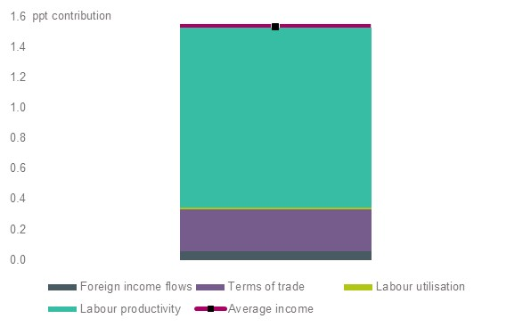
Source: Business Council calculation using ABS, 5260.0; ABS, 6202.0
- Investment has been the main driver of labour productivity
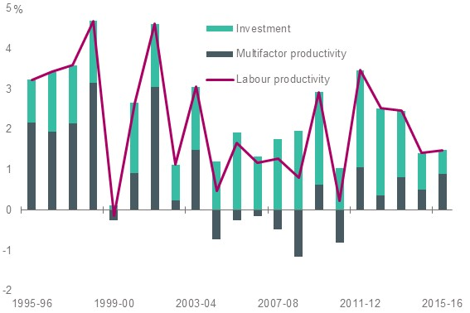
Source: Business Council calculation using ABS, 5260.0; ABS, 5204.0

Efficient infrastructure is needed to underpin productivity growth
Australia’s growing population and economy are creating increasing demand for high-quality transport, communications, water, energy, health and educational services. To keep pace, the provision of these services will require investment in efficient, reliable infrastructure.
Infrastructure investments have to be planned, delivered and paid for. This is the role of the private sector and private users in many sectors, including, for example, energy and communications. However, governments continue to have a responsibility to fund infrastructure provision, particularly where there are social equity considerations or where the market would underprovide. In many cases these projects are the major road and public transport investments that our fast-expanding cities desperately need to maintain liveability and reduce congestion costs.
Since its establishment in 2008, Infrastructure Australia has been advising the federal government on national infrastructure priorities. In 2016 it released a well-developed, 15-year infrastructure reform plan and an infrastructure priority project list. The Business Council endorses the reform proposals and projects in these documents.
These documents should be used as a foundation for implementing:
- an infrastructure reform agenda across governments that will lead to improved infrastructure planning and project prioritisation, more streamlined and efficient planning approvals systems, and a comprehensive national road pricing scheme
- a federal infrastructure funding program that supports, over time, the roll-out of infrastructure investments on Infrastructure Australia’s infrastructure priority list.

The reform agenda
An intergovernmental infrastructure reform agenda should be agreed at COAG that implements the planning, pricing and procurement reforms in Infrastructure Australia’s plan.
The intergovernmental reforms agenda should prioritise improved long-term strategic planning by state and territory governments to help identify future infrastructure needs in each jurisdiction. Infrastructure and land-use planning need to be fully integrated and corridors reserved to cater for future growth. Infrastructure agencies should be established in states and territories that are independent, expert and transparent.
Infrastructure procurement in all jurisdictions should be well informed, through clear needs assessments and the use of independent cost–benefit analyses. New infrastructure projects should be assessed against options to make more efficient use of existing infrastructure, such as through the application of technology. This can promote efficient allocation of capital.
Infrastructure regulation reforms should support more efficient infrastructure provision and use. Opportunities for expanding cost-reflective pricing models into the road and water infrastructure sectors should be prioritised. Regulatory barriers that prevent, limit or hinder the efficient use of infrastructure should be removed, simplified or avoided (such as restrictions on the use of some roads by heavy vehicles).
Planning approvals processes should support more efficient project delivery by moving to a ‘one project, one assessment, one decision’ approach to assessing major projects. This will encourage more private sector investment, realise potential benefits sooner and reduce costs.
Governments should adopt asset governance models that encourage the efficient management of capital. Wherever possible, governments that continue to own infrastructure should seek to move towards corporatisation and then privatisation as a means to increase the efficient operation of the asset. Capital from asset sales should be recycled into new productive infrastructure. Regulatory structures should be implemented where needed to ensure that service standards and other community expectations around service quality and pricing are met.

Infrastructure investment to support growth
Federal government budgets in recent years have prioritised public infrastructure investment. This needs to continue if we are to meet the needs of a growing population and increase workforce participation and productivity. Infrastructure Australia should be tasked to work with the states and territories to speed up the development of the infrastructure projects on its infrastructure priority list.
The planning approvals for these projects should be ‘de-risked’ by putting in place all major planning approvals and then put to the market to maximise opportunities for private investment. User charges and value-capture funding should be fully utilised to limit the funding contribution by taxpayers and to encourage efficient use of the assets.
A well-designed and regular public infrastructure investment pipeline will not only provide the infrastructure our growing population needs – it will be an ongoing source of job creation and promote economic activity.
Preconditions for government infrastructure borrowing
Public infrastructure differs from private investments in that usually users do not pay directly for the infrastructure, taxpayers do. (If the costs of a project can be recouped through user charges, private provision is generally feasible.)
Government borrowing defers the tax liability for funding (paying for) a project from current to future taxpayers. This may be justifiable for significant national projects when the upfront costs would otherwise be borne by today’s taxpayers while the benefits accrue to future taxpayers. (That said, the match between project benefits and particular taxpayers may not be close whatever the timing. That is why much government infrastructure spending is undertaken on a pay-as-you-go basis, without debt finance.)
There is another important difference between government and business provision. Governments are not subject to day-to-day commercial constraints and competition. They do not have direct shareholders, although taxpayers ultimately must bear the costs and risks of projects.
In the absence of these commercial checks and balances, there are several preconditions that must be met before governments borrow to finance infrastructure projects:
- Projects must meet rigorous and transparent evaluation hurdles to ensure they will deliver net benefits to the community.
- Projects could not be financed, built and operated more efficiently by the private sector.
- Borrowing will not adversely affect the AAA credit rating.
  - To avoid ‘shifting’ debt from recurrent spending to infrastructure projects, there should be a credible path for deficit and debt reduction that will demonstrably improve the overall budget position. Existing debt cannot be converted from ‘bad’ to ‘good’ at the stroke of a pen.
In short, federal borrowing should only be considered within the AAA credit rating and where it is ring-fenced for demonstrably high-quality infrastructure projects.
Ultimately, only a stronger budget position can give governments greater capacity to pay for infrastructure, whether or not they use debt finance.

Recommendation 12
- Improve the efficient provision and use of infrastructure through initiating an intergovernmental reform agenda based on the recommendations in Infrastructure Australia’s infrastructure plan, with priority given to:
  - improved long-term infrastructure planning and project prioritisation
  - more streamlined and efficient planning approvals regimes
  - implementing road policy reforms to link cost-reflective pricing models with road funding
  - ‘asset recycling’ initiatives that incentivise state and territory governments to privatise infrastructure assets and reinvest the proceeds into new infrastructure.
Recommendation 13
- Maintain public infrastructure funding as a priority in the federal budget and roll out a regular pipeline of infrastructure projects by:
  - adequately resourcing Infrastructure Australia to advise on infrastructure priorities
  - bringing forward ‘ready-to-go’ projects from Infrastructure Australia’s priority project list
  - attaching performance-based conditions to federal funding of infrastructure
  - speeding up planning approvals and maximising opportunities for private investment
  - maximising funding from user charges and the appropriate use of ‘value capture’ mechanisms.

More efficient and effective regulation
The cumulative burden of regulation on business continues to grow. It directly adds to production costs and deters innovation and entrepreneurship.
The Business Council strongly supports measures to improve the efficiency of business regulation. The government’s deregulation program has, to date, reduced regulatory burdens in a number of areas and needs to be rebooted in 2017 with a new agenda to implement challenging and substantive reforms.
The Productivity Commission should undertake a series of reviews to measure the cumulative impact of regulation by sector and identify sectoral priorities for reform.
A substantive new reform agenda should be developed on the basis of the Commission’s advice and the recommendations of other independent policy reviews.
Immediate priorities should include progress on the removal of cabotage for coastal shipping, Australian Industry Participation Plans under the Australian Jobs Act and labour market testing of 457 visas under the Migration Act.
The Regulator Performance Framework should be strengthened by reporting on KPIs relating to business engagement, costs on business and the contribution regulators make to improving productivity and competitiveness. The framework should also be rolled out in the states and territories.
Recommendation 14
- Federal government should establish and prioritise a clear and transparent regulatory reform agenda, with a pipeline of reform priorities, and overseen by a minister with accountability for reducing the regulatory burden.
- Strengthen the Australian Government’s Regulator Performance Framework and introduce similar regimes in the states and territories.

A competitive tax system
Australia’s tax system is outdated and holding back people and businesses from realising their full potential.
Australia needs to move to a more modern, sensible mix of taxes that encourages people to participate in the workforce and be entrepreneurial and businesses to invest, innovate and create well-paid jobs in Australia. This requires a tax system that overall reduces the tax burden on investment, working and other highly valuable and productive activities. This is why it is vital that broader taxation reform remains on the policy agenda.
In March 2016 the Business Council laid out a comprehensive three-stage plan to achieve growth-enhancing tax reform by 2025. It calls for:
- lower personal income taxes and addressing bracket creep
- progressive lowering of the company tax rate to make businesses more competitive in the global contest for investment
- a rebalancing from narrow and volatile tax bases to broader tax bases, including in state jurisdictions
- more neutral tax treatment of savings income
- greater integrity and simpler taxes.
The government subsequently announced its Enterprise Tax Plan to moderate the immediate effect of bracket creep for middle-income earners and reduce the company tax rate to 25 per cent over 10 years.
Reducing the company tax rate has become urgent as more and more countries reduce their rates and new business investment in Australia is weak. While the government’s proposal is careful and modest, locking in the 25 per cent rate for all businesses by 2026-27 will send a credible signal that reorients the dynamic in favour of investing in Australia.
In addition, the Business Council believes that the petroleum resource rent tax has worked appropriately to date and that no changes should be pursued without a clear, demonstrable net benefit from doing so. The tax system, indeed the broader investment climate, must ensure that the Australian economy, which is heavily reliant on trade and foreign investment, remains strong, builds investor confidence and continues to grow. This is especially important as we look for the next wave of industry exploration, investment and growth.
Recommendation 15
- The Enterprise Tax Plan Bill should be passed in full to ensure that Australia is not left stranded in the global contest for investment.
- Broader tax reform to reduce the overall deadweight burden should be kept on the policy agenda.

Future-orientated workplace relations
Australia needs a modern workplace relations system that delivers a safety net for workers, recognises the shared interests of managers and workers in an enterprise's success, and gives all enterprises the agility they need to compete and succeed.
The final report of the Productivity Commission’s inquiry into the workplace relations system picked up some of the key concerns the Business Council raised in its response to the draft report, particularly in relation to awards, transfer of business, and greenfield agreements. While some of these recommendations have not gone as far as the Business Council would have liked, the recommendations provide an opportunity for significant reform.
However, the Business Council believes that even if the Productivity Commission’s final report were fully implemented, we would still have a rigid system not suited to the modern world of work. Additional reform is required to:
- define the employment relationship in the legislation, rather than rely on legal precedent, so there is a clear set of rules about what can be included in agreements
- streamline awards to their core purpose of establishing a floor of wages and conditions
- respond to employer concerns about right-of-entry provisions, caused by inherent issues in the legislation
- understand the problems organisations face when undertaking structural change, and the barriers that the adverse action provisions present.
Recommendation 16
- Implement the Productivity Commission’s recommended workplace reforms.
- Implement additional reforms including to clarify allowable contents of agreements, streamline awards to their core purpose and create greater enterprise flexibility.

An open, dynamic economy
Competition is absolutely essential for productivity growth and maintaining Australia’s high standard of living. Effective competition generates benefits for consumers, businesses and the economy through lower prices, greater choice, increased innovation and improved productivity.
A more globally competitive Australian economy requires Australian businesses to continually lift productivity and enables them to compete vigorously in overseas markets.
Priorities for facilitating competition should include:
- progressing the reforms from the 2015 Competition Policy Review in agreement with state and territory governments, such as streamlining planning approval processes, removing restrictions on retail trading hours and mutual recognition of occupational licensing, among other potential reforms
- lifting trade and investment through bilateral and multilateral trade negotiations
- maintaining a stable competition law framework that provides clarity and certainty for vigorously competing businesses, while addressing anti-competitive behaviour. The government’s proposed changes to section 46 (‘misuse of market power’) of the Competition and Consumer Act 2010 must minimise unintended consequences for innovation and competition
- ensuring that regulation or other government interventions do not impede competition, especially where technology or other developments may have made legacy regulation obsolete or no longer fit for purpose (e.g. taxi regulation)
- identifying opportunities to inject more competition and contestability in the provision of human services delivery – including health care – to improve consumer outcomes and delivery efficiencies.
Recommendation 17
- Progress reforms from the 2015 Competition Policy Review in agreement with state and territory governments, to streamline planning approval processes, remove restrictions on retail trading hours and increase mutual recognition of occupational licensing, among other potential reforms.
Recommendation 18
- The government’s changes to section 46 (‘misuse of market power’) of the Competition and Consumer Act 2010 should minimise unintended consequences for innovation and competition and be reviewed within five years.

AIHW expenditure data cubes, 2014-15 and Business Council calculations.
Productivity Commission, An Ageing Australia: Preparing for the Future, 2013.
Business Council calculations based on ABS, Government Finance Statistics, 2014-15, cat. no. 5512.0 and Taxation Revenue, 2014-15, cat. no. 5506.0.
M Baird, 'Mike Baird: Raise the GST to 15 per Cent to Pay for Healthcare', The Australian, 20 July 2015.
AIHW expenditure data cubes, 2014-15 and Business Council calculations.
H Britt, G Miller, J Henderson, et al., General Practice Activity in Australia 2013-14, Sydney: Sydeny University Press, 2014.
Australian Health Policy Collaboration, Getting Australia’s Health on Track, 2016.
Select Senate Committee on School Funding, Chapter 5: Rudd/Gillard Governments’ school funding reforms, Canberra: Parliament of Australia, 2016.
S Thomson, L De Bortoli, and C Underwood, PISA 2015: A first look at Australia’s results, Camberwell: Australian Centre for Educational Research, 2016.
Ibid.
B Jensen, Investing in Our Teachers, Investing in Our Economy, Melbourner: Grattan Institute, 2010. BUSINESS COUNCIL OF AUSTRALIA 42/120 Collins Street Melbourne 3000 T 03 8664 2664 F 03 8664 2666 www.bca.com.au © Copyright March 2017 | ISBN: 978-1-922058-70-6 | Business Council of Australia ABN 75 008 483 216 All rights reserved. No part of this publication may be reproduced or used in any way without acknowledgement to the Business Council of Australia. The Business Council of Australia has taken reasonable care in publishing the information contained in this publication but does not guarantee that the information is complete, accurate or current. In particular, the BCA is not responsible for the accuracy of information that has been provided by other parties. The information in this publication is not intended to be used as the basis for making any investment decision and must not be relied upon as investment advice. To the maximum extent permitted by law, the BCA disclaims all liability (including liability in negligence) to any person arising out of use or reliance on the information contained in this publication including for loss or damage which you or anyone else might suffer as a result of that use or reliance.

