**Australian Self Medication Industry**

**2017 Pre-Budget Submission**

**EXECUTIVE SUMMARY**

The [Australian Self Medication Industry](http://www.asmi.com.au) (ASMI) is the peak body representing sponsors of non-prescription medicines, including over-the-counter (OTC) and complementary medicines, an industry valued at more than $4 billion in Australia and delivering $1.2 billion in export revenue.

ASMI believes that the adoption of the recommendations below will not only deliver savings to the health portfolio, they also have potential to incentivise investment in R&D and manufacturing facilities, increase employment and exports, and provide significant benefits for consumers and healthcare professionals. The Federal Government’s current ongoing Medicines and Medical Devices Review provides great opportunity for any legislative changes to be made.

**KEY RECOMMENDATIONS**

1. **Develop a Schedule 4 to Schedule 3 ‘switch’ agenda and reform the Australian scheduling policy framework (SPF)**The down-scheduling (‘switch’) of medicines from prescription (S4) to OTC (S3) is a key enabler for consumers to better self manage their health, in consultation with a pharmacist. A regulatory environment favourable to switch would encourage innovation in OTC medicines and also provide significant savings to the healthcare system.
2. **Reduce restrictions on direct-to-consumer communications for Pharmacist Only (S3) medicines**ASMI recommends that the default regulatory position be modified to become one where direct-to-consumer communications about all Schedule 3 medicines is permitted in a standardised format ***unless*** there are compelling reasons that it would not be in the public interest in relation to a specific product or product group.
3. **Introduce data/market exclusivity mechanisms to stimulate research and innovation**Mechanisms such as data and market exclusivity provide incentives for companies to invest in research and innovation for OTC and complementary medicines. Innovation is critical for the ongoing provision of high quality and accessible medicines. Data protection will encourage investment in R&D and enable greater capacity for return on that investment.

**Summary of recommendations**

|  |  |  |
| --- | --- | --- |
| **RECOMMENDATION** | **COST TO GOV’T** | **BENEFIT** |
| Changes to Scheduling Policy Framework | Minimal | Increased consumer access to medicines and reduced Govt health expenditure (Medicare, PBS payments, improved productivity through better self care,[1] fewer visits to doctors) |
| Reduce restrictions on S3 direct-to-consumer communications | NONE | As above |
| Data/market exclusivity mechanisms | NONE | REVENUE POSITIVE through stimulus to investment and employment. |

**Australian Self Medication Industry**

**2017 Pre-Budget Submission**

**Adoption of the recommendations contained in this pre-budget submission will provide incentives for local investment and innovation in the non-prescription medicines sector, and increase consumer access to medicines. This will contribute to reducing Medicare and PBS costs and increase the sustainability of the Australian healthcare system. It will also increase consumer access and empowerment for improved health outcomes.**

The Australian Self Medication Industry (ASMI) is the peak body representing sponsors of non-prescription medicines. This includes over-the-counter (OTC) and complementary medicines. Our members make up 85 per cent of this $4 billion consumer healthcare products market and employ approximately 18,000 people, with exports estimated at $1.2 billion annually.

Overall, OTC medicines provide high value to the Australian health system. Consumer research from Macquarie University Centre for the Health Economy (MUCHE) [2] estimates that if the eight largest categories of OTC medicines were not available, there would be an estimated 58 million additional GP visits for people to obtain their medication. The cost of this would be approximately $3.86 billion per year – ***of which $2.5 billion would be borne by Medicare, $1.04 billion by consumers and $360 million by health insurers***. This cost increases to over $10 billion per annum if the *indirect* costs of visiting a doctor (e.g. productivity losses) are taken into account:



*The Value of OTC Medicines in Australia,* The Macquarie University Centre for the Health Economy, March 2014

The chart below shows the estimated savings that Australia’s eight largest categories of OTC medicines, calculated in terms of the money saved annually by not paying for a visit to a doctor:

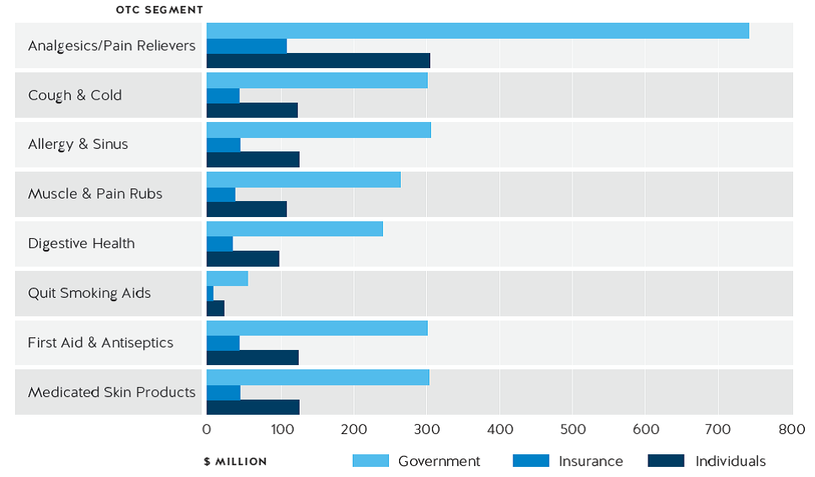

*The Value of OTC Medicines in Australia,* The Macquarie University Centre for the Health Economy, March 2014

The following recommendations deliver both savings to the health portfolio and benefits for consumers and healthcare professionals, while positive outcomes will accrue to other portfolios through stimulation of the Australian consumer healthcare industry, resulting in greater incentives for investment in R&D and manufacturing facilities, increased employment and export growth.

***RECOMMENDATION 1***

**Develop a Schedule 4 to Schedule 3 ‘switch’ agenda   
and reform the Australian scheduling policy framework (SPF)**

[Scheduling](https://www.tga.gov.au/scheduling-basics) is a national classification system that controls how medicines are made available to the public. Medicines are classified into Schedules according to the level of regulatory control over the availability of the medicine that is required to protect public health and safety.

Many medicines now commonly available over-the-counter started out as prescription-only, and have gradually been down-scheduled (‘switched’) to OTC as their efficacy and safety profile is better understood and proven over time. Examples include ibuprofen and naproxen for pain relief and acyclovir for cold sores.

**The economic benefit of switch**

According to the MUCHE research in 2014, switching 11 prescription-only medicines to OTC showed the potential to produce a direct cost savings of $1.1 billion to the Australian healthcare system. This consists of savings amounting to almost $730 million for Medicare and $300 million for consumers. The $730m savings to Medicare alone would be enough to fund more than 600 registrar-level trainee doctors per year in regional areas for 10 years, according to calculations from the [Department of Health Specialist Training Programme](http://www.health.gov.au/internet/main/publishing.nsf/content/work-spec) (STP). The indirect value of productivity gains (e.g. reduced sick leave, travel time) is estimated at almost $1 billion per annum:



*The Value of OTC Medicines in Australia,* The Macquarie University Centre for the Health Economy, March 2014

The same study found that every $1 spent on the eight categories of the most commonly used OTC medicines in Australia produces a saving of more than $4. This is in line with research[3] conducted in the United States, which found that for every US$1 spent on OTC medicines, the U.S. healthcare system saves $6 to $7, providing US$102 billion in value each year.

A blueprint has been set in markets with a higher rate of switch. For example, in 2012 the British government announced an initiative aimed at [halving the time it takes to switch a prescription-only medicine to OTC](http://www.pharmatimes.com/news/rx-to-otc_switch_process_time_to_be_halved_976069). Since 2003, Australia has lagged behind comparable nations in the number of medicines switching from prescription only to OTC. Consequently, we recommend reforms that will help expedite the down-scheduling of suitable medicines to ensure Australia does not fall further behind other comparable countries in terms of medicines availability. Australia once led the world in switch, but in recent years the frequency with which prescription drugs have been down-scheduled has dropped to a rate that is half or less that of nations such as New Zealand, the United Kingdom and Japan.

**Progressive Rx to OTC Switch Activity 2003-13**

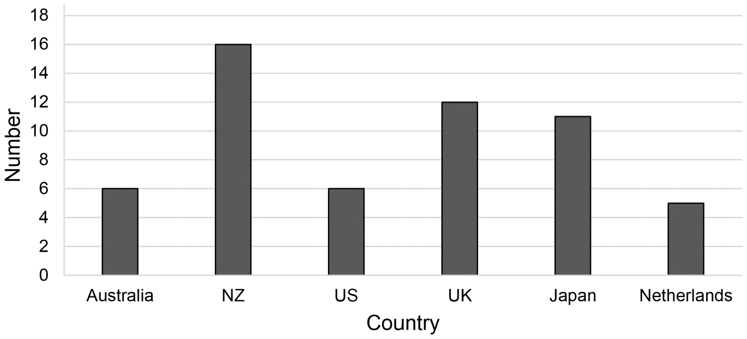

*Widening Consumer Access to Medicines through Switching Medicines to Non-Prescription: A Six Country Comparison*, Gauld et al

In light of the benefits that can flow from the responsible switching of medicines, ASMI is pleased with the Government’s acceptance of Recommendation Eleven of the *Review of Medicines and Medical Devices Regulation* in 2016, which proposed that the Scheduling Policy Framework be reviewed in consultation with the State and Territory Governments. We support this and further recommend a Government-sponsored national switch agenda to help enable the down-scheduling of suitable medicines. This will require the removal of current policy and regulatory hindrances in order to reach a level of down-scheduling more in line with comparable nations.

Several recommendations from the review relate to scheduling reform. In ASMI’s view, the scheduling framework should:

* incorporate benefit as well as risk
* streamline and integrate the processes for registration and variation with related scheduling decisions
* include a mechanism for reviewing scheduling decisions
* incentivise re-scheduling applications
* remove the complexities introduced through the various State requirements
* have a transparent mechanism for policy oversight.

A switch agenda should:

* identify target candidates for future switches
* be a collaborative effort with consumers, pharmacists, GPs, and the medicines industry
* limit unnecessary red tape by minimising the need for formal engagement during the assessment process
* reduce the types of applications requiring engagement
* place time limits on the engagement process
* form the basis of a progressive and best-practice scheduling framework
* reduce restrictions on S3 direct-to-consumer communications to increase consumer awareness of this category, which will encourage medicines sponsors to engage in switch *(see more in Recommendation 2).*

In Australia, there are currently a number of prescription-only (S4) medicines that are candidates for a switch to OTC. These include low-dose statins for cholesterol, triptans for migraine, antibiotics for urinary tract infection and chlamydia, oral contraceptives and erectile dysfunction medicines. Medications in these categories meet the criteria of having a good efficacy and safety profile that has been demonstrated over time to address minor ailments that may be diagnosed and managed without medical intervention. Many of these are already available over-the-counter or are in the process of being [transitioned to OTC in New Zealand](https://www.academia.edu/28460653/Widening_Consumer_Access_to_Medicines_A_Comparison_of_Prescription_to_Non-Prescription_Medicine_Switch_in_Australia_and_New_Zealand), which has a similar healthcare system and regulatory framework to Australia.

***RECOMMENDATION 2***

**Reduce restrictions on direct-to-consumer communications for Pharmacist Only (S3) medicines**

Schedule 3 medicines are used to treat a range of everyday conditions that either do not require medical diagnosis or only require initial medical diagnosis and no close medical management. Examples include cold sores, conjunctivitis, mouth ulcers, nausea and vomiting associated with migraine and travel sickness. All S3 medicines have been deemed “substantially safe with pharmacist intervention” by the TGA.

The current default regulatory position is that S3 medicines cannot be advertised, unless the manufacturer applies for and is granted an exemption. The current regulatory ‘mindset’ focuses almost exclusively on risks with little consideration of the benefits.

ASMI proposes that these restrictions be revised in the interest of raising consumer awareness of safe and proven therapeutic products that they already have access to. A good example of a current S3 medicine which can’t be advertised direct to consumers is chloramphenicol, which is used for bacterial conjunctivitis, an easily identified condition that is common among young children. The current arrangements disempower consumers because ‘they are not allowed to know’ about these medicines.

In conjunction with other stakeholders, ASMI developed a proposed communication model for S3 medicines that provides potential to ease pressure on health costs and resources by making greater use of community pharmacists, who are vastly under-utilised as a primary healthcare resource. The proposed model advocates a strict, standardised format that delivers condition-specific health information to consumers as well as brand promotion and emphasises mandatory consultation with a pharmacist.

Australia is currently out of step with nations that have a similar regulatory framework for medicines (e.g. New Zealand, the UK, Canada) yet have a more liberal attitude to advertising non-prescription medicines. This is discouraging innovation in the local medicines sector.

In 2016, the Centre for Health Economics Research and Evaluation (CHERE) at the University of Technology Sydney conducted a randomised studyiv to assess the impact of a [‘mock S3 product TV advertisement’](https://www.youtube.com/watch?v=1YhzDp0_rWQ). The study involved almost 1300 consumers, 500 pharmacists and 500 pharmacy assistants. A test and control environment was used to isolate the impact of advertising on health outcomes and the behaviour of both consumers and pharmacists.

Findings from CHERE indicate better [quality use of medicine](http://www.health.gov.au/internet/main/publishing.nsf/Content/nmp-quality.htm-copy2) (QUM) outcomes for the consumer   
*with* advertising than without it.

**The research dispels myths currently held towards S3 advertising:**

|  |  |
| --- | --- |
| **MYTH** | **WHAT THE EVIDENCE SAYS** |
| Advertising just **sells the brand advertised** | S3 Advertising increases consumer awareness of:   * + Therapeutic options   + Pharmacy Services   S3 Advertising **drives more ‘health conversations**’  between pharmacists and consumers |
| Advertising **drives inappropriate demand** | **Consumers are comfortable with Pharmacists** determining  whether the advertised S3 product is suitable for them |
| **Pharmacists buckle under pressure** of consumer demand that advertising generates | Pharmacists **appropriately triage consumers** and recommend  a suitable course of action if advertised product is not appropriate (referral to GP or alternate product) |

**Who benefits from S3 advertising?**

|  |  |
| --- | --- |
| Consumers | Better-informed consumers will communicate more with pharmacists about their medicine selection, according to CHERE research. The proposed model encourages industry to play a greater role in improving health literacy through investment in consumer awareness of disease states and therapeutic options. |
| **Public health budgets** | Consumers will have more convenient access to information regarding safe, proven and affordable medicines that have the potential to make  a positive impact on public health and ease the load on doctors. |
| **Community pharmacists** | More pharmacist-consumer conversations will encourage greater customer loyalty and promote the professional role of community pharmacists in primary health care. |
| **Industry** | S3 advertising encourages innovation: currently, product sponsors are reluctant to switch or bring new medicines into a category considered to be a “black hole” as consumers are often unaware of these products. |

**Implementation**

ASMI recommends that Government allows direct-to-consumer communications for all S3 medicines unless there are compelling reasons that it would not be in the public interest – e.g. products with ingredients that have a documented history of misuse, abuse or diversion for illegal use.

At a time when the Federal Government is looking at medicines scheduling, the CHERE research has identified the advertising of S3 medicines as a key area in which we can better empower consumers, encourage self care and avoid unnecessary GP visits for minor ailments and the associated costs that this brings to the healthcare system.

***RECOMMENDATION 3***

**Introduce data/market exclusivity mechanisms   
to stimulate industry research and innovation**

ASMI notes that both the industry and the community desire increased access to evidence based complementary medicines and that greater investment in research and development will expand the range of evidence-based non-prescription medicines available for self-care.

Currently a limiting factor to investment in innovation is that non-prescription medicines (both over-the-counter and complementary) do not benefit from the same level of intellectual property protection as prescription medicines. In most cases, any patent covering the active ingredient will have expired and often the level of innovation for over-the-counter and complementary medicines does not meet the requirements for a standard patent. Furthermore, there is currently no provision for data protection in relation to regulatory data generated for non-prescription medicines.

Nevertheless, the substantial investment required for new therapeutic claims, products and ingredients should still be protected. To this end, tailored measures that encourage investment in innovation for over-the-counter and complementary medicines need to be put in place.

Our position is simple: where there has been substantial investment, there should be appropriate data protection or market exclusivity (commensurate with the degree of innovation and investment) so as to incentivise research into new therapeutic claims, products and ingredients. This will act as an incentive to research new therapeutic claims and products and in turn will have flow-on effects for the economy through generating more jobs, investment and exports in the consumer healthcare products market.

Unlike innovator prescription products, both over-the-counter and complementary medicines generally lack standard patent protection and there is currently no provision for data protection in relation to non-prescription medicines. Other markets, particularly the European Union and the United States, have mechanisms in place for these product categories that offer significant benefit to product sponsors.

In ASMI’s view, there are two methods by which innovation can be incentivised:

* **Data exclusivity** – a defined period during which subsequent sponsors of equivalent therapeutic goods may not benefit from data provided by the first sponsor. ASMI considers data exclusivity appropriate for:   
  – new indications, claims and/or dosage regimes for products or ingredients  
  – new listable ingredients   
  – new formulations  
  – new combinations
* **Market exclusivity** – a defined, enforced period during which a sponsor that is successful in obtaining some form of approval for a therapeutic good is granted an exclusive market status that prevents subsequent sponsors from obtaining similar approval for equivalent goods even if new data is provided. ASMI considers market exclusivity appropriate for:  
  – medications that have been rescheduled

The data protection and exclusivity measures above will encourage investment in innovation, because they will give sponsors an opportunity to gain a return on their investment before competing products enter the market. Furthermore, it will foster an environment that will help meet both the industry and community desire for increased access to evidence-based complementary medicines through greater investment in scientific research and development, which will in turn expand the range of well-evidenced non-prescription medicines accessible to consumers.

**Summary**

The adoption of the recommendations within this submission has the potential to reduce healthcare costs by providing the Australian population with greater options for evidence-based medicines and to deliver a more efficient, effective and sustainable healthcare system at no cost to the Commonwealth.

1. **References**

   The World Health Organization defines **self care** as: “*activities individuals, families, and communities undertake with the intention of enhancing health, preventing disease, limiting illness, and restoring health. These activities are derived from knowledge and skills from the pool of both professional and lay experience. They are undertaken by lay people on their own behalf, either separately or in participative collaboration with professionals.”*
2. Macquarie University Centre for the Health Economy: [*The Value of OTC Medicines in Australia*](http://www.asmi.com.au/media/14036/final_web_copy_asmi_valuestudy_a4.pdf), March 2014.
3. Booz & Co in conjunction with Consumer Healthcare Products Association: [*The Value of OTC Medicine to the United States*](http://www.yourhealthathand.org/images/uploads/The_Value_of_OTC_Medicine_to_the_United_States_BoozCo.pdf), January 2012.

   iv University of Technology Sydney Centre for Health Economics Research and Evaluation: *Estimating the impact of Schedule 3 consumer advertising,* November 2016.