The Hon Scott Morrison MP
Treasurer
The Treasury
Langton Crescent
PARKES ACT 2600

19 January 2017

Federal government pre-budget submission 2017-18

The Australian Retailers Association (ARA) offers support, information and representation to over 5,500 retailers across the nation, representing more than 50,000 shop fronts. The ARA ensures the long-term viability and position of the retail sector as a leading contributor to Australia’s economy.
The ARA is urging the Government to use the 2017 Budget to assist retailers, Australia’s biggest private sector employer, to reduce costs and compliance burden in the face of a difficult operating environment. In the last ten years, the structure of the retail sector has shifted and evolved as a result of globalisation, advances in the supply chain economy and changes to business practice policies. In addition, the retail sector has experienced varying economic environments, an inflexible wages system, lack of consumer/business confidence and high company tax rates. Further, overseas taxation treatments on imported goods are continuing to have a significant effect on the performance of the industry and increasing trade exposure from overseas.
The ARA continues to advocate for greater harmonisation across jurisdictions, while not harming competitive federalism, the cost benefits from standardisation and transferability to national and small retailers are significant.

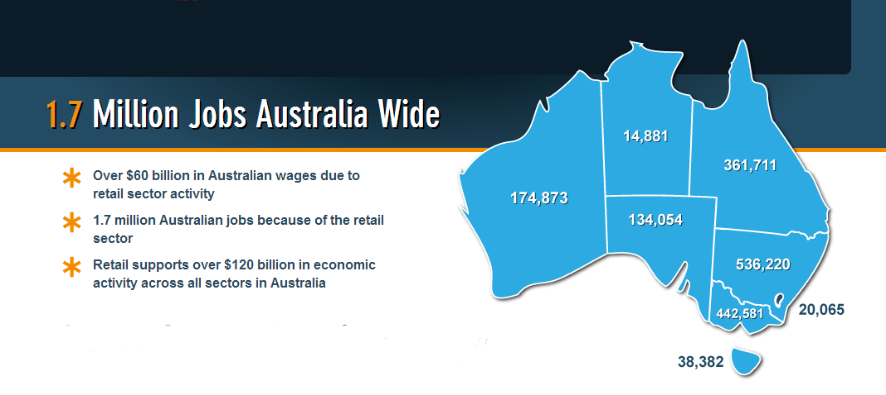
Key issues:

Domestic conditions remain soft throughout the economy with the resource economy slowing down and global conditions creating a weaker than expected trading environment. The Australian economy is suffering from a lack of confidence through uncompetitive policies with productivity remaining a key issue not only in retail but other sectors. An inefficient tax system which is yet to be fully addressed sees many businesses lacking international competitiveness and in some cases offshoring their administrative support to remain competitive. Business profitability has been hit hard by rising cost pressures from wages to compliance burden. We have seen some costs like energy easing slightly due to Federal Government action and global markets jobs.

The ARA and its members have a strong vision for the retail industry based on free markets, growth, productive and innovative businesses and responsible individual initiatives supported by government where appropriate.

The ARA is committed to promoting retail as a viable and exciting career choice for young people, and to retaining and developing the highest standards of practice within individuals at all levels of the industry. The ARA is also committed to assisting members in dealing with new technologies, supply chain efficiencies and logistics.

In this environment, the Government needs to look at what it can do to responsibly promote the role of the private sector as the key driver of economic growth, jobs, investment and improved living standards.

Despite some negative media coverage, there are a number of successful Australian retailers (such as Cotton On, Bakers Delight, Smiggle, Bunnings and Forever New) who through their success within Australia, are now expanding overseas. Some recent Australian entrants such as Specsavers are growing their specific sectors through franchising and established a manufacturing plant in Australia without any Government support.

The Government has a solid base to increase further growth if it addresses current structural spending, high tax, productivity and over regulation issues. The economy is holding up under difficult circumstances as we are encouraged to see strong jobs growth in the retail sector while recognising disruptive technologies have created greater skill needs.

The Government should support the retail industry as an important sector forecasted to raise productivity, increase employment and the economy through lower taxes, improve retail sector investment and career growth. The retail sector finds itself in both an area of opportunity and challenge.

The Budget commitments the ARA would like to see are:
- Responsible economic management and expenditure restraint
- No new taxes or increases in existing taxes including excise taxes
- A genuine plan to stimulate growth through tax cuts
- Continued regulation reduction through harmonisation within a competitive federal framework
- Accelerated government/private infrastructure investment and planning reform
- Commitment to the services sector through continued and further Vocational Education Training (VET)
- Continued development of effective employment pathways into the retail sector
- Keep Australia’s AAA credit rating
- Industrial relations advocacy to support more flexible employee working hours in the retail sector
- Taxation reform including making company taxes more internationally competitive reducing the low value threshold on GST
- Planning reform and harmonisation
- Removal of trade barriers such as intellectual property rights on books which only affect Australian based book retailers

These and other initiatives need to be delivered by the Government in the Federal Budget, as these commitments will benefit the Australian retail industry and the wider community by raising productivity and improving the prospects for investment, employment and reforms.
The priorities for retail in this respect are for the Government to:
- Implement retail tenancy lease reform recommended by the Productivity Commission through COAG and competition policy to create transparency
- Reform the Australian GST Tourist Refund Scheme (TRS) to allow private operators and grow tourist retail sector
- Work with states to give tax and duty relief to consumers and business though taxation reform
- Support skills and employment pathways through VET in the retail and service sector
- Commence the quick implementation for the removal of the Low Value Imports Threshold (LVIT) on GST
- Complete planning reform through competition policy and COAG
- Allow more flexible workplace laws and support penalty rate changes
- Harmonise state based laws and regulations through competition policy
- Simplify workplace safety harmonisation
- Implement balanced recommendations from the Financial Systems Inquiry (FSI) around payments reform
The rising cost of doing business in retail are:
- Skills shortages in the retail sector
- Uncompetitive wages
- Issues surrounding Enterprise Bargaining Agreements
- Taxation structure
- Trade restrictions through regulation
- Consumer law support

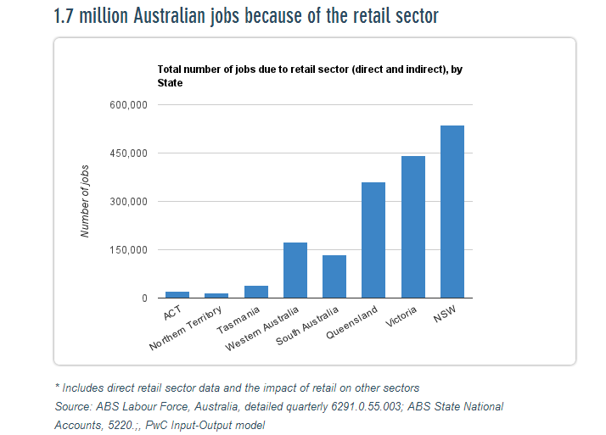

Tax reform
- A lighter tax burden on business and individuals to drive stronger economic growth, more jobs and stronger government revenues
- Tax changes should include reducing base rates to address the effects on overseas investment and trade related issues
- Application of the GST on Low Value Imports under $1000
- A change to the tax base to facilitate the abolition of inefficient State and Federal Taxes
- A reduction in company tax rates to meet a globally competitive market
- Abolition of Payroll Tax through State and Federal tax changes
- A halt to ever increasing excise taxation grabs which is draining money from consumer pockets and creating black markets

Policy principles
Australia needs a tax system that supports the balance of economic and social principles. Australia’s competitiveness should be assisted, not harmed, by the tax system.

Tax revenue should be adequate to meet all elected Governments reasonable expenditure needs, consistent with the exercise of fiscal responsibility. The tax system should be such that all taxpayers feel confident and satisfied in complying with it.

The cessation of unindexed tax increases or the introduction of additional indexation which in sapping consumer spending power, or in the case of some products such as alcohol and tobacco, is driving them out of the legitimate retail market into the black market.

Support for a root and branch review of the tax system to include the GST with a view to abolish inefficient taxes along with reducing the overall tax burden to business and the productive economy.

A sustainable tax structure will only be achieved through an integrated package of reform across all significant Commonwealth and State tax bases in the form of a balanced package covering consumption, income, assets and offshoring.

Policy objectives
- Economic efficiency – taxation should impact neutrally on the economy and commercial decisions must not be skewed by tax considerations. The tax system should improve the competitiveness of Australia by encouraging productive investment, risk taking, economic growth and attracting capital along with skilled labour
- Adequacy – tax systems should raise sufficient revenue for public expenditure needs, be sustainable in the long run and be consistent with fiscal responsibility
- Simplicity – taxpayers being able to clearly understand and meet their obligations
- Transparency – taxpayers should understand how and when they are paying tax and how much tax they are paying. Hidden taxes should be minimised
- Limit costs – compliance and collection costs should be minimised
- Limit evasion– there should be minimum incentive and potential for evasion or avoidance of taxation, if the system needs to compete with global tax rates it should keep both business and human capital in Australia
- Consistency – tax policy should be internally reliable and consistent with broader Government policies
- Flexibility – the tax system should be able to respond to developments in the economy and society, through demographic changes, financial innovation, globalisation, supply chain and capital
- Public perception – there should be the widest possible public support for the tax system
While changes in the early 2000s to Australia’s taxation regime improved equity, sustainability and efficiency, there is still much more room for further improvement 16 year later with a greatly changed market place.

Based on the tax design principles above, the main reasons for further reform of Australia’s tax system include:
- Improving the efficiency and international competitiveness of the Australian economy
- Continuing Australia’s strong growth and productivity results
- Ensuring Australia can meet long-term challenges, particularly disruptive technology
- Promoting innovation, risk taking and entrepreneurship
- Encouraging investment in human capital, through education and training
- Encouraging skilled migration and the retention of skilled people
- Not causing distortions in competitiveness or driving unintended illegal markets through excessive taxation
- Reducing tax avoidance and evasion, to improve the perceived and actual fairness of the tax system.

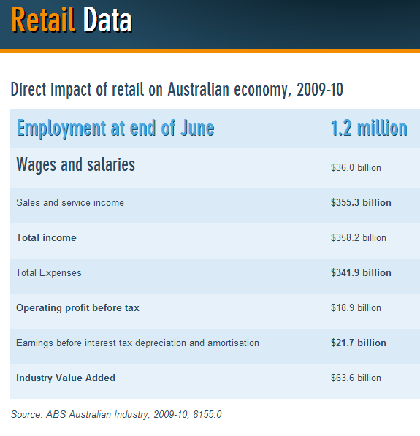

Low Value Imports Threshold (LVIT) on GST
The ARA welcomed the Government commitments in supporting plans to lower the LVIT which would enable collection of GST on goods below $1000.

Lowering the GST threshold on imported goods needs to happen swiftly if Australian retailers are to be put on a level playing field with their online overseas counterparts, who currently have the distinct advantage of escaping GST when sending their goods to Australia.

The ARA has made a submission to Treasury on the legislation to implement the change and supports the broad approach of the Government. We encourage this reduction to be implemented quickly for the economic benefit of retailers and retailers will look very poorly on any delay to the 1 July 2017 implementation caused by the Senate.
Company tax cuts

Investment levels are floundering despite low interest rates. Businesses need incentives and certainty to grow and employ more workers, which in turn, will support wage growth.

Company tax is an inefficient tax. The US and UK recognise this and have made public commitments to significantly reduce their tax rates, following the path of many countries before them who have much lower company tax rates than Australia. A more competitive corporate tax rate will increase investment in Australia from both foreigners and local investors, which boosts incomes for local workers, domestic businesses and households. Two-thirds of the benefits are expected to flow to households, while only one-third flows to businesses. The ARA along with the Australian Chamber of Commerce, whom we are a member, supports the Government’s efforts to lower the company tax rate to 25% over a decade through annual reduction.

The tax cut must be extended to businesses of all sizes to extract maximum benefit – the largest businesses can grow, hire more people and attract significant additional investment under a core competitive company tax regime.

Further, the ARA supports the legislation of the tax cuts because certainty over future tax cuts will put in place a glide path that will give investors the confidence to make future decisions.

Infrastructure

The ARA calls for enhanced investment in logistics and infrastructure to lift productivity and efficiency, in response to changes in demography in both urban and regional Australia. The real cost of living pressure and business costs are measurable by retail businesses, proving the urgent need to improve supply chain flows. The Federal Government’s commitment shown so far to infrastructure has been impressive and can be seen around the country, in particular the massive infrastructure Catch-up programme in NSW is a classic case of where public/private Federal and State Government cooperation is now a key driver in that state’s economy.

Policy principles
Infrastructure is vital to Australia, now and in the future. We must continuously improve our national infrastructure if we are to:

- Improve Australia's economic performance and achieve economic growth
- Maintain and enhance our international competitiveness

Policy objectives
- Port, rail, airport and road investment creates greater efficiencies for supply chain logistics
- Encourage technological change in all areas related to infrastructure
- Ensure the private sector plays a major role in financing, designing, building, operating and maintaining infrastructure
- Support transport development which enhances customer and business transport links to key retail hubs
- Ensure that all infrastructure projects are subject to a proper cost-benefit analysis
- Make certain that equitable and sustainable risk allocation models are developed
for each project undertaken by the private sector.

Budget & fiscal responsibility by Governments
- Return the Federal Budget to surplus over time ensuring the economy continues to grow, to take pressure off borrowings, interest rates and ensure that the Government has the means to execute a fiscal response to a future crisis
- Efficient delivery of public and community services by Government and an annual two percent reduction of spending by Government on Government for the next five years
- Grow revenue by lowering the cost of doing business through lower and more efficient taxes
- Growth in government expenditure is unsustainable and must be addressed.

Respond to the flexibility, productivity & participation needs of the modern workplace
- A workplace relations system which is fair to both employers and employees, recognises that they share substantial common interests and seek to operate with a framework of fair and economically responsible standards and behaviours
- Make targeted investments in training and skills development a high a priority including effective employment pathways
- Change the Fair Work Act where problems arise, when they become apparent and as the system evolves.
The Fair Work Commission (FWC) needs to be empowered to effect change within the current Award structure. FWC must consider whether Modern Awards:
- Achieve the Modern Awards objective
- Are operating effectively, without anomalies or technical problems arising from the Award modernisation process
- Allow greater flexibility in workplace arrangements
- Are taking into account cost pressures and flexibility needs for Australian retailers operating in a globally competitive environment
- Have an appeals jurisdiction.
Objectives

FWC must be obliged to review all modern awards on a regular basis:
- A review will be a vitally important issue for the retail industry to improve both productivity and sustainability for the Australian retail industry. The effective management of labour costs has become more important than ever before for the industry in an environment where sales are stagnant and the consumer has developed an expectation of globally competitive pricing
- The recognition of the difficulties faced by retailers working under an Award structure that imposes higher labour costs at times when consumers want to shop is causing major distortions in the ability for retailers to trade competitively. This is becoming increasingly problematic as Sunday continues to establish itself as an important trading day with many retailers not finding it economically viable to trade on Sundays
- ARA will be pushing for amendments to the Fair Work legislation and changes to FWC that will allow retailers to more effectively manage their labour costs and provide greater flexibility via FWC
- ARA will, over the course of this Government, be actively seeking the views of members and engaging with the broader retail industry to identify key common concerns and develop a strategy for ensuring FWC conducts a comprehensive review of these concerns
- As Australia’s peak employer association for the retail industry, the ARA will be taking a lead role in the process to achieve a positive outcome for retailers.
- To achieve outcomes, we need to have an appeals mechanism to ensure due process.

Fair, productive & creative workplaces
In Australia, 120,000 retailers employ over 1.2 million Australians – as retail is Australia’s largest private employer.
Modern 21st century workplaces increasingly reflect the joint enterprise and common goals of business, the workforce, employers and employees.

The ARA believes in a safety net of standards of behaviour and norms that underpin rights and responsibilities in the workplace, but which also do not detract from individual or enterprise flexibility in workplace agreements.
Above all, the ARA supports enterprises large and small and their employees and contractors to tailor remuneration and working arrangements in a way that provides the best chance for the business and its employees to fully develop and prosper.

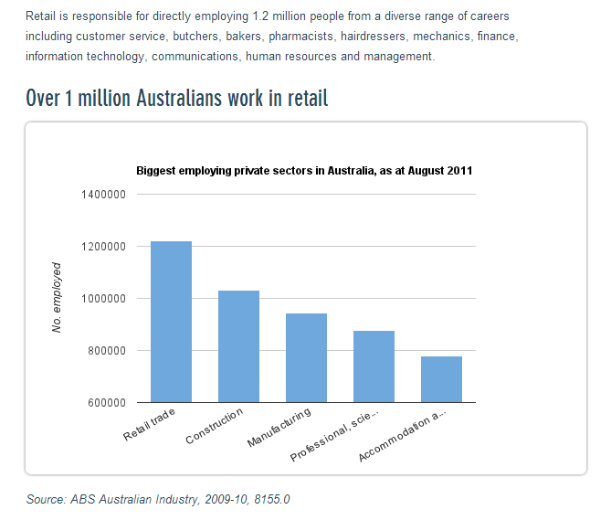

Economics

The ARA calls for recognition by Government that long term business planning requires investment certainty, the minimisation of risk, low taxation, a flexible wages systems, stability, reliable inexpensive sources of energy supply and capital.

A strong, globally competitive economy which provides businesses large and small with the commercial freedom to take calculated risks, invest and secure productive rewards that benefits business owners and managers, their families, employees and consumers is desirable.
The retail economy has fundamentally transformed since the 1980s and is now deeply integrated in regional and global trade.

Our economy is comprised of over 120,000 retail enterprises, most of which are small businesses, but some are amongst the largest and most successful corporations in the world.

The ARA's policy department is committed to making sure that the environment for doing business in Australia gives our private sector and business sector a competitive and productive edge.

We believe in economic reform and the leadership that Government and the private sector business organisations can provide in facilitating reform and community support for the reform effort. The ARA is particularly concerned in ensuring that Australia's tax and regulatory systems support private entrepreneurship.

The ARA is excited to see the private sector continuously invest in physical infrastructure and human capital that can add to economic growth as well as community and social wellbeing.

The ARA continues to be committed to support our private sector and our Governments to restore the health of the financial and capital markets. The ARA also seeks to ensure the flow of capital to Australian businesses, large and small, can fuel a new wave of growth and economic prosperity.

Policy objectives
- Making the case for economic reform and the adoption of policies that promote commercial freedom, entrepreneurship and private sector investment
- A tax system that creates incentives for the private sector to flourish, improve economic growth and increase employment
- Reduce the size and interference of Government including local Government bureaucracy
- Freeing up finance availability
- Removing multijurisdictional compliance through harmonisation, utilising competition policy and COAG forums with each Minister delivering tangible outcomes in the next term of parliament.

Participation in the nation's economic affairs by retailers

The ARA would like to see:
- Rewarding personal entrepreneurship to maximise job creation and wealth for families and local communities
- An increase in the numbers of self-employed people
- Reduce red tape and compliance burden on all business, with a particular effort to assist the small to medium retail sector

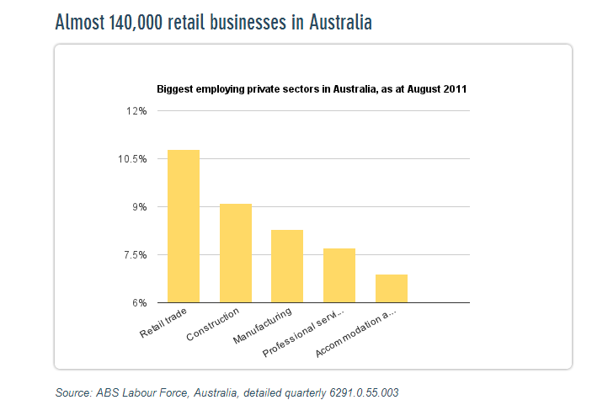

Online

The ARA believes the utilisation of online web presence for small business, coupled with the rollout of national infrastructure including high speed broadband and fourth generation wireless services, provides a critical platform for business to harness productivity and business improvements.

The ARA has developed skills sets with Skills IQ and the National Online Retailers Association (NORA) which work to support existing supply chain and business skills. With many commercial drivers creating and assisting change within the sector including the ICT sector developing products and supporting retail.

The Government’s role should focus on commercial facilitation in this technology product rollout and skills building, encouraging and facilitating through existing skills development opportunities allowing market forces to do the rest.

Education and training policies

Schools
- The ARA supports a smaller federal bureaucracy for school education, and decentralisation of delivery to the states and schools. That said, there is a continuing role for the national development of curriculum and the need for the Federal Government to take a more active role in school to work (directly or via further education) transitions. The Federal Government has more financial stake in successful transitions due to the significant cost of funding welfare benefits should the student not successfully transition into further training or work. Specifically related to this the Federal Government should:

  - Take greater leadership of vocational training in schools by increasing the dialogue and engagement between schools and industry, and focus on improving the quality and significant inefficiencies created by poor pathways between VET qualifications
  - Improve the embedding of employability skills in the school curriculum
  - Encourage and if necessary incentivise the states to introduce minimum requirements for literacy and numeracy to standards required in the workplace, using international benchmarks
  - Continue current programs for youth connections (addressing disengaged early school leavers) and school partnership brokers under a redefined and more focused initiative School to Work Transitions. This focus maintains a direct connection between the prevention of poor outcomes and the cost of failure (welfare).

Vocational training
The ARA supports the efficiency and effectiveness of the vocational training system currently being conducted. However, although there are specific issues within each part of the education and training system (early childhood, schools, vocational training, and higher education), it is important that there is greater clarity of roles between the Commonwealth and the States across the system not just within each component. Pathways and recognition of quality outcomes should be improved between the sectors to achieve efficiency of public funding spend. In other words, any changes made to VET should be done so within a holistic approach to the total system and with a focus on industry not providers.

Funding in VET specifically should be focused on high quality and national qualifications with industry engagement including work integrated learning models such as apprenticeships.

There is no doubt that a more effective national partnership skills agreement with the States and Territories is needed. This will deliver medium to long term outcomes in vocational training. In the meantime, overall investment should not be reduced, and indeed more targeted effort should be placed on increasing apprenticeships particularly for school to work transitions and the disadvantaged groups to save on welfare support. Also, the priority is to focus on improving quality across the system, and in turn improving pathways and recognition of prior learning so that students do not have to duplicate learning which is resulting in wasted public funds.

Traineeships
The policies of the previous Government, most specifically with the removal of non-trades apprenticeship incentives and mature age trade apprenticeship wage subsidies have had a significant negative impact on apprenticeship numbers. The major impact to commencements occurred after July 2012 when the 2012/13 Budget and MYEFO cuts took effect.

Maintain funding for VET at the current levels and introduce policies to boost apprenticeship numbers:
• At a minimum, maintain funding in the vocational education and training system at current levels;

National Partnership Agreement – VET:

The Federal Government must maintain, at a bare minimum, current funding to VET through the National Partnership Agreement. The Agreement provides a timely opportunity to secure commitment to reform from the jurisdictions, and should be focussed on the apprenticeships system and the development of a national taskforce. The agreement should:

- create a national apprenticeship and traineeship system;

- remove duplication and better align Commonwealth, State and Territory programs, services, and funding related to apprenticeships and traineeships; and

- improve commencements and completions of apprenticeships and traineeships.

To do this, the Government should:

- Establish an apprenticeship taskforce involving industry and Federal and State Governments to examine the issues impacting on apprenticeships and facilitate action, with a particular focus on recommending how best to improve the business case for employers offering apprenticeship and traineeship opportunities.

Promote the value of apprenticeships and traineeships. The Government should work with industry to better promote apprenticeship and traineeship pathways as a high value employment opportunity for school students, existing workers and unemployed Australians.

Industry Skills Fund
This programme potentially provided funds on a co-contribution basis for employers to support up-skilling using national qualifications. The ARA and its members strongly supported the Fund, although saw it should be have more efficiently managed directly by the department. Our members and own experience would indicate the process and complexity for small to medium retailers made the Fund difficult to access. The Industry Skills Fund was a good concept, various iterations of like programmes have worked in the past and we believe this is a needed and useful concept which we encourage the Government to look at again to improve productivity.

VET architecture
ARA members support the basic underpinning of the structure of the VET system being the development of training packages that are reviewed to reflect changes in occupations and skill needs. The ARA is concerned the changes could see major national businesses develop unaccredited non-transferable packages if there isn’t comprehensive enough consultation with industry stakeholders. We see real issues around the funding structure to allow adjustments to packages and updates to those packages.

The ARA recommends that the Federal Government establishes a well-resourced, more effective labour market analysis and forecasting team somewhere in the bureaucracy to underpin decisions regarding skills need and training particularly in migration, employment and education policy.

Career development
The Federal Government should revisit the important issues in the release but not funded National Career Development Strategy. The significant spend on workforce development should be complemented by an effective spend on career development, to ensure:
- Students are undertaking courses with a strong understanding of career opportunities and the demands of the occupation
- The right skills are deployed to the right place at the right time
- Better coordination between all Government parts that currently provide careers advice, support and funding
- Industry leadership and professionalism in careers advice.

Removal of employer incentive payments for existing worker traineeships

The removal of the employer incentive payments has impacted dramatically for enrolments on traineeships which impacts on young workers in up-skilling and improving career prospects.

The ARA recognises the Government needs to work within current budgetary restraints but there needs to be a refocusing of allocation in alignment with younger workers.
- Retail is second to aged care sector in employment in Australia and particularly in regional areas
- Constant need for employees as many large retailers particularly supermarkets have staff turnover rate of 20-30% annually, always requiring skilled staff
- Flexibility of retail i.e. varied shifts, part-time employment; fulltime employment can adequately meet most people’s requirements.
Employment

The economic and fiscal policy context for this important priority is increasing workforce participation to improve productivity and reduce welfare dependency

The ARA has been working closely with industry and Government to develop the PaTH programme to deliver the needs of industry while addressing employment opportunities for job seekers.

Employment services need to be employer-facing, not supply side driven. All indications illustrate that the new system addresses many of the industry needs and we look forward to seeing how effective Government changes will be as the new system is implemented with retailers working with Government to improve outcomes.

The Federal Government should begin the process of reviewing employment services. Cognisant of the fact the current JobActive contracts are in place until 2019, therefore 2017 is an ideal time to trial and pilot new programs with new technologies. Work needs to be done to ensure employment services are client facing, ensuring the jobseeker and potential employer have access to the system to search jobs or post jobs – guaranteeing the job services area has a truly informed market.

The Government should fund the development of a technology platform that would enable access to available jobs by service providers, employers and jobseekers.
The Government should identify a suite of qualifications with high employment outcomes and attach training funding and employer incentives in a program aimed at a minimum of 50,000 unemployed young Australians over two years to assist them in gaining employment and training through an apprenticeship or traineeship.

A small pilot of this program could be delivered through the Try, Test, and Learn Fund.

A reduction of the red-tape burden on business

Ensure that well-designed regulation and effective functioning of the Federation supports the seamless operation of a national economy and business efficiency.

The ARA supports work already underway in some states and believes the mechanism of competition policy is a means of driving this critical reform.

Every new regulation, tax, law and public servant increases compliance burden for business and the ARA supports the fundamental principle of small Government which removes laws and regulation which create unnecessary burden for business.

From our work, retailers are clearly identifying the size and bureaucracy levels within local Government as creating significant delays and compliance for business.

That is efficient, cost effective & fair policy objectives
- A net benefit approach to new and existing regulation or laws
- An emphasis on the shift from a detailed and prescriptive ‘input-based’ approach to a broader ‘output-oriented’ approach. Businesses should be given flexibility in meeting the aims of regulations rather than simply having to meet set obligations
- Appropriate accountability to ensure that essential objectives of regulation are achieved without unduly restricting or impacting on business
- Regulatory structure that involves adequate consultation, assessment of the alternatives to regulation, accurate cost benefit analysis and the monitoring of the performance of regulatory agencies
- A comprehensive and continuous review approach across jurisdictions led by a commission level body at the Commonwealth level with greatly increased resources compared to the Office of Regulation Review in the Productivity Commission
- Ensuring that the regulatory decision-making process is transparent, leads to fair outcomes and involves consultation processes that are accessible and responsive to business and the community
- New regulatory culture where there is an understanding of business processes and the burden created by regulatory compliance and a commitment to providing a ‘business-friendly’ operating environment
- Use of competition policy and COAG to force reform
- Removal of overlap and duplication particularly resulting from separate Commonwealth and State regulation
- Red tape target with bench marks for achieving of targets.
Counterfeit product and intellectual property rights
Globally and here in Australia, counterfeiting is a significant problem, affecting brand owners and consumers across all industries. Although the significant negative impact of counterfeiting has long been known, Australia’s anti-counterfeiting laws have simply not kept pace with the problem. Indeed, the flow of fake goods into Australia, and their sale in our markets, continues unabated.
Our main objectives regarding law reform in the area of counterfeit goods are:
- Improved border control measures to identify and halt the importation of counterfeits
- Removal on restrictive publisher rights impacting retailers
- Removal of the ‘personal use’ exemption for importation of counterfeit goods under the Trade Marks Act 1995 (Cth)
- Institution of a ‘no counterfeits’ declaration on passenger arrival cards used for entry into Australia
- Increased public awareness of the impact of counterfeit products
- Clarification regarding the right of citizens and companies to act as ‘private prosecutors’ in criminal cases involving counterfeit products.
The ARA along with members and stakeholders are undertaking research to identify key issues and measures needed in greater detail.

GST Tourist Refund Scheme initiative

The ARA is co-Chair of the group supporting advocating on behalf of the Tourism Refund Scheme (TRS). Australia’s current TRS is administered by the Department of Immigration and Border Protection (DIBP) through the Australian Border Force (ABF). As one of the few known government-run TRS systems in the world, this is labour-intensive, time-consuming, paper-based and an inefficient use of scarce fully-trained ABF officers.

As one of few known countries that administer a government-run TRS, Australia is also one of the few countries in the world where the cost of administering the TRS is met by the taxpayer rather than the traveller.

Continual increases in TRS usage by departing international travellers, particularly from China, along with a range of entitlement changes implemented in 2013, have put increasing strain on the existing TRS at Australian airports. The ABF-run scheme’s antiquated, paper-based administration is inconsistent with the Government’s long-standing objectives to enhance passenger facilitation and improve the airport visitor experience.

The TSRG is advocating for the introduction of private refund operators, who can provide the TRS within an open and competitive market. The Australian Government’s consideration of TRS enhancement creates an opportunity for policy makers to adopt an open market, with private refund providers, to enhance the administration of the TRS.

The TSRG notes that the then-Australian Customs and Border Protection Agency (ACBPA) has previously identified the need to modernise TRS technology.

The TSRG appreciates recent formal consultation with the Australian Government, led by the DIBP, but notes that progress on this matter has been slow, mainly led by the GST sensitivity with the States and Territories. The TSRG welcomes the growing momentum for TRS reform, most recently expressed late in 2016 in an industry briefing by the Hon Alex Hawke MP, Assistant Minister for Immigration and Border Protection, and values the opportunity to make this updated submission to the Federal Government’s 2017-18 Pre-Budget process.

We understand that the following objectives will drive the Australian Government’s considerations for TRS reform:
- Reducing airport congestion: use of best practise technology to streamline the traveller claims process on airport.
- Limiting (or removing) the role of ABF officers in the refund process: future refund processing should not require physical issuance of refunds by ABF officers, enabling them to focus on more relevant and pressing issues of border security. Ongoing TRS administration could also include a reduced requirement for ABF officers to physically verify the export of goods at the border.
- Minimal change to the law: ensuring that reforms to the TRS will require as minimal changes to existing GST legislation and regulations as possible.
Parameters of existing GST law and its impact on TRS administration

Australia’s existing TRS provides that purchases made within Australia are eligible for a refund of GST paid, provided that the purchase meets certain criteria, including:
- That the good is a good, the supply of which is a ‘taxable supply’, and hence liable to GST;
- That the good is not excluded from TRS eligibility (including non-wine alcohol and tobacco products, consumed or partly-consumed goods or goods purchased and imported into Australia over the internet); and
- That the good is purchased within 60 days of departure from Australia, and is of a minimum value of $300 from a single retailer (from which multiple tax invoices can be aggregated).

The current GST law entitles all departing travellers to access a TRS refund, provided they have the goods in their possession at export and have a valid Australian tax invoice. As such, the current TRS requires access for (close to) 100 per cent of all eligible transactions and therefore the legal framework does not enable a universal ‘opt-in’ model, where TRS access is optional for departing travellers or retailers.

The ‘opt-in model’ – general application of a private provider TRS within an open market – International Best Practice

Internationally, private provider-led TRS models provide for users (departing international travellers) to ‘opt-in’ to the access to the system. Under an opt-in framework, departing travellers can only access a refund of GST paid on their purchase in the event that the retailer is affiliated with a private refund provider. Such a system restricts access to certain transactions and enables retailers, refund providers and customs authorities to design and implement an integrated process between purchase and refund.

Such a system requires provisions within the relevant tax legislation and/or regulations to specify conditions associated with access to the TRS. Given the preference of Australian policy makers to minimise any requirements to change GST laws, it may be unlikely that the Australian Government will consider, at this stage, the introduction of an opt-in model that restricts TRS access from non-affiliated retailers. However, the TSRG believes the Government should consider implementing a hybrid interim model, with a view to transitioning to an international best-practice retailer model in the future.

Developing an ‘opt-in model’ within a TRS with 100 per cent coverage framework

Given the existing legal framework for the TRS, policy makers will need to develop a hybrid model that enables a world’s best practice ‘opt-in’ model to coexist with existing applicability of the TRS to (close to) 100 per cent of all eligible purchases.

Under such a hybrid model, retailers seeking to utilise the TRS can opt-in to an affiliation with a private refund provider. Affiliated retailers and their customers will have access to services provided by the refund operator, including sophisticated payment/refund options and targeted destination marketing to potential high-yield international travellers. A hybrid model can enable ongoing TRS access for travellers who make purchases from retailers who have not formally affiliated with a private refund provider. Policy makers could consider a ‘tiered’ TRS system, where government plays a minimal role in export validation, and a number of licensed private refund operators provide post-sale refund services for purchases made at non-affiliated retailers. This will ensure compliance with the current 100 per cent coverage entitlement under Australian GST law.

The hybrid model requires further consideration and consultation with government and industry stakeholders. Importantly, the model enables a broad capture of eligible transactions by departing travellers, whilst ensuring that there is only a minimal residual role for government to ensure comprehensive coverage. The hybrid model leverages recent developments in electronic payments technology, in particular, digital platforms in developed markets around the world. Effective utilisation of technology can ensure that government’s ongoing role in the TRS is virtual, requiring limited government resources and personnel.

It is envisaged that all administrative arrangements and ‘back-office’ functions for the hybrid model (both retailer affiliation and non-retailer affiliation processes) would be provided by private refund providers, on behalf of the government and departing travellers.

This system builds on the Reimbursement Agent Model concept, developed by the TSRG in its engagement with the Australian Government between 2005 and 2008. This model ensures that the TRS continues to operate, from a legal perspective, as an interaction between the Australian Government (‘the Commissioner of Taxation’) and the departing traveller.

Various tiers of TRS services will require an agency agreement between the departing traveller and the private refund provider, who the traveller can appoint as his or her representative in the refund provision process.

Recommendations
The TSRG proposes reform to TRS administration, enabling provision by private sector operators, in line with common international practice. This would assist the TRS to deliver on its policy objectives and provide numerous other benefits, including:

- reducing administrative costs to Federal and State taxpayers;
- enhancing the tourism shopping experience in Australia;
- maximising the benefits of ever-growing tourism shopping, especially by Chinese travellers;
- improving the attractiveness of Australia as a tourist destination;
- assisting the ABF to focus on its key roles; and
- creating additional private sector employment opportunities along the TRS services supply chain.

Such a reform is consistent with the Turnbull Government’s innovation and cutting red-tape agendas, including the government’s resolution to lead by example by embracing innovation and agility in the way it conducts business.

This reform is a strong example of how shifting administration of the TRS from government to the private sector will better place Australia to compete with other countries around the world, which have long realised the benefits of a privately operated system. Whilst government will retain responsibility for the export verification functions, industry is far better equipped to efficiently provide refunds to travellers.

Private providers have an additional incentive to actively promote the TRS and encourage travellers to make further retail purchases. This is particularly important if Australia wants to capture a larger share of the ever-increasing shopping expenditures by Chinese travellers. Indeed, shopping is a high priority for Chinese travellers.

Importantly, the TRS reform will radically improve the visitors’ travel experience at airports. The current, manual process for TRS claims results in long queue times, delayed or missed flights, frustration and even incidents at airports. Allowing private refund providers to operate in the TRS system would streamline administrative processes at international airports and sea terminals.

Furthermore, allowing private providers to operate freely in the TRS system will lead to new employment opportunities all along the TRS services supply chain. Private providers will indeed bring new ideas and innovation into the TRS system. New jobs will be created in the most value adding areas of the supply chain in order to develop creative, technological and more efficient TRS solutions. By implementing our TRS reform proposal, the Government will have the chance to embrace and harness new sources of growth to deliver the next age of economic prosperity in Australia.

The TSRG supports the recommendation of the NSW Government, in response to its Visitor Economy Industry Action Plan, which recommends that the Federal Government enable the entry of private sector TRS providers within an open market. Since the plan was released, the Premier of NSW has written letters of support to the Federal Government. In tourism destinations - such as Singapore - which promote shopping as a key aspect of the tourism experience for international travellers, private refund providers are a key element of the shopping system. Private providers within a competitive market have the incentive to develop sophisticated and innovative products which build the knowledge of, and access to, the TRS for international travellers and thus promote additional sales to tourists.

Private refund providers in other markets also actively promote destinations such as Singapore as a tourism shopping destination to prospective travellers around the world. Such innovation is currently not a feature of Australia’s TRS:
- The TSRG IS recommending that the Australian Government allow the entry of private refund providers into the Australian market; and
- The TSRG IS NOT recommending any changes to the current policy establishing eligibility for TRS claims.

International experience suggests that such a change could be implemented quickly, once a decision has been taken. For example, Malaysia appointed, through a tender, a private refund provider to operate its tourist refund scheme. The new TRS was implemented upon the introduction of Malaysia’s goods and services tax on 1 April 2015.

The TSRG proposes the following recommendation that will enhance the returns from tourism shopping to the Australian economy:

The ARA would like to refer Treasury to the broader pre-budget submission by the TSRG.

That the Federal Government reform Australia’s GST Tourist Refund Scheme (TRS) to provide an open, competitive system by private refund operators, noting that this will drive tourist shopping and product development to international visitors and allow reimbursement whilst visitors are still in Australia.
Retail tenancy and planning reform
The dependency on securing tenancies within shopping centres poses a significant structural challenge for the ongoing viability of the retail sector. The oligopolistic nature of shopping centre ownership and a retail tenancy regime which is skewed in favour of these large-scale landlords both present an inherent disadvantage to Australian domestic bricks and mortar retailers in terms of equitable competition.
The ARA has agreed with the overall intent of Productivity Commission reports that all the current national Tenancy Working Group projects overseen by COAG must achieve a more equal framework for retailers negotiating leases; however, this needs real Federal Government support to drive change. The ARA does recognise some State Governments have identified transparency of information and level playing field issues and commends those Governments for taking action to rectify competition issues.
There are distinct issues retailers are currently facing in relation to retail tenancies that ARA would see as needing to be addressed.

Objectives

In addition to the base rental cost, significant additional rental expenditure is imposed through ‘turnover rent’ whereby, built into the rental agreement, the landlord is entitled to a percentage of takings in addition to the minimum rent.

A retailer conducting business in a rental premise has little long-term certainty significant costs associated with set-up, and relocation is heavily leveraged at the point of re-negotiation. Due to the standard terms of a lease, which is usually five or seven years, a retailer has no security and can be told to leave the premises for the simple reason of “not fitting” with the centre’s image, notwithstanding the investment into the retail space. Retailers are subject to the perceived threat that an alternative tenant is prepared to pay more for the same tenancy.

- The ARA believes there should be a first and last right of refusal by a sitting tenant on any rental offering
- The ARA seeks to require that a sitting tenant must be offered both first and last right of refusal to release the premises prior to the landlord executing a lease for another tenant. We believe that such a mechanism will force the landlord to meet the real market value for the demised premises and not take advantage of a veiled threat or misrepresentation of the true facts as to an alternative tenant for the tenancy. We also believe this mechanism will create an environment conducive to bargaining in good faith, fair disclosure and transparent undertakings
- The ARA also sees this mechanism as being a solution to the problem experienced by a retailer whereby a sitting tenant effectively gives up a large percentage of goodwill of the business to the landlord (via increased rent) as a defence to the threat that a third party will take over the lease at a higher rent without having to purchase the goodwill of the existing business
- The ‘turnover rent’ provisions by landlords, where they are able to determine rent increases which are geared within what a retailer ‘can afford to pay’ rather than a common and transparent market rate mechanism, thanks to accrued data provided under the turnover rent clauses, needs removing
- The structure of such a term is usually based around financial requirement within the lease to pay a percentage of ‘turnover rent’ as an additional rent component. Almost without fail, this financial requirement to pay ‘turnover rent’ is set at such an unrealistic level of turnover which would most likely never be achievable by the tenant
- The ARA believes the retailer’s monthly turnover figures should be reported by the tenant to a third party aggregator, and not directly to the landlord. These figures can then be advised from the third party to the shopping centre on an aggregated category basis, rather than individual figures being reported to the landlord directly which would allow landlords access to the statistics they require to run a centre and retailers a level playing field. An exception could apply if the rent paid by the retailer was based solely as a percentage of tenants’ turnover figures
- In the period after the current lease term is expired, but prior to a new lease being agreed to, the tenant is regarded as being the occupant month-to-month under a ‘lease hold over prevision’ period. If, and when, a new lease is signed at a different rate, the retailer is obliged to pay back the difference and this is obviously an unbudgeted and unexpected financial burden to the individual retailers.
For these reasons ARA, would require these changes to protect tenants’ turnover and any other commercial in-confidence information which could impact on negotiations with landlords.

Planning
The Council of Australian Governments (COAG) should be the recommended body used to facilitate a national approach which will create a greater availability of retail space in retail activity areas driven by the Federal Government.

The ARA supports any move to create a greater competitive environment allowing retail development to be a positive outcome, and the ARA would like to see a mechanism facilitated by the Federal Government through COAG to achieve this outcome. The ARA would also like to note with the Budget of new State Governments has been real change implemented by at least one major Government with others hopefully following suit.

- Take into consideration the social and economic impacts of ‘dead centres’ when local Government undertakes assessment of new ‘out-of-centre’ planning proposals. The ARA would support this if part of that assessment would be to still allow rejuvenation projects in existing retail areas. It is also important to consider ‘out-of-centre’ developments which are beneficial to the community such as outlying areas
- Costs be awarded against vexatious planning appeals would, in all reason, reduce compliance costs, time and funding costs for retail developments. As with a number of these matters, the Commonwealth would need to look at ways of facilitating this move through mechanisms such as COAG
- ARA will support moves which reduce unnecessary regulatory development costs
- With improving technology, local Government could undertake large parts of the approval processes electronically using methods such as process application interfaces meaning as an application went through an applicant could instantly see what was wrong before trying to continue and address the issue immediately. This would limit the appeals process, improve the ability of council staff to understand the commercial implications of any delays, and gain an understanding of how significant any delays can be for developers and retail tenants.
Parallel Importation of Books

The Federal Government has agreed to repeal existing Parallel Importation Restrictions (PIRs) on books after accepting the Competition Policy Review’s recommendations to drop PIRs.
The ARA represents Australia’s largest book retailers and call on the urgent implementation of this measure to level the playing field with international competition and reduce prices for consumers in Australian based businesses.

The Government published a full response to the report, saying it will commence removing the restrictions once the Productivity Commission’s intellectual property inquiry.

The Government has said the removal of PIRs will ‘make local booksellers more competitive with international suppliers, promote lower prices for consumers and ensure the timely availability of titles’.

Representations from publisher aligned groups only protect the profits of those organisations and misrepresents the impacts on Australian book retailers and overplays international publishers support of Australian authors.
Removing these restrictions would create an open market for books: enabling Australian booksellers the freedom to choose from local and overseas suppliers. This would lead to globally competitive prices and quicker availability on book titles. It would encourage greater efficiency from both retailers and publishers/suppliers in the Australian market and ultimately support a vibrant and flourishing publishing and book retail industry. This will benefit our customers and all Australian readers as well as the broader Australian economy.
Parallel importation restrictions do not impact evenly upon Australian retailers. Australian online retailers currently have the advantage of effectively circumventing PIR. They can source from overseas suppliers enabling them to supply books often more quickly and cheaply than they can through a local publisher. Physical book retail stores are constrained by outdated agreements with only one method of supply, the Australian based publisher.
The removal of parallel importation restrictions will give local suppliers stronger incentives to provide greater efficiencies in their operations, sharpen their supply chain practices and make their prices and delivery times more competitive. These benefits would be passed on to our customers.
The ARA strongly recommends the removal as a Budget measure which will improve the economic performance of the retail sector and put cash back into consumer pockets.

Executive summary

The ARA has a long tradition of representing the retail sector. In light of the challenging economic times our nation is now facing, we are calling on the Government to remember the importance of the services sector as an overall proportion of Australian economic activity and job creation. Retail is one of the few forecasts growth areas of the economy over the forward estimates.

- Responsible economic management and expenditure restraint
- No new taxes, or increases in existing taxes such as excise taxes
- The only exception should be broadening of the GST base or raising the rate to lower inefficient taxes and reduce the tax base
- Continued regulation reform and harmonisation
- Accelerated private infrastructure investment and planning reform
- Commitment to the services sector through Vocational Education Training
- Keep Australia’s AAA credit rating
- Industrial relations advocacy to support more flexible employee working hours and agreements in the retail sector and reform of Fair Work
- Reducing the low value threshold on GST for imports
- Support major transport infrastructure development to resolve supply chain efficiencies.

Our members thank Treasury and the Treasurer for the opportunity to be involved in this consultation and we would be pleased to discuss this submission further, at your convenience.

Kind regards,
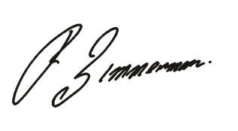
Russell Zimmerman
Executive Director
Australian Retailers Association

Heath Michael
Director of Policy, Government & Corporate Relations
Australian Retailers Association

Customs Blueprint for Reform, 2013-2018, p 37
GST Regulations, Subdivision 168-1
Australian Government, National Innovation and Science Agenda, Released by Prime Minister Malcom Turnbull on 09 December 2015.
Royal Malaysian Customs Department, GST Guidelines on TRS, http://gst.customs.gov.my/en/cp/Pages/cp_trst.aspx , accessed on 09 December 2015

