ABOUT AAMRI

SUBMISSION
2017-18 Pre-budget submission
January 2017

Contact:
Professor Tony Cunningham AO
President
Association of Australian
Medical Research Institutes
ABN 12 144 783 728

PO Box 2097
Royal Melbourne Hospital VIC 3050
president@aamri.org.au
www.aamri.org.au

The Association of Australian Medical Research Institutes (AAMRI) is the peak body representing medical research institutes (MRIs) across Australia. Our 47 member institutes are leaders in health and medical research, working on an extensive range of human health issues, from preventative health and chronic disease, to mental health, Indigenous health and improved health services. Collectively AAMRI’s members employ over 15,000 staff and students and have an annual turnover of more than $1.3 billion. MRIs are engaged at all stages of the research commercialisation pipeline. In 2014-2015 MRIs recorded 150 invention disclosures, were awarded 207 new patents, were active in 1,220 clinical trials, undertook nearly 1,200 contracts, consultancies and collaborations, and generated nearly $90 million in commercial income from research IP.

Pre-budget submission

Summary of recommendations
- Ensure the Medical Research Future Fund (MRFF) reaches $20 billion in capital by 2020-21, and ensure the remaining $124 million of the forecast 2016-17 investment is made this financial year.
- Start the process of disbursements from the fund this financial year, and that future disbursements from the fund be in line with the forecasts in the 2016-17 budget.
- Increased support for the National Health and Medical Research Council (NHMRC) Practitioner Fellowship scheme, with support coming from disbursements from the MRFF.
- Provide increased funding for NHMRC medical research at levels above CPI.
- Restore Independent Research Institute Infrastructure Support Scheme (IRIISS) funding to 20 cents for every dollar of NHMRC research funding, and then build support for IRIISS up to 30 cents for every dollar of NHMRC research funding by 2019-20. The additional investment required to reach the goal of 30c per NHMRC funding dollar would be $34 million over the next three years.
- Provide the full research support costs incurred in undertaking MRFF research projects. This should include providing additional IRIISS funding for independent medical research institutes, and additional funding through the university research block grants for universities and their affiliated medical research institutes undertaking MRFF research projects.
- Fund the research infrastructure requirements recommended by the forthcoming National Research Infrastructure Roadmap.

Delivering Minister Hunt’s vision for the Australian healthcare system
The Minister for Health, the Hon Greg Hunt MP, has stated his vision is for Australia to have the best healthcare system. His vision involves working with medical researchers to find new cures and to get best value for money from the health system.
Delivering the Minister’s vision will require building the Medical Research Future Fund up to $20 billion in capital funding, strong and sustained investment in the National Health and Medical Research Council, investment in major national research infrastructure, and ensuring the right research support funding frameworks are in place to allow the sector to support high quality research.

Medical Research Future Fund
Since it was first announced by the Government, AAMRI has been a strong supporter of the Medical Research Future Fund (MRFF). It was central to the formation of the MRFF Action Group that has worked to galvanise community support for the initiative. AAMRI believes that the MRFF is essential to improve health outcomes for Australia, as well as for the future prosperity of the nation.
The MRFF will deliver returns through the form of health savings by delivering more effective healthcare and a healthier community, a reduction in the burden of premature mortality and morbidity on productivity, commercial returns from medical innovations, and other productivity gains resulting from improved health outcomes. Investment in health and medical research has an average return of $3.40 for every dollar expended. Polling shows widespread community support for the MRFF, with more than 87% in favour of the development of the MRFF. This makes the MRFF both prudent and a popular investment by the Government, and it should be seen as a high priority.
The Government has committed to investing $20 billion by 2020-21 to capitalise the MRFF, and has already invested $4.4 billion into the fund. Under the MRFF legislation this capital will be preserved, with only the investment returns from the $20 billion used for funding new medical research and innovation projects.
AAMRI congratulates the Government on its investment of $4.4 billion into the fund so far, and is delighted to see that it is on track to meet its committed $20 billion capitalisation target. Of the $1.401 billion the Government committed to investing into the fund in 2016-17, a total of $1.277 billion has been invested so far.
As required under the Medical Research Future Fund Act, funding priorities and a strategy have now been developed to guide MRFF investment in medical research. The release of these documents by the Prime Minister opens the way for the Government to meet its 2016-17 budget commitment, and to make the first investment in medical research and innovation from the fund this financial year. The priorities provide a sound basis to begin the process of investing in new health and medical research through the MRFF.
AAMRI urges the Government to ensure the MRFF reaches $20 billion in capital by 2020-21, and to ensure the remaining $124 million of the forecast 2016-17 investment is made this financial year.
AAMRI recommends that the government start the process of disbursements from the fund this financial year, and that future disbursements from the fund be in line with the forecasts in the 2016-17 budget. Disbursements from the fund should be invested in the health and medical research priorities identified in the recently released Australian Medical Research and Innovation Priorities 2016-18.

Clinical researcher fellowships
One of the most effective ways to deliver on the Minister’s vision for the best healthcare system in the world through the use of research is to expand the number of clinical researcher fellowships. Australia needs to do much better at embedding research within the healthcare system itself. The NHMRC Practitioner Fellowship Scheme increases engagement of research-focused clinicians in problem-solving and the translation into clinical practice.
Increasing support for clinical researcher fellowships was a priority identified in the Australian Medical Research and Innovation Priorities 2016-18, and could be supported through disbursements from the Medical Research Future Fund.
AAMRI recommends increased support for the NHMRC Practitioner Fellowship scheme, with support coming from disbursements from the Medical Research Future Fund.

National Health and Medical Research Council funded research
The 2016-17 Budget projected increases for NHMRC funding of about 1.5% per annum. As CPI forecasts by Treasury are around 2.25 to 2.5% over the next three years, this will mean that funding through the NHMRC Medical Research Endowment Account is set to decline in real terms over the forward estimate period. The costs incurred in undertaking world-class, high quality research are increasing beyond CPI levels, with the equipment and infrastructure required becoming more complex and requiring greater investment.
Already the success rates for research funded through the NHMRC are at, or close to, historic lows at around 15%. This means that much outstanding research with real potential is going unfunded. Continued support for the NHMRC needs to be increased to levels beyond CPI to ensure appropriate investment in the full research pipeline, from discovery research right the way through to clinical trials and commercialisation activities. Strong support through the NHMRC for investigator-led and discovery research is needed to ensure a healthy research pipeline, and to ensure the full potential of MRFF investment in later stage commercialisation and translation research activities can be achieved.
AAMRI recommends that the 2017-18 Budget provide increased funding for NHMRC funded medical research at levels above CPI.

Supporting the research support costs incurred in undertaking NHMRC research projects
NHMRC research grants cover the direct costs associated with medical research projects, but do not cover research support costs. These costs include commercialisation services, IT, legal expenses, HR, building running costs. These costs amount to 60 cents for every $1 of NHMRC research expenditure.
The NHMRC provides some support through the Independent Research Institute Infrastructure Support Scheme (IRIISS) to help eligible institutes meet these costs. The support provided through this scheme should, according to the program guidelines, be provided at 20 cents for every $1 of NHMRC competitive research grants awarded. The gap between the support provided through this program and the costs incurred is substantial, and is becoming harder to meet each year as the NHMRC has scaled back its support through IRIISS.
Support through IRIISS has declined from $35.4 million in 2012 to just $29.5 million in 2016. IRIISS now pays just 18 cents per dollar of NHMRC competitive funding received, 2 cents per dollar less than is current policy.
Year | Amount
2012 | $35,364,535
2013 | $34,745,659
2014 | $32,715,778
2015 | $30,525,924
2016 | $29,450,665
Table 1: Expenditure on research support costs in MRIs through the NHMRC Independent Research Institute Infrastructure Support Scheme.
While support is offered by some state governments, medical research institutes (MRIs) currently have a funding shortfall for their total research support costs of 29 cents for every $1 spent on research. Even when the IRIISS contribution to research support funding was at 20 cents per dollar of NHMRC research funding, MRIs were having to scale back their support for important and vital new equipment and facilities, as well as their investment in areas that can deliver longer-term financial savings such as new IT systems, payroll systems, and procurement systems. Commercialisation and translation activities that have the potential to return long-term financial and healthcare benefits are also hampered due to a lack of resources and support funding.
Endowments and philanthropic donations are being drawn upon to meet these costs, but it is increasingly difficult to ask donors to direct their funding to such activities when they want to donate to specific medical research projects.
AAMRI recommends that provision is made within the Budget to immediately restore IRIISS funding to 20 cents for every dollar of NHMRC research funding, and then build support for IRIISS up to 30 cents for every dollar of NHMRC research funding by 2019-20. The additional investment required to reach the goal of 30c per NHMRC funding dollar would be $34 million over the next three years.

Year | Rate | Total cost (in 2016) | Estimated additional annual investment in IRIISS required
2016-17 | 18 | $29,450,665 | -
2017-18 | 20 | $32,722,961 | $3,272,296
2018-19 | 25 | $40,903,702 | $11,453,036
2019-20 | 30 | $49,084,442 | $19,633,777
 |  |  | TOTAL | $34,359,109
Table 2: Estimated additional annual investment in NHMRC IRIISS required to support NHMRC research funding at a rate of 30 cents per NHMRC research dollar by 2019-20.

Meeting the research support costs incurred in undertaking MRFF research projects
The recently released Australian Medical Research and Innovation Strategy makes clear that it would be preferable to use existing mechanisms such as NHMRC’s IRIISS and the university research block grants to support the research support costs incurred in undertaking MRFF funded research.
At present, it is unclear how the infrastructure support costs incurred as a result of MRFF funding will be met. A mechanism is sorely needed otherwise both medical research institutes, universities and hospitals will be hampered from undertaking MRFF-funded research.
AAMRI recommends provision is made within the Budget to provide full research support costs incurred in undertaking MRFF research projects. This should include providing additional IRIISS funding for independent medical research institutes, and additional funding through the university research block grants for universities and their affiliated medical research institutes undertaking MRFF research projects.

National research infrastructure
Undertaking outstanding health and medical research and innovation requires access to high quality national landmark research infrastructure. Such infrastructure not only allows our researchers to undertake complex and innovative research, it helps Australia attract and retain the best and brightest researchers from around the world.
The first round of the National Innovation and Science Agenda provided the welcome announcement for ongoing operational funding for the nation’s existing national landmark research infrastructure facilities. However, in the coming weeks the final National Research Infrastructure Roadmap will be released highlighting the new research infrastructure needs for the nation. As per the earlier draft released in December, it is likely to recommend the development of a Roadmap Investment Plan.
AAMRI recommends provision is made within the 2017-18 Budget to fund the research infrastructure requirements recommended by the forthcoming National Research Infrastructure Roadmap.

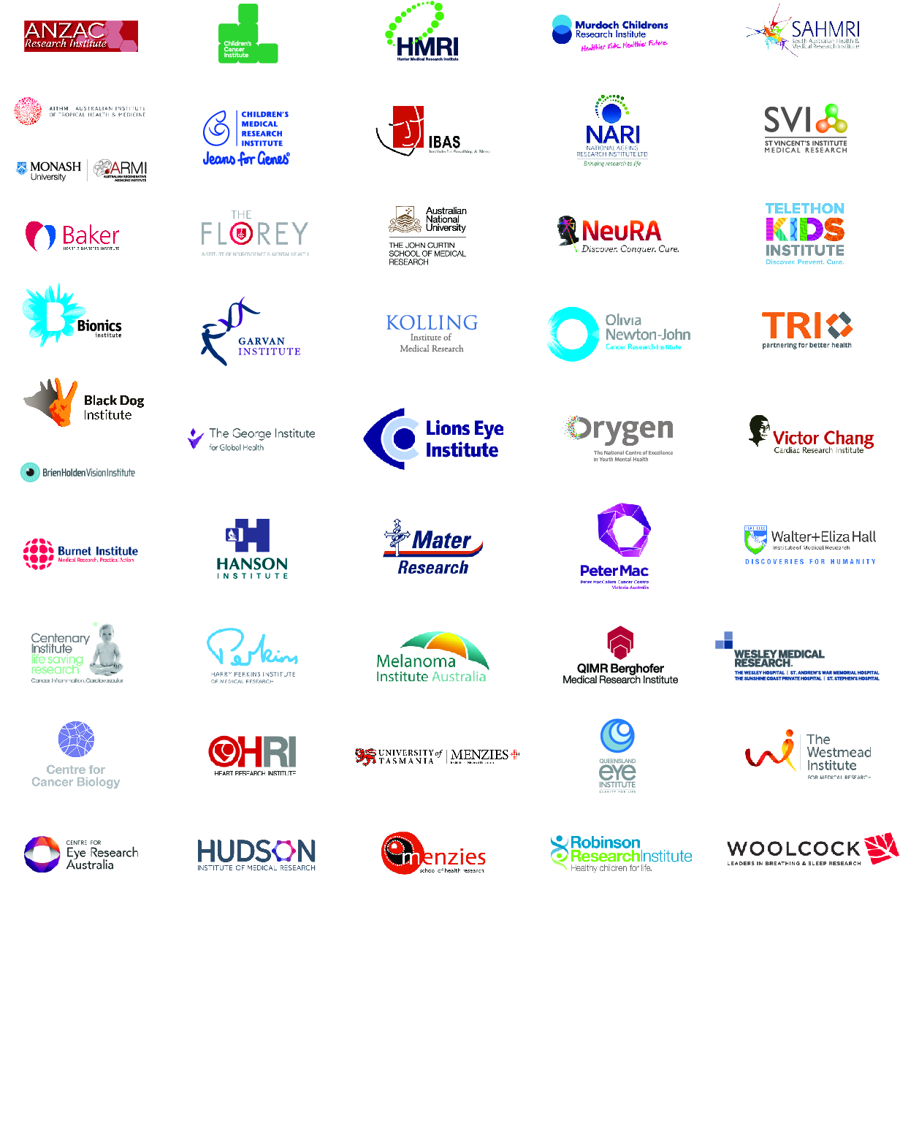
AAMRI MEMBERS

The Hon Greg Hunt MP (2017) Transcript – Frankston Hospital Doorstop. Available at: http://www.greghunt.com.au/Home/LatestNews/tabid/133/ID/4130/Transcript--Frankston-Hospital-doorstop.aspx
Deloitte Access Economics (2014) Extrapolated returns from investment in medical research future fund (MRFF), prepared for the Australian Society of Medical Research, Sydney. Available at: http://www.asmr.org.au/ASMR%20Deloittee%20Report_MRFF.pdf
Research Australia (2016) Australia Speaks! Research Australia Opinion Polling 2016. Available at: http://researchaustralia.org/reports/public-opinion-polling/
Australian Government (2016) Medical Research Future Fund: Australian Medical Research and Innovation Priorities. Available at: http://health.gov.au/internet/main/publishing.nsf/Content/mrff/$FILE/Australian%20Medical%20Research%20and%20Innovation%20Priorities%202016.pdf
The Treasury (2016) The Pre-election Economic and Fiscal Outlook 2016, Table 2
LEK (2010) Costing Medical Research to Reform Health Outcomes. The case for increased indirect cost funding for Australian accredited MRIs. Available at: http://aamri.org.au/wp-content/uploads/2014/05/LEK_Report_Australian_MRI_indirect_cost_funding_JAN2010.pdf
NHMRC (2010) Independent Research Institutes Infrastructure Support Scheme (IRIISS) Funding Policy. Available at: https://www.nhmrc.gov.au/_files_nhmrc/file/grants/iriis_2010_jun2011.pdf
Source: NHMRC (2016) Outcomes of funding rounds. Available at: https://www.nhmrc.gov.au/grants-funding/outcomes-funding-rounds
Australian Government (2016) Medical Research Future Fund: Australian Medical Research and Innovation Strategy 2016-2021. Available at: http://health.gov.au/internet/main/publishing.nsf/Content/mrff/$FILE/Australian%20Medical%20Research%20and%20Innovation%20Strategy%202016.pdf

