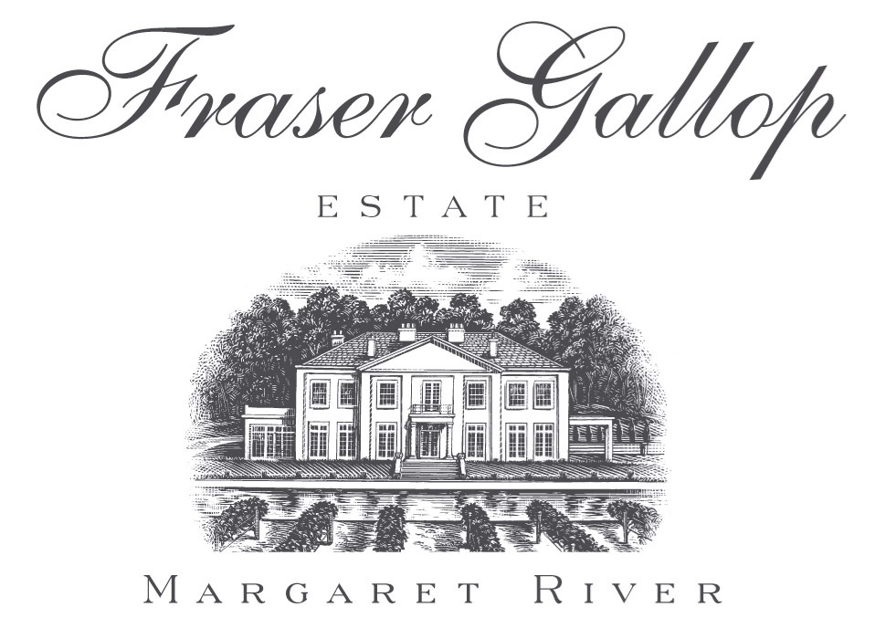Re: Wine Equalisation Tax Rebate – Implementation Paper September 2016

It was my honour and privilege to be a member of The WET Rebate Consultative Group convened in Canberra by the then Assistant Treasurer The Hon. Josh Frydenberg in September 2015. The group was – I thought – representative, intelligent and highly motivated to achieve a proper and fair result for the Wine Industry. At the same time there was a clear understanding of Government’s need to maximize revenue from the sector .

This group subsequently , after a number of meetings, made recommendations to Treasury to address the problems in The WET Rebate. It appears that these recommendations were ignored without further consultation with the Group.

To this day there has been no explanation.

The implementation paper issued by the Government in September mentions the recommendations but gives them no credence. Instead it relies upon unsubstantiated claims that a Rebate Cap reduction will result in less motivation for undeserved claims. There is no evidence to support this view.

There is , however, plenty of evidence to support the view that the cap reduction will be devastating for the local economy of regions like The Margaret River Wine Region. Hundreds of job losses will result . This negative effect will be felt through the entire community – including the tourism industry.

If the Government is truly committed to “putting the wine industry in a stronger long-term position” then the following should be implemented.

* Eligibility rules should be tightened, in a way easily enforceable by the ATO, so that the rebate may only be claimed by those producers for whom it was originally intended.
* These rules should be introduced on July 1 , 2017.
* The WET Rebate cap should be left unchanged at $500,000.
* The cap should be reviewed on July 1, 2019 to give time for the revenue increase achieved by tighter eligibility to be measured.
* The $50 million to AGWA should be scrapped and the funds redirected to Export Development Grants. This to be dependent upon achieving revenue targets by July 1, 2019.

Sincerely,

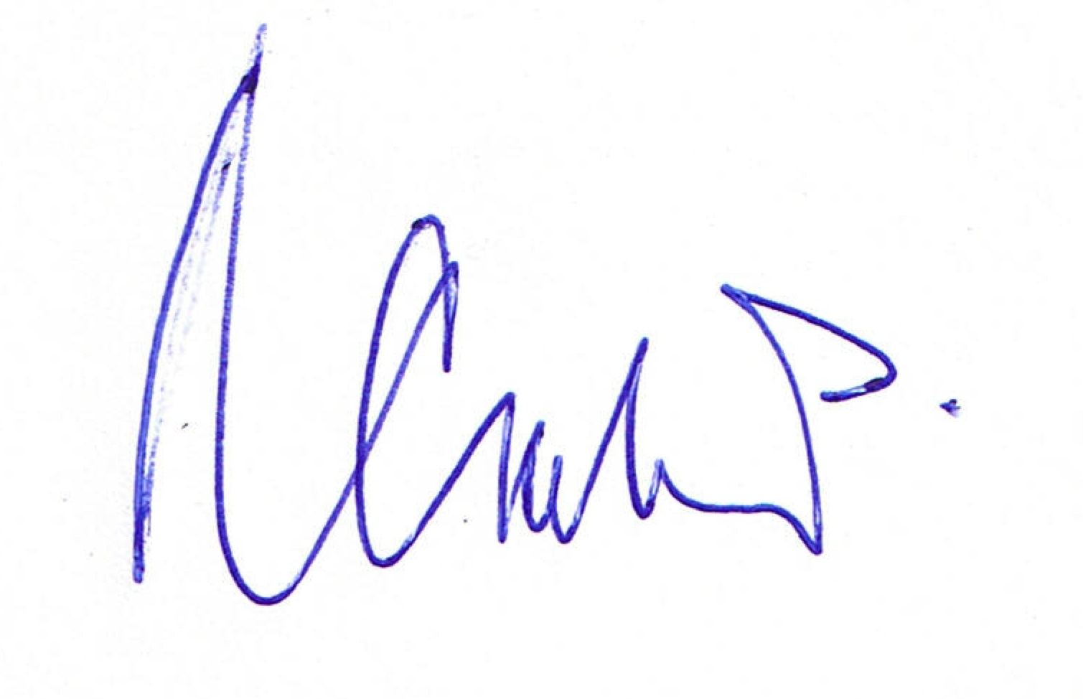

Nigel Gallop

Proprietor

[nigel@fgewines.com.au](mailto:nigel@fgewines.com.au) 0407 088 438