

12th February 2016
Attention: The Treasurer

Scott Rogers
Manager
Communications
The Treasury
Langton Crescent
PARKES ACT 2600

Dear Scott,

OPTIONS TO STRENGTHEN THE MISUSE OF MARKET POWER LAW
February 2016 response

SAIR represents 115 South Australian families that own between them 236 supermarkets trading under the brands of Foodland, IGA and Friendly Grocer that employ 15,000 people across the State, representing 13% of the total South Australian Retail workforce.

This group of independent owners have over many years thrived on competition in the market place and collectively over this long period of time have been able to achieve the largest portion of the market share in our State. The group is continuously looking for new market opportunities.

The Independents success has been the result of their understanding of the need, to be competitive, by creating excellent personal service, by the continuous high profile promotion of local South Australian manufactured goods and fresh foods, and their strong support of many major national brands.

Collectively we understand and accept the successes and failures of a strong competitive marketplace and the obvious benefits to consumers. There are however downsides in this competitive marketplace when those with excessive market power abuse this power and effect the competitive nature of the market causing significant consequent loss to the consumer.

In our industry, there has been many various forms of misuse of market power ranging from local specific abuse of power between a small operator and a major player through to the industry wide abuse of power. This occurred in the case of the fuel docket program created by Coles and Woolworths that had a catastrophic effect on numerous groups of small business operators and consequently reduced competition for consumers.
It took the ACCC almost four years for this abuse to be controlled.

Competition Law was introduced to deal with this abuse of market power but the law has been found to be lacking as the market power of the major supermarket chains increased in our particular industry over the last 10 years. Plus it is taking way too long for these cases of abuse to be resolved.

Recognising many competition difficulties the Government setup the Harper enquiry.

One of the major issues identified in this competition law review was misuse of market provisions in Section 46 of the Act.

“The Harper Review considered that Section 46 is deficient in its current form and was of the view that the current misuse of market provisions is not reliably enforceable and permits conduct that undermines the competitive process”.

Harper in his final report made a strong recommendation on the “Misuse of Market Power” (recommendation 30) to correct this situation.

As a group we strongly support the Harper recommendation. Consequently, our preference of the options floated by the Treasurer is OPTION ‘F’.

We have chosen this option because we believe the remaining options are watered down options, being put for consideration because of the undue pressure from a very small number of large politically influential companies some of which in the supermarket arena are regularly before the ACCC to explain their behaviour on misuse of their market power.

It seems incredible that these major companies are complaining about the inclusion of the “effects test” when this test is the same test that is currently found in Section 45 (Contracts, arrangements or understandings that restrict dealings or affect competition), Section 47 (Exclusive dealings) and Section 50 (Mergers) of the same Competition & Consumer Act 2010. It is well known that the companies squealing the loudest about the addition of the “effects test to section 46” have long been working with these sections as noted above with little concern.

While all this noise is coming from a few big companies on the dire consequences of introducing an “effects test” into Section 46 to improve competition in Australia, the Harper report publicly records that the US, EU and Canada already have provisions that adopt an ‘effects test’ or go further than that.

The other two significant strong supporters of the recommendations of the Harper review to Section 46 is the regulator for competition, the ACCC, and the major consumer advocate in Australia, CHOICE.

The independent supermarkets in South Australia are part of 800,000 small businesses in Australia trading today that employ in excess of 5 million Australians in their businesses.

We collectively support The Harper report and acknowledge the strong support of the ACCC and CHOICE.

We have already made two (2) submissions to this Review which are attached and contain several examples of our concerns re abuse of market power.

Additionally, in adopting the full set of changes recommended by the Final Harper Report the government needs to recognise that small business requires access to a court or tribunal system at minimal cost in cases of misuse of market power.

The main reason that small businesses do not proceed with the many cases of abuse that occur is because of the significant costs to be a witness in the full court arena.

To sum up we:
- Support Option ‘F’ of the Options to strengthen the misuse of market power law Discussion Paper December 2015
- Recommend that a tribunal be established to hear cases that small business can easily access, at minimal cost and with a rapid resolution process

We look forward to your final considerations in this matter.

Yours sincerely,

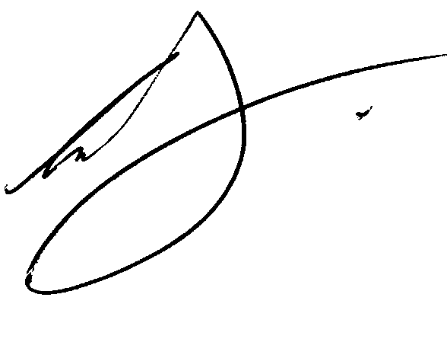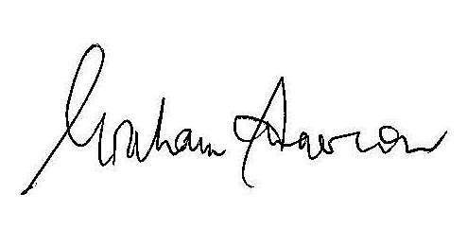

Colin Shearing Hon Graham Ingerson
Executive Spokesperson Government Relations Adviser

Encs. 2

