LET’S COMPETE: CHANGE THE LAW
SEND THE GOVERNMENT A MESSAGE TODAY -SUPPORT THE CAMPAIGN!

“There has never been a more exciting time to be a retailer”

QNN IGA State Retail Board
A presentation on behalf of the IGA retail network, Queensland
February 2016

TABLE OF CONTENTS

There has never been a more exciting time to be a retailer………………………………2

Introduction…………………………………………………………………………………………2
Innovation…………………………………………………………………………………………..3
Diversity……………………………………………………………………………………………...6
Entrepreneurship…………………………………………………………………………………..7
Market balance meets consumer expectations……………………………………………8
Getting the policy settings right………………………………………………..………………9
Let's compete: change the law………………………………………………………………..9

THERE HAS NEVER BEEN A MORE EXCITING TIME TO BE A RETAILER
In the words of the Hon. Prime Minister Malcolm Turnbull ‘there has never been a better time to be an Australian’ inspires our network to respond, there has never been a more exciting time to be a retailer.
The IGA retail network appreciates the work undertaken by the Australian Government since the independent Competition Policy Review was commissioned on 24 March 2014. We acknowledge the recommendations made by the Harper Panel in the Final Report on 31 March 2015, in particular the amendments to section 46 proposed by the Harper Panel. We note the subsequent Australian Government response to the recommendations, released on 24 November 2015.
This paper serves to respond to the Discussion Paper dated December 2015 issued by the Australian Government, “Options to strengthen the misuse of market power law”. We note the purpose of the Discussion Paper and are pleased for the opportunity to contribute to the debate on the misuse of market power provision of the Competition and Consumer Act 2010 (CCA).
This submission will explain how the independent supermarket sector propels innovation, diversity and entrepreneurship, substantiated with real life examples to qualify our compelling argument.
The paper will reveal key principles of industry interactions to highlight how our network correlates to fulfil consumer demand and explain why it is critical to achieve competition legislation policy fit for purpose. It will outline beneficial impacts to the economy achieved through reciprocal trade activity and collaboration and how these elements are pivotal to the competitive process.
INTRODUCTION
IGA supermarkets in various formats and footprints serve hundreds of Queensland communities as part of a 1400 store strong national network offering consumers a genuine shopping alternative. IGA retailers represent a portion of the millions of small and independent businesses employing almost 5 million people, contributing to the largest share of total employment in Australia. A further 2.6 million people are employed by medium sized businesses (source: http://www.aph.gov.au).

We are a large voting population, a demographic of hard working Australians, living and contributing to enjoy a life of choice and prosperity. We heartily participate and form a vital hub to our local communities. We are proud and passionate Australians.
The Australian Governments Discussion Paper revealed that competition is a process of rivalry between businesses seeking to out-do each other for their individual commercial gain. It stated that this process drives businesses to increase sales and service offerings by bringing new products to market, find new ways to deliver lower prices and meet customer expectations to increase market share and return on capital invested.
We agree with this analysis of competition and seek to emphasise in this paper, critical elements which contribute to the competitive process.
INNOVATION
To quote, innovation “generally refers to changing or creating more effective processes, products and ideas, and can increase the likelihood of a business succeeding. Businesses that innovate create more efficient work processes and have better productivity and performance.
For businesses, this could mean implementing new ideas, creating dynamic products or improving your existing services. Innovation can be a catalyst for the growth and success of your business, and help you adapt and grow in the marketplace.

Being innovative does not mean inventing; innovation can mean changing your business model and adapting to changes in your environment to deliver better products or services. Successful innovation should be an in-built part of your business strategy, where you create a culture of innovation and lead the way in innovative thinking and creative problem solving” (Source: www.business.gov.au).

Based on the English language proverb ‘necessity is the mother of invention’ and in the context of achieving innovation, a nimble and agile business model has the ability to execute quickly and efficiently. This is the model of the independently owned supermarket.
Consumers dictate a changing environment, embracing trends, to which responses achieve market relevance. Small and independent operations are modelled to respond agilely and quickly to evolving consumer demands and well equipped to foster innovative initiatives and emerging opportunities.

Vital interdependent relationships activate sustainable platforms for new market entrants which is pivotal in the competitive process.

Advanced Refrigeration Technology (www.artmaslen.com.au) founder, John Maslen, manufacturer of innovative commercial refrigeration equipment, collaborated with local IGA retailers to provide a fine example of creating vital interdependent synergies.

A brand new 1800m2 IGA supermarket required a large scale refrigeration solution and a mutually viable deal was negotiated between the two locally based business owners. A cutting edge, state of the art refrigeration prototype with innovative technology to deliver major reductions in energy consumption was designed and manufactured. Refrigerant gas loss risks were significantly reduced through the smart design. The prototype delivers positive environmental outcomes.

The implementation of the large scale, closed door refrigeration model was considered a bold move in the industry due to its extent across fresh areas, but it promised to improve the quality freshness of goods. Consumer feedback confirms a heightened sense of quality and hygiene to the fresh goods on offer.

Since installation, the functioning prototype has generated keen interest from the industry around Australia and overseas. The display provides an example of the innovative model and subsequently new orders have enabled an expanded manufacturing team. The local company now has interest from China.

John W Maslen makes the following contribution to this submission:
“Advanced Refrigeration Technology Pty Limited (ART) is a privately owned company carrying out research and development of commercial refrigeration equipment. It then licenses to its licensees or manufacturers and markets and installs equipment, using its own staff and subcontractors.
ART employs 24 full time staff with a further 22 full timers employed by our licensees based in Queensland and Western Australia.
We are a small, niche, manufacturer providing energy efficient products designed to be environmentally responsible while providing an excellent platform for our clients to present their perishable products in the best possible condition.
We have seen particularly good growth in the JCM Refrigerated Display Case range of products since being given the opportunity to supply them to White’s IGA store at Bli Bli on the Sunshine Coast, QLD with this range of products accounting for approximately 40% of our turnover last year.
Although we have had this product available since 2009 the uptake was slow with little interest from major players in the supermarket Industry. We were considered too small to be a viable supplier, regardless of our superior technology and therein lay’s the catch 22.
To compete with the foreign owned and largely imported products used by the major players, requires an enormous investment. Once having made this investment you have only 2 customers within Australia capable of supporting this level of production. A position they are well aware of as they control approximately 80% of our available market.
History shows they have been willing to exploit this position to the detriment of many who tried to satisfy their needs. We believe that if this situation continues there is little scope for our company to expand within Australia with the exception of the market provided by independent grocers who are prepared to support us and our innovative technologies.
Those independents that have supported our products have been rewarded with high sales and low operating costs with a product that also has longevity while providing manufacturing jobs in Australia.
In the 35years that ART’s managing director, John W Maslen has been in business, he has seen the number of SME’s (small and medium enterprise) that consume his products, fall dramatically as the giants swallow them up or force them out of business, thus reducing ART’s potential customer base. Without a strong independent retail industry, ART sees little opportunity for further growth in Australia.
Because of this situation ART has opened a new factory in China in the hope of growing overseas where a much higher level of competition exists in the retail sector. The possibility of exports into other countries is also possible. While this in itself will bring profits back to Australia, it does not create jobs for Australians.
ART feels forced to go this way even though we have such a small piece of the Australian market but also, to pursue this growth with the big players in Australia is deemed commercial suicide”.
The above example of innovation and entrepreneurship is the result of collaboration between a small agile business and a local manufacturer with a great idea. Small businesses embrace innovation and entrepreneurship more than large businesses. This spirit creates economic and growth which is what competition policy seeks.

The IGA model made the above innovation possible. Large format chain retailers would not have entertained engaging a small scale refrigerant company and the innovation would not have occurred.

DIVERSITY
Consumers embrace choice. Consumer feedback harvested at the ‘coal face’ by IGA retailers confirms this. Responding and delighting customers is the essence of ‘retail 101’. Customers reciprocate by shopping with us as we aim to fulfil their shopping expectations.
Price is important to customers but so is great customer service, a diverse range of quality fresh goods, and a pleasant shopping environment. Consumers recognise IGA’s diverse range of goods fulfilling their desire for choice. Consumers love the story behind the product. Handmade, hand crafted, artisan style items are a sought after commodity; items such as cheese, breads, condiments, cooking sauces and flavoursome enhancements to make simple entertainment fun and inspirational.
IGA stores source up to 35% of their purchased goods from other independent, local and artisan suppliers supporting a myriad of markets and sectors and generating enormous economic benefits. Our customers live locally and we employ their children.
IGA retailers do business locally engaging services such as the local accountant, insurance broker, local law firm or cleaning contractor, freighter and primary producer. Reciprocal trade activities drive economic benefits in smaller communities. Living and giving locally is the heart and soul of a community. IGA retailers love supporting local people.
IGA provides a platform which delivers diversity and choice to a market, making a contribution to the competitive process. Mutually viable commercial interaction creates diversity. In contrast, dominant chains devalue commodities and reduce choice. Cheap milk is paid for by prices on other lines. The erosion of the dairy industry after the introduction of cheap milk has had an adverse impact on the economy due to the reduction of participants in the sector.
The IGA model plays a pivotal role in the competitive process because small and medium players provide a robust trading environment by driving equitable prices in the chain of trade through direct interaction with other small and medium enterprise.

ENTREPRENEURSHIP
Entrepreneurs bring diversity and innovation offering new services, products or solutions. Leaders and innovators create concepts and improve efficiencies which require support programs to exist and build.
Start-ups usually enter a market with moderate capacity until they have some success and increase their volumes. While the chains offer a lucrative channel to facilitate robust growth, new entrants and emerging suppliers are nearly always too small to start with a chain retailer.
The IGA model supports start-up level companies and provides an ideal avenue to facilitate new market growth.
Here are some real life examples:
Example 1) 2.5 years ago, boutique cheese maker, Graeme Paynter, founder of Woombye Cheese (www.woombyecheese.com) commenced a start-up company and created a superb range of fresh cheese lines. With moderate operational capacity, the entrepreneur sought a suitable outlet to introduce his product to market. Engaging with a local IGA operator, a mutually agreeable contract was negotiated. Consumer demand increased, the entrepreneur increased capacity and expanded his market to supply outlets across Australia.
Example 2) Zehnder Gluten Free (gfbakehouse.com.au) also obtained its start up support from a local IGA store and now stocks large and small supermarkets and retail outlets right across Australia. Josef Zehnder was approached by his local IGA owner and asked if he would create a range of gluten free lines to sell in his store. Josef began supplying the IGA store with a wholesale range of goods and as consumer demand grew so did his operational capacity. Within 6 years, the Zehnder Gluten Free brand expanded into other IGA stores, into large chain store outlets such as Woolworths across Australia and it now exports to Asia, New Zealand, Europe and Norfolk Island.

This provides another fine example of the effective interdependent relationships being initiated through entrepreneurial relationships and building into successful business models.

The IGA model provides vital support to entrepreneurial enterprise by facilitating new growth to achieve economic prosperity. This is a significant contribution to creating healthy competition which impacts on the competitive process.

MARKET BALANCE MEETS CONSUMERS EXPECTATIONS
The entry of a discounter to the Australian grocery sector has heightened consumer awareness to price. Major supermarket chains and independent supermarket operations recognise a consumer’s desire for value. The interpretation of value to the consumer comes in various forms and it is not always based solely on price. Value to a consumer may mean convenient access, quality assurance of fresh goods or excellent customer service.
Various market players become market leaders based on their offer such as the low cost model offering cheap prices or the market differentiators offering diversity. Consumer behaviour influences the competitive process because consumers vote with their feet so to speak. In other words, they choose where they shop according to what value they seek.
The U.K. grocery market displays growth (Figure 1) in discounter and premium sectors which clearly indicate both price and choice are important across the market. Interestingly, they operate with laws and procedures whereby the competition regulator has power to make orders and impose fines for breaches of competition laws (source: www.kwm.com) but it is achieving the required balance to meet these consumers’ expectations.
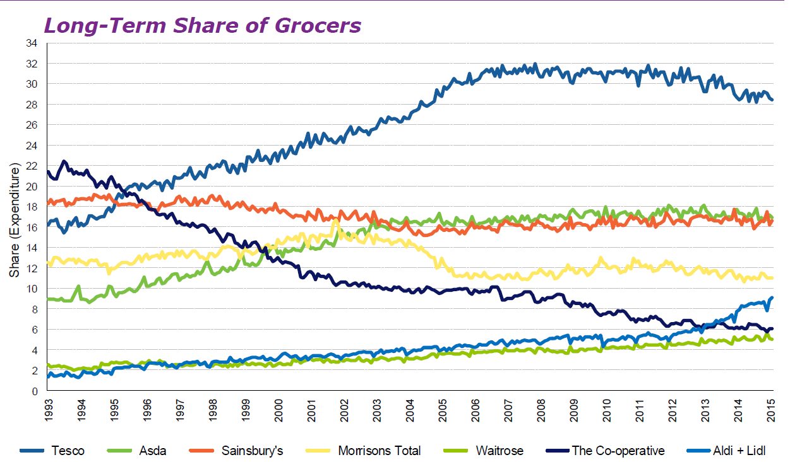Figure 2 (source:!him U.K)

GETTING THE COMPETITION POLICY SETTINGS RIGHT
As addressed in the Australian Governments Discussion paper December 2015, the Harper Panel considered that section 46 is deficient in its current form, asserting the view that the current misuse of market power provision is not reliably enforceable and permits conduct that undermines the competitive process.
The level of dominance of the major chains in the grocery sector is stifling competition both among suppliers to supermarkets and for consumers. The growth of home brands in chain stores over the last 5 years is dramatic proof of this problem.
A competition policy structure not fit for purpose and not supportive of all industry players will deliver poor outcomes for consumers in the long run. The impact on innovation is greater and harder to identify. It’s difficult to know what you are missing out on, if you haven’t seen it yet.
We value the vital work being undertaken to ensure competition policy settings are fit for purpose, allowing continued growth, diversity and innovation for future generations.

LET’S COMPETE: CHANGE THE LAW
As responsible custodians of this great country we have a responsibility to build a solid platform for a prosperous future. We each have a role to play shared with decision makers and the government of the day. IGA retailers are eager to contribute but it is vital for our communities that we compete. Trading partners, suppliers, service providers, community groups, local, state and national charities, our staff and our consumer’s demand that we do.
There has never been a more exciting time to contribute to our market and industry, to seek to fulfil the needs of the consumer. We take pride in supporting our community. We love creating new jobs. We value the reciprocal support of our trading partners. We are eager to support new and emerging business in the spirit of entrepreneurship. We will continue to deliver diversity to the consumer and innovation to the market by collaborating to generate synergies and great outcomes.
We are differentiators, we are innovators, we are agile and nimble, we are responsive and we are vital. To continue to exist we require government support to this end.

