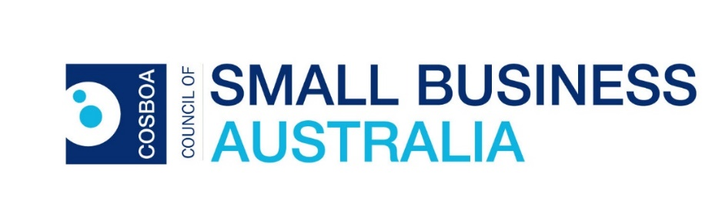
Secretariat: PO Box 576
Crows Nest NSW 1585
(02) 9431 8646
CEO: 0433 644 097
Our CEO is based in Canberra
Email: ceo@cosboa.org.au
www.cosboa.org.au

Response to: Options to strengthen the misuse of market power law

February 2015

This response should be read in conjunction with other responses particularly from the Australian Newsagents Federation, the Master Grocers Association, John Dahlsen, the WA Independent Grocery Association; the Retail Guild of Australia, among others representatives of small business people.

This submission focuses on the process we have gone through to get to this point. We will stress that there is an obvious need for major change in Section 46 when a few (three) big businesses can circumvent a transparent and independent process that resulted in the recommendations of the Harper report upon which this extra process is based.

We note the discussion paper developed for this extra process. We note that many of our members have chosen Option F as the preferred option.

We believe that the proposals from the Harper Report do not actually go far enough to achieve real competition. We know that we need to remove the words ‘take advantage’ from section 46. We also know that proving “Substantial lessening of Competition’ (SLC) in a market is basically impossible for a small business to achieve. The way to overcome this problem is to better define a market place or better still remove SLC as well as ‘take advantage’ from Section 46.

Failing that we support the findings of the original independent review.

The fact that basically only three businesses - Wesfarmers, Woolworths and Telstra; have objected to the Harper findings and made threats to the then government and well as sending hidden letters and reports shows the results of a failed competition policy. These businesses have been allowed to grow so big that they believe that they are not answerable to due diligence or proper process. This hubris and their belief that they are above transparency should be enough of a warning to cause section 46 to be changed.

For the sake of competition in industry sectors involved in human services and other emerging and important services we need to ensure that ethically challenged oligopolies cannot be created by regulations that do not give the regulator the capacity to do their job.

Please refer to previous submissions to the Harper Review for further information.

Ends

