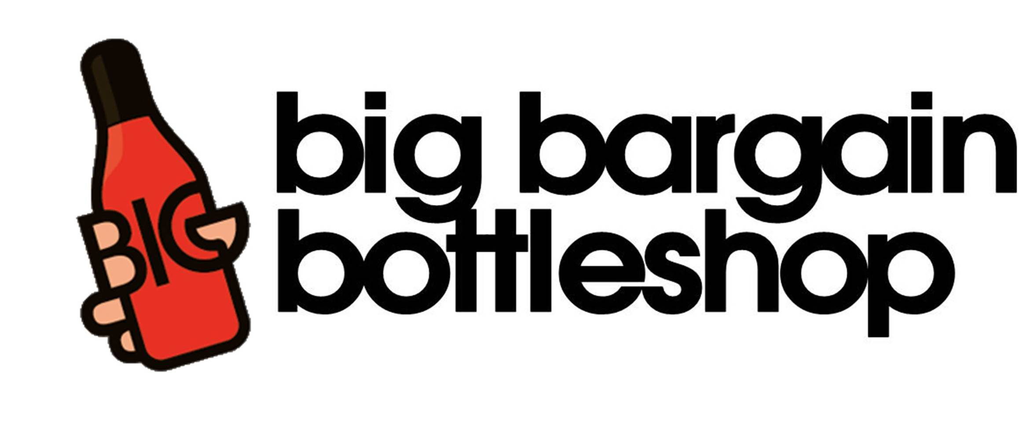
DONOJ Pty Ltd T/A BIG BARGAIN BOTTLESHOPS
ABN 35 109 512 290
6-10 STEELE STREET
PO BOX 345
DEVONPORT TAS 7310
PH: 03-6424 0640 F: 03-6423 5858
E: bigbargain@goodstone.com.au

Submission to Discussion Paper
Options to strengthen the misuse of market power law

I am the Group Co-ordinator for the Big Bargain Liquor Group. Big Bargain are the largest liquor banner group (by number of outlets) in Tasmania with 51 stores. I have been in the liquor store business for 24 years. I am also a wine and cider producer.

I am writing this submission because I have concerns that the Tasmania liquor store sector is failing consumers because competition laws are failing to stop domination.

Tasmania Liquor Store market facts :

- The only major chain liquor store business in Tasmania is BWS, which is owned by Woolworths.
- BWS has 32 stores in Tasmania.
- BWS has upward of 50% market share in Tasmania in the off license liquor market.
- The top 8 BWS stores by turnover nationally are in Tasmania.
- BWS grew its market share in Tasmania by predominantly purchasing the most successful independent liquor stores over the last 20 years.
- Woolworths is proposing to build three Dan Murphys in Launceston and Devonport & Hobart which will further consolidate their domination of the off license liquor market in Tasmania. This would see an additional huge market share swing to Woolworths. We believe that if these 3 proposed sites do go ahead, it is possible that Woolworths would then have between 70-80 % market share in the state.
The level of domination by Woolworths of the Tasmanian liquor store market is already unmatched in any other western country. This is leading to significantly less choice for consumers and will in time lead to higher prices for consumers.

I am also concerned about what this level of domination will do to the manufacturers of alcohol. Woolworths is actively down ranging alcohol brands in favour of home brands. This is difficult for consumers to see because home brands look like private brands. I am observing that the eye level shelf in the fridges at BWS stores, contain mainly home brand bottles with one or two proprietary brands.

The home brand business strategy of BWS devalues the product and leads to less innovation in the sector. I know from my own experience as a wine maker, that it is becoming increasingly difficult for small boutique Tasmanian wine producers to get access to retail channels for their product. Less access guarantees less volume, business failure and less innovation in the boutique wine sector.

Lastly, I was very pleased to see Coles convicted and fined $10m for breaching the unconscionable conduct parts of our competition laws last year in relation to its conduct with suppliers. That case however, is an example of why Section 46 needs to be strengthened. The Coles/suppliers case should have been brought under Section 46 and it wasn’t because the Section 46 is too difficult to prove in its current form. Damages under Section 46 are much greater than under the unconscionable conduct sections of the law. Had the Coles action been brought under Section 46, damages could have been up to 10% of annual turnover of Coles.

The BCA’s argument against an effects test is founded on their proposition that there is no proof that the existing misuse of market power laws are failing. I think the Tasmanian liquor store market is dysfunctional because the current section 46 has failed to ensure this market has the competitive tension it needs to drive innovation and entrepreneurship.

Please adopt Option F to ensure the Tasmanian liquor store sector remains a vibrant competitive market place.

Regards

Andrew Quarry
Group Co-ordinator
Big Bargain Bottleshop
M: 0408525541
E: aquarry@bigbargain.com.au

