Consultation Draft – Information Paper on Commissioner’s Remedial Power and Related Issues
Introduction
On 1 May 2015, the Assistant Treasurer announced that the Government will provide the Commissioner of Taxation (the Commissioner) with a statutory remedial power to allow for the timely resolution of unforeseen or unintended outcomes in the application of taxation and superannuation laws (tax laws). This announcement was incorporated into the 2015-16 Budget Paper No.2 – Revenue Measures.
This statutory remedial power, or Commissioner’s Remedial Power, would be a mechanism available to the Commissioner to ensure that tax laws can be administered consistently with their purpose or object. This power to modify the operation of a tax law will not change the requirement for the Commissioner to pursue an interpretation of the law which can achieve the purpose or object of the law in the first instance.
The Remedial Power is to be exercised as a power of last resort after the other options available to the Commissioner have been considered by the Commissioner and found not to provide a suitable solution. Although the power may be able to resolve some issues, there will still be many cases where it might be more appropriate for the Commissioner to seek an amendment to the primary legislation.
The Remedial Power will not allow the Commissioner to directly amend the text of primary legislation or to alter or extend the purpose or object of the law. Rather it will allow the Commissioner to modify the operation of a provision of a tax law where that modification is not inconsistent with the purpose or object of the provision and any budget impact from the modification is negligible.
The purpose of this Information Paper is to outline the Australian Taxation Office (ATO) administrative framework which implements the proposed Remedial Power; and to discuss related issues. We are seeking stakeholder views on some issues about the operation and administration of the power. You should also consider the exposure draft legislation and draft explanatory memorandum in preparing your response.
What is the Commissioner’s remedial power?
The Remedial Power will be a discretionary legislative power that will allow the Commissioner to make a disallowable legislative instrument that would modify the operation of tax laws within certain parameters.
There are two broad circumstances where the Commissioner may exercise this power:
- where the outcome provided by the tax law is inconsistent with the purpose or object of the law – in this case, the Commissioner may modify the law to realign with its purpose or object; and
- where the outcome provided by the law is consistent with the purpose or object of the law, but in achieving that outcome the application of the law imposes compliance costs that are disproportionate to achieving the purpose or object of the law – in this case, the Commissioner may provide an outcome that reduces compliance costs, but is not inconsistent with the purpose or object of the law.
It is anticipated that this power will reduce the time it takes to give effect to minor legislative corrections. It may also allow for some minor technical corrections to be fixed where this may otherwise not occur.
The Commissioner will not be able to use the power to:
- alter or extend the purpose or object of the law;
- directly amend the text of the law; or
- make modifications to the operation of the law which will result in more than a negligible Commonwealth budget impact
In addition, an entity (the first) entity must treat a modification to the operation of the law as not applying to it and any other entity if it would produce a less favourable result for the first entity.
As the power is discretionary, the Commissioner cannot be compelled to exercise the power. Consultation and governance arrangements will be established by the Commissioner to assist the Commissioner to manage the exercise of the power.
The enabling legislation for the power will outline key limitations, and each exercise of the power will be subject to scrutiny by the Parliament through the disallowance process for legislative instruments. Each exercise of the power will be subject to other requirements prescribed by the Legislation Act 2003. Review by the courts will be available where a taxpayer considers an exercise of the power is beyond the Commissioner’s jurisdiction.
Administrative framework
The Commissioner will establish an administrative process to ensure that the Remedial Power will operate in a transparent and efficient manner. This process will also provide stakeholders with the opportunity to provide input on the proposed exercise of the power. The process will be subject to monitoring and ongoing review (including consultation with ATO consultation groups and other stakeholders) to ensure that it is enabling an effective and fit for purpose operation of the Remedial Power.
In particular, it is proposed that this administrative process operate under the following principles:
- designed to cut red tape;
- more timely resolution of certain legislative tax issues;
- consolidate all tax and superannuation issues into a single database;
- transparent and accountable;
- consultation in accordance with legislative requirements;
- consistency in exercising or not exercising discretionary power;
- compliance with relevant Commonwealth standards, procedures and delegations;
- triaging tax and superannuation issues into relevant streams; that is, law or advocacy, administrative or Commissioner’s remedial power; and
- streamlined and in accordance with Reinventing the ATO strategic programs.

The ATO will implement a communication plan to inform external stakeholders on how issues that they consider may be appropriate to be resolved by the power are raised and processed by the ATO.

How will issues be raised with the ATO?
The ATO becomes aware of issues with the tax system in a variety of ways, including internally through existing processes or from externals through the ATO’s Consultation Hub or the Tax Issues Entry System (TIES system).

The Consultation Hub coordinates all consultation between the ATO and the public, which enables the ATO to capture and consider tax matters raised by the community. Technical and minor amendments are administered through the TIES system, which collects and collates tax issues that are generated by taxation practitioners and the general public. It is proposed that tax issues that should be considered for the Remedial Power are raised by taxation practitioners, general public and other sources through the Consultation Hub.
Consideration of issues
Once an issue is raised, as for current issues, the ATO considers the implications of the issue and possible options to resolve it including external consultation, if appropriate. The possible options for resolving the issues include statutory interpretation, use of the Commissioner’s general powers of administration or recommending an amendment to the law, which is a matter for Treasury to raise with the Government.
Following a preliminary assessment that the use of the Remedial Power may be appropriate to resolve the issue, the ATO would refer the issue to a technical advisory group established for the purpose of advising the Commissioner on the operation of the power. This technical advisory group, consisting of private sector experts as well as the Treasury and the ATO, would advise on the exercise of the Remedial Power in relation to each tax issue.
Consultation
In addition to the Commissioner being advised on the operation of the Remedial Power by a technical advisory group, the Commissioner would also, prior to the exercise of the power:
- conduct public consultation, and
- advise the Assistant Treasurer and the Treasurer.
The ATO considers that the Board of Taxation (Board) should be kept informed of all the tax issues before the technical advisory group in order to assist the Board’s role in improving the design of tax laws and their operation.
Where the power is to be exercised in relation to a law which is jointly administered with another government agency, the Commissioner will consult with that other agency as appropriate (e.g. the Australian Prudential Regulation Authority).
This consultation will not only inform the Commissioner as to whether the Remedial Power should be used to modify the operation of the law in a particular circumstance, but will also assist the Commissioner on whether it is appropriate to use the power in those circumstances. Since the Remedial Power is a discretionary power, there may be circumstances where even though the power is available for use it is not appropriate to exercise it.
The Commissioner may consider that an issue highlights systemic issues with the law and it may not be appropriate to use the power to resolve the issue. In some cases, systemic issues may be more appropriately addressed through a review of the law and principles-based legislative amendment by the Parliament.
Moreover, the Commissioner may not consider it reasonable to use the Remedial Power where there are differing views on how an issue may be resolved. In such cases, the issue might be better addressed by the Parliament.
Developing the legislative instrument
Where the technical advisory group advises and recommends to the Commissioner that the Remedial Power can be used to modify the operation of the law to resolve an issue and the Commissioner determines that it is appropriate in the circumstances to use the power, a legislative instrument will be drafted by the ATO.
This instrument will be drafted, developed and consulted on in accordance with the requirements in the Legislation Act 2003 using established standards and processes (such as those set out in the Legislative Instruments Handbook 2004).
Legislative instruments made using the Remedial Power are disallowable by either House of Parliament. This ensures that there is appropriate Parliamentary scrutiny of the Commissioner’s use of the power.
The below diagram sets out the administrative process for applying the Remedial Power to tax issues and the various decision points the Commissioner will need to consider when exercising that power.

DIAGRAM: COMMISSIONER’S REMEDIAL POWER DECISION PROCESS

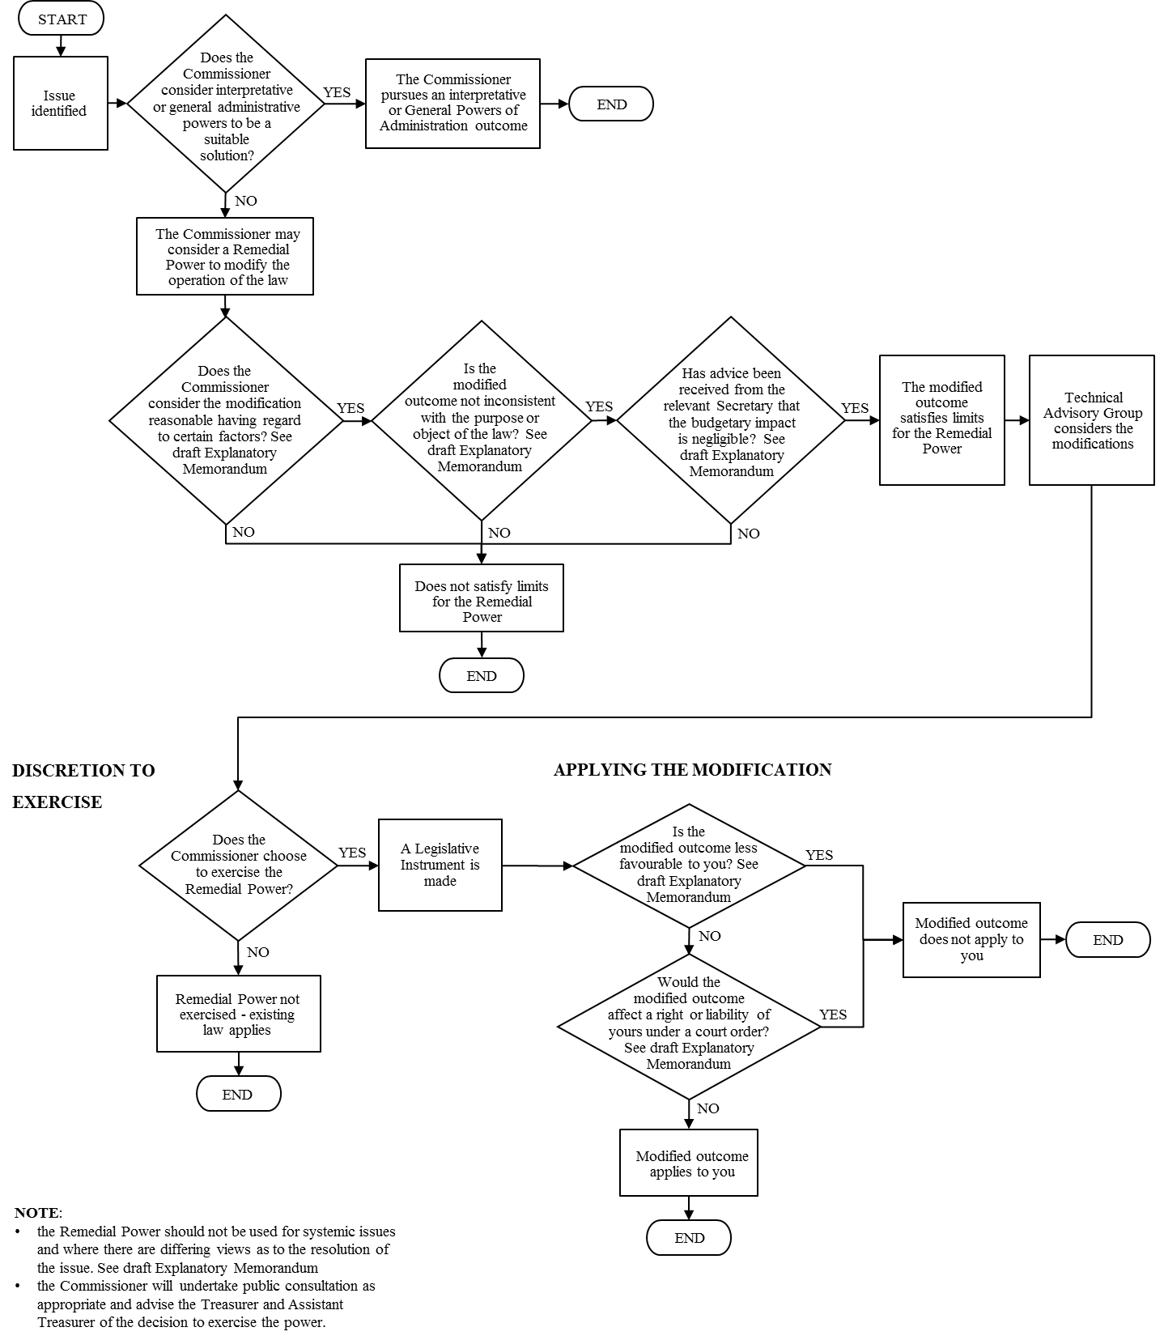
Consultation question
- Do you agree that the proposed consultation process will be appropriate to obtain relevant stakeholder input?
Timeframes
Exercise of the power would be done in accordance with ATO timeframes required to implement the enabling legislation for the power and the requirements under the Legislation Act 2003 (such as disallowance periods for legislative instruments).
It is important to recognise that the Remedial Power will operate within statutory limitations and will not be able to resolve the demand for changes to the primary legislation even where the change is of low priority.
Implementation
Where the Remedial Power has been used to modify the operation of the law, that modification will need to be implemented to ensure that taxpayers can apply it to their circumstances. The ATO will implement any modification in the same way as other legislative or administrative changes, using established communication methods and issuing guidance material as needed. Consistent with the operation of the self-assessment system, taxpayers will, in conjunction with guidance material, assess the application of the modification to their circumstances.
Consultation question
- Do you agree that the administrative process proposed by the ATO achieves the right balance between ensuring robust consideration of issues including thorough consultation with stakeholders, and flexibility to ensure that issues can be resolved in a timely manner?
Review
The proposed Remedial Power administrative process, as part of the ATO consultation framework, will be subject to monitoring and ongoing review (including consultation with ATO consultation groups and other stakeholders) to ensure it supports the effective operation of the power.
It is also proposed that the ATO and Treasury conduct a post implementation review of the use of the Remedial Power two years following the implementation of the power. In order to assess the effectiveness of the power, it is proposed that the post implementation review examine the instances where:
- the power was used, and evaluate whether it was able to appropriately resolve the issues it was intended to resolve in a timely manner; and
- the power was not used, to identify (where possible) the reasons for the power not being used.
In addition, the sunset of the instruments made using the Remedial Power will also provide another opportunity to review whether the modification to the operation of the law is:
- no longer necessary,
- still required and therefore needs to be remade, or
- still required but better resolved through amendment to the primary legislation.
Sunsetting of legislative instruments
Under the Legislation Act 2003, all legislative instruments sunset after 10 years unless they are explicitly exempted, actively remade or the sunsetting date is deferred by the Commonwealth Attorney-General.
It is proposed that legislative instruments made under the Remedial Power will sunset after five years, however this period is a focus area for consultation. Regardless of whether the period is five or 10 years, the existence of such legislative instruments provides an additional body of law. This additional body of law can increase the compliance burden and costs for taxpayers.
One argument for limiting the period of sunsetting to five years is that it may deal with compliance cost concerns. However, it is not clear that such a limitation would necessarily provide taxpayers with longer term certainty as to the operation of the relevant law.
As the sunsetting date approaches, it is necessary to review whether an instrument is still required. A review will determine whether it is necessary to remake the instrument or if it is more appropriate to allow the instrument to cease.
Finally, as an instrument made under the Remedial Power is merely a mechanism to be used where the ordinary course of legislative amendment would not provide a suitable and timely solution, it will also be necessary to consider whether changes to the primary legislation should be made to address ongoing issues if there is capacity at that time.

Consultation question
- What would be an appropriate sunsetting period for legislative instruments made under the Remedial Power?

Conclusion
Ultimately, the Remedial Power is:
- a discretionary power to be exercised by the Commissioner in accordance with the statutory requirements;
- to be used as a last resort in the event that there are not any viable interpretative or administrative solutions; and
- will only be used for issues that have been assessed through administrative processes as being best resolved through the use of the power.

The Legislative Instruments Act 2003 is currently the name of the relevant Act which governs legislative instruments. However, the name will change to the Legislation Act 2003 when changes made by the Acts and Instruments (Framework Reform) Act 2015 commence. These changes will commence on proclamation or 5 March 2016 (if no proclamation is made).

