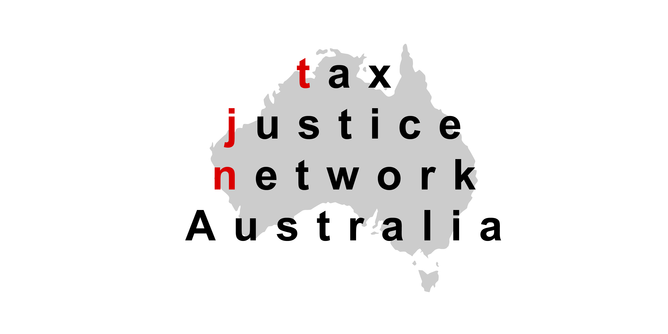


General Manager
Corporate and International Tax Division
The Treasury
Langton Crescent
PARKES, ACT, 2600
E-mail: taxlawdesign@treasury.gov.au

Submission on the Tax Laws Amendment (Tax Integrity Multinational Anti-avoidance Law) Bill 2015: Country by country reporting and Tax and Superannuation Laws Amendment (2015 Measures No. 4) Bill 2015: Scheme penalties for large companies
2 September 2015

The Tax Justice Network Australia (TJN-Aus) and Publish What You Pay Australia (PWYP-Aus) welcome the opportunity to make this submission on Tax Laws Amendment (Tax Integrity Multinational Anti-avoidance Law) Bill 2015: Country by country reporting and Tax and Superannuation Laws Amendment (2015 Measures No. 4) Bill 2015: Scheme penalties for large companies. We support the Government putting both Bills to the Parliament.

We support the two-tier structure of master and local files as being very helpful because it simplifies documentation requirements for both tax administrations and firms.

Public Disclosure
However, both TJN-Aus and PWYP-Aus are disappointed that the Tax Laws Amendment (Tax Integrity Multinational Anti-avoidance Law) Bill 2015 fails to provide any public disclosure of the country-by-country reporting of large multinational companies. The organisations urge that the Bill be amended to allow for the disclosure of country-by-country reporting on the parts of the information that cannot be justified as commercially confidential.

We appreciate that from that viewpoint, the main priority is to ensure disclosure of the information necessary for effective risk assessments by national tax authorities. However, there are wider concerns of corporate accountability both to stakeholders and the general public. This is also a question of good tax governance. As the BEPS project has recognised, the public concern that large corporations are able to deploy BEPS techniques to minimise the taxes they pay also undermines the general legitimacy of taxation. This has already resulted in the development of international standards for country-by-country reporting for specific industry sectors, notably extractive industries and banking and finance, which are also legal requirements in the USA and the EU, as well as many other countries. There are also differing disclosure requirements on companies depending on where they seek a stock exchange listing. There are therefore many strong arguments for going beyond a merely sectoral approach, and establishing a general disclosure standard for all large transnational corporations. There is no justification for secrecy of aggregate information on items such as employees, assets, profits and taxes by country. In our view, the only valid reason for non-publication is commercial confidentiality. This test should be applied strictly in this context.

Public country-by-country reporting would save on time and resources for tax authorities (which would have no role in passing on data that is publicly available) by allowing for a simple query of the data instantly via a register, rather than their having to record and compile different sets of files sent by various transnational enterprises and other tax authorities. Making the country-by-country reports public would ensure that more sets of eyes, across different stakeholder groups, could help digest the mass of data filed by companies and flag any indicators of risk to appropriate tax authorities.

The publication of a profit and loss account for a multinational enterprise on a country-by-country basis allows investors to assess:
- The risk that the internal supply chains create for the company, most especially for governance. The use of secrecy jurisdictions has frequently been association with governance failures leading in turn to corporate failure, as occurred with Enron and Parmalat as examples;
- The flow of finance charges within the group, and the particular impact these might have on an intragroup basis with regard to the reallocation of profits between jurisdictions, giving rise to risk of transfer pricing or thin capitalisation challenge from taxation authorities, prejudicing the potential quality of future earnings; and
- The rate of return on capital employed by jurisdiction, suggesting whether or not assets are efficiently allocated by group management to the locations in which the company trades.

Business efficiency is dependent upon the availability of high quality information. Unless that information is available then sub-optimal decisions on everything from resource allocation within a company to capital allocation between companies will be inefficient at the cost to society as a whole. Public disclosure of country-by-country reporting may take away some of the advantages that the current opacity provides to certain multinational companies, but it is beneficial to business as a whole.

Even if the country-by-country report was made public it would not remove the need for stand-alone legislation to require extractive companies to have to report on the payments they have made to governments on a project-by-project basis. Such legislation already exists, or is being put in place in the European Union and by the Governments of Canada, Norway and the United States.

Project level disclosure is vital to identify and prevent corruption and to help ensure that revenues benefit communities impacted by resource extraction activities. Specifically, project-by-project reporting will be of great assistance to parliaments, local governments and citizens as they monitor the extent to which intergovernmental transfers adhere to distribution rules that determine how much of a company’s total project payment is distributed to local governments or communities. In countries that have fiscally decentralised or are undergoing fiscal decentralisation, such as Indonesia, the Philippines, Cambodia and other countries of strategic interest to the Government and companies listed in Australia, there is little public information to monitor this large flow of revenues to local governments, providing a ripe incentive for government corruption. The data produced by project reporting will not only produce evidence needed to address corruption risks, but would reduce incentives for corruption in fiscal transfers.

In order to engender greater transparency of the financial flows between the resource sector and governments a growing number of jurisdictions have introduced, or are introducing, payment disclosure legislation for extractive industry companies:
- In 2010 President Obama signed into law Section 1504 of the Dodd Frank Wall Street Reform and Consumer Protection Act, which requires all extractive industry companies registered with the United States Securities and Exchange Commission to report payments made to governments on a country-by-country and a project-by-project basis. Rules implementing the law are expected to be issued in 2015.
- In 2013 the European Parliament voted to adopt new Accounting and Transparency Directives that require all public and large private extractive and logging companies in the European Union to report their payments to governments on a project-by-project basis. The United Kingdom and France have since completed transposition of the Directives into national law. In both countries the first reports on payments made in 2015 will be published in 2016.
- On 16 December 2014 the Canadian Parliament passed into law payment reporting requirements under the Extractive Sector Transparency Measures Act, which the Canadian Government has stated will come in to force no later than 1 June 2015.
- Payment disclosure legislation for extractive industry companies came in to force in Norway on 1 January 2014.
- In November 2014 the Swiss Government published for public consultation draft reporting rules that are in line with the United States and European Union laws.
- Since 2010 the Hong Kong Stock Exchange has required prospective mining and oil and gas companies to disclose payments to governments in their listing applications.

The EU Directives, which were written to align with the US legislation, and the Canadian legislation allow for overseas reporting regimes to be considered equivalent. These clauses permit cross-listed companies to only have to report in one jurisdiction, as long as the other deemed its reporting regime equivalent, and pave the way for a truly global reporting standard.

It is also important that the data from country-by-country reports should be made available for analysis and research purposes. The inadequacy of existing data on corporate tax payments and their relationship to the real activities in each country has been recognised as a major obstacle to proper evaluation of the extent of tax avoidance and of the effectiveness of reform measures, in the report by the OECD under BEPS Action 11, Improving the Analysis of BEPS. Publication of the country-by-country reports would obviously be the easiest way to ensure this availability. However, even if it is decided that the reports should not be published, the data they contain should be made available to researchers, subject to protections to ensure that analyses which are published include data only in aggregate form. Tax returns of individuals and legal entities are already made available for research purposes by tax authorities in a number of countries subject to such protections. It is especially important that data relating to large corporations which have a major social and economic role should be available for this type of analysis and research.

Threshold
TJN-Aus and PWYP-Aus are disappointed the threshold for reporting in the Bill has been set at $1 billion in global revenue (which is consistent with the OECD recommendation from the BEPS Action Plan). We would have preferred to see Australia apply a lower threshold for producing the reports.

Stronger Penalties
TJN-Aus and PWYP-Aus support the increased administrative penalties that can be applied to large companies that enter into tax avoidance or profit shifting schemes as contained in the Tax and Superannuation Laws Amendment (2015 Measures No.4 ) Bill 2015. The organisations would prefer if the increased penalties applied to the large company threshold of businesses with global revenue of $250 million and more, rather than a global revenue of $1 billion.

Dr Mark Zirnsak  Secretariat  Tax Justice Network Australia  c/- 130 Little Collins Street  Melbourne, Victoria, 3000  Phone: (03) 9251 5265  E-mail: mark.zirnsak@victas.uca.org.au | Jessie Cato  Coordinator  Publish What You Pay Australia  c/- 130 Little Collins St  Melbourne, Victoria, 3000  E-mail: Jessie.Cato@victas.uca.org.au

Acknowledgement: TJN-Aus and PWYP-Aus are grateful for the work of the BEPS Monitoring Group, with this submission drawing on their work.
Background on the Tax Justice Network Australia
The Tax Justice Network Australia (TJN-Aus) is the Australian branch of the Tax Justice Network (TJN) and the Global Alliance for Tax Justice. TJN is an independent organisation launched in the British Houses of Parliament in March 2003. It is dedicated to high-level research, analysis and advocacy in the field of tax and regulation. TJN works to map, analyse and explain the role of taxation and the harmful impacts of tax evasion, tax avoidance, tax competition and tax havens. TJN’s objective is to encourage reform at the global and national levels.

The Tax Justice Network aims to:
(a) promote sustainable finance for development;
(b) promote international co-operation on tax regulation and tax related crimes;
(c) oppose tax havens;
(d) promote progressive and equitable taxation;
(e) promote corporate responsibility and accountability; and
(f) promote tax compliance and a culture of responsibility.

In Australia the current members of TJN-Aus are:
- ActionAid Australia
- Aid/Watch
- Australian Council for International Development (ACFID)
- Australian Council of Trade Unions (ACTU)
- Australian Education Union
- Anglican Overseas Aid
- Baptist World Aid
- Caritas Australia
- Columban Mission Institute, Centre for Peace Ecology and Justice
- Community and Public Service Union
- Friends of the Earth
- Global Poverty Project
- Greenpeace Australia Pacific
- Jubilee Australia
- National Tertiary Education Union
- New South Wales Nurses and Midwives’
- Oaktree Foundation
- Oxfam Australia
- Save the Children Australia
- SEARCH Foundation
- SJ around the Bay
- Social Policy Connections
- Synod of Victoria and Tasmania, Uniting Church in Australia
- TEAR Australia
- Union Aid Abroad – APHEDA
- UnitedVoice
- UnitingWorld
- UnitingJustice
- Victorian Trades Hall Council
- World Vision Australia
Background on Publish What You Pay Australia
Publish What You Pay is a global campaign for transparency and accountability in the mining and oil and gas industries. In Australia, the campaign is supported by a coalition of organisations that are committed to promoting good governance in resource-rich countries to ensure that citizens benefit equitably from their natural wealth, including through advocacy for the mandatory disclosure of all payments made between extractive industry companies and governments on a country-by-country and project-by-project basis.

The current members of Publish What You Pay Australia are:
- Action Aid Australia
- Aid Watch
- Anglican Overseas Aid
- Australian Conservation Foundation
- Australian Council for International Development
- A Billion Little Stones
- Burma Campaign Australia
- Caritas Australia
- Catholic Mission
- ChildFund Australia
- Columban Mission Institute
- Conservation Council of Western Australia
- CFMEU – Mining and Energy
- CAER – Corporate Analysis. Enhanced Responsibility
- Economists at Large
- Friends of the Earth Australia
- Global Poverty Project
- Greenpeace Australia Pacific
- Human Rights Law Centre
- Jubilee Australia
- Mineral Policy Institute
- Oaktree Foundation
- Oxfam Australia
- Search Foundation
- SJ Around The Bay
- Tear Australia
- Transparency International Australia
- Union Aid Abroad – APHEDA
- Uniting Church in Australia – Synod of Victoria and Tasmania
- World Vision Australia

Richard Murphy, ‘Country-by-Country Reporting. Accounting for globalisation locally’, Tax Justice Network, 2012, pp. 33-34.
Richard Murphy, ‘Country-by-Country Reporting. Accounting for globalisation locally’, Tax Justice Network, 2012, p. 56.
www.reginfo.gov/public/do/eAgendaViewRule?pubId=201410&RIN=3235-AL53
UK, The Reports on Payments to Governments Regulations and Early implementation of the Transparency Directive’s requirements for reports on payments to governments, 2014 France, Projet de loi portant diverses dispositions d'adaptation de la législation au droit de l'Union européenne en matière économique et financière, 2014.
Canada, Extractive Sector Transparency Measures Act, 2014.
Norway, Forskrift om land-for-land rapportering, 2013.

