2015

EXPOSURE DRAFT

Improving the Integrity of the Scrip for Scrip Roll-over

EXPLANATORY MATERIAL

(Circulated by the authority of the
Treasurer, the Hon J. B. Hockey MP)
Glossary
The following abbreviations and acronyms are used throughout this explanatory memorandum.
Abbreviation | Definition
CGT | Capital gains tax

- Improving the integrity of the scrip for scrip roll-over

Outline of chapter
  - The Exposure Draft to makes amendments to improve the integrity of the scrip for scrip roll-over in Subdivision 124-M of the Income Tax Assessment Act 1997.
  - All legislative references in this Chapter are to the Income Tax Assessment Act 1997 unless otherwise indicated.

Context of amendments
  - The purpose of the scrip for scrip roll-over is to ensure that tax considerations are not an impediment to takeovers or mergers involving companies or trusts.
  - If shares or trust interests, or options or similar rights over shares or trust interests (scrip) are exchanged for similar interests in another entity in a takeover or merger, the scrip for scrip roll-over defers taxing a capital gain on the disposal of the scrip until the disposal of the replacement scrip. This reduces the cost of takeovers, as the acquiring entity need not compensate the holders of scrip for the CGT they would otherwise have paid on the exchange.

Stakeholder rules
  - Integrity provisions (the stakeholder provisions in sections 124-782 and 124-784) are intended to ensure that potentially indefinite CGT deferral opportunities do not arise when the same person or group has influence over both the acquired entity and the acquiring entity. Inappropriate deferral could otherwise occur where an acquiring company receives shares in the original company in exchange for shares in itself and on-sells the original company. A cost base uplift would otherwise apply to the shares now held by the acquiring company while the original company’s shareholders benefit from reinvesting capital gains tax-free.
  - To prevent deferral, special cost base rules apply so that the cost bases for the acquiring entity of the interests in the acquired entity reflects the cost bases of the original interest holder rather than the market value of the interests. These rules apply in respect of takeovers and mergers involving companies or trusts where neither the acquired entity nor the acquiring entity is widely-held (that is they each have less than 300 members or beneficiaries).
  - The threshold levels of influence are called a significant stake or common stake, and are defined by section 124-783:
- A shareholder of a company has a significant stake if the shareholder and the shareholder’s associates own shares with 30 per cent or more of the voting rights or entitlements to dividends or entitlements to capital distributions.
- One or more shareholders in a company have a common stake if they and their associates own shares with 80 per cent or more of the voting rights or entitlements to dividends or entitlements to capital distributions.
  - Section 124-783 also defines a significant stake and common stake in relation to trusts using equivalent tests that assess beneficiaries’ entitlements to receive distributions from the trust.

Restructure rules
  - Further integrity provisions (the restructure provisions in sections 124-784A to 124-784C) apply to scrip for scrip roll-overs that are treated as corporate restructures because there is substantial continuity of ownership. Under a restructure, the cost bases for the acquiring entity of the affected interests in the entity acquired under the restructure reflect the cost bases of the acquired entity’s underlying net assets rather than the market value of the interests.
  - The restructure rules apply to restructures involving companies, including widely-held companies, but do not apply to trusts.

The AXA case
  - The arrangement considered by the Full Federal Court in AXA Asia Pacific Holdings Ltd v Commissioner of Taxation [2009] FCA 1427 (AXA) highlighted a number of limitations in the existing integrity rules. The case itself concerned the arm’s length test in subsections 124-780(3) and (4) and the application of Part IVA of the Income Tax Assessment Act 1936. The amendments in the Exposure Draft do not address either of those provisions but rather the issues highlighted by the arrangement considered in AXA.
  - Subdivision 124-M treated the AXA arrangement as a genuine takeover involving a substantial change in ownership rather than as a corporate restructure. As a result, AXA was able to obtain the benefit of a CGT cost base uplift when eventually disposing of one of its subsidiaries.
  - The AXA arrangement demonstrated that the stakeholder provisions can be circumvented by temporarily suppressing the ownership rights of a party in a scrip for scrip exchange through the use of convertible shares, options and similar interests. Later, when the stakeholder provisions no longer apply, these interests can be executed to give the holder an increased level of rights that would have meant the stakeholder provisions would have applied if the relevant party had held that level of ownership rights at the earlier time.

Repayment of intra-group debts
  - Where the stakeholder or restructure provisions apply to a scrip for scrip exchange, any capital gain arising on the settlement of a debt owed by an acquiring entity to its parent company as part of the scrip for scrip acquisition is disregarded. This rule can be used to shelter part of the deferred capital gain from taxation.
  - In ‘downstream acquisitions’, the acquiring company is a member of a wholly owned group and original shareholders receive shares in the parent company in exchange for their shares in the original company. As consideration for the shares issued by the parent, the acquiring company may incur a debt to the parent company in addition to, or instead of, issuing equity. To accommodate downstream acquisitions, the provisions include the term ‘replacement entity’, which extends the concept of ‘acquiring entity’ to include the parent company (the ultimate holding company defined by subsection 124-780(7)).
    - Downstream acquisitions
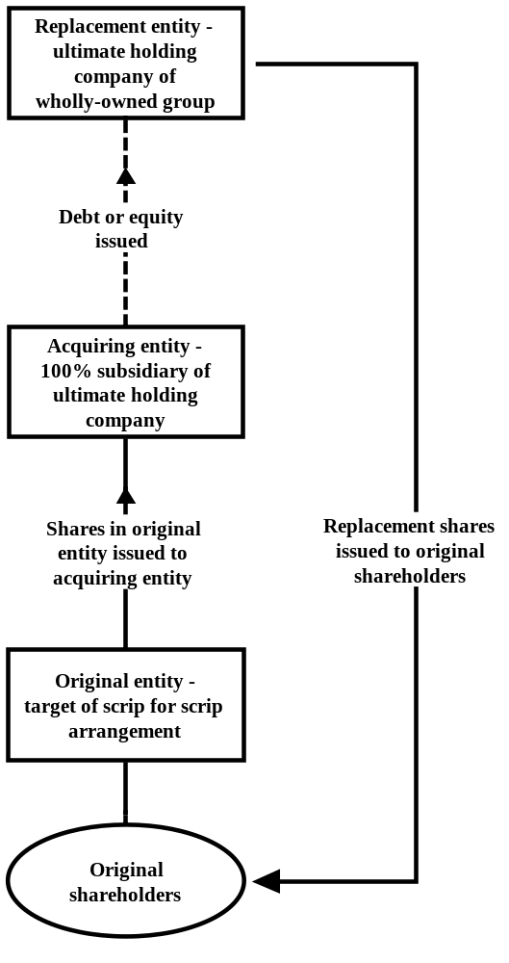

  - When an acquiring company repays a loan to its parent company acquired under a takeover arrangement, the capital gain that would otherwise arise (that is, if the cost base allocated to the debt is less than its market value) is exempted from CGT under subsection 124-784(3), or 124-784C(3) under the restructure provisions.
  - However, if the parent company sells the acquiring company (and therefore the original company) by selling all of the equity of the acquiring company, the capital gain that arises reflects only a portion of the capital gain that would otherwise arise if the acquiring entity had sold the original company. The use of debt between the acquiring company and the parent company provides a shelter for a portion of the capital gain that should be transferred with the cost base transfer to the parent company if it had sold the acquiring company. For example, even if the stakeholder provisions had applied to the AXA transaction, the use of debt between the acquiring entity and the parent entity in that transaction would have resulted in the recovery of only part of the inappropriately deferred CGT liability.

Intra-group cost base allocation rules
  - A separate issue with the cost base allocation rules for downstream acquisitions, which are set out in sections 124-784 and 124-784C, arises if the acquiring company issues debt or equity to a company in the group other than the parent company. The rules assume that the equity or debt is issued directly by the acquiring company to the parent company.
  - This rule does not apply where a company in the group other than the parent company makes the acquisition and issues equity or owes a debt as a result of the acquisition to another company in the group other than the parent company. This means there will be no cost base transfer or no reduction to the cost base of the debt asset or equity issued by the acquiring company to the other group company as part of the scrip for scrip acquisition. If the other company then on-sells its equity in the acquiring company, the integrity provisions would not recapture any of the tax deferral.

Trusts
  - Further analysis of the underlying issues in the AXA arrangement revealed similar problems with the scrip for scrip roll-over provisions as they apply to trusts.
  - The stakeholder provisions do not apply to scrip for scrip arrangements where either the original or the replacement entity has at least 300 members or beneficiaries (subsections 124-783(5) and (8)). In contrast, the restructure rules in section 124-784A apply to all scrip for scrip transactions involving companies, regardless of the number of members. The restructure rules do not apply in relation to trusts.
  - If an acquisition that qualifies for the scrip for scrip roll-over is taken to be a restructure and roll-over relief is chosen, the cost base for the original interests that the acquiring entity acquires reflects the cost bases of the underlying net assets of the original entity, rather than the market value of the original entity. The rationale behind the restructure integrity provisions is that a takeover by an entity of low value relative to the target entity is considered a restructure rather than a takeover.
  - Widely-held trusts may also engage in similar transactions that are more like restructures of an existing trust, with no substantial change in ownership, rather than a genuine takeover.

Summary of new law
  - The Exposure Draft makes a number of changes to the scrip for scrip roll-over:
- Options and other entitlements to acquire membership interests and other rights are taken into account for the purposes of the significant and common stakeholder test.
- A capital gain arising on the settlement of a debt owed, as part of a scrip for scrip acquisition, by an acquiring company to its parent company will no longer be disregarded.
- The cost base allocation rules for debt and equity issued by an acquiring entity will apply regardless of whether the interest is issued to the group’s parent company or to another member of the group.
- In downstream acquisitions, roll-over relief will not be available where debt or equity (other than a replacement interest) has been issued to an entity outside the wholly-owned group.
- The restructure provisions that apply to companies will be amended so that they apply correctly to trusts.

Comparison of key features of new law and current law
New law | Current law
The significant and common stakeholder tests will also take into account any entitlements that interest holders have to acquire additional distribution or voting rights. | The significant and common stakeholder tests are based on the distribution rights of interest holders and, in the case of companies, voting rights.
The capital gains are not disregarded. | Certain capital gains, made by an ultimate holding company when settling debt issued by a subsidiary acquiring entity under a scrip for scrip arrangement, are disregarded.
The cost base allocation rules will apply to debt and equity issued by an acquiring entity to any member of their corporate group. | The cost base allocation rules apply to debt and equity issued by an acquiring entity to the ultimate holding company of their group.
Roll-over relief will not be available where an acquiring entity issues debt or equity (other than a replacement interest) to an entity that is not a member of the wholly-owned group. | No equivalent
The restructure provisions apply to both companies and trusts that enter into restructures. | The restructure provisions apply to company restructures but not trust restructures.

Detailed explanation of new law

Stakeholder rules and entitlements to acquire rights
  - Amendments are made to ensure that entitlements to acquire relevant interests are taken into account in the significant and common stakeholder tests. This is achieved by treating any entitlement to acquire relevant interests to have been realised. [Exposure Draft, item 8, subsections 124-783A(1) and (2) of the ITAA 1997]
  - The relevant interests assessed under the stakeholder tests (for example voting rights in a company) are known as ‘stake interests’. An entitlement to acquire stake interests includes entitlements arising under a right, option, share or other interest (a ‘stake option’). [Exposure Draft, item 8, subsections 124-783A(3) and (4) of the ITAA 1997]
  - Where a stake option may be exercised or converted in a number of ways or has a variable outcome in terms of the stake interests acquired, it is assumed that the maximum number of stake interests possible is realised. In some circumstances, it may not be possible to ascertain the maximum amount with certainty and a reasonable estimation will be required.
  - The rule does not apply in situations where an interest holder has an entitlement to exercise an option that diminishes its holding, such as a put option.
  - This rule does not apply to stake options or interests that cannot be realised within five years of the scrip for scrip arrangement being completed. The integrity rule is targeted towards short-term entitlements that distort the application of the stakeholder rules without having an ongoing impact on the commercial positions of the relevant entities. [Exposure Draft, item 8, subsection 124-783A(3) of the ITAA 1997]
      - Entitlements to acquire stake interests
An original interest holder owns all of the ordinary shares and voting rights in a company (the target company). The original interest holder enters into a scrip for scrip arrangement with an acquiring entity. Under the arrangement, the acquiring entity acquires all of the shares in the target company. In return, the acquiring entity issues convertible preference shares in itself to the original interest holder.
The replacement shares currently carry 15 per cent of the voting rights in the acquiring entity. The shares are capable of converting after 12 months. Following the conversion of the shares, the shares will carry 40 per cent of the voting rights in the acquiring entity.
Under the current law, the original interest holder does not have a significant stake (30 per cent) in the acquiring entity after the arrangement. Under the amendments, the original interest holder is treated as having converted its shares and it will have a significant stake.
  - The amendments apply in addition to the current law. That is, if an entity would have a significant or common stake under the current law (section 124-783), they will continue to do so under the amended law. [Exposure Draft, item 8, subsection 124-783A(5) of the ITAA 1997]

Repayment of debt within corporate groups
  - Subsections 124-784(3) and 124-784C(3) provide that, if a loan is repaid by the acquiring entity to its ultimate holding company, any capital gain made on the debt from that repayment is disregarded.
  - Those provisions are repealed as part of a broader rewrite of sections 124-783 and 124-784C. [Exposure Draft, items 8 and 11, sections 124-784 and 124-784C of the ITAA 1997]
  - This amendment ensures that the full value of a capital gain deferred under the scrip for scrip roll-over is recovered through the operation of the stakeholder rules. Replacement entities that are controlled by original interest holders who are significant or common stakeholders will not be able to shelter the capital gain with the use of intra-group debt.

Cost base allocation rules
  - Sections 124-784 and 124-784C contain cost base allocation rules for debt and equity issued as part of a downstream acquisition. The cost base of the parent company’s debt or equity received is determined by reference to the acquisition cost of the membership interests in the original company that the acquiring entity acquires.
  - Currently, the rules only apply to debt and equity issued by an acquiring entity to the parent company of the group. An amendment is made to apply these rules equally where the acquiring entity issues debt or equity to another member of the group. [Exposure Draft, items 8 and 11, sections 124-784 and 124-784C of the ITAA 1997]
      - 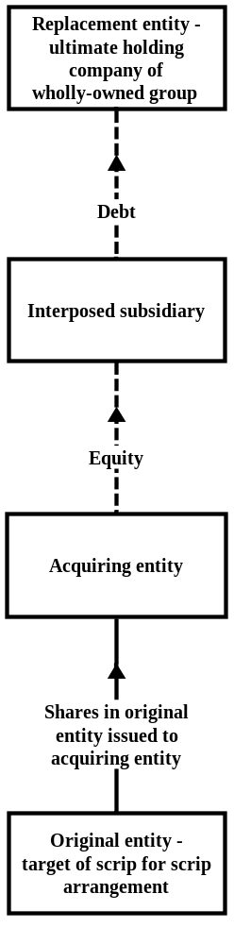 Cost base allocation rules
As part of a scrip for scrip arrangement, the acquiring entity acquires all the shares in the original entity. The original entity’s shareholders, who are significant stakeholders, receive shares of the replacement entity in exchange.
The acquiring entity issues equity to the interposed subsidiary, and the interposed subsidiary issues debt to the replacement entity for the issue of its shares.
The cost base of the significant stakeholders in the original entity’s shares is transferred to the acquiring entity, but is not allocated to the interposed subsidiary or the replacement entity under the existing law.
Under the proposed change, the acquiring entity’s cost base would be allocated to the interposed subsidiary for the shares issued by the acquiring entity, and to the replacement entity for the debt issued by the interposed subsidiary.
  - To prevent structuring that circumvents these expanded rules, a new condition is placed on the availability of scrip for scrip roll-over relief. That is, roll-over relief will not be available where the acquiring entity has issued debt or equity (other than a replacement interest) to an entity outside the wholly-owned group. [Exposure Draft, item 4, paragraph 124-780(3)(f) of the ITAA 1997]
  - This rule will prevent scenarios where the acquiring entity issues debt or equity to another member of the group through an interposed entity that is not part of the wholly-owned group.
      - 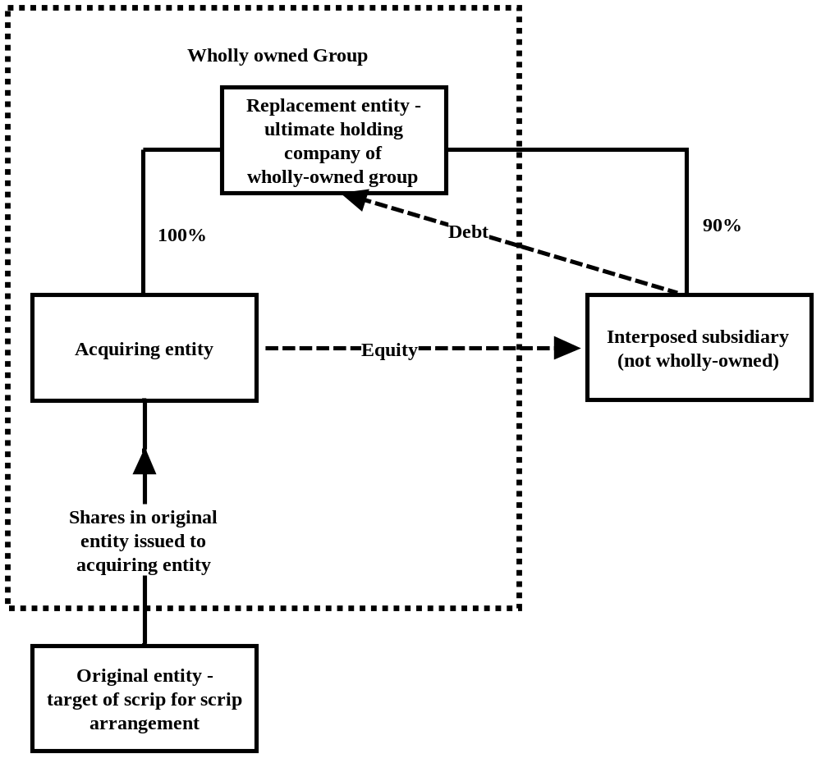 New roll-over condition for interposed entities
Consider the same facts as in Example 1.1, except the interposed subsidiary is not a member of the wholly-owned group.
The original interest holders will not be entitled to roll-over relief under the arrangement.

Trusts
  - A number of amendments are made to the scrip for scrip roll-over in order to align the treatment of trusts with that of companies.
  - The primary amendment is to allow the restructure provisions to apply to trusts. [Exposure Draft, item 9, subparagraph 124-784(1)(a)(i) of the ITAA 1997]
  - Currently, the method statement in section 124-784A relies on calculating the market value of shares and associated rights and options. An amendment is made to expand the scope of the method statement to include units in trusts and options and rights to acquire units. [Exposure Draft, item 10, step 3 of the method statement in subsection 124-784A(2) of the ITAA 1997]
  - Further amendments are made to the trust roll-over provision (section 124-781) and the common stakeholder provisions (subsections 124-783(9) and (10)). The amendments include trusts in the defined term ‘replacement entity’ and apply this term in a standardised way so that it applies correctly to both companies and trusts. [Exposure Draft, items 5 and 7, subparagraphs 124-781(1)(a)(i) and (ii), and subsection 124-783(9) and (10) of the ITAA 1997]

Minor and consequential amendments
  - A consequential amendment is made to remove a note that refers to repealed subsection 124-784(3). [Exposure Draft, item 1, note 4 to subsection 104-25(5) of the ITAA 1997]
  - Two consequential amendments are made in relation to the expanded operation of the cost base allocation rules. [Exposure Draft, items 2 and 6, table item 2 in section 112-53 and note 2 to subsection 124-782(1) of the ITAA 1997]
  - Consequential amendments are made to the definitions of ‘common stake’ and ‘significant stake’. [Exposure Draft, items 12 and 13, subsection 995-1(1) of the ITAA 1997]
  - The definitions ‘stake interest’ and ‘stake option’ are inserted into the Act’s dictionary. [Exposure Draft, item 14, subsection 995-1(1) of the ITAA 1997]
  - A minor amendment is made to insert an omitted asterisk denoting the term ‘arrangement’ as a defined term. [Exposure Draft, item 3, paragraph 124-780(3)(d) of the ITAA 1997]

Application and transitional provisions
  - The amendments apply in relation to CGT events that occur after 7:30pm (AEST) on 8 May 2012 – the date of the original Budget announcement. [Exposure Draft, item 15]

