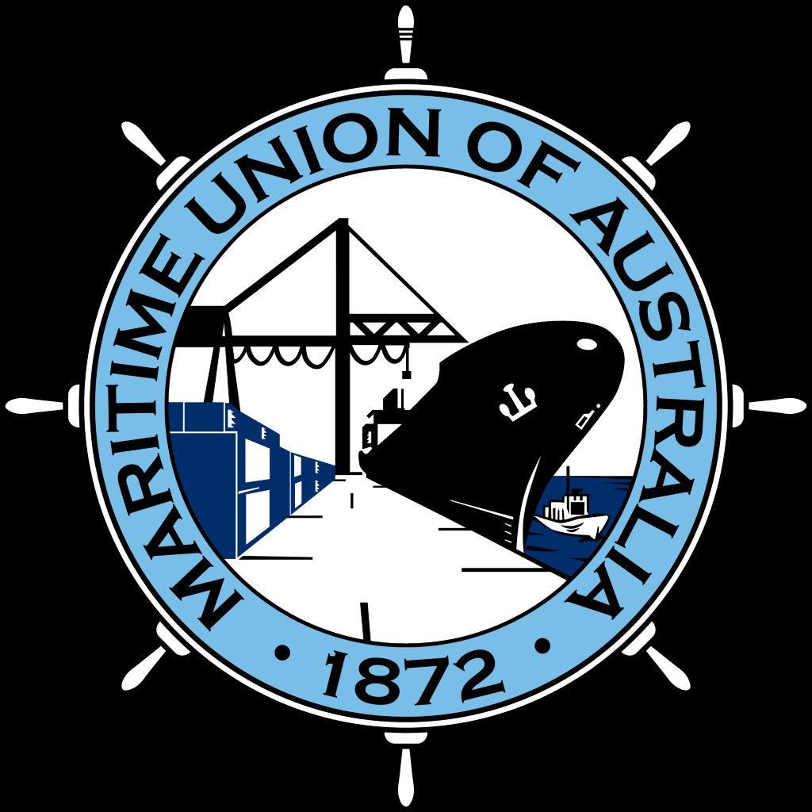

MARITIME UNION OF AUSTRALIA (MUA)

SUBMISSION TO TREASURY

NATIONAL INJURY INSURANCE SCHEME (NIIS) WORKPLACE ACCIDENTS

CONSULTATION REGULATION IMPACT STATEMENT (RIS)

17 APRIL 2015
Introduction

The Maritime Union of Australia (MUA) represents Australian seafarers and maritime workers. We are a stakeholder in the Commonwealth Seacare scheme of workers compensation regulated under the Seafarers Rehabilitation and Compensation Act 1992 (Seafarers Act).

Principles

The Maritime Union of Australia (MUA) supports a National Injury Insurance Scheme (NIIS) scheme that, for catastrophic injuries that arise from workplace accidents, is wholly funded by workers compensation agencies, which in turn are funded by insurance purchased with employer payments. Neither the injured worker nor the community should bear the cost of lifetime care and support for those suffering catastrophic injury, illness or disease arising from workplace injuries.

The MUA supports the no-fault model of workers’ compensation in Australia which means that every worker who suffers a catastrophic injury in a workplace accident is entitled to initial medical and rehabilitation support through their workers’ compensation scheme. What concerns us is that some workers’ compensation schemes cap the amount of services that can be provided (particularly attendant care), while others allow workers to commute or cash out existing and future rights into a lump sum payment by the insurer. The Seacare scheme, operating under the provisions of the Seafarers Act is a case in point. These limitations are inappropriate in circumstances where lifetime care and support is required and are not in the longer term interests of a catastrophically injured worker.

The MUA notes the observation of the Productivity Commission that the low prevalence of catastrophic workplace injuries means that workers’ compensation schemes are generally not adequately equipped to support the lifelong needs of catastrophic injury sufferers under current legislative arrangements..

The union is concerned that workers who are catastrophically injured in workplace accidents are not entitled to a minimum level of coverage because jurisdictions have not yet agreed to minimum benchmarks for the provision of lifetime care and support, and there remains considerable variation in the standards of care and support provided under the various workers compensation schemes.

The MUA supports the adoption of ‘minimum benchmarks’ for the provision of lifetime care and support for people have suffered a catastrophic injury arising from a workplace accident.

The options – we favour Option 4.2 Minimum benchmarks

As a general principle, the MUA does not favour a dual system such that workers need to be involved with separate schemes and regulators, separate rules and so on to obtain support arising from a catastrophic workplace accident. This would be the situation under the base case, where for example, a worker would be required to deal with their workers compensation scheme up to a cap and then transfer to the NIIS. The way to avoid such duplication is to integrate the minimum benchmarks into the workers’ compensation schemes.

As a result the union favours Option 4.2 Minimum benchmarks. We support this federated model for the NIIS for workplace accidents, and would favour this approach for the Seacare scheme, necessitating reform of the Seafarers Act so that a minimum agreed level of support is offered on a no-fault basis in accordance with a set of agreed benchmarks that could be implemented in a way that best suits the Australian merchant shipping industry, including the possibility of exceeding the minimum benchmarks.

This position is conditional on there being some amendments to the Minimum benchmarks as proposed. The changes we propose are those advocated by the ACTU:

- The minimum benchmarks should include recognition ‘up front’ of an active workers compensation claim, before any other consideration was made. Those satisfying this threshold need not then satisfy any further threshold text.

- Eligibility rules should include those who suffer catastrophic injury as a result of work-related disease. Work-related diseases should be referenced in the list of injury benchmarks and the adequacy of this reference should be part of the 2020 review.

- A “work-related catastrophic injury” should include those sustained in the course of all recess breaks, including those occurring on-site and those occurring off-site. This is particularly important for workers covered by the Seafarers Act as seafarers remain at the workplace (the ship) during all recess breaks.

- NIIS should provide coverage to all workers who suffer catastrophic injury, even where they may have engaged in what may be deemed serious or wilful misconduct. This is a scheme with the intention of ensuring that “all individuals who are catastrophically injured in an accident will be entitled to lifetime care and support regardless of whether or not they are able to prove another party was at fault for their injuries." It is inconsistent with this principle to seek to exclude a worker by apportioning ‘blame’ and is inconsistent with the no-fault principle.

- We would nevertheless be prepared to accept the exclusion of journey associated catastrophic injury on the basis that such injuries were covered by the motor vehicle accident stream of the NIIS.

