Northern Minerals welcomes the opportunity to present the Government with proposals for the 2019/20 Federal Budget. In the context of its preparation, Northern Minerals seeks Government consideration for funding to support road upgrades for Northern Minerals’ Browns Range Heavy Rare Earths Project in the East Kimberley.

**Northern Minerals Browns Range Heavy Rare Earths Project**

The pilot stage of the Project produced its first rare earths carbonate in October 2018. Browns Range is now globally the only producer of heavy rare earths outside of China.

The Project is producing a critical commodity vital to current technological development and creating jobs in one of the most remote parts of Australia. It is located 160 kilometers south-east of Halls Creek and 50 kilometers south east of the Yaruman Community at Ringer Soak in the East Kimberley. See map below.

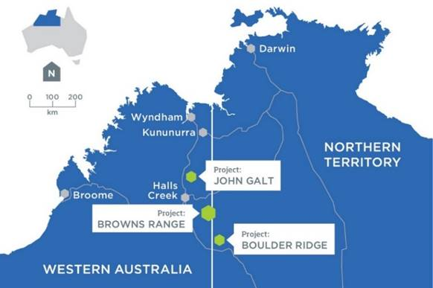

Northern Minerals has invested $190 million on the Project to date. It produces a mixed rare earth carbonate which includes a high grade of Dysprosium and Terbium which are a key component of the highly energy efficient permanent magnet motors used in electric vehicles, wind turbines, air conditioning, and industrial robots.

Beyond producing a mixed rare earth carbonate, Northern Minerals is actively pursuing plans for downstream processing. In 2018 and 2019 the company is focused on establishing ore sorting and moving towards producing separated oxides which will allow products to be sold to a greater range of markets globally.

**Size of resource**

Northern Minerals has spent $35million on exploration to date at Browns Range. The Browns Range dome is a massive geological feature covering 1,500km2 and stretching 60km x 30km, most of which hasn’t been effectively explored. Northern Minerals believes there is huge, long term potential for production from Browns Range and the surrounding region. Northern Minerals also holds tenements for nearby Boulder Ridge and John Galt.

To date, Northern Minerals has drilled 15 targets at Browns Range, six of which have been converted to JORC compliant resources. These are open at depth and along strike (length) which indicates upside potential. This compares to industry average conversion rates of 10,000 prospects drilled producing one mine. A current drilling program is showing extremely promising results with two new high-grade discoveries.

**Geopolitical importance of product**

Browns Range is now globally the only producer of heavy rare earths outside of China.

There is growing global demand for the critical minerals used in the technologies that save energy and produce low cost or renewable energy – including Dysprosium and Terbium. Governments and companies in the US and Europe are increasingly focused on ensuring reliable supplies of such minerals. Geoscience Australia maintains a list of those minerals it has identified as of critical significance. The list includes Rare Earth Elements – see Appendix A.

China has long dominated the supply of rare earths to world markets. This has been achieved by utilising its significant deposits of rare earths and also with focused investment in developing the facilities to process (beneficiate) ore into the high-grade oxides required by manufacturers throughout the world. The lack of beneficiation facilities outside of China currently means almost all ore mined outside China must be exported to the country for processing before it can be used by manufacturers throughout the world. This investment in processing has given China monopolistic control over the global rare earth market.

* In 1992, Chinese Premier, Deng Xiaoping stated: “Saudi Arabia has oil, but China has rare earths.”
* In 2011, China reacted to nations critical of its South China Sea activities by cutting rare earths exports. This resulted in global prices skyrocketing to historic highs. The price of Dysprosium peaked at US$1,508 per kg in 2011. Prices subsequently fell when China resumed controlled export.
* In 2017, China commenced a program of closing illegal heavy rare earths mines which use highly polluting leach mining techniques. This policy remains in place with mines continuing to close. Prices for heavy rare earths have risen as production in China has fallen.
* In December 2017, the United States Geological Survey published its first critical minerals assessment since 1973. The report flagged the lack of US domestic and secure sources of a range of minerals that are expected to be used increasingly in critical technology. Later that month US President Donald Trump signed the ‘Presidential Executive Order on a Federal Strategy to Ensure Secure and Reliable Supplies of Critical Minerals’. The order states: *“It shall be the policy of the Federal Government to reduce the Nation’s vulnerability to disruptions in the supply of critical minerals, which constitutes a strategic vulnerability for the security and prosperity of the United States.”*
* In February 2018, the US Department of the Interior released a draft list of 35 minerals deemed ‘critical’ to US national security. A following report by the Centre on Sustainable Investment at Columbia University noted that of the six minerals “most critical for the transition to the green economy”, the US only has domestic supplies of two – Tellurium and Indium. According to the Centre of Sustainable Investment – the remaining minerals are: Lithium, Cobalt, Neodymium and Dysprosium. Australia has deposits of all four of these minerals. Also in February, President Trump met with then Australian Prime Minister Malcolm Turnbull where the countries agreed to form a partnership on critical minerals. This work is being led by Senator the Hon. Matthew Canavan, Minister for Resources and Northern Australia and the Department of Industry, Innovation and Science.
* In May 2018, the Western Australian State Government announced the appointment of a Task force to develop a Lithium and Energy Materials Strategy for WA. The strategy aims to maximize opportunities for the State from the global interest in its critical minerals and downstream processing and manufacturing potential. George Bauk, Managing Director of Northern Minerals is a member of the Industry Reference Group advising the Taskforce.
* In July 2018 US Secretary of State Michael Pompeo, US Defense Secretary James Mattis, then Australian Foreign Minister the Hon Julie Bishop, and then Australian Defence Minister (now Foreign Affairs Minister) Senator the Hon Marise Payne met for the 2018 Australia-U.S. Ministerial Consultations (AUSMIN). They agreed to hold a critical minerals dialogue, with planning now underway for the meeting to be tentatively held in the first quarter of 2019.
* In August 2018, the President of the United States signed into law legislation which prohibits the US Department of Defense from acquiring rare earth magnets from China, Russia, North Korea and Iran. While there are some provisos related to reliability and cost, the legislation is significant given over 90 per cent of rare earth magnets consumed by the US Military are currently produced by China alone.
* In October 2018, the Australian Government’s Resources 2030 Taskforce released its report on Australia’s mineral commodity future. This report includes many references to the importance of well-funded and targeted Australian Government R&D programs and the importance of this to future economic activity.
* Also in October, the US Geological Survey sent two geologists to visit and gather information on the Browns Range Heavy Rare Earths Project and Lynas Corporation’s Mount Weld light rare earths processing facility.

**The Duncan and Gordon Downs Roads upgrade – a priority project**

The Duncan and Gordon Downs Roads provide access from Halls Creek and the Great Northern Highway and the Buntine Highway to the community of Ringer Soak, several pastoral stations and the Browns Range Project access road. The Great Northern Highway provides access to the Port of Wyndham and on to the Port of Darwin while the Buntine Highway provides access to the Port of Darwin. Both are currently being upgraded.

The Duncan and Gordon Downs Roads are of low quality with numerous floodways. Each year the roads are closed due to wet season rain and flooding. In 2017, the roads were closed for four months after record rainfall (see images on following pages).

Inaccessibility of the Browns Range site via these roads means that the Project can currently only operate for 10 months of year. Northern Minerals has worked with Main Roads WA and the Federal Department of Infrastructure, Regional Development and Cities to develop a plan to upgrade the roads to a level which will allow the Project to operate year-round and significantly reduce the amount of time that the Project, pastoral stations and the Ringer Soak community are inaccessible by road each year.

Main Roads WA has costed the upgrades at $43million. It is currently completing a detailed scoping report and business case. These will be completed shortly and provided to the Federal Government.

**The WA State Government has identified this roads upgrade project as priority**

* The WA Premier and State Government listed the road upgrade as a priority on the Federal Government’s Northern Australian Pipeline of Projects (NAPOP) and with Infrastructure Australia; and
* WA Ministers have written to their federal counterparts identifying the Project as a priority:
  + - WA Minister for Transport, Planning and Lands Hon. Rita Saffioti has written to her federal counterpart Hon. Michael McCormack.
    - WA Minister for Regional Development, Agriculture and Food Hon. Alannah MacTiernan has written to her federal counterpart with responsibility for northern regions, Minister for Resources and Northern Australia Senator the Hon. Matthew Canavan.

Northern Minerals has contributed towards Main Roads WA’s project development costs to plan for the upgrades. Our company has provided $167,000 - one third of the costs of a $500,000 planning project.

The WA State Government has indicated that it will contribute to the cost of the upgrades under the normal 20/80 road funding model ($8.6million/$34.4million).

Subject to Federal and State Government funding commitments, Northern Minerals would ideally like to see on-site road upgrade work commence in April 2019 and be substantially progressed by November 2019, ahead of the 2019-20 wet season.

**What impact will the road upgrades have?**

With the current conditions of the roads the Project is inaccessible by road and unable to operate for two months of each year during the wet season.

Upgrading the Duncan and Gordon Downs Roads will significantly shorten the periods each year during which the roads are unpassable. It will enable the Project to operate throughout the year. It will allow the pilot stage of the Project to process an extra 12,000 tonnes per annum each year (total 72,000), resulting in an extra 114.6 tonnes of mixed rare earth carbonate (total 687.6).

Year-round operation of the pilot stage processing plant will have the following benefits:

* Provide a supply of rare earths carbonate that is not contracted to the Chinese market;
* The additional rare earths carbonate can be used to test and develop a downstream processing options which will ultimately open the market and be capable of supplying buyers both inside and outside of China;
* Increased royalties and taxes paid to the State and Federal Governments;
* Contribute to de-risking the development of the full-scale Browns Range Heavy Rare Earths Project – along with Northern Minerals’ current exploration program, refinement of the processing plant design and operation, and focus on international market development;
* Less disruption to the workforce and training to work program, including indigenous workers from Ringer Soak and other Kimberley communities;
* More efficient access to the Browns Range site – allowing services and supply materials to be brought to site more easily; and
* Safer and more reliable access to the Ringer Soak community and surrounding pastoral stations. The 50-70 strong community at Ringer Soak relies on the roads to access Halls Creek and the services and infrastructure available there. In 2017, following record rainfall, the roads were closed between mid-January and mid-May and residents were unable to vote in the State election or access health and other vital services. In periods when the roads are frequently closed, it is common for people to leave the Ringer Soak community and stay in Halls Creek, putting extra pressure on that community.

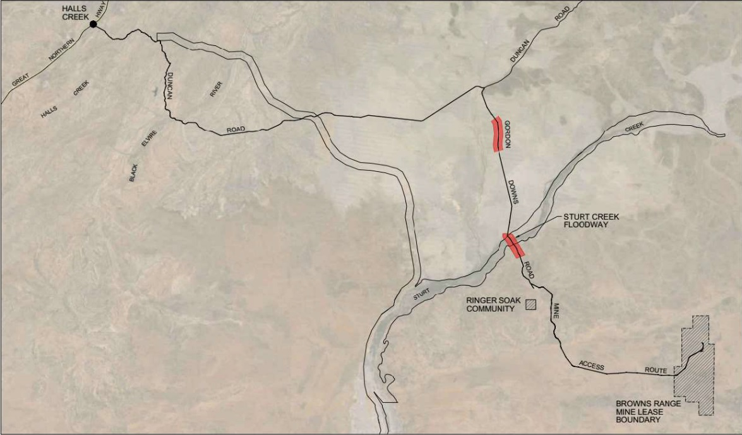

**Map showing the Duncan Road and Gordon Down Road, linking Halls Creek and Ringer Soak.**

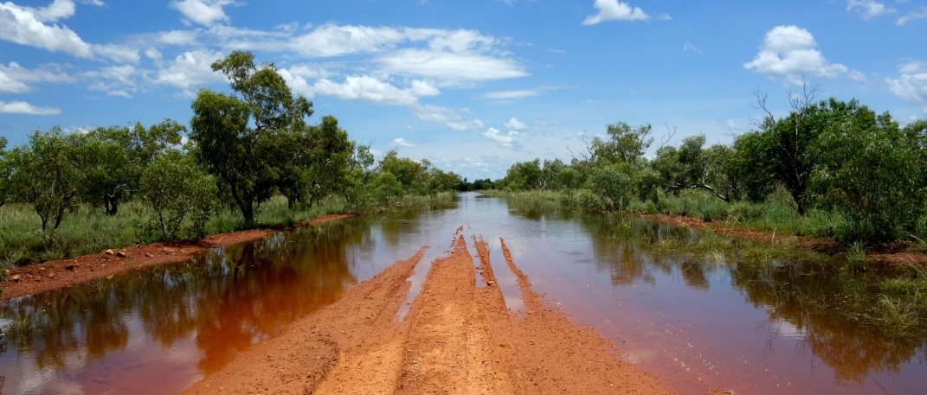

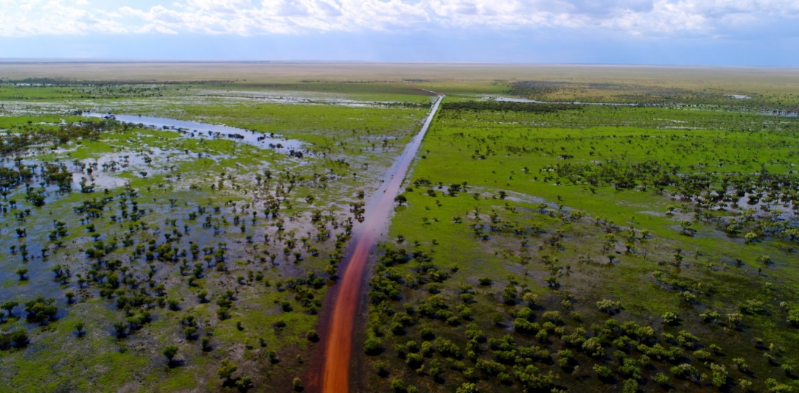

***Sturt Creek Crossing on Gordon Downs Road, February 2017: shows extent of flooding along road – some 3 kilometers***

**Contacts:**

George Bauk [gbauk@northernminerals.com.au](mailto:gbauk@northernminerals.com.au) 0408 931 746

Astrid Serventy [aserventy@canningspurple.com.au](mailto:aserventy@canningspurple.com.au) 0407 383 117

**January 2019**

**Attachments**

* Letter of support from Senator the Hon. Matthew Canavan, Minister for Resources and Northern Australia
* Letter of support from Hon. Minister MacTiernan MLC, Minister for Regional Development; Agriculture and Food; Ports; Minister assisting the Minister for State Development; Jobs and Trade
* Letter of support from the Hon Minister McCormack MP, Deputy Prime Minister, Minister for Infrastructure, Transport and Regional Development