2019-20 FEDERAL BUDGET SUBMISION
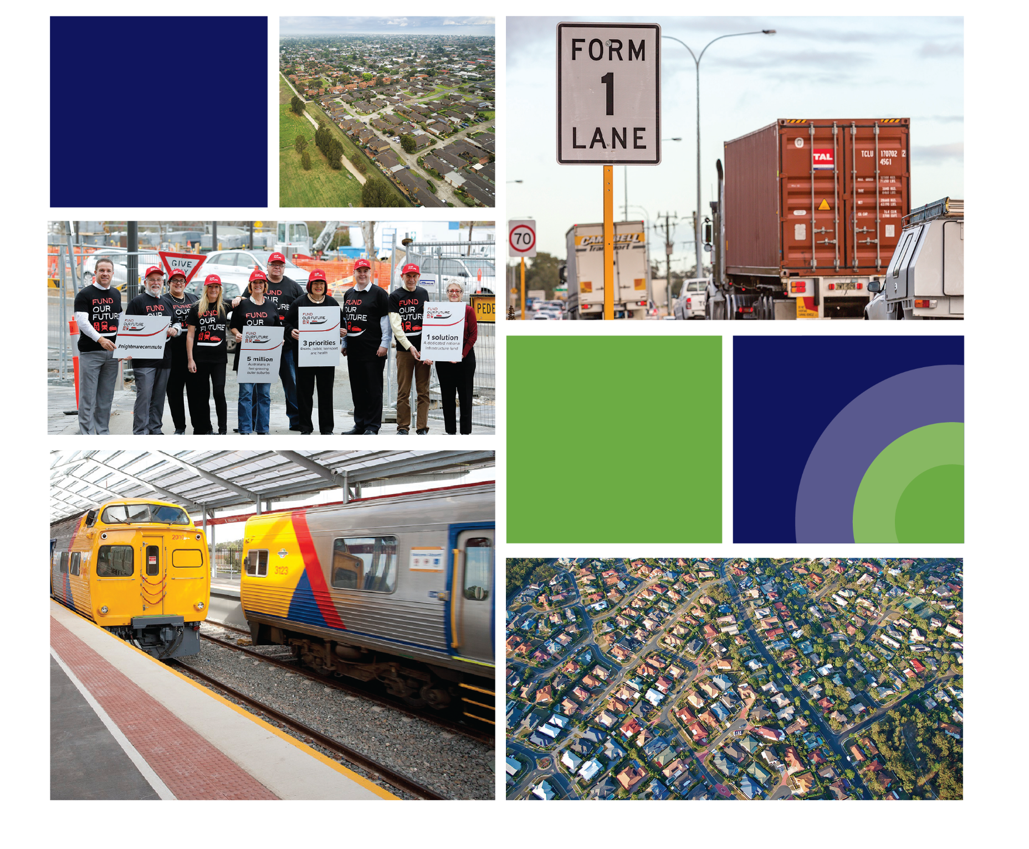

CONTENTS

THE NATIONAL GROWTH AREAS ALLIANCE 3
SUMMARY OF 2019-20 BUDGET RECOMMENDATIONS 3
THE FAST GROWING OUTER SUBURBS 4
LOOKING TO THE FUTURE 5
BUILDING BLOCKS FOR GOOD GROWTH 5
Reform and Rebalance 5
People and Place-based Investment 6
Connect Communities 7
Accelerate Economic Transition 8
Innovate: funding, financing and governance mechanisms 9
REFERENCES 9

CONTACT

Bronwen Clark
Executive Officer
National Growth Areas Alliance
bronwen.clark@ngaa.org.au
Mob: 0448 401 257

THE NATIONAL GROWTH AREAS ALLIANCE
The National Growth Areas Alliance (The Alliance) is the peak body for Local Government Areas across Australia which are experiencing rapid and sustained population growth and are located on the outskirts of our capital cities. We refer to these areas as Australia’s Fast Growing Outer Suburbs.

SUMMARY OF 2019-20 BUDGET RECOMMENDATIONS

Reform and Rebalance
- Install a Fast Growing Outer Suburbs reference group to support the federal government’s national population growth and infrastructure planning.

People and Place-based Investment
- A Co-investment Community Infrastructure Fund for Growth Areas to fill the clear and significant gap in available funding for community facilities in growth areas.
- Commitments to ongoing service delivery for growth area communities.

Connect Communities
- Target infrastructure investment, including through the Urban Congestion Fund, in key projects which connects growth area communities, unlocks productivity and brings jobs close to home including: roads of significance, commuter rail, commuter hubs, grade separation and digital infrastructure.

Accelerate Economic Transition
- Provide direct funding via a co-investment model with local and state government to accelerate targeted precinct development
- Support transformational infrastructure projects in growth areas to drive productivity and employment growth.

Innovate: funding, financing and governance mechanisms
- Invest in a capacity building program for collaborating local governments to identify and prepare suitable proposals for consideration for a ‘City Deal’ project.
- Leverage the learnings from the current City Deals to inform improved and replicable models to enhance future deals for local government, including, but not limited, to Planning Partnerships and Governance and Collaboration models.
- Accelerate support for alternative funding and financing mechanisms including but not limited to, incentive-based payments or concessions for targeted developments, public- private partnerships, co-investment models and value capture.

THE FAST GROWING OUTER SUBURBS
The Fast Growing Outer Suburbs are defined as those suburbs surrounding Australia’s capital cities, with an annual population growth rate greater than 2 per cent per annum, characterized by rapid greenfield, low density residential development for a largely commuter workforce, with large tracts of employment lands, typically supporting manufacturing, freight and logistics.

The Alliance’s 2018 State of Australia’s Fast Growing Suburbs report, states that these suburbs are in transition, economically as well as demographically. Their populations and economies are becoming more diverse. Critically, the role of the Fast Growing Outer Suburbs to national productivity is pivotal – with the potential to connect the growing skilled labour market to industry.

Almost one in five Australians now call the outer suburbs home. These suburbs are growing by around 3.0% per year, well above the Australian rate (1.7%). But the nature of this growth is changing - the Fast Growing Outer Suburbs are home to a diverse mix of age groups, offering opportunities for first homebuyers, upgraders and retirees. More residents are living in medium and high density housing than ever before, renting is becoming more common and the population has become more culturally diverse.

The economic role and function of the Fast Growing Outer Suburbs is generally geared toward its large resident base but they also have important export industries such as manufacturing and freight and logistics. The jobs analysis suggests that the traditional economic role and function is transitioning, with several indicators showing early signs of entrepreneurial activity.
- The Fast Growing Outer Suburbs are among the largest growing employment areas in Australia, with nine featuring among the top 25 growth LGAs between 2011 and 2016. On average, employment has grown by around 2.6% per year, well above the national rate of 1.2% per year.
- The share of high skilled jobs has increased across many industries, with health, education and professional services leading the way.

For the Fast Growing Outer Suburbs to continue this pivotal role in accommodating population growth, the planning and timely delivery of supporting infrastructure, particularly transport and community infrastructure, is vital.

A plan for sustainable city growth that provides transport infrastructure to connect people to local and regionally accessible jobs, social infrastructure and green space to create thriving, liveable local communities, will ensure the Fast Growing Outer Suburbs continue to successfully contribute to national productivity.

Ultimately, failing to plan and invest in the infrastructure that enables a successful transition to the new economy will put national productivity at stake.

LOOKING TO THE FUTURE
Australia’s Fast Growing Outer Suburbs are a secure investment for the Federal Government. The 2019-20 Federal Budget is the chance for Government policy and spending to catch up with the five million people already living, working, raising families, building homes, growing businesses and creating new communities in Australia’s Fast Growing Outer Suburbs.

The demographic and economic changes that are occurring in our cities are profound. With one in every five Australian citizens living in a Fast Growing Outer Suburb, the right investment in these areas will not only impact local communities, but the nation.

Our vision for communities in the outer suburbs of every city is clear – each citizen deserves access to safe, sustainable, high amenity places with the opportunity to work and study closer to home or in connected centres further afield; building resilient, liveable and productive communities.

BUILDING BLOCKS FOR GOOD GROWTH
The Alliance calls on Federal and State Governments to make Australia’s unprecedented population growth ‘good growth’, using the following building blocks for future policy and investment decisions:

Reform and Rebalance
Rebalancing the spatial structure of our capital cities needs public policy reform and investment that supports distributing and diversifying jobs and housing more evenly across metropolitan areas.

Australia’s larger capital cities are now experiencing the challenges that come with sustained and unbalanced dispersal of population growth. The economic gains of concentrating economic activity in Central Business Districts are being outweighed by productivity lost in travel-time and congestion. In 2016, the job deficit position was 69 for every 100 workers living in the outer suburbs with up to 80 per cent of workers across the nation commuting from the outer suburbs.

Interventions that better align the distribution of new jobs growth, transport and social infrastructure to Fast Growing Outer Suburbs will support polycentric and better performing cities, characterised by multiple activity hubs critical for the nation’s economic and social sustainability.

Importantly, the Alliance supports outcomes that will prevent the continued isolation of growth communities already burdened with poor access to the right job opportunities, infrastructure and services. Metropolitan planning must adopt an integrated and place-based approach to development and infrastructure sequencing.

Recommendations:
- Install a Fast Growing Outer Suburbs reference group to support the federal government’s national population growth and infrastructure planning.

People and Place-based Investment
As we rebalance the structure of our cities at a metropolitan scale to accommodate growth, concurrent place-based local and neighbourhood planning and design will bring together the critical elements required to support productive, liveable and resilient places for people to live and work and for businesses to invest.

Place-based urban planning demands an urban configuration where residents can access work, study, cultural, recreational facilities and essential services such as healthcare within minutes of their home - reducing congestion and emissions, and returning time to residents for greater social and family connectivity, health and well-being.

Recommendation:
- A Co-investment Community Infrastructure Fund for Growth Areas. There is a clear and significant gap in available funding for community facilities in growth areas. Co-investment between three levels of government assisted by developer contributions is needed to ensure sufficient community facilities in growth areas including:
  - Regional-level sporting precincts in Perth’s growing suburbs through a special purpose fund, including:
    - Alkimos Regional Open Spaces
    - Butler North District Open Space
    - Kingsway Regional Sporting Complex Development
    - Regional North Coast Swimming Pool
    - Ellenbrook Indoor Leisure Centre in Swan
    - Dixon Reserve in Cockburn
    - Keirnan Park Recreation Precinct in Serpentine-Jarrahdale
    - Armadale Regional Recreational Reserve
    - Sutherland Park in Gosnells
  - Regional Soccer Centre of Excellence in the City of Casey in south east Melbourne.
  - Sports facilities and community hub in the Mernda in the City of Whittlesea
  - Community centres, sports fields and kindergartens in the City of Hume
  - Community facilities in Blacktown City Council in Sydney’s north west growth area where there is a significant shortfall in funding for basic community facilities in new housing estates.
  - Community Workshops to provide a home for a range of community groups in the City of Swan in response to changing demographics and aging facilities
  - Autism Regional Intervention Centre in Cardinia Shire Council
  - Continued funding of 15 hrs of Kindergarten. Since 2013, Australia’s federal, state and territory governments have agreed to jointly fund kinder for all Australian 4-year-olds. The federal government contributes around one-third of total funding.

Connect Communities
The Bureau of Infrastructure, Transport and Regional Economics estimated that congestion cost Australia $16.5 billion in 2015. Without major policy changes, congestion costs are predicted to reach between $27.7 and $37.3 billion by 2030. The communities of the Fast Growing Outer Suburbs need improved roads with reliable travel times, better public transport, commuter parking and pathways for active transport. Transport is critical to growing healthy and productive cities where people are connected to jobs.

Recommendations:
- Target infrastructure investment, including through the Urban Congestion Fund, in key projects which connects growth area communities, unlocks productivity and brings jobs close to home including: roads of significance, commuter rail, commuter hubs, grade separation and digital infrastructure:
  - Access to Berwick Health and Education Precinct in the City of Casey
  - Access for residents of the City of Casey and Shire of Cardinia to Jobs Precincts through Thompsons Road Extension, Racecourse Road Pakenham upgrade, Princes Highway Intersection Upgrades, Southern Dandenong Bypass Extension and Glassnocks Road Extension
  - Western Highway Upgrade in the City of Melton to urban freeway standard
  - Duplications of key arterial roads in the City of Hume
  - Fast track consideration of the E6 freeway from the Hume Freeway to the M80 Ring Road in Melbourne’s north west
  - Fund a feasibility study into the Wollert Transport Corridor in the City of Whittlesea to connect three new town centres with employment and health precincts
  - In the City of Wyndham, a comprehensive freight infrastructure investment plan, including running the new Inland Rail link via the Outer Metropolitan Ring corridor; building the Western Interstate Freight Terminal at Truganina; and fast-tracking work on a port freight rail shuttle

  - Fast track completion of the connector road in the Mount Barker Growth Areas
  - Duplication of Curtis Road in Munno Para in the City of Playford

  - Castlereagh Connection and extended Mulgoa Road upgrade in the City of Penrith
  - Road and public transport projects to service the City of Blacktown’s future population of 522,000 in 2036.
  - Stage 1 of Western Sydney’s North South Rail Line to St Marys to be operating by 2026 planning and funding for entire North South Rail from Macarthur to Tallawong
  - Electrified rail past Macarthur station to improve access for current residents of the Shire of Wollondilly

  - Removal of eight level crossings on the Transperth Network within the City of Gosnells that significantly impact traffic flow.
  - Duplication of Flynn Drive in the City of Wanneroo to facilitate access to the Neerabup Industrial Area

Accelerate Economic Transition
The Fast Growing Outer Suburbs have a pivotal role in the nation’s economy by providing affordable housing to a large resident base and also employment land for export industries such as manufacturing, freight and logistics. They account for more than 11 per cent of GDP, despite making up only six per cent of Australia’s LGAs. To support the economic transition in the Fast Growing Outer Suburbs, we look to the expanding role of freight and logistics and the transition to knowledge intensity jobs.

Health, education and professional services are driving most of the high skilled growth in the outer suburbs, with 40 percent of the jobs growth over the last 5 years in high skilled occupations. Given the historic reliance on population and construction-based employment and the constraints on greenfield development, it is critical to support these seeds of transition to ensure that the Fast Growing Outer Suburbs secure a growing and equitable share of high-tech jobs.

The Fast Growing Outer Suburbs need the support of transformational infrastructure to successfully transition to the service and knowledge based economy and continue to contribute to economic nation building. This includes transport and digital infrastructure and economic assets such as airports, universities and hospitals. From 2011 to 2016, the outer suburbs captured a growing labour pool with 35 per cent population growth but only received 13 per cent of the asset growth (non-dwelling).

Recommendations:
- Provide direct funding via a co-investment model with local and state government to accelerate targeted precinct development in line with the Australian Governments, Statement of Principles for Australian Innovation Precincts:
  - Lyell McEwan Health Precinct, City of Playford, South Australia
  - Mount Barker Innovation and Gig City Hub, City of Mt Barker, South Australia

- Develop a Master Plan and a business case for the South East Melbourne Airport. This includes finalising the preferred site and apply the required planning protections for the site, flights paths, noise contours and the rail corridor that will connect the site to the rail network.

- The Armadale City Centre is the only one of Perth’s eight Strategic Metropolitan Centres without a purpose built Higher Education/TAFE campus. Given there are currently 27 primary and 12 high schools in the City, with more to come, a pathway and improved access to higher education services for its younger citizens is clearly needed.

- Economic and social development through recycled water initiatives in Mount Barker District Council

- A collaboration hub in the Campbelltown CBD will provide opportunities for employees to work closer to home, reducing already extensive commute times, and have a positive impact on general health benefits of the broader community.

Innovate: funding, financing and governance mechanisms
For the nation to keep pace, or even catch up, on the infrastructure and services needed to support the productive growth of our fastest growing cities, new funding and financing models together with planning and governance frameworks, are critical to streamline the actions of all three levels of government.

Continued reform of the responsibilities shared between the three levels of government for planning, funding and delivery of strategic transport, economic and community development infrastructure is the only way forward. Sector-led infrastructure at state level leads to uncoordinated outcomes and assets, with communities suffering from delivery lags in critical community and social infrastructure.

Recommendations:
- Invest in a capacity building program for collaborating local governments to identify and prepare suitable proposals for consideration for a ‘City Deal’ project.

- Leverage the learnings from the current City Deals to inform improved and replicable models to enhance future deals for local government, including, but not limited, to Planning Partnerships and Governance and Collaboration models.

- Federal government to accelerate support for alternative funding and financing mechanisms including but not limited to, incentive-based payments or concessions for targeted developments, public- private partnerships, co-investment models and value capture.

REFERENCES

Id Consulting, State of Australia’s Fast Growing Outer Suburbs, The Economic and Demographic transition of the Fast Growing Outer Suburbs, 2018
ibid, pp1-2
Id Consulting, State of Australia’s Fast Growing Outer Suburbs, The Economic and Demographic transition of the Fast Growing Outer Suburbs, 2018, p 9
ibid, pp 29-30
Australian Automobile Association, (2018), Road Congestion in Australia, p 4-5
ibid, p2
ibid p20-28
Ibid

