SECTION 4: CASE STUDIES

4.1: Introduction
This section presents case studies of Treasury’s forecasting performance. The case studies relate to the most recent challenges confronting forecasters, namely Mining Boom Mark I (2003-04 to 2007-08) and the global financial crisis (GFC) and Mining Boom Mark II (2008-09 to 2011-12).
Treasury underestimated the extent of the rise in the terms of trade during Mining Boom Mark I, which led to the underestimation of nominal economic outcomes and, in turn, taxation revenue, over the period. In contrast, during the GFC and Mining Boom Mark II, taxation revenue growth has generally been overestimated, with taxation receipts having struggled to recover from their post-crisis lows, as accumulated losses continued to flow through the tax system.
The Budget forecast errors (forecast minus actuals) over these periods for nominal GDP and taxation revenue growth are shown in Figure 4.1, below.
Figure 4.1: Budget Forecast Errors for Nominal GDP and Taxation Revenue Growth
As part of Treasury’s process of continuous internal evaluation, these forecasting errors have resulted in several improvements to economic and revenue forecasting methodology and process.

4.2: Mining Boom Mark I

Summary
- In common with many other forecasters, Treasury underestimated the extent of the rise in Australia’s terms of trade during Mining Boom Mark I, which led to the underestimation of nominal economic outcomes. This reflected misjudgement of both demand and supply-side developments in the mining sector.
- On the demand side, economic growth in China consistently exceeded forecasts over this period, on average by around 2½ percentage points per annum. As a result, the demand for steel and, in turn, iron ore and metallurgical coal, was underestimated.
- Treasury also overestimated the speed at which global mining production would respond to the rise in mining output prices. Treasury’s assessment was largely based on the mining companies’ global projections for production and export volumes, which consistently exceeded actual outcomes. In Australia this partly reflected infrastructure bottlenecks and the impact of natural disasters.
- In response to these forecast errors, Treasury has progressed several initiatives designed to enhance its capability to forecast commodity prices and volumes. As part of the JEFG process, a balance of payments subcommittee has been established to focus specifically on the outlook for bulk commodities, comprising Treasury, the RBA, BREE and the ABS. Treasury’s business liaison program has been refocused to place greater weight on the mining industry. A major project is also underway which uses detailed projections of commodity supply and demand to model the outlook for commodity prices through the medium-term.
- Taxation revenue outcomes were also underestimated, largely reflecting the underestimation of the strength of the nominal economy during this period. Counterfactual analysis finds that the revenue forecast errors would have been small if the actual economic outcomes had been known at the time that the revenue forecasts were being prepared.
- Capital gains tax (CGT) was a major source of forecast error during Mining Boom Mark I, in large part, due to the underestimation of the sharp rise in asset prices over the period.
- In response to these forecast errors, Treasury overhauled its forecasting models to take better account of the volatile nature of this head of revenue. CGT is now explicitly forecast in a stock model (rather than being grown in line with other heads of revenue), which better allows for periods of rapid asset price growth and the accumulation of capital gains and losses.

Background
The first phase of the mining boom spanned the five-year period to 2007-08, with rapid rates of industrialisation in Asia, particularly in China, increasing worldwide demand for natural resources and in turn, underpinning an investment boom and a sharp sustained rise in output prices in the mining sector. As a result, Australia’s terms of trade rose by almost 50 per cent from early 2004 until the onset of the GFC in 2008. The economy began to approach capacity constraints around 2006 and 2007, with unemployment heading down towards 4 per cent — a rate not seen since the early–1970s. Monetary policy was tightened to address inflationary pressures, with inflation peaking at 5 per cent in mid-2008.

Macroeconomic forecasting performance
In common with many other forecasters, a feature of Treasury’s macroeconomic forecasts during Mining Boom Mark I was the underestimation of the sharp rise in Australia’s terms of trade, and in turn nominal GDP growth, over the period. The main driver of the rise in the terms of trade, and hence the main driver of Treasury’s forecast error, was a sustained increase in iron ore and coal prices. Both demand and supply-side surprises explain the forecast errors. Figure 4.2 highlights the consistent underestimation of the rise in the terms of trade over successive Budgets.
Figure 4.2: Budget Forecasts of Australia’s Terms of Trade
Note: The figure plots the forecast level of the terms of trade against outcomes, with the forecast level derived from forecast growth rates of the terms of trade from successive Budgets beginning with the 2005-06 Budget.
On the demand side, forecasters consistently underestimated economic growth in China and other emerging economies and hence underestimated the demand for steel and in turn iron ore and metallurgical coal. This pattern was observed over the period of the first mining boom, with forecasts of the Chinese economy only recently becoming more accurate. Over the period 2003 to 2007, the average forecast error was 2½ percentage points per annum. Figure 4.3 shows the Consensus Economics two-year forecasts for Chinese real GDP growth against outcomes.
Figure 4.3: Consensus Economics Two-year Forecasts for Chinese Real GDP growth
Source: Consensus Economics and Treasury estimates
On the supply side, despite strong growth in mining investment in response to the sharp rise in commodity prices, growth in mining production and in turn export volumes was consistently slower than expected. As early as the 2005-06 Budget, the expectation was that production would quickly catch-up with forecast demand. The expected supply response was based on what was perceived at the time to be a conservative assessment of mining companies’ global projections for production and export volumes, which consistently exceeded actual outcomes. In Australia this has partly reflected infrastructure bottlenecks and the impact of natural disasters. Figure 4.4 shows that non-rural commodity export volume forecasts have been consistently overstated, with the error largely due to overestimation of iron ore and coal export volumes.
Figure 4.4: Evolution of Non-Rural Commodity Export Price and Volume Growth Forecasts
Non-rural commodity export prices | Non-rural commodity export volumes
As a result of this experience Treasury has progressed several initiatives to build a deeper understanding of developments in China and other emerging market economies and the links these developments have with Australia. In particular:
- a dedicated unit has been established within Treasury that focusses on the Chinese economy and Treasury representation in Asia has been enhanced by opening up a new post in India;
- there has been a greater focus on developing resource industry contacts as part of Treasury’s business liaison program;
- a BOP subcommittee meeting has been incorporated into the JEFG process, drawing upon the expertise of the Bureau of Resources and Energy Economics to forecast the outlook for bulk commodities;
- more resources have been devoted to forecasting non-rural commodity production, export volumes and prices; and
- a major project is currently underway using industry data to develop a methodology for projecting bulk non-rural commodity export prices based on a medium-term supply and demand framework, supplemented by a comparison with projections by BREE, Consensus and private sector providers.

Revenue forecasting performance
As observed with Treasury’s nominal economy growth forecasts, taxation revenue growth was also underestimated during Mining Boom Mark I. In particular, nominal economic growth was underestimated by an average of 1.8 percentage points per annum, compared with an average forecast error of 2.9 percentage points for taxation revenue growth (Figure 4.5).
Figure 4.5: Budget Forecast Errors for Growth in Nominal GDP and Taxation Revenue
In the case of taxation revenue forecast errors, it is useful to distinguish between those that reflect errors in the macroeconomic forecasts and those that reflect other sources of error. The latter might include:
- error in items that are within scope of the tax base, but not the economic base;
- error in estimates of taxation revenue elasticities;
- error in estimates of the timing of the receipt of taxation revenue; and
- miscellaneous factors, such as errors in Budget policy costings, post-Budget policy decisions and court decisions relating to tax law interpretation.
A counterfactual exercise has been undertaken to decompose taxation revenue forecast errors into those that reflect macroeconomic forecast errors and those that reflect other sources of error. The results of this exercise are detailed in Figure 4.6, below. The left-hand panel of Figure 4.6 shows the actual forecast errors over Mining Boom Mark I. The right-hand panel shows the results of a counterfactual exercise, which estimates the revenue forecast errors that would have occurred if actual economic outcomes had been known at the time that the forecasts were being prepared. The presence of significant revenue forecast error in the counterfactual would suggest scope to improve revenue forecasting methodology.
The counterfactual exercise assumes in particular that the outcomes for compensation of employees (the income tax withholding economic base), consumption subject to GST (the GST economic base) and gross operating surplus (the corporate tax economic base) are known. In the case of capital gains tax, it is assumed that actual asset price outcomes are known (that is, share prices and house prices). Not all heads of revenue have been included in this exercise, although the four heads of revenue considered comprise around 85 per cent of taxation revenue and on average account for around 80 per cent of the forecast error over the case study period.
Figure 4.6: Contribution to Budget Revenue Forecast Error by Head of Revenue
Actual forecast errors | Counterfactual forecast errors
The counterfactual exercise finds that most of the taxation revenue forecasting error during Mining Boom Mark I can be attributed to errors in the nominal economy forecasts. The average actual revenue forecast error during Mining Boom Mark I was (an underestimate of) $6.2 billion, whereas the average estimated forecast error under the counterfactual exercise is (an overestimate of) $0.3 billion. This suggests that the revenue forecast error reflects the underestimation of the strength of the nominal economy during Mining Boom Mark I, rather than any systematic tendency to underestimate revenue over this period.
The sections, below, discuss the errors in each of the major heads of revenue over this period.

Income Tax Withholding
Income tax withholding is the largest tax revenue head, comprising over 45 per cent of total taxation revenue. The relevant economic base for income tax withholding is compensation of employees, which measures the total wage bill of the economy (and can be split into the total number of employees multiplied by the average wage). The correlation between the growth in income tax withholding and the growth in compensation of employees over the past decade (2002-03 to 2011-12) has been 0.87, indicating a good relationship.
Figure 4.7 below shows the forecast errors for compensation of employees during Mining Boom Mark I. The strength in employment growth was consistently underestimated during this period, as was average wages growth, albeit to a lesser extent. The forecast errors are significantly reduced when the actual employment and wages outcomes are applied to the income tax withholding model (as shown in the right-hand panel of Figure 4.6, above), indicating that there was minimal forecasting error beyond the underestimation of the strength of the labour market over this period.
Figure 4.7: Budget Forecast Errors for Growth in Compensation of Employees and Income Tax Withholding

Company tax
Company tax is the second largest revenue head, comprising over 20 per cent of total revenue. The main component of the economic base for company tax is gross operating surplus (GOS). The correlation between the growth in company tax and the growth in GOS over the past decade has been 0.26, indicating that the relationship between the two series is not particularly strong. This is due to the conceptual differences between corporate taxable income and GOS, and the lag between the timing of the economic activity and the associated receipt of taxation revenue, which are discussed further in Section 4.3.
Figure 4.8 shows the Budget forecast errors for GOS and company tax (excluding CGT). The strength of GOS was generally underestimated during Mining Boom Mark I, which led to the underestimation of company tax.
Figure 4.8: Budget Forecast Errors for Growth in Gross Operating Surplus and Company Tax
The company tax forecast errors are significantly reduced when the actual GOS outcomes are applied to the company tax model, (as shown in the right-hand panel of Figure 4.6, above).

Goods and Services Tax
The goods and services tax (GST) comprises around 15 per cent of total taxation revenue. The primary economic base for GST is consumption subject to GST. The correlation between growth in GST and consumption subject to GST over the past decade has been 0.75, indicating a good relationship between the two series.
GST was not a significant source of forecast error during Mining Boom Mark I; however, the head of revenue was typically underestimated (as shown in the left-hand panel of Figure 4.6, above). When actual outcomes for consumption subject to GST are applied to the GST model, the forecast errors are reduced (as shown in the right-hand panel of Figure 4.6 above) and display less bias. This indicates that there was minimal error in the GST forecasts over this period beyond a slight underestimation of the strength of consumption subject to GST.

Capital gains tax
Capital gains tax (CGT) is a relatively small, but very volatile, head of revenue. This reflects volatility in asset prices and variability in both realisation rates (since CGT is only payable when assets are sold) and also the extent to which capital losses are offset against capital gains. Over the period of the case study, the annual growth rate of CGT has varied from a rise of 60 per cent in 2004-05 to a fall of 43 per cent in 2009-10, resulting in CGT being a large source of forecast error.
The stock of accrued capital gains accelerated rapidly during Mining Boom Mark I, with asset values rising at a historically rapid rate. Over this period, CGT was significantly underestimated, particularly in 2005-06 and 2006-07 (as shown in the left-hand panel of Figure 4.6).
The CGT forecast errors are significantly reduced when the actual outcomes for equity and house prices are applied to the current CGT model, (as shown in the right-hand panel of Figure 4.6 above) and the bias in the forecast errors disappears. Treasury does not forecast these asset prices, but instead adopts the technical assumption that asset prices grow in line with nominal GDP growth. The counterfactual exercise shows that if the technical assumption had accurately predicted asset prices, the current CGT model would not have systematically underestimated revenue over this period.

Capital gains tax model improvements
As a result of Treasury’s forecasting experience during Mining Boom Mark I, the CGT models have been overhauled. The development has been an ongoing process, with the first improvements implemented in 2006-07, following the sharp rise in CGT revenue in 2005-06.
There are three broad types of CGT taxpayers — individuals, companies and superannuation funds. The previous methodology did not separately model CGT for individuals and companies. It effectively assumed that CGT collections would grow in line with the associated taxpayer revenue stream; for example CGT paid by companies would grow in line with company tax. CGT paid by superannuation funds was forecast using a simple model based on recent trends and judgement.
The new CGT models are structured to mirror the balance sheet of relevant taxpayers, by tracking the stock of assets subject to CGT and their price movements. Figure 4.25 (Appendix A) provides an overview of the model for CGT paid by superannuation funds, by way of an example.
The changes to the CGT modelling framework have improved forecast performance. Figure 4.9 shows the forecast errors for CGT over the recent period, compared with the errors that would have been generated using the old CGT forecasting methodology for individuals and companies (which was in place until 2006-07). The average absolute forecast error for CGT since 2006-07 has been $2.8 billion per annum. However, if the old methodology had been in place the average absolute forecast error would have been much larger at $5.3 billion per annum.
Figure 4.9: Capital Gains Tax Forecast Errors

4.3: Global Financial Crisis and Mining Boom Mark II

Summary
- In common with many other forecasters, Treasury did not predict the degeneration of the US subprime crisis into the GFC in 2008-09 and subsequently overestimated the impact of the crisis on economic growth in 2009-10.
- Treasury’s forecasting error for economic growth in 2009-10 largely reflected misjudgements of the efficacy of Australia’s policy response and the relatively early, and strong, recovery in economic growth in most of our major trading partners throughout 2009.
- One lesson from this experience is the importance of having in-house expertise to understand the operation of financial markets and their linkages with the real economy. To this end the Treasury has employed a technical specialist with deep financial markets experience and created a dedicated unit for this purpose.
- Taxation revenue outcomes were consistently overestimated during this period, despite the nominal economic forecast errors being close to zero on average. Counterfactual analysis finds that even if the economic outcomes had been known at the time the forecasts were being prepared, revenue would still have been overestimated, primarily reflecting company tax errors.
- In response to the perceived source of these taxation revenue forecasting errors, Treasury is currently developing a three sector company tax model that takes better account of the different characteristics of these sectors for taxation purposes, for example, the capital-intensive nature of the mining sector, and the measurement of finance sector income in the National Accounts.

Background
The world economy experienced a severe financial and economic shock in the second half of 2008. The Global Financial Crisis (GFC) began in 2007 with the US sub-prime crisis and the crisis intensified dramatically in September 2008 with the collapse of Lehman Brothers. During this period, financial conditions deteriorated rapidly, financial and real asset prices collapsed, and business and consumer confidence fell steeply. The GFC saw the world economy change course sharply from a five-year period of above-trend growth to the deepest recession since the Great Depression.
The Australian economy performed better than other advanced economies during the GFC. Although financial conditions were stressed, the financial system held up remarkably well; the economy slowed, but did not fall into recession; and while unemployment rose, it did so by far less than in many other advanced economies. The strong performance of the Australian economy largely reflected the strength of the Australian financial system and public finances; the rapid deployment of fiscal stimulus measures; the first effects of a significant easing in monetary policy; and a pickup in demand from China which partly offset pronounced external weakness elsewhere. More broadly, it also reflected improved policy and institutional arrangements in Australia following a quarter century of reforms that have made the Australian economy much more resilient to external shocks.
As the impact of the GFC subsided, Australia’s terms of trade rebounded, with the emergence of a second phase of the mining boom, and reached a new record high in late 2011 (Mining Boom Mark II). In contrast to Mining Boom Mark I, the second phase occurred against a backdrop of global uncertainty and balance sheet consolidation by the corporate and household sectors, reflected in a significant decline in credit growth. Sectors aligned with mineral resources have grown strongly, while there has been pressure on some domestic manufacturing and trade-exposed sectors from the high level of the Australian dollar over this period.

Economic forecasting performance
In common with other forecasters, Treasury did not predict the degeneration of the US subprime crisis into the GFC in 2008-09 and subsequently overestimated the impact of the crisis on the nominal economy in 2009-10.
The impact of the GFC on Australia was expected to be severe, with the 2009-10 Budget, prepared in May 2009, the first in history to forecast a contraction in both real and nominal GDP. Gruen (2010) notes that at the time the 2009-10 Budget forecasts were being prepared the international context was dire, with forecasters making significant downgrades to global growth and global trade. For example, as the global outlook deteriorated, the IMF downgraded its forecasts for 2009 global GDP growth by 4.3 percentage points between October 2008 and April 2009. Over the same period, it downgraded its forecasts for advanced economy growth by 4.3 percentage points and for global trade volumes by over 15 percentage points. In line with these forecasters, Treasury significantly downgraded its forecasts for global growth and correspondingly Australian goods and services export volumes, using the IMF and OECD forecasts from their inter-country trade models as a guide.
Domestic indicators were also bleak (Gruen, 2010). At the time the 2009-10 Budget forecasts were being prepared, the latest comprehensive reading on the economy, the December quarter 2008 National Accounts, which was released in early March 2009, showed a contraction of 0.5 per cent. At the time, this was the weakest quarter — indeed the first negative quarter — since the December quarter 2000. With subsequent revisions to the National Accounts, that quarter now stands as the weakest since March 1983. The unemployment rate had also risen sharply from 4.1 per cent in August 2008 to 5.7 per cent in March 2009.
By the time the Budget forecasts were finalised in April 2009, the average Consensus forecast was predicting a contraction in Australia’s real economy in 2009 of around 0.6 per cent. As Figure 4.10 shows, the Budget forecast for a contraction of 0.9 per cent was around the median of the range of forecasts surveyed by Consensus in mid-April.
Figure 4.10: Forecasts for Australian real GDP growth in 2009, as at April 2009
Source: Consensus Economics (Survey date 14 April 2009), Treasury (Budget, 11 May 2009).
Although the real economy did experience a significant slowdown in 2009-10, it performed significantly better than Treasury expected, largely reflecting misjudgements of the efficacy of Australia’s policy response and the relatively early, and strong, recovery in economic growth in most of our major trading partners throughout 2009.
The largest contributions to the 2009-10 Budget forecast error for real GDP growth were from household consumption, exports and business investment. Household consumption was forecast to decline moderately in 2009-10. In the event, it grew by 2.5 per cent. As noted in Gruen (2010), expansionary monetary and fiscal policy appears to have been large enough and quick enough to convince consumers and businesses that the domestic slowdown would be relatively mild. In turn this supported confidence and led consumers and businesses to continue to spend. While the stimulus was explicitly factored into Treasury’s forecasts, it was also a contributing factor to the 2009-10 forecast errors.
The 2009-10 Budget forecast exports to contract sharply, by 4 per cent, in 2009-10. In the event, the outcomes were significantly better than forecast. The outlook for exports was heavily influenced by expert views on the scale of the global downturn at the time that the forecasts were being prepared. Within the export forecast error, the main contribution was from non-rural commodity exports, with smaller contributions from exports of elaborately transformed manufactures and other goods and services (Figure 4.11). Relative to the 2009-10 Budget forecasts, non-rural commodity exports performed significantly better than expected, with volumes exceeding forecasts by a significant margin.
Figure 4.11: Contribution to Budget Forecast Errors for Exports in 2009-10, by Component
The better-than-expected outcome for exports largely reflected the better-than-expected performance of non-Japan Asia, particularly China. Chinese economic activity shifted into more commodity-intensive sectors, particularly infrastructure spending associated with the Chinese government’s stimulus packages. There was also substitution away from Chinese domestic production and towards imports, as lower commodity prices resulted in the closure of some relatively high-cost Chinese production.
Business investment made the largest contribution to the 2009-10 Budget forecast error. Although, business investment contracted in 2009-10, the actual contraction was considerably less than forecast. As Figure 4.12 indicates, all components of business investment fell by less than expected, with machinery and equipment and non-residential construction finding greater-than-expected support from the macroeconomic stimulus, and engineering construction benefiting from a rebound in the outlook for resource commodities reflecting the stronger-than-expected growth performance of non-Japan Asia, particularly China.
Figure 4.12: Contribution to Budget Forecast Errors for Business Investment in 2009-10,
by Component
One lesson from this experience was the importance of having in-house expertise to understand the operation of financial markets, advances in financial market products and the linkages between financial markets and the real economy. To this end, Treasury has employed a technical specialist with deep financial markets experience and created a dedicated unit for this task.
The Review observes that the large forecasting errors seen during the GFC highlight the fact that during such extreme events the evolution of the economy is fundamentally less predictable than at other times. A large number of official agencies overseas also had large forecasting errors during this period (Figure 4.13). That suggests a case for greater use of risk assessments around the central forecasts, rather than necessarily a major overhaul of forecasting procedures.
This leads the Review to make the following recommendation:
Recommendation 8:
Scenario analysis is useful as a way of assessing the risks around the economic and revenue forecasts. Simulation models have an important role to play in this regard and further development of Treasury’s suite of models may be required to deliver this capability, including in relation to the international economic outlook.
Figure 4.13: Forecast Errors for Real GDP Growth for Calendar Year 2009, by Selected Official Agencies Overseas

Revenue forecasting performance
The outcomes for the nominal economy and taxation revenue diverged significantly during the GFC, largely reflecting the impact of accumulated losses on taxable incomes. During the GFC, taxation revenue fell by 6¼ per cent over 2008-09 and 2009-10, while nominal GDP continued to grow in year-average terms (Figure 4.14). This resulted in a large decline in the tax-to-GDP ratio.
Figure 4.14: Nominal GDP Growth versus Taxation Revenue Growth
Treasury’s forecast errors for the nominal economy and taxation revenue also diverged significantly during the GFC and Mining Boom Mark II. As shown in Figure 4.15, below, the Budget forecasts of nominal economic growth were underestimated by an average of 0.1 percentage points over this period, while taxation revenue growth was overestimated by an average of 4.0 percentage points.
Figure 4.15: Budget Forecast Errors for Growth in Nominal GDP and Taxation Revenue
The counterfactual exercise undertaken for Mining Boom Mark I has been repeated for this case study, with the results detailed in Figure 4.16. The left-hand panel of Figure 4.16 shows the actual revenue forecast errors and the right-hand panel shows estimates of the forecast errors that would have occurred if economic outcomes had been known at the time the forecasts were being prepared. The errors for most heads of revenue are reduced significantly in the counterfactual. However, in contrast to the Mining Boom Mark I analysis, the overestimation bias in the revenue forecasts does not disappear in the counterfactual. This is due to company tax overestimation errors, which actually materially increase in the first two years of the counterfactual. This finding will be examined in more detail, below.
Figure 4.16: Contribution to Budget Revenue Forecast Error by Head of Revenue
Actual forecast errors | Counterfactual forecast errors
The sections, below, discuss the errors in each of the major heads of revenue in turn over this period.

Income Tax Withholding
Income tax withholding was a relatively small source of error during the GFC and Mining Boom Mark II. The average error over this period for the forecasts of both income tax withholding and compensation of employees was just -0.1 of a percentage point. When the actual outcomes for compensation of employees are applied to the income tax withholding model, the forecast errors for income tax withholding are broadly unchanged (as shown in the right-hand panel of Figure 4.16).
Figure 4.17: Budget Forecast Errors for Growth in Compensation of Employees and Income Tax Withholding

Company Tax
Company tax made the largest contribution to the overall revenue forecast error in each of the years since the GFC (left hand panel of Figure 4.16). Company tax revenue is generally a significant source of forecast error as it is a relatively large, and volatile, head of revenue. This section discusses some factors that made company tax revenue forecasting difficult over this period. Figure 4.18, below, shows the forecast errors for GOS and company tax during the GFC and Mining Boom Mark II period. GOS was underestimated by an average of 1.0 percentage points per annum over this period, whereas company tax was overestimated by an average of 12.2 percentage points per annum.
Figure 4.18: Budget Forecast Errors for Growth in GOS and Company Tax
The relationship between GOS and company tax is complex. First, there are many conceptual differences between GOS and corporate taxable income. For example, corporate GOS is measured before deducting depreciation charges and debt-servicing interest expenses, and excludes holding gains or losses in trading stock and realised capital gains or losses in the assets and liabilities of the corporate sector. These conceptual differences are taken into account when translating forecasts of GOS (blue bars in the left-hand panel of Figure 4.19) into forecasts of company tax on an income-year basis (red bars in the left-hand panel of Figure 4.19).
Second, there are significant timing differences between these series that reflect the lag between the earning of economic profits and the receipt of the associated tax revenue. This means that company tax forecasts on an income year basis (red bars in the left-hand panel of Figure 4.19, below) need to be translated into company tax forecasts on a cash basis (red bars in the right-hand panel of Figure 4.19), which introduces a further potential source of forecast error.
Figure 4.24 in the appendix to this section provides more detail about the company tax model.
Figure 4.19: Company Tax Growth: Forecasts and Outcomes — Income-year and Cash
Note: Income-year company tax outcomes for 2010-11 or 2011-12 are not yet available.
In both 2008-09 and 2009-10, the company tax forecast on an income-year basis was closely aligned with the GOS forecast (the red and blue bars in the left-hand panel of Figure 4.19). However, the outcomes for the two series diverged significantly (the green and blue dots in the left-hand panel of Figure 4.19). GOS grew in total by 13.9 per cent over these two years, whereas company tax (income-year) fell in total by 8.9 per cent.
A major contributing factor to the weak outcome for company tax was high depreciation deductions (see Figure 4.20 below), relating to the huge increase in capital investment as part of the mining boom, and higher royalty expenses (also related to increased mining activity). As mentioned, GOS is measured gross of depreciation expenses. At the time, depreciation expenses were forecast separately in the company tax model based on historical trends. The methodology for forecasting depreciation deductions has been improved in light of this experience, and now utilises the investment forecasts produced by the macroeconomic forecasters.
Figure 4.20: Depreciation and Other Investment-related Deductions
Note: Deductions include depreciation, rents and royalties, research and development, mining exploration, capital expenditure, capital allowances and industry payments.
In addition, the timing adjustments made to the income-year forecast for 2009-10 proved to be inaccurate (as shown in the right-hand panel of Figure 4.19). Company tax was expected to fall by less on a cash, than on an income-year, basis, due to backwards-looking elements in the company tax payment system. In the event, company tax fell by around the same amount in 2009-10 on both a cash and income year basis. In fact, the company tax forecast for the 2009-10 income-year for a fall of around 10 per cent turned out to be reasonably accurate (left-hand panel of Figure 4.19), even though the cash forecasts for 2009-10 and 2010-11 were inaccurate. This, again, indicates problems with the assumptions made in relation to the timing of cash payments of company tax.
The majority of company tax is paid in quarterly instalments, based on an instalment rate derived from the most recently assessed tax return. This was expected to lead to overpayments of company tax on a cash basis in 2009-10, since it was a year of declining taxable profits. However, as companies became aware that the quarterly instalment payments that they were making in 2009-10 were likely to overestimate their yearly tax liability, they elected to vary down their instalments payments (to a greater extent than was anticipated in the forecasts).
Company tax revenue growth was also overestimated in 2010-11 and, to a lesser extent, in 2011-12. The reasons behind these forecast errors will be difficult to discern until tax return data are available for these income years. In both years, the company tax growth rates were adjusted upwards in translating from income-year to cash forecasts. This is based on the typical pattern of company tax payments after a downturn, where instalments rates are varied upwards as profits recover.
The counterfactual exercise finds that the forecast errors do not improve when the GOS outcomes are applied to the current company tax model (as shown in the right-hand panel of Figure 4.16, above). In particular, the overestimation of company tax increases in 2009-10, due to the GOS outcome being significantly higher than forecast, with flow-on implications for the 2010-11 forecast error, due to the lags in the company tax payment system.
Figure 4.21, below, shows the historical mismatch between estimates of company tax (income-year) based upon GOS and actual company tax (income-year) outcomes. This shows that even when all of the economic and tax schedule data are known, it is not possible to completely reconcile the actual company tax outcomes with GOS. That said, the relationship was stable over the five-year period between 2003-04 and 2007-08. In recent years the relationship appears to have deteriorated.
Figure 4.21: Actual Company Tax Collections versus Company Tax Calculated from GOS
Note: The ratio is set equal to one in 2003-04.
It is possible that future revisions to the GOS outcomes may improve the relationship between GOS and company tax in recent years. In the past, GOS has been revised significantly: for example, the outcome for growth in GOS in 2008-09 was revised upwards from 6.8 per cent, as first published, to 14.2 per cent (as at the June 2012 National Accounts). As they stand, the current GOS outcomes for 2008-09 and 2009-10 are particularly difficult to reconcile with the company tax outcomes through the GFC.
Significant work has been undertaken to improve the company tax model in response to the forecast errors that have been observed in recent years. In particular, Treasury is developing a three sector company tax model which splits the economy into mining, finance and insurance and other sectors. This should allow the model to take better account of the different characteristics of these sectors, such as:
- the greater role of the mining sector in the Australian economy and its capital-intensive nature;
- the measurement of the income of the finance sector in the National Accounts; and
- substituted accounting periods, which makes it more difficult to accurately estimate the timing of the receipt of cash payments of corporate tax. In particular many large financial companies operate on an accounting year ending in September and many large mining companies operate on an accounting year ending in December.
Notwithstanding these developments, due to the difficulty that Treasury has had forecasting revenue, in particular company tax revenue, the Review recommends that:
Recommendation 9:
Treasury should give further consideration to the appropriate balance between the top-down versus bottom-up approaches to forecasting revenue.

Recommendation 10:
Treasury, in conjunction with the ABS as necessary, should explore further ways of improving the current methodology for forecasting corporate tax, and also consider alternatives to the current methodology, which could perhaps be used to complement existing approaches.

GST
During the GFC period, the outcomes for GST revenue diverged significantly from the outcomes for its main economic base (consumption subject to GST), which presented challenges for forecasting. GST revenue fell in 2008-09, following the onset of the GFC (the light blue line in Figure 4.22). At the time, growth in consumption subject to GST fell only marginally (the blue line). This series has since been revised (the red line) and now better tracks GST revenue growth during 2008-09. However, a large discrepancy opened up again in 2011-12 between GST revenue and consumption subject to GST growth, with the National Accounts data again indicating a stronger economy than would be suggested by the GST revenue data.
Figure 4.22: GST and Consumption Subject to GST
When the consumption subject to GST outcomes are applied to the GST model, the forecast errors reduce significantly (as shown in the right-hand panel of Figure 4.16 above, the green bars), except in 2011-12. The consumption subject to GST outcome for 2011-12 may be revised in the future, as the ABS reconciles the National Accounts consumption data with the ATO tax collections data.

Capital gains tax
The extent of the run-up in CGT revenue during Mining Boom Mark I was unanticipated, as was the extent of the drop-off following the GFC. As shown in Figure 4.23 below, CGT peaked as a share of revenue in 2007-08 at 6.3 per cent of revenue in that year. The stock market began to decline in December 2007 and by 2010-11 CGT comprised only 2.3 per cent of taxation revenue.
Figure 4.23: Evolution of Capital Gains Tax Forecasts (as a Percentage of Taxation Revenue)

The CGT forecast errors reduce significantly when actual asset price outcomes are applied to the current model, (as shown in the right-hand panel of Figure 4.16, the light blue bars), indicating that if asset prices had been known at the time the forecasts were being prepared, the current CGT model would not have generally overestimated revenue over this period.
This observation leads the Review to recommend that:
Recommendation 11:
The technical specialist with deep financial market experience employed by Treasury should be tasked with improving the accuracy of the technical assumptions for equity and housing prices that are used to generate the capital gains tax revenue forecasts.

APPENDIX A: REVENUE FORECASTING MODELS

Current Company Tax Model (Figure 4.24)
Of the National Accounts variables forecast by DED, company tax is most closely related to gross operating surplus (GOS), which is a measure of company profits. However, the relationship is far from simple. There are many conceptual differences between GOS and corporate taxable income, including depreciation, the treatment of losses, net interest income and capital allowances. There are also significant timing differences between profits being earned and the receipt of the associated tax revenue. As a rule-of-thumb, around 60 per cent of company tax is received in the year the profit is generated, with the remaining 40 per cent received in the following year. This means that at times when profits are varying significantly from year-to-year, as occurred over the GFC period, incorrect assumptions around timing can be a major source of forecast error.
Part A, of Figure 4.24, below, shows the steps undertaken to translate from GOS (economic income on a National Accounts basis) to gross operating profit/loss subject to tax (economic income on a tax basis). Part B shows how deductions and other items are subtracted, and the average tax rate is applied, to generate company tax on an income-year basis (the forecasts for which are shown in the left-hand panel of Figure 4.19, the blue bars). Part C shows how timing adjustments are applied, and government policy measures are taken into account, to generate company tax on a cash basis (the forecasts for which are shown in the right-hand panel of Figure 4.19, the red bars).

Capital Gains Tax Forecasting Model — Superannuation Funds (Figure 4.25)
Broadly, the first step in forecasting CGT payable by superannuation funds is to estimate the stock of unrealised gains and losses, as at the end of the previous year. Unpublished APRA and ATO data are used to assist in this process. Since these data are generally released with a lag, modelled estimates of capital gains and losses are used to build the stock from the last available data point.
The second step is to forecast the current year capital gains. Unpublished APRA data is used to estimate the level and mix of assets held by superannuation funds, and data on year-to-date price movements in the ASX 200 and house prices are used to calculate asset price growth in the current year. Beyond the current year, all asset prices are assumed to grow in line with nominal GDP. Current year losses are assumed to be a certain fraction of current year gains, based on recent historical averages.
A realisation rate is then applied to the capital gains (and an application rate to the losses), to account for the fact that the assets may not be sold in the current year and that losses from previous years may be applied to the current year. The realisation rate is based on recent historical averages, unpublished data from the ATO and judgement.
The final steps are to apply the CGT discount, and then multiply the net capital gain by the effective tax rate (15 per cent in the case of superannuation funds) to calculate a CGT forecast.
Figure 4.24: Current Company Tax Model
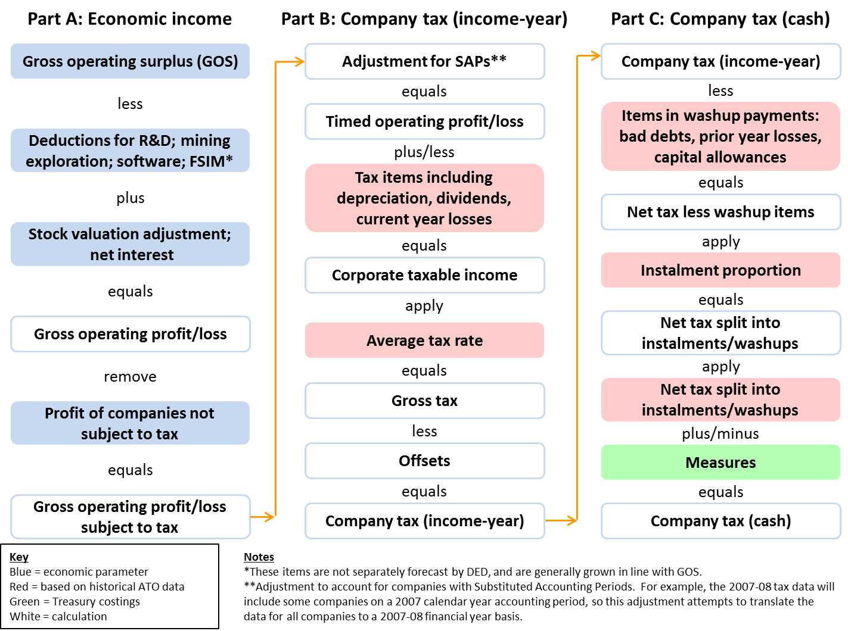
Figure 4.25: Capital Gains Tax Forecasting Model — Superannuation Funds
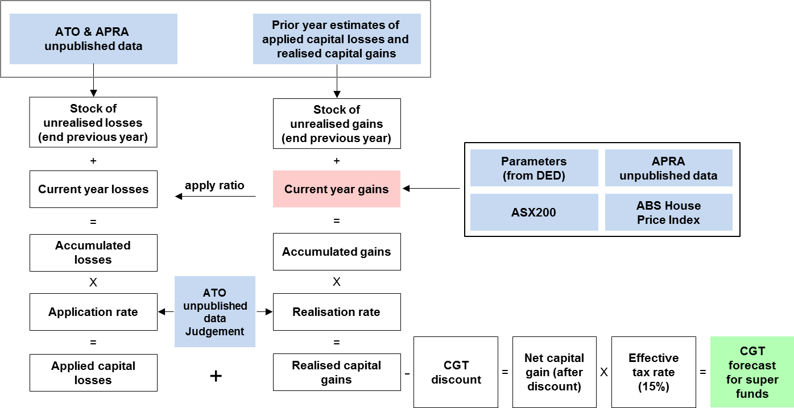

For example, the company tax base includes deductions for depreciation and current year losses, which are not part of gross operating surplus (the associated economic base).
This is largely an issue for income tax withholding. In contrast, the elasticities of the other heads of revenue to their taxable bases should be one, by definition, as they have flat tax rates.
The correlation coefficient has been calculated after adjusting income tax withholding for tax policy changes (largely personal income tax cuts). Tax policy changes are costed and taken into account separately in the forecasting process.
McDonald, T, and Morling, S, 2011, ‘The Australian Economy and the Global Downturn, Part 1: Reasons for resilience’, Economic Roundup, Issue 2, pp 1-31.
Gruen, D, and Stephan, D (2010), ‘Forecasting in the Eye of the Storm’, Address to the NSW Economic Society, 4 June.
The Taxation Statistics are released with a significant lag, with the 2009-10 edition being released on 1 May 2012.
See the box on page 5-22 of the 2012-13 Budget Paper No 1 for further discussion of this issue.

