Summary of the Australian Competition and Consumer Commission Advice to Government

The following summarises the key advice provided by the ACCC to Government in relation to the gas price cap and development of the industry code of conduct.
Advice on the Need for Reforms
- The ACCC has raised concerns with Government in relation to the significant volatility and substantial international price rises over the past year. They have indicated that this has contributed to worsening market conditions on the east coast, which has seen significant rises in domestic prices that are impacting Australian industry and households. Chart 1 shows offers made by producers and retailers for 2023 supply over the period from 1 Jan 2021 to 19 August 2022.
Chart 1 – Gas commodity prices (2023$/GJ) offered in the east coast gas market for 2023 supply
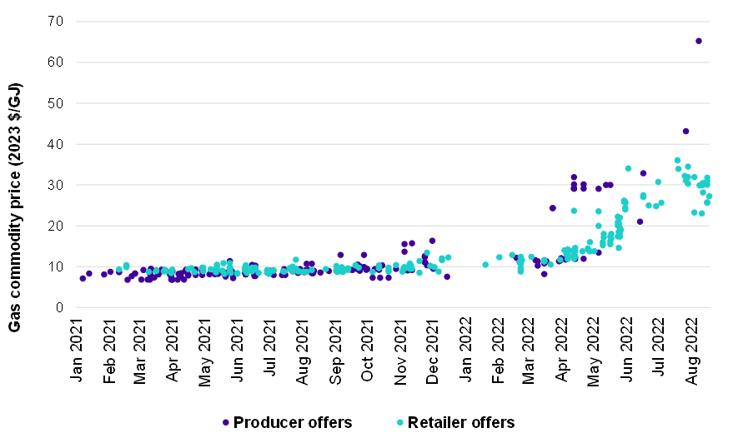
Source: ACCC analysis of bid and offer information provided by suppliers.
Note: Prices are for gas commodity only. Actual prices paid by users may also include transport and retail cost components. All offers are for quantities of at least 0.5PJ per annum and a contract term of at least 12 months. Some offers in the chart may be between the same supplier and buyer and/or represent further offers between parties if a previous offer did not result in the execution of a GSA.

- Further, the ACCC have advised that while gas prices have increased on the east coast, the costs of producing and supplying gas to customers have not significantly changed and remain well below both international prices and the prices being offered on the east coast.
  - Given production costs are not expected to have increased significantly, gas producers stand to make windfall gains from the all-time highs in international gas and LNG prices stemming from a decline in Russian gas supply leading up to and following the conflict in Ukraine. In a well-supplied and competitive domestic market these outcomes would not be possible.
- ACCC has also advised that concerns continue to be expressed to the ACCC that:
  - Offers to domestic users are not being made with reasonable notice.
  - Offers to supply are withdrawn, not followed through, or only offered to a selected number of potential users.
  - There have been poor levels of compliance reporting and documentation in respect of the HoA.
  - Gas has been offered on terms unlikely to meet users’ needs.
- This has significantly heightened the urgency with which issues in the east coast gas market need to be addressed.
Overall Advice on Action Needed
- In view of the conclusions about the need for action, the ACCC recommended a targeted interim emergency price requirement and a strengthened and mandated gas code of conduct, including a reasonable price framework.
Introduction of a Mandatory Code
- The ACCC has previously expressed concerns about the effectiveness of the existing voluntary code of conduct to address conduct and pricing issues evident in the market.
  - The voluntary code has not achieved broad adoption and a number of the supporting mechanisms have not been operationalised.
  - There have been ongoing concerns expressed by stakeholders to the ACCC that offers to domestic users were made without reasonable notice, withdrawn, not followed through, only offered to selected users, or offered on terms unlikely to meet users’ needs.
  - The voluntary code is broad, not capable of enforcement or dispute resolution, lacks meaningful obligations on suppliers and contains ambiguous pricing positions.
- The introduction of a mandatory code of conduct will help address bargaining power imbalances between producers and buyers. The code will set minimum standards to support producers and buyers arrive at agreements on reasonable terms, including price.
Introduction of a Price Cap and the Appropriate Level
- The ACCC has advised that a temporary price cap is an appropriate response to the current operation of the market and domestic prices being driven by international factors that do not reflect the underlying cost of production.
- The proposed emergency temporary price cap of $12/GJ reflects what the ACCC considers to be reasonable costs of production at currently developed fields, including a reasonable return on capital, for a 12 month period.
  - While gas prices have increased on the east coast, the ACCC has noted that it has not seen evidence that the costs of producing and supplying gas to customers have significantly changed. Given this, gas producers would stand to make windfall gains from the very high international gas and LNG prices.
  - The ACCC found that in 2021 there were 289 domestic offers made by producers and retailers, with 96 per cent of offers made below $12/GJ and an average price of $9.20/GJ.
  - AEMO’s 2019 estimates of the lifecycle costs of production faced by gas suppliers on the east coast for 2P reserves (adjusted for inflation) for the most costly sources of supply were below $9.50/GJ, with costs for most supply sources well below that.
- The emergency temporary cap and reasonable pricing provision in the Mandatory Code of Conduct will put downward pressure on prices and lead to a more reasonable pricing framework and a sustainable domestic gas market.
Reasonable pricing framework
- The ACCC have advised that current low levels of competition between producers, high prices and risks of supply shortages warrant the inclusion of a reasonable pricing provision within the code, where ‘reasonable prices’ are defined as efficient long run marginal costs of domestic supply, allowing for a commercial return on capital reflective of the industry’s risk profile.
- This would be assessed with reference to the cost of the most likely new domestic gas production to meet forecast domestic demand, including:
  - operating expenditure reflecting efficient new development(s);
  - depreciation based on the economic life of the new development(s);
  - return on capital (set as a benchmark return reflecting the financing costs of an efficient business facing similar risks); and
  - an allowance for taxation and royalties.
- A reasonable pricing provision in the code would be expected to be required until domestic gas prices are reflective of the underlying costs of production and that there is sufficient supply at these prices.

ACCC Response to the Announced Reforms
- The ACCC welcomes the Australian Government’s proposed reforms to address domestic supply issues and record high prices in Australia’s east coast gas market.
- During the five years of our ongoing east coast gas market inquiry, we have regularly raised concerns about the availability and price of gas for domestic users.
- The war in Ukraine has resulted in significant volatility and extensive international price rises. This has driven significant domestic price rises for Australian industry and households.
- Recently published ACCC gas market inquiry data showed that as of August this year, the majority of offers to commercial and industrial gas users for supply next year were above $30/GJ, which is the highest we have seen.
- In August this year, the ACCC’s LNG netback series, which is a measure of short-term export parity prices, showed prices at more than three times those at the same time last year.
- The Government’s proposed reforms give the ACCC additional responsibilities and powers relating to both gas market emergency price rules and a gas market code. We have assisted the Government in recent months on the steps it could take to improve the functioning of the gas market and have provided input on its proposed regulatory changes.
- The ACCC has previously expressed concerns about the effectiveness of the existing voluntary code of conduct to address conduct and pricing issues evident in the market.
- We support the introduction of a mandatory code of conduct to help address bargaining power imbalances between producers and buyers. The code will set minimum standards to support producers and buyers arrive at agreements on reasonable terms, including price.
- The proposed emergency temporary price cap of $12/GJ reflects what we consider to be reasonable costs of production at currently developed fields, including a reasonable return on capital, for a 12 month period.
- The emergency temporary cap will lower prices as we transition to the reasonable pricing framework in the Mandatory Code of Conduct. Together, these measures should lead to a more reasonable and sustainable domestic framework.
- The ACCC already makes an important contribution to energy market regulation. We will strongly enforce any new energy market regulation or reforms falling under the Competition and Consumer Act 2010.

