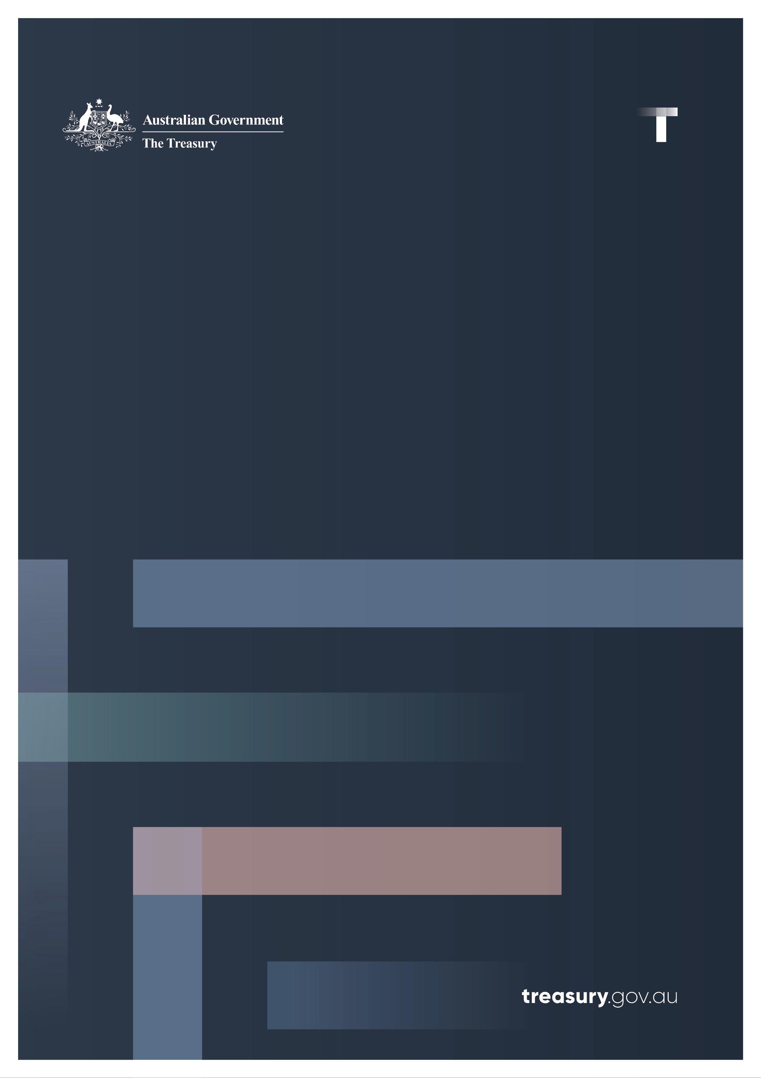

Evaluation of the 2021 foreign investment reforms

Final report

10 December 2021

© Commonwealth of Australia 2021

This publication is available for your use under a [Creative Commons Attribution 3.0 Australia](http://creativecommons.org/licenses/by/3.0/au/deed.en) licence, with the exception of the Commonwealth Coat of Arms, the Treasury logo, photographs, images, signatures and where otherwise stated. The full licence terms are available from <http://creativecommons.org/licenses/by/3.0/au/legalcode>.

Creative Commons attribution licence 3.0 icon. 

Use of Treasury material under a [Creative Commons Attribution 3.0 Australia](http://creativecommons.org/licenses/by/3.0/au/deed.en) licence requires you to attribute the work (but not in any way that suggests that the Treasury endorses you or your use of the work).

*Treasury material used ‘as supplied’.*

Provided you have not modified or transformed Treasury material in any way including, for example, by changing the Treasury text; calculating percentage changes; graphing or charting data; or deriving new statistics from published Treasury statistics — then Treasury prefers the following attribution:

*Source: The Australian Government the Treasury*.

**Derivative** **material**

If you have modified or transformed Treasury material, or derived new material from those of the Treasury in any way, then Treasury prefers the following attribution:

*Based on The Australian Government the Treasury data*.

**Use of the Coat of Arms**

The terms under which the Coat of Arms can be used are set out on the Department of the Prime Minister and Cabinet website (see [www.pmc.gov.au/government/commonwealth-coat-arms](http://www.pmc.gov.au/government/commonwealth-coat-arms)).

**Other uses**

Enquiries regarding this licence and any other use of this document are welcome at:

Manager  
Media and Speeches Unit  
The Treasury  
Langton Crescent   
Parkes ACT 2600  
Email: [medialiaison@treasury.gov.au](mailto:medialiaison@treasury.gov.au)

**Contents**

Foreword to the evaluation 1

Summary of findings 3

1. Context: the framework and the reforms 5

2. Implementation of the reforms 8

3. Attractiveness: foreign investment flows into Australia 11

4. Reform analysis: national security 16

5. Reform analysis: compliance 19

6. Reform analysis: streamlining 22

7. Reform analysis: fees 24

Appendix A: list of submissions 26

# Foreword to the evaluation

On 9 December 2020, the Parliament passed legislation that gave effect to the most significant reforms to Australia’s foreign investment framework (the framework) since 1975.

Given the scope of the reforms and the importance of foreign investment to the Australian economy, the *Foreign Investment Reform (Protecting Australia’s National Security) Act 2020* included a requirement for the Secretary of the Treasury to undertake an evaluation of the reforms over their first year.

In accordance with the legislative requirement, the evaluation of the foreign investment reforms (the Evaluation) commenced before 10 January 2021. The Terms of Reference were agreed on 8 January 2021 and published on the Treasury’s website on 19 February 2021.

|  |
| --- |
| In accordance with section 4 of the *Foreign Investment Reform (Protecting Australia’s National Security) Act 2020*, the Treasury is to conduct an evaluation of the operation of the reforms implemented by the *Foreign Investment Reform (Protecting Australia’s National Security) Act 2020* and the *Foreign Acquisitions and Takeovers Fees Imposition Amendment Act 2020* (together, the foreign investment reform Acts).  The Secretary of the Treasury is responsible for the evaluation, but in accordance with section 5 of the *Foreign Investment Reform (Protecting Australia’s National Security) Act 2020*, the Secretary may delegate their powers and functions with regards to the evaluation to another person in the department.  Scope of review  The evaluation will assess the reforms implemented by the foreign investment reform Acts, including:   * legislative instruments made under the *Foreign Acquisitions and Takeovers Act 1975* and the *Foreign Acquisitions and Takeovers Fees Imposition Act 2015* to implement the foreign investment reform Acts; and * administrative changes made to implement the foreign investment reform Acts.   The evaluation will consider:   * the impact that the foreign investment reform Acts and their implementation have had on foreign investment in Australia and the broader Australian economy; and * whether the right balance is struck between welcoming foreign investment into Australia and protecting Australia’s national interest.   Process  The evaluation is to commence as soon as practical, and by no later than 10 January 2021. The evaluation, and written report, is to respect the confidentiality provisions of Part 7 the *Foreign Acquisitions and Takeovers Act 1975*, and other privacy laws, as applicable.  The review will include consultation with relevant stakeholders. It will also take into account the unusual economic and policy circumstances in which the reforms have commenced, particularly in relation to the COVID-19 pandemic.  As the evaluation is starting soon after the reforms commence, these Terms of Reference will be reviewed after six months.  The Secretary of the Treasury (or delegate, if applicable) is to provide a written report of the evaluation to the Treasurer by 10 December 2021.  The Treasurer is to cause a copy of that report to be tabled in each House of the Parliament within 15 sitting days of that House after the report is given to the Treasurer.  The Secretary of the Treasury (or delegate, if applicable) is to also publish a copy of the report on the Treasury’s website by no later than the day on which the report is tabled. |

On 27 July 2021, the Treasury published a consultation paper on the Evaluation and invited interested parties to provide written submissions in response to questions posed in the paper. At that time the Terms of Reference were reviewed, and the Treasury advised in the consultation paper that they would remain unchanged. This process garnered 38 written submissions, including 10 that were confidential.[1]  Details regarding the submissions can be found at Appendix A.

The Treasury also conducted open roundtable discussions with peak industry bodies, investors and their advisers, and state and territory consultation partners. It also engaged with relevant Commonwealth agencies.

The Treasury appreciates the input that stakeholders provided to the Evaluation through consultations and written submissions.

The Evaluation has focused on the impact of the reforms to the foreign investment framework which came into effect on 1 January 2021. Where appropriate, the Evaluation has referenced some broader issues identified by stakeholders about the operation of the framework.

# Summary of findings

This is the evaluation report required under section 4 of the *Foreign Investment Reform (Protecting Australia’s National Security) Act 2020*. The Evaluation has assessed:

* the implementation of the foreign investment reform Acts – meaning the *Foreign Investment Reform (Protecting Australia’s National Security) Act 2020*, the *Foreign Acquisitions and Takeovers Fees Imposition Amendment Act 2020*, the *Foreign Investment Reform (Protecting Australia’s National Security) Regulations 2020* and the *Foreign Acquisitions and Takeovers Fees Imposition Regulations 2020* – and their impact on foreign investment in Australia and the broader Australian economy; and
* the extent to which those reforms strike the right balance between welcoming foreign investment into Australia and protecting Australia’s national interests.

Overall, the Evaluation finds that in their first year of operation, the reforms have achieved the Government’s intentions, particularly by enabling scrutiny of investments that may pose national security risks that previously were not subject to scrutiny. It is too early to determine whether the reforms have affected foreign investment flows into Australia or the broader economy. In the first year of operation, indications are that the reforms to the framework are striking the appropriate balance between supporting foreign investment into Australia and protecting the national interest. However, the framework should continue to be monitored to ensure it keeps pace with developments in the foreign investment landscape.

While the reforms have met the Government’s intentions, submissions to the Evaluation raised a range of issues regarding the framework and its administration. Some submissions proposed significant changes that warrant consideration but could not be properly considered in detail in the time available. These matters may be considered as part of future policy adjustments, including in the context of the post‑implementation evaluation of the reforms that the Treasury has committed to undertake by 2025 in line with the Regulation Impact Statement that accompanied the reforms.

List of findings

|  |
| --- |
| Finding 1  The reforms have been implemented and investors are adjusting to the new framework. Work on establishing the Register of Foreign Ownership of Australian Assets and the Treasury’s enhanced foreign investment case management system is well progressed. To increase transparency of its operations, the Treasury is developing additional public performance reporting.  Finding 2  It is too early to determine whether the reforms have had a singular impact on foreign investment inflows, given the short time period and significant impact that COVID-19 has had on foreign investment flows globally, including into Australia. Australia’s attractiveness to foreign investment will continue to be underpinned by our stable democracy, strong rule of law, highly skilled workforce, proximity to dynamic and fast-growing markets, abundant natural resources, world class industrial capabilities, and strong and well‑managed economy. |

|  |
| --- |
| Finding 3  The new national security measures are working as intended by identifying transactions that raise national security concerns. Investors would welcome greater clarity on the application of the national security test, which the Treasury will consider in future updates to investor guidance material.  Finding 4  The Treasury has established new processes and procedures to support the enhanced compliance and enforcement powers provided for in the reforms. There are opportunities for further refinements of the compliance and enforcement measures to ensure proportionate and scalable responses are available for any contravention of the foreign investment framework.  Finding 5  Stakeholders welcomed the streamlining measures in the reforms. While more time is required to fully assess the effectiveness of the passive foreign government investor exemption certificate, investors are keen to ensure they can maximise the benefits that all types of exemption certificates can provide.  Finding 6  Stakeholders suggested changes to further clarify, liberalise and simplify the framework. As the economy recovers from COVID-19, it is important to continue exploring options to refine the framework to better facilitate the foreign investment that has been and remains critical to Australia’s economic prosperity, while continuing to manage risks to the national interest and national security.  Finding 7  The new fee structure introduced as part of the reforms has ensured the cost of administering the foreign investment framework continues to be borne by foreign investors, and not Australian taxpayers. Aggregate fees collected in the first nine months of 2021 were $13 million higher than in the corresponding period in 2020, reflecting the revised fees framework – where each fee is more closely linked to the transaction size – and an increase in the value of notified investments. |

# 1. Context: the framework and the reforms

Australia’s foreign investment framework

The Australian Government welcomes foreign investment for the important and beneficial role it plays in the Australian economy. This welcoming approach has been critical to Australia’s long-term prosperity. For much of the country’s history, foreign capital has enabled Australia to realise investment opportunities that could not have been financed through domestic savings alone. Even when not needed to address this shortfall, foreign investment improves the welfare of Australians by supporting economic growth, creating skilled jobs and driving productivity improvements.

While foreign investment provides significant benefits, successive governments have recognised the need to mitigate the risk where individual investments may be contrary to Australia’s national interest. It is for this reason that since 1975, Australia has had a legislative framework in place to review foreign investment proposals on a case-by-case basis.

This framework allows the Government to protect Australia’s national interest while ensuring Australia remains an attractive place to invest. It does so by using a ‘negative test’ – meaning there is a presumption that foreign investment proposals should proceed unless found to be contrary to the national interest. If it is determined that a proposed investment is contrary to the national interest, it will not be approved or conditions will be applied to safeguard the national interest. In this regard, the framework strikes a balance between facilitating investment and protecting the national interest.

The 2021 foreign investment reforms

Over recent years, the risks from foreign investment to Australia’s national interest, particularly national security, have increased due to a confluence of developments, including rapid technological advancements and changes in the international security environment. Australia has witnessed the return of strategic competition, which is increasingly playing out in the economic arena and further blurring the lines between economics and national security.

On 5 June 2020, the Treasurer announced a major package of foreign investment reforms to address these risks and improve the overall operation of the framework. Following the Treasurer’s announcement, the Treasury undertook extensive stakeholder consultation to inform the development of the reforms, including through the release of exposure draft legislation on 31 August 2020 and exposure draft regulations on 18 September 2020. This consultation process reached over 2,000 stakeholders. The legislation passed the Parliament on 9 December 2020 and received Royal Assent on 10 December 2020, ahead of the commencement of the reforms on 1 January 2021.

The reforms introduced a number of elements to the framework, including new national security powers and actions; expanded compliance, monitoring and enforcement capabilities; measures to streamline the foreign investment process for passive investors and non-sensitive investments; fairer and simpler application fee arrangements; and a Register of Foreign Ownership of Australian Assets (the Register).

Australia is not alone in recognising and responding to increasing risks associated with foreign ownership. Many other countries – including the United States (US), Canada, China, New Zealand, the United Kingdom, Japan, the European Union and India – have recently updated their foreign investment rules. The Organisation for Economic Co-operation and Development (OECD) has observed that at least 87 per cent of OECD member countries had a foreign investment screening mechanism in place by May 2021, up from 79 per cent at the end of 2020 and just over 60 per cent a decade earlier.[2]

**National security**

The national security reforms comprised four main elements:

* mandatory notification of proposed investments into the most sensitive sectors of the Australian economy, regardless of value (‘notifiable national security actions’);
* the ability for the Treasurer to call in investments that are not otherwise subject to mandatory notification, but which are assessed as posing national security risks (‘reviewable national security actions’);
* the option for investors to voluntarily notify investments to avoid the risk of being called in; and
* a last resort power to enable the Treasurer, in extraordinary circumstances and subject to extensive safeguards, to review and revise the approval for an investment where national security risks emerge that could not have been foreseen at the time of the initial approval.

In each of these instances, an investment is assessed on national security grounds only rather than the broader national interest test, which has always considered national security risks among a range of factors. If an investment requires screening under the national interest test as well as the national security test, it will be screened under the former only.

**Compliance and enforcement**

The reforms introduced stronger and more flexible compliance and enforcement options to enhance the Treasury and the Australian Taxation Office’s (ATO) ability to monitor, investigate and pursue breaches of Australia’s foreign investment laws (see Chapter 5 for more details). Effective powers, in line with other regulators, to hold investors to account and manage compliance was a major feature of the reforms. It included expanded infringement notices, and higher civil and criminal penalties and was particularly important given the increasing number of foreign investments approved subject to conditions. In 2020-21, 72 per cent of cases by value had conditions attached to them, compared with 35 per cent in 2014-15.

**Streamlining, fees, integrity and technical changes**

The reforms also implemented a range of further measures beyond national security and compliance, including:

* measures to streamline the foreign investment review process and reduce the regulatory burden for certain low-risk investments. These included exemptions for certain investment funds with passive foreign government investor partners – a measure that was complemented by the introduction of a new type of exemption certificate in July 2021;
* measures to establish the framework for the Register, which will record all legal interests acquired by foreign investors in Australian land and water entitlements, and capture most business transactions that are notified under the foreign investment framework;
* technical measures to improve the overall integrity of the framework, for example: foreign investors must now notify of any increase in their actual or proportional shareholdings in an Australian business above what has been previously approved, including where they do not actively acquire extra shares; the definition of an Australian media business was updated and expanded to include digital only media businesses in addition to traditional media business like newspapers, television and radio; and the application of the tracing rules was extended to include unincorporated limited partnerships as well as corporations and trusts;
* an updated fees framework to ensure foreign investors, not Australian taxpayers, would bear the increased administration costs associated with the reforms (see Chapter 7 for more details); and
* changes to the protected information rules to enable information provided by foreign investors to be shared with other government agencies and international counterparts, subject to appropriate safeguards.

**Removal of zero-dollar arrangements**

The commencement of the reforms on 1 January 2021 occurred alongside the removal of the temporary zero-dollar screening arrangements. The zero-dollar arrangements were introduced on 29 March 2020 to ensure the Government had sufficient scrutiny of foreign investments at a time when the economy was under intense pressure from the COVID-19 pandemic.

The removal of these temporary arrangements meant many proposed investments no longer required foreign investment approval under the national interest test. However, consistent with the reforms, investments in national security businesses and national security land continued to be subject to a zero‑dollar monetary threshold for mandatory national security screening.

# 2. Implementation of the reforms

As the most significant reforms to the foreign investment framework since its introduction in 1975, they constituted a major change for investors. Recognising this, the Treasury worked hard from late 2020 to support investors through the transition, including by developing new operational arrangements and policies.

Guidance material on the Foreign Investment Review Board (FIRB) website was updated in December 2020 and then again in July 2021, drawing on insights gained through consultations with stakeholders as well as the Treasury’s own experience in administering the new framework during its first six months. On 30 September 2021, further guidance was published on compliance and reporting obligations and the application of the framework’s compliance and enforcement measures. This was to reinforce the expectation that investors were aware of, understood and complied with their obligations under Australia’s foreign investment laws.

|  |
| --- |
| A refreshed FIRB website and guidance notes  Following the passage of the foreign investment reform Acts on 9 December 2020 but ahead of their commencement on 1 January 2021, the Treasury updated the guidance notes and the FIRB website to reflect the new rules. As well as adding reform-related content, the guidance was consolidated into a more user‑friendly format and the total number of guidance notes were reduced from 53 to 15. This included a new *National Security* guidance note, developed in consultation with national security agencies, that outlined the mandatory national security notification requirements and areas where voluntary notification is encouraged. A standalone *Transitional* guidance note was also published to address investor questions about transitional arrangements. Several design changes were made to the FIRB website to ensure investors and other stakeholders could readily access information on the new legislative changes, particularly in relation to national security, compliance and reporting. Changes were also made to the application portal to enable applicants to notify the new types of actions established under the reforms. |

The legislative reforms were supported by an additional $149.1 million in funding provided to foreign investment regulating agencies (the Treasury and the ATO) and some consultation partners (the Department of Home Affairs and the Australian Security Intelligence Organisation) across the 2020 July Economic and Fiscal Update and the 2020-21 Budget. In addition to increased staffing, these packages provided funding for the Treasury to implement a digital transformation program and for the ATO to establish the Register.

The Treasury has recruited additional staff across its case management, compliance, governance and national security functions. Prior to the commencement of the reforms, it significantly expanded the number of staff working on compliance and enforcement, and established a dedicated unit to provide advice on national security actions and to manage a market scanning capability to support the new national security call-in power. The funding has enabled a near doubling in the number of staff in the Treasury’s Foreign Investment Division, from 76 staff in early 2020 to 146 staff in late‑2021.

The business community supported the transition both during the development and implementation of the reforms. Through their engagement with the exposure draft consultation process in 2020, investors, their advisers and industry groups helped ensure the reforms were designed in a way that minimised unintended consequences or inefficiencies, including by identifying issues that were addressed in the update to the guidance material in July 2021.

Overall, these various lines of effort to implement the reforms contributed to a smooth transition to the new system, with investors adjusting to the new framework. Stakeholders were generally positive about the Treasury’s handling of the transition from the temporary arrangements to the newly commenced legislation. A number of submissions commended the updated FIRB website and guidance notes, the Treasury’s external engagement and the professionalism of its staff, noting that these support structures helped them understand the new framework and the obligations of investors.[3]

Meanwhile, the Treasury and the ATO have progressed the implementation of the Register and the Foreign Investment Digital Transformation Program, which includes the development of an enhanced case management system. The Register is required to be in place by 2024 but is on track to be operating by the end of 2022. At the time of writing, the Treasury was in the final stages of selecting a delivery partner for the first phase of the case management and advanced analytics elements of the Foreign Investment Digital Transformation Program.

While many stakeholders identified slow processing times and the need for improvement in these as a priority issue in their submissions,[4] the data indicates that the reforms have not had a material impact on processing times. The median processing time for applications in the first quarter of 2021-22 (1 July 2021 to 30 September 2021) was 49 days, compared with 51 days for the 2020‑21 financial year and 48 days for the 2019-20 financial year. A number of other factors contributed to elevated processing timeframes through this period, notably the challenges presented by COVID‑19, particularly the increased applications from zero-dollar screening. During this period, the Treasury maintained its longstanding commitment to meeting commercial deadlines where possible.

Following this period of increased applications, the Treasury has focused on reducing the number of outstanding applications on hand from 630 on 1 January 2021 to 397 cases at the end of September 2021. During these nine months the Treasury received, on average, 34 cases and finalised 40 each week. These efforts brought down the average number of active cases on hand during the first nine months of 2021 to 446 per week, noting this is still higher than the pre COVID-19 weekly average of 213 active cases in 2019.

Figure 1: The Treasury’s weekly net foreign investment case flow in 2021

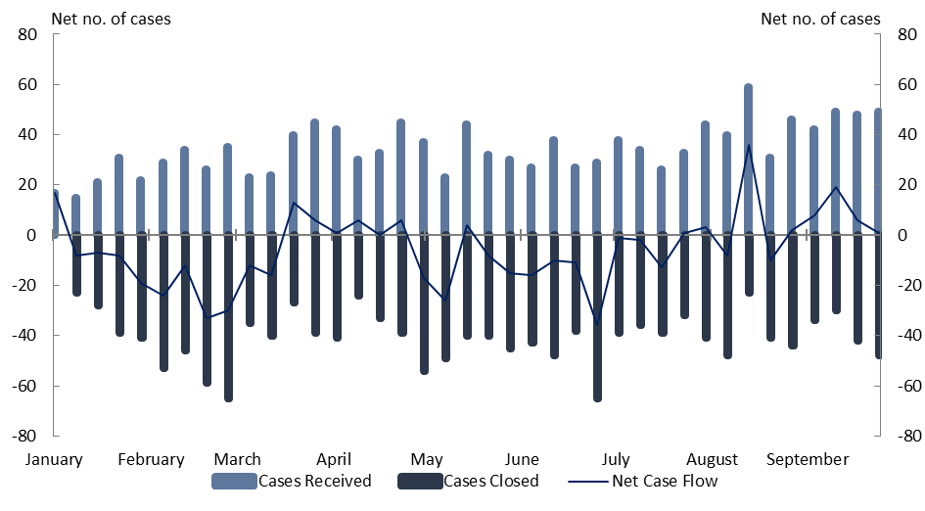

The Treasury shares the investment community’s interest in ensuring applications are processed in a timely manner. To increase transparency of its operations, the Treasury is developing enhanced public performance reporting to supplement existing reporting mechanisms, such as the FIRB Annual Report and regulator performance indicators reported against Treasury’s Corporate Plan. Enhanced reporting will ensure Treasury aligns with regulator best practice.

The Treasury also has a number of initiatives underway to improve the efficiency of case processing, with the most significant being implementing the new case management system as part of the Foreign Investment Digital Transformation Program. Some stakeholders welcomed this extra resourcing, though recognised it may take time for efficiency gains to be realised.[5]

|  |
| --- |
| Finding 1  The reforms have been implemented and investors are adjusting to the new framework. Work on establishing the Register of Foreign Ownership of Australian Assets and the Treasury’s enhanced foreign investment case management system is progressing well. To increase transparency of its operations, the Treasury is developing additional public performance reporting. |

# 3. Attractiveness: foreign investment flows into Australia

Australia has long been one of the most attractive destinations in the world for foreign investment. Australia’s attractiveness is reflected in foreign investment inflows, which relative to the size of our economy are higher than many comparable economies (*Figure 2* refers).[6] For instance, in the three years to 2020, foreign direct investment (FDI) inflows into Australia averaged 2.9 per cent of Gross Domestic Product (GDP) – compared with 1.2 per cent for the OECD and 1.3 per cent for the G20.[7]

Figure 2: FDI inflows internationally

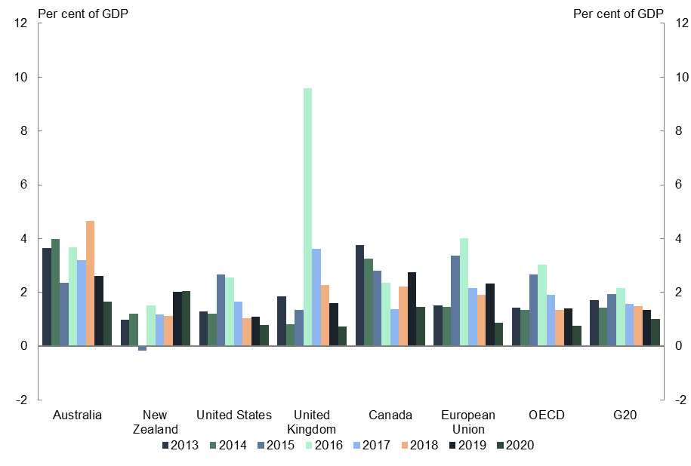

The effect of the reforms

As the reforms have been in place only for a short time, it is too early to determine if they have affected foreign investment flows. This uncertainty is reinforced by a number of factors, including: the fluid global economic and geopolitical environment; foreign investment and other economic reforms undertaken by many countries, which affects the relative attractiveness of investing in those jurisdictions; the limited data available on investor activities in 2021; and the COVID-19 pandemic, which led to a global economic downturn, the effective closure of Australia’s international borders, and prolonged lockdowns and border restrictions within Australia.

COVID-19 had a major impact on FDI flows globally and into Australia. FDI flows into developed economies in 2020 were down 58 per cent from 2019 levels, according to the United Nations Conference on Trade and Development (UNCTAD).[8] The impact for Australia was smaller but still substantial, with FDI inflows falling by 48 per cent in the same period.[9]

Australian Bureau of Statistics (ABS) data shows that Australia recorded $13.6 billion in FDI inflows during the first nine months of the reforms, from 1 January 2021 to 30 September 2021.[10] This compares with $15.3 billion in FDI inflows during the preceding nine‑month period,[11] from 1 April 2020 to 31 December 2020, which was also COVID-19 affected. While inflows were noticeably higher, at $25.2 billion,[12] from 1 January 2020 to 30 September 2020, part of that period preceded the economic shock precipitated by COVID-19.

While an important indicator, this data relating to FDI inflows needs to be put into context.

First, FDI inflows are volatile. The data can vary considerably from quarter to quarter and year to year depending on the timing of a small number of large transactions. As such, nine months is too short a period on which to draw firm conclusions about FDI trends or the impact of a policy change.[13] The potential for this volatility was highlighted in 2021, as FDI inflows into Australia jumped from $1.9 billion in the June quarter to $8.3 billion in the September quarter amid a surge in merger and acquisition activity.[14]

Second, FDI inflows is a net figure, meaning it captures – but does not disaggregate – FDI coming into Australia and divestments of existing FDI. As such, it is not possible to identify whether a change in inflows is driven by a reduction in the former or an increase in the latter. While foreign investment screening may affect some incoming FDI, it is unlikely to have any effect on FDI divestments.

Third, foreign investment screening is one of many factors that could influence FDI inflows. It sits alongside factors such as macroeconomic conditions and other regulatory settings in Australia and elsewhere. Even if a sustained shift in FDI inflows could be identified, it would not be possible to say whether or to what extent it may be attributed to changes in the foreign investment framework.

Fourth, developments in 2021 need to be understood in a broader historical and economic context. FDI inflows into Australia and throughout the OECD have been declining for a number of years,[15] with the reasons varying from the economic effects of COVID-19 and, before that, tax reforms in the US which led many multinationals to repatriate earnings to the world’s largest economy.[16]

Finally, FDI flows is one of many factors that affect movements in Australia’s current account balance and its counterpart, the combined capital and financial account. Unusually in its history, Australia’s current account balance has shifted into surplus for the past ten quarters – the longest current account surplus period on record. This shift is associated with net capital outflows, and has been driven by a range of factors independent of foreign investment screening, including strong commodity prices and export volumes; lower‑than‑average business investment, which is partly due to the end of the mining investment boom and robust corporate savings supported by elevated mining profits; and the effect on tourism of international border closures due to COVID-19.

In many respects, the Treasury’s foreign investment applications data provides a more useful indicator of the impact of foreign investment screening on foreign investment. This is because it reflects incoming FDI but not FDI divestments, and so does not face the problems discussed above in relation to net inflows data. It is also a measure of intended rather than actual investment.

The Treasury’s applications data shows that the value of all non‑residential proposed investments notified under Australia’s foreign investment regime has held up well since the reforms commenced (*Figure 3* refers). The value of those approvals (excluding zero‑dollar applications) in 2020 was $239.9 billion, up from $168.6 billion in 2019. From 1 January to 30 September 2021, the value of cases assessed or under assessment was $254.5 billion. However, like the ABS data, this data can be volatile, with the potential for significant year‑to‑year changes being driven by a small number of large transactions.

Figure 3: Value of investments submitted for screening by the Treasury

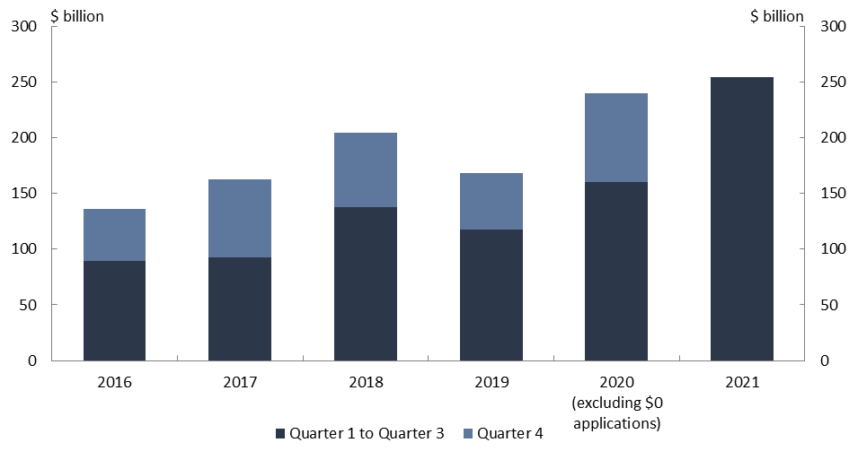

The Treasury’s data is less susceptible to this problem when expressed in terms of application numbers. Again, this data suggests that investor sentiment remained robust following the commencement of the reforms. From 1 January to 30 September 2021, the Treasury received 1,218 non-residential foreign investment applications.[17] This is comparable to the 1,230 applications received during the equivalent nine-month period in 2020 (excluding zero‑dollar applications) and more than the 1,061 applications made during the equivalent nine-month period in 2019.

Figure 4: Non-residential applications received by the Treasury

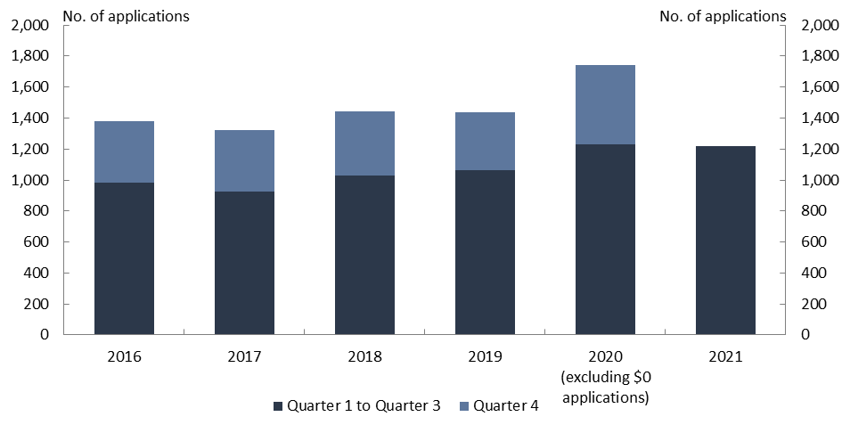

Future trajectory

As already noted, foreign investment provides significant economic benefits to Australia. It is therefore critical the foreign investment framework does not undermine Australia’s attractiveness for foreign investment, whilst managing risks to the national interest or national security. Australia’s attractiveness to date has been founded on a range of attributes, including our stable democracy, strong rule of law, highly‑skilled workforce, proximity to dynamic and fast-growing markets, abundant natural resources, world class industrial capabilities, and strong and well‑managed economy.

The dominant view of professional literature is that the key determinant of FDI flows are institutional factors – particularly good governance, low sovereign risk, a stable rule of law and mature legal systems – because those are the characteristics that investors look for when deciding where to direct their money.[18] Feedback from stakeholders largely endorsed this view about the primacy of institutions, while also noting the importance of macroeconomic conditions such as stable investment returns, lucrative commercial opportunities, and sound economic and population growth.[19] However, some stakeholders cautioned the reforms may have had the effect of reducing this attractiveness.[20]

In this context, stakeholders provided different views about the relative importance of foreign investment screening as a determinant of a country’s attractiveness to foreign investment. For instance, Herbert Smith Freehills said in its submission that alongside economic strength and financial institutions, investors consider how quickly a transaction can be undertaken, a country’s openness to FDI and the general ease of doing business.[21] According to the Property Council of Australia, jurisdictions are more likely to have foreign capital invested where regulatory approval can be obtained both quickly and inexpensively.[22] By contrast, PwC Australia considered foreign investment screening a lower priority consideration, saying investors are more concerned about a country’s macroeconomic stability, natural resources and access to markets.[23]

Overall, expectations of Australia’s ability to attract beneficial foreign investment remain positive, though flows are likely to remain volatile from year to year. In its 2021 FDI Confidence Index, Kearney’s Global Business Policy Council ranked Australia seventh for countries that are likely to attract the most foreign investment over the next three years.[24] The 2021 index takes into account investor views on the foreign investment reforms that commenced on 1 January 2021, and represents a nil change compared to 2020 when Australia moved up two places from ninth place.[25] Australia is currently one of only two Asia‑Pacific economies in the top ten for this index, alongside Japan; and the gap between Australia and the most attractive destination on the index, the US, is at its lowest level in over five years.[26]

As such, while more time is needed to assess the reforms’ impact on foreign investment inflows and the broader economy, the reforms do not appear to have affected Australia’s attractiveness as a destination for foreign investment. However, it is important to continue exploring options to refine the framework to better facilitate the foreign investment that has been and remains critical to Australia’s economic prosperity.

|  |
| --- |
| Finding 2  It is too early to determine whether the reforms have had a singular impact on foreign investment inflows, given the significant impact that COVID-19 has had on foreign investment flows globally, including into Australia, over the same period. Australia’s attractiveness to foreign investment will continue to be underpinned by our stable democracy, strong rule of law, highly skilled workforce, proximity to dynamic and fast-growing markets, abundant natural resources, world class industrial capabilities, and strong and well‑managed economy. |

# 4. Reform analysis: national security

The national security reforms were introduced to ensure the framework kept pace with evolving geopolitical risks, emerging technologies and growing foreign investment into sensitive sectors like electricity, transport and defence providers, which were posing an increasing risk to Australians and the resilience of the Australian economy.

The 2021 reforms introduced two new classes of actions: notifiable national security actions and reviewable national security actions. These actions provide the Government with greater visibility and powers over foreign investments that may raise national security concerns but are below the monetary and control thresholds that trigger the national interest test. Proposed investments that satisfy these criteria are screened under a narrower national security test.

The reforms also provided the Government with the ability to call in direct investment for screening where it has not otherwise been notified but raises national security concerns, and a last resort power to revisit an initial approval where serious national security concerns have arisen post-acquisition.

|  |
| --- |
| Notifiable national security action  An action is a notifiable national security action if the action is taken, or proposed to be taken, by a foreign person and the action is any of the following:   * to start a national security business; * to acquire a direct interest in a national security business; * to acquire a direct interest in an entity that carries on a national security business; * to acquire an interest in Australian land that, at the time of acquisition, is national security land; or * to acquire a legal or equitable interest in an exploration tenement in respect of Australian land that, at the time of acquisition, is national security land.   Reviewable national security action  The types of actions that may constitute a reviewable national security action are outlined in Part 2, Division 4B of the *Foreign Acquisitions and Takeovers Act 1975* (FATA). Generally, reviewable national security actions are proposals to give foreign persons potential influence and rights, such as the ability to influence or participate in the central management or policy of an entity or business, or the right to occupy Australian land. This includes instances where a foreign person is already in a position to influence or participate in the central management or control of an entity, but would gain further power to influence or participate as a result of the action. |

During their first nine months of operation, from 1 January and 30 September 2021, the new national security rules resulted in the notification of 89 proposed investments that would otherwise not have been subject to government scrutiny, comprising 58 mandatory notifications and 31 voluntary notifications. While applications data for a full year is not yet available, on a pro-rata basis this is a smaller number than anticipated in the Regulation Impact Statement and the Explanatory Memorandum for the reforms, which estimated the national security rules would result in an additional 161 foreign investment applications each year.[27] While these additional applications were screened on national security grounds only, all cases screened under the existing national interest test are also assessed on national security grounds, among other factors.

To date, the Treasury’s foreign investment data, including information collected via the Treasury’s new market scanning capabilities, shows that investors have been complying with the form and intent of the reforms by notifying actions when it is mandatory to do so, and voluntarily notifying actions for which the Government seeks visibility.

Discussion

Over the course of their first year of operation, the reforms have achieved their objective of managing national security risks associated with foreign investment.

The additional 89 proposed investments notified in the first nine months of 2021 is relatively small in the context of 1,218 non-residential applications overall during that period, but a material improvement in the Government’s ability to scrutinise potential national security risks to Australia. Of the applications processed, none had been rejected and 17 had conditions applied. In other words, the effect of the reforms to date has been to manage risks while continuing to welcome foreign investment. Without the reforms in place, none of these 89 proposed investments would have been subject to scrutiny, and 17 would not have had conditions applied to safeguard Australia’s national security.

While the overall regulatory burden of the national security changes has been relatively small, a number of stakeholders expressed uncertainty about their application.[28] Some linked this concern to the expansion of the definition of a national security business arising from the *Security Legislation Amendment (Critical Infrastructure) Act 2021*,[29] which passed the Parliament on 23 November 2021.

Many stakeholders indicated uncertainty about which investments should be mandatorily or voluntarily notified under the new measures.[30] Stakeholders proposed remedies such as updating the *National Security* guidance note to more clearly identify investments of concern,[31] and publishing lists of investments and/or businesses that fall within the purview of national security.[32]

While opportunities exist to clarify the national security requirements under the framework, there are challenges with precisely identifying which investments are in or out of scope – a challenge that is not exclusive to national security. For example, though feasible for certain highly concentrated markets,[33] a public list of national security businesses would not be all-inclusive, could raise its own national security risks and could harm identified businesses by deterring potential investment opportunities. The intent of the national security reforms is not to restrict investment, but to ensure adequate scrutiny of foreign investments in strategically important sectors and sensitive technologies regardless of their value. The range of investments that require national security screening must also be responsive to changing circumstances and technology.

|  |
| --- |
| Finding 3  The new national security measures are working as intended by identifying transactions that raise national security concerns. Investors would welcome greater clarity on the application of the national security test, which the Treasury will consider in future updates to investor guidance material. |

# 5. Reform analysis: compliance

The 2021 foreign investment reforms made changes to the FATA’s compliance and enforcement regime. Their purpose was to ensure the Treasurer and the Treasury have sufficient powers, comparable with other regulators, to ensure compliance and enforcement of the framework and to safeguard the national interest.

As a result of these reforms, the Treasurer can now: revoke a no objection notification or exemption certificate, or vary an exemption certificate, if it was obtained on the basis of false or misleading information; direct investors to act in accordance with the conditions of their approvals, or to not act contrary to those conditions; and accept enforceable undertakings from investors to manage non‑compliance with the FATA.

Under the *Regulatory Powers (Standard Provisions) Act 2014*, the Treasury now has monitoring powers to enter premises to verify investor compliance, investigation powers to enter premises to gather information about potential breaches, and the power to issue infringement notices for a range of civil penalty provisions – not just for breaches in the residential real estate sector, as was the case prior to the reforms.

This enables the Treasury to respond to a broader range of compliance issues and credibly deter non‑compliance across all forms of foreign investment. In addition, the infringement notice regime previously comprised only lower‑level tier one penalties that apply if the person self-discloses a breach and higher tier two penalties that apply in all other cases. The reforms introduced a third‑tier for serious breaches that have the potential to harm the national interest, such as ongoing non‑compliance with the conditions applied to a high-value investment, or taking a high-value notifiable action without providing notice.

The Treasury has continued to build its compliance capability since the reforms commenced. Through 2021, it has established the operational framework for the exercise of the new powers, recruited staff with relevant qualifications and experience, trained staff and published information on foreign investors’ compliance obligations under the FATA. It has also improved processes relating to the recommendation of conditions during the proposal screening phase to provide a defensible foundation for compliance and enforcement activity.

It has not been necessary to exercise the new compliance and enforcement powers during the first nine months of 2021, noting the full suite of these powers can only be exercised for investments approved after 1 January 2021. However, warning letters have been issued and the Treasury has identified a number of matters that are under active consideration for an enforcement response.

The Treasury continues to publish, as part of the FIRB Annual Report, statistics and commentary on the types of compliance activities that are undertaken, including information on the number of audits and their outcome, referrals and whether they result in an assessment of non‑compliance, and investor reporting whether it is legislatively mandated or imposed by conditions.

This data shows that there has been a significant increase in investor reporting and independent audit activity between 1 January 2021 and 1 December 2021. In that period, a total of 43 independent audit proposals (22 approved and 21 under assessment) and 32 independent audit reports (19 finalised and 13 under review) were received. From 1 January 2021 to 30 September 2021, the Treasury received over 1,000 condition mandated compliance reports and 443 investor notifications of actions taken post‑approval.

Discussion

Though a major component of the reforms, the new compliance regime received relatively little commentary in stakeholders’ submissions.[34] Some noted that investors do their best to comply with the framework – with most cases of non-compliance being inadvertent – and that the obligations on investors in the public guidance material were clear and sufficiently described.[35] The Technology Council of Australia considered that the new compliance powers were not an issue for investors.[36]

To raise awareness of what these changes mean for investors, the Treasury intends over time to publish more quantitative information on compliance activities and outcomes, as part of the more detailed reporting it plans to release on its performance (see Chapter 2 for more details). This will provide information on the effectiveness of various types of compliance activities undertaken, the overall compliance profile of foreign investors, the nature of any non-compliance identified and the responses to non-compliance.

In relation to enforcement, the general sentiment among stakeholders was that any penalties should be commensurate to the risks and extent of non-compliance[37] – a position consistent with the policy intent that any compliance and enforcement measures imposed are proportionate and scalable. In this light, the Treasury’s experience in preparing for the use of the enforcement powers has highlighted opportunities for further enhancements to ensure appropriate deterrence and to enable more nuanced and targeted enforcement and compliance activities. These include refinements to:

* clarify the definitions of tier one, tier two and tier three infringement notices; and
* ensure there are scalable and proportionate responses for any non-compliance with the framework, including where a foreign investor fails to keep required records, provides false or misleading information or acts in a way that avoids the application of the FATA.

The Treasury’s experience also suggests one effect of the new compliance powers is that foreign investors are now paying closer attention to conditions that are proposed to be attached to approvals. This in itself is a useful indication that the compliance and enforcement component of the reforms is meeting its intent – to enhance the Government’s ability to mitigate the risks associated with foreign investment. This is reflected in the number of submissions that commented on conditions.[38] In the Treasury’s experience, greater focus on conditions by investors has also contributed to longer processing times for certain applications, particularly exemption certificates.

Some of these submissions questioned whether the use of conditions had extended the framework’s remit.[39] The Productivity Commission has previously noted that conditions should not act as a substitute for proper regulation, because the framework only assesses and imposes conditions on proposed investments at a point in time, whereas tax and national security risks evolve over time.[40]

In this regard, the recently legislated amendments to the *Security of Critical Infrastructure Act 2018* provide an avenue to address national security risks on a broad basis rather than solely through the foreign investment framework. The same applies to the risks of multinational tax avoidance, which the Government is addressing through programs with international partners to end domestic tax base erosion and profit shifting.

|  |
| --- |
| Finding 4  The Treasury has established new processes and procedures to support the enhanced compliance and enforcement powers provided for in the reforms. There are opportunities for further refinements of the compliance and enforcement measures to ensure proportionate and scalable responses are available for any contravention of the foreign investment framework. |

# 6. Reform analysis: streamlining

The reforms included a number of measures to streamline the foreign investment review process and reduce the regulatory burden for certain low-risk investments. For example, foreign investment approval is no longer required where a private foreign investor acquires exploration tenements or certain revenue streams from mining and production tenements that do not provide rights, control or influence.

The streamlining measures also targeted certain investment funds which source capital from foreign government investors. Previously, where multiple foreign governments held an aggregate interest of 40 per cent or more in an investment fund, the fund itself was treated as a foreign government investor under the framework, and therefore subjected to more stringent screening thresholds. As a result of the reforms, the same investment fund is treated as a private foreign investor under the framework, provided its foreign government investors are passive and no single foreign government holds an interest in it of 20 per cent or more.

To complement this legislative change, the Treasury’s 21 July 2021 update to the guidance notes introduced the concept of a passive foreign government investor exemption certificate. That is, if a foreign government investor passively holds an interest of 20 per cent or more in an investment fund, the fund may apply for an exemption certificate with the effect that it would be treated under the framework as a private foreign investor.

Discussion

Stakeholders generally welcomed the streamlining measures targeted at investment funds with passive foreign government investors.[41] Herbert Smith Freehills said industry has appreciated the changes to allow some funds with foreign government investors to be treated as foreign private investors.[42] But like some other stakeholders, it noted an investment fund may be unable to benefit from the change if it has foreign government investors from the same country that together hold a substantial interest.[43] Positive sentiments were also expressed about the new passive foreign government investor exemption certificate, though it was acknowledged more time was needed to assess its effectiveness and that practical market experience was yet to be established.[44]

|  |
| --- |
| Finding 5  Stakeholders welcomed the streamlining measures in the reforms. While more time is required to fully assess the effectiveness of the passive foreign government investor exemption certificate, investors are keen to ensure they can maximise the benefits that all types of exemption certificates can provide. |

As well as commenting on the streamlining measures in the reforms, stakeholders identified a range of opportunities for further changes to the framework to reduce regulatory burden and to support the COVID‑19 recovery phase for Australia’s businesses and economy. These proposals were made in the context of concerns about the complexity of Australia’s framework, as well as its broad scope.

Stakeholders proposed a range of transactions that could be considered for exemptions under the framework, including:[45]

* subdivisions and amalgamations of land;
* acquisitions of additional securities by a foreign investor in an Australian entity already controlled by them, and ownership percentage increases in businesses that occur without the foreign investor acquiring additional securities;
* certain types of passive investments, such as investments by prescribed funds or schemes that are made primarily for the benefit of Australian members or policyholders; and
* investments made through certain new investment structures – for instance, interfunding.

In addition, some stakeholders proposed the overall design of the framework could be changed so that transactions that are considered to be low-risk and routine, such as some of those outlined above, would be required to be notified but not automatically screened.[46]

In the context of the reforms, several stakeholders raised concerns about the definition of an Australian media business. This definition was expanded under the reform package to encompass digital media businesses like websites, podcasts and streaming services, as well as traditional media businesses like newspaper, television and radio. Some stakeholders said the change means the definition now captures businesses that have no material connection to Australia or are not traditionally in the media sector.[47]

Concerns about the scope and complexity of the framework predate the reforms. The relatively wide reach of Australia’s foreign investment regime is a consequence of decisions taken over decades to ensure the framework remains responsive to changes in the strategic context, business environment and community expectations around foreign investment. It is for this reason that the national interest test is not defined in legislation.

Alongside scope and complexity, stakeholders identified exemption certificates as an area where further changes could help reduce regulatory burden.[48] Exemption certificates provide a mechanism for investors to obtain approval for a program of investments rather than multiple approvals for individual transactions. In order to receive the maximum benefit offered by exemption certificates, investors proposed a range of options to improve their administration and implementation.

|  |
| --- |
| Finding 6  Stakeholders suggested changes to further clarify, liberalise and simplify the framework. As the economy recovers from COVID-19, it is important to continue exploring options to refine the framework to better facilitate the foreign investment that has been and remains critical to Australia’s economic prosperity, while continuing to manage risks to the national interest and national security. |

# 7. Reform analysis: fees

Since December 2015, the Government has charged fees for foreign investment applications to ensure the costs of the framework are borne by foreign investors, and not Australian taxpayers.[49]

To ensure this principle was maintained under the reforms, the fees framework was updated in recognition that the framework’s operational costs would increase as a result of greater staffing numbers and upgrades to IT infrastructure. At the heart of the update was a more graduated fee structure that ensures fees are more closely aligned with the overall value of a transaction.

Foreign investment taxation receipts totalled $78 million from 1 January 2021 to 30 September 2021, compared with $65 million in the first nine months of 2020 and $87 million for the full 2020 calendar year.[50] These figures reflect both the revised fees framework – which means each fee is more closely linked to transaction size – and an increase in the value of proposed investments during 2021 (see Chapter 3 for more details), which has been driven in part by a surge in the number and average size of merger and acquisition deals in Australia.[51]

Discussion

Many stakeholders commented on the overall increase in application fees.[52] Some considered the fee revenue collected was not proportionate to the cost incurred by foreign investment regulating agencies in administering the regime – a view previously voiced by the Productivity Commission.[53]

While the updated framework means fees have increased in aggregate, fees overall remain a relatively small proportion of the costs of an investment. For instance, the maximum fee for a commercial acquisition[54] over $50 million is not more than 0.03 per cent of the consideration. For agricultural land acquisitions over $2 million, it is not more than 0.63 per cent of the consideration.

In addition, the changes to the fees framework have made the system fairer, with the effect that fees have increased for many larger investments but declined for some smaller transactions.

For example, larger investors, and investors that previously paid a disproportionately smaller fee for their investment, now pay a more reasonable proportion of the costs of administering the framework. Fees for most exemption certificates increased, removing distortions in the previous fee structure that sometimes made it more expensive to seek approval for certain proposed investments of a lesser value outside of an exemption certificate. For example, previously notifying a $10 million agricultural land acquisition attracted a higher fee than a $100 million agricultural land exemption certificate.

On the other hand, investors making a commercial acquisition between $10 million and $150 million now pay lower fees, as do investors acquiring agricultural land between $2 million and $6 million. To support new business investment in Australia, such as start-up businesses in the innovation sector, the fee payable for starting an Australian business (including a national security business) was lowered to $2,000.

It is also important to note that fees for commercial investments are partially subsidised by fees for dwelling investments. While the overall fee framework underwent significant changes, the fee differentials for different types of investment – for instance, agricultural land versus commercial land – remained broadly the same. An important consequence of this is that relative to their value, residential real estate applications continue to shoulder a larger share of the cost of operating the foreign investment review system.

Beyond the level of fees, an issue raised by a number of stakeholders concerned application fees paid by unsuccessful bidders in a competitive bid process. Some stakeholders proposed that application fees should be payable only by the successful bidder, split between all foreign bidders or substantially refunded for unsuccessful bidders.[55] As noted in guidance, the policy on fees is that following an unsuccessful competitive bid process, a foreign person may on a case-by-case basis request those fees to be credited to a subsequent application.[56]

|  |
| --- |
| Finding 7  The new fee structure introduced as part of the reforms has ensured the cost of administering the foreign investment framework continues to be borne by foreign investors, and not Australian taxpayers. Aggregate fees collected in the first nine months of 2021 were $13 million higher than in the corresponding period in 2020, reflecting the revised fees framework – where each fee is more closely linked to the transaction size – and an increase in the value of notified investments. |

# Appendix A: list of submissions

The Treasury received 28 public submissions (see below stakeholders) and 10 confidential submissions.[57]

Australia China Business Council

Australian Investment Council

Australian Industry Group

Association of Mining and Exploration Companies

Australian Sugar Milling Council

Business Council of Australia

Baker McKenzie

Clean Energy Council

Consolidated Pastoral Company

H-bar: Quantum Consultants

Herbert Smith Freehills

Investment Company Institute

Dr Jonathan Kolieb

Law Council of Australia

Law Society of New South Wales

MinterEllison

Minerals Council of Australia

National Farmers’ Federation

NSW Farmers

PwC Australia

Property Council of Australia

Q-CTRL

Society of Trust and Estate Practitioners Australia

Tech Council of Australia

United States Studies Centre

Water Services Association of Australia

1. Wherever possible, stakeholder comments in this paper are attributed to the relevant submission. However, where a submission is confidential, comment from it may be referenced without attribution.
2. OECD, “Freedom of Investment process: Investment policy developments in 62 economies between 16 October 2020 and 15 March 2021,” May 1, 2021, https://www.oecd.org/daf/inv/investment-policy/Investment-policy-monitoring-March-2021-ENG.pdf.
3. See for example, submissions from Baker McKenzie, Herbert Smith Freehills, MinterEllison, PwC Australia, the Consolidated Pastoral Company, the Law Council of Australia, the Minerals Council of Australia and the Technology Council of Australia.
4. See for example, submissions from Baker McKenzie, Herbert Smith Freehills, PwC Australia, Q‑CTRL, the Australia China Business Council, Australian Investment Council, the Business Council of Australia, the Law Society of New South Wales and the Minerals Council of Australia.
5. The Consolidated Pastoral Company, *Submission*, page 5; the Australian Investment Council, *Submission*, page 3.
6. OECD, *FDI flows (indicator)*, https://data.oecd.org/fdi/fdi-flows.htm#indicator-chart.
7. Ibid.
8. UNCTAD, “World Investment Report 2021 - Investing in sustainable recovery,” April 1, 2021, https://unctad.org/system/files/official-document/wir2021_en.pdf, page 2.
9. ABS, “International Investment Position: Supplementary Statistics - Table 1,” May 5, 2021, https://www.abs.gov.au/statistics/economy/international-trade/international-investment-position-australia-supplementary-statistics/2020/5352001_2020.xlsx; ABS, “Balance of Payments and International Investment Position, Australia - Table 13,” August 31, 2021, https://www.abs.gov.au/statistics/economy/international-trade/balance-payments-and-international-investment-position-australia/jun-2021/5302013.xls.
10. ABS, “Balance of Payments and International Investment Position, Australia - Table 13,” November 30, 2021, https://www.abs.gov.au/statistics/economy/international-trade/balance-payments-and-international-investment-position-australia/sep-2021/5302013.xls.
11. Ibid.
12. Ibid.
13. A view that submissions from Herbert Smith Freehills and the Association of Mining and Exploration Companies also conveyed.
14. For a discussion of the M&A surge see, [https://go.corrs.com.au/rs/596-VPW-402/images/Corrs-M-A-Outlook-2022.pdf%20?mkt_tok=NTk2LVZQVy00MDIAAAGBDK9TW2eLguobUI-4Z2b3pbUZIEHcMYK0fWIyLQ ej9ZVLyIbik9XRm9n-s8VgiGXo7ENfUqZ0RH6f6zrrSQcY6anb6sNd2uxp4K4485-xAjQR](https://go.corrs.com.au/rs/596-VPW-402/images/Corrs-M-A-Outlook-2022.pdf%20?mkt_tok=NTk2LVZQVy00MDIAAAGBDK9TW2eLguobUI-4Z2b3pbUZIEHcMYK0fWIyLQej9ZVLyIbik9XRm9n-s8VgiGXo7ENfUqZ0RH6f6zrrSQcY6anb6sNd2uxp4K4485-xAjQR).
15. ABS, “International Investment Position, Australia: Supplementary Statistics - Table 2,” May 5, 2021, https://www.abs.gov.au/statistics/economy/international-trade/international-investment-position-australia-supplementary-statistics/2020/5352002_2020.xlsx; OECD, *FDI flows (indicator)*.
16. OECD, “FDI in Figures: April 2020,” April 10, 2020, https://www.oecd.org/investment/FDI-in-Figures-April-2020.pdf; Dorine Boumans et al., “Expected effects of the US tax reform on other countries: global and local survey evidence,” *International Tax and Public Finance 27* (2020).
17. The Treasury does not process residential real estate applications.
18. OECD, “Policy Framework for Investment, 2015 Edition,” September 11, 2015, https://www.oecd.org/daf/inv/investment-policy/Policy-Framework-for-Investment-2015-CMIN2015-5.pdf, pages 13 and 15.
19. See for example, submissions from the Australia China Business Council, the Association of Mining and Exploration Companies, the Australian Sugar Milling Council, the Consolidated Pastoral Company and the Law Council of Australia.
20. See for example, submissions from the Association of Mining and Exploration Companies, the Clean Energy Council and the Minerals Council of Australia.
21. Herbert Smith Freehills, *Submission*, page 2.
22. The Property Council of Australia, *Submission*, page 9.
23. PwC Australia, *Submission*, page 1.
24. Paul A. Laudicina and Erik R. Peterson, “On shaky ground: The 2021 FDI Confidence Index,” March 24, 2021, https://www.kearney.com/documents/3677458/88299256/On+shaky+ground%E2%80%932021+FDI+confidence+index.pdf/4f8fd544-ce57-d498-96e3-dfb5fd81f77e?t=1616536746000, page 7.
25. Ibid, page 19; Paul A. Laudicina and Erik R. Peterson, “Entering the storm: anticipating risk in an uncertain world - The 2020 FDI Confidence Index,” June 16, 2020, https://www.kearney.com/documents/20152/17744880/The+2020+Kearney+Foreign+Direct+Investment+Confidence+Index.pdf/18e45f29-867f-2cad-1899-8294b94e89d5?t=1608470571000, page 6.
26. Laudicina and Peterson, “On shaky ground: The 2021 FDI Confidence Index,” page 6.
27. The Treasury, “Regulation Impact Statement - Foreign Investment Reform Package 2020,” *The Office of Best Practice Regulation*, November 11, 2020, https://obpr.pmc.gov.au/sites/default/files/posts/2020/11/foreign_investment_reform_package_2020_ris.pdf, page 24; Parliament of Australia, “Foreign Investment Reform (Protecting Australia’s National Security) Bill 2020 and the Foreign Acquisitions and Takeovers Fees Imposition Amendment Bill 2020 Explanatory Memorandum,” October 28, 2020, https://parlinfo.aph.gov.au/parlInfo/download/legislation/ems/r6614_ems_8e124275-a752-4a63-a028-70ae95c2ff6d/upload_pdf/JC000292.pdf;fileType=application%2Fpdf, page 178.
28. See for example, submissions from MinterEllison, the Australian Sugar Milling Council and the Law Council of Australia.
29. See for example, submissions from Herbert Smith Freehills, the Clean Energy Council and the Law Society of New South Wales.
30. See for example, submissions from Baker Makenzie, Herbert Smith Freehills, H-bar: Quantum Consultants, MinterEllison, National Farmers’ Federation, Q-CTRL, the Australian Investment Council, the Clean Energy Council, the Investment Company Institute, the Law Council of Australia, the Minerals Council of Australia and the Water Services Association of Australia.
31. See for example, submissions from Baker McKenzie, the Australian Investment Council, the Association of Mining and Exploration Companies and the Water Services Association of Australia.
32. The Business Council of Australia, *Submission*, page 7; the Investment Company Institute, *Submission*, page 4; and MinterEllison, *Submission*, page 4.
33. For example, the liquid fuel, energy market operator, and food and grocery distribution sectors. At the time of writing, an updated *National Security* guidance note was expected to be published shortly to reflect the *Security Legislation Amendment (Critical Infrastructure) Act 2021,* including by identifying specific businesses and owners and operators in the aforementioned sectors that require mandatory notification under the national security test.
34. One confidential submission stated that in general, investors have not been focused on the compliance‑related aspects of the reforms.
35. Herbert Smith Freehills, *Submission*, page 5; the Law Council of Australia, *Submission*, page 12.
36. The Technology Council of Australia, *Submission*, page 6.
37. The Australian Sugar Milling Council, *Submission*, page 2; the Law Council of Australia, *Submission*, page 12.
38. A total of 17 out of 38 submissions (including confidential submissions) contained statements on conditions.
39. See for example, submissions from PwC Australia, the Australia China Business Council and the Business Council of Australia.
40. The Productivity Commission, “Foreign Investment in Australia - Productivity Commission Research Paper,” June 23, 2020, https://www.pc.gov.au/research/completed/foreign-investment/foreign-investment.pdf, page 86.
41. The Technology Council of Australia, *Submission*, page 6.
42. Herbert Smith Freehills, *Submission*, pages 5-6.
43. Ibid, pages 5-6; MinterEllison, *Submission*, pages 2-3.
44. The Australian Investment Council, *Submission*, page 2; the Law Council of Australia, *Submission*, page 14.
45. See for example, submissions from Herbert Smith Freehills, MinterEllison and the Law Council of Australia.
46. The Australian Investment Council, *Submission*, page 3; the Business Council of Australia, *Submission*, page 10; the Law Council of Australia, *Submission*, page 14.
47. For instance, MinterEllison said the definition may extend to education providers (*Submission*, page 4).
48. See for example, submissions from the Australian Investment Council and the Business Council of Australia.
49. The imposition of fees is achieved through general taxation and not by way of cost recovery or fees for service.
50. The figures stated are inclusive of small collections of vacancy fees for houses left vacant by foreign investors for more than six months in a 12-month period.
51. Corrs Chambers Westgarth, “M&A 2022 Outlook: Public M&A trends and strategies,” November 30, 2021, <https://go.corrs.com.au/rs/596-VPW-402/images/Corrs-M-A-Outlook-2022.pdf%20?mkt_tok=NTk2LVZQVy00MDIAAAGBDK9TW2eLguobUI-4Z2b3pbUZIEHcMYK0fWIyLQej9ZVLyIbik9XRm9n-s8VgiGXo7ENfUqZ0RH6f6zrrSQcY6anb6sNd2uxp4K4485-xAjQR>, page 3.
52. See for example, submissions from STEP Australia, the Australia China Business Council, the Business Council of Australia and the Clean Energy Council.
53. See for example, submissions from the Australian Sugar Milling Council, the Consolidated Pastoral Company and the Minerals Council of Australia.
54. A commercial acquisition is an acquisition of business or entities, commercial land, or mining or production tenement.
55. See submissions from Herbert Smith Freehills, the Australian Investment Council, the Business Council of Australia, the Clean Energy Council and the Law Council of Australia.
56. FIRB, “Guidance 10 - Fees on Foreign Investment Applications,” July 9, 2021, https://firb.gov.au/sites/firb.gov.au/files/guidance-notes/GN10_Fees.pdf, page 40.
57. Submissions are published on the Treasury website unless they confidential or contain content that is defamatory, obscene, indecent, threatening or abusive.