Consumer Data Right: Giving customers greater control over their data

# The Consumer Data Right will give you greater control over your data.

The Consumer Data Right will allow you to ask for your data to be safely shared with trusted recipients. When you choose to share your data in this way, you will have control over who receives it and how they use it.

You will be able to use the Consumer Data Right initially for your banking, energy and telecommunication services, and eventually for other services across the economy.

# The Consumer Data Right will enable more choice, tailored products and lower prices.

Comparison services will be better able to consider your specific circumstances to help you select deals that give you the best value for money.

Service providers will also be able to offer you a broader range of products and services that are tailored to your specific needs, such as services that assist your budgeting or help you decide whether to invest in solar panels.

The scope of services enabled by the Consumer Data Right is only limited by the imagination of entrepreneurs.

# Strong privacy protections and information security will ensure your data is safe and secure.

Safeguards will be introduced to ensure strong privacy protections and information security when you are sharing your data. You will be able to feel confident that your information is secure and that you are in control of your data.

# Save on your banking through a range of new services

You could save time by using new services to compare various credit card plans for you. These new services will be able to easily compare interest rates, annual fees, insurance policies and other elements of credit card products to help you find the best card for your lifestyle and budget.



New budgeting apps could help you better manage your finances to understand how you spend your money, and find ways you can save.

# Save on your phone, internet and energy bills

With your permission, services could analyse your energy usage to help you decide what plan is best for you, and whether a particular energy source, such as solar power, is suited to your lifestyle.



Analysing your mobile phone usage could help you decide whether a cheaper service provider can provide you with a package that is more suited to your preferences.

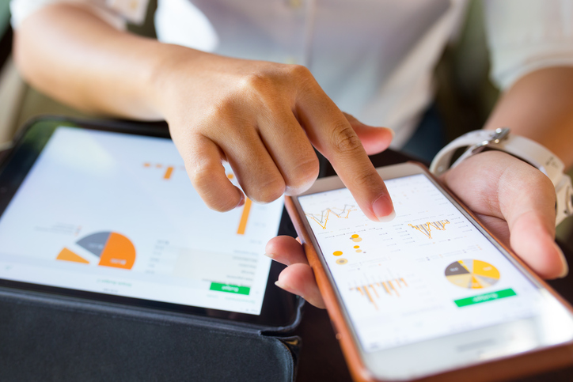

# You can use the Consumer Data Right from February 2020

Banking will be the first industry in which you will be able to access your data. You will be able to direct the major banks to share your banking data on credit, debit, transaction and saving accounts with trusted recipients from February 2020.

The Consumer Data Right will then be applied to the energy and telecommunications sectors, giving you greater convenience in choosing your energy, internet and phone plans.

To help you understand your rights and responsibilities under the Consumer Data Right, a range of tools and guidance materials will become available prior to the new system commencing.

Only trusted and accredited recipients will be able to have access to your data. They will only be allowed to use it for the purposes you have authorised.

Regulators will be well-resourced to enforce your privacy and consumer rights.

The Australian Competition and Consumer Commission will ensure appropriate consumer protections, and the Office of the Australian Information Commissioner will ensure appropriate privacy protections.

A newly formed Data Standards Body will set technical standards so that you can access your data in a safe and convenient way.

# You will have simple and meaningful ways to resolve any concerns.

If you have any concerns, regulators and external dispute resolution services will be there to help you obtain any meaningful remedies you require.

The Office of the Australian Information Commissioner will be the single point of contact for all consumers to ensure that your concerns are handled by the right organisation.

# Convenient data sharing will support our future economic growth and create high value jobs in Australia

Consumer data will provide the fuel that will inspire domestic entrepreneurs and help grow our domestic data industry. New businesses will emerge and will create high value jobs for Australians. Encouraging high value employment increases economic growth and your standard of living.