United Voice Pre-Budget Submission 2019-2020

United Voice Pre-Budget Submission 2019-2020

About United Voice
United Voice is a union of workers organising to win better jobs, stronger communities, a fairer society and a sustainable future. As the Early Childhood Education and Care (ECEC) union we represent early childhood directors, teachers and educators across Australia. We have members in every state and territory working in both large organisations and smaller centres. We are proud of the work we do educating over one million young Australians. As professionals working in centres delivering early education and care every day, United Voice members have unique insights into the strengths and weaknesses of current and proposed policy settings. It is the expertise of these professionals that informs this pre-budget submission.

Achieving world-class early childhood education through professional wages
Everyone agrees: education is the key to unlocking a child’s potential. We can’t have a thriving nation if we don’t nurture our youngest citizens and early childhood education is our first opportunity to do so. The research and evidence on the importance of early learning is stacking up and there is consensus across the sector that quality early learning matters. Quality early learning means quality educators. Early childhood educators are the people shaping Australia’s future, one child at a time.
But understanding this and doing something about it are two very different things. A large gap still exists between the theory and the practice of valuing early education and the people who provide it. A gap the current Federal Government choses to do nothing about. Valuing children means valuing educators and United Voice again calls on the Government to finally recognise this in its 2019-2020 Budget.
Early childhood educators across the country call on the Government to increase Australian ECEC funding in line with OECD best practice and dedicate part of that increase to funding professional pay. Australia is a wealthy country; we can and should have an ECEC system in which all children are given the best possible start in life by skilled educators earning professional wages.
Families and the government now accept that modern, high quality ECEC is a complex field that requires educators to have significant technical skill and knowledge to assist children to develop emotionally, cognitively and socially. Like their counterparts in schools, educator’s knowledge of early childhood developmental stages, language acquisition, individualised play-based pedagogy and behaviour management are preconditions to working in our system, and rightly so.
Early childhood educators deserve professional wages for professional work, but they earn about one third less than those educating children just a few years older. For too long ECEC has been economically and socially undervalued due to its historical association with unpaid ‘women’s work’. United Voice members, like generations of women working in feminised industries before them, are sick of living under a government that undervalues the work of people based on their gender. In 2019, the Australian Government must acknowledge that early educators’ pay should reflect the value of their role in shaping our children's future and fund professional wages. Without this commitment their words of support for families and early education is hollow and meaningless.
Early learning is the first big step in a child’s education and governments around the world have taken note - it is time this government did too. It is time this Government listened to educators. Our member’s 10 year policy vision for a world-class early childhood education sector is attached. It is a plan to ensure that quality in the sector is high, every educator is valued and that no child is left behind. Educators call on the Government to ensure the 2019-2020 Budget reflects this plan.
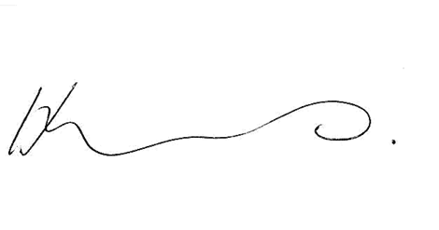

Authorised by Helen Gibbons
Assistant National Secretary

Authorised by H. Gibbons, Assistant National Secretary, United Voice
303 Cleveland St, Redfern NSW 2016

