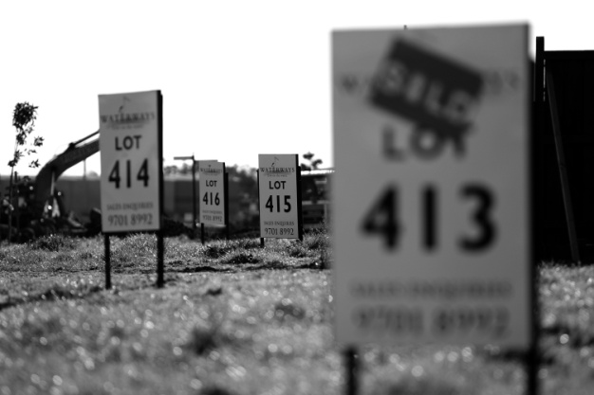 | 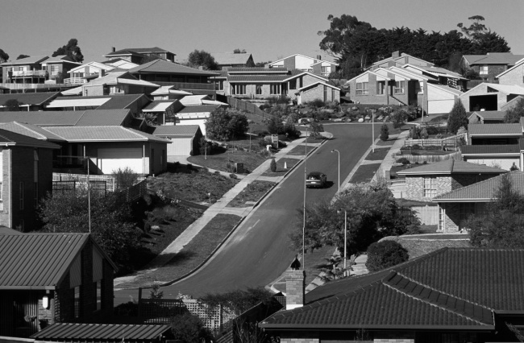

REPORT 2011

National Housing Supply Council
State of Supply Report

© Commonwealth of Australia 2011
ISSN 1836-215X
ISBN 978-921380-09-9
This work is copyright. Apart from any use as permitted under the Copyright Act 1968, no part may be reproduced by any process without prior written permission from the Commonwealth available from the Commonwealth Copyright Administration, Attorney-General’s Department. Requests and inquiries concerning reproduction and rights should be addressed to the Commonwealth Copyright Administration, Attorney‑General’s Department, Robert Garran Offices, National Circuit, Barton,
ACT 2600 or posted at http://www.ag.gov.au/cca.
Disclaimer: The National Housing Supply Council Secretariat has prepared this report. It draws on information, opinions and advice provided by a variety of individuals and organisations, including the Commonwealth of Australia. The Commonwealth accepts no responsibility for the accuracy or completeness of any material contained in this report. Additionally, the Commonwealth disclaims all liability to any person in respect of any thing, and of the consequences of any thing, done or omitted to be done by any such person in reliance, whether wholly or partially, upon any information presented in this report.
Caution: Data in this report is made available on the understanding that neither the Commonwealth nor the National Housing Supply Council is providing professional advice. Before relying on any of the information contained in this report, users should obtain appropriate professional advice. Views and recommendations which may also be included in the report are those of the Council only, and do not necessarily reflect the views of the Commonwealth, the Minister for Sustainability, Environment, Water, Population and Communities or the Australian Government Department of Sustainability, Environment, Water, Population and Communities or indicate a commitment to a particular course of action.
Any enquiries about or comments on this publication should be directed to:
Department of Sustainability, Environment, Water, Population and Communities
GPO Box 787
Canberra ACT 2601
Email: nhsc@environment.gov.au
Published December 2011

Photo credits
Front cover: Left side, Land lot billboards, AAP Image/Simon Mossman
Right side, Urban landscape, AAP Image/Jason Busch/Wildlight

Table of Contents
Foreword ix
Executive summary xi
Chapter 1 Introduction 1
Chapter 2 Demand for housing 13
Chapter 3 Housing supply 34
Chapter 4 Demand–supply balance 79
Chapter 5 Affordability 90
Chapter 6 Conclusions 111
Appendix 1: Terms of reference 113
Appendix 2: Demand 116
Appendix 3: Supply 128
Appendix 4: Demand–supply balance 162
Glossary 169

Tables
Table 1.1 State and federal government initiatives for first-home buyers, selected states 5
Table 2.1 Underlying demand projections based on low, medium and high household growth: annual increase in underlying demand and total underlying demand projections (households), 2010–2030 18
Table 2.2 Cumulative additional households projected under low, medium– and high- household growth scenarios (’000 households), June 2010 – June 2030 19
Table 2.3 Projections of national underlying demand by household type, medium household growth scenario, 2010–2030 21
Table 2.4 Projected additional households by region for low, medium- and high- household growth scenarios (’000 households), 2010–2030 23
Table 2.5 Projections of underlying demand by dwelling structure, medium-growth scenario (’000 dwellings), 2010–2030 26
Table 2.6 Projections of underlying demand by tenure type, medium-growth scenario (’000 dwellings), Australia, 2010–2030 28
Table 2.7 State- and territory-based shares of migrants and population (percentage of total), 2009 32
Table 3.1 Existing supply, 2010 36
Table 3.2 Summary of demolition rate information (percentages) 42
Table 3.3 Projected net increase in supply of residential dwellings, Australia, low-, medium- and high-supply scenarios, 2010–2030 42
Table 3.4 Projected additional residential dwellings by state and territory for low, medium and high dwelling production, adjusted for demolitions (’000 dwellings), 2010–2030 43
Table 3.5 Variations in net completions, 1981 to 2010 43
Table 3.6 Residential construction activity, time taken to completion and proportion of approvals not completed 45
Table 3.7 Short-term forecasts for dwelling completions, 2011 calendar year 54
Table 3.8 Stages of the generic supply pipeline for greenfield development 56
Table 3.9 Stages of the generic supply pipeline for infill development 56
Table 3.10 Estimated dwelling supply: number of potential dwelling completions capital cities, 2010–2020 58
Table 3.11 Estimated dwelling supply: percentage of potential dwelling completions, from infill and greenfield in the next 10 years 61
Table 3.12 Recent and future projected employment growth, five years to February 2011 and five years to February 2016 71
Table 4.1 Adjustment for unoccupied dwellings where the reason unoccupied was not ‘usual resident absent’ (percentages), 2006 81
Table 4.2 Estimates of the net dwelling supply gap, Australia, 2001–2010 82
Table 4.3 Estimated additional underlying demand and adjusted net supply, July 2009 to June 2010 83
Table 4.4 Estimated dwelling gap since June 2001 (number of dwellings), Australia, June 2010 83
Table 4.5 Estimated dwelling gap since June 2001 (’000 dwellings, rounded to nearest hundred), June 2010 83
Table 4.6 Growth in gap between underlying demand and adjusted net supply (number of dwellings), including cumulative impact 84
Table 4.7 Change in gap between underlying demand and dwelling supply, five years (June 2010 to June 2015), using different projection assumptions 85
Table 4.8 Cumulative gap since 2001 between underlying demand and dwelling supply at June 2015, using different projection assumptions 86
Table 4.9 Change in gap between underlying demand and dwelling supply (adjusted), 20 years (June 2010 to June 2030), using different projection assumptions 86
Table 4.10 Cumulative gap since 2001 between underlying demand and adjusted dwelling supply at June 2030, using different projection assumptions 87
Table 5.1 Percentage change in median house prices over past year and past decade 93
Table 5.2 Proportion of homes considered affordable for purchase by low- and moderate-income households, and proportion in mortgage stress (percentages) 100
Table 5.3 Percentages of low-income households in rental stress 108
Table 5.4 Mean fortnightly rent paid by income units receiving rental assistance ($), years ending June 2010 and June 2008 108
Table A2.1 State splits for share of NOM (%), 2011 report 117
Table A2.2 State splits for share of NOM (%), 2010 report 117
Table A2.3 Levels of annual net migration (ANM) for regions (international and internal) 117
Table A2.4 Assumptions underpinning the Council’s household projections 120
Table A2.5 NHSC and ABS household projections – NHSC medium household growth and ABS Series II: annual increase in number of households and total households, 30 June 2010 – 30 June 2030 121
Table A2.6 Underlying demand projections based on low, medium and high household growth: annual increase in underlying demand and total underlying demand projections, 2010–2030 122
Table A2.7 Projections of underlying demand based on low household growth, by state and territory, 2009–2030 124
Table A2.8 Projections of underlying demand based on medium household growth, by state and territory, 2009–2030 125
Table A2.9 Projections of underlying demand based on high household growth, by state and territory, 2009–2030 126
Table A2.10 Additional households by region for dwelling structure (medium growth scenario) (’000), 2010–2030 127
Table A3.1 Details of the revised demolition methodology 132
Table A3.2 Projections of dwelling completions plus conversions and net completions (adjusted for demolitions), 2010–2030 133
Table A3.3 Low trend projection of dwelling completions plus conversions, by state and territory, 2011–2030 134
Table A3.4 Medium trend projection of dwelling completions plus conversions, by state and territory, 2011–2030 135
Table A3.5 High trend projection of dwelling completions plus conversions, by state and territory, 2011–2030 136
Table A3.6 Low trend projection of dwelling completions plus conversions, adjusted for demolitions (net completions) by state and territory, 2011–2030 137
Table A3.7 Medium trend projection of dwelling completions plus conversions, adjusted for demolitions (net completions), by state and territory, 2011–2030 138
Table A3.8 High trend projection of dwelling completions plus conversions, adjusted for demolitions (net completions), by state and territory, 2011–2030 139
Table A3.9 Low trend projection of gross completions, 2011–2030 140
Table A3.10 Medium trend projection of gross completions, 2011–2030 141
Table A3.11 High trend projection of gross completions, 2011–2030 142
Table A3.12 Information on relevant state and territory government land supply projections 143
Table A3.13 Comparison of the key steps in the land supply process in six jurisdictions, based on the Council’s generic supply pipeline for major greenfield development 145
Table A3.14 Key data areas of the land/dwelling supply pipeline for greenfield areas 147
Table A3.15 Initiators of activity in the land/dwelling supply pipeline for greenfield areas 147
Table A3.16 Amount of greenfield land identified at Stage 1 future urban at 30 June 2010 155
Table A3.17 Amount of greenfield land at Stage 2 and/or 3: Zoned for residential (specific use zoning) and/or structure planning, as at 30 June 2010 156
Table A3.18 Greenfield land at Stage 4 that has received development/subdivision approval, as at 30 June 2010 157
Table A3.19 Greenfield land at Stage 5 for which residential title has been issued but not yet given, as at 30 June 2010 158
Table A3.20 Greenfield land at Stage 6 for which building approval has been issued but where building has not yet commenced, as at 30 June 2010 158
Table A3.21 Estimates of the average time taken to reach each stage in the greenfield land supply pipeline 159
Table A3.22 Estimates of short-term infill dwelling^{(a)} supply, as at 30 June 2010 161
Table A4.1 Projected demand–supply gap using medium household growth and medium supply projections (number of dwellings), 2010–2030 162
Table A4.2 Change in the gap since 2001, based on the difference between underlying demand and supply adjusted for demolitions and unoccupied dwellings (’000 dwellings), by state and territory, 2001–2010 163
Table A4.3 Projected demand–supply gap using medium household growth and medium supply projections (’000 dwellings), by state and territory, 2010–2030 164
Table A4.4 Average number of people per household, by state and territory 165
Table A4.5 Change in underlying demand (’000 households), by state and territory 165
Table A4.6 Supply growth (’000 dwellings), by state and territory 166
Table A4.7 Supply growth, net of demolitions (’000 dwellings), by state and territory 166
Table A4.8 Adjustment for unoccupied dwellings where the reason unoccupied was not ‘usual resident absent’ (per cent), by state and territory 167
Table A4.9 Supply growth, net of demolitions, with allowance for unoccupied dwellings excluding ‘usual resident absent’ (’000 dwellings), by state and territory 167
Table A4.10 Major data limitations identified in producing the 2011 State of Supply Report 167

Figures
Figure 1.1 Economic growth and unemployment 3
Figure 1.2 Mortgage commitments for owner-occupier house purchases 4
Figure 1.3 Investor loans, value and share of all loans for house purchase 7
Figure 1.4 Monthly levels of building approvals (trend) 8
Figure 1.5 Mortgage market composition, $ billions lent to owner-occupiers 9
Figure 1.6 New loans by loan-to-value ratio (LVR), per cent 10
Figure 1.7 New mortgages taken out on a low-documentation or interest-only basis 11
Figure 2.1 Growth in households and the Australian population, 1961–2011 15
Figure 2.2 Projected change in household types, 2010–2030 20
Figure 2.3 Projected demand by dwelling structure, medium-growth scenario, Australia, 2010–2030 26
Figure 2.4 Proportion of owner-occupiers (with or without a mortgage) in each age group by whether born in Australia 30
Figure 2.5 Tenure status of recently arrived migrants in 2002, 2005 and 2009 surveys 31
Figure 3.1 Dwelling construction activity per quarter, Australia, 1985 to March quarter 2011 36
Figure 3.2 Dwelling construction activity per quarter, New South Wales, 1985 to March quarter 2011 37
Figure 3.3 Dwelling construction activity per quarter, Victoria, 1985 to March quarter 2011 37
Figure 3.4 Dwelling construction activity per quarter, Queensland, 1985 to March quarter 2011 38
Figure 3.5 Dwelling construction activity per quarter, South Australia, 1985 to March quarter 2011 38
Figure 3.6 Dwelling construction activity per quarter, Western Australia, 1985 to March quarter 2011 39
Figure 3.7 Dwelling construction activity per quarter, Tasmania, 1985 to March quarter 2011 39
Figure 3.8 Dwelling construction activity per quarter, Northern Territory, 1985 to March quarter 2011 40
Figure 3.9 Dwelling construction activity per quarter, Australian Capital Territory, 1985 to March quarter 2011 40
Figure 3.10 Quarterly completion data and upper and lower trend lines, Australia, 1981–2011 41
Figure 3.11 Quarterly dwelling approvals, quarterly data and long-term best fit, Australia, 1983 to March quarter 2011 44
Figure 3.12 Quarterly dwelling completions, four-quarter moving average and long-term best fit, Australia, 1981 to March quarter 2011 44
Figure 3.13 Quarterly dwelling completions overlaid on dwelling approvals (houses), New South Wales, June 1984 to June 2010. 45
Figure 3.14 Quarterly dwelling completions overlaid on residential dwelling approvals (houses), New South Wales, June 1984 to June 2010, smoothed and lagged in accordance with Table 3.6 46
Figure 3.15 Quarterly dwelling completions overlaid on residential dwelling approvals (other residential), New South Wales, June 1984 to June 2010, smoothed and lagged in accordance with Table 3.6 47
Figure 3.16 Quarterly dwelling completions overlaid on residential dwelling approvals (houses), Victoria, June 1984 to June 2010, smoothed and lagged in accordance with Table 3.6 47
Figure 3.17 Quarterly dwelling completions overlaid on residential dwelling approvals (other residential), Victoria, June 1984 to June 2010, smoothed and lagged in accordance with Table 3.6 48
Figure 3.18 Quarterly dwelling completions overlaid on residential dwelling approvals (houses), Queensland, June 1984 to June 2010, smoothed and lagged in accordance with Table 3.6 48
Figure 3.19 Quarterly dwelling completions overlaid on residential dwelling approvals (other residential), Queensland, June 1984 to June 2010, smoothed and lagged in accordance with Table 3.6 49
Figure 3.20 Quarterly dwelling completions overlaid on residential dwelling approvals (houses), South Australia, June 1984 to June 2010, smoothed and lagged in accordance with Table 3.6 49
Figure 3.21 Quarterly dwelling completions overlaid on residential dwelling approvals (other residential), South Australia, June 1984 to June 2010, smoothed and lagged in accordance with Table 3.6 50
Figure 3.22 Quarterly dwelling completions overlaid on residential dwelling approvals (houses), Western Australia, June 1984 to June 2010, smoothed and lagged in accordance with Table 3.6 50
Figure 3.23 Quarterly dwelling completions overlaid on residential dwelling approvals (other residential), Western Australia, June 1984 to June 2010, smoothed and lagged in accordance with Table 3.6 51
Figure 3.24 Quarterly dwelling completions overlaid on residential dwelling approvals (houses), Tasmania, June 1984 to June 2010, smoothed and lagged in accordance with Table 3.6 51
Figure 3.25 Quarterly dwelling completions overlaid on residential dwelling approvals (other residential), Tasmania, June 1984 to June 2010, smoothed and lagged in accordance with Table 3.6 52
Figure 3.26 Quarterly dwelling completions overlaid on residential dwelling approvals (houses), Northern Territory, June 1984 to June 2010, smoothed and lagged in accordance with Table 3.6 52
Figure 3.27 Quarterly dwelling completions overlaid on residential dwelling approvals (other residential), Northern Territory, June 1984 to June 2010, smoothed and lagged in accordance with Table 3.6 53
Figure 3.28 Quarterly dwelling completions overlaid on residential dwelling approvals (houses), Australian Capital Territory, June 1984 to June 2010, smoothed and lagged in accordance with Table 3.6 53
Figure 3.29 Quarterly dwelling completions overlaid on residential dwelling approvals (other residential), Australian Capital Territory, June 1984 to June 2010, smoothed and lagged in accordance with Table 3.6 54
Figure 3.30 Type of housing production (gross completions) 55
Figure 3.31 Social and subsidised housing demand 68
Figure 3.32 Employment level among construction industry sectors (’000), February 2011 72
Figure 3.33 Employed people by age (’000) – construction industry compared to all industries, February 2011 73
Figure 3.34 Employed people by age (’000) – construction industry, years to February 2001, 2006 and 2011 73
Figure 3.35 Top 10 developers’ share of plot sales 76
Figure 5.1 Dwelling prices and average weekly earnings, Australia, 1994–2011 92
Figure 5.2 House price index, Australian capital cities (suburbs ranked by price), 2004 to 2011 93
Figure 5.3 Interest rates, 1990–2011 94
Figure 5.4 Annual change in average household income, 2007–2010 95
Figure 5.5 Price growth of housing-related expenses (annual change), 1999–2011 95
Figure 5.6 Loans to first-home buyers, 1992–2011 96
Figure 5.7 Housing affordability for first-home buyers, 1994–2011 97
Figure 5.8 Share of mortgages 90+ days past due, 1994–2011 101
Figure 5.9 Net excess mortgage repayments (percentage of scheduled payments), 2008–2011 102
Figure 5.10 Rental and income growth (annual change), 2001–2011 103
Figure 5.11 Rental vacancy rates (percentages), Sydney, Melbourne, Brisbane, Adelaide, four-quarter averages, 1980–2011 104
Figure 5.12 Rental vacancy rates (percentage), Perth, Hobart, Darwin, Canberra, four-quarter averages, 1980–2011 104
Figure 5.13 Median weekly rents ($) by area and property type, Sydney, 1990–2011 105
Figure 5.14 Median weekly rents ($) by area and property type, Victoria, 1999–2011 106
Figure 5.15 Rental growth (percentage), Brisbane, by region, 2001 to 2011 107
Figure A3.1 Summary of supply-based estimates and projections 129

Boxes
Box 2.1 The Australian Census of Population and Housing .........................................................32
Box 3.1 Sustainable Australia – Sustainable Communities ..........................................................76
Box 3.2 Social housing in Australia and its role in remote Indigenous communities ....................81
Box 3.3 Costs of infill and greenfield development .......................................................................94

Foreword

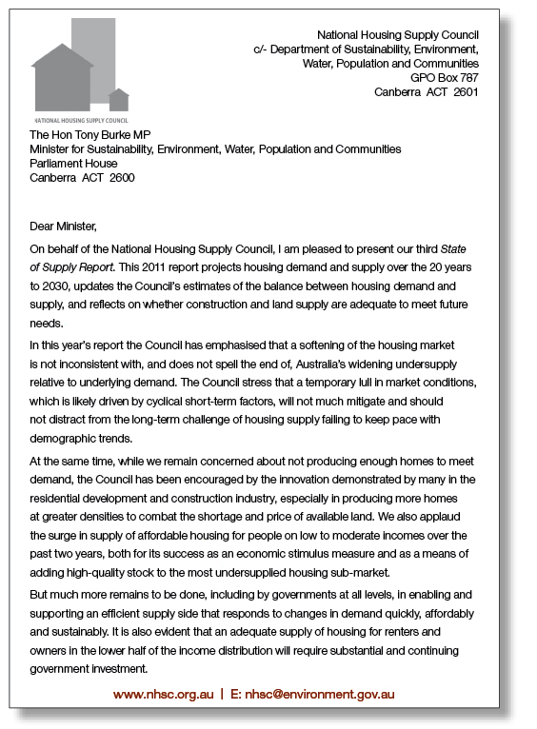
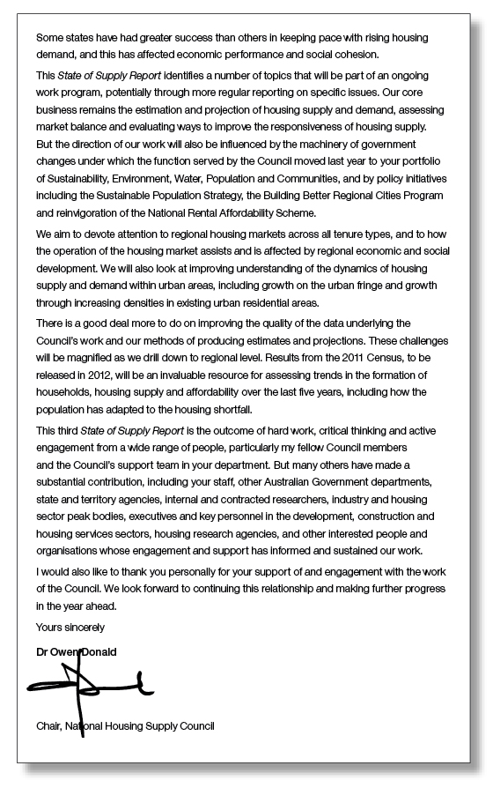

Executive summary
The National Housing Supply Council was established by the Treasurer and the Minister for Housing in 2008 to monitor housing demand, supply and affordability in Australia, as well as to identify gaps between housing supply and demand and to highlight strain on the housing system. It has been producing an annual State of Supply Report since 2009. Since the 2010 report was released the Council has been reappointed, with eight of its now 12 members being new appointments.
In this year’s report the Council has updated its projections for underlying housing demand and supply through to 2030, as well as its analysis of the gap between the two.
Introduction
The wider housing market has changed significantly since the 2010 report was published. The market has slowed since the middle of 2010, with transaction levels and prices declining variably in most parts of the country. This has coincided with a widening gap between supply and underlying demand, and evidence that the rental market has tightened further. While a softening of the housing market and a projected widening gap between supply and underlying demand might seem contradictory, the Council does not believe this is an inconsistent situation in the short term. The supply gap means that housing costs are higher than they would otherwise be, but there can still be volatility around these higher levels.
In the Council’s view, a large part of the problem is driven by a growing divergence between underlying demand, which is demographically driven, and effective demand, which is what actually happens in the market and which is driven by economic as well as demographic factors.
In the short term effective demand is influenced by a range of factors, including life-cycle factors (e.g. starting a family, changing jobs), confidence, strength of the labour market and prospects for income, perceptions of the housing market, availability and cost of finance and, for investors, anticipated returns, and the impact of wider living costs, such as utility bills. Policy changes and their aftermath also affect demand. For example, the surge in first-home buyers encouraged by the stimulus measures introduced during the global financial crisis (GFC) has now ended. Some of these buyers would have brought forward their decision to buy a home, inevitably leading to a fall in transaction numbers following this surge.
The building industry has also had to face up to a weaker market, and the volume of property being built has thus fallen significantly. Approvals for building dwellings other than detached houses (largely multi-unit apartment buildings) saw a longer downturn than those for building houses following the GFC. This could have been partly due to more limited access to development finance for this type of development.
Meanwhile, the amount of property on the market is not solely driven by new home building. The existing market is the main driver of stock that is actually for sale at any given point in time; new properties comprise only a relatively small share of home sales. Many of these existing properties will be subject to short-term cycles. Some owners will be under little pressure to sell, while others will have more immediate reasons, and these groups can react differently to changing market conditions.
So for both demand and supply, short-term cyclical trends can move very differently from the longer-term structural drivers of population growth and aggregate housing supply.
Chapter 1 of this report looks at these short-term trends in more detail, further explaining the differences between underlying demand and recent market trends.
Demand for housing projected to increase over the next 20 years
The projected demand (number of households) identified in this report is higher than in previous reports. This increase reflects the unanticipated population growth of 2008–09, giving rise to a higher base population. The projected rate of increase over the next 20 years has not changed significantly.
The key points of the Council’s analysis are as follows.
- The Council estimates that in June 2010, there were just over 8.7 million households in Australia.
- The number of households is projected to be 12 million by 2030 (medium underlying demand projection), representing a net increase of nearly 3.3 million households between 2010 and 2030.
- Households of lone persons and of couples without children are projected to grow proportionally much more rapidly than those of families with children, in all regions.
- The projections are for most regions to see a greater relative increase in demand for flats, apartments and townhouses than for detached houses.
- Underlying demand for public housing and affordable private rental accommodation is likely to increase as the population ages.
- Members of the Australian-born population are more likely to own their home than immigrants. However, immigrants tend to move from rental accommodation to owner-occupation over time.
- Of new arrivals, around 64 per cent of family visa arrivals and 89 per cent of skilled visa arrivals form new households within the year they arrive in Australia.
These projections are for underlying demand growth, and implicitly assume that household formation decisions are taken without regard to circumstances in the housing market. They assume that underlying demand would equal effective demand if the market could provide sufficient housing products to meet the needs, aspirations and capacity to pay of all households. In reality, a lack of housing supply (or a housing surplus) would likely affect household formation patterns and household size.
Chapter 2 explains the methodology behind the demand projections and, along with the supporting Appendix 2, presents the demand projections in greater detail.
Housing supply also to increase, but at a slower rate than demand
The Council has produced long-term projections for the supply of new housing. These ‘medium-trend’ projections are based on an assumed continuation of the rate of building completions seen over the past 30 years.
The Council has also reviewed recent trends in building approvals and pipeline supply information from the states and territories. Both suggest that the immediate outlook for supply growth is somewhat lower than in the medium-trend projections.
Key points from the Council’s analysis of supply are as follows.
- The stock of private dwellings in Australia was estimated to comprise 9,148,300 dwellings at June 2010. While this estimate was produced using a similar methodology to that used in the 2010 State of the Supply Report, it includes conversions for the first time (which marginally increase total stock estimates).
- The medium-trend projection for housing supply, based on assumed continuation of the trend for average annual net additions to the housing stock since 1980, would see total growth of 2,986,700 dwellings in the period 2010 to 2030 (an average net additional increase of just under 149,300 dwellings per year).
- Victoria, Western Australia and the ACT are experiencing larger increases in housing supply, relative to population, than are other states and territories.
- Pipeline supply data indicate that the majority of new homes built in the capital cities in the coming years are to be built on infill rather than greenfield land, particularly in Sydney.
- The Australian and state and territory governments have invested in a number of programs in an attempt to increase the supply of housing, particularly at the more affordable end of the market and in the social housing market, where shortages are most severe.
- The construction industry encountered less difficulty in finding skilled workers in 2010 than in previous years. While there were areas of skills shortages, recruitment was less difficult in 2010 than it was in 2007 and 2008.
The Council has noted that supply is likely to continue to fall short of the growth in underlying demand. The Council welcomes the industry’s response to the shortage of affordable dwellings by producing more diverse housing stock, which has included building more affordable homes on smaller plots (hence reducing land costs) as well as building a greater volume and variety of higher density housing in established areas. This has increased the complexity and challenge of housing supply. For example, it is more capital intensive to build apartments, as there are rarely progress payments involved in high- and medium-density products. Financiers are requiring many developers to achieve a higher proportion of pre-sales and provide more equity than they were before the GFC. In addition, the majority of buyers of new apartments are second- or third-time buyers rather than first-home buyers, and many prefer to see the product built before committing to purchase. For these reasons, higher-density developments tend to incur higher construction costs per square metre, higher interest costs for the developer and higher end-costs for consumers which, depending on relative shares of higher density infill and lower density greenfield, may exacerbate the dwindling supply of affordable housing for those on low to moderate incomes and further restrict locational choices.
Chapter 3 and the supporting Appendix 3 provide more detailed projections for supply, as well as background information on state, territory and Australia-wide programs and policies and more information on the state of the construction sector.
Imbalance between demand and supply to grow
The Council’s analysis indicates that the housing shortfall is likely to increase further in the coming years. The key points are as follows.
- The gap between total underlying demand and total supply is estimated to have increased by approximately 28,200 dwellings in the year to June 2010, to a cumulative shortfall of 186,800 dwellings since 2001.
- There was a net increase of 131,000 dwellings in 2009–10, after adjusting for conversions, demolitions and some properties being vacant.
- The approach used in this report to estimating the gap between supply and underlying demand produces a shortfall of 80,500 dwellings over the year to end June 2009, and a revised cumulative gap of 158,500 by June 2009. This compares with estimates for the same period of 78,800 and 178,400, respectively in the 2010 State of Supply Report. The inclusion of conversions reduces the estimated level of the gap from 2002 onwards compared to previous projections.
- The Council has also updated its longer-term projections of the gap, although these are highly sensitive to the assumptions used. The Council’s central projection suggests that over the five years to 2015, the cumulative demand–supply gap since 2001 is projected to grow by a further 142,000 dwellings to 328,800 dwellings.
- By 2030, the same projection assumptions produce a cumulative gap of 640,200 dwellings.
- The emergence of a sustained and major gap between supply and demand would likely be mitigated by a combination of supply side response, reduced demand (including by a move to larger households and lower migration) and government intervention.
- There are several short- to medium-term issues that could affect the balance between supply and demand in ways that are not taken into account by these simple projections.
- Some increases in population, including those occurring through migration, may not increase housing demand proportionally. For example, increases in household size, ‘group households’ and short-term residency for work or study may increase demand only temporarily or to a lesser extent than other drivers.
Chapter 4 and the supporting Appendix 4 provide more detailed projections.
Housing affordability remains stretched
While there is no single measure that can give a full picture of ‘housing affordability’, a range of indicators points to pressures in parts of the housing system. The key findings in this area are as follows.
- The rate of house price growth slowed in 2010, and there have been falls in many places in 2011. However, higher interest rates have limited the subsequent improvement in affordability on most measures and income growth has been solid rather than dramatic. The overall picture is one of a modest improvement in affordability since mid–late 2010, but still a stretched situation on a historic comparison.
- Higher interest rates have also had an impact on existing mortgage holders. The proportion falling behind on mortgage payments by three months or more is still very low (less than 1 per cent), but has increased significantly to above the previous high point in 1995. Many households are ‘ahead’ on their mortgage payments because they maintained their repayments when interest rates fell, effectively creating a buffer against future difficulties.
- It is not just within the owner-occupier market that households face these pressures. Rental increases have outstripped earnings growth in recent years and vacancy rates are low. Rental increases for flats have outstripped those for houses in the largest cities over the past year.
- Across the country, most measures show that households in Sydney face the greatest pressures, followed by those in Melbourne.
- Most affordability measures tend to focus on relatively narrow definitions of housing costs; that is, on direct housing outlays. They ignore the wider costs of living, such as electricity, water and transport costs, which are part of overall living affordability and which have increased significantly in recent years.
Chapter 5 analyses a range of measures of affordability produced by third parties for potential home buyers, existing owners and renters (both those in the private sector and those receiving government support), reporting on what they measure and what the recent data show.
While the rate of deterioration in affordability has eased, the difficulties encountered by those looking to enter the market may still have longer-term implications. Potential first-home buyers may spend longer in the private rental market (leading to an even tighter rental market), stay in the parental home longer or share housing (reversing the long-term trend of a declining number of people per household) and live in units or apartments rather than houses due to price and location constraints.
The effects of strained affordability will be felt most acutely at the lower end of the private market and in increased demand for public housing.
Conclusions
Despite the apparent easing of demand and price pressures in the market, demographic trends and current and historic rates of house building point to a widening of the ‘housing shortfall’. This is not solely evident in the owner-occupier market. With social housing building rates not keeping up with growth in demand in this sector despite recent substantial investment, and little sign of any easing in rents at the lower end of the market, the problem is likely to be more acute for less wealthy households. In addition, lower-income households tend to spend a larger proportion of their income on ‘essentials’, such as food and fuel, which have increased in price by more than overall inflation in recent years.
While there has been some slowing in the rate of underlying demand growth since the 2010 report was published, the short-term outlook for the delivery of new homes has also fallen. The current rate of new home building is exceptionally low, so the ‘gap’ may widen by more than forecast in the medium-trend projections over the next couple of years.
Growth in housing demand relative to housing supply implies a worsening of living standards, or at least a slowing in the rate of improvement experienced in Australia in recent years. The household projections are based on an assumed continuation of recent trends in household formation. If these trends are constrained by a lack of supply, household sizes will be higher than those assumed in the projections and than those households would otherwise choose.
Increased household sizes will have social consequences beyond the housing market. The impact is likely to be felt most at the lower end of socioeconomic spectrum, which may, in turn, put additional pressure on the social and community housing sector. Lower-income groups’ ability to access the market is already a significant issue that affects access to employment and services. Lack of access to healthy, affordable, well-located housing can have intergenerational implications for engagement with work and the community, and for productivity in the economy.
The Council has highlighted a number of areas for further research over the coming two years. Such research will help to improve understanding of some of the more detailed issues relating to the housing shortage. The areas are as follows.
- Immigrant demand for housing among both permanent and temporary migrants
- The capacity and sustainability of the building industry
- The effects of Australia’s ageing population on the type, size and location of housing
- How local, state and territory and Commonwealth government policies affect housing supply
- A more detailed review of regional, including provincial town and city, submarkets across all tenures and how these interact with one another and with the rate and form of economic development
- Greater understanding of housing supply and underlying demand, and modelling of opportunities to address imbalances in various parts capital cities, including in growth areas on the urban fringes
- Market, government and not-for-profit sector responses to the deterioration in housing affordability over the past decade
- Understanding and evaluating the housing-related contributors to affordable living to build more comprehensive and useful measures of cost and affordability.
Chapter 6 provides more detailed conclusions and areas of future focus.
The Council will continue to focus on the underlying imbalance between demand and supply. Underpinning much of this work will be the understanding that tackling the housing shortage is not simply about increasing the number of homes being built. It is also important to build a diverse range of dwellings. Housing is a large part of wider communities, and producing the right types and mixes of homes contributes to developing sustainable communities that work for the population at large.
The Council believes that in order to tackle affordability pressures and the housing shortage more effectively, greater focus is needed on increasing supply rather than on subsidising demand.

Chapter 1 Introduction
Much has happened in the housing market, in housing policy and on the housing supply front since the 2010 State of Supply Report was published. In the Council’s view it is important that the current weakness in the market does not distract attention from tackling the longer-term issues associated with Australia’s current and projected housing shortage.
This 2011 report focuses on the Council’s key projections for housing demand (Chapter 2) and supply (Chapter 3), and the balance between the two (Chapter 4), before turning to a range of measures of affordability (Chapter 5). It is a shorter report than the 2008 and 2010 editions, and future publications may take a different approach. Beyond 2011, the Council will consider producing a number of one-off reports focusing on various factors influencing housing supply, in addition to annual calculations of the balance between supply and demand.
The Australian Government’s housing programs have been reorganised since the 2010 report was published. Affordable housing initiatives including the National Rental Affordability Scheme (NRAS), the Housing Affordability Fund (HAF) and the National Housing Supply Council (NHSC) have moved to the portfolio of Sustainability, Environment, Water, Population and Communities. Social housing and Indigenous housing have stayed with the Families, Housing, Community Services and Indigenous Affairs portfolio, while other portfolios such as Regional Development and Infrastructure also have a stake in the supply of housing.
The year 2010–11 has seen the continuation and extension of affordable housing programs such as the HAF and the NRAS, as well as the establishment of the Building Better Regional Cities Program. Much of the stimulus spending on housing such as the Social Housing Initiative is now winding up, but this has had a noticeably positive effect on the supply of social housing. Such programs are discussed in more detail in Chapter 3.
Progress is being made in the Council of Australian Governments’ (COAG’s) reform agenda as outlined in last year’s report. The Housing Supply and Affordability Reform agenda is nearing completion and the Productivity Commission released the Performance Benchmarking of Australian Business Regulation: Planning, Zoning and Development Assessments Research Report on 16 May 2011. The COAG Reform Councils’ review of States and Territories’ metropolitan planning systems is also almost complete. The results and analysis of this work will be examined in the Council’s future reports.
While new dwelling investment grew solidly in 2010-11 (by 5.2 per cent), the broader housing market has slowed since the middle of 2010, with transaction levels and prices declining to different degrees across the country. At the same time, the gap between supply and underlying demand has widened and there is evidence that the rental market has tightened further. The Council does not believe that the coexistence of softening demand and a widening undersupply is contradictory in the short term.
Weak market conditions despite a housing gap
There has been a clear slowing in housing market activity since the 2010 State of Supply Report was published. The number of housing transactions has fallen and there has been a softening in prices, with some areas seeing declines. This has happened despite the widening imbalance between underlying demand and supply which, this report shows, continued in 2009–10, albeit at a slightly slower pace than in previous years. As a result of the slowdown in the market, some commentators have questioned whether the imbalance really exists.
The Council believes that it does, for a number of reasons. There can often be a divergence between the short and the long term in the housing market. A housing shortage should mean that the cost of housing is higher than it would otherwise be, but it does not eliminate short-term cycles around higher price levels. In fact, there is some evidence from overseas that a weak supply response to rising underlying demand (i.e. a widening gap) leads to greater price volatility as well as higher prices. The Council believes that there is nothing inconsistent in transacted house prices moving in cycles around higher levels and turnover being low for a period of time, despite the growing shortfall in supply. Much of it comes back to the difference between underlying demand (which is effectively demographically driven) and effective demand (what actually happens in the market, which is driven by economic as well as demographic factors).
To understand the divergent short-term and long-term trends we must look at both sides of the market. On the demand side, at any given point in time underlying demand may not feed through directly into effective (actual) demand. On the supply side, new homes account for only a fairly small share of the total stock of housing, and thus have a relatively small effect on the number of properties being traded. The number of properties on the market at any given point in time can vary considerably depending on market and economic conditions and the expectations of buyers and vendors. In other words, short-term trends may move in a different direction from the underlying drivers.
In the short term the demand side is influenced by a range of factors, including life-cycle factors (e.g. starting a family, changing jobs), confidence, strength of the labour market and prospects for income, perceptions of the housing market (is now a good time to buy?) and the availability and cost (which do not always move together) of finance. In addition, for investors (and in some cases owner-occupiers), central to the decision to buy are expected returns from housing as against other investments, including as a result of the existing tax status (or any potential changes to it) of the investment.
The situation is also complicated on the supply side. Homeowners’ willingness to market their properties at any given point in time will also be affected by interest rates, the wider economy and confidence in the market. However, the decisions made by those who put their properties on the market can vary. Some will sell for less immediate purposes (such as landlords under no financial strain to sell, or owner-occupiers contemplating ‘trading up’), only being prepared to sell at certain price levels. Others will have less discretion, such as those under financial pressure to sell (e.g. because they are in danger of falling behind on mortgage repayments) or those relocating for work or family reasons.
In addition, the new-build market can operate differently from the market for established homes, but usually still functions within local markets that include existing stock. While a new home will often sell at a premium over existing stock in the same area (as it will usually be of higher specifications), the state of the wider market in that area will still play an important role in the achievable selling price.
These factors all have short-term cyclical elements. As a result they will not always move in line with longer-term trends. This chapter examines these more cyclical drivers, while Chapters 2 to 4 focus on the longer-term trends. Over time one would expect the underlying trends largely to feed through into higher prices if supply continues to fall short of rising demand, although there may not always be a one-for-one relationship. For example, a rise in household numbers across lower-income groups is less likely to feed into higher realised housing demand than a rise in the number of higher-income households.
The wider economic backdrop
An important part of the cyclical backdrop to the housing market is the broader economy. Compared to the vast majority of the developed world, Australia emerged relatively unscathed from the global financial crisis (GFC). Australia did not experience a recession – which is defined as two successive quarters of declining real gross domestic product – and has seen generally solid performance since the period of greatest financial turbulence ended in the first half of 2009 (see Figure 1.1). While there was a fall in gross domestic product in the first quarter of 2011 there was a subsequent bounce-back in the second quarter, as the initial decline was entirely due to natural disasters and is not expected to be the start of a downturn – although other indicators, including retail sales and employment, have continued to be softer than generally expected.
Most commentators expect the strength of the Asian economies, especially China’s, to continue, underpinning buoyant demand for Australian raw materials. Despite some recent slowing in employment growth, Australian unemployment levels remain low by both historical and international standards, and employee earnings growth fairly robust.
This is what is perhaps unusual about the current downturn in the housing market. Typically a slowing occurs when the economy is sluggish, although rising interest rates will act as a brake. However, there is abundant evidence of widely varying growth rates both geographically and across different sectors of the economy, with much of the boom occurring in mining and related industries while some sectors (such as manufacturing, retailing and tourism) are experiencing their most difficult trading conditions since at least the recession of the early 1990s. So the headline data mask some areas of weakness.
The housing downturn appears to have been driven by deteriorating sentiment and worsening affordability. The latter resulted from an increase in interest rates and from the rise in prices that followed the interest rate and housing assistance reactions to the GFC, rather than by a significant deterioration in household earnings or by a rise in the number out of work. However, it should be noted than interest rates rose from historic lows, and mortgage rates remain below pre-GFC levels. Partly as a result of the impacts on sentiment and affordability, while activity has held up in the house building sector, building approvals data suggest signs of emerging weakness.
Figure 1.1 Economic growth and unemployment
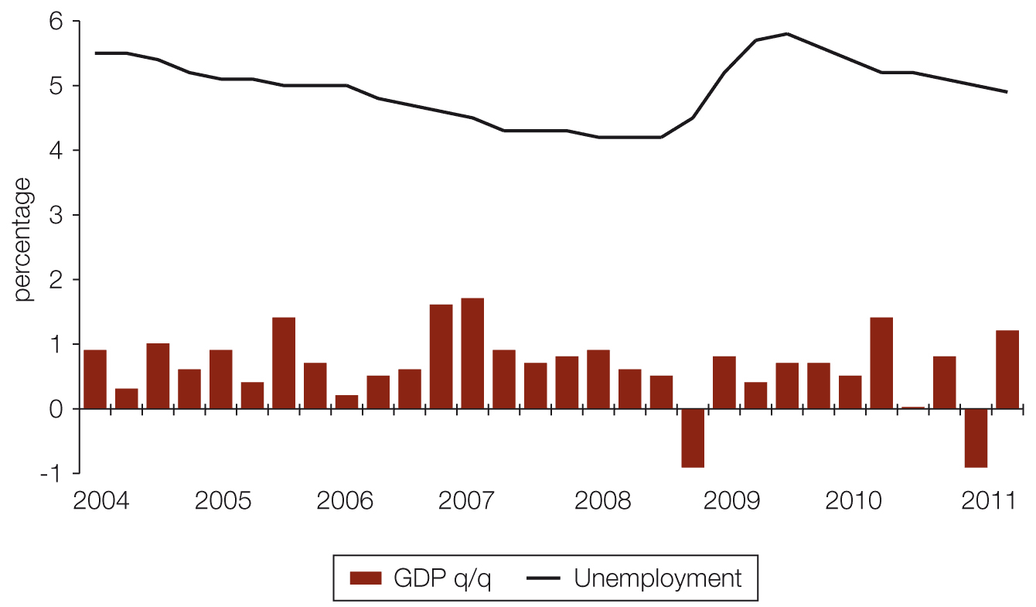
Source: ABS 2011, Australian national accounts: national income, expenditure and product, cat. no. 5206.0, ABS, Canberra; —2011, Labour force, Australia, May 2011, cat. no. 6202.0, ABS, Canberra.
Notes: Figure based on quarterly economic growth and unemployment rates.
q/q denotes change from previous quarter

The Reserve Bank of Australia (RBA) expects the economy to continue to grow, driven by strong Asian demand for Australia’s resources, albeit at a slower rate than previously anticipated. The 2011 outlook weakened somewhat over the course of the year, partly due to external influences such as the European and US debt crises and the impact on household wealth of falls in equity prices, which have almost certainly had some effect on housing market sentiment. In addition, the RBA has noted higher levels of household saving and greater caution about borrowing, the higher exchange rate and the winding back of the fiscal stimulus implemented during the GFC as all having a dampening effect on domestic demand.
Market softness
As well as the recent falls in prices (which are also discussed in Chapter 5), one of the more notable aspects of the market has been the drop in turnover since the end of 2009. As Figure 1.2 shows, mortgage commitments for households looking to buy a home to live in (rather than solely as an investment) fell sharply from the end of 2009 as various stimulus measures were phased out (and interest rates rose). The early part of 2011 saw the level of commitments fall to around its lowest level for a decade – below even that seen during the GFC. The increase in interest rates would be expected to have some impact on mortgage demand as the cost of finance increased.
Figure 1.2 Mortgage commitments for owner-occupier house purchases
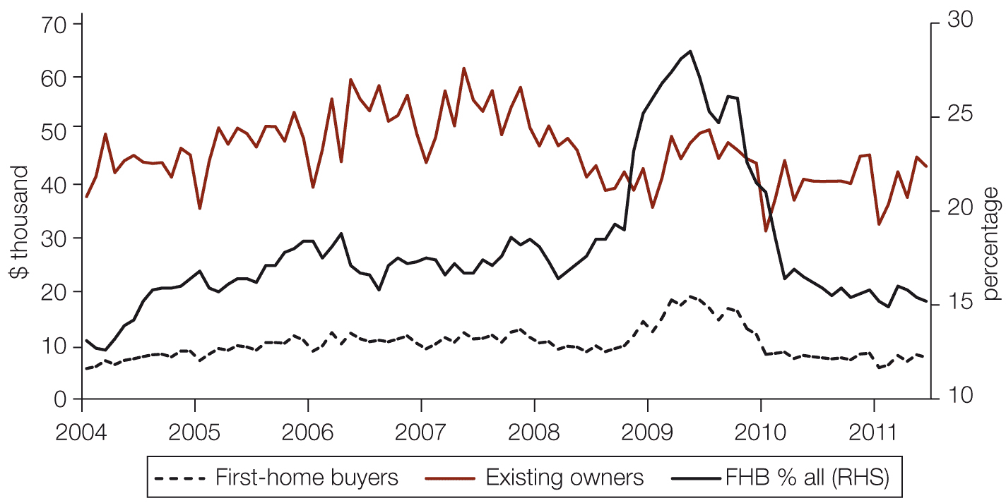
Source: ABS 2011, Housing finance, Australia series, cat. no. 5609.0, ABS, Canberra.
Notes: Figure based on monthly seasonally adjusted numbers of mortgage commitments for house purchases for owner-occupiers.
RHS = right-hand scale.
However, the fall has been particularly sharp among first-home buyers (FHBs) – in fact, the drop in overall activity looks to have been largely due to a drop among this group. As was noted in the 2010 report, the rise in 2009 and subsequent fall was likely driven by the temporary increase in first home owner grants (and its subsequent withdrawal) in response to the GFC, in addition to the sharp cut and following swift rise in interest rates. For 2010 as a whole, the number of mortgage commitments halved from 2009, while the number to existing owners declined by a more modest 11 per cent as FHBs’ share of activity declined to more typical levels. Although not all housing transactions are mortgage-based, the majority (typically around 75 per cent) are, especially among FHBs, so it is a strong guide to wider activity.

Table 1.1 State and federal government initiatives for first-home buyers, selected states
 |  | Until Jun 2009 | Jul-Sep 2009 | Oct-Dec 2009 | Jan-Jun 2010 | Jul-Dec 2010 | Jan-Aug 2011 | Aug 2011 onwards | Ending
NSW | Federal first-home owner grant | $7,000 | $7,000 | $7,000 | $7,000 | $7,000 | $7,000 | $7,000
 | Federal boost | $14,000 | $14,000 | $7,000
 | State supplement | $3,000 | $3,000 | $3,000 | $3,000
 | Total entitlement | $24,000 | $24,000 | $17,000 | $10,000 | $7,000 | $7,000 | $7,000
 | Current stamp duty exemptions | Full exemption of transfer duty for first home buyers for homes up to $500,000 or land up to $300,000 under First Home Plus scheme From the start of 2012 this will only be available on new properties
Vic | Federal first-home owner grant | $7,000 | $7,000 | $7,000 | $7,000 | $7,000 | $7,000 | $7,000
 | Federal boost | $14,000 | $14,000 | $7,000
 | State bonus | $5,000 | $11,000 | $11,000 | $11,000 | $13,000 | $13,000 | $13,000 | 30 Jun 2012
 | Regional supplement | $3,000 | $4,500 | $4,500 | $4,500 | $6,500 | $6,500 | $6,500 | 30 Jun 2012
 | Total entitlement | $29,000 | $36,500 | $29,500 | $22,500 | $26,500 | $26,500 | $26,500
 | Current stamp duty exemptions | Concessional land transfer duty rates for first home buyers currently reduced by 20%, increasing to 50% for principle place of residence by September 2014
Qld | Federal first-home owner grant | $7,000 | $7,000 | $7,000 | $7,000 | $7,000 | $7,000 | $7,000
 | Federal boost | $14,000 | $14,000 | $7,000
 | State grants |  |  |  |  |  |  | $10,000* | 31 Jan 2012
 | Regional boost |  |  |  |  | $4,000 | $4,000 | $4,000 | 30 Jun 2011
 | Total entitlement | $21,000 | $21,000 | $14,000 | $7,000 | $11,000 | $11,000 | $11,000
 | Current stamp duty exemptions | No mortgage duty or stamp duty for properties under $500,000. Stamp duty increase of $7,175 for all existing home owners buying a new or established home
SA | Federal first-home owner grant | $7,000 | $7,000 | $7,000 | $7,000 | $7,000 | $7,000 | $7,000
 | Federal boost | $14,000 | $14,000 | $7,000
 | State grants** | $4,000 | $4,000 | $4,000 | $4,000 | $4,000 | $4,000 | $8,000
 | Total entitlement | $25,000 | $25,000 | $18,000 | $11,000 | $11,000 | $11,000 | $15,000
 | Current stamp duty exemptions | None
WA | Federal first-home owner grant | $7,000 | $7,000 | $7,000 | $7,000 | $7,000 | $7,000 | $7,000
 | Federal boost | $14,000 | $14,000 | $7,000
 | Total entitlement | $21,000 | $21,000 | $14,000 | $7,000 | $7,000 | $7,000 | $7,000
 | Current stamp duty exemptions | No transfer duty payable for land with a home up to $500,000. No transfer duty payable for land only up to $300,000
Tas | Federal first-home owner grant | $7,000 | $7,000 | $7,000 | $7,000 | $7,000 | $7,000 | $7,000
 | Federal boost | $14,000 | $14,000 | $7,000
 | Total entitlement | $21,000 | $21,000 | $14,000 | $7,000 | $7,000 | $7,000 | $7,000
 | Current stamp duty exemptions | Eligible FHB were entitled to duty concessions for homes worth up to $350,000 between 20 May 2004 and 16 June 2011. These concession have ended.

Source: State governments.
Notes: Table covers the major concessions and grants.
Some state grants represent maximum available; actual grant awarded depends on FHB’s situation.
* Available to all owner-occupiers and investors on new dwellings worth up to $600,000.
** For new homes worth up to $450,000.

FHB activity was ‘brought forward’ by the temporary increase in grants (see Table 1.1), with some households able to enter the market as grants helped them to overcome mortgage deposit constraints. It is not surprising that activity declined as this stimulus was wound back. In addition, the rise in prices over 2009 and the early part of 2010 meant that the cost of housing moved out of reach for more potential first-home buyers, further suppressing activity. Under such circumstances it is not so much the case that demand has dried up as that there are not products available at the price this demand can afford – with the result that effective demand is lagging behind underlying demand. The surge in activity in the FHB segment, given that the increased grants would have increased borrowers’ purchasing power and in some cases helped overcome credit constraints, was a likely contributor to the increase in prices at the time, particularly in certain segments of the market. The unwinding of the grants may have contributed to the subsequent price softness.
The investor market has not seen the same fluctuations as the owner-occupier market. While its share of activity dropped following the GFC, this was largely due to the relative rise in FHB loans. The value of loans to investors fell by 14 per cent from 2007 to 2008, while the equivalent drop in the owner-occupier sector was 16 per cent.
Figure 1.3 Investor loans, value and share of all loans for house purchase
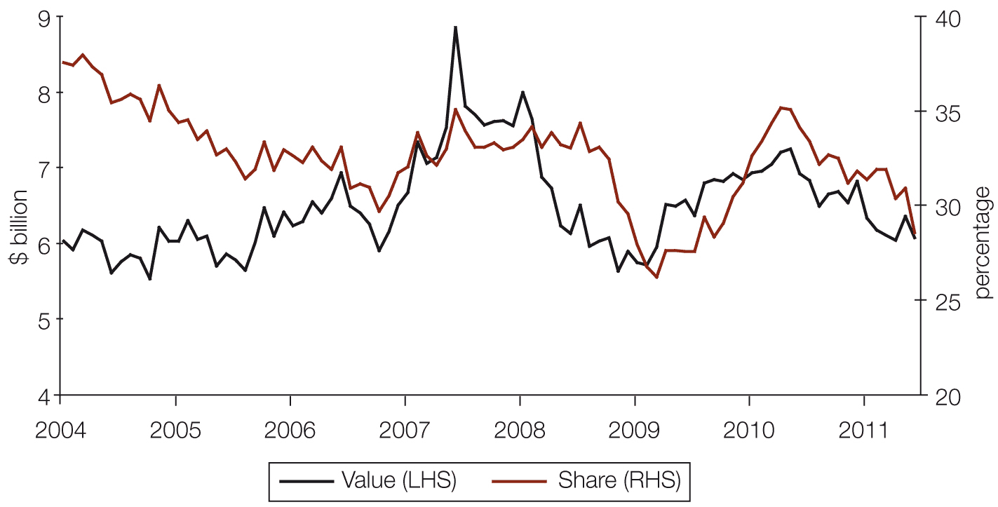
Source: ABS 2011, Housing finance, Australia series, cat. no. 5609.0, ABS, Canberra.
Notes: Figure based on monthly seasonally adjusted value of mortgage commitments for house purchase for investors.
The number of loans to investors is not available.
However, investor activity has weakened by more than the rate shown in the wider market since the middle of 2010 (see Figure 1.3). This weakening may be driven by diminished expectations regarding future capital appreciation. A study by the Institute of Actuaries of Australia (IAA) showed that, assuming an 80 per cent mortgage at a 7.5 per cent interest rate, an initial rental yield of 4.5 per cent and rental growth of 4 per cent, for an investor paying a marginal tax rate of 45 per cent, annual house price growth of around 5 per cent is needed for the investment to make a positive return. While such calculations are highly dependent on the assumptions made, they do indicate that, at current rental yields, above-inflation house price growth is required for the investment to be profitable. And still higher growth is needed for the return to be greater than perceived less risky investments such as bank deposits. Under the above assumptions, the IAA’s calculations suggest that capital appreciation must be near 6 per cent per annum for 10 years for the post-tax return to be greater than that on a 6 per cent term deposit.
Despite the continued strong building investment performance in 2010-11 noted above, anecdotal reports from the home building industry support the signs of a soft market. Builders have noted fewer people visiting housing display villages and, of those who visit, a smaller share making further enquiries. Builders report that there is little sense of urgency among potential buyers to start the process. It may be argued that this lack of urgency is partly attributable to the perception that house prices will face further corrections. The widely publicised debate about Australia’s residential prices remaining high by world standards may potentially be affecting buyers’ confidence and contributing to their hesitancy in acting.
Figure 1.4 Monthly levels of building approvals (trend)
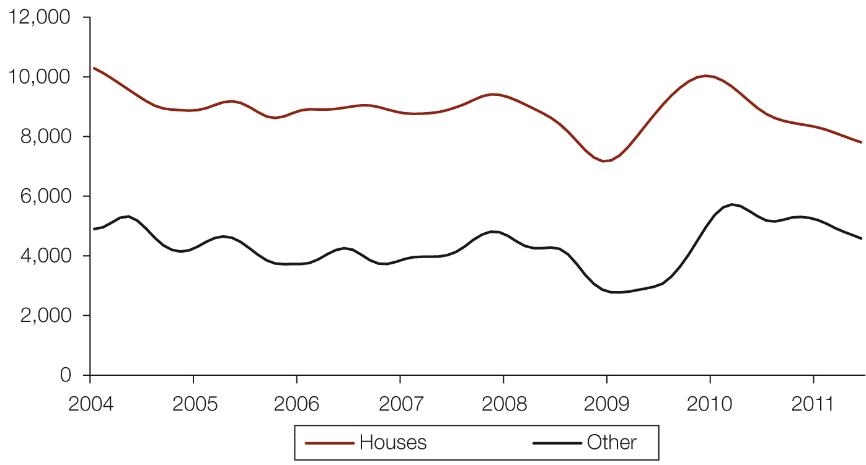
Source: ABS 2011, Building approvals, Australia, cat. no. 8731.0, ABS, Canberra.
Notes: Figure based on trend estimates.
‘Other’ covers mainly multi-unit dwellings such as apartment buildings.
While difficult to disentangle from the effects of planning decisions and other external factors, the building approvals data show a marked decline since the initial impact of the post-GFC stimulus. Land supply may be a factor for potential greenfield developments, and planning constraints may affect brownfield or infill. As seen in Figure 1.4, building approvals have been on a downward trend since early 2010. Approvals for dwellings other than houses (largely multi-unit apartment buildings) saw a longer downturn than those for houses following the GFC. Approvals for other dwellings only picked up in mid-2009, approximately six months after those for houses. This could be at least partly due to greater difficulty for builders in obtaining finance for this type of development, particularly in South-east Queensland (see later in this chapter). Clearly, building a block of apartments requires a larger initial outlay than building a single house. These higher initial development costs often require a larger loan, with which comes greater associated risk.
Availability of mortgage finance
One of the most important factors determining whether underlying demand can translate into effective demand in the owner-occupier sector is the price and availability of mortgage finance. The GFC brought some fairly stark changes to the mortgage market and the availability of finance in Australia, even if the fall in the rate of credit growth was modest compared to many other economies. Some of these changes have been reinforced by changes to financial regulations overseen by the Australian Prudential Regulatory Authority (APRA).
In response to these difficulties, in October 2008 the Treasurer announced that the Australian Office of Financial Management (AOFM) would purchase $8 billion of securitised loans to support ‘competition in residential mortgage lending and lending to small business’. This was extended by a further $8 billion in November 2009 and a further $4 billion in April 2011, in addition to the $3.5 billion of capacity that was outstanding at the time. Under the program the AOFM buys a stake in the issuance of Residential Mortgage Backed Securities (RMBS) from an issuer that is independent of the four major banks. As of October 2011, the AOFM had invested $14.0 billion in 53 RMBS issues, supporting mortgages on around 116,000 residential properties across Australia.
One of the defining features of the GFC was its impact on the ability of financial institutions to access funding markets. This was particularly severe for smaller specialist firms. The larger banks may have faced increased funding costs but were generally still able to raise funds (albeit for part of this period only with the assistance of a government guarantee). However, those mortgage lenders that relied heavily (or even solely) on being able to package and securitise the loans they originated – the ‘non-bank lenders’ – were particularly hard hit. This group had seen their mortgage market share increase in the years leading up to the crisis, as shown in Figure 1.5. They tended to operate in more specialist, and at times higher-risk, markets.
Figure 1.5 Mortgage market composition, $ billions lent to owner-occupiers
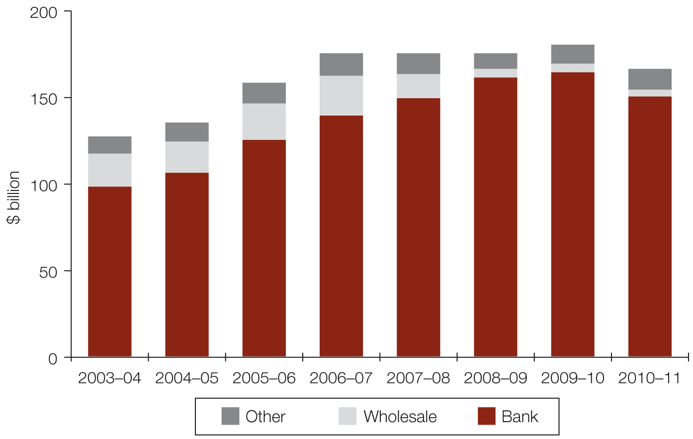
Source: ABS 2011, Housing finance, Australia series, cat. no. 5609.0, ABS, Canberra.
Notes: Figure based on $ billions lent for housing to owner-occupiers by type of financial institution.
‘Other’ lenders are largely building societies.
Banks were still the dominant players in the market even leading up to the GFC, but the concentration has become more intense since. Wholesale lenders accounted for 12–15 per cent of lending to owner-occupiers in the years leading up to the crisis. Since then this share has fallen away to less than 3 per cent. And it is not just these lenders who have been directly affected: banks also used the securitisation markets, so have become more dependent on other sources of funding (chiefly retail deposits) as a result of the crisis.
While the mortgage market now looks different compared to before the GFC in terms of market shares, it is difficult to infer that higher concentration implies lower competition. For example, although the major banks market shares in the housing market have risen significantly, the RBA noted in the September 2011 Financial Stability Review that ‘There has been an increase in competition in the residential mortgage market in the past year. Signs of increased competition recently include higher discounts being offered on housing loans, lower fees and increases in maximum allowable loan-to valuation ratios from 90 to 95 per cent.’
Although Australia did not experience as substantial a relaxation in mortgage lending criteria as occurred in a number of other advanced economies in the years leading up to the GFC, credit did nonetheless become more easily available. As already described, there have been fewer players in the mortgage market since the crisis and, despite the re-emerging competition, those that remain are somewhat more cautious than before the crisis.
There is little by way of consistent ‘hard’ data available on the terms under which mortgages are taken out and how these change, but the RBA has tracked what has happened to the take-up of higher-risk mortgages, as shown in Figure 1.6.
Figure 1.6 New loans by loan-to-value ratio (LVR), per cent
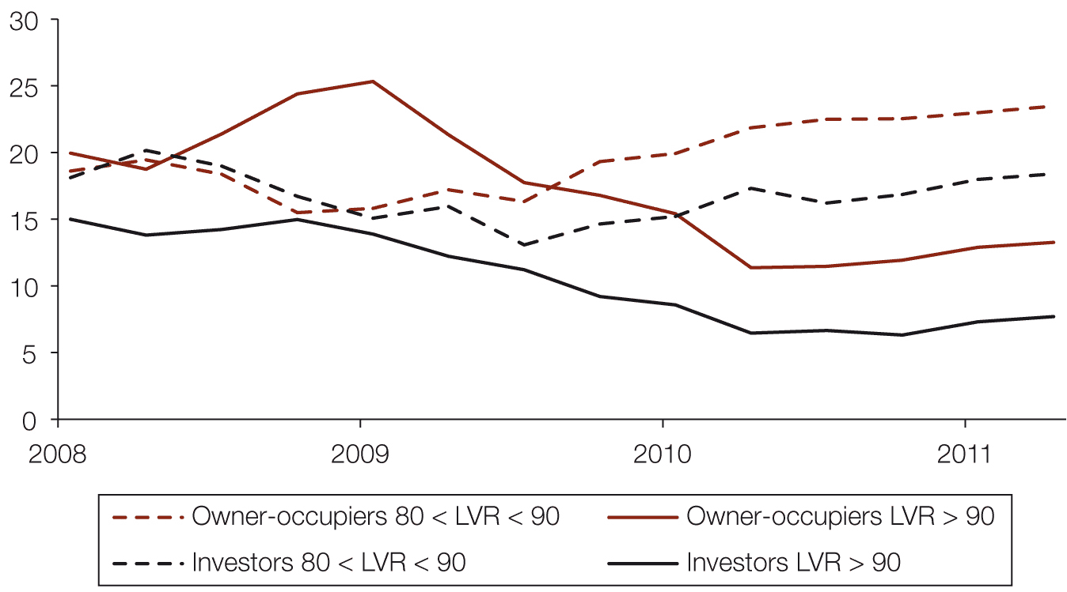
Source: RBA, Financial stability review September 2011.
Note: The lines represent the share of new mortgages taken out in each LVR band each quarter.
The share of loans taken out at higher loan-to-valuation ratios (LVRs) fell from the start of 2009, with fewer taken out at 90 per cent or more of the value of the property. However, for owner-occupiers, the share between 80 and 90 per cent LVR rose to compensate. There has been a small increase in the share of loans at higher LVRs over the early part of 2011. Among investors the share at over 90 per cent declined, while those between 80 and 90 per cent were fairly stable from 2008 to the end of 2010, although both also rose a little in 2011.
Most of this tightening in lending criteria appears to have taken place immediately following the GFC. This is complicated by the surge in FHB activity in 2009. FHB borrowers typically take out loans at higher LVRs, so the rise in the share of higher-LVR loans at that time among owner-occupiers was likely to have been largely due to the increase in activity in this cohort of the period. The subsequent decline in the share of loans of over 90 per cent LVR could be due to the subsequent fall in the share of FHBs among total buyers. But overall, the tightening of criteria appears to have levelled off from around mid-2010, and has been stable since then on this measure.

The share of new mortgages that are taken out on a ‘low-documentation’ basis (see Figure 1.7) has fallen steadily and continually over the past three years.
While a less direct measure of credit criteria, the RBA also records the share of loans taken out on an interest-only basis. These loans can be considered more risky, as the underlying debt is not automatically paid down. However, the RBA has noted that most lenders assess borrowers’ ability to service these loans on the basis of full capital repayment, not just interest payments.
Figure 1.7 New mortgages taken out on a low-documentation or interest-only basis
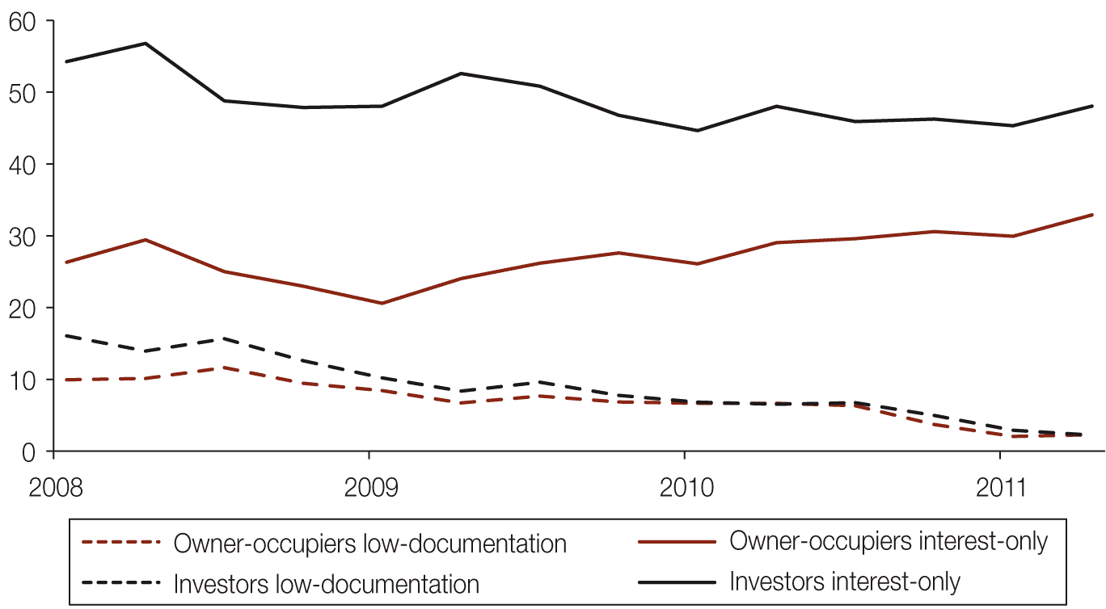
Source: RBA, Financial stability review September 2011.
Note: The lines represent the share of new mortgages taken out in each category each quarter.
A relatively large share of investors (just under 50 per cent in recent quarters) took out interest-only mortgages. In fact, given that mortgage interest is a tax-deductible cost for investors, so there is an incentive not to pay down the capital component, it is a little surprising that the share is not higher. This share did decline immediately after the GFC, but has held fairly steady since.
The share of owner-occupiers taking out interest-only mortgages (just under one-third in the second quarter of 2011) has risen following a decline in the immediate aftermath of the GFC. This share has slowly increased since early 2009. This may be due to affordability constraints and a favouring of interest-only loans as a method of reducing monthly payments in the short term.
More generally, the RBA has noted a more cautious attitude to increased indebtedness among households, and concerns of greater sensitivity to interest rate increases. Demand for credit appears to have slowed sharply. Credit growth increased by an average of 14 per cent per annum in the three years to mid-2008, slowing to around 4 per cent per annum since.
There have been tentative signs that mortgage lenders have responded to weaker demand. As noted above, some financial institutions have recently raised the maximum LVR limits at which they will lend, and some headline mortgage rates have been reduced. However, this is yet to show up in the aggregate data in any meaningful way. But some geographic submarkets, including parts of South-east Queensland, are also experiencing valuation issues (where a valuer values a property below the contract price, affecting lenders’ willingness to lend) which could limit the effects of a loosening of credit conditions.
It is not possible to disaggregate the demand and supply sides – that is, to determine whether this trend is due to some potential borrowers being unable to access loans due to limited availability, or to their being less inclined to borrow due to rising interest rates or expectations about a soft or even negative outlook for house prices. In reality the cause is likely to have been a mixture of both since the GFC, although the more recent drop-off is probably more demand-driven, as credit does not appear to have become noticeably more difficult to access and there are some signs of easing in credit access conditions since early 2010. The RBA expects this more cautious approach to continue and has welcomed the rise in the savings rate.
Developer finance
It is harder still to assess the effects of the GFC on developers’ access to finance for bringing new homes onto the market. Discussions between the Council and the industry have pointed to some restriction in the availability of credit to developers, particularly for multi-unit apartment developments. Lenders have become more cautious, with some smaller firms having withdrawn from specific local markets, such as south-east Queensland. As with the mortgage sector, smaller or more peripheral lenders that are heavily dependent on raising funds in wholesale markets have been particularly hard hit. But these were not thought to have had a significant role in the market even in the peak of the boom years. Some developers have noted tougher criteria being applied by banks in assessing lending decisions.
However, it is difficult to disentangle this from the effects of the weaker market. Finance is often dependent on achieving certain levels of pre-sales on a development, which in turn is affected by a quiet housing market. So in some cases it may be harder to meet the criteria set for a loan due to market conditions, rather than because the criteria themselves have been tightened. The Council will conduct further research in this area and gather evidence from across the development and finance sectors.
Conclusions and future work
Despite the increasing housing shortage since the 2010 report was published, there have been signs of softness in the market. This appears to have been driven by a diminished willingness to take on housing debt (and by deteriorating affordability) rather than by increased difficulty in accessing credit. The Council does not believe that this is inconsistent with an underlying shortfall in supply. The gap means that housing costs are higher than they would otherwise be, but there can still be volatility at these higher levels.
In the long term, the shortage makes housing less affordable or accessible than would otherwise be the case. It also raises questions regarding the circular nature of some of these drivers. There will be a number of ways that the market will react to a housing shortage, in addition to some of the social issues highlighted in Chapter 4. If it leads to an increase in household size and more multi-generational households (as it has done since the 2001 Census), will this change be permanent? Will the increased prevalence of adult children living in the family home continue? Will households put off having children permanently, or just delay the decision? These factors can all affect both underlying and effective housing demand in the future.
Questions can also be raised about the effectiveness of subsidising housing demand through grants and the tax system to improve affordability or increase the supply of housing. Australia has a long history of attempting to help those looking to get into the housing market, and housing enjoys preferential tax treatment over many other asset classes. Without measures to increase specifically the supply of housing, it is difficult to see how subsidising demand, particularly for existing homes, is a solution. However, a more targeted approach with incentives for purchasing new-build properties could help to increase supply.

Chapter 2 Demand for housing
This chapter discusses underlying housing demand, which is defined by the Council as the total number of households. In addition to presenting projections of household numbers, the chapter describes historical trends in household numbers. It also includes an overview of the housing experiences of migrants as a specific submarket.
Key points
- The Council estimates that in June 2010, there were more than 8.7 million households in Australia.
- The number of households is projected to be 12.0 million by 2030 (medium underlying demand projection), representing a net increase of nearly 3.3 million households between 2010 and 2030.
- This projected demand (number of households) is higher than in previous State of Supply Reports. The later projections capture the unanticipated population growth in 2008–09 and reflect some changes to state and territory migration patterns since 2006.
- The numbers of households comprising couples without children and lone-person households are projected to grow much more rapidly in all regions than are the number of households that are families with children.
- Sydney’s growth from migration is largely the product of international migration. Sydney’s net annual growth in households more than doubles under the high household growth scenario (high net overseas migration) compared with the medium scenario.
- The projections suggest most regions will experience an increased propensity for households to live in flats, apartments and townhouses rather than detached houses.
- Demand for public housing and affordable private rental accommodation is likely to increase as the population ages.
- Members of the Australian-born population are more likely than immigrants to own their home. However, immigrants tend to move from rental accommodation to owner-occupation over time.
- Of new arrivals to Australia, around 64 per cent of family visa arrivals and 89 per cent of skilled visa arrivals form new households within the year they arrive in Australia.
Underlying demand for housing
The Council’s demand projections focus on underlying demand for housing (which is defined as the total number of households), rather than effective demand for housing (which is demand as expressed in the housing market, including both the private rental sector and the social housing system, and is therefore driven by economic as well as demographic factors). Some of the differences between these two types of demand are discussed in Chapter 1.
The use of household projections assumes that underlying demand would equal effective demand if the market could provide housing products to meet the needs, aspirations and capacity to pay of all households. However, a small proportion of households may choose not to consume housing or may be accommodated outside the housing sector (such as in nursing homes and shelters).
The Council defines a household as a group of two or more related or unrelated people who usually reside in the same dwelling and who regard themselves as a household. In the 2006 Census of Population and Housing, the Australian Bureau of Statistics (ABS) changed the definition of a household to incorporate all usual residents of a private dwelling, regardless of whether they considered themselves to comprise a household or made common provision for food or other essentials. Under the latter definition, for Census purposes, the total number of households is equal to the total number of occupied private dwellings. Households include family households, lone-person households, and group households of unrelated people. Family households include couples with or without children, families with children, and adult siblings sharing a dwelling. Households can also include more than one family.
As the Census household counts form the basis of the Council’s household estimates, people who are usually resident in non-private dwellings, such as hotels, motels, boarding houses, jails and hospitals, are not included in household numbers. Consistent with the ABS definition used in the Census, people residing in non-private dwellings are effectively not included in household estimates. However, non-private dwellings are likely to house at least some of the people whose underlying demand for housing is not being met.
The level of underlying demand is driven mostly by migration and other demographic factors. Social and economic factors, including the cost of housing, also affect these demographic factors. Several of the influences on underlying housing demand have changed over time and are likely to continue to change. Examples include:
- changing international and internal migration levels, with settlement patterns often linked to employment and education opportunities and preferred retirement locations
- regional differences in housing opportunities, along with mismatches between housing location and labour markets
- changing patterns of household formation, reflecting trends towards later partnering and becoming parents at an older age
- people living longer and being healthier, with a marked increase in the number of people aged 65 years and over.
Trends in household formation and change
Australia’s population is continuously changing in size, composition and spatial distribution, and this affects the level and nature of demand for housing. The influence of demography on the level of demand for housing is obvious, but it is not a simple relationship wherein population growth produces an equivalent increase in demand for housing. The drivers of trends in the need and demand for housing are a complex mix of economic, political, social and demographic forces.
The three variables determining growth in the number of households are the rate of population growth, the age-specific rates at which particular age groups form households, and changes in the age structure of the population. In examining the demographic drivers of demand for housing, we need to consider:
- the rate at which overall population growth is occurring, and some of the forces driving this growth
- the change in age structure (each age group as a proportion of the total population), and how this affects the likelihood of forming new households
- how and why specific age cohorts change their likelihood of forming new households; (for instance, whether the current cohort of 20–25-year-olds is more or less likely to form new households than were 20–25-year-olds 10 years ago).
Impact of population growth
In recent decades the rate of growth in the number of households has been considerably greater than the rate of growth in population (see Figure 2.1). Although population growth has been a major factor in the growth of households, its contribution to household growth has declined since 1991–96, and decreased markedly in 1996–2001 to less than half of household growth for the first time in the last three decades. The numbers of households continued to increase at a faster rate than the population from 2001 to 2006. However, recent ABS survey data suggest there has been an increase in household size since the 2006 Census and, therefore, a lower rate of growth of households relative to population growth since that time.
Figure 2.1 Growth in households and the Australian population, 1961–2011
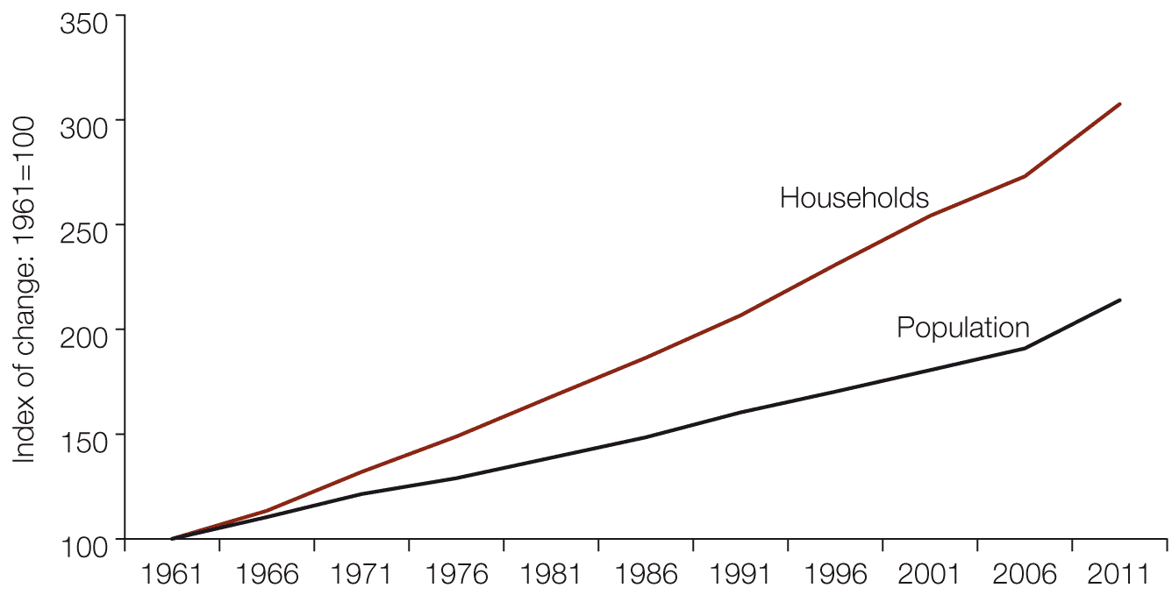
Source: ABS Census of Population and Housing 1961, 1966, 1971, 1976, 1981, 1986, 1991, 1996, 2001, 2006, ABS, Canberra; —2011, Australian demographic statistics, Dec 2010, cat. no. 3101.0, ABS, Canberra.
The ABS notes that the proportion of lone-person households increased from 15.7 per cent of all households in the 1976 Census to 24.4 per cent in the 2006 Census. The proportion of two-person households also increased from 28.1 per cent in 1976 to 34.1 per cent in 2006. A further major influence on decreasing household size was the decline in both the number and the proportion of households of five or more people. The number of lone-person households has grown, largely as a result of population ageing combined with longer life expectancy. Population ageing, increased childlessness among couples and an increase in the number of one-parent families also contributed to the increase in the number of two-person households.
Social and demographic change
Age-specific rates of household formation have been volatile over time. Increasing time in education and changing patterns of partnering have an impact. Household formation rates are also influenced by interest rates, social policy, housing policy, housing affordability and the health of the economy. Many of these factors have a different impact across age groups.
Over the past decade, the age at which people partner and form new households has increased. Adult children are staying at home longer and completing education and entering the full-time workforce later than did previous generations. The proportion of 20–24 year olds participating in education increased from 32 per cent to 37 per cent between 1996 and 2006. Both men and women are getting married for the first time at older ages (from a median age of 26.3 years for men and 24.2 years for women in 1989 to a median age of 29.6 years for men and 27.7 years for women in 2009). This partly reflects later partnering, although the effect on household formation has been moderated by an increase in couples living together before marriage in recent decades. Seventy-eight per cent of couples who married in 2008 had lived together before marriage, compared with 23 per cent in 1979.
The other demographic factor affecting the number of households is the age structure of the population, although this has had the smallest impact. Australians are surviving longer and remaining in independent households longer than ever before, influencing the level and nature of demand for housing. In the 20 years from 1989 to 2009, the life expectancy of Australians over the of age 50 years increased by five years for men (to another 31.7 years) and nearly four years for women (to another 35.3 years). The 2010 Intergenerational report produced by Treasury (IGR 2010) notes that in the 40 years to 2050 the ageing of the population will see the number of people aged 65 to 84 years more than double, and the number of people aged 85 years or over more than quadruple. The Council notes that while the ageing of the population has made a relatively small contribution to increased aggregate underlying demand for housing, its influence on the level of demand for different housing types and locations may be more profound. This is explored further below.
The Council’s model for projecting demand
The Council’s 20-year outlook for housing demand is based on projections commissioned from Professor Peter McDonald and Dr Jeromey Temple from the Australian Demographic and Social Research Institute at the Australian National University. Their model estimates the probable formation of different household types based on various assumptions relating to migration and household transition. For this report, assumptions made about destinations of migrants have been adjusted to reflect more recent trends. More detail is provided in Appendix 2.
The model’s assumptions regarding the probability of household transitions for individuals at each age are based on household transitions between the 2001 and 2006 Censuses, and are likely to reflect indirectly the social and economic influences on households at that time. As previously discussed, these influences are likely to change over time. Future reports will examine the Council’s household projections to 2011 against the changes observed between the 2006 and 2011 Censuses, to assess some of the impacts of changes to the drivers of underlying demand, and the significance of such changes. The Council aims to develop a more refined set of assumptions for future household projection work. These assumptions could address, for example, the impacts of different forms of migration (particularly of temporary migrants) on the demand for housing.
Current underlying demand for housing
The starting point for projections of future underlying demand is estimated current demand for dwellings in Australia. The Council estimates that there were just over 8.7 million households in Australia at the end of June 2010, and just under 8.6 million households in Australia at the end of June 2009. The latter estimate is slightly higher than the estimate of 8.5 million households in 2009 published in the 2010 State of Supply Report, and than the estimate of 8.3 million households in 2008 published in the 2008 and 2010 reports.
Projections of future underlying demand for housing
In the 2008 State of Supply Report (published in 2009), the Council’s medium-scenario projections of the number of households suggested an increase from 8.3 million in 2008 to 11.4 million in 2028 – an increase in underlying demand of 3.1 million households (or an average of 153,000 additional households per year) over the 20 years from 2008 to 2028.
Under the Council’s current medium-scenario projections, the number of households in Australia is projected to be 12 million by 2030 – an increase of nearly 3.3 million (or more than 163,000 additional households per year) in underlying demand over the 20-year period from 2010 to 2030 (see Tables 2.1 and 2.2). These projections are also slightly higher than those in the 2010 report. These differences reflect the higher net overseas migration (NOM) in recent years, which has been factored into the base population for the current projections. That is, the change in underlying demand is due to a change in the base population estimate rather than in the projections for future years.
Table 2.1 presents the projected total underlying demand, based on three population growth scenarios (low, medium and high). The scenarios reflect different assumptions about migration. The low-growth scenario is based on an assumption of low immigration (120,000 persons per year). The high-growth scenario is based on 250,000 persons per year, and the medium-growth scenario on 180,000 people per year. Tables of household projections by state and territory are presented in Appendix 2.
Table 2.1 Underlying demand projections based on low, medium and high household growth: annual increase in underlying demand and total underlying demand projections (households), 2010–2030
 | Average annual increase in underlying demand in intervening period |  |  |  | Total underlying demand
Year | Low household growth | Medium household growth | High household growth |  | Low household growth | Medium household growth | High household growth
2010 | 135,900 | 159,200 | 186,300 |  | 8,723,300 | 8,746,600 | 8,773,700
2015 | 140,100 | 164,300 | 192,500 |  | 9,423,900 | 9,568,100 | 9,736,300
2020 | 138,900 | 164,500 | 194,400 |  | 10,118,500 | 10,390,800 | 10,708,300
2025 | 135,500 | 162,200 | 193,500 |  | 10,795,800 | 11,202,000 | 11,675,700
2030 | 133,900 | 161,900 | 194,600 |  | 11,465,400 | 12,011,500 | 12,648,500
Source: National Housing Supply Council projections based on McDonald and Temple low, medium and high household growth scenarios. Figures are rounded to the nearest hundred.
Notes: The shaded area depicts the main projection series used in this report.
These figures are projected from estimated resident population as at 30 June 2009.
The increase for 2010 is solely for that year. Subsequent increases are averages for five-year periods (2011–2015, 2016–2020, 2021–2025, 2026–2030).

The Council’s medium household growth scenario is considered the most likely outcome. The medium-growth assumption of 180,000 NOM per year is broadly consistent with the Department of Immigration and Citizenship forecasts of NOM to the year ending June 2015.
NOM has already fallen, due in part to changes in migration policy such as the new Skilled Occupation List, and changes to student visas. These policies began to have an effect from July 2010.
The medium household growth scenario is now also broadly consistent with the NOM assumptions used in the IGR 2010 of the high immigration levels of 2008 to 2010 falling from 2012 and in future years. The IGR 2010 incorporated higher short-term NOM figures, with an average of around 244,000 people per year for the three years to June 2009, falling to 180,000 people per year from 2012.
The current Council projections are higher than those in previous reports and higher than the household projections produced by the ABS. For further comparison of the Council’s projections with the ABS projections, see Appendix 2. The Council’s current projections use the latest available final estimated resident population (ERP) figures at the time of the projections being prepared (year ending June 2009) as a baseline. Although later population estimates have since become available, the current projections capture the unanticipated population growth (a peak growth rate of 2.2 per cent) to the year ending June 2009 in the base population used as the ‘starting point’ for the projections. The later population estimates (preliminary data for the year ending December 2010) are in line with the Council’s projections.
Recent years have seen dramatic growth in NOM, with 299,900 people for the year ending June 2009 and just under 215,600 for the year ending June 2010. Therefore the high-growth scenario for 2009 and 2010 published in the 2010 report is likely to have been closer to reality than the medium-growth scenario. However, the projections in this report have captured much of that growth in the base population estimate. As most of this population growth is from immigration (57 per cent in 2009–10, but only 53 per cent in 2010), and recent changes to immigration policy suggest much lower intakes for the next five years, this dramatic rate of population growth is not projected to continue, although it could if labour shortages translate into significant increases in skilled and temporary migration. Migration continued to decline to the end of December 2010. The ABS preliminary NOM overseas migration estimate for 2010 (171,100 people) was 35 per cent lower than that for 2009. Medium-growth projections for 2010 and 2011 (see Table 2.3) are slightly higher than the high-growth scenario projections for the same years in the 2010 report.
Table 2.2 Cumulative additional households projected under low, medium– and high- household growth scenarios (’000 households), June 2010 – June 2030
Year |  | Scenario
 | Low growth | Medium growth | High growth
2012 | 279.4 | 326.8 | 382.2
2015 | 700.5 | 821.5 | 962.6
2020 | 1,395.2 | 1,644.2 | 1934.6
2025 | 2,072.5 | 2,455.4 | 2902.0
2030 | 2,742.0 | 3,264.9 | 3692.8

Source: National Housing Supply Council projections based on McDonald and Temple low, medium and high household growth scenarios from June 2009.
Table 2.2 shows projected cumulative additional underlying demand from 2010 to 2030. As discussed later in this chapter, population ageing is likely to change household structures and demand for different tenure types. While the ageing of the population also increases the death rate and this, in itself, reduces the demand for additional dwellings, the results of the Council’s current projections suggest this impact will be relatively small.
Projections for growth of different household types
Table 2.3 shows likely growth in household types in the 20 years from 2010 to 2030. Lone-person households are expected to increase as a share of all households from 26 per cent in 2010 to 32 per cent in 2030. Family households with children are expected to decrease as a proportion of all households from 43 per cent in 2010 to 38 per cent in 2030. Households consisting of couples without children (living in the house) or lone persons are projected to increase as a share of all households more rapidly than are households of families with children in all regions in the next 15 years. Only medium-scenario projections are presented here, as household type projections are not noticeably affected by different migration assumptions.
The next 10 to 15 years will see gradual but significant changes in the distribution of the population across household types. As Figure 2.2 illustrates, the most obvious changes will be growth in the proportion of lone-person households and decline in the proportion of families with children. The 2030 projection (see Figure 2.2) also shows the beginning of a slowing of the growth of couple-only households (from 2025). This reflects an ageing population structure.
Figure 2.2 Projected change in household types, 2010–2030
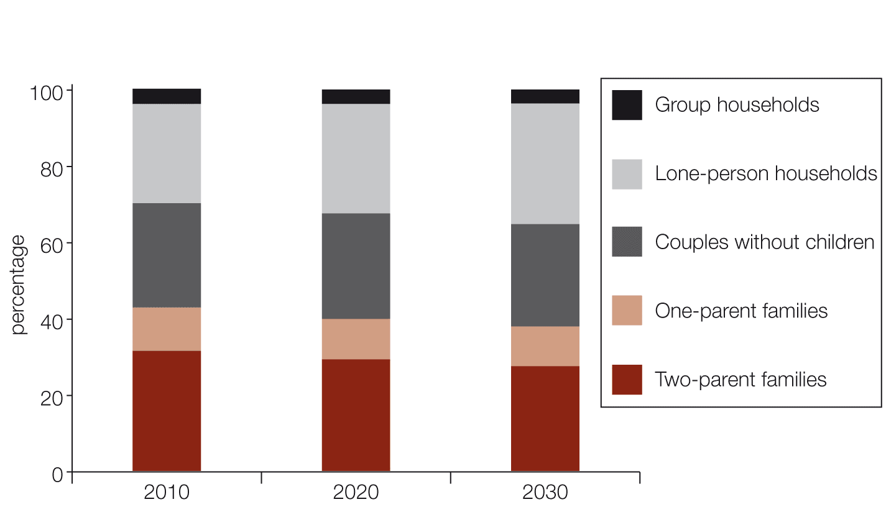
Source: National Housing Supply Council projections based on McDonald and Temple medium household growth scenarios, 2010 to 2030.

Table 2.3 Projections of national underlying demand by household type, medium household growth scenario, 2010–2030
 | Year, as at 30 June
Household type | 2010 |  | 2011 | 2012 | 2013 | 2014 | 2015 | 2020 |  | 2030
Number of households (’000)
Two-parent families | 2,743.6 | 2,771.4 |  | 2,799.8 | 2,828.6 | 2,857.9 | 2,887.6 | 3,036.4 |  | 3,296.7
Single-parent families | 994.2 | 1,007.1 |  | 1,019.2 | 1,030.6 | 1,040.2 | 1,050.2 | 1,105.7 |  | 1,246.0
Couples without children | 2,384.8 | 2,438.1 |  | 2,491.1 | 2,543.6 | 2,595.1 | 2,645.3 | 2,871.0 |  | 3,222.8
Lone-person households | 2,272.5 | 2,334.8 |  | 2,399.7 | 2,466.7 | 2,536.2 | 2,606.8 | 2,979.2 |  | 3,800.1
Group households | 351.5 | 357.8 |  | 363.6 | 368.9 | 373.8 | 378.3 | 398.5 |  | 445.9
Total households | 8,746.6 | 8,909.2 |  | 9,073.4 | 9,238.5 | 9,403.2 | 9,568.1 | 10,390.8 |  | 12,011.5
 | Percentage of households
Two-parent families | 31.4 | 31.1 |  | 30.9 | 30.6 | 30.4 | 30.2 |  | 29.2 | 27.4
Single-parent families | 11.4 | 11.3 |  | 11.2 | 11.2 | 11.1 | 11.0 |  | 10.6 | 10.4
Couples without children | 27.3 | 27.4 |  | 27.5 | 27.5 | 27.6 | 27.6 |  | 27.6 | 26.8
Lone-person households | 26.0 | 26.2 |  | 26.4 | 26.7 | 27.0 | 27.2 |  | 28.7 | 31.6
Group households | 4.0 | 4.0 |  | 4.0 | 4.0 | 4.0 | 4.0 |  | 3.8 | 3.7
Total households | 100.0 | 100.0 |  | 100.0 | 100.0 | 100.0 | 100.0 |  | 100.0 | 100.0

Source: National Housing Supply Council projections based on McDonald and Temple medium household growth scenarios, 2010 to 2030.
Notes: Figures have been rounded to the nearest hundred. Percentages have been calculated using raw data. Numbers and percentages may not sum to totals, due to rounding.

Regional differences in housing demand
The projections of underlying demand presented in this report are primarily designed to provide a national picture. The model has, however, also been used to produce capital city and ‘rest of state’ estimates for the states, and territory-wide estimates for the ACT and the Northern Territory (Table 2.4). It is important to note that these estimates may differ considerably from household projections prepared by state and territory planning agencies, which typically include assumptions about future changes in the trend of population growth. Being projections of existing trends focused primarily on projecting aggregate underlying demand, the Council’s projections do not include future inter-regional changes in economic performance, jobs growth, attractiveness as a destination for international and internal migrants or housing opportunities, or changing relativities between housing location and labour markets, but do account for change in demand overall.
This report presents projected underlying demand for each capital city and the balance of each state. Future reports may examine housing demand in smaller regions, in particular in some non-capital cities. The key differences in housing markets may be between coastal and inland areas – for example, coastal cities compared to inland cities – or resource areas compared to declining dry-land farming communities. The Council will undertake or commission future research to develop a more detailed understanding of the drivers of change in housing demand across regions. It is important to note the limitations of long-term projections across small subdivisions of the total population.
Table 2.4 compares additional underlying demand on a state and territory basis (each derived from location-specific application of the McDonald and Temple model, including location-specific transitional probabilities) under the low, medium and high household growth scenarios. The states’ shares of NOM outlined in this report differ from those in the 2010 State of Supply Report. The changes are based on recent trends and are detailed in Appendix 2 (Table A2.1). Changes in inter-regional relativities across the scenarios are driven by changes in annual net migration between regions. Details of the assumed regional shares are given in Appendix 2 (Table A2.3).
Table 2.4 Projected additional households by region for low, medium- and high- household growth scenarios (’000 households), 2010–2030
Region | Low-growth scenario | Medium-growth scenario | High-growth scenario
Sydney | 364.3 | 516.3 | 693.5
Rest of NSW | 304.8 | 311.8 | 319.9
Total NSW | 669.1 | 828.0 | 1,013.4
Melbourne | 479.9 | 609.1 | 759.8
Rest of Vic | 155.3 | 163.1 | 172.3
Total Vic | 635.1 | 772.3 | 932.2
Brisbane | 310.7 | 372.3 | 444.1
Rest of Qld | 510.6 | 554.8 | 606.4
South-east Qld (a) | 611.0 | 697.0 | 797.4
Total Qld | 821.3 | 927.1 | 1,050.6
Adelaide | 77.0 | 103.2 | 133.9
Rest of SA | 44.4 | 46.8 | 49.7
Total SA | 121.3 | 150.0 | 183.5
Perth | 283.8 | 357.3 | 443.0
Rest of WA | 101.1 | 109.6 | 119.5
Total WA | 384.9 | 466.9 | 562.5
Hobart | 19.6 | 21.9 | 24.5
Rest of Tas | 20.1 | 21.7 | 23.6
Total Tas | 39.8 | 43.6 | 45.5
Total NT | 30.6 | 33.2 | 36.3
Total ACT | 39.9 | 43.7 | 48.2
Australia | 2,742.0 | 3,264.9 | 3,874.8

(a) South-east Queensland includes the statistical divisions of Brisbane, the Gold Coast, the Sunshine Coast and West Moreton and Toowoomba Regional Council (Cambooya Shire Pt A, Crows Nest Pt A, Jondaryan Shire Pt A, Rosalie Shire Pt A and Toowoomba City).
Source: National Housing Supply Council projections based on McDonald and Temple low, medium and high household growth scenarios.
Notes: Figures have been rounded to the nearest hundred. Numbers may not sum to totals, due to rounding. Data for capital cities and ‘rest of states’ are based on ABS-defined statistical division boundaries.
By region, projected housing demand differs according to the migration scenario used. The three scenarios do not, however, include the interaction of population movements and housing market circumstances. If housing supply in some regions is constrained, or if prices rise relative to other regions, this may affect net migration flows. For instance, internal out-migration from Sydney may well have been influenced by tight supply and relatively poor affordability. It is also possible that, for example, population growth in South-east Queensland could slow relative to these scenarios if housing prices rise more there than in other regions and/or housing supply is constrained. Despite strong growth over the past decade, Brisbane’s house prices and rents have been lower than those of Sydney and Melbourne, possibly encouraging migration from the southern capitals and directly from overseas. Possible restrictions in supply associated with recovery from the January 2011 floods might also see a location preference switch away from South-east Queensland.
Medium household growth scenario
As shown in Table A2.3 in Appendix 2, consistent with the trend in recent years, Queensland is assumed to gain from migration (from both overseas and within Australia) more than any other state or territory. The medium household growth scenario assumes net migration to Queensland of approximately 64,000 persons per year – substantially higher than for the next highest state, Victoria (41,400).
Among the capital cities, the highest net migration in 2010 is for Melbourne, at approximately 33,800, followed by 25,200 each for Perth and Brisbane and 19,100 for Sydney. However, net migration to South-east Queensland (excluding Brisbane) is nearly 26,800 – higher than migration to Brisbane itself. Considering South-east Queensland as a whole (see Table 2.4), its level of migration is by far the highest of any of the regions in the table, at approximately 51,900. In New South Wales, net migration to areas outside Sydney (16,300) is only a little lower than net migration to Sydney. In Queensland, migration to areas outside Brisbane is much greater than migration to Brisbane. In contrast, Victoria and Western Australia, net migration is heavily concentrated on the respective capital city.
Low household growth scenario
Sydney’s net growth from migration is mostly the product of international migration, while the growth from migration for the rest of the state is determined by internal migration (largely from Sydney). With a very low international migration scenario (even less than 120,000 people per year), Sydney would experience a small annual net loss of population, while net migration for the balance of New South Wales would fall only marginally.
This story is largely repeated across other states: lower international migration has a larger impact on net migration for the capital cities but only a marginal impact on net migration for the balances of each state. The exception to this is Queensland, where direct overseas migration occurs in parts of South-east Queensland other than Brisbane. A fall in NOM would affect South-east Queensland more that it would other areas of Australia outside the capitals.
High household growth scenario
Under this scenario, the areas outside the capitals have much the same levels of annual net migration as under the medium household growth scenario, but net migration to the capital cities is much higher. The population of Sydney is the most influenced by changes to NOM, followed by Melbourne. Net annual migration to Sydney more than doubles under the high household growth scenario compared with the medium household growth scenario.
Effects of household size
In general, differences in household sizes across regions are not the product of preferences about household size. Rather, they reflect variations in household composition across cities and regions (a higher proportion of two-parent families with children will lead to higher average household sizes) and possibly the housing supply situation (cities or regions with the largest housing shortages relative to needs, all else being equal, will have larger household sizes).
The Council does not yet know whether changes in household size that stem from tight housing supply or poor affordability will be adopted as longer-term preferences. It may be that supply-induced household compositions lead to longer-term changes in housing preferences, of that people may revert to more fundamental preferences if the supply shortfall disappears. For example, a young adult might have a partner move in to the parental home with him or her; with an increase in supply a similar couple might form a new single-family household, as was more typical in the 1980s.
The Australian Local Government Association’s State of the Regions report notes that average household size increased markedly in areas with rising rents or tight supply, whereas household size fell in areas with relatively slack housing markets, such as the non-metropolitan regions of South Australia and Tasmania.
The Council’s demand modelling shows that if Sydney and Melbourne had the same household composition as Australia as a whole, they would need more dwellings. That is, if Sydney and Melbourne had their current population but with higher proportions of smaller household types (lone persons, couples only) replacing larger households types (two-parent families), then they would need more dwellings. Over time, the differences become smaller as the projected household compositions of Sydney and Melbourne become more like those of the rest of Australia. Demand for housing outside the capital cities would be lower if their household compositions were the same as that of Australia as a whole.

Box 2.1 The Australian Census of Population and Housing
The Australian Census of Population and Housing provides data on the characteristics of the Australian population and households, which form the basis of the Council’s demand projections. The Census is the only official source of information on the characteristics of the Australian population and households that covers the entire population and can be disaggregated to small areas. Data from the 2011 Census will be available from mid-2012.
Future State of Supply reports will compare the Council’s projections to 2011 against findings from the 2011 Census to assess the accuracy of our assumptions and findings and the impact of social and economic change on housing demand. Changes (including an undersupply of housing) might trigger changes in household formation patterns, internal migration patterns, household types, and types and uses of dwellings. The current projections cannot anticipate any such changes. Comparing our projections to results from the 2011 Census may offer some insights into how Australians have adapted to changes in housing supply and affordability.
The Census is the source of population estimates (known as estimated resident population, or ERP). These are derived from ‘usual residence’ Census counts adjusted on two bases: one for Census undercounting and the other to include estimates of Australian residents temporarily overseas. Data on a person’s usual residence one and five years ago, combined with ‘usual residence at Census time’, give information on the extent and patterns of internal migration of the population. This is also used in the production of intercensal and postcensal ERP – the baseline population data used for household projections.
Since the 2006 Census, a household has been defined as all usual residents of a private dwelling. While it is possible for more than one household to occupy the same dwelling on Census night, the total number of households is equal to the total number of occupied private dwellings. Traditionally the Census has defined a dwelling as the space occupied by a household.
The work of the National Housing Supply Council and others has emphasised the need for detailed information about Australia’s housing stock. Census dwelling structure data may be used to examine, among other things, changes in housing patterns and density, and for land use monitoring and forecasting.
Census data provide a range of data that might help to assess how underlying demand for housing is affected by housing supply, including number of bedrooms, tenure type, rent level, landlord type, mortgage repayments, structure of private dwelling, location of private dwelling, non-private dwelling type, number of motor vehicles garaged, and tenure type by landlord type. Census Socio-economic Indexes for Areas (SEIFA) might be used to examine the underlying demand for housing subsidies to support low-cost housing supply or subsidies to households to improve affordability.

Projections of demand by dwelling and tenure type
The Council’s projections include underlying housing demand for occupied dwellings (by dwelling structure and tenure type) that would result from changing household composition over time if the existing patterns of housing consumption (‘demand propensities’) of different household types continued over the period of the projections.
The model assumes that the dwelling and tenure preferences of each cohort of the population (by age, household type and location) over the next 20 years will be the same as that cohort’s proportional use of each dwelling and tenure type in 2006.
The resulting projections do not take into account changes in housing preferences and consumption patterns driven by non-demographic factors such as housing prices relative to income, the development of new types and styles of housing, increased transport congestion and resulting increased journey times to work, increased or reduced working hours, fuel prices, changing fashions, government policy and performance with regard to housing and land development, policy and behavioural responses to climate change and so on. Many of these phenomena have changed significantly in the past and are likely to change further in future.
The Council’s housing type and tenure type projections simply provide, therefore, an answer to the question ‘What would be the underlying demand for housing types and tenures if only the size and structure of the population had changed since 2006?’.
Tables 2.5 and 2.6 present projections of underlying demand by dwelling and tenure type.
Table 2.5 Projections of underlying demand by dwelling structure, medium-growth scenario (’000 dwellings), 2010–2030
 | Year, as at 30 June |  |  |  |  |  | Percentage increase
Dwelling structure | 2010 | 2012 | 2015 | 2020 | 2025 | 2030 | 2010–30
Separate house | 7,318.6 | 7,579.8 | 7,977.0 | 8,650.4 | 9,318.0 | 9,967.3 | 36.2
Semidetached | 594.8 | 620.7 | 659.1 | 719.7 | 779.5 | 842.9 | 41.7
Flat | 717.5 | 751.6 | 801.8 | 875.2 | 943.3 | 1024.1 | 42.7
Other | 115.7 | 121.4 | 130.2 | 145.5 | 161.2 | 177.2 | 53.2
Total | 8,746.6 | 9,073.4 | 9,568.1 | 10,390.8 | 11,202.0 | 12,011.5 | 37.3

Source: National Housing Supply Council projections based on McDonald and Temple medium household growth scenario.
Notes: Figures have been rounded to the nearest hundred. Numbers may not sum to totals, due to rounding.
‘Other’ includes caravans, cabins, houseboats, improvised homes, tents, sleepers out and houses or flats attached to a shop, office, etc.
Table 2.5 suggests that demand for separate houses will grow proportionally less than that for other types of dwellings, including semi-detached dwellings and flats (also see Figure 2.3). However, demand may be redirected if the supply of dwellings does not match anticipated demand, or if factors related to affordability favour, for example, smaller medium-density attached dwellings. Given the ageing of the population, we might expect an increase in demand for semi-detached housing and flats relative to that for separate houses.
Figure 2.3 Projected demand by dwelling structure, medium-growth scenario, Australia, 2010–2030
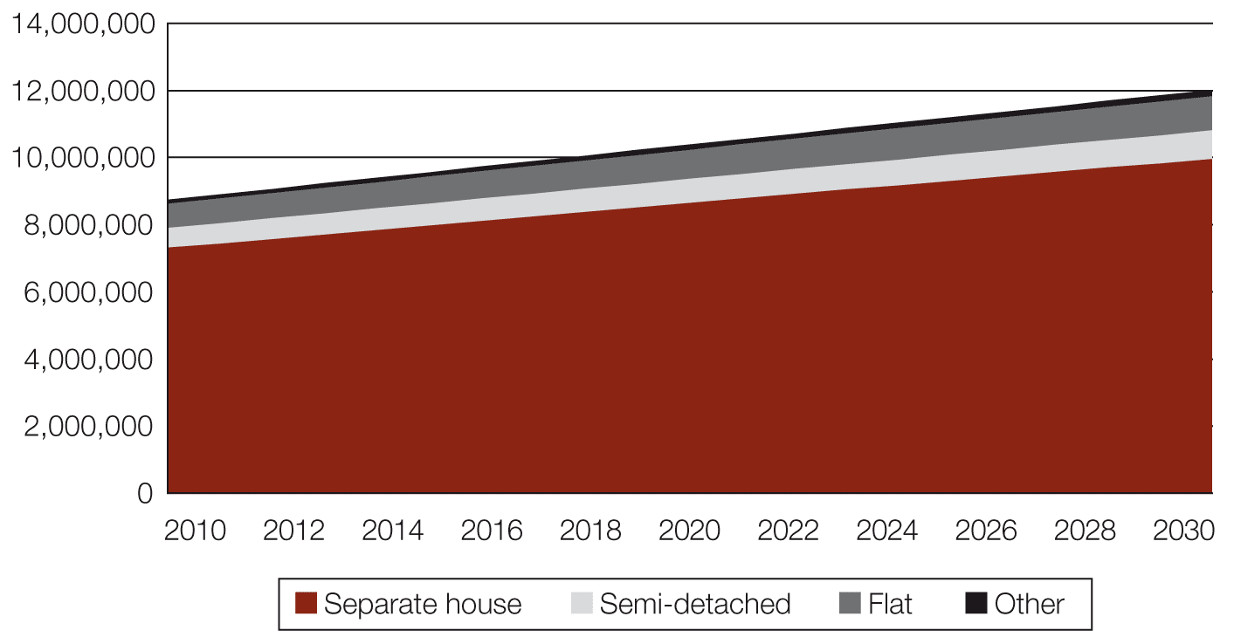
Source: National Housing Supply Council projections based on McDonald and Temple, medium household growth scenario, 2010 to 2030.
The projections suggest that most regions can expect a greater relative increase in demand for flats than for separate houses – see Table A2.10 in Appendix 2. The greater relative increase in demand for flats is particularly evident in Western Australia and in South Australia excluding Adelaide. In Sydney, however, the relative increase in demand is a little higher for separate houses than for flats, and in Queensland there is essentially no difference.
Table 2.6 Projections of underlying demand by tenure type, medium-growth scenario (’000 dwellings), Australia, 2010–2030
 | Year, as at 30 June |  |  |  |  |  | Percentage increase
Tenure type | 2010 | 2012 | 2015 | 2020 | 2025 | 2030 | 2010–2030
Owned/ purchasing | 6200.6 | 6433.1 | 6790.1 | 7414.4 | 8042.8 | 8639.7 | 39.3
Public rental | 358.9 | 372.5 | 393.3 | 430.5 | 470.6 | 511.7 | 42.6
Other rental | 2028.3 | 2102.7 | 2210.1 | 2356.6 | 2485.3 | 2642.3 | 30.3
Other | 158.8 | 165.1 | 174.6 | 189.2 | 203.3 | 217.8 | 37.2
Total | 8,746.6 | 9,073.4 | 9,568.1 | 10,390.8 | 11,202.0 | 12,011.5 | 37.3

Source: National Housing Supply Council projections based on McDonald and Temple medium household growth scenario, 2010–2030.
Table 2.6 suggests an increase in relative demand for rental tenure across Australia. From 2025, when ageing of the population is further advanced, the number of people in non-private dwellings (included in ‘other’) is projected to begin increasing dramatically, with high growth rates in many regions.
It is important to note, again, that these projections do not include demand and supply-side determinants that will affect the actual demand for different dwelling types and tenures. Increasing wealth from superannuation, changes in the relative supply of retirement accommodation and nursing-home beds, and a host of other factors could, for example, see larger proportions of future generations of older people living longer in their own homes.
That said, it is evident that population ageing will be associated with increased demand for a variety of housing-related interventions. Maintaining independent living for as long as possible is an important priority for most older people. The Council’s 2010 report noted that, as the population ages and longevity increases, there will be a considerable increase in both the number and the proportion of older people seeking housing assistance, support to remain in their own home and transition to other housing options better suited to their emerging circumstances. Meeting the housing needs of older Australians is as much about facilitating health, mobility and maintaining connections with friends, family and other supports as it is about dwelling type, income and housing costs. Location preferences for older and middle-aged cohorts are also likely to be affected as ageing parents seek to be nearer their adult children and vice versa.
The Council has a continuing interest in the housing experiences of different generations. Future reports may explore how the experiences and preferences of particular generations can affect and be affected by circumstances in the housing market. Questions of interest include, for example, ‘To what extent will “baby boomers” move from their family-size home to retire to different types of housing in similar or different locations, such as by downsizing, moving to the coast or to an inner-suburban area, or retiring to an existing holiday home?’
The projections of tenure type by region suggest additional relative demand for public housing, particularly in Victoria, Brisbane, South Australia, Western Australia, the Northern Territory and the Australian Capital Territory. These projections reflect the present higher rate of use of public and community-managed housing by older people and other lone-person households, combined with the ageing of the population over time. On present trends in the supply of such accommodation, much of this projected increase in underlying demand would not be met, in which case a larger proportion of older and lone-person households may choose, or effectively be forced, to switch to a different tenure type or location.
The projections of underlying demand for private rental dwellings increase at a much lower relative rate in the same areas in which the demand for public housing increases most significantly. However, as suggested above, demand for private rental dwellings may well increase more sharply than is projected, due to social housing stock not increasing in proportion to increased underlying demand, or because increased income and wealth lead to lower levels of eligibility for public housing and to changing preferences. The demand for private rental dwellings is projected to increase at a much lower rate than for some other regions, such as New South Wales and South-east Queensland.
In Queensland (excluding Brisbane) and in Western Australia (excluding Perth), there are notable relative increases in demand for owner/purchaser tenure.
Housing experiences of migrants
The Council’s projections are based on household and housing transitions of all Australians, so they mask any differences in the housing experiences of both overseas-born and Australian-born Australians. Recognising that different categories of migrants and different cultures may have different patterns of household formation and different housing preferences, the Council commissioned an exploratory study of the housing experience of permanent migrants.
The study draws extensively on data from the 2006 Census. Migrants as defined in the 2006 Census are those people resident in Australia for more than one year who were born outside Australia. The remainder of the resident population comprises those who are ‘Australian-born’. The study also examines data from several surveys conducted by the Department of Immigration and Citizenship.
The study finds that, regardless of income and age, a greater proportion of Australian-born people than immigrants live in their own home (either owned outright or with a mortgage). The data suggest that a range of cultural, demographic and socioeconomic factors play a role in producing a different pattern of tenure between Australian-born and overseas-born Australians.
This study also demonstrates that the housing characteristics of migrants change over time, particularly in the first few years after arrival. Migrants may add to actual housing demand in years following first arrival, as many stay with family or friends before becoming self-sufficient (forming a new household).
Preferences of dwelling and tenure type
There are differences in the housing tenure patterns of migrants relative to the Australian-born population, and these show up across most age cohorts. In all age categories migrants are more likely to rent than are non-migrants. Migrants are less likely to own or be buying their home than are the Australian-born population, except in the over-80 age group (see Figure 2.4).
Figure 2.4 Proportion of owner-occupiers (with or without a mortgage) in each age group by whether born in Australia
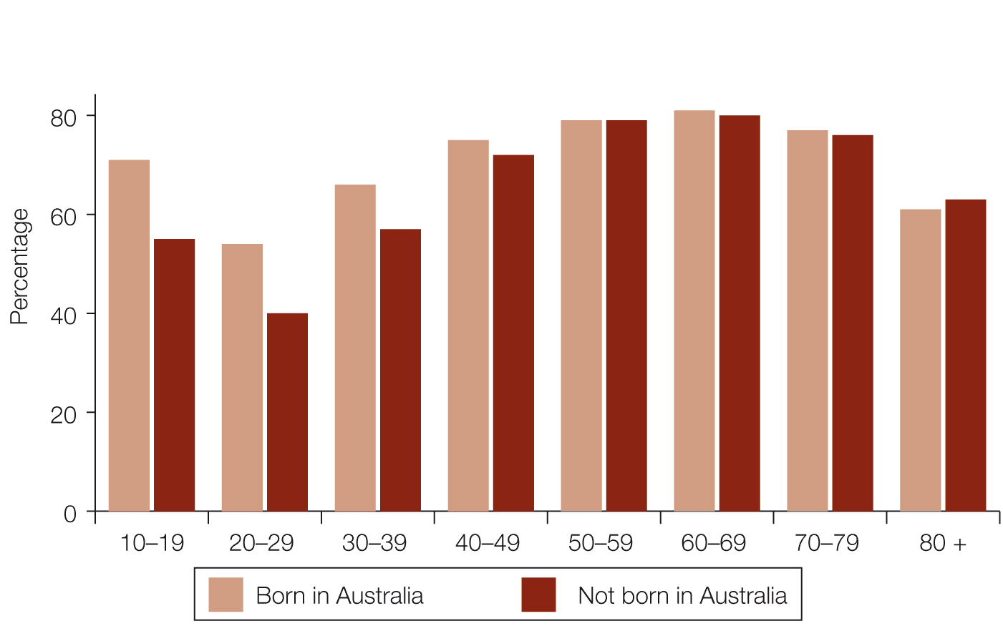
Source: Deloitte Access Economics analysis of ABS 2006 Census data.
In all age groups, Australians who were born overseas are more likely than are those born in Australia to live in rental properties. The difference is more significant in the younger age groups. All Australians in the 20–29-year age group are most likely to live in rental homes. However, within this age group, 51 per cent of those who were not born in Australia lived in a rental property, compared to 40 per cent of those who were born in Australia. For overseas-born Australians under the age of 40, the propensity to move out of the rental market and into one’s ‘own’ home (whether fully owned or with a mortgage) is significantly lower than it is among Australian-born people of the same age.
While the propensity to rent remains higher for migrants by age, the housing tenure of migrants does change notably over time depending on the number of years since arrival. Some 70 per cent of new migrants to Australia are initially renters. However, over the first decade after arrival:
- the proportion of renters drops notably (to 32 per cent by year 10 after arrival)
- there is a drop in the proportion of migrants who are living with others rather than forming a new household (from 12 per cent in year 1 to 6 per cent by year 5).
There is also a sharp increase over time in migrants who are paying off their house (from 12 per cent in year 1 to 38 per cent by year 5, peaking at 50 per cent in year 14). There is also a slow and steady increase over time in the share of migrants who have paid off their home, which eventually reaches 70 per cent, but not until almost 60 years after arrival.
A migrant’s tenure status also has an effect on the type of dwelling they live in. Approximately 80 per cent of migrants who own their own home live in a separate house rather than in a flat or townhouse. By contrast, approximately 70 per cent of migrants who rent live in a flat or townhouse.
Differences in housing tenure by reason for migrating
Migrants who come to Australia on a skilled visa are far more likely to rent than migrants who come to Australia on a family visa (80 per cent of skilled migrants live in a rental property, compared to 50 per cent of family migrants). Those on a family visa, who have migrated to join a partner or family unit, are more likely to be living in their own home rather than renting. Migrants coming to Australia to study have the greatest likelihood of renting.
As seen in Figure 2.5, just over 50 per cent of recently arrived migrants live in rental accommodation, a measure that has been fairly stable in the past decade across three different surveys. Around 20 per cent live in their own home – either owned outright or being purchased (with a mortgage). Additionally, around one-quarter of newly arrived migrants are ‘dependants’ – living with family or friends.
Figure 2.5 Tenure status of recently arrived migrants in 2002, 2005 and 2009 surveys
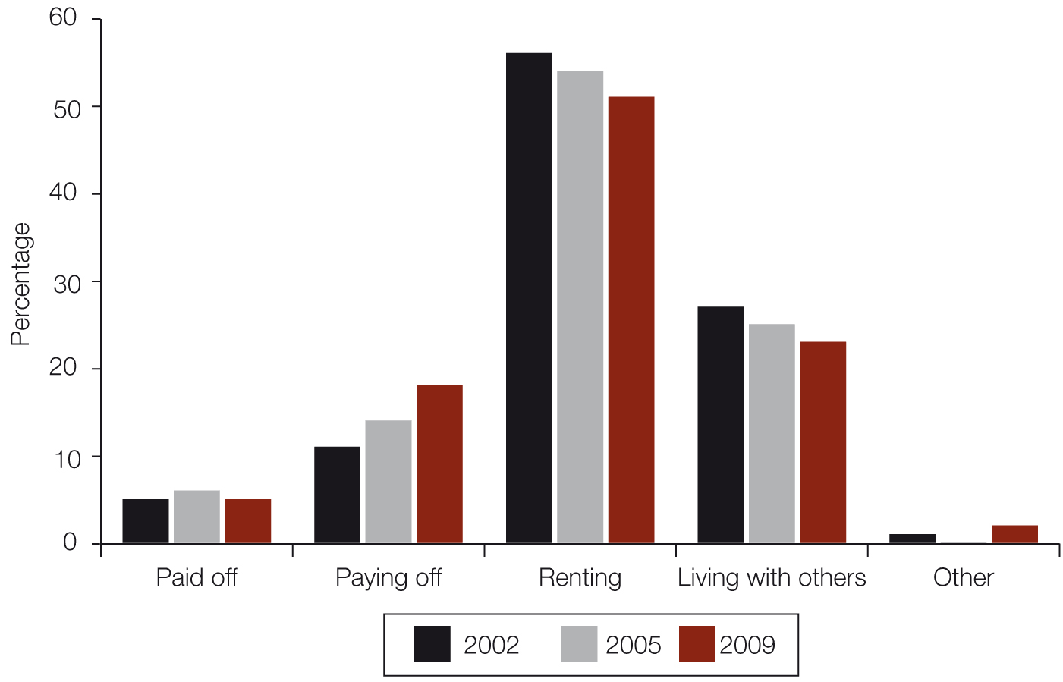
Source: Deloitte Access Economics analysis of DIAC surveys: DIAC 2002, second Longitudinal Survey of Immigrants to Australia (LSIA); DIAC 2005, third LSIA; and DIAC 2009, Continuous Survey of Australian Migrants (CSAM).
Notes: The LSIA surveys interview migrants around six months after they arrive and again around 12 months later. LSIA 2 was conducted on migrants who first arrived in Australia between September 1999 and August 2000. LSIA 3 was conducted on migrants who arrived between December 2004 and March 2005.
The CSAM was started in September 2009 and is intended to be a continuing survey.
The longitudinal data from the surveys behind Figure 2.5, which track the same migrants over time, show that a greater share of migrants across all visa categories own or are buying their own home 12 months on than when they were first surveyed.
Across visa streams, once tenure status is accounted for there is very little difference in the types of dwelling migrants live in. That is, most migrants who own or are paying off their own home live in houses (regardless of visa status), while only around 30 per cent of migrants who rent live in houses (again, regardless of visa status).
Migrants are also highly mobile. Some 40 per cent of all migrants interviewed in the second wave of the Longitudinal Survey of Immigrants to Australia (LSIA 2, in 2002) indicated that they had moved between their first and second interview (36 per cent of family visa holders, 44 per cent of skilled visa holders and 45 per cent of humanitarian visa holders). About 11 per cent of these had moved more than once.
Migrants’ initial tenure status is also often not their last. While many migrants (around one-quarter) live rent-free or pay board with an existing Australian household (whether family or friends) when they first arrive, and thus do not immediately add to the demand for housing, this is only temporary. In a year’s time, many of those migrants are looking for their own home, either to own or to rent.
Regional (state and territory) differences
Table 2.7 shows each state’s and territory’s share of family migrants, skilled migrants and these two categories combined, as well as its share of Australia’s population – based on the population at September 2009 when the Continuous Survey of Australian Migrants (CSAM) was first undertaken. Unsurprisingly, given that they are by far the two most populous states, New South Wales and Victoria housed the majority of migrants interviewed in the CSAM.

Table 2.7 State- and territory-based shares of migrants and population (percentage of total), 2009
State or territory | Family visa | Skilled visa | Total migrants | Total population
NSW | 37 | 25 | 31 | 32
Vic | 30 | 33 | 32 | 24
WA | 11 | 17 | 14 | 10
Qld | 14 | 13 | 13 | 20
SA | 5 | 10 | 8 | 7
ACT/NT/Tas | 3 | 3 | 3 | 6
Source: Deloitte Access Economics analysis of DIAC CSAM data; and ABS 2011, Australian demographic statistics September 2010, cat. no. 310 1.0, ABS, Canberra.

The general finding that migrants are more likely to rent than Australian-born Australians, but that skilled migrants are far more likely to rent than family migrants, holds true for each of the states and territories. Across the five mainland states, between 50 per cent and 53 per cent of family migrants, and between 73 per cent and 82 per cent of skilled migrants, lived in a rental property.
Migrants as a component of projected housing demand
As noted above, a sizeable share of family migrants are initially dependent on others (such as family or friends) for housing. Skilled and humanitarian migrants, who generally do not have the same connections as family migrants, are less likely to be dependent on others for their initial housing arrangements.
The Deloitte Access Economics study also indicates that, in any one year, about 64 per cent of the number of family arrivals will directly add to the demand for housing in that year. The remaining 36 per cent will initially be dependent on others for housing. At some point over the next five years, about 20 per cent will enter the property market and form a new household. In other words, about 16 per cent of family migrants will arrive as dependants and will continue to be dependent into the future – for example, they may be partners, parents or grandparents who have moved to Australia to live with their family.
Unsurprisingly, perhaps, about 89 per cent of skilled migrants directly add to housing demand in their first year in Australia. About three-quarters of skilled migrants originally part of an existing household (described here as dependants), or 8 per cent of all skilled migrants, will have moved out of dependency (or formed a separate household) and entered the property market within five years.
The exploratory study has also attempted to estimate the component of underlying housing demand created by migration. Estimates of the number of dwellings needed have been obtained by dividing the estimated number of migrants in any one year adding to the demand for accommodation by the average household size for each visa and dwelling category.
This method gives an estimate that a total of 71,000 dwellings were needed to house the new migrant component of housing demand in 2010–11 (this is a subset of overall demand, not an addition). Of these dwellings, about 53 per cent would be flats, owing to the large number of temporary (mostly student) migrants. A further 29 per cent would be houses and 18 per cent would be townhouses.
As flagged by the Council’s 2010 report, it is also important to explore the impact on underlying demand for dwellings among various categories of temporary migrants. This research has not yet been undertaken.
Conclusions and future work
The Council’s projections simply show what Australia’s underlying demand for dwellings would be if the assumed levels of components of household change (births, deaths, migration and household formation) were realised over the next 20 years. They represent what would happen if existing patterns of household transitions were to continue, and do not take into account other factors or policies that could have an influence.
The level of underlying demand (the number of households) is driven by migration and other demographic factors influencing growth in population and household numbers. It can also reflect housing supply and affordability, where these affect household formation. The Council’s projections only take into account these factors to the extent that they are reflected in historical rates of household formation. For example, it is possible that the effects of the global financial crisis on housing supply may have affected the rate of household formation, but these data are not yet available.
Data from the 2011 Census (or Council projections based on the changes between the 2006 Census and the 2011 Census) may start to show the effect of supply constraints on household formation and change. Recent increases in average household size (following decades of decline) may indicate that housing shortages and costs are leading to larger household sizes and reduced household formation rates. But there are other influences at work, including an increase in the fertility rate and improved longevity among older Australians meaning that a greater number of older couples are staying in their home together.
These projections of underlying demand for housing can, however, be compared with existing and planned levels of housing supply of housing. The scope for possible corrections of demand–supply mismatches could be assessed against a variety of factors affecting the ability of the supply side to respond to demand. Where meeting demand by adding housing stock would create supply difficulties, important questions arise about how demand would (or could) be absorbed or redirected.
As noted earlier, aggregate underlying demand would equal effective demand if the market could provide housing products to meet the needs, aspirations and capacity to pay of all households. In practice, the availability and affordability of housing is likely to affect realised preferences, but we do not know whether it may also influence underlying preferences.
In a situation of undersupply, households may retain their dwelling preference but change their location, or they may change their dwelling preference within their current location. Lack of supply may also prevent or defer the formation of new households, or see an increase in household size. We do not know, however, whether these enforced preferences will become underlying preferences over time. For example, if housing supply increases we may see a return to the longer-term trend of decreasing household size; alternatively, the recent upturn in household sizes may continue and larger household sizes may become the community norm.
The Council’s projections cannot predict cultural change in dwelling and tenure preferences. Neither do they incorporate possible changes in housing consumption preferences since 2006.
Future reports will compare projections to 2011 against findings from the 2011 Census to assess the impact of social and cultural change on housing demand.
The Council recognises the need to consider particular aspects of demographic change driving changes in demand in more depth, and intends to commission research into future housing needs by examining certain submarkets such as different regions or population groups, and specific tenure types such as rental. The significance of an Australian population that is getting older but remaining active, engaged and healthy should also be explored, as should the housing experiences of different generations of Australians.

Chapter 3 Housing supply
This chapter examines the supply of housing in Australia and some of the factors that affect it, and includes short- and long-term projections for new supply.
Key points
- The stock of private dwellings in Australia was estimated to comprise 9,148,300 dwellings at June 2010. While this estimate was produced using a similar methodology to that used in the 2010 State of the Supply Report, it includes conversions for the first time (which have a small effect, adding an average of about 1,350 new dwellings per year).
- The medium-trend projection for housing supply, based on assumed continuation of the trend for average annual net additions to the housing stock since 1980, would see total growth of 2,986,700 dwellings in the period 2010 to 2030 (an average net additional increase of just under 149,300 dwellings per year).
- The Council has also devised a methodology for forecasting supply one year in advance based on building approvals data. This forecast suggests that actual completions will marginally undershoot the long-term projections for 2010–11 and over the first part of 2011–12.
- Victoria, Western Australia and the ACT are seeing larger increases in housing supply, relative to population, than are other states and territories.
- Pipeline supply data suggest that the majority of new homes built in the capital cities in the coming years will be built on infill rather than greenfield land, most markedly in Sydney.
- The Council is working with State and Territory officers to improve the consistency and coverage of pipeline data.
Overview of supply
The Council has previously identified a number of factors that influence supply apart from suppliers’ perceptions of demand:
- land prices
- construction costs (labour, materials)
- infrastructure costs
- land availability (geography, zoning, environmental and heritage constraints)
- land release and development processes (including fees and regulation)
- taxes and transfers
- availability and cost of development finance and time taken to
- complete construction.
One of the Council’s challenges is to project future supply. This is difficult in relation to greenfield areas because of data limitations and the many factors influencing the conversion of raw land to completed residential estates. Moreover, land identified and zoned for residential development is usually used for a variety of purposes in addition to housing.
The challenge is even greater within established urban areas (infill development), whether in relation to existing residential areas or on land previously used for other urban purposes (brownfield development). The identification of development opportunities and their conversion involves a greater number of independent players with even more uncertain time frames. Apart from known major projects, there is little to guide the Council on the projected rate of additions to housing stock other than past experience.
For future reports, the Council will engage further with planning agencies and the development industry to obtain and evaluate additional information on historical trends, projects in the pipeline, planning agencies forecasts by area, and the reliability of those forecasts.
In addition to updating the Council’s long-term projections, this chapter also:
- includes short-term projections for building completions, including a breakdown by state/territory and type of dwelling
- updates information on the supply pipelines for greenfield and infill developments
- updates the National Dwelling Cost Study, conducted by property consulting firm Urbis Pty Ltd, which examines the costs faced by developers in bringing new supply to the market
- examines the state of the construction industry.
For future reports, the Council intends to develop more robust estimates as it obtains improved data on housing markets and factors influencing supply, including capacity constraints.
Existing supply
In the 2008 State of Supply Report (published in 2009), the Council estimated that the stock of private dwellings in Australia comprised 8,860,000 dwellings in June 2008. This estimate was produced using 2006 Census of Population and Housing data and incorporating data on completions and stock losses. In the 2010 report, using a similar methodology, but with revised estimates of demolitions, the Council estimated that the stock of dwellings at June 2008 was 8,874,200, and at June 2009 was 9,009,000.
In this report, aggregate housing supply also includes conversions from non-residential buildings to residential dwellings. Up to and including the quarter ended December 1997, the Australian Bureau of Statistics (ABS) published conversions as part of a broad category called ‘conversions, etc.’, which included some non-residential activity. Since 1998 more detailed information has been available for the components of this category. In this report, ‘conversions of non-residential buildings to residential buildings’ are added to completion totals from 1998 onwards – these are additions to the housing supply that are not included in the completions data and are referred to as ‘conversions’ throughout this report. For more information see Appendix 3.
Using the same underlying methodology as that used for the 2010 report, but with the new adjustment made for conversions into dwellings, the Council now estimates that the stock of dwellings at June 2010 was 9,148,300 (see Table 3.1). The addition of conversions has had a small positive impact on the aggregate figures, with 5,400 conversions in the period September 2006 to June 2010 (an average of 1350 per annum). The addition of conversions increased the outstanding stock marginally to 8,876,700 in 2008, and to 9,012,900 in 2009.
Annual completions were relatively consistent over the four years to June 2010, and ranged from 144,700 in 2008 to 149,600 in 2007, with total completions for the period being 589,900. The low coincided with the height of the global financial crisis (GFC). While there was a modest rise in building rates after the crisis, building approvals have since declined and point to continuing (although the Council notes that annual completions to June 2011 have lifted to over 155,000, assisted by over 13,000 dwelling completions for the public and not-for-profit sector).
As discussed in Chapter 1, a weakening in demand and challenges in raising funds for some smaller developers have contributed to a reduction in building approvals. Estimated annual stock losses (demolitions) ranged from 11,500 in 2008 to 12,100 in 2010, with a total of 47,400 over the four-year period. Estimated net additions ranged from 133,200 in 2008 to 137,600 in 2007, with a total of 542,500 for the four years to June 2010.
Table 3.1 Existing supply, 2010
 |  | Number of dwellings
1 | 2006 ABS Census occupied private dwellings and unoccupied dwellings, adjusted for undercounting | 8,605,800
 | plus
2 | ABS dwelling completion data for 2007, 2008, 2009 and 2010 | 589,900
 | less | –
3 | Estimated stock losses in 2007, 2008, 2009 and 2010 due to demolition | 47,400
 | equals | =
 | Total supply in 2010 (rounded to nearest hundred) | 9,148,300
Source: Adapted from ABS 2007, Census of population and housing – details of undercount, cat. no. 2940.0, ABS, Canberra; ABS 2010, Building activity, Australia, June 2010, cat. no. 8752.0, ABS, Canberra; and National Housing Supply Council estimates.
Construction activity
The historic volatility of gross housing construction activity (not considering demolition rates) and the variations between the states and territories in activity levels over time are shown in Figures 3.1 to 3.9. These graphs illustrate the number of residential dwelling commencements and completions per quarter, and the number of residential dwellings under construction. A building is regarded as being under construction at the end of a period if it has been commenced but has not been completed, and work on it has not been abandoned.
Given the different levels of construction activity in the different jurisdictions, the vertical scales on the graphs vary.
It is clear from these graphs that actual building activity outcomes in any one year may vary significantly from expectations that are based on longer-term trends. Given the different size of each jurisdiction, there are inherent differences in the levels of residential construction activity among the states and territories. At any one time, the specific economic factors and other drivers in each state and territory will influence the type and level of housing industry activity in that jurisdiction. In addition, while the long-term trend is reasonably stable over the 25-year period for Australia as a whole, this does not hold at individual state and territory level.
Figure 3.1 Dwelling construction activity per quarter, Australia, 1985 to March quarter 2011
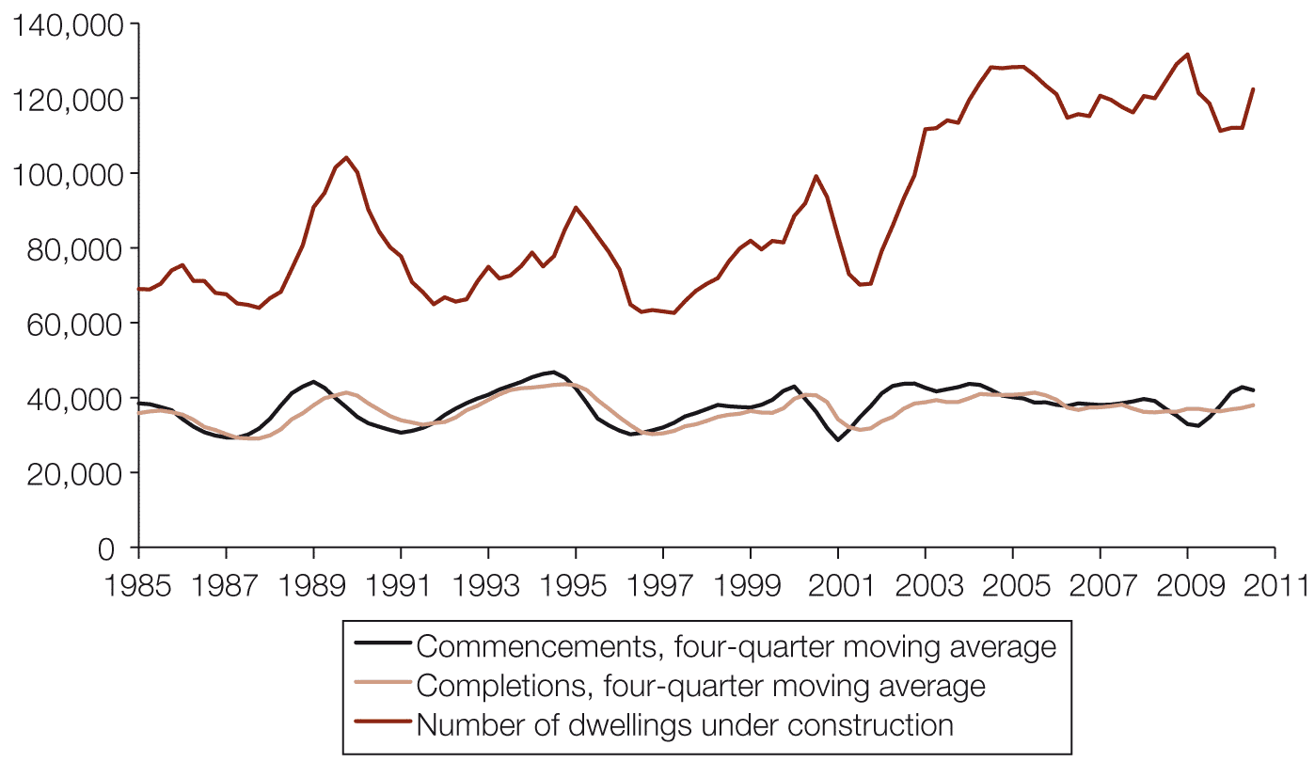
Source: ABS 2011, Building activity, Australia, March quarter 2010, cat. no. 8752.0, ABS, Canberra.
Figure 3.2 Dwelling construction activity per quarter, New South Wales, 1985 to March quarter 2011
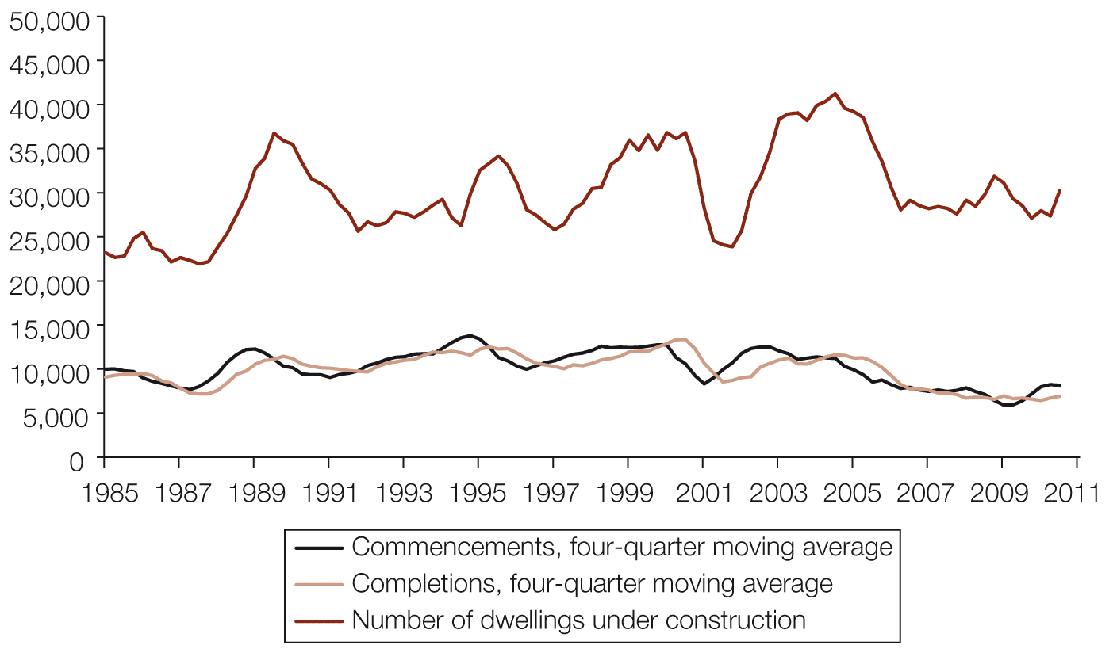
Source: ABS 2011, Building activity, Australia, March quarter 2010, cat. no. 8752.0, ABS, Canberra.

Figure 3.3 Dwelling construction activity per quarter, Victoria, 1985 to March quarter 2011
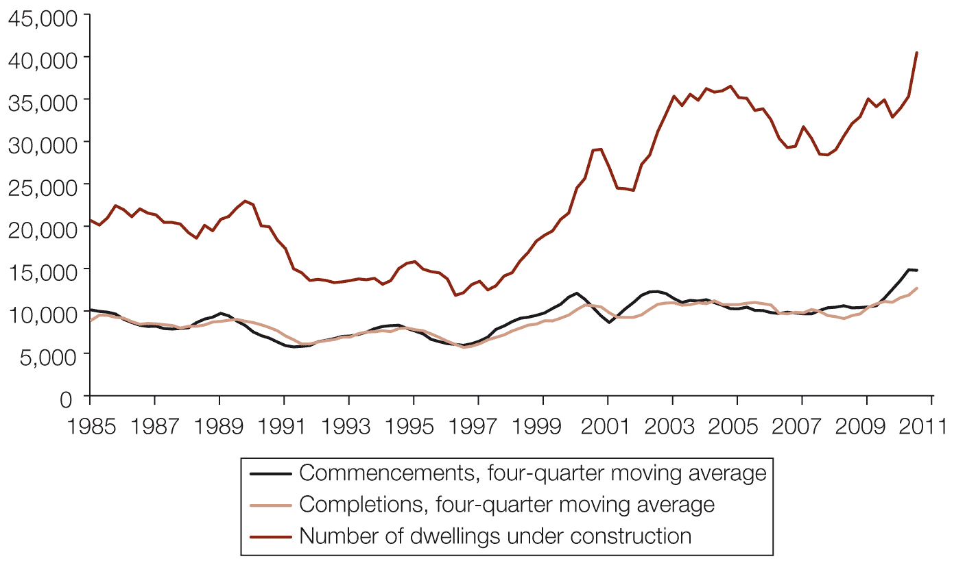
Source: ABS 2011, Building activity, Australia, March quarter 2010, cat. no. 8752.0, ABS, Canberra.
Figure 3.4 Dwelling construction activity per quarter, Queensland, 1985 to March quarter 2011
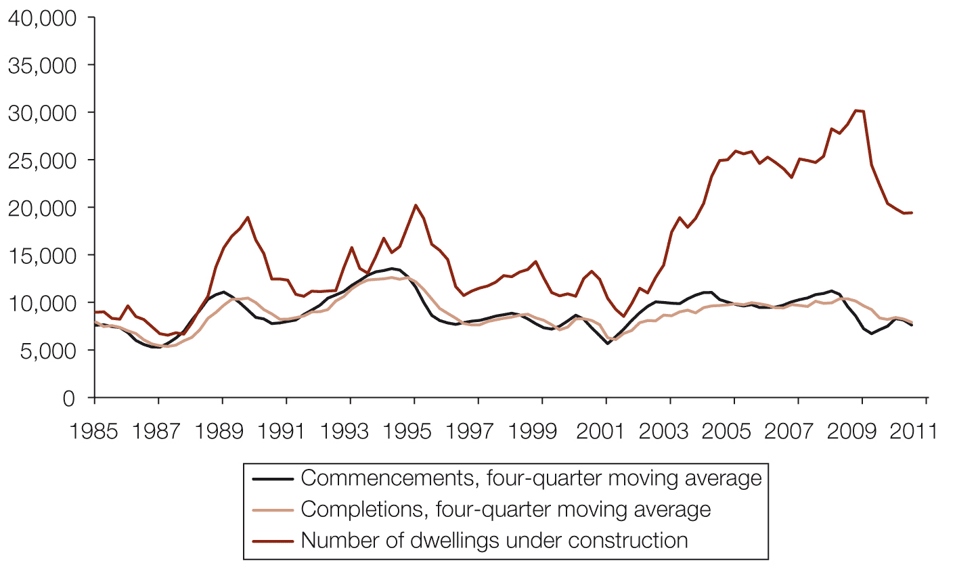
Source: ABS 2011, Building activity, Australia, March quarter 2010, cat. no. 8752.0, ABS, Canberra.

Figure 3.5 Dwelling construction activity per quarter, South Australia, 1985 to March quarter 2011
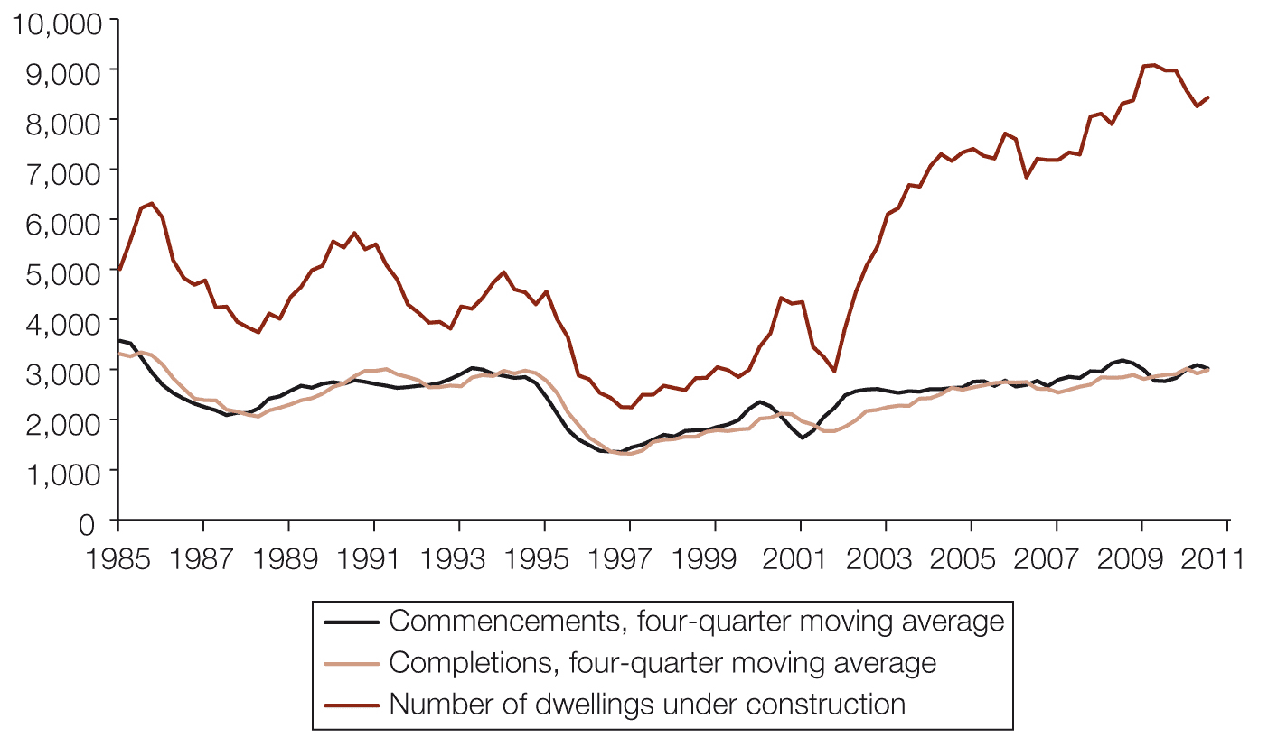
Source: ABS 2011, Building activity, Australia, March quarter 2010, cat. no. 8752.0, ABS, Canberra.
Figure 3.6 Dwelling construction activity per quarter, Western Australia, 1985 to March quarter 2011
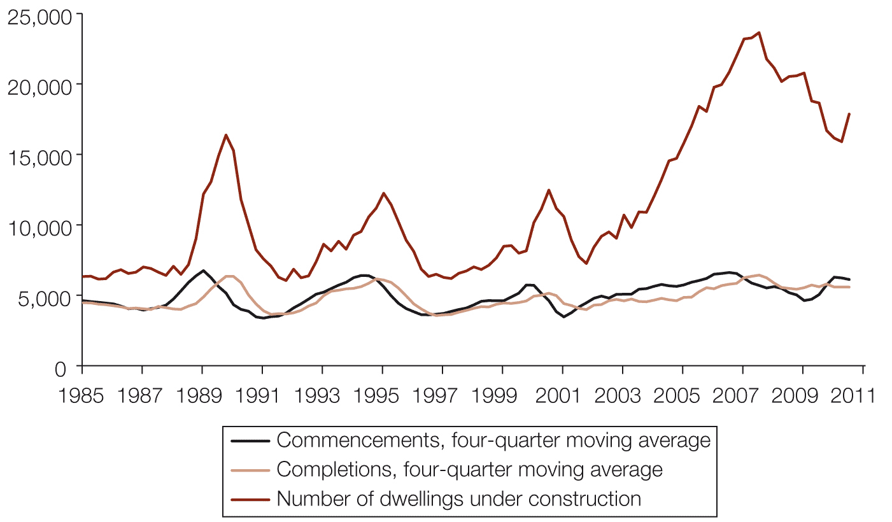
Source: ABS 2011, Building activity, Australia, March quarter 2010, cat. no. 8752.0, ABS, Canberra.

Figure 3.7 Dwelling construction activity per quarter, Tasmania, 1985 to March quarter 2011
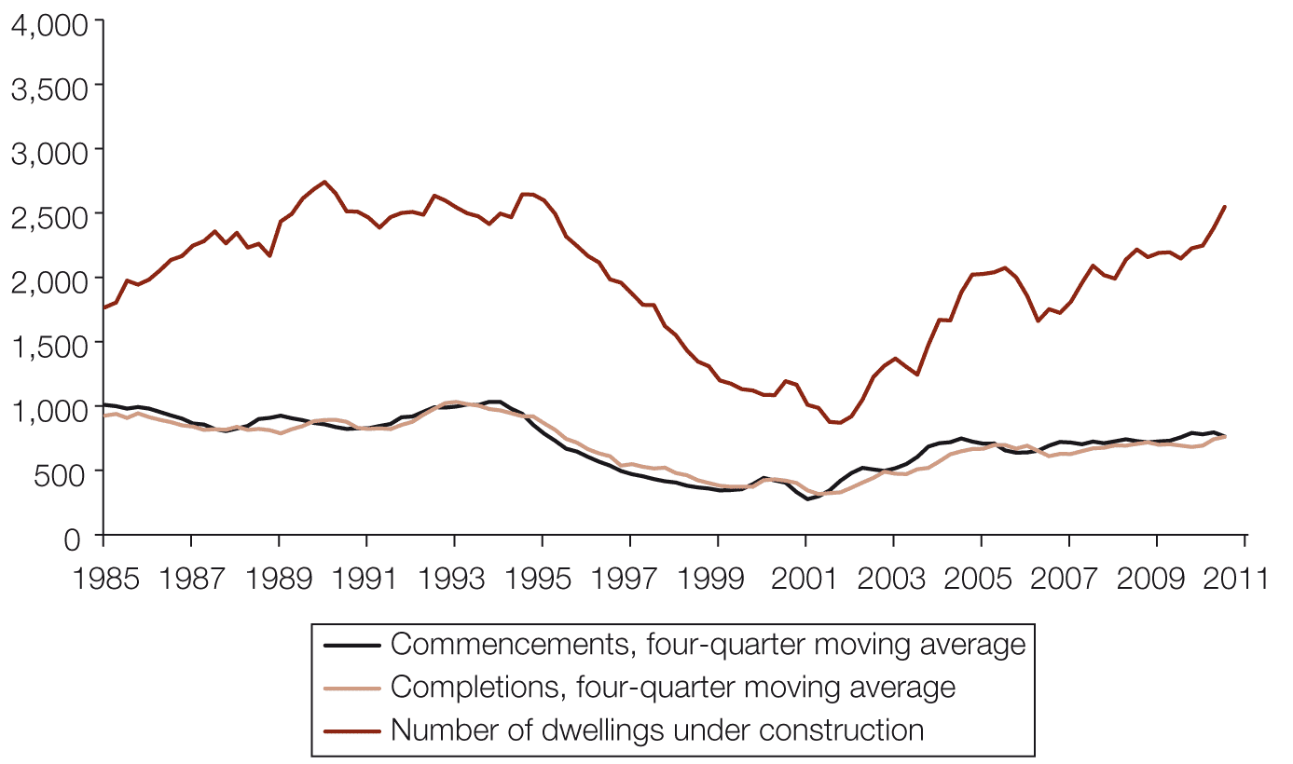
Source: ABS 2011, Building activity, Australia, March quarter 2010, cat. no. 8752.0, ABS, Canberra.
Figure 3.8 Dwelling construction activity per quarter, Northern Territory, 1985 to March quarter 2011
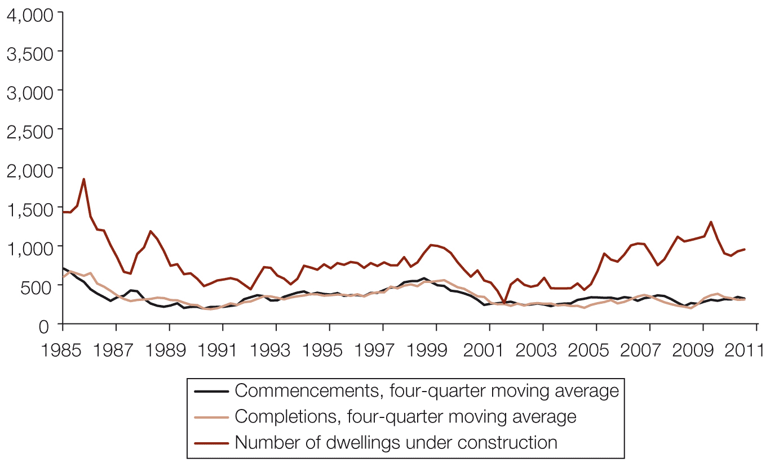
Source: ABS 2011, Building activity, Australia, March quarter 2010, cat. no. 8752.0, ABS, Canberra.

Figure 3.9 Dwelling construction activity per quarter, Australian Capital Territory, 1985 to March quarter 2011
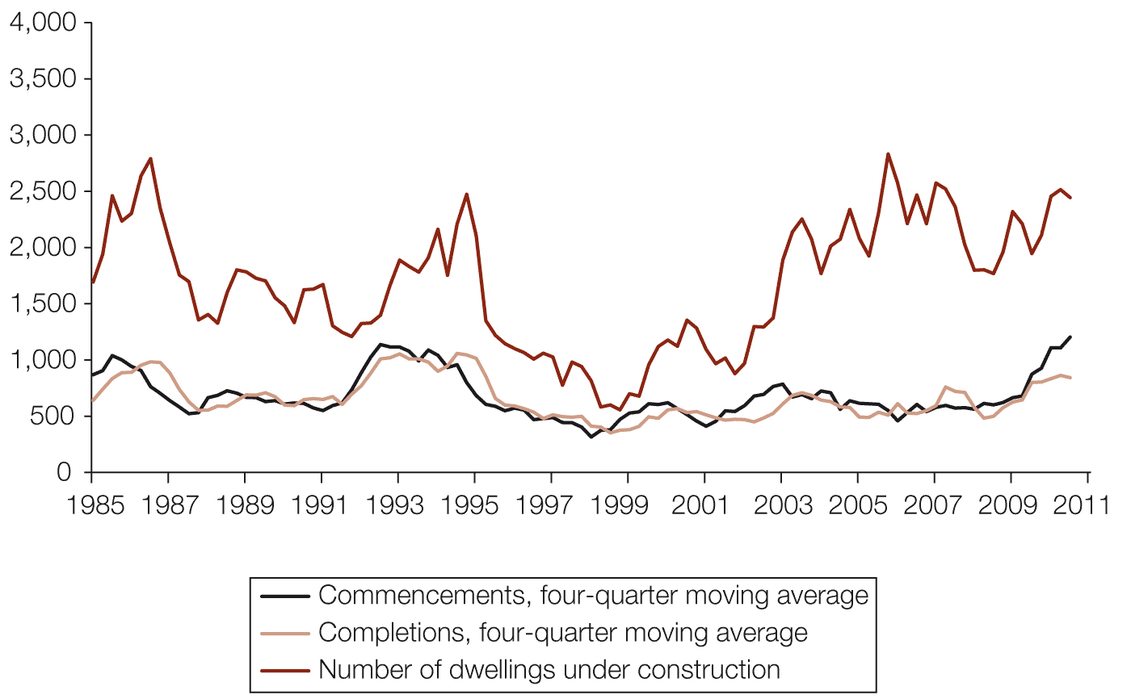
Source: ABS 2011, Building activity, Australia, March quarter 2010, cat. no. 8752.0, ABS, Canberra.

Projecting supply to 2030
The 2010 State of Supply Report projected future housing supply based on the trend in growth of aggregate housing supply (as measured by ABS data on building completions) since 1980 (adjusted for loss due to demolitions).
The Council has used the same methodology for forecasting building completions in this report to update its medium-supply scenario dwelling supply projections to 2030. It uses the following three scenarios of future supply.
- The low-supply scenario is based on the lowest number of net additions in any one year, relative to the trend rate, for Australia as a whole since 1980.
- The medium-supply scenario is based on a trend rate using the average annual net additions since 1980.
- The high-supply scenario rate is based on the highest number of net additions, relative to the trend rate, in any one year for Australia as a whole since 1980.
Figure 3.10 illustrates the low-, medium- and high-supply scenarios with reference to actual housing completions over the period 1981 to 2010. Year-on-year projections produced by this methodology for Australia and for each state and territory are included in Appendix 3 to this report. The likelihood of the actual outcome being above or below these outer bounds for a sustained period is extremely low.
Figure 3.10 Quarterly completion data and upper and lower trend lines, Australia, 1981–2011
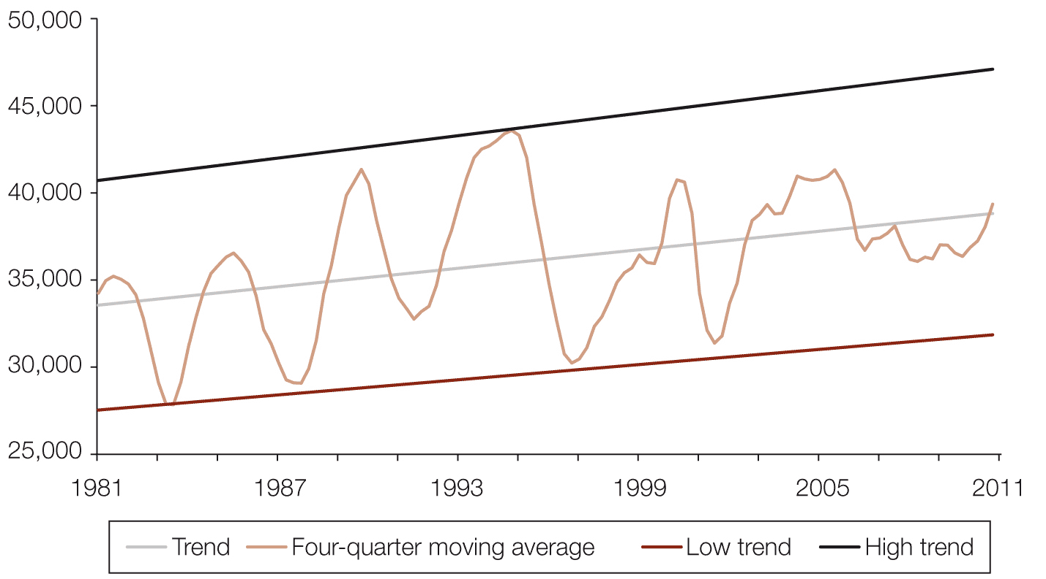
Source: ABS 2011, Building activity, Australia, March quarter 2011, cat. no. 8752.0, ABS, Canberra.

For the 2010 report, the Council revised its estimates of the demolition rates, and it continues to use this methodology in this report. The revisions were based on further development of the Census-based methodology used in the 2008 report, and also incorporate estimates provided by state and territory planning agencies where available from members of the Council’s Data Sub-Group. The revised demolition rates are shown in Table 3.2.
For New South Wales, Western Australia, Tasmania and the Northern Territory, the revised estimates of dwelling demolition rates are based on the revised Census methodology.
For Victoria, South Australia and the Australian Capital Territory, the revised estimates of dwelling demolition rates are based on data provided by members of the Council’s Data Sub-Group.
For Queensland, the demolition rates used in the 2008 report were also used in the 2010 and 2011 reports.
Table 3.2 Summary of demolition rate information (percentages)
 | NSW | Vic | Qld | SA | WA | Tas | NT | ACT | National average
2008 report demolition rate | 21.85 | 17.07 | 1.51 | 28.52 | 19.53 | 20.16 | 56.05 | 14.66
Using Census data, revised method | 8.25 | 8.75 | –5.65 | 18.27 | 14.41 | 6.73 | 21.29 | 5.91
Data Sub-Group demolition data |  | 7.04 |  | 19.87 |  |  |  | 3.28
2010 report demolition rate | 8.25 | 7.04 | 1.51 | 19.87 | 14.41 | 6.73 | 21.29 | 3.28 | 7.84

Source: National Housing Supply Council estimates.
Note: Negative figure for Queensland reflects statistical anomalies revealed by the methodology.
The cumulative effects of projected building activity on total supply from 1 July 2010 are set out in Table 3.3. These estimates include updated adjustments for losses due to demolition.
Table 3.3 Projected net increase in supply of residential dwellings, Australia, low-, medium- and high-supply scenarios, 2010–2030
Time period | Low-supply scenario | Medium-supply scenario | High-supply scenario
2010–11 to 2011–12 | 235,300 | 286,700 | 347,900
2010–11 to 2014–15 | 592,400 | 721,800 | 875,900
2010–11 to 2019–20 | 1,198,300 | 1,460,200 | 1,771,900
2010–11 to 2029–30 | 2,450,700 | 2,986,700 | 3,623,900

Source: Based on dwelling completion trend, 1 July 1980 to 31 December 2010, from ABS 2011, Building activity, Australia, December 2010, cat. no. 8752.0, ABS, Canberra; and National Housing Supply Council estimates for completions net of demolitions.
Over the 20 years of updated (medium-trend) supply projections commencing from 2011, the projected average net annual increase in dwellings is 149,300, or 1.5 per cent per year. By contrast, the average annual increase in the number of households is projected to be around 163,200, or 1.7 per cent (medium underlying demand), indicating a growing shortfall between supply and demand. Chapter 4 analyses the imbalance between current and future demand and supply, and compares the production and gap estimates presented in this report with those presented in the 2010 report.
Projections by state and territory
The projected total of 2,986,700 net additional dwellings produced under the medium-supply scenario is based on a trend rate using the average annual net additions since 1980. The low- and high-supply projections are based on the scenario that national production tracks at the lowest and highest trend levels experienced since 1980 (see Table 3.4). Similarly, the projections for each state and territory are based on the lowest, average and highest trend data for each state or territory.
Table 3.4 Projected additional residential dwellings by state and territory for low, medium and high dwelling production, adjusted for demolitions (’000 dwellings), 2010–2030
 | Low-supply  scenario | Medium-supply scenario | High-supply scenario
NSW | 546.6 | 637.5 | 756.7
Vic | 720.0 | 887.6 | 1,019.6
Qld | 638.1 | 793.1 | 998.0
SA | 108.9 | 159.6 | 195.4
WA | 378.0 | 418.0 | 531.6
Tas | 19.7 | 32.5 | 39.6
NT | 7.0 | 12.3 | 17.2
ACT | 31.8 | 46.4 | 65.7
Australia |  | 2,986.7
Source: ABS 2011, Building activity, Australia, December 2010, cat. no. 8752.0, ABS, Canberra; and National Housing Supply Council estimates for completions net of demolitions.
Notes: Figures are rounded to the nearest hundred. Projections by state and territory are based on the lowest, average and highest trend data (from 1 July 1980 to 31 December 2010) for each individual state and territory.
The sum of these state and territory figures would not be expected to add up to the low, medium and high data for Australia as a whole, due to the low likelihood of all states and territories experiencing their individual historic high and low completion rates at the same time.

Possible variations in production levels
While the average net national increase in dwellings (gross production minus estimated demolitions) was 132,800 per year over the period 1 July 1981 to 30 June 2010, national net annual additions to supply varied by as much as 49 per cent (between 107,300 and 159,800) over this period (see Table 3.5).
As stated in the notes to Table 3.4, the sum of the state and territory minima and maxima do not add up to the low-, medium- and high-trend data for Australia as a whole. Individual states and territories experienced their individual historic high and low completions in different years, while the Australia-wide scenarios are based on the lowest and highest annual sum of states’ and territories’ completions in the period 1981 to 2010.
Table 3.5 Variations in net completions, 1981 to 2010
 | Average annual additions | Minimum annual additions | Maximum annual additions | Percentage difference between minimum and maximum annual additions
NSW | 36,700 | 23,600 | 47,300 | 100.5
Vic | 31,900 | 22,300 | 43,000 | 92.8
Qld | 34,400 | 21,400 | 49,200 | 129.2
SA | 7,700 | 4,200 | 10,600 | 150.4
WA | 15,900 | 10,800 | 21,700 | 101.8
Tas | 2,600 | 1,300 | 3,800 | 199.3
NT | 1,200 | 700 | 2,000 | 185.6
ACT | 2,500 | 1,500 | 4,100 | 177.2
Australia | 132,800 | 107,300 | 159,800 | 49.0
Source: ABS 2010, Building activity, Australia, September 2010, cat. no. 8752.0, ABS, Canberra.
Notes: Figures for annual additions have been rounded to the nearest hundred.
Percentage differences are calculated from unrounded figures.
Figures for states and territories are based on the lowest, average and highest annual data for each individual state and territory.
Figures for Australia are the lowest, average and highest annual data for Australia as a whole. The sum of the state and territory minimum and maximum figures do not add to the figures for Australia as a whole, because the states and territories experienced their lowest and highest levels of completions at different times, whereas the national figures represent the lowest and highest levels of completions in any one year.
Short-term construction activity trends and outcomes
In previous reports, the Council noted that the shorter-term projections could be optimistic given economic circumstances. Lack of investment and credit restrictions appear to have led to a drop in dwelling commencements in some jurisdictions, particularly in the multi-unit sector.
The actual number of dwelling units commenced in 2009–10 was 165,500, which was higher than the 131,700 commenced in 2008–09, but similar to the 158,500 commenced in 2007–08 as the GFC evolved.
Although residential dwelling approvals showed signs of recovery in the latter part of 2009 and throughout most of 2010 (see Figure 3.11), a sustained recovery requires improved confidence among investors and developers and improved access to development finance, especially in the multi-unit sector. Access to finance since the GFC appears to have tightened, particularly for developments where an impact assessment is a requirement. There was a modest pick-up over 2010 from the post-GFC lows, but dwelling approvals in the June quarter of 2011 totalled 37,800, down 14 per cent on a year earlier. The March 2011 quarter saw an even larger annual decline of 18 per cent, although this is likely to have been mainly due to the extreme weather at that time. Lower approvals forecast lower commencements and completions in the period ahead.
Figure 3.11 Quarterly dwelling approvals, quarterly data and long-term best fit, Australia, 1983 to March quarter 2011
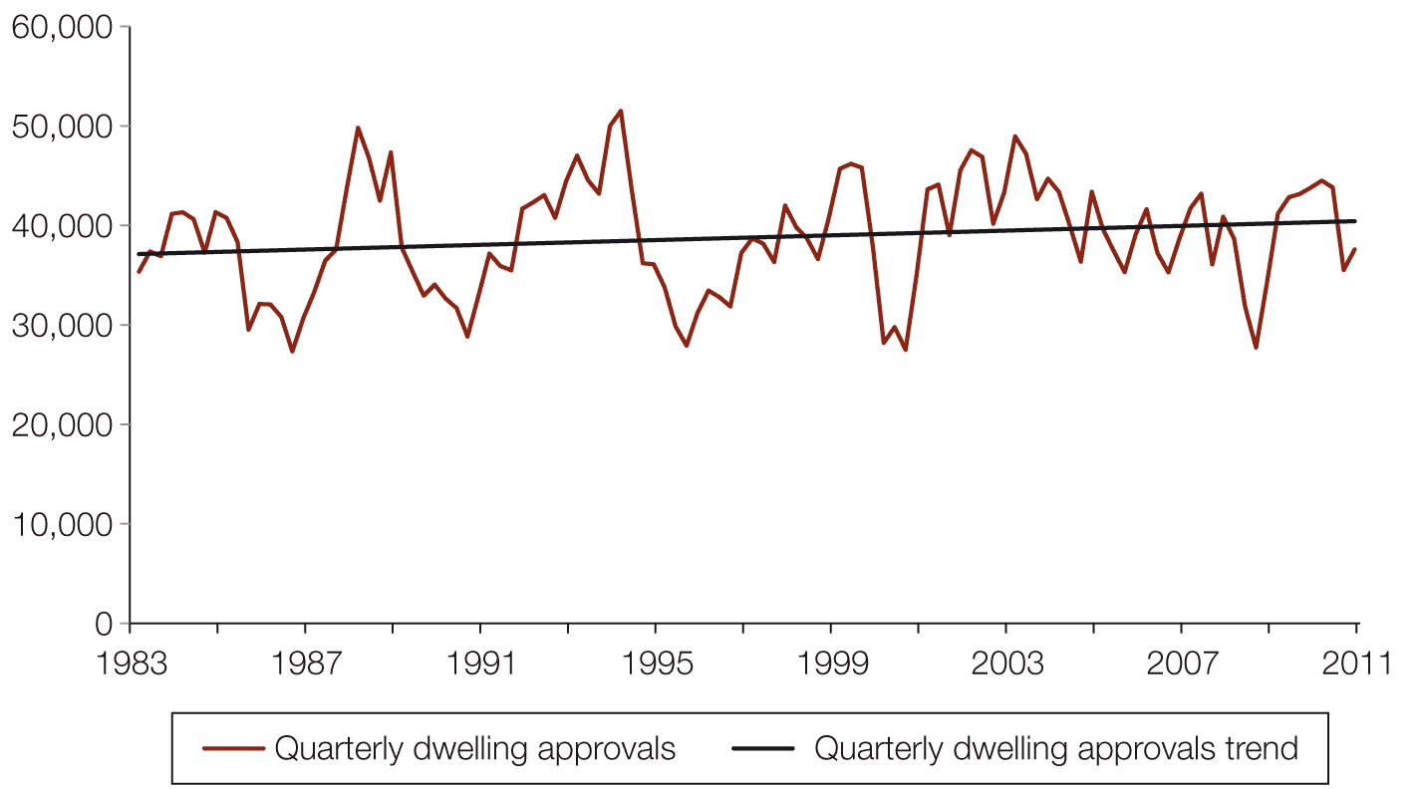
Source: ABS 2011, Building approvals, Australia, Mar 2011, cat. no. 8731.0, ABS, Canberra.
Figure 3.12 Quarterly dwelling completions, four-quarter moving average and long-term best fit, Australia, 1981 to March quarter 2011
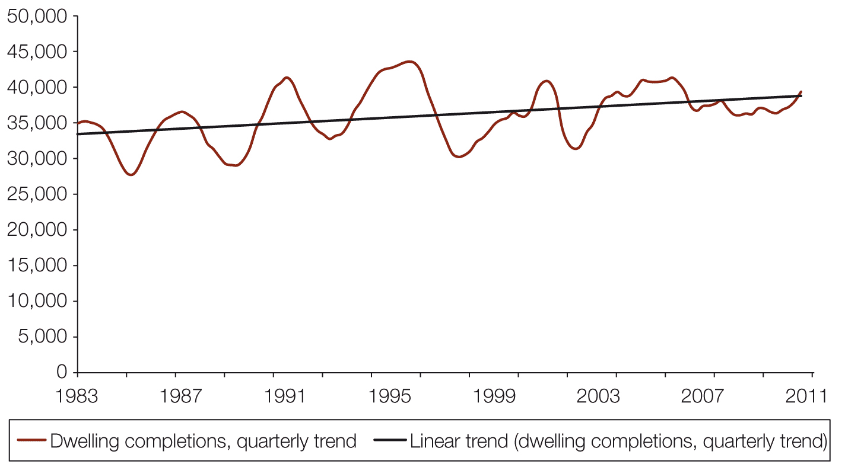
Source: ABS 2011, Building approvals, Australia, Mar 2011, cat. no. 8731.0, ABS, Canberra.
While using linear trends to estimate future housing supply is appropriate for long-term projections, the potential for error in the short term is significant. An alternate is to compare the relationship between historic residential dwelling approvals (a leading indicator of completions) and historic completions in order to estimate supply that will come onto the market in the next year or two (see Figure 3.13).
The Council has disaggregated the ABS building approvals data for each state and territory into houses and other dwellings (largely flats and apartments). While completions follow approvals quite closely, they obviously lag. The extent of this lag provides an estimate of the time taken between the peaks and troughs of approvals and completions in a building cycle.
Figure 3.13 Quarterly dwelling completions overlaid on dwelling approvals (houses), New South Wales, June 1984 to June 2010.
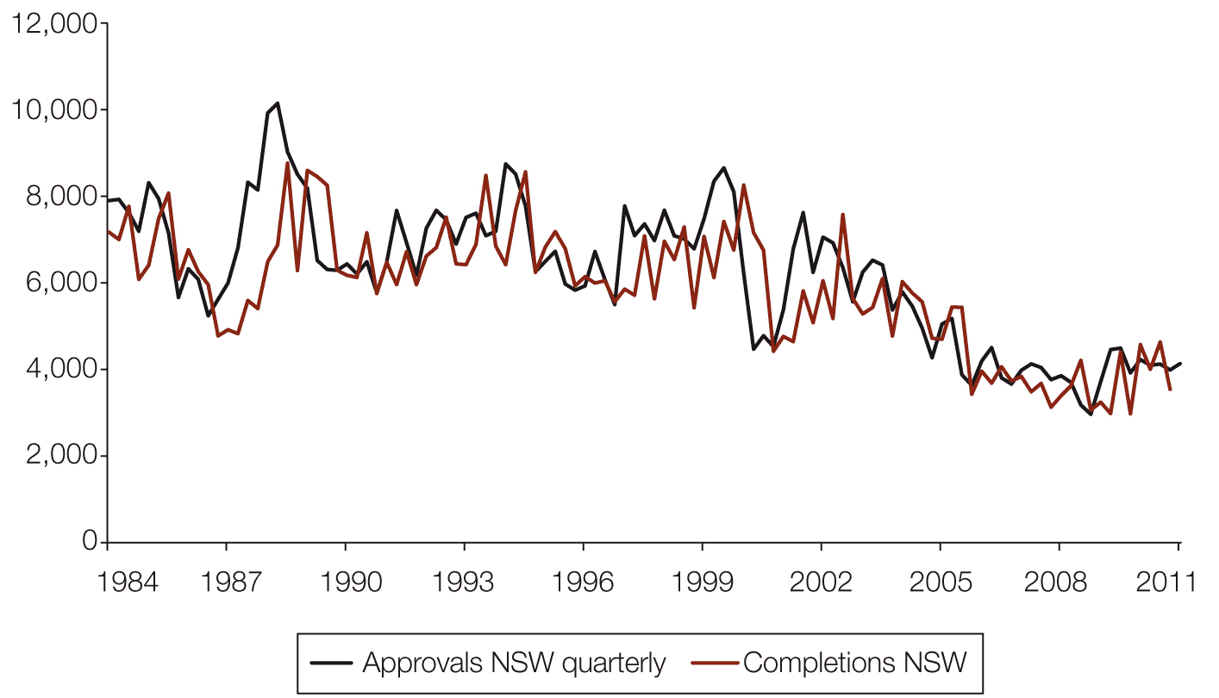
Source: ABS 2011, Building approvals, Australia, Mar 2011, cat. no. 8731.0, ABS, Canberra; and ABS 2011, Building activity, Australia, Mar 2011, cat. no. 8752.0, ABS, Canberra.

Data volatility adds uncertainty to the mapping of approvals to completions. To overcome this, the Council has adopted a moving average technique and ‘lagged’ the approvals figures to come up with the best match between approvals and completions for each state and territory for both dwelling types. After making an adjustment for the share of approvals that do not reach completion (see Table 3.6) due to factors such as change in financial situation or reapplication for approval due to a change in the project specifications, the Council has forecast the number of completions across the states and territories (see Table 3.7).
Table 3.6 Residential construction activity, time taken to completion and proportion of approvals not completed
 | Houses |  | Other residential
 | Time between approval and completion | Approvals not commenced or not completed  (%) | Time between approval and completion | Approvals not commenced or completed  (%)
NSW | 2 quarters | 6.83 | 5 quarters | 4.77
Vic | 2 quarters | 3.60 | 8 quarters | 6.85
Qld | 2 quarters | 3.30 | 5 quarters | 3.48
SA | 2 quarters | 6.90 | 5 quarters | 9.19
WA | 3 quarters | 6.90 | 5 quarters | 5.71
Tas | 2 quarters | 6.75 | 5 quarters | 3.40
NT | 2 quarters | 4.54 | 3 quarters | 2.70
ACT | 2 quarters | 1.21 | 4 quarters | 0.50
Source: National Housing Supply Council estimates derived from ABS, Building activity, Australia, December quarter 2010, cat. no. 8752.0; and ABS, Building approvals, Australia, Mar 2011, cat. no. 8731.0, ABS Canberra.

Figures 3.14 to 3.28 show smoothed and lagged data for quarterly dwelling completions overlaid on dwelling approvals for houses and other residential dwellings, for each state and territory.
Figure 3.14 Quarterly dwelling completions overlaid on residential dwelling approvals (houses), New South Wales, June 1984 to June 2010, smoothed and lagged in accordance with Table 3.6
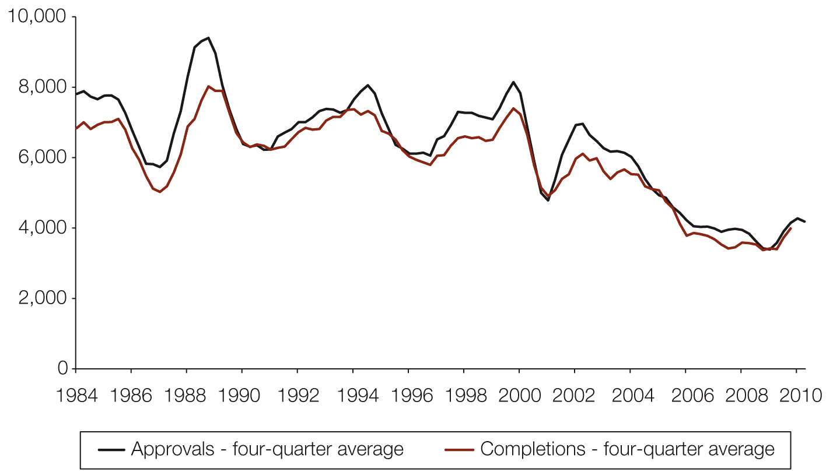
Source: ABS 2011, Building approvals, Australia, Mar 2011, cat. no. 8731.0, ABS, Canberra; and ABS 2011, Building activity, Australia, Mar 2011, cat. no. 8752.0, ABS, Canberra.
Figure 3.15 Quarterly dwelling completions overlaid on residential dwelling approvals (other residential), New South Wales, June 1984 to June 2010, smoothed and lagged in accordance with Table 3.6
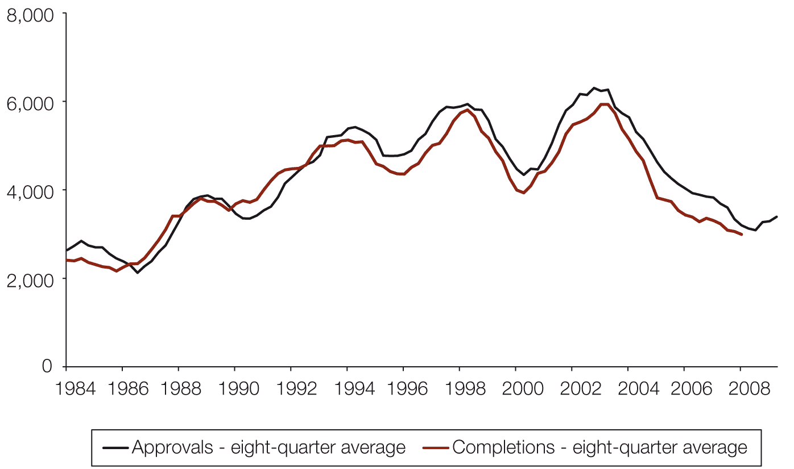
Source: ABS 2011, Building approvals, Australia, Mar 2011, cat. no. 8731.0, ABS, Canberra; and ABS 2011, Building activity, Australia, Mar 2011, cat. no. 8752.0, ABS, Canberra.

Figure 3.16 Quarterly dwelling completions overlaid on residential dwelling approvals (houses), Victoria, June 1984 to June 2010, smoothed and lagged in accordance with Table 3.6
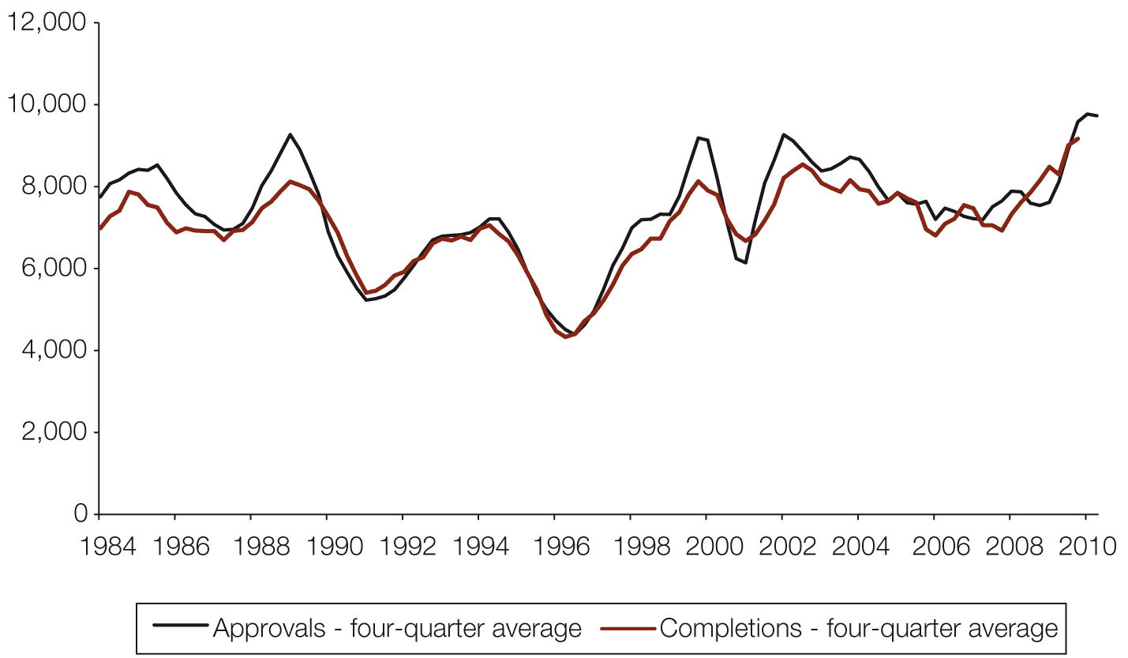
Source: ABS 2011, Building approvals, Australia, Mar 2011, cat. no. 8731.0, ABS, Canberra; and ABS 2011, Building activity, Australia, Mar 2011, cat. no. 8752.0, ABS, Canberra.
Figure 3.17 Quarterly dwelling completions overlaid on residential dwelling approvals (other residential), Victoria, June 1984 to June 2010, smoothed and lagged in accordance with Table 3.6
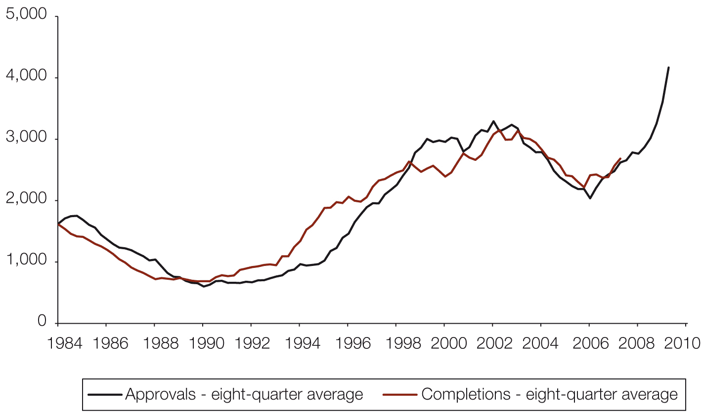
Source: ABS, Building approvals, Australia, Mar 2011, cat. no. 8731.0, ABS, Canberra; and ABS 2011, Building activity, Australia, Mar 2011, cat. no. 8752.0, ABS, Canberra.

Figure 3.18 Quarterly dwelling completions overlaid on residential dwelling approvals (houses), Queensland, June 1984 to June 2010, smoothed and lagged in accordance with Table 3.6
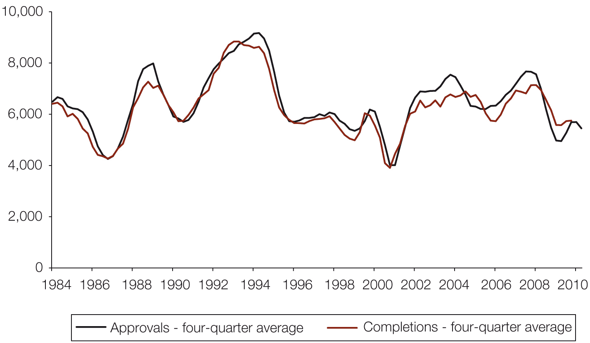
Source: ABS 2011, Building approvals, Australia, Mar 2011, cat. no. 8731.0, ABS, Canberra; and ABS 2011, Building activity, Australia, Mar 2011, cat. no. 8752.0, ABS, Canberra.
Figure 3.19 Quarterly dwelling completions overlaid on residential dwelling approvals (other residential), Queensland, June 1984 to June 2010, smoothed and lagged in accordance with Table 3.6
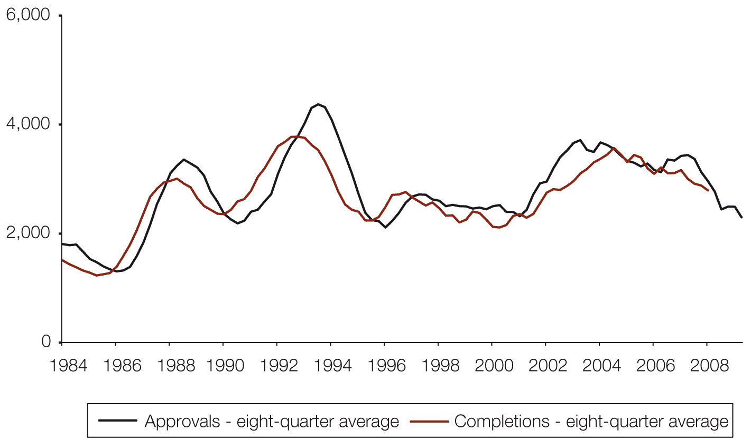
Source: ABS 2011, Building approvals, Australia, Mar 2011, cat. no. 8731.0, ABS, Canberra; and ABS 2011, Building activity, Australia, Mar 2011, cat. no. 8752.0, ABS, Canberra.

Figure 3.20 Quarterly dwelling completions overlaid on residential dwelling approvals (houses), South Australia, June 1984 to June 2010, smoothed and lagged in accordance with Table 3.6
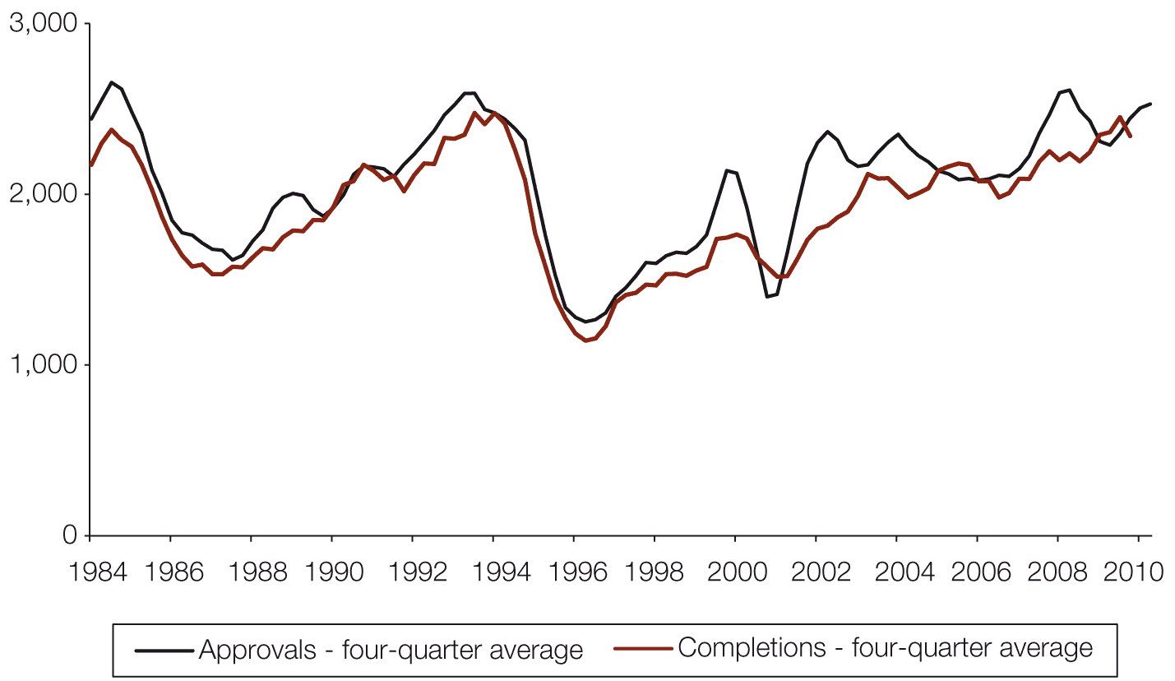
Source: ABS 2011, Building approvals, Australia, Mar 2011, cat. no. 8731.0, ABS, Canberra; and ABS 2011, Building activity, Australia, Mar 2011, cat. no. 8752.0, ABS, Canberra.
Figure 3.21 Quarterly dwelling completions overlaid on residential dwelling approvals (other residential), South Australia, June 1984 to June 2010, smoothed and lagged in accordance with Table 3.6
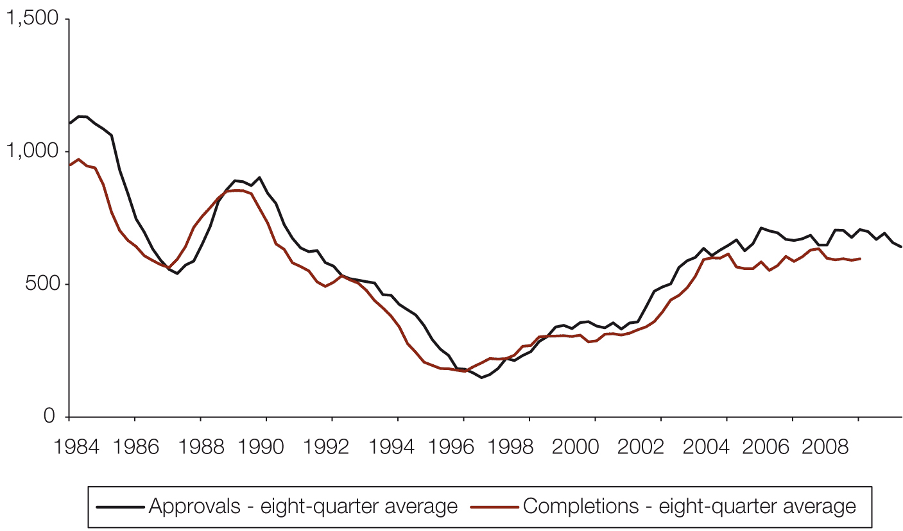
Source: ABS 2011, Building approvals, Australia, Mar 2011, cat. no. 8731.0, ABS, Canberra; and ABS 2011, Building activity, Australia, Mar 2011, cat. no. 8752.0, ABS, Canberra.

Figure 3.22 Quarterly dwelling completions overlaid on residential dwelling approvals (houses), Western Australia, June 1984 to June 2010, smoothed and lagged in accordance with Table 3.6
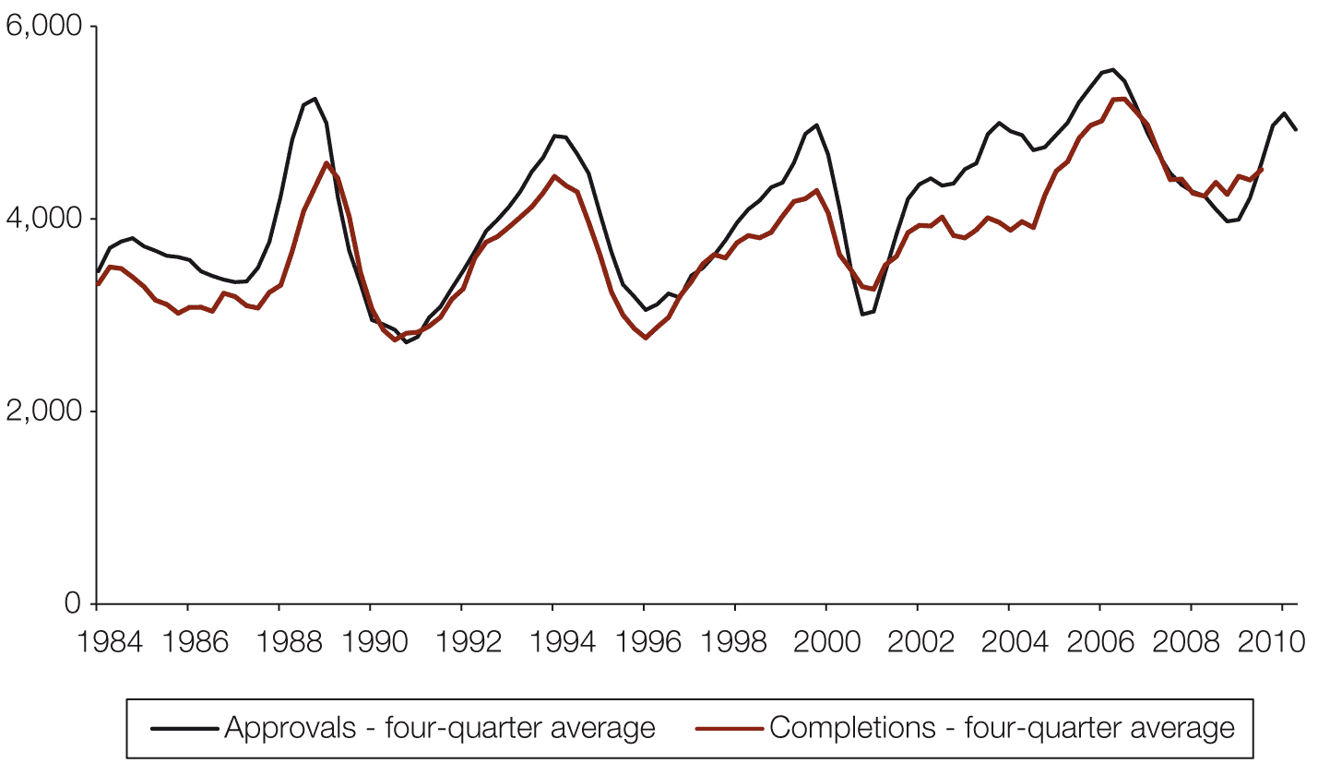
Source: ABS 2011, Building approvals, Australia, Mar 2011, cat. no. 8731.0, ABS, Canberra; and ABS 2011, Building activity, Australia, Mar 2011, cat. no. 8752.0, ABS, Canberra.
Figure 3.23 Quarterly dwelling completions overlaid on residential dwelling approvals (other residential), Western Australia, June 1984 to June 2010, smoothed and lagged in accordance with Table 3.6
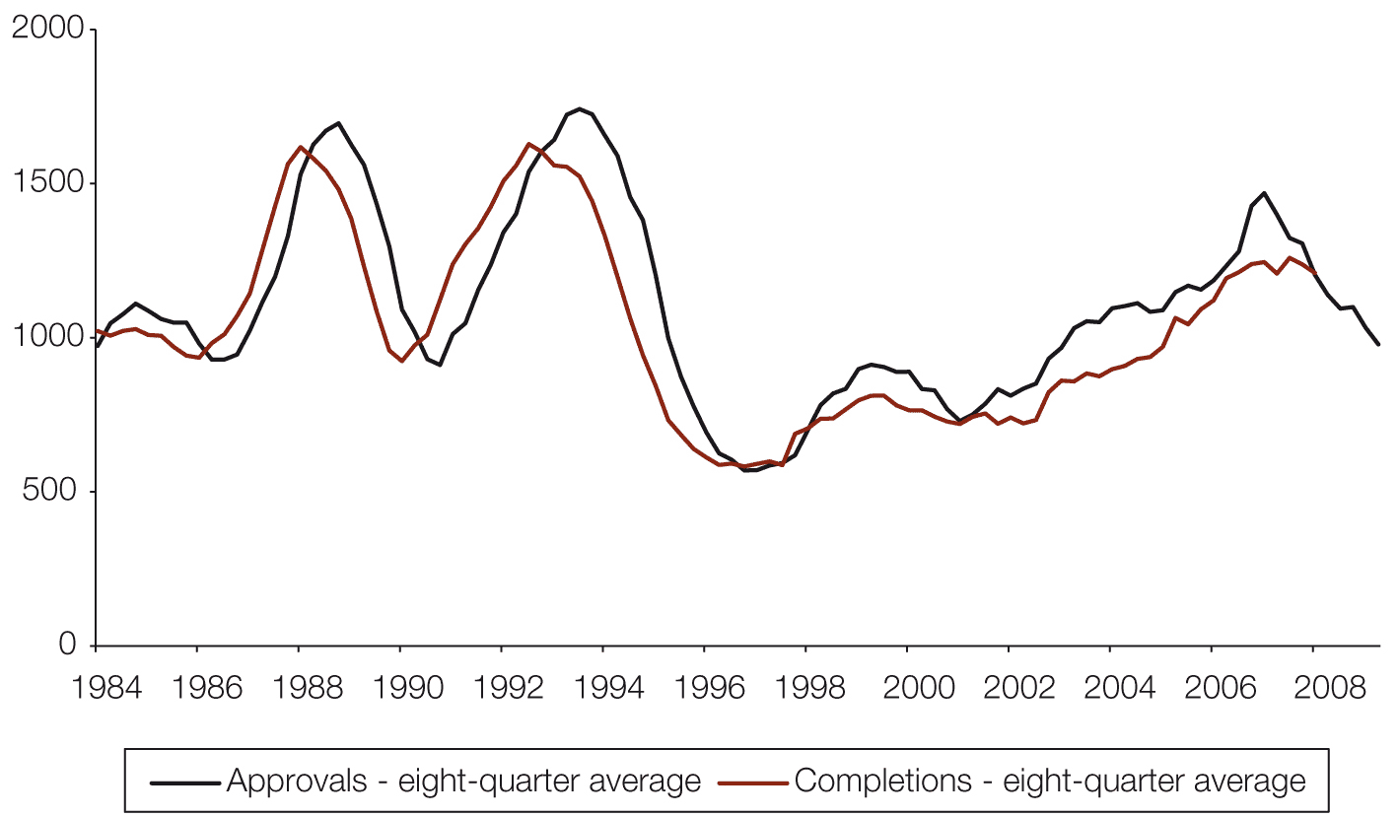
Source: ABS 2011, Building approvals, Australia, Mar 2011, cat. no. 8731.0, ABS, Canberra; and ABS 2011, Building activity, Australia, Mar 2011, cat. no. 8752.0, ABS, Canberra.

Figure 3.24 Quarterly dwelling completions overlaid on residential dwelling approvals (houses), Tasmania, June 1984 to June 2010, smoothed and lagged in accordance with Table 3.6
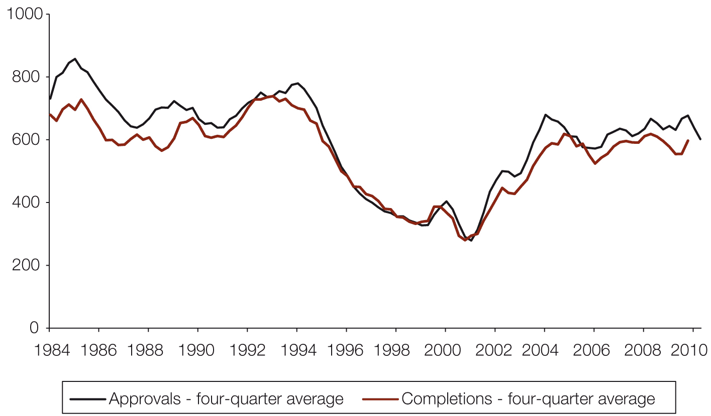
Source: ABS 2011, Building approvals, Australia, Mar 2011, cat. no. 8731.0, ABS, Canberra; and ABS 2011, Building activity, Australia, Mar 2011, cat. no. 8752.0, ABS, Canberra.
Figure 3.25 Quarterly dwelling completions overlaid on residential dwelling approvals (other residential), Tasmania, June 1984 to June 2010, smoothed and lagged in accordance with Table 3.6
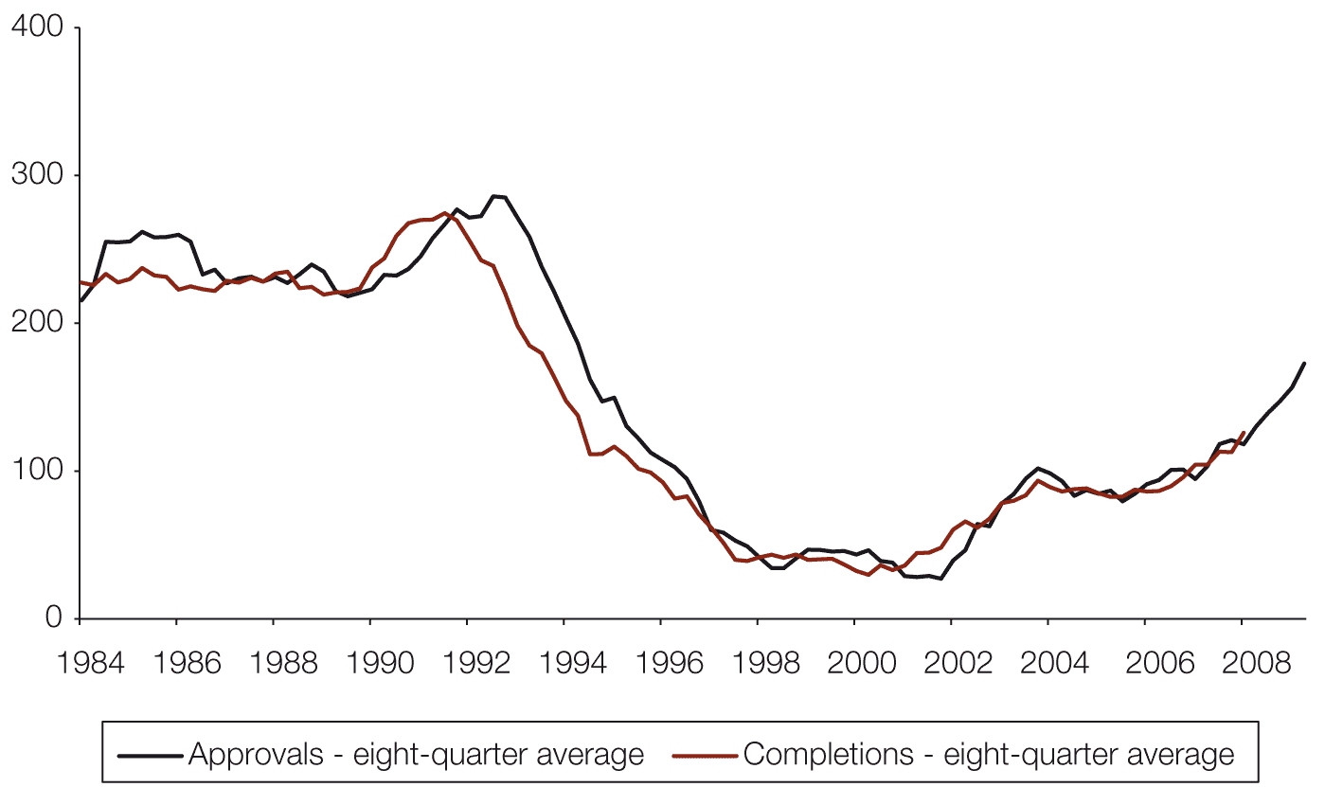
Source: ABS 2011, Building approvals, Australia, Mar 2011, cat. no. 8731.0, ABS, Canberra; and ABS 2011, Building activity, Australia, Mar 2011, cat. no. 8752.0, ABS, Canberra.

Figure 3.26 Quarterly dwelling completions overlaid on residential dwelling approvals (houses), Northern Territory, June 1984 to June 2010, smoothed and lagged in accordance with Table 3.6
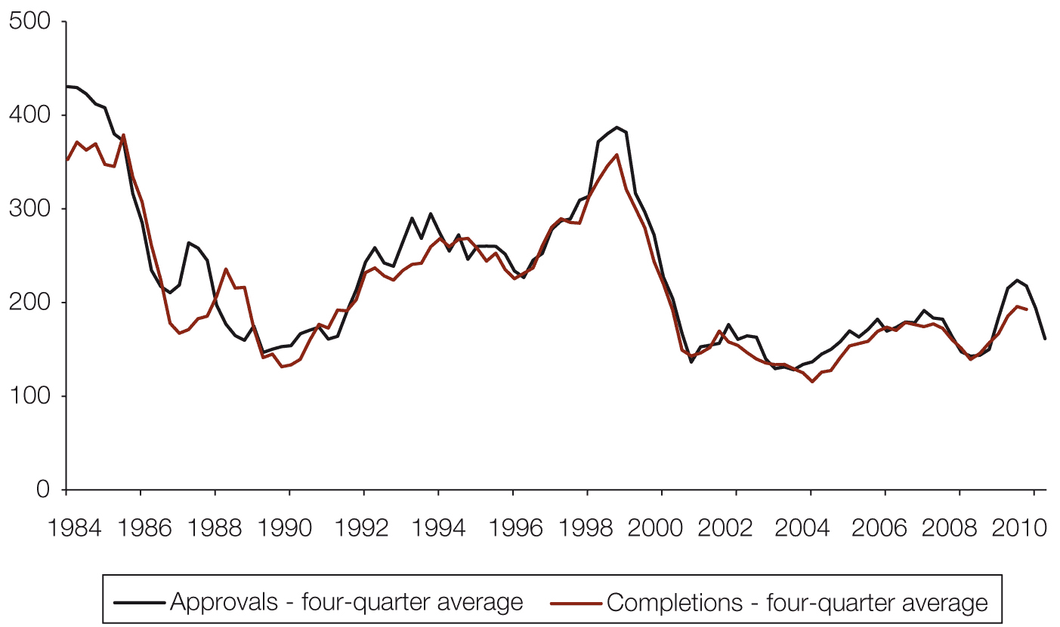
Source: ABS 2011, Building approvals, Australia, Mar 2011, cat. no. 8731.0, ABS, Canberra; and ABS 2911, Building activity, Australia, Mar 2011, cat. no. 8752.0, ABS, Canberra.
Figure 3.27 Quarterly dwelling completions overlaid on residential dwelling approvals (other residential), Northern Territory, June 1984 to June 2010, smoothed and lagged in accordance with Table 3.6
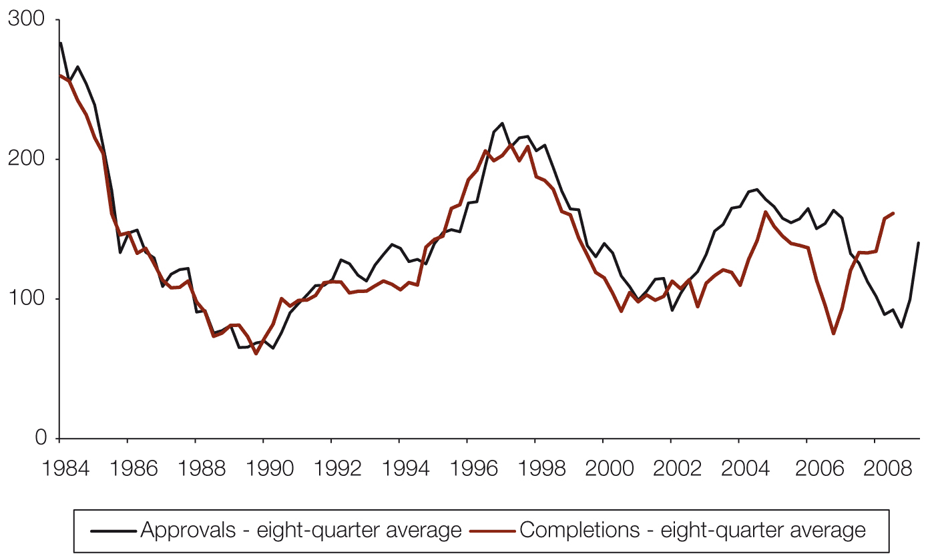
Source: ABS 2011, Building approvals, Australia, Mar 2011, cat. no. 8731.0, ABS, Canberra; and ABS 2011, Building activity, Australia, Mar 2011, cat. no. 8752.0, ABS, Canberra.

Figure 3.28 Quarterly dwelling completions overlaid on residential dwelling approvals (houses), Australian Capital Territory, June 1984 to June 2010, smoothed and lagged in accordance with Table 3.6
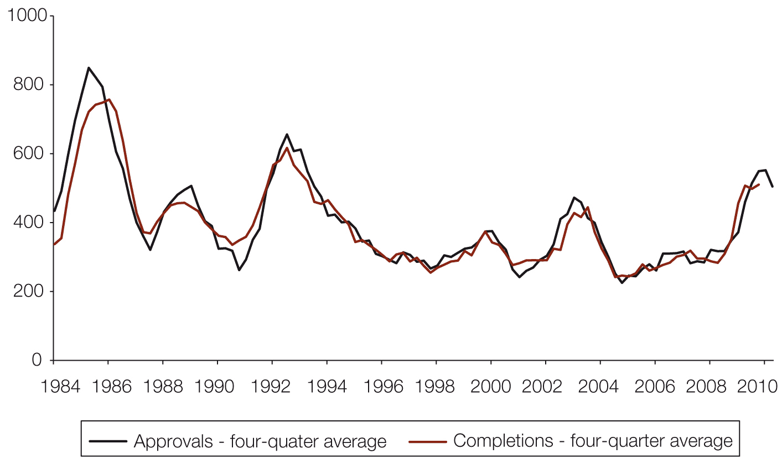
Source: ABS 2011, Building approvals, Australia, Mar 2011, cat. no. 8731.0, ABS, Canberra; and ABS 2011, Building activity, Australia, Mar 2011, cat. no. 8752.0, ABS, Canberra.
Figure 3.29 Quarterly dwelling completions overlaid on residential dwelling approvals (other residential), Australian Capital Territory, June 1984 to June 2010, smoothed and lagged in accordance with Table 3.6
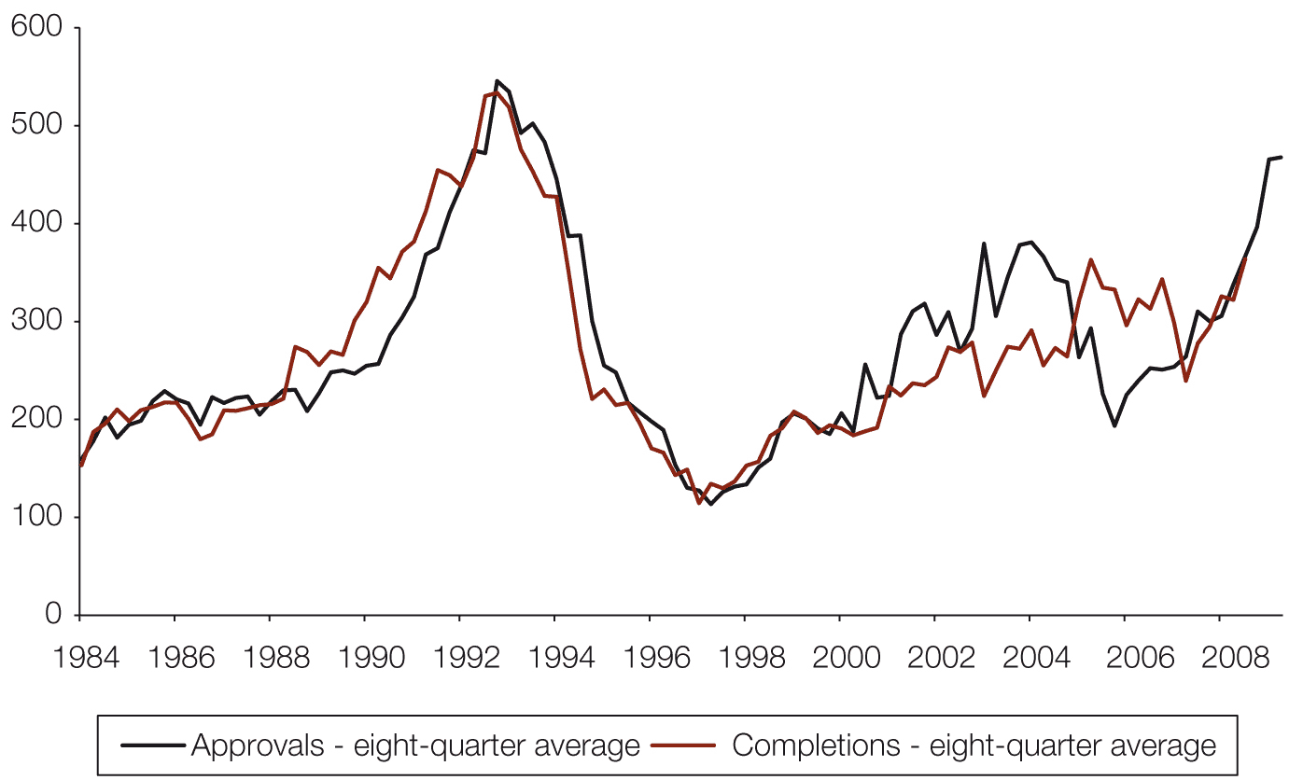
Source: ABS 2011, Building approvals, Australia, Mar 2011, cat. no. 8731.0, ABS, Canberra; and ABS 2011, Building activity, Australia, Mar 2011, cat. no. 8752.0, ABS, Canberra.

Table 3.7 shows the Council’s forecasts of gross completions in the 2010 calendar year, based on the observed lags and cancellation rates described above. Given the averaging processes involved, it is clearly unrealistic to expect a high degree of accuracy in these forecasts. However, they provide a basis for adjusting short-term expectations on the basis of leading indicators of residential development activity.
Table 3.7 Short-term forecasts for dwelling completions, 2011 calendar year
State/territory | New houses | Other dwelling construction | Total dwellings
NSW | 15,300 | 12,400 | 27,800
Vic | 33,900 | 12,100 | 46,000
Qld | 17,400 | 9,600 | 27,000
SA | 8,000 | 2,200 | 10,300
WA | 16,800 | 4,200 | 21,000
Tas | 2,100 | 600 | 2,700
NT | 500 | 600 | 1,100
ACT | 1,700 | 1,800 | 3,500
Total | 95,700 | 43,500 | 139,200
Source: National Housing Supply Council estimates.
Note: Figures are rounded to the nearest hundred.

The 139,200 projected completions for 2010–11 are lower than actual completions (155,900) and significantly below the trend suggested by the 74,300 completions recorded in the first two quarters of the 2011 calendar year. The Council’s long-term projection of gross completions for the year to June 2012 is 156,000 (this is the estimate for completions before adjustments are made for demolitions).
The short-term forecast suggests that the actual outcome for supply in the next year or two will be below that suggested by the medium scenario projection method. Along with recent trends in activity, the forecast indicates the relative success of the Victorian and Western Australian markets in increasing housing supply, especially by comparison with New South Wales. Victoria has 25 per cent of Australia’s households and a lower proportionate shortfall than many states, and is forecast to build 33 per cent of all new homes in 2011. Western Australia is forecast to build 15 per cent of homes despite having only 10 per cent of households. New South Wales is forecast to build 20 per cent of new homes in Australia, while having 32 per cent of households. There is already a substantial housing shortage in New South Wales by the Council’s assessment.
Type of dwellings
Figure 3.30 shows that over the longer term there has been a decline in completions of detached houses relative to flats, units and apartments. This is likely to reflect the housing preferences of the increasing proportion of lone-person households and two-person households without dependent children, the reduced availability and high price of detached housing in some locations, and the focus on infill development in several cities that tends to favour higher density building.
Figure 3.30 Type of housing production (gross completions)
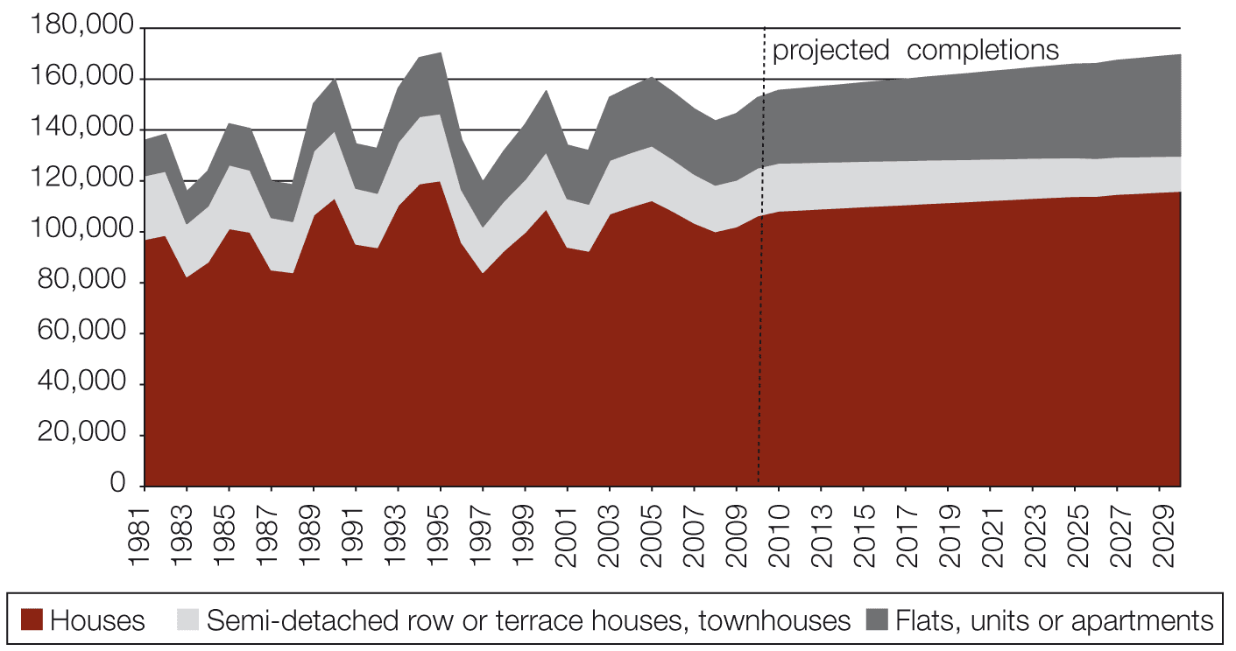
Source: Projections based on dwelling completion trend, 1 July 1980 to 31 December 2010, from ABS 2011, Building activity, Australia, December 2010, cat. no. 8752.0, ABS, Canberra.
Note: Actual completions data used up to 2010. Projections used thereafter.

Around 30 per cent of all residential dwelling completions in recent years have been flats, apartments or townhouses. Medium-density developments (townhouses and terraces) have fallen slightly in relative share, while detached houses have declined from around 76 per cent of completions in the 1980s to an average of about 70 per cent since 2001.
As indicated by Figure 3.30, the Council’s supply projections assume that these trends continue, although the modest decline in medium-density construction could be substantially reversed if there are continued reductions in average lot sizes and mixed styles of housing in greenfield developments and if the rate of infill development increases in middle suburbs.
How new supply becomes available
Understanding the stages that precede dwelling construction and the factors that affect the land and dwelling supply pipeline is important in better understanding how the market adds new supply and responds to changes in demand.
The 2008 and 2010 reports included a chart showing the stages involved in the land and dwelling production pipeline and the estimated times taken to proceed through those various stages on a greenfield development. This process was estimated to take from six-and-a-quarter to 14-and-a-half years, depending on the project’s complexity and variations in lags across developments and jurisdictions. However, there are considerable variations in both the process and timing across the states and territories.
Table 3.8 Stages of the generic supply pipeline for greenfield development
Stage of supply pipeline | Description
Stage 1 | Future urban designation
Stage 2 | Specific-use zoning
Stage 3 | Structure planning
Stage 4 | Development/subdivision approval
Stage 5 | Civil works and issue of title
Stage 6 | Building approval and completion

Source: Council of Australian Governments (COAG) Data Sub-Group.
For this report, the Council has developed a similar generic approach to describing the stages of infill development. As can be seen when comparing Tables 3.8 (greenfield development) and 3.9 (infill development), infill development is typically more diverse in scale and housing form, and at times more complex. It has not been possible to produce a generic timeframe for infill development.
Table 3.9 Stages of the generic supply pipeline for infill development
Stage of supply pipeline | Description
Stage 1 | Strategic planning
Stage 2 | Rezoning
Stage 3 | Development application
Stage 4 | Development permit approval
Stage 5 | Building permit or approval/construction permit
Stage 6 | Commencement/completion
Stage 7 | Strata title registration
Stage 8 | Available for occupation
Source: Council of Australian Governments (COAG) Data Sub-Group.

Estimating future dwelling supply
The Council is currently working with state and territory governments to improve understanding of the stages that precede dwelling construction and provide better data on how the market adds new supply and responds to changes in demand.
The lack of comprehensive information available on infill development – especially on smaller-scale ad hoc infill capacity – is of particular concern to the Council given the emphasis in most capital city metropolitan plans on infill development providing as much as 70 per cent of future residential dwelling supply.
Table 3.10 shows estimates of potential dwelling completions in both greenfield and infill developments for five capital cities and South-east Queensland, as well as an estimate for Australia’s eight capital cities.
Over the next five years, it is estimated that approximately half of the increase in dwelling supply is planned to come from infill development – 59 per cent in the next two years and 49 per cent over the subsequent three years. In the next two years, Sydney is expected to achieve 77 per cent of its growth in dwelling completions from infill, and 73 per cent in the subsequent three years. These relatively high shares are consistent with previous trends. It is also notable that Sydney’s data, unlike those of other jurisdictions, are provided on a net-of-demolitions basis. This means that infill’s share of gross completions will need to be even higher in Sydney to achieve the net predicted outcomes, while net infill outcomes in other jurisdictions would be lower than suggested by the forecasts of gross completions. South-east Queensland has the lowest proportion of expected dwelling completions being infill, at 36 per cent in the next two years and 31 per cent in the subsequent three years (see Table 3.11).
Disaggregated information on expected residential dwelling completions from greenfield and infill development was not available for Hobart or Darwin.

Table 3.10 Estimated dwelling supply: number of potential dwelling completions capital cities, 2010–2020
 | Sydney (a) | Melbourne (b) | South-east Queensland (c) | Adelaide (f) | Perth | Canberra | Subtotal for five capital cities and SE Qld | Estimate to eight capital cities (g)
Estimated dwelling supply
Next 2 years or less
Greenfield land (gross) | 7,100 | 27,000 | 26,000 | 6,100 | n.a. | 4,000 | 70,200 | 85,900
Infill land
Large projects (50+ dwellings) | 15,200 | 18,300 | 5,200 | n.a. | n.a. | n.a. | n.a. | n.a.
Medium projects (11– 49 dwellings) | }8,900{ | 5,300 | 4,200 | 4,300 | n.a. | n.a. | n.a. | n.a.
Small projects (10 or less dwellings) |  | 11,200 | 5,400 | 6,000 | n.a. | n.a. | n.a. | n.a.
Total infill (gross) | 24,100 | 34,800 | 14,800 | 10,300 | n.a. | 4,000 | 88,000 | 107,700
Total completions (gross) | 31,200 | 61,800 | 40,800 | 16,400 | n.a. | 8,000 | 158,200 | 193,600
Average gain per annum (gross) | 15,600 | 30,900 | 20,400 | 8,200 | n.a. | 4,000 | 79,100 | 96,800
More than 2 and up to 5 years
Greenfield land (gross) | 17,100 | 39,300 | 62,400 | 10,800 | 53,700 | 6,000 | 189,300 | 190,800
Infill land
Large projects (50+ dwellings) | 30,800 | 25,700 | 20,700 | n.a. | 4,400 | n.a. | n.a. | n.a.
Medium projects (11– 49 dwellings) | }15,600{ | 5,100 | 6,400 | 3,800 | 1,200 | n.a. | n.a. | n.a.
Small projects (10 or less dwellings) |  | 21,900 | 1,400 | 9,000 | 300 | n.a. | n.a. | n.a.
Total infill (gross) | 46,400 | 52,700 | 28,500 | 12,800 | 6,000 | 6,000 | 152,400 | 153,600
Total completions (gross) | 63,500 | 92,000 | 90,900 | 23,600 | 59,700 | 12,000 | 341,700 | 344,400
Average gain per annum (gross) | 21,200 | 30,700 | 30,300 | 7,900 | 19,900 | 4,000 | 113,900 | 114,800
More than 5 and up to 10 years
Greenfield land (gross) | 26,700 | 65,300 | 70,200 | 15,500 | 32,300 | 10,000 | 220,000 | 221,800
Infill land
Large projects (50+ dwellings) | 42,200 | 31,300 | n.a. | n.a. | 31,800 | n.a. | n.a. | n.a.
Medium projects (11– 49 dwellings) | }46,600{ | 2,600 | n.a. | 9,000 | 100 | n.a. | n.a. | n.a.
Small projects (10 or less dwellings) |  | 50,400 | n.a. | 15,000 | n.a. | n.a. | n.a. | n.a.
Total infill (gross) | 88,800 | 84,300 | n.a. | 24,000 | 31,900 | 10,000 | 300,000(f) | 319,200(f)
Total completions (gross) | 115,500 | 149,500 | 70,200(e) | 39,500 | 64,200 | 20,000 | 485,800(f) | 516,800(f)
Average gain per annum (gross) | 23,100 | 29,900 | 14,000(e) | 7,900 | 12,800 | 4,000 | 97,200(f) | 103,400(f)
Estimated dwelling supply
Next 10 years or less
Greenfield land (gross) | 50,900 | 131,600 | 158,600 | 32,400 | 86,000 | 20,000 | 479,500 | 498,500
Infill land
Large projects (50+ dwellings) | 88,200 | 75,200 | 25,900(d) | n.a. | 36,200 | n.a. | n.a. | n.a.
Medium projects (11– 49 dwellings) | }71,000{ | 13,000 | 10,600(d) | 17,100 | 1,300 | n.a. | n.a. | n.a.
Small projects (10 or less dwellings) |  | 83,500 | 6,800(d) | 30,000 | 300 | n.a. | n.a. | n.a.
Total infill (gross) | 159,200 | 171,700 | 43,300(d) | 47,100 | 37,800 | 20,000 | 575,800(f) | 618,900(f)
Total completions (gross) | 210,100 | 303,300 | 201,900(d) | 79,500 | 123,800 | 40,000 | 1,013,000(f) | 1,085,100(f)
Average gain per annum (gross) | 21,000 | 30,300 | 20,200(d) | 8,000 | 12,400 | 4,000 | 101,300(f) | 108,500(f)

Source: National Housing Supply Council estimates and data supplied by state and territory planning agencies. See Appendix 3 for more detail.
Notes: Data are not directly comparable between individual states and territories due to differences in the way data are collected and categorised. See notes below and more detailed information in Appendix 3.
‘n.a.’ = not available.
(a) Sydney
All Sydney data is net, not gross, and therefore understated in comparison to other states. All forecasts are for the period commencing July 2010. Data in this table are based on unpublished data. Minor sites (generally those with fewer than 50 dwellings) are calculated based on the difference between forecast total and the forecast major sites.
(b) Melbourne
Data are for proposed dwelling project commencements rather than completions, as they link better with Urban Development Program (UDP) data. Data in this table are based on unpublished data. The numbers given for ‘small projects’ correspond to a subtraction of UDP-identified projects from Victoria In Future (VIF) 2011 (unpublished) projected demand. ‘Total’ is anticipated demand under VIF 2011 (state population projections). Victoria is aware that ‘normal’ supply that ‘normal’ supply in Melbourne each year has resulted in around 12,000 greenfield dwellings, 10,000 major redevelopment dwellings and 8,000 infill dwellings.
(c) South-east Queensland
The figures are based on the expected long-term dwelling yield from lots that are expected to be registered during the periods specified (for outside the existing urban area, i.e. Greenfield areas, only) These figures would exceed the expected dwelling completions during the same periods.
(d) Excludes south-east Queensland infill data for the ‘More than 5 and up to 10 years’ period.
(e) Excludes south-east Queensland infill data for the ‘More than 5 and up to 10 years’ period and Adelaide infill data for large projects for the ‘More than 5 and up to 10 years’ period.
(f) Adelaide data are from 2008. Newer data was not available.
(g) Pro-rated from figures for five capital cities and South-east Queensland.

Table 3.11 Estimated dwelling supply: percentage of potential dwelling completions, from infill and greenfield in the next 10 years
 | Sydney (a) | Melbourne (b) | South-east Queensland (c) | Adelaide (d) | Perth | Canberra | Subtotal for five capital cities and SE Qld | Eight capital cities (estimated) (e)
Estimated dwelling supply | Percentage of potential dwelling completions in jurisdiction
Next 2 years or less
Greenfield land (gross) | 23 | 44 | 64 | 37 | n.a. | 50 | 44 | 44
Total infill (gross) | 77 | 56 | 36 | 63 | n.a. | 50 | 56 | 56
Total completions (gross) | 100 | 100 | 100 | 100 | n.a. | 100 | 100 | 100
More than 2 and up to 5 years
Greenfield land (gross) | 27 | 43 | 69 | 46 | 90 | 50 | 55 | 55
Total infill (gross) | 73 | 57 | 31 | 54 | 10 | 50 | 45 | 45
Total completions (gross) | 100 | 100 | 100 | 100 | 100 | 100 | 100 | 100
More than 5 and up to 10 years
Greenfield land (gross) | 23 | 44 | 100 | 39 | 50 | 50 | 48 | 38
Total infill (gross) | 77 | 56 | 0 (c) | 61 | 50 | 50 | 52 | 52
Total completions (gross) | 100 | 100 | 100 | 100 | 100 | 100 | 100 | 100

Source: National Housing Supply Council estimates and data supplied by state and territory planning agencies. See Appendix 3 for more detailed information on sources.
Notes: Data are not directly comparable between individual states and territories due to differences in the way data are collected and categorised. See notes below and more detailed information in Appendix 3.
‘n.a.’ = not available.
(a) Sydney
All forecasts are for the period commencing July 2009. Data in this table are based on unpublished data.
(b) Melbourne
Based on 2010 Urban Development Program and Victoria in Future 2011 projections (unpublished data).
(c) South-east Queensland
Figures based on expected long-term dwelling yields from lots that are expected to be registered in the identified periods (for outside the existing urban areas, i.e. greenfield areas, only). No infill data are available for this period.
(d) Adelaide
Data as used in the 2010 State of Supply Report. No updated data available. Excludes Adelaide infill data for the ‘More than 5 and up to 10 years’ period.
(e) Pro-rated from figures for five capital cities and South-east Queensland.

As in the 2010 report, the Council have extrapolated these pipeline figures from the capital cities, on a pro rata basis, to estimate the number of dwelling completions for Australia as a whole. Figures are as follows:
- 138,000 for years 2011 to 2012
- 150,000 for years 2013 to 2015
- 188,000 for years 2016 to 2020.
Demolitions are estimated by the Council to total around 12,000 per year, while conversions have been a little over 1,000 per year over the past four years. Adjusting gross completions by approximately 11,000 per year to account for these adjustments would give a net increase in supply of:
- 127,000 for years 2011 to 2012
- 138,000 for years 2013 to 2015
- 176,000 for years 2016 to 2020.
However, it is important to bear in mind that, as the data for Sydney are reported on a net rather than gross completion basis, these calculations are likely to produce something of an underestimate of actual expected gross completions – perhaps by up to 2,000 per year.
As outlined in Chapter 2, the Council has projected an increase in underlying demand of a little over 160,000 households per year from 2011 to 2030. The pipeline data suggest that the gap between supply and demand will increase further in the short term, unless there is a substantial increase in housing production outside the capital cities. The Council’s 2010 report also anticipated that finance system changes emanating from the GFC could cause delays in the supply pipeline, particularly if finance became harder to obtain for multi-unit infill developments.

Box 3.1 Sustainable Australia – Sustainable Communities
The Australian Government Minister for Sustainability, Environment, Water, Population and Communities, the Hon Tony Burke MP, launched the Sustainable Australia – Sustainable Communities strategy in May 2011. The strategy outlines proposed directions to help ensure that future population change enhances economic, environmental and social wellbeing.
The strategy’s focus is on population change, encouraging growth in regional areas by attracting skilled workers and housing to areas of emerging job opportunity, and alleviating pressures in outer suburbs of major capital cities by supporting more local jobs. It sets out a framework for improving the mix of services, jobs, training opportunities and affordable housing, while boosting the ‘livability’ of Australia’s cities and regions.
Implementation of the strategy is supported by several initiatives announced in the 2011–12 Budget:
- $100 million for a Suburban Jobs initiative
- more than $80 million in new investments in the National Urban Policy to support projects aimed at more productive, sustainable and liveable cities, including $20 million for a Liveable Cities program to invest in the development of urban renewal projects
- nearly $30 million for a new Sustainable Regional Development initiative to support planning for environmental sustainability in regions experiencing high growth – these funds will support strategic assessments under national environmental law regional and coastal growth areas
- 16,000 new places for skilled migrants through the Regional Sponsored Migration Scheme.
The Australian Government has also committed $100 million under the Building Better Regional Cities initiative to build more affordable homes in regional cities to relieve pressure on major capital cities.
A further $100 million has been committed to a Suburban Jobs Program to support state, territory and local governments’ planning and provision of local employment hubs close to residential areas in order to reduce travel times to work and services. The program will focus on the outer suburbs of major cities that are experiencing pressures from population growth and transport costs.
Australian Government programs to increase the supply of housing
Since publication of the previous State of Supply Report in April 2010, some of the Australian Government’s housing programs have moved to the new portfolio of Sustainability, Environment, Water, Population and Communities. These programs focus on increasing the supply of affordable housing, and include the National Rental Affordability Scheme (NRAS) and the Housing Affordability Fund (HAF). The Building Better Regional Cities program announced at the 2010 election is also included in this portfolio. Commonwealth social housing and Indigenous housing programs have stayed with the Families, Housing, Community Services and Indigenous Affairs portfolio. Other portfolios, including Treasury and Regional Development and Infrastructure, also have roles in the supply of housing. This section provides a summary of Australian Government programs aimed at improving housing affordability.
National Rental Affordability Scheme
The National Rental Affordability Scheme (NRAS) is a $4.3 billion initiative to stimulate the supply of new affordable rental dwellings in partnership with the states and territories. NRAS aims to increase the supply of affordable housing in Australia by providing annual incentives (as cash, tax offsets or in‑kind assistance) to approved participants for a period of 10 years to create new affordable rental properties for low- and moderate-income households, with rents at 20 per cent or more below the market rate.
Investor interest and engagement has been growing. As at 30 September 2011, 4,604 dwellings have been built and are now tenanted or available for rent. Many more are in development and, following the announcements of successful applications from the fourth call for proposals, substantial progress has been made towards achieving the Australian Government’s target of 50,000 new affordable rental dwellings – 35,000 dwellings by 30 June 2014 and a further 15,000 dwellings by the end of 2015–16.
Housing Affordability Fund
The Housing Affordability Fund (HAF) is a five-year, $450 million investment aimed at reducing the cost of new homes.
The HAF aims to address two significant barriers to increasing the supply of affordable housing:
- the ‘holding’ costs incurred by developers as a result of long planning and approval times
- infrastructure costs, such as for the laying of water pipes, the installation of sewerage systems, the establishment of transport networks and the creation of parks.
The HAF has provided grants to state, territory and local governments to work in conjunction with the private sector to address these market barriers and ensure that savings generated are passed on to the new-home buyer.
The HAF funding is now fully committed. A total of 75 projects have been approved.
Of these, 23 are targeted to promote and develop best practice in planning and development assessment processes at local government level. Nine of these projects will assist with the implementation of electronic Development Assessment (eDA) systems in each jurisdiction to enable faster assessment of development approvals. $3.6 million has been allocated for a national protocol to allow different IT systems to ‘talk’ to each other to ensure that eDA develops consistently across Australia.
A further 52 projects have been funded to reduce the burden of infrastructure charges on developers and generate savings for purchasers of new entry-level and moderately priced homes. These infrastructure investments will also help to speed up the release of land for residential development. Eight of these infrastructure projects also include elements of planning reform to help speed up development assessment processes within the local government area.
Projects are located in every state and territory. Completion dates vary, with the longest-running project due for completion in 2028.
Building Better Regional Cities
The Building Better Regional Cities (BBRC) program is a $100 million funding commitment to invest in local infrastructure projects that support new housing developments in regional cities. The objectives of the program are to support an increase in the number of homes for sale and rent that are affordable for working families on ordinary incomes, in communities experiencing positive jobs and population growth that need more homes to be built.
Forty-seven regional cities (listed below) are eligible to apply for funding under the program.

NSW | Queensland | Western Australia
Albury | Bundaberg | Bunbury
Ballina | Cairns | Geraldton
Bathurst | Gladstone | Kalgoorlie-Boulder
Cessnock | Gold Coast | Mandurah
Coffs Harbour | Hervey Bay
Dubbo | Mackay | Tasmania
Gosford | Rockhampton | Burnie
Lake Macquarie | Sunshine Coast | Devonport
Lismore | Toowoomba | Launceston
Maitland | Townsville
Newcastle
Nowra | Victoria | South Australia
Orange | Ballarat | Mount Gambier
Port Macquarie | Bendigo
Queanbeyan | Geelong | Northern Territory
Tamworth | Mildura | Palmerston
Tweed Heads | Shepparton
Wagga Wagga | Traralgon
Wollongong | Warrnambool
Wyong | Wodonga
Up to $15 million will be provided for infrastructure in each successful regional city. Funding for the program became available in the 2011–12 financial year and will cease on 30 June 2014. Only one funding round is proposed. Applications opened on 7 October 2011 and closed on 18 November 2011.
Social, public and community housing
National Affordable Housing Agreement
The Australian Government and the state and territory governments are parties to a National Affordable Housing Agreement (NAHA) applying from 1 January 2009 with the aspirational objective that all Australians have access to affordable, safe and sustainable housing that contributes to social and economic participation.
The National Affordable Housing Specific Purpose Payment provides $6.2 billion in Commonwealth funding over five years to achieve the outcomes and objectives of the NAHA. The funds are applied to a range of measures including: social housing; assistance to people in the private rental market; support and accommodation for people who are homeless or at risk of homelessness; and home purchase assistance.
Further, the agreement commits all levels of government to undertake reforms in the housing sector, including to:
- improve integration between the homelessness service system and mainstream services
- reduce concentrations of disadvantage that exist in some social housing estates
- improve access by Indigenous people to mainstream housing, including home ownership
- enhance the capacity and growth of the not-for-profit housing sector
- increase capacity to match new housing supply with underlying demand, including as a result of work undertaken by the National Housing Supply Council
- plan reform for greater efficiency in the supply of housing.
The NAHA is complemented by additional Commonwealth funding through National Partnership Agreements ($550 million for homelessness over five years to be matched by the states and territories, $400 million for social housing and $834.6 million over five years for remote Indigenous housing).
National Partnership Agreement on Social Housing
The $400 million National Partnership Agreement on Social Housing will deliver between 1,600 and 2,100 new social housing dwellings. Around 1,960 dwellings have been approved under the agreement, comprising 1781 social housing dwellings and an additional 179 affordable housing dwellings that will be delivered through partnering with the community housing sector. At 30 June 2011, work had commenced on 1,868 dwellings and 1,540 dwellings were complete. All of the approved dwellings are expected to be completed by the first half of 2012.

Box 3.2 Social housing in Australia and its role in remote Indigenous communities
Over the past 30 years, the two major forms of social housing in Australia – public rental housing managed by state and territory social housing agencies and rental housing managed by not-for-profit community-based organisations – have increasingly focused on providing housing for people who struggle to find and retain affordable housing in the private market.
Public housing accounted for 4.3 per cent of total occupied dwellings and about 15 per cent of all rental housing at the 2006 Census, although there were several Census collection districts where the proportion of public housing exceeded 20 per cent, and in some areas it was as high as 80 per cent. The concentration of public housing in some areas relates to factors such as:
- the provision of government-owned housing in areas or situations (such as housing for workers in remote locations) where private provision is low
- the construction of major public housing estates.
The 2006 Census data also show that public rental housing accommodated 20 per cent of Indigenous households across Australia, while private rental accounted for 18.7 per cent of Indigenous households.
Community-managed social housing accounted for just 0.7 per cent of occupied dwellings across Australia in 2006, but there were areas of high concentration. In the northern areas of Australia and other geographically remote locations, Indigenous Community Housing Organisations (ICHOs) have been major providers of dwellings.
There are parts of Australia in which ICHOs account for the majority of dwellings. Community-managed housing accommodated 8.9 per cent of all Indigenous households in 2006. Since that time, the National Partnership Agreement on Indigenous Housing has been established under the framework of the National Affordable Housing Agreement, with a focus on adding substantially to the supply of remote Indigenous housing as well as improving management, maintenance standards and financial viability.
Social housing (public and community housing) accounts for 29 per cent of all Indigenous housing tenures, while only 4.4 per cent of non-Indigenous households are in social housing.

Social Housing Initiative
The Social Housing Initiative was launched in February 2009 as part of the Nation Building and Jobs Plan. The initiative is providing a further funding boost for social housing of more than $5.6 billion over the years 2008–09 to 2011–12. Around 19,600 new social housing dwellings will be delivered under the initiative. Over 15,400 of these dwellings were completed at 30 June 2011 and the balance are scheduled to be completed by June 2012. Over 80,000 existing dwellings have also received repairs and maintenance. This work is now complete, and included major upgrades to around 12,000 social housing dwellings that were vacant or would have become uninhabitable without this work.
NAHA Review
The COAG Reform Council reports annually on progress against the NAHA outcomes. The 2009–10 NAHA Performance Report was released in June 2011. Among the key findings were across-the-board improvements in home purchase affordability and a drop in the proportion of clients with a repeat need for specialist homelessness services. The report includes data on progress against five of the seven NAHA outputs and the National Partnerships that support the NAHA.
The 2009–10 report also provides an update on key work underway to develop the performance reporting framework and data sources on which it relies. It details work that has been undertaken to address the recommendations of the 2008–09 Baseline Report, and recommends priorities for further improvements to the performance reporting framework.
Additionally, the Heads of Treasuries reported to COAG in February 2011 on their review of the National Agreements, National Partnerships and Implementation Plans. The review considered the consistency of agreements with the design principles of the Intergovernmental Agreement for Federal Financial Relations; the clarity and transparency of objectives, outcomes, outputs and roles and responsibilities; and the quantity and quality of performance indicators and benchmarks.
Subsequently COAG announced reviews of the performance frameworks of National Agreements. The reviews will ensure that progress is measured and that all jurisdictions are clearly accountable to the public and COAG for their efforts. The review of the NAHA will commence in August 2011 for conclusion by June 2012 - it is to be a technical review that will address the performance reporting issues identified in previous reports from the Heads of Treasuries and COAG Reform Council.
The stock of social housing
Historically, social housing in Australia has been predominantly provided by state and territory housing agencies, with limited provision by not-for-profit providers. This contrasts with significant community-sector involvement in the provision of social housing in most European countries.
The make-up of Australian social housing is changing, and not-for-profit housing providers are playing an increasing role. The number of mainstream community housing dwellings increased by around 27 per cent between June 2007 and June 2010, and further growth of the sector is expected. ‘Enhancing the growth of the community housing sector’ is an agreed housing reform, and housing ministers have set a target of up to 35 per cent of social housing being owned or managed by not-for-profit providers by 2014. Additionally, the state and territory governments have indicated that around 80 per cent of Social Housing Initiative stock will be managed by the community housing sector.
Housing ministers have also agreed to implement a national regulatory system for not-for-profit housing providers and further industry development. The states and territories are already undertaking a number of industry development activities, and public consultation on the national regulatory system commenced in the second half of 2011. Larger and more professionalised housing associations will be able to increase the overall social housing stock through large-scale acquisition and development projects that leverage housing assets for growth.
Despite the increase in community housing, national social housing stock numbers have remained relatively stable in recent years and declined as a proportion of total housing stock. Growth of the community housing sector has been matched by a decline in public housing, and there was only a slight increase in social housing stock overall between June 2007 and June 2010. However, greater growth is anticipated beyond June 2010 as dwellings are delivered under the Social Housing Initiative and the National Partnership Agreement on Social Housing.
As noted in the Council’s previous reports, there has been a continuing decline in the social housing stock as a proportion of total housing stock, and an increased shortage of private rental dwellings at rents that are affordable and available for lower-income households.
In Chapter 2 it is noted that the number of households with a propensity to occupy social housing is likely to increase. Separate projections for social housing supply have not been undertaken in this report, but the 2010 report identified a gap between the demand and supply of affordable rental and social housing of more than 100,000 dwellings (see Figure 3.31). This gap is expected to grow despite the anticipated increase in supply from the Social Housing Initiative, the National Partnership Agreement on Social Housing and the National Rental Affordability Scheme.
Figure 3.31 Social and subsidised housing demand
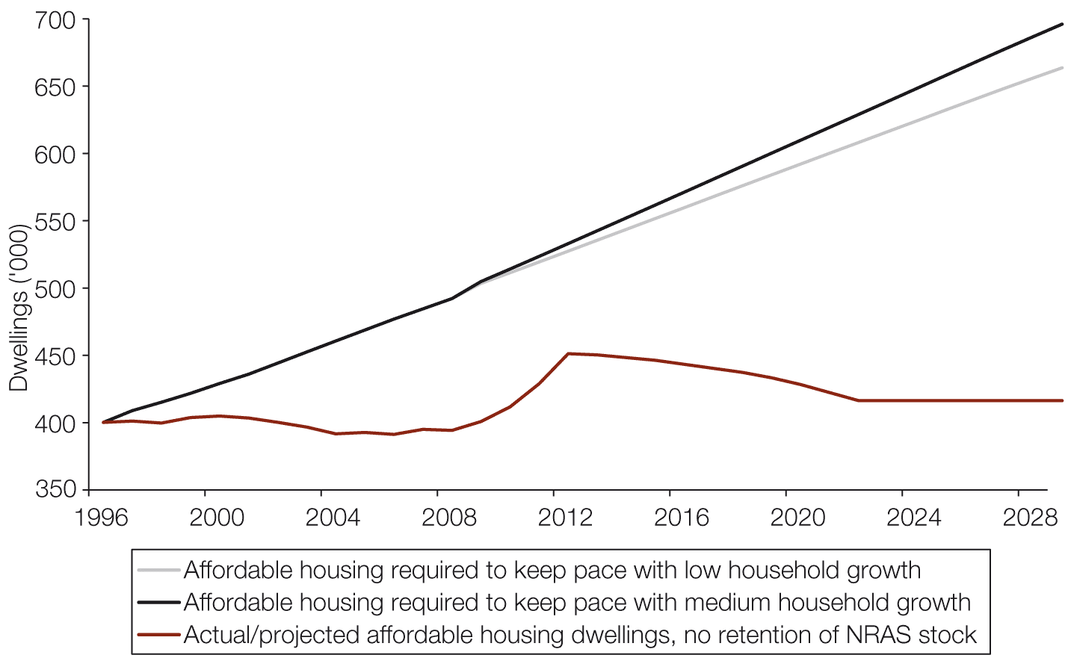
Source: National Housing Supply Council 2010, State of Supply Report, p. 89.
Social housing stock can be increased in a number of ways, including through stock additions by existing state providers, by transferring assets to community housing providers to leverage additional investment, by giving development approval concessions to projects that include social housing dwellings, and through planning measures such as affordable housing targets and inclusionary zoning. Inclusionary zoning and other planning mechanisms have been used in the United Kingdom to require, and contribute to the cost of, a sizeable proportion of affordable dwellings in major development projects. All of these approaches are being used currently in Australia, although with a different mix and at different rates in different jurisdictions.
State and territory housing and planning reform
The states and territories have different regimes for housing and planning. This section highlights some of the changes seen since the 2010 report was published. Earlier initiatives were highlighted in the 2010 report. As noted alongside the short-term forecast for housing completions, Victoria, Western Australia and the Australian Capital Territory are currently witnessing higher rates of dwelling completions than other states and territories.
New South Wales
The New South Wales Government is undertaking a review of the current planning legislation, the Environmental Planning and Assessment Act 1979. A Planning Review Panel has been appointed and the review will be undertaken in three stages: a listening and scoping stage to identify key outcomes and principles for new planning systems; release of a Green Paper outlining options for a future planning system and legislative scheme; and a final White Paper outlining the new framework for New South Wales planning system and draft legislation. It is anticipated that the draft legislation will be put before the New South Wales parliament in the second half of 2012.
In December 2010, the then New South Wales Government released its Metropolitan Plan for Sydney to 2036. The current government has not formally stated its position on the plan. The 30-year plan as published seeks to contain Sydney’s urban footprint and provide a more networked and accessible city. The plan identifies the number of additional dwellings required over the period and distributes them between 10 sub-regions and the Central Coast. At least 70 per cent of these additional dwellings are planned for established areas.
The government is undertaking a review of State Infrastructure Contributions and has established a ministerial-level Taskforce on Housing Supply to identify and resolve impediments to achieving increased housing construction, particularly in Sydney. Targets for Sydney on the delivery of new dwellings each year and levels of stock of zoned and trunk serviced land to be maintained are included in the State Plan NSW 2021, released in September 2011.
Victoria
The Victorian Government is undertaking a two-year consultation process as part of reform of the planning system. In June 2011 an expert advisory group was appointed to advise on how the Victorian planning system could be improved and to undertake public consultation.
An Urban Renewal Authority (URA) has been established, with responsibility for urban change in strategic locations, attracting investment to fund development and accommodate population growth. The URA will also focus on regional cities and will contribute to work on housing supply and affordability.
A Housing Affordability Unit has also been established within the Department of Planning and Community Development. Other initiatives as part of the reform include introducing code assessment, improving the development contributions system (the system of payments and works contributed provided by developers) and reviewing the Urban Growth Boundary to address the metropolitan land supply shortage.
Queensland
Queensland has adopted the Sustainable Planning Act 2009 and the Sustainable Planning Regulations 2009, which aim to achieve sustainable planning outcomes by managing the development process, managing the environmental impacts of development and coordinating and integrating state, regional and local planning. The Queensland Regionalisation Strategy is currently open for consultation. The public consultation period for the Queensland Infrastructure Plan 2011 closed on 9 September 2011.
The Queensland Housing Affordability Strategy, released in 2007, aims to release state land to the housing market quickly and help the market to provide housing more effectively. The Queensland Government has also established the Urban Land Development Authority, made changes to the planning and development assessment process, increased land supply and reformed the local government infrastructure charging framework. The new infrastructure charging framework sets maximum infrastructure charges for residential and non-residential development, with the aim of making infrastructure charges simpler and more equitable.
South Australia
South Australia commenced a program of Planning Reform initiatives in June 2008, including a new approach to assessment and approvals for residential home building matters and new planning strategies for the state. As part of the Planning Reform, the 30–Year Plan for Greater Adelaide was released in February 2010, and new regional plans for country South Australia have also been developed.
Other initiatives include making changes to planning systems to better facilitate urban development, including streamlining zoning and state significant development processes and updating the building code. Following the adoption of the 30-Year Plan for Greater Adelaide, the 2010 Housing and Employment Land Supply Program report was released, which will help to guide the management of land supply for residential, commercial and industrial purposes by identifying the amount of land needed, monitoring supply and consumption trends, ensuring land capacity to meet housing and employment targets and assisting with infrastructure planning.
Western Australia
Amendments to the state’s Planning and Development Act 2005 became law in November 2010, including extension of use of strategic instruments, such as improvement plans and planning control areas. The Act also established Development Assessment Panels – independent decision-making bodies that will rule on applications under local and regional planning schemes. Directions 2031, a strategic plan and spatial framework for metropolitan Perth and the Peel region for the planning and delivery of housing, infrastructure and services to accommodate growth, was released August 2010.
Western Australia also has the Affordable Housing Strategy: Opening Doors 2010–2020, which aims to deliver at least 20,000 affordable rental and home-ownership options by 2020. The WA Government also released its Activity Centres policy in September 2010, which encourages the development of community-focused town centres.
Tasmania
The Tasmanian Government announced an overhaul of its planning system in July 2011. A new statewide single-dwelling residential code has been implemented, and a new code for multi-unit dwellings is being developed. The overhaul will include a new streamlined approvals process, new statewide planning scheme templates for local council planning schemes and new regional planning strategies. The Greater Hobart Capital City Project and the Southern Tasmania Regional Land Use Strategy are both at draft stage.
Northern Territory
The Greater Darwin Regional Land Use Plan: Towards 2030 was released for public consultation in February 2011. The Northern Territory also has the Territory 2030 strategic plan, launched in December 2009. Related initiatives include Housing the Territory – a program for land release, affordable land and house sales, new homes to rent and public housing – and Growing the Territory, which includes a 10-year infrastructure strategy.
Australian Capital Territory
The Australian Capital Territory Government undertook planning reform in 2007, culminating in the Planning and Development Act 2007 and supporting regulations, and a new Territory Plan. The Territory Plan, the territory’s key statutory planning document and policy framework for planning administration, is currently under review. It has been the subject of considerable public consultation, incorporating changes through a draft variation (No. 306) to residential and subdivision codes among other changes. Phase 2 has also commenced, with the release of a discussion paper on possible changes to commercial policies. The Canberra 2030: Time to Talk strategic plan was released in 2010, and the 10-year infrastructure plan was released in July 2011.
A raft of minor changes have been made to the Planning and Development Act 2007 in recent times through two Planning and Building Legislation Amendment Bills, which are part of a commitment to ongoing monitoring, evaluation and enhancement of the new system introduced in 2008.
A new ACT Planning Strategy has been prepared over the past 12 months (following three years of background research and community engagement), which will replace the 2004 Spatial and Sustainable Transport Plans after it has been released for public comment in the near future.
The territory’s Affordable Housing Action Plan was also released in 2007. It contains initiatives including a new land release program, steps towards a streamlined planning system, stamp duty concessions, ways of ensuring the supply of skilled workers for the housing construction industry, new standards for affordable housing design and construction, support for public, community and not-for-profit housing providers, more affordable rental properties and new initiatives to help people to enter the housing market.
The construction industry
The construction industry is an important part of the Australian economy, contributing 7.9 per cent of gross value added in 2009–10. Construction is the third-largest industry in terms of employment in Australia, with 1,031,800 people (9.1 per cent of the total workforce) employed in the sector as at August 2011. There have been anecdotal reports of some employers struggling to remain viable in the weaker sub-markets. Relatively low levels of residential building activity may be an indicator of a decline in employment in the construction industry in the short term. This section looks at overall trends in employment in the construction industry, with detailed information available only through to February 2011 at the time of writing.
The demand for and supply of construction activity is driven by a variety of factors, including economic growth, changes in interest rates, immigration policies, labour availability and changes experienced within other industries such as mining and manufacturing. The availability and price of housing in the established home market are also factors.
Recent and projected future growth in the construction industry
Indicators such as dwelling approvals (13.5 per cent decline for the year ending April 2011), value of residential building work (0.5 per cent decline in the March 2011 quarter) and finance commitments for the construction of new dwellings all suggest that building activity will remain subdued in the near future. While reconstruction efforts following the recent Queensland and Victorian floods will generate increased demand, with a proportion of this demand being for replacement stock, it is expected that there will be some moderating effect from higher interest rates and constraints on the availability of investment capital. However, expectations in the medium term are that demand for labour in the construction industry will be strong, and continuing competition for labour with the mining industry will place pressure on the supply of skills in the construction industry.
In the year to February 2011, employment in the construction industry overall grew by 2.6 per cent (26,600), while employment in the residential building construction industry fell by 1.3 per cent.
Construction activity is broadly divided into residential building, non-residential building and engineering construction. Most people employed in the two largest industry sectors of building installation services and building completion services will be working on residential building jobs at any given time. In this sense, residential building generates more employment in construction than any other area of construction activity.
In the five years to February 2011, the construction industry experienced an increase in employment of 150,900 (3.2 per cent per year). During this period, building installation services grew by 72,000 (6.9 per cent per year), building completion services grew by 18,000 (1.9 per cent per year), and the residential building construction sector grew by 13,500 (an average of 3.4 per cent per year). Table 3.12 presents recent and future projected employment growth for all sectors in the construction industry, and for all industries overall.

Table 3.12 Recent and future projected employment growth, five years to February 2011 and five years to February 2016
Industry | Recent growth –  five years to February 2011 |  | Future growth –  five years to February 2016
 | ’000 | % | ’000 | %
Heavy and civil engineering construction | 27.5 | 9.6 | 24.5 | 6.5
Building installation services | 72.0 | 6.9 | 78.1 | 5.4
Building completion services | 18.0 | 1.9 | 47.3 | 4.4
Land development, site preparation | 3.7 | 1.6 | 11.7 | 4.1
Other construction services | 5.3 | 1.1 | 19.1 | 3.5
Non-residential building construction | –8.2 | –4.2 | 3.5 | 1.9
Building structure services | –3.3 | –0.8 | 8.7 | 1.8
Residential building construction | 13.5 | 3.4 | 7.6 | 1.8
Construction industry | 150.9 | 3.2 | 195.8 | 3.6
All industries | 1,311.6 | 2.5 | 1,260.3 | 2.1
Source: Department of Education, Employment and workplace Relations (DEEWR) 2011, Annual employment projections to 2015–16; and DEEWR trend data based on ABS 2011, Labour force, Australia, Feb 2011, Cat no: 6291.0.55.003, ABS, Canberra.
Note: Percentage growth presented in the table is annual average percentage growth for the relevant five-year period.

Construction industry employment by sector
The two largest sectors within the construction industry, building installation services and building completion services, represent close to half of all employment in the industry (456,400, or 44.3 per cent) as at February 2011. The building installation services sector employed 254,800 people (24.7 per cent of industry employment) as at February 2011, and building completion services employed 201,600 people (19.6 per cent). Residential building construction employed 88,500 (8.6 per cent). Figure 3.32 shows employment in the construction industry by sector.
Figure 3.32 Employment level among construction industry sectors (’000), February 2011
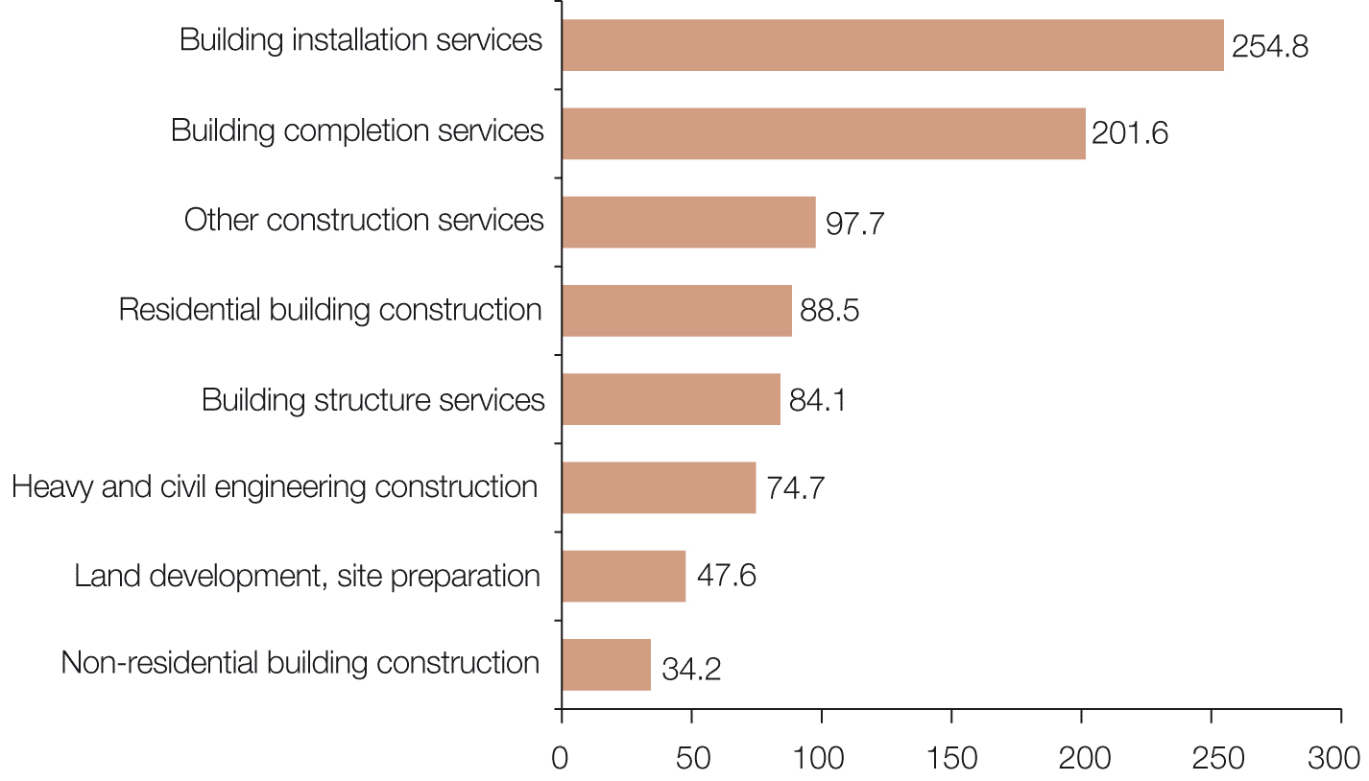
Source: Employment level by industry sector, DEEWR trend data based on ABS 2011, Labour force, Australia, February 2011, cat. no. 6291.0.55.003, ABS, Canberra; and Skills info website.

Construction industry workforce ageing
The Australian labour force is being skewed to older age groups as a result of the ageing of the population. This means that most future growth in the Australian labour force is likely to be in the older age categories.
Construction has a slightly younger workforce than those of other industries, with a median age of 37 years compared with 39 years for all industries. The sector with the lowest median age (35 years) is building installation services.
The share of ‘prime age’ workers (those aged 25 to 44 years) in the construction industry is higher (47.4 per cent) than the average for all industries (44.6 per cent). The proportion of workers aged 20 to 24 years is also larger: 13.2 per cent of the workforce, compared with 10.7 per cent for all industries. The lower proportion of mature-aged workers (45 years and over) – 33.7 per cent compared with the all-industries average of 38.4 per cent – reflects the physical demands of many occupations in this industry. Figure 3.33 shows employed people by age in the construction industry compared with all industries.
Figure 3.33 Employed people by age (’000) – construction industry compared to all industries, February 2011
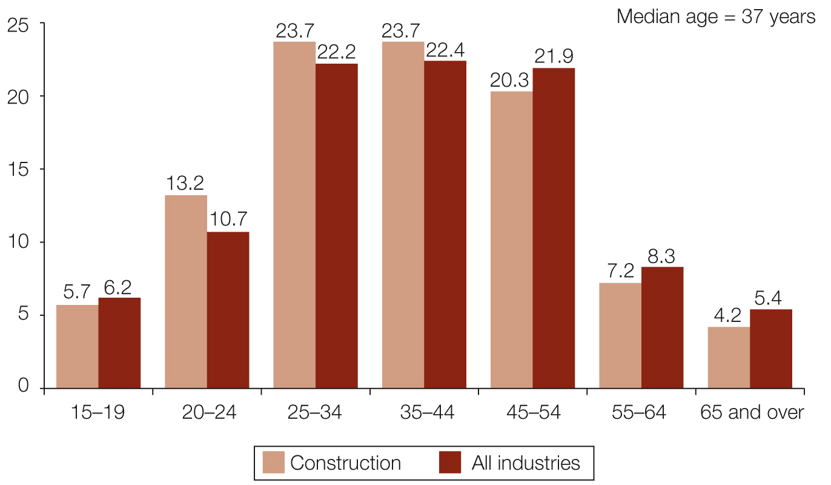
Source: DEEWR trend data based on ABS 2010, Labour force, Australia, cat. no. 6291.0.55.003 (four-quarter annual average), ABS, Canberra.

Over the 10 years to February 2011, employment growth in the industry was highest among those aged 25–34 years (70,500, or 20 per cent of all growth), those aged 45–54 years (65,800 or 19.0 per cent of all growth) and those aged 20–24 years (61,700 or 17.8 per cent of all growth). Figure 3.34 shows employed people by age in the construction industry, for the years ending February 2001, 2006 and 2011.
Figure 3.34 Employed people by age (’000) – construction industry, years to February 2001, 2006 and 2011
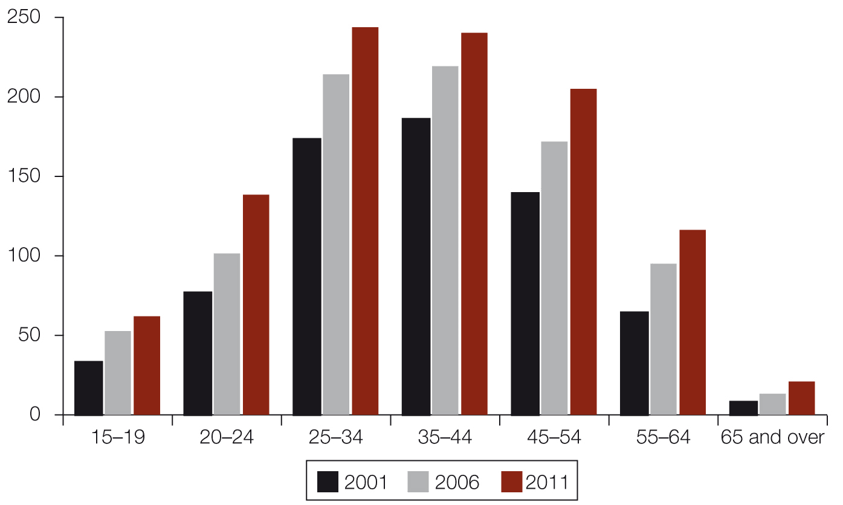
Source: DEEWR trend data based on ABS, Labour force, Australia February 2001, 2006 and 2011, cat no: 6291.0.55.003, ABS, Canberra.

Construction industry qualifications
The majority of those employed in the construction industry and working in residential housing have a non-school qualification, most commonly a trade-related Certificate III or IV qualification. In May 2010 almost three-quarters (72.5 per cent) of those employed in building installation services had a non-school qualification, with 59.4 per cent having a Certificate III or IV. Approximately two-thirds (67.6 per cent) of those employed in residential building construction had a non-school qualification, with 41.3 per cent having a Certificate III or IV, while 59.0 per cent of those employed in building completion services had a non-school qualification, 46.1 per cent having a Certificate III or IV.
Skills in the construction industry
The supply of labour is an important determinant of the supply of housing and its cost. In 2010, skills shortages were reported as being patchy and employers experienced less difficulty recruiting than they had in 2007 and 2008. There were shortages reported for some occupations; however, subdued construction activity in some jurisdictions meant that there was capacity in some of those occupations key to the industry.
Recent research conducted by Department of Education, Employment, and Workplace Relations showed that 10 of the 17 trade occupations assessed were either in shortage or subject to recruitment difficulty. There were also shortages in occupations such as construction project managers, civil engineers and surveyors.
Since 2002 there has been strong growth in the numbers of students completing apprenticeships in the construction trades. In 2009, 11,500 students completed a construction trade apprenticeship, more than double the number in 2002 (5,900) and an increase of 48 per cent on 2006 (8,300). However, a sharp drop in the number of apprenticeship commencements in construction trades in 2009 (down 22.1 per cent) may be reflected in a lower supply of final-year apprentices and newly qualified trades workers in this field in 2012–13.
In addition to existing shortages in the building trades, increasing standards of energy efficiency in housing will affect skills requirements for building new dwellings and retrofitting existing dwellings.
Barriers to infill and medium-density construction
The 2010 State of Supply Report presented information on the barriers to achieving greater density within existing urban boundaries through infill development. Recent research on housing preferences has examined some of these barriers as they relate specifically to the housing markets in Sydney and Melbourne.
The research found that there was a mismatch between the type of housing that is being supplied and the desired mix of dwelling types indicated by a survey of people’s preferences taking account of their ability to pay. More specifically, the research indicated unmet demand for semi-detached houses and apartments in Sydney and Melbourne. The vast majority of new dwelling supply in Sydney in recent years has been infill development in established areas, albeit construction volumes have contracted sharply since 2005. In Melbourne, greenfield development has predominated for a variety of reasons relating to land supply, financing, planning and development approval arrangements.
A range of barriers to developing medium- and high-density infill development were highlighted in the 2010 report. Some of these related to finance. Cash-flow problems in financing apartment development were cited. The researchers reported that small developers were experiencing greater difficulties than they had in the past in accessing finance. Large developers reported difficulties with aggregating land into commercially viable plots.
The research also found that planning delays, and the uncertainty and costs that they cause, are a significant disincentive to embarking on medium-density housing projects, particularly for small-scale medium-density development in established areas of Melbourne. Community concern about medium-density housing development in these areas was often reflected in appeals to planning bodies.
The authors of the research observed that construction costs for apartment blocks of more than four storeys are much higher than those for other types of dwellings, due mainly to the combination of more expensive material and labour costs. Apartment blocks of more than four storeys are classified as commercial projects, for which the workforce largely comprises waged employees with high rates of union membership, who attract a higher commercial wage that the predominantly independent contractors working on detached housing projects.
Recent research commissioned by the Queensland Government examined barriers to financing infill property developments in Queensland. This research found that since the GFC, conditions for access to finance had changed: there were greater equity requirements and higher presale requirements, which meant lower lending volumes by financial institutions. Macro finance barriers to development were also cited, because credit allocated to the property sector continued to be constrained even after easing of the effects of the GFC.
The Queensland Government report also cited lengthy and sometimes uncertain planning and development approval processes as a barrier to infill development, with some developers citing as a particular problem the time and cost of obtaining development approval for projects that are impact assessable. Other barriers, similar to those reported by the Grattan Institute research for Sydney and Melbourne, were also reported as issues for infill development in Queensland. These included difficulties in aggregating land and preparing land for construction, community perceptions of infill development, and higher construction costs for infill compared to greenfield development.

Box 3.3 Costs of infill and greenfield development
The Department of Sustainability, Environment, Water, Population and Communities commissioned property consulting firm Urbis Pty Ltd to update the study reported in the 2010 State of Supply Report looking into the cost of developing new infill and greenfield housing in Sydney, Melbourne, Brisbane, Adelaide and Perth.
While caution is needed due to the small sample of developments on which their conclusions were based, Urbis drew the following main conclusions for homes built on infill land in 2010.
- The cost of development was greatest in Sydney, due to higher land costs and taxes and charges.
- Construction costs were highest in Melbourne and Perth.
- Land costs for infill developments were lowest in Melbourne.
- Government taxes and charges accounted for 14–16 per cent of the total cost across the five cities, being highest, both as a share and in absolute terms, in Sydney.
- Estimated profit, based on comparing total estimated costs and median selling price, showed the largest returns for developers in Melbourne and Brisbane.
For greenfield development the main findings were as follows.
- Land was significantly more expensive in Sydney, and made up a larger share of costs than elsewhere.
- Taxes and charges made up 17–18 per cent of costs in all cities except Sydney, where they totalled 22 per cent.
- As with infill, construction costs were highest in Melbourne, although the difference was relatively small between all cities.
- Developer returns were highest in Perth.
More generally, infill development was found to be more expensive than greenfield development across all cities, but particularly in Brisbane and Perth.
The report is available on the Council’s website (www.nhsc.org.au/supply.html). It was commissioned before the current Council was appointed, so the current Council was not involved in its scoping or methodology. Council members are concerned that the small sample may lead to conclusions that do not necessarily represent accurately the development experience in each city.

Concentration of activity in the residential development and construction industry
The development industry is often characterised as one in which a small number of large nationwide companies have a high profile and significant market share, but in fact many smaller firms operate and together account for a large share of activity. The Council has obtained survey data from property consulting and valuation firm Charter Keck Cramer which, among other things, tracks plot sales across the nation’s largest cities. These data confirm the characterisation.
The data were gathered through a survey that has run since 2008 and shows both the level of concentration of business among developers and how that has changed over time, nationally and within the major cities. As Figure 3.35 illustrates, the plot sales data show a market that is not especially concentrated. Across the largest Australian cities as a whole, the largest 10 developers accounted for 47 per cent of plot sales in 2010–11. This share had fallen a little from 50 per cent in 2008–09. Unsurprisingly, industry concentration was somewhat higher within each specific city, as many of the larger firms focus their efforts in particular states. But the phenomenon of the top 10 developers experiencing smaller market share in 2010–11 than in 2008–09 held for each city except Canberra, where the top 10 accounted for all sales in both periods.
Figure 3.35 Top 10 developers’ share of plot sales
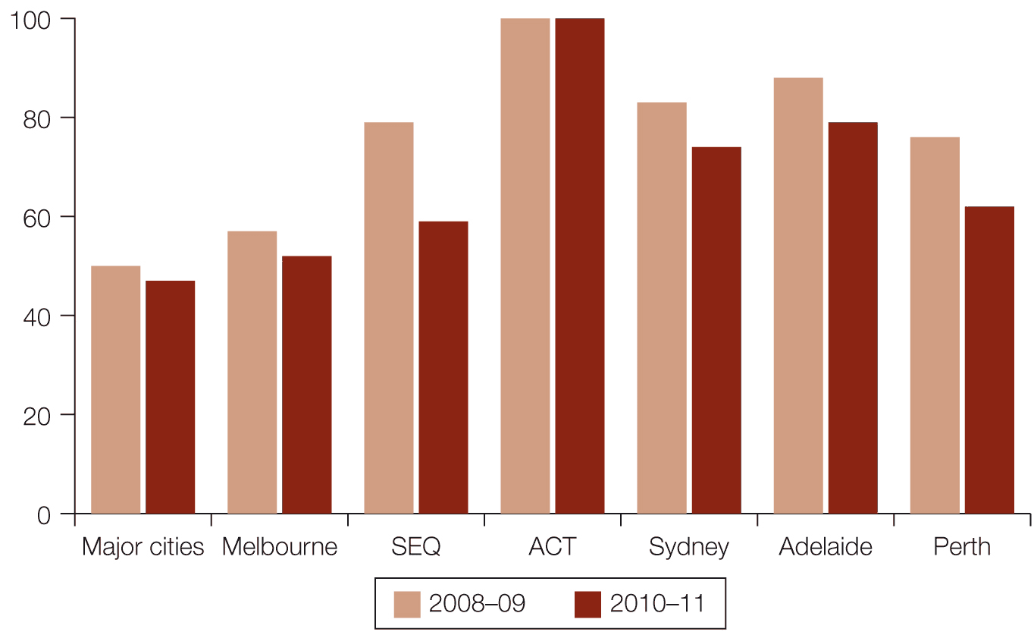
Source: Charter Keck Cramer.
Notes: Data are based on analysis of plot sales. City totals do not sum to major capital cities, because each city has its own set of top 10 developers and not all top 10 developers are represented in each city.

As these data relate to plot sales, they account for the developer side of the house building business, with a particular focus on greenfield development. The Housing Industry Association (HIA) collates data on the market share of Australia’s 100 largest homebuilders. These data also show relatively little concentration in the home construction side of the industry. In 2008–09 the largest 100 builders accounted for 38 per cent of housing starts across the country, compared to 36 per cent in 2009–10. The share fell further to 33 per cent in 2010–11.
Conclusions and future work
The Council’s projections indicate that housing supply will continue to fall short of demand. The consequences and magnitude of this are explored in Chapter 4.
The Council has slightly modified its medium-supply projections to reflect the effect of conversions on housing supply. However, this has had a minimal positive impact on estimated and projected supply. These supply projections are significantly lower than projected growth in the number of households.
The medium-supply projections require a return to more typical construction levels than the current low. In the short term it is unlikely that output will increase to this extent. Both the pipeline data provided by the states and territories and the Council’s analysis of building approvals data point to low levels of dwelling construction in the short term. To improve its short-term projections of net growth in housing supply, the Council will further explore attrition rates and lags between building approvals, commencements and completions, as well as seeking better data on demolitions and other sources of stock loss. The latter would also help to improve the longer-run projections.
Although the volume of supply continues to fall short of demand, the Council is encouraged by many firms’ innovative responses to the challenges of meeting changing preferences and the needs of those on the margins of affordability. Council members observe that the residential development and construction sectors have together built more affordable homes on smaller plots (hence reducing land costs) and increased the mix of types and styles of housing in greenfield and mid-suburban locations. The industry has also built more apartments, and increased the supply of smaller apartments that are more affordable to a wider range of buyers and renters. Some of these innovations have occurred in conjunction with not-for-profit housing associations and been supported by government interventions such as the Social Housing Initiative, the National Rental Affordability Scheme and the Housing Affordability Fund.
While the extent of change varies across firms and locations, these trends are likely to continue and accelerate under anticipated market circumstances and in the light of state and territory governments’ plans for more infill development.
On the other hand, the abovementioned government interventions are time limited and have funding caps. Further substantial investment or reform is required for continuing improvements in the supply of affordable housing for lower-income households. The not-for-profit sector is focused on maintaining a program of capital funding and stock transfers to increase the supply of affordable housing. Private-sector developers and builders are also predictably focused on land supply, and on the taxes and charges that find their way into dwelling prices, as significant constraints on the volume and price of new housing.
A further caveat relates to the cost of higher-density development. As industry innovates and produces homes at greater density to tackle changing housing preferences, constraints on greenfield land supply and housing affordability problems, delivery becomes more expensive and complex. The Council has observed the challenges of securing land and development approval for suburban infill projects as well as the higher material and labour costs associated with multi-storey residential developments. Innovations in prefabrication show promise in reducing the period of construction and per-square-metre cost of apartments, but they are at an early stage.
Multi-residence infill developments are also more capital intensive to build because they take longer and there are no progress payments from contracted buyers for most high- and medium-density projects. Many developers are required to achieve higher pre-sales and provide more equity than they were before the GFC. In addition, Council members observe that most new-build buyers into multi-dwelling infill projects are second- or third-time buyers (for owner-occupancy or rental investment) rather than first-home buyers, who often prefer to see the product built before committing to purchase. These factors mean that more funding needs to be invested during the early and mid stages of planning and construction, which increases risk and overall costs.
While higher rates of infill development are widely, but not universally, supported for environmental and liveability reasons, it will be difficult to achieve the required volumes without interventions related to planning and development approval processes and hard to avoid the increased unit cost of higher-density development.
In short, the Council observes that lifting the rate of housing construction and improving affordability represent considerable ongoing challenges for the industry and for all levels of government. Recent innovations in policy and product have shown promise and made progress, but major hurdles remain to lifting housing supply, especially in the challenging market segments of first-home buyers and others on low to moderate incomes.

Chapter 4 Demand–supply balance
This chapter assesses the balance between housing supply and underlying demand in 2009–10, and how the gap between the two may change over time.
Key points
- The gap between underlying demand and housing supply in Australia is estimated to have increased by approximately 28,200 dwellings in the year to June 2010, to a cumulative shortfall of 186,800 dwellings since 2001.
- The housing shortage estimated in this chapter pertains to underlying rather than effective (market) demand. Income constraints and a range of other factors mean that effective demand differs from underlying demand.
- The inclusion of conversions as additions to housing supply has reduced the estimated level of the gap from 2002 onwards in this report compared with previous projections.
- The Council’s revised estimates for 2009 are a shortfall of 80,500 dwellings over the year to end-June 2009, and a revised cumulative gap of 158,500 since 2001.
- The Council has also updated its longer-term projections of the gap, noting that they are not predictions, but simply indications of what would happen if certain trends continue. They are highly sensitive to the assumptions used, and are unlikely to be realised in the longer run because an enduring and substantial gap would likely stimulate responses in demand (lower net migration, slower household formation), supply (higher production in manifestly undersupplied markets) or government policy (such as a supply stimulating program).
- By 2015, applying the Council’s medium scenarios for demand and supply, the cumulative demand–supply gap from 2001 is projected to grow by a further 142,000 dwellings to 328,800 dwellings by 2015.
- By 2030, the same projection assumptions produce a cumulative gap of 640,200 dwellings.
- There are several short- to medium-term issues that could affect the balance between supply and demand in ways that have not been taken into account by these simple projections. Changes in household size and the nature of migration may alter the proportionate impact of population growth on the level of underlying demand.
- Changes in the production of housing (whether in relation to policy settings, product innovation or productivity) may affect the housing industry’s ability to meet the challenge of rising underlying demand generally or in some submarkets.
Overview of the demand–supply balance
As indicated in Chapter 2, underlying demand is driven by long-term demographic trends. It differs from effective (or actual) demand, which is influenced by factors such as changes in the level and distribution of household income, interest rates, credit conditions, employment trends and confidence, as well as demography. In the short term there are many factors that might limit an increase in population from feeding through into an increase in effective housing demand.
While the gap between estimated underlying demand and supply is an indicator of housing shortage or surplus, neither is necessarily a mark of market failure or policy failure. On the face of it, a long cycle between periods of demand–supply equilibrium would indicate inefficiency in the market’s response to changes in population and an ineffective response by governments to the same challenges. An enduring gap between underlying demand and supply would indicate market failure or the failure of policy settings in one or more submarkets. However, it is important to understand the composition, causes, likely duration and impact of the gap, and to consider whether a palatable market response is likely to redress aspects of concern, or whether action is needed in response to failures of the market, policy design or policy implementation.
Methodology
This report replicates the method used in the 2010 report to estimate the extent of any ‘oversupply’ or ‘undersupply’ of housing relative to underlying demand. It identifies changes in the supply of and underlying demand for housing from June 2001. Nationally, the housing market was fairly close to ‘equilibrium’ at this time – that is, demand and supply were close to being in balance, with housing prices moving in line with economic fundamentals. The Council has been attracted to such an equilibrium-based measure but has also been cognisant of the conceptual and practical challenges associated with it, specifically:
- the existence of geographically separate housing markets across Australia, including regional variations and markets serving recent migrants, in which equilibrium-like market conditions have been observed at different times from one another
- the existence of submarkets across tenures, house types, price strata and income strata, each likely to have different variations in relevant market dynamics
- lead and lag relationships, substitution effects and ‘spillovers’ between submarkets leading to diverse points of equilibrium, and the possibility that equilibrium in one submarket could be causally associated with disequilibrium in another
- lack of availability of reliable data to support the development and quantification of a set of equilibrium-based measures of the demand–supply balance across the full variety of submarkets
- the complexity – even with comprehensive and reliable data – of constructing and interpreting an aggregate measure for the Australian housing system as a whole.
The Council selected 2001 as the base year from which to cumulate measures of supply and underlying demand because a Census of Population and Housing was conducted in that year, providing comprehensive baseline data, and because 2001 was sufficiently long ago to allow normal market cycles to have since corrected any imbalances existing at that at time. Analysis by Australia and New Zealand Banking Group (ANZ) Property Research indicates that the Australian housing market was indeed close to balance between supply and demand in 2001 and that most of the states and territories were also close to balance, particularly relative to the extent of imbalance in 2010. The ANZ estimates indicate that New South Wales and Western Australia each had a small housing surplus in 2001 of about 10,000 and 3,000 dwellings, respectively, and that Queensland and South Australia each had a deficit of about 15,000 and 4,000 dwellings, respectively.
The methodology employed by the Council for this and the 2010 report generated estimates consistent with those in the 2008 report, which were calculated from an unmet needs methodology that can be updated only with new Census data.
The Council’s replication of last year’s approach in this report uses Australian Bureau of Statistics (ABS) household projections (Series II, the central projections) for the period 2001 to 2010, adjusted as follows.
- For 2001 to 2006, revised estimated resident population (ERP) for these years divided by the ABS assumed household size in each of the years for the central scenario underlying the household projections.
- For 2007, ERP divided by average assumed household size in 2006 taken from the ABS household and family projections 2001 to 2026 estimates of people per household (ABS 3236.0, 2004).
- For 2008, ERP divided by estimates of people per household based on the Council’s medium household projections provided by McDonald and Temple in their model (see Chapter 2).
- For 2009 and 2010, the number of households comprises the Council’s medium household projections as provided McDonald and Temple.
The differences between the household projections in the 2010 report and those in this report arise from the latter’s incorporation of the updated higher base ERP figure for 2009 and inclusion of the 2010 estimate of ERP.
The supply estimates have also been updated, as described in Chapter 3, to take into account losses to housing stock due to demolitions and additions from conversions since 2001. The result is a slightly higher rate of net supply (due to conversions) than in the 2008 and 2010 reports.
The 2011 report provides the following projections of estimated demand-supply gap.
1 2010 gap size = 2009 gap size + increase in underlying demand – net increase in dwelling supply (gross completions and conversions less estimated demolitions, as explained in Chapter 3) further discounted by 5.9 per cent to account for estimated unavailable unoccupied dwellings
2 Gap at a point in time over the period 2011 to 2030 = 2010 gap + projected growth in households from 2010 – projected net increase in housing stock from 2011 discounted as above to account for estimated unavailable unoccupied dwellings
Adjustment for unavailable unoccupied stock
At any given time, a proportion of total housing stock is vacant. Some of the vacant dwellings are holiday homes or ‘second dwellings’ and therefore unavailable for occupancy by a new household, some are undergoing demolition or renovation, and some are on the market and are available for occupancy. When assessing the adequacy of additions to housing stock relative to increases in the number of households, it is important to discount the stock additions to account for the number of vacant dwellings unavailable for occupancy by new household.
The proportion of Australia’s dwelling stock that was unoccupied at the 1996, 2001 and 2006 Censuses was on average 9.5 per cent of the total stock, of which around 3.6 percentage points are estimated (on the basis of information from earlier Censuses) to have related to vacancies that were available for occupancy. The Council has used the remainder (5.9 per cent nationally, but calculated separately for each state and territory) as the discount factor applied to net additions to stock. The Council emphasises that this discount factor is based on historic Census data, and may not provide an accurate contemporary estimate of the proportion of unavailable unoccupied dwellings. Equally, however, it is important that allowance is made for the fact that not every addition to stock houses a new household or releases another home for a new household.
Table 4.1 shows a breakdown of unoccupied housing stock by state and territory.
Estimates by state and territory of net additional supply available to meet underlying demand have been discounted by the respective vacancy rate in each state or territory.
Table 4.1 Adjustment for unoccupied dwellings where the reason unoccupied was not ‘usual resident absent’ (percentages), 2006
 | NSW | Vic | Qld | SA | WA | Tas | NT | ACT | Australia
Unoccupied  (% of all dwellings) | 9.1 | 10.0 | 9.0 | 9.9 | 10.2 | 12.9 | 8.4 | 6.3 | 9.5
Resident absent  (% of unoccupied dwellings) | 38.4 | 37.0 | 38.1 | 35.1 | 48.2 | 30.1 | 36.7 | 53.6 | 38.4
Unoccupied (adjusted)  (% of all dwellings) | 5.6 | 6.3 | 5.6 | 6.4 | 5.3 | 9.0 | 5.3 | 2.9 | 5.9
Occupied (adjusted)  (% of all dwellings) | 94.4 | 93.7 | 94.4 | 93.6 | 94.7 | 91.0 | 94.7 | 97.1 | 94.1
Sources: Derived from ABS 2007, 2006 Census tables, ‘Dwelling structure by occupied/unoccupied dwellings’, 1996, 2001, 2006, cat. no. 2068.0, ABS, Canberra; — 1979, 1976 Census, ‘Table 61: Unoccupied private dwellings by reason unoccupied (section of state)’, cat. no. 2104.0, ABS, Canberra; and — 1988, 1986 Census, ‘Table C80: Reason private dwelling unoccupied by section of state: unoccupied private dwellings’, cat. no. 2102.0, ABS, Canberra.
Results
The approach used in this report to estimating the gap between underlying demand and supply produces a revised estimated cumulative shortfall of 158,500 dwellings from June 2001 to June 2009, which more than doubled (worsened by 80,500 dwellings) during the 2008–09 financial year. These estimates compare with those published in the 2010 report of 178,400 and 78,800, respectively.
In 2009–10 the shortfall worsened by a comparatively modest 28,200 in the year to June 2010, increasing the cumulative gap to 186,800.
The inclusion of conversions is the reason for the slightly reduced Council estimates of the gap from 2002 onwards compared to the Council’s previous estimates.

Table 4.2 Estimates of the net dwelling supply gap, Australia, 2001–2010
Year | Change in underlying demand | Supply growth, net of demolitions, with allowance for unoccupied dwellings excluding ‘resident absent’ | Cumulative net dwelling supply gap 2001–2010, based on the difference between change in underlying demand and supply adjusted for demolitions and unoccupied dwellings
 | (’000 households) | (’000 dwellings) | (’000 dwellings)
2002 | 138.1 | 117.7 | 20.4
2003 | 139.7 | 135.5 | 24.6
2004 | 138.3 | 139.6 | 23.2
2005 | 137.1 | 142.5 | 17.9
2006 | 137.4 | 137.4 | 17.9
2007 | 162.1 | 131.7 | 48.3
2008 | 157.4 | 127.6 | 78.0
2009 | 210.6 | 130.1 | 158.5
2010 | 159.2 | 131.0 | 186.8
Source: National Housing Supply Council estimates of underlying demand for dwellings since June 2001.

Table 4.3 shows the increase in the gap for 2010 based on the increase in underlying demand and adjusted net supply in 2010, based on the state- and territory-specific demolition rates and unoccupied dwelling rates shown in Table 4.2. The term ‘adjusted net supply’ refers to the Council’s estimates of dwelling completions net of demolitions and adjusted for unoccupied dwellings.
Table 4.3 Estimated additional underlying demand and adjusted net supply, July 2009 to June 2010
 | NSW | Vic | Qld | SA | WA | Tas | NT | ACT | Australia
 | (’000 households)
Underlying demand | 40.2 | 38.1 | 42.9 | 7.6 | 23.3 | 2.5 | 1.9 | 2.6 | 159.2
 | (’000 dwellings)
Adjusted net supply growth | 23.2 | 40.3 | 32.5 | 9.4 | 18.9 | 2.4 | 1.1 | 3.1 | 131.0
Increase in gap in year to  June 2010 | 17.0 | –2.2 | 10.4 | –1.8 | 4.5 | 0.2 | 0.8 | –0.6 | 28.2

Source: National Housing Supply Council estimates of underlying demand for dwellings.
This growth in the gap is then added to the gap for 2009. The effect of the growth in the gap for 2010 on the existing gap is shown in Table 4.4.
Table 4.4 Estimated dwelling gap since June 2001 (number of dwellings), Australia, June 2010
Estimated gap as at June 2009, revised(a) |  |  |  |  |  |  | 158,500
Growth in estimated gap between June 2009 and June 2010
plus | Increase in underlying demand in year to June 2010 |  |  |  |  | + 159,200
minus | Increase in adjusted net supply(b) in year to June 2010 |  |  |  |  | – 131,000
equals |  |  |  |  |  | = 28,200 | + 28,200
Estimated gap as at June 2010 |  |  |  |  |  |  | 186,800

Source: National Housing Supply Council estimates.
Notes: (a) The gap estimate of 178,400 for June 2009 in the 2010 report has been revised (to reflect an updated methodology) to 158,500.
(b) Adjusted net supply is gross additional supply less estimated demolitions, with resulting net production discounted by 5.9 per cent to account for dwellings unavailable to meet underlying demand.
The distribution of the gap across states and territories as at June 2010 is presented in Table 4.5. The national gap is the sum of state and territory gaps.
Table 4.5 Estimated dwelling gap since June 2001 (’000 dwellings, rounded to nearest hundred), June 2010
 | NSW | Vic | Qld | SA | WA | Tas | NT | ACT | Australia
2010 | 73.7 | 17.6 | 61.9 | –4.5 | 28.0 | 0.4 | 10.3 | –0.6 | 186.8

Source: National Housing Supply Council estimates of underlying demand.
The method used by the Council indicates that New South Wales and Queensland have the largest absolute housing shortfalls (73,700 and 61,900 dwellings, respectively). However, relative to population size, the Northern Territory and Western Australia also face significant shortfalls. According to Table 4.5 there is a small surplus of housing in both South Australia and the Australian Capital Territory (4,500 and 600 dwellings, respectively).
However, it is important to note that these cumulative estimates do not include the extent to which underlying demand and supply were out of balance in June 2001. If, for instance, South Australia had a shortfall of 4,000 dwellings in 2001, as suggested by the aforementioned ANZ Property Research estimates, the cumulative surplus of 4,500 since 2001 identified in Table 4.5 would translate into a cumulative surplus of just 500 dwellings since the last point of equilibrium between underlying demand and supply.
Future changes in the demand–supply gap
Projecting the future balance between housing demand and supply is complex. In a well-functioning housing market, the emergence of a significant shortfall in supply would be expected to stimulate an increase in supply or a fall in effective demand (thus closing the gap). This dynamic aspect of the market should be borne in mind when interpreting the following projections.
The following projections of the demand–supply gap are derived simply by subtracting the net supply projections (presented in Chapter 3) from the demand projections (presented in Chapter 2), taking into account the estimated cumulative gap since 2001 of 186,800 as at June 2010, and adding an adjustment for unoccupied stock. The ‘central’ estimate of the gap presented below compares the medium-growth projection of demand with the medium-growth projections for supply (that is, the average new dwelling production trend since 1980, adjusted for demolitions).
The value of these projections is simply their capacity to show how the gap between supply and demand would develop in a situation of ‘all other things being equal’. This provides a potential springboard for change on the part of market participants, housing providers and government policy and programs.
Medium demand and medium supply
Table 4.6 shows how, under the medium-supply trend and medium-demand trend scenarios, the estimated gap of 186,800 in 2010 is projected to change over the next 20 years. Over the two years to 2012, the gap is projected to grow by an estimated 56,900 to 243,700 dwellings. This is the result of a projected 269,900 net new dwellings (adjusted for vacancies and conversions) over the period while projected underlying demand increases by 326,800 households.
By 2015 the gap is projected to increase to 328,800 dwellings, by 2020 to 456,400 dwellings and by 2030 to 640,200 dwellings.
Table 4.6 Growth in gap between underlying demand and adjusted net supply (number of dwellings), including cumulative impact
Additional annual underlying
demand and supply
Year ending  30 June | Medium household growth | Adjusted net medium supply growth(a) | Annual growth in gap between underlying demand and adjusted net supply | Cumulative gap
2010 | – | – | – | 186,800
2011 | 162,600 | 134,600 | 27,900 | 214,700
2012 | 164,200 | 135,300 | 29,000 | 243,700
2013 | 165,100 | 135,900 | 29,100 | 272,800
2014 | 164,800 | 136,500 | 28,300 | 301,100
2015 | 164,800 | 137,100 | 27,700 | 328,800
2020 | 163,500 | 140,300 | 23,300 | 456,400
2025 | 162,200 | 142,100 | 20,100 | 556,900
2030 | 161,900 | 145,300 | 16,700 | 640,200
Source: National Housing Supply Council projections based on McDonald and Temple medium household growth scenario; National Housing Supply Council projections based on trends in dwelling completions. For full details see Appendices 2, 3 and 4.
Note: (a) Adjusted net medium supply growth is additional supply less estimated demolitions, with resulting net production discounted by 5.9 per cent to account for dwellings unavailable to meet underlying demand.
These projections are sensitive to the assumptions used. This is illustrated by Table 4.7, which shows projected underlying demand and dwelling production increases over the five years 2011 to 2015, and the resulting gap, using different combinations of the three underlying demand scenarios and the three dwelling production scenarios.
For example, in a high demand growth–high supply growth scenario, underlying demand is projected to increase over the five-year period by 962,600 additional households and supply is projected to increase by 824,400 dwellings. These increases lead to a projected increase in the shortfall of 138,200 dwellings from June 2010 to June 2015. By contrast, in a low demand growth–medium supply growth scenario, underlying demand is projected to increase by 700,500 while supply is projected to increase by 679,500, with a projected increase of 21,000 in the shortage of dwellings.
Table 4.7 Change in gap between underlying demand and dwelling supply, five years (June 2010 to June 2015), using different projection assumptions
 |  | Supply projection: production of dwellings
Demand projection: underlying demand |  | Low adjusted net production | Medium adjusted net production | High adjusted net production
 |  | Increase over five years (2010 to 2015)
Low household growth | Increase in underlying demand | 700,500 | 700,500 | 700,500
 | Increase in net supply | 557,600 | 679,500 | 824,400
 | Change to gap(a) | 142,900 | 21,000 | –123,900
Medium household growth | Increase in underlying demand | 821,500 | 821,500 | 821,500
 | Increase in net supply | 557,600 | 679,500 | 824,400
 | Change to gap(a) | 263,900 | 142,000 | –2,900
High household growth | Increase in underlying demand | 962,600 | 962,600 | 962,600
 | Increase in net supply | 557,600 | 679,500 | 824,400
 | Change to gap(a) | 405,000 | 283,100 | 138,200
Source: National Housing Supply Council projections based on McDonald and Temple low, medium and high household growth scenarios; National Housing Supply Council projections based on trends in dwelling completions.
Notes: (a) Size of gap is measured as the difference between the increase in underlying demand and the increase in adjusted supply. A negative value indicates oversupply.

The data in Table 4.7 exclude the estimated cumulative gap from 2001 to 2010, meaning that it only shows additions to the shortfall from this point. The effect of including the cumulative gap since 2001 is shown in Table 4.8, which shows the change in the total gap over the five years 2010 to 2015, using different combinations of the three underlying demand scenarios and the three dwelling production scenarios. For example, high projected growth in both underlying demand and net supply would see the cumulative gap grow to 325,000 dwellings over the five-year period. By contrast, in a low demand growth–medium supply growth scenario, the gap would increase to 207,800. Given recent population growth rates, this scenario seems unlikely.

Table 4.8 Cumulative gap since 2001 between underlying demand and dwelling supply at June 2015, using different projection assumptions
 | Supply projection: production of dwellings
Demand projection: underlying demand | Low adjusted net production | Medium adjusted net production | High adjusted net production
Low household growth | 329,700 | 207,800 | 62,900
Medium household growth | 450,700 | 328,800 | 183,900
High household growth | 591,800 | 469,900 | 325,000
Source: National Housing Supply Council projections based on McDonald and Temple low, medium and high household growth scenarios; National Housing Supply Council projections based on trends in dwelling completions; National Housing Supply Council estimate of initial gap between underlying demand and supply.

Tables 4.9 and 4.10 present the same approach as that used in Tables 4.7 and 4.8, but for the 20-year projection period (2010 –2030) rather than the five-year projection period.
Table 4.9 shows, for instance, that the high-growth scenarios for both underlying demand and net supply would result in an increase in the gap of 463,700 dwellings. By contrast, in a low demand growth–medium supply growth scenario, a narrowing of the gap by 69,500 dwellings is projected.
Table 4.9 Change in gap between underlying demand and dwelling supply (adjusted), 20 years (June 2010 to June 2030), using different projection assumptions
Demand projection: underlying demand |  | Supply projection: production of dwellings
 |  | Low adjusted net production | Medium adjusted net production | High adjusted net production
 |  | Increase over 20 years (2010 to 2030)
Low household growth | Increase in underlying demand | 2,742,000 | 2,742,000 | 2,742,000
 | Increase in net supply | 2,306,900 | 2,811,500 | 3,411,100
 | Change to gap(a) | 435,100 | -69,500 | -669,100
Medium household growth | Increase in underlying demand | 3,264,900 | 3,264,900 | 3,264,900
 | Increase in net supply | 2,306,900 | 2,811,500 | 3,411,100
 | Change to gap(a) | 958,000 | 453,400 | -146,200
High household growth | Increase in underlying demand | 3,874,800 | 3,874,800 | 3,874,800
 | Increase in net supply | 2,306,900 | 2,811,500 | 3,411,100
 | Change to gap(a) | 1,567,900 | 1,063,300 | 463,700
Source: National Housing Supply Council projections based on McDonald and Temple low, medium and high household growth scenarios; National Housing Supply Council projections based on trends in dwelling completions.
Notes: (a) Size of gap is measured as the difference between the increase in underlying demand and the increase in adjusted supply. A negative value indicates oversupply.

The data presented in Table 4.10 include the initial gap in 2010. High growth in underlying demand and adjusted net supply as discussed earlier would see the gap grow from 186,800 dwellings to 650,500 dwellings over the 20-year period to 2030. By contrast, low demand growth and medium supply growth would see the gap of 186,800 decline to 117,300 dwellings.
Table 4.10 Cumulative gap since 2001 between underlying demand and adjusted dwelling supply at June 2030, using different projection assumptions
 | Supply projection: production of dwellings
Demand projection: underlying demand | Low adjusted net production | Medium adjusted net production | High adjusted net production
 | Increase over 20 years (2010 to 2030)
Low household growth | 621,900 | 117,300 | –482,300
Medium household growth | 1,144,800 | 640,200 | 40,600
High household growth | 1,754,700 | 1,250,100 | 650,500

Source: National Housing Supply Council projections based on McDonald and Temple low, medium and high household growth scenarios; National Housing Supply Council projections based on trends in dwelling completions; National Housing Supply Council estimate of initial gap between underlying demand and supply.
Note: A negative value indicates oversupply.
With the different projection assumptions it is worth considering that the high and low scenarios for supply are at the extremes of what has happened in any individual year in recent history. The likelihood of these continuing for a sustained period is extremely low. Accordingly, a daunting conclusion from this analysis is that housing production would have to increase to above its historical annual high to remove the present gap by 2030 for all except the low demand scenario. Unless there were very significant changes in the factors constraining production, the likelihood is that behavioural adjustments in underlying demand will be required if population growth continues even somewhat below its present trajectory. Formation of larger households and reductions in immigration are among the possibilities.
Limitations of the demand–supply gap
There has been very little criticism of the Council’s measurement and application of the demand–supply gap, but the Council readily acknowledges that the measure has limitations. As already noted, the Council’s measure of demand is driven by demographic factors alone and therefore makes no explicit provision for the ways in which housing supply and dwelling prices may influence the level and pattern of demand across submarkets. Moreover, the estimation of underlying demand (estimated resident population divided by projected average household size) makes a virtue of the decline in household size by describing as ‘undersupply’ a scenario in which housing supply does not keep up with, among other things, an assumed reduction in average household size resulting from increases in immigration (permanent and temporary) of single students and workers. Indeed, estimation and projection of the demand–supply gap is highly sensitive to a range of assumptions.
It is important to understand the intended purpose of the measure. The housing gap figures are intended to provide an indication of how the balance between housing demand and housing supply has changed in recent years, along with forecasts of how the gap might change in the future, given various scenarios with respect to demand and supply. They play the role of ‘What if … ?’ questions about the ability of Australia’s housing stock to keep pace with the change in the size and structure of the population. This is why the Council believes that the number should not be interpreted as an absolute estimate of the shortage of dwellings. The methodology also assumes that there was no imbalance in 2001.
Another limitation is that the measure is affected by the accuracy or otherwise of the estimates of demolitions and unoccupied dwellings. The Council has used the best available data to estimate numbers of demolitions and unoccupied dwellings, but there are issues with the quality of these data. Future Council work will focus on improving the estimates of demolitions and unoccupied dwellings.
There has also been criticism of the Council’s approach to estimating the number of households. A full description of the methodology used can be found in Appendix 2. As discussed in Chapter 2, the demand projections are ‘unconstrained’, in that they do not account for how a shortfall in available housing may affect the formation of new households. The underlying demand projections thus reflect the level of future housing demand, if recent trends in household formation continue. As discussed in Chapter 2, other factors will also affect household formation and housing demand, and these in part determine how underlying demand translates into actual, or realised, demand.
Despite these limitations (or because they are shared with similar methodologies), the Council’s approach produces estimates and conclusions that are consistent with other organisations’ assessments of housing supply. The 2010 State of Supply Report estimated a cumulative shortfall to June 2009 of 178,400 dwellings, compared to 158,500 for the same period in this report. The 2010 report noted that ANZ economists calculated a gap of 200,000 dwellings in 2009, Westpac economists assessed the gap at 190,000 dwellings and BIS Shrapnel estimated 160,000. While the Council has estimated the cumulative gap in 2010 to be nearly 187,000 dwellings, the Housing Industry Association has estimated a shortfall of 228,400 dwellings in 2010, and the ANZ’s estimate is about 220,000 dwellings.
Where do people live whose housing needs are not being met?
Housing shortages affect housing prices and both affect consumers, who may react in a variety of ways. One frequently asked question about the housing shortfall is, ‘What happens to those whose housing needs are not being met by the available stock of dwellings?’ The Council has identified a number of possible responses to this question in addition to those noted in Chapter 2 (with respect to people not being included in the household count). They include the following.
- New households may not form at the expected rate. Examples include adult children remaining in the parental home for longer, older people living with their adult children, and bigger group households forming, with possible overcrowding among groups such as students.
- There may be greater use of non-private dwellings, such as boarding houses and supported accommodation.
- There may be greater use of non-permanent dwellings, such as caravans.
- There may be an increase in the number of people who are homeless, which may include ‘sleeping rough’, staying in ‘improvised dwellings’ or ‘couch surfing’.
This is not an exhaustive list. The Council looks forward to further work on the effects of housing shortage on the formation of new households.
Conclusions and future work
Despite recent weakness in the housing market, Australia continues to face a shortfall of available housing relative to the underlying demand for it, and this shortfall looks set to increase in coming years. Higher house prices and rents are not the only indicators of the shortfall. Those at the lower end of the income distribution are likely to be most at risk, and they have relatively little influence on the broader housing market.
The Council has identified a number of ways in which housing shortages and, in particular, shortages of affordable housing are resolved. Many of these will not register in official statistics. Not all will be addressed automatically by an increase in the supply of private dwellings. Data permitting, the Council’s work program envisages more fine-grained analysis to identify the extent, causes, effects and ways of ameliorating housing shortages in submarkets characterised by geographic, demographic, social and economic circumstances.
In the longer run, the impact of housing shortages on access to housing is likely to filter down the distribution of income and wealth. The impact on housing prices may be felt more widely, in households’ capacity to save, consumption and locational choices, vulnerability to unemployment, and a variety of other ways that affect quality of life. In addition, regional issues - such as a spike in demand and house prices occasioned by a mining boom - may have a displacing impact on a wide cross-section of affected communities. This may endure in regional economies that fail to attract a significant supply response because of risks associated with a narrow economic base or volatile resources prices.
The economic impact of housing shortages is also likely to be significant, including through the fiscal challenges arising from increased payments for rent assistance and demands for greater expenditure on social housing, high housing prices distorting capital and investment choices away from other productive avenues, and limited housing choices impacting adversely on labour productivity and mobility.

Chapter 5 Affordability
This chapter examines some of the indicators of housing affordability, looking at what they actually measure and relevant recent developments.
Affordability means different things to different people, depending on their circumstances and perspective. There is no single measure that gives a complete picture. However, a range of methods can shed light on the situation faced by owners, purchasers and renters.
Key points
- The rate of house price growth slowed in 2010, and there have been falls in 2011. However, higher interest rates have until very recently limited the subsequent improvement in affordability on most measures, and income growth has been solid rather than dramatic. Higher interest rates have also had an impact on existing mortgage holders. While the number falling behind on their mortgage payments is at a relatively low level, there are signs that it has started to rise.
- It is not just within the owner-occupier market that households face these pressures: rental increases have outstripped earnings growth in recent years. The rate of rental increases for flats has also outstripped that for houses in the major cities in the past year.
- Across the country, most measures show that households in Sydney face the greatest pressures, followed by those in Melbourne.
- Most affordability measures tend to focus on relatively narrow definitions of housing costs, specifically direct housing outlays. They ignore the wider costs of living, such as electricity and water bills, which are related to the quality, form and location of housing and have increased significantly in recent years.
This chapter does not provide exhaustive coverage of all possible measures. The choice of indicators has been constrained by the availability of current data. Data through to the end of the 2010–11 financial year have been used where possible. Updated data from some valuable sources that were used in the Council’s first and second reports (including the Census and the Survey of Income and Housing) have not yet been processed and made available. The Council will continue to monitor existing sources and look to expand its coverage of affordability measures in future.
Overview of affordability
One of the consequences of housing demand exceeding housing supply is that prices rise relatively quickly, other things being equal. In theory, housing production should also increase in response to excess demand and increased prices, and over time this would be expected to close the supply gap and ease affordability. In practice, the lags are long and high prices can reduce effective demand (especially for second-home buyers and investors), so that housing production can fall rather than increase. The Reserve Bank of Australia (RBA) may also increase interest rates in response to rapidly increasing prices, thus reducing affordability. In a similar way, rents will also respond to an imbalance between demand and supply.
Deteriorating affordability means that some households are required to devote a higher share of their income to housing than would otherwise be the case, effectively limiting their disposable income, their expenditure on other goods and services and their capacity to save.
Affordability is a relative term sometimes conceived of as capacity to enter the housing market as a purchaser and/or ability to sustain tenure choice as an owner or a renter without incurring undue hardship. Several measures focus on the share of households in lower-income brackets that are perceived as being under housing ‘stress’ – usually defined as seeing their housing costs exceed a specified share of their income.
What is particularly important when measuring affordability is to consider the distributional effects across and within submarkets. An average figure for a broad area or group of people provides little insight into who might be under particular stress and how this might change. For example, higher-income households are likely to be able cope with higher housing costs, relative to income, than those on lower incomes. This is why measures that focus on those with low to moderate incomes can be more meaningful than those that don’t make this distinction. However, aggregate measures are useful for describing broad trends.
Affordability can also be measured from a range of other perspectives. In the case of home ownership this might be the cost of maintaining current ownership, the cost of entering ownership for new buyers or the theoretical cost of achieving home ownership for a certain type of property for a potential buyer with defined characteristics (for example, someone on an average income purchasing a median-priced house).
For purchasers, some commonly cited affordability measures are based on the following factors.
- Price-to-income ratio This is probably the most common measure of affordability used for comparisons across time and regions. It usually compares the ratio of the median house price in an area with the median wage or household income. Its main advantage is its relative simplicity. However, it does not take into account the actual cost of purchasing a home with a mortgage (interest rates), or whether the median income and the median house price reflect the ability to pay and aspirations of potential first-home buyers (FHBs). As the share of mortgages supported by multiple incomes has risen over time, price-to-income comparison may not be on a like-for-like basis with previous generations.
- Borrowing constraints These measures typically compare the income needed to finance the size of loan needed to purchase a median-priced house with some standard level of income (such as average household income). They tend to assume that the household has access to a specified, required deposit.
- Deposit constraints These measures look at households’ ability to save for a deposit on a (usually first) home. They typically measure the gap between the borrowing capacity of a household on some standard level of income and the price of a median-priced house, or how many years it would take to save for a certain percentage (of house value) deposit. Both borrowing and deposit constraint measures describe financial constraints faced by purchasers or would-be purchasers at the point of entry into the market.
- Default rates or arrears rates At the more extreme end of the scale, default or arrears rates measure those who were successful in obtaining a loan but who are unable to keep up with the mortgage payments.
After some improvement as interest rates were reduced significantly in the wake of the global financial crisis (GFC), housing affordability for purchasers deteriorated by most accepted definitions over 2010 as a whole. Interest rates were returned to more normal levels as the economy emerged relatively unscathed from the crisis, and house prices rose by more than incomes. The deterioration in affordability slowed towards the end of 2010 and into 2011, partly due to more stable house prices (and declines in some areas) and interest rates being held steady. Some measures have shown small improvements.
For renters, affordability measures are more straightforward. The conventionally used rent-to-income ratio is not subject to the same criticisms as price-to-income ratios, and access is limited primarily by income rather than by capacity to save. However, issues relating to narrow or broad-based definitions of affordability and to the importance of outcomes in specific submarkets are equally important.
The proportion of low-income households paying above a specified proportion of their income in rent is often used as a measure of affordability in the rental market and is particularly relevant at submarket level.
In contrast with affordability of home purchase, the rental sector has experienced a continued deterioration in affordability as private sector rents have continued to rise by more than income. At an aggregate level, the relative rise in rents since 2010 is not as severe as was the case from 2007 to 2009.
This chapter describes broad trends in the key variables (including house prices, interest rates, rents and related housing costs) that affect affordability outcomes, and looks at affordability measures that focus specifically on:
- potential new market entrants (FHBs)
- existing owners/purchasers
- renters.
Most of the major indicators showed a deterioration in affordability from any perspective over 2010 as a whole. As the economy emerged relatively unscathed from the GFC, the RBA began returning interest rates to more ‘normal’ levels. Meanwhile, house prices in most areas rose significantly over the early part of the year before the rate of increase slowed somewhat, with small declines at national level since mid-2010.
Over the past decade, earnings have not kept pace with rising house prices, as is clearly demonstrated in Figure 5.1. From 2001 to 2011, full-time average weekly earnings increased by just under 60 per cent, while house prices rose by 104 per cent. Over the same period, consumer prices rose by 33 per cent, meaning that real house prices rose by more than 60 per cent while real earnings increased by just under 30 per cent. Even over 2010, when house price growth slowed to 6 per cent, this was still more than the 3.9 per cent increase in wages.
Figure 5.1 Dwelling prices and average weekly earnings, Australia, 1994–2011
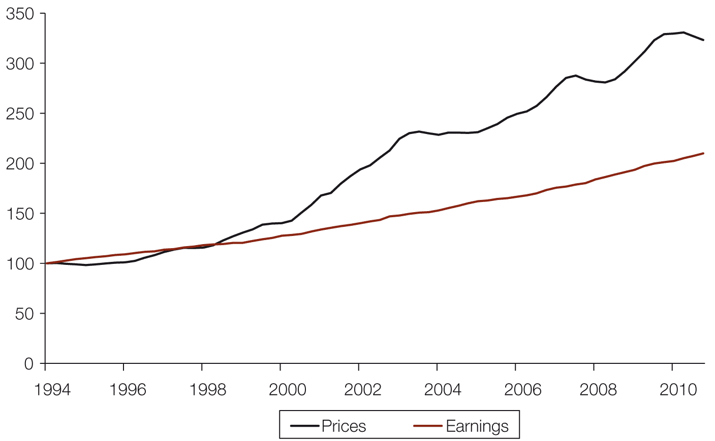
Source: ABS 2011, Average weekly earnings, cat. no. 6302.0, ABS, Canberra; RP Data-Rismark house price data.
Notes: Index: 1994 = 100.
Dwelling prices are for the eight capital cities.
Earnings are the weekly average for all adults. Weekly earnings are full-time ordinary hours’ earnings for all persons.
Data are not adjusted for inflation.

However, it is important to bear in mind that the average weekly earnings data used in these calculations are not a complete measure of broader household income. While clearly there will be a strong correlation, wage and salary earnings cannot account for household income from sources such as benefit payments, changes to tax payments or interest and dividends from investments. However, the average weekly earnings data are the most timely available.
The National Centre for Social and Economic Modelling (NATSEM) drew similar conclusions when comparing post-tax income and prices, estimating a more than doubling of median prices over the past decade, but an after-tax rise in incomes of only around 50 per cent.

Table 5.1 Percentage change in median house prices over past year and past decade
 | Sydney | Melbourne | Brisbane | Adelaide | Perth | Hobart | Darwin | Canberra | Australia
Past year | 0.1 | –1.9 | –6.1 | –2.7 | –4.9 | –3.3 | –0.8 | –0.1 | –1.8
Past decade | 63.7 | 124.0 | 158.3 | 138.0 | 195.1 | 199.9(a) | 251.5 | 161.0 | 104.1

Source: RP Data-Rismark indices, 2011.
Notes: ‘Past year’ refers to the period from the second quarter of 2010 to the second quarter of 2011. ‘Past decade’ refers to the period from the second quarter of 2001 to the second quarter of 2011.
Changes are not adjusted for inflation.
(a) Hobart change for past decade is based on ABS data, as RP-Rismark data are not available for this period.
Short-term changes in prices, especially in individual cities, can be volatile and should be considered in comparison with longer-term trends. Over the 2010–11 financial year, several of Australia’s major cities saw a decline in prices on the ABS measure, although these were typically the cities that had seen the largest increases in the years before this. Over the past decade, all the largest cities have seen prices more than double, with the exception of Sydney, which saw a rise of almost two-thirds.
Figure 5.2 House price index, Australian capital cities (suburbs ranked by price), 2004 to 2011
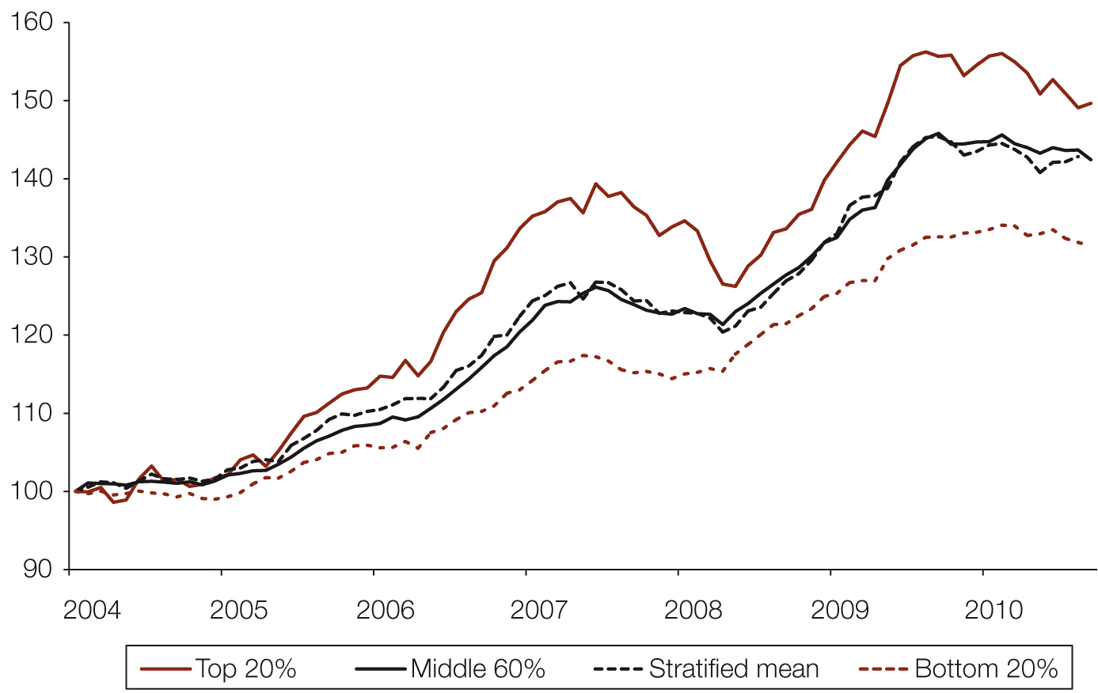
Source: RP Data-Rismark 2011, Stratified hedonic index.
Notes: Stratified data are for the average price in suburbs in each price sector, rebased to September 2004 – the first available data. Data are based on the capital cities.

The stratified indices compiled by RP Data-Rismark show that median prices have risen by just over 40 per cent from September 2004 (the first point at which these data are available) to the middle of 2011. However, prices in those suburbs ranked in the top 20 per cent (by price) saw an increase of just under 50 per cent over the same period, while those in the bottom 20 per cent saw a smaller increase of just over 30 per cent. The distribution of price increases is important, and Figure 5.2 suggests that price rises and recent declines have been more extreme at the top end of the market.
Interest rates
The RBA increased its cash rate as the economy moved onto a stronger footing following the GFC. Some lenders increased mortgage rates more rapidly than this, citing funding costs rising beyond the increase in official rates. Between the start and end of 2010 the cash rate was increased by 100 basis points, while the average standard variable rate rose by 115 basis points.
Interest rate changes have an immediate effect on the cost of servicing a mortgage for the vast majority of Australian mortgage holders with variable-rate home loans. However, there have been some signs of lenders looking to attract borrowers, with modestly discounted mortgage rates since the start of 2011. These rates are typically set below the headline standard variable rate, and a share of new customers, or those refinancing existing loans, would borrow at these lower rates. There is some anecdotal evidence from the industry that this practice has also been driven by a drop-off in demand for mortgage finance.
Fixed-rate loans, which make up only a small share of housing loans in Australia, have not moved significantly since the middle of 2010. Over that year, fixed-rate loans accounted for just 4–5 per cent of all new mortgage commitments, despite expectations of further rate increases.
Figure 5.3 Interest rates, 1990–2011
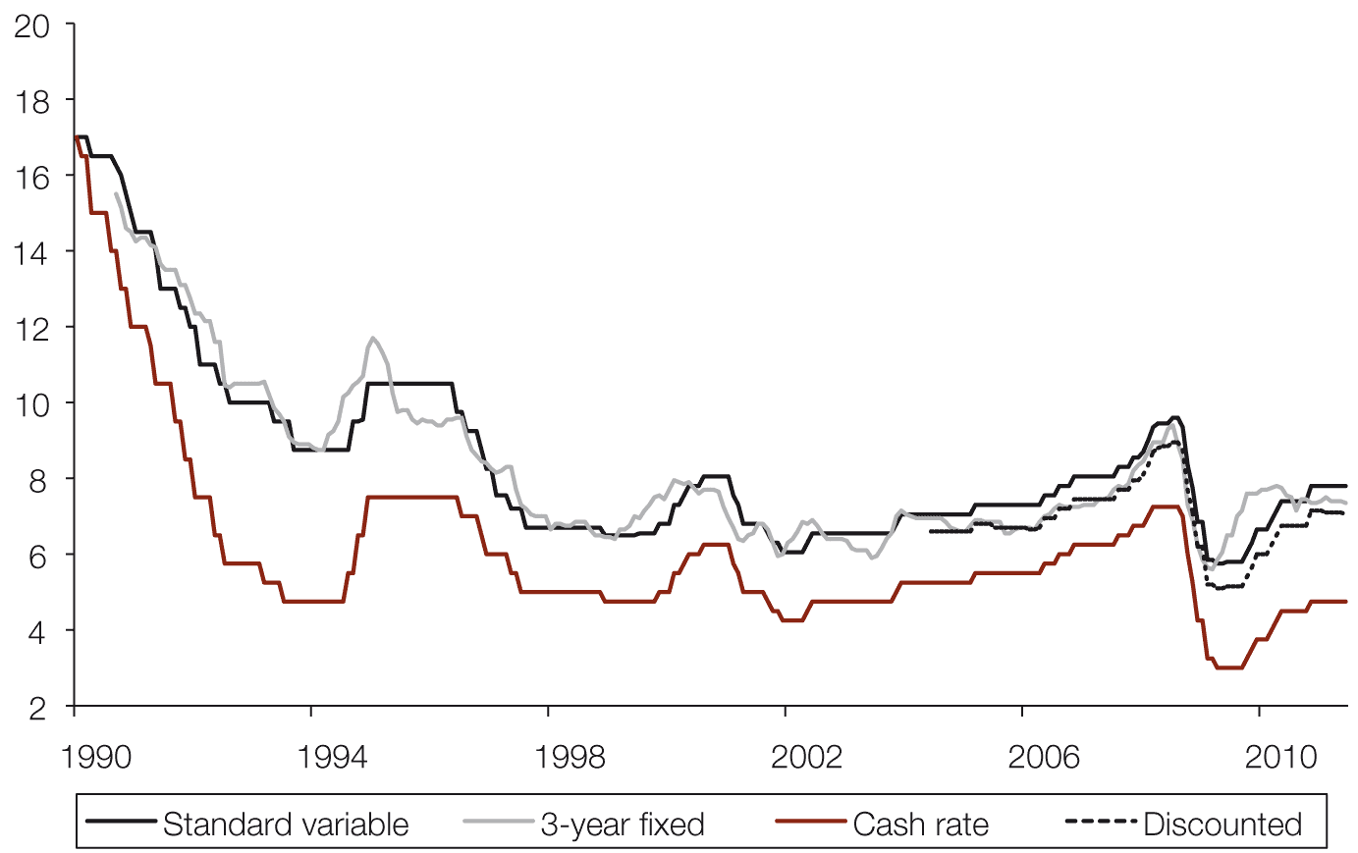
Source: RBA June 2011, Indicator lending rates.
Note: Mortgage rates shown (except cash rate) are for customers of banks.

The current sovereign debt problems in Europe, sentiment regarding the US economy and wider concerns of geopolitical risk all mean that global financial markets remain nervous. While the Australian financial sector is generally acknowledged to be in good health, ‘ripple effects’ may continue to keep funding costs relatively high as the major banks raise a substantial share (albeit a somewhat reduced one since the GFC) of their funds offshore. In addition, some institutions will need to refinance existing credit lines that were originally negotiated prior to the GFC, and could face higher costs as a result. These factors may keep mortgage rates high, relative to the official cash rate, for some time.
Income and other housing costs
Mortgage rates are very important in assessing housing affordability for purchasers. Household income is also a critical factor for both purchasers and renters. Over the longer term, the composition of household income has been important. Current generations are more likely to have dual incomes, due to the higher participation of women in the workforce, and can support proportionately greater housing costs as a result. Their greater capacity to pay, however, can mean that some single- or lower-income households are squeezed down and possibly out of the market. The distribution of income can also have an effect on capacity to pay.
More recently, as Figure 5.4 shows, post-tax income growth per household slowed markedly in 2010, rising by just over 2 per cent from the previous year. Gross income is not always a good indication of what is happening with respect to actual take-home pay. Post-tax income grew significantly faster than gross income in 2009 largely due to the fiscal stimulus, which included cash rebates paid under the household stimulus package. Over the same period, the distribution of income became more unequal, as measured by the ratio of disposable income of households in the top quintile (or decile) to that of those in the bottom quintile (or decile), after adjusting for differences in household size.
Figure 5.4 Annual change in average household income, 2007–2010
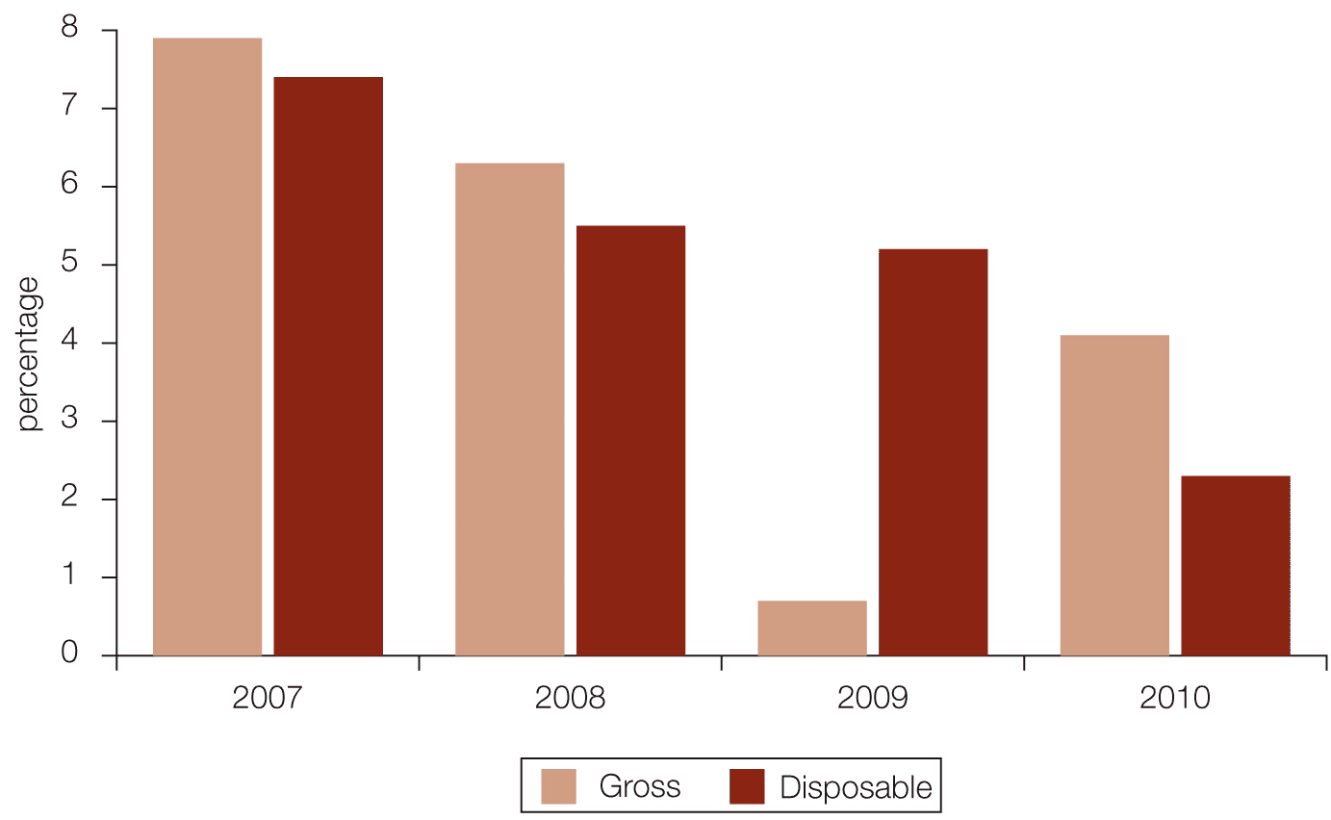
Source: Based on ABS 2011, Australian national accounts, cat. no. 5204.0 and Household and family projections, cat. no. 3236.0, ABS, Canberra.
Note: Gross and net disposable income per household were calculated from income data in the national accounts and ABS Series II household estimates.

It is not just on the income side that household finances need to be considered from a wider perspective. Broader associated housing costs are an important factor in assessing pressure on household budgets. These are the non-discretionary aspects of household spending, and are costs that households have only limited ability to avoid or reduce, as they are an integral part of the wider costs of housing tenures. They are an important part of any wider consideration of housing affordability. The Council intends to look further into broader aspects of housing affordability in the future.
Figure 5.5 Price growth of housing-related expenses (annual change), 1999–2011
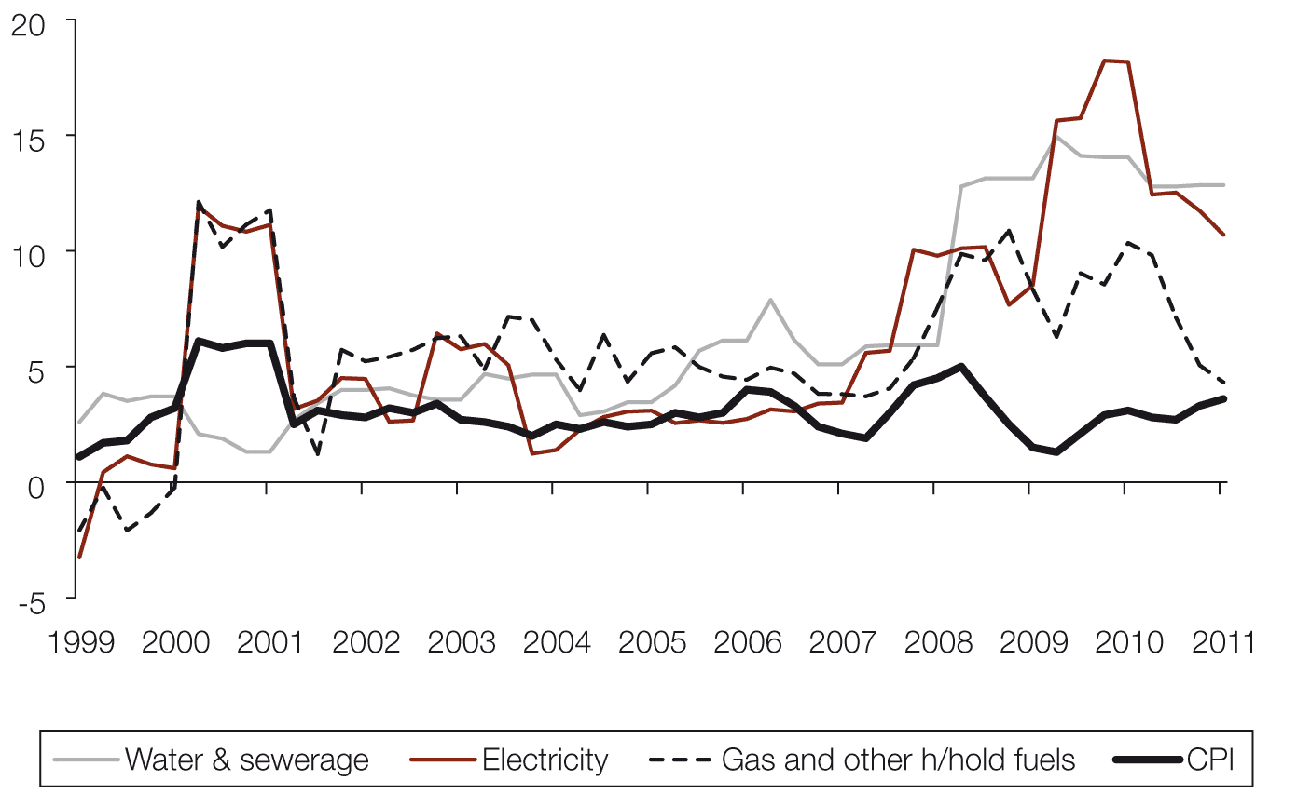
Source: ABS 2011, Consumer price index, Australia, September 2011, cat. no. 6401.0, ABS, Canberra.
Prices of housing-related costs – including both direct costs such as rent and associated costs such as utilities – have risen considerably more quickly than the overall consumer price index (CPI) over the past decade, and particularly over the past few years. As Figure 5.5 shows, utility costs (which include electricity, gas, water, sewerage and so on) have, in some cases, been increasing at more than 10 per cent per year for the past two years. This is a considerably faster increase than the average increase in consumer prices across the country of less than 3.5 per cent per year over the same period.
Issues relating to homes’ energy efficiency and fuel, electricity and gas costs are likely to be an especially significant aspect of affordability for households at the lower end of the income distribution. Energy costs, particularly for transport, are also affected by the location of housing relative to work, education and other services, and have implications for the planning of new housing supply.
Potential market entrants
The RBA has reported that FHBs accounted for approximately 25–30 per cent of all home sales over the past decade. However, there have, at times, been considerable divergences from this average, driven by factors including changes to government-funded purchase incentives such as the First Home Buyers Grant, interest rates, prices and incomes. Prior to the GFC there had also been a steady increase in the share of FHB activity over the past decade. Because FHBs are more likely to require a mortgage to fund their purchase (90 per cent of FHB transactions) than repeat buyers (65 per cent), the increased availability of mortgage credit boosted activity in the FHB segment by more than it did in the wider market.
As was noted in Chapter 1, such government subsidies increased in 2008–09 through the First Home Owners Boost, as part of a range of stimulus measures brought in following the GFC. This increased purchase activity among members of this group, who have typically been aged between 25 and 34 years in the past. The proportion of all house purchases involving a FHB grant rose to its highest on record in mid-2009, at more than 40 per cent. There are a number of possible explanations for the fall in the share of FHBs since the early part of the past decade. These may include affordability constraints, a change in attitude to debt, lifestyle choices, an increase in investor activity in the ‘typical’ first-home market and reduced likelihood of capital gains (particularly more recently).
Since the First Home Owner Boost was withdrawn, FHB activity has fallen away significantly as a share of all activity. Over 2010 and into 2011, FHBs made up only around 16 per cent of all owner-occupier mortgage lending, significantly below levels seen over the past decade.
Figure 5.6 Loans to first-home buyers, 1992–2011
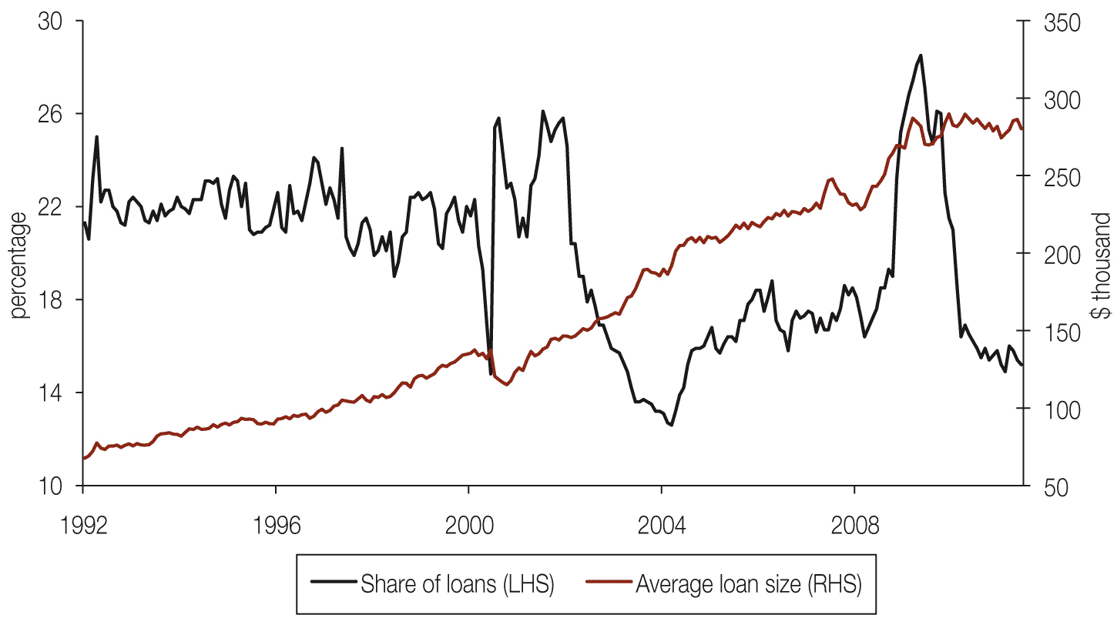
Source: ABS 2011, Housing finance, Australia, cat. no. 5609.0, ABS, Canberra.
Note: The graph shows the share of all owner-occupier mortgage commitments made to first-home buyers and the average value of these loans.
Housing affordability for FHBs is tracked by a number of interested parties, including the Housing Industry Association (HIA), the Commonwealth Bank and Bankwest. A summary of their findings is presented here.
HIA–Commonwealth Bank Affordability Report
The HIA–Commonwealth Bank Affordability Report looks at the accessibility of home ownership to first-home buyers. The index used is the ratio of average income to the income judged necessary to meet the repayments on a typical established dwelling purchased by a first-home buyer. In other words, the index is a comparison of average income and the income required to service a mortgage on a typical (first) property. It looks at affordability from the perspective of an ‘average’ prospective buyer. It does not look at the situation faced by those who actually buy property.
An increase in the ratio represents an improvement in affordability, while a decline represents a deterioration.
Results from the June quarter of 2011 showed a third successive modest increase in the index (that is, housing became more affordable). This improvement has been due to broadly steady house prices and mortgage rates at a time when incomes continue to increase. The index had declined considerably from the March quarter of 2009 to June 2010, as interest rates and house prices rose. Prior to this the index had increased, with interest rates being lowered sharply in wake of the GFC.
As Figure 5.7 shows, affordability is still stretched compared to its longer-term average (represented by the dotted line) over the available data back to the fourth quarter of 1994. According to the index, housing is currently less affordable than it has been over most of the past 20 years. However, it is currently a little more affordable than it was in the immediate lead-up to the GFC, from mid-2006 to late 2008.
Figure 5.7 Housing affordability for first-home buyers, 1994–2011
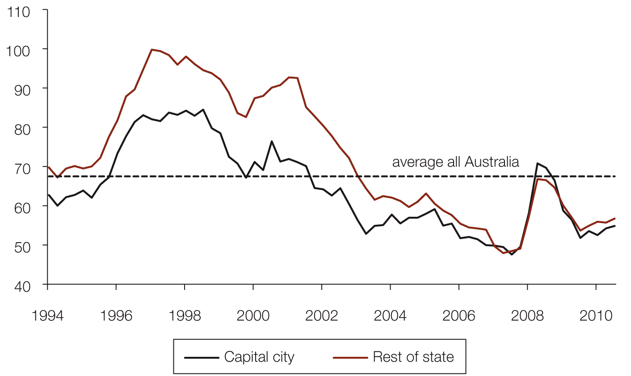
Source: HIA–CBA Affordability Report, June quarter 2011.
Note: The dotted line represents the average level of the index for all of Australia since the series began in the last quarter of 1994.

At regional level the index shows that Melbourne is the least affordable of the major cities, followed by Sydney. It also reveals a little more about relative affordability within individual states. In New South Wales, Victoria and Western Australia, the respective capital city is considered less affordable than the rest of the state, according to this index. However, in Queensland and South Australia, the respective capital city is actually more affordable than elsewhere in the state. There is little difference in affordability between Hobart and the rest of Tasmania. The reason for some of these counterintuitive differences is not that average dwelling prices or mortgage servicing costs are lower, but that average incomes are higher.
Bankwest First Time Home Buyers Reports
Bankwest calculates affordability in terms of the time a prospective first-home buyer couple will take to save for a deposit on a home. It is useful to look at this in conjunction with the HIA–Commonwealth Bank index, because the latter does not assess the difficulty of saving the deposit. In reality, there may be times when a loan becomes more affordable (if interest rates decline), but saving for a deposit becomes harder if prices are still increasing, so both are important parts of the picture.
The Bankwest measure is calculated by comparing house and unit prices with income data for first-time buyers – using buyers aged 25–34 as a proxy – at local government, regional and state scales. The measure is based on how long it would take this group to save for a 20 per cent deposit that includes first-home owner grants and accrued interest on savings.
Bankwest reported in August 2011 that first-home buyer couples now need to save 20 per cent of their salary for 4.1 years before they can afford a deposit on a house. This was a modest improvement from 4.3 years in 2010, but longer than the 3.8 years estimated in 2006. When examined by state and territory, saving for a deposit took longest in the Northern Territory (4.6 years), Victoria (4.4 years) and New South Wales (4.3 years), and the least amount of time in South Australia (3.7 years) and Tasmania (3.4 years).
Those looking to buy in the capital cities face a longer wait than elsewhere to save a deposit. Prospective buyers in Sydney face the greatest challenge in saving for a deposit, taking an average of 5.7 years in 2011, with those in Melbourne taking 5.4 years. In contrast, it takes 4.0 years in Brisbane, Hobart and Adelaide.
The Bankwest report also presents these calculations down to local government area (LGA) level. There are areas where few, if any, first-home buyers will enter the market – specifically, in the higher-priced areas of some affluent city suburbs – not least because there are not suitable products for them to buy. In contrast, there are a number of more remote LGAs where first-home buyers would be able to save a 20 per cent deposit in less than a year, typically in more remote areas, reflecting the relatively low prices in these areas. However, income is calculated at a statistical district level, which can span across LGAs. As LGA and income can be highly correlated, some caution should be taken in interpreting estimates at this level – it is possible that average income for the LGAs with the lowest house price may be lower than that estimated by this method (and vice versa for the most affluent LGAs).
Bankwest Key Worker Housing Affordability Report
The Bankwest Key Worker Housing Affordability Report looks at the specific submarket of ‘key workers’ (defined as comprising five groups of workers within the public sector: nurses, teachers, police officers, fire fighters and ambulance officers). These workers face significant barriers to entering the housing market, especially in capital cities, where increased demand for housing and static supply have increased house prices. Strictly speaking, this report does not measure affordability solely for potential new entrants within this group, because it is based on the incomes of all workers in each group, rather than solely on those of potential entrants. In addition, the report is based on individual key workers’ income rather than household income.
The ratio of house price to earnings for key workers is calculated by dividing the median house price by annual average earnings for the relevant occupation in each state. The earnings calculation for key workers is based on earnings data by state from the ABS Employee Earnings and Hours survey. The numbers used in this release are not entry-level salaries. For example, the average (rather than starting) salary for a nurse has been used in the calculations.
Affordability for these 480,000 workers deteriorated significantly over the past five years, as measured by the ratio of house prices to earning levels among these professions. The report found that 78 per cent of LGAs within the capital cities were ‘unaffordable’ in 2010, where the ratio of house price to key worker income was greater than five.
The latest (2010) data show a deterioration focused in Sydney, Melbourne and the Australian Capital Territory. Sydney is identified as the least affordable city, followed by Melbourne, with Hobart the most affordable.
In 2010, 115 of the 147 LGAs were classified as unaffordable, compared to 110 in 2009 and 103 in 2005.
The report also found that median house prices are unaffordable in more than 90 per cent of capital-city LGAs for nurses, teachers and fire fighters, and still unaffordable in 82 per cent and 78 per cent of LGAs for police officers and ambulance workers, respectively.
COAG National Affordable Housing Agreement: Performance report for 2009–10
The National Affordable Housing Agreement (NAHA), an agreement of the Council of Australian Governments (COAG), aims to ensure that “all Australians have access to affordable, safe and sustainable housing that contributes to social and economic participation”. A wide range of issues are reported under NAHA, including the conditions of the owner-occupied and rental (see later in this chapter) markets.
NAHA on the owner-occupied market
Under NAHA, the COAG Reform Council updated a range of indicators in its Baseline performance report for 2009–10. The 2007–08 report had proposed that the level at which people can purchase affordable housing is indicated by home ownership levels and by the proportion of homes affordable to low- and moderate-income households.
The 2007–08 report found that home ownership levels are consistent across the country on the basis of data which have not yet been updated. More than two-thirds (68.3 per cent) of all households in Australia were home owners, with or without a mortgage. An exception was in the Northern Territory, where home ownership was somewhat lower, at 57.1 per cent of households. Subsequent data on home ownership levels are now available from the Survey of Income and Housing 2009–10 and these show little change in home ownership levels (still over 68 per cent nationally), but comprehensive data from the 2011 Census will not be available until 2012.
In 2009–10 a relatively small proportion (11.5 per cent) of homes sold were considered affordable to low-income households (those at or below the 40th income percentile). In the Northern Territory and the Australian Capital Territory the proportion was significantly higher (around 35 per cent), indicating greater availability of homes at the lower end of the market. The share of homes sold at these levels had actually increased from the 2007–08 report, when it was 6.9 per cent across the country. This improvement was mainly due to lower mortgage interest rates than those at the time of the 2007–08 report.
The proportion of homes considered affordable to moderate-income households (those at or below the 60th income percentile) varied markedly across jurisdictions, from 22 per cent in Western Australia to 56 per cent in the Australian Capital Territory, averaging out at 42 per cent across the country as a whole. This share had improved from 27 per cent in 2007–08.
Table 5.2 Proportion of homes considered affordable for purchase by low- and moderate-income households, and proportion in mortgage stress (percentages)
 |  | NSW | Vic | Qld | SA | WA | Tas | NT | ACT | Australia
Proportion of homes affordable to (2009–10): | low-income households | 8.5 | 13.3 | 14.9 | 6.8 | 6.6 | 10.0 | 34.9 | 35.2 | 11.5
 | moderate-income households | 44.2 | 50.2 | 33.2 | 50.4 | 22.4 | 52.1 | 51.1 | 56.0 | 42.0
Proportion of low-income households in mortgage stress (2007–08) |  | 41.0 | 31.5 | 42.1 | 34.9 | 29.3 | 14.4 | 22.6 | 40.2 | 36.0
Source: COAG Reform Council 2009, National Affordable Housing Agreement: Performance report for 2009–10, COAG Reform Council, Sydney, available at www.coagreformcouncil.gov.au.

While each of these measures has different weaknesses, they all point to the same conclusion: namely, deteriorating affordability for new entrants into the market. Due to the high rate of home ownership among the ‘baby boomer’ generation, the impact of deteriorating affordability seems yet to be translated into significantly lower rates of home ownership generally across Australian households.
Existing owners/purchasers
This section looks at affordability issues for the largest group in the housing market, those in owner-occupation.
There are a number of indicators that can be, and have been, used to highlight the implications of affordability problems that arise as a result of high housing costs for households that do become home owners.
National Housing Supply Council measure
The 2010 State of Supply Report found housing affordability problems at a variety of points on the income distribution scale, but mainly concentrated among lower-income households (those with equivalised disposable household income at or below the 40th percentile).
The 2010 report showed that approximately half of all home buyers in the lower 40 per cent of the income distribution scale in 2007–08 were in ‘housing stress’ – that is, paying more than 30 per cent of their gross income in mortgage repayments. These measures have not been updated for this report. Key indicators 3 to 6 from the 2010 report will be updated in the future, drawing on detailed data from the ABS Survey of Income and Housing for 2009–10.
Mortgage arrears
One of the most direct measures of whether housing is affordable for existing owner-occupiers is whether they can meet their mortgage repayments. This measure has some limitations, in that it does not look at the cost of entering ownership or fully account for problems faced by owners with little or no mortgage. However, it does provide hard evidence on the number of people already in owner-occupation for whom mortgage payments have has become unsustainable.
Mortgage default rates in Australia are low in comparison with most of the rest of the world. However, as Figure 5.8 shows, the proportion of borrowers falling behind has increased as interest rates have risen modestly. There was a brief decline from mid 2007 to mid 2008 as interest rates fell sharply, but the upward trend resumed in mid-2009. The RBA has noted that Western Australia and Queensland have seen the sharpest deterioration in loan performance. This echoes Sydney’s experience earlier in the past decade when a rise in mortgage arrears followed a period of unusually strong house price growth. The RBA cites rising interest rates and utility and petrol prices, as the rate of employment growth slowed, as likely factors for the deterioration. As noted above, the proportion experiencing difficulty is small, but each 0.1 per cent increase in the proportion in arrears for more than 3 months represents some 3,000 mortgagors.
While concerns have been raised about the cohort that moved into home ownership when the FHB grant was increased, there is no evidence that they represent a disproportionately high share of arrears cases. In fact, arrears rates among those who took out mortgages in 2009 and 2010 (which include the ‘spike’ in FHB activity) have been lower than for the wider mortgage population. FHBs typically borrow larger amounts relative to the value of the property and their income than existing owners. The 2009 and 2010 cohorts are experiencing higher interest rates than when they first took out their mortgage. However, they have not seen a significant deterioration in default rates.
This probably reflects more relaxed lending criteria prior to the GFC, and suggests that the recent increase is more likely to be due to a rise in defaults rates among that cohort of borrowers.
Figure 5.8 Share of mortgages 90+ days past due, 1994–2011
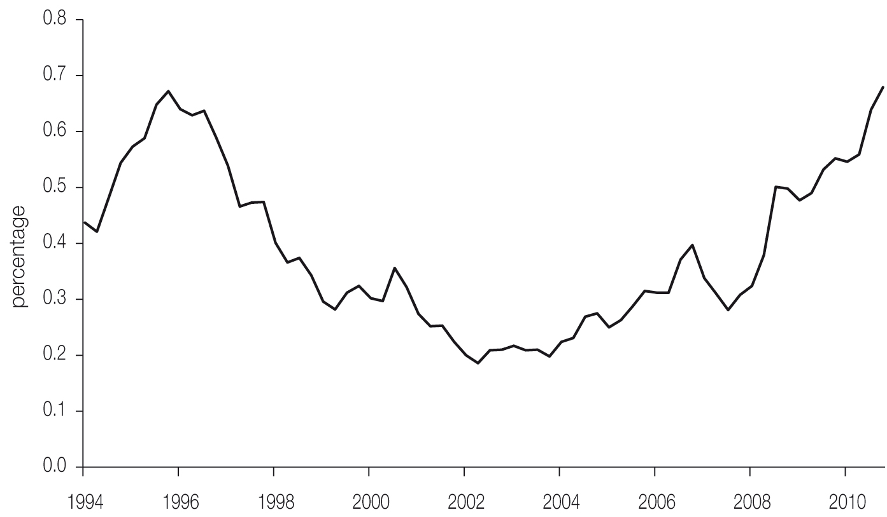
Source: RBA 2011, Financial stability review September 2011, RBA, Sydney.

Rates of application for property possessions have picked up in line with mortgage arrears, but remain below their peaks across most regions. As with mortgage arrears, Australian mortgage repossessions are exceptionally low on any international comparison. Australia is not expected to suffer the large increase in unemployment seen elsewhere, it did not see the same degree of relaxation of lending criteria in the lead-up to the crisis (with virtually no ‘sub-prime’ loans) and a large share of its borrowers have chosen to make excess mortgage payments. As Figure 5.9 shows, mortgage holders have made over-payments of around 75 per cent of scheduled payments – effectively creating a buffer against future difficulties. This is a tax-efficient form of saving in Australia, as mortgage interest is not tax deductible, while interest income from savings is subject to income tax.
Figure 5.9 Net excess mortgage repayments (percentage of scheduled payments), 2008–2011
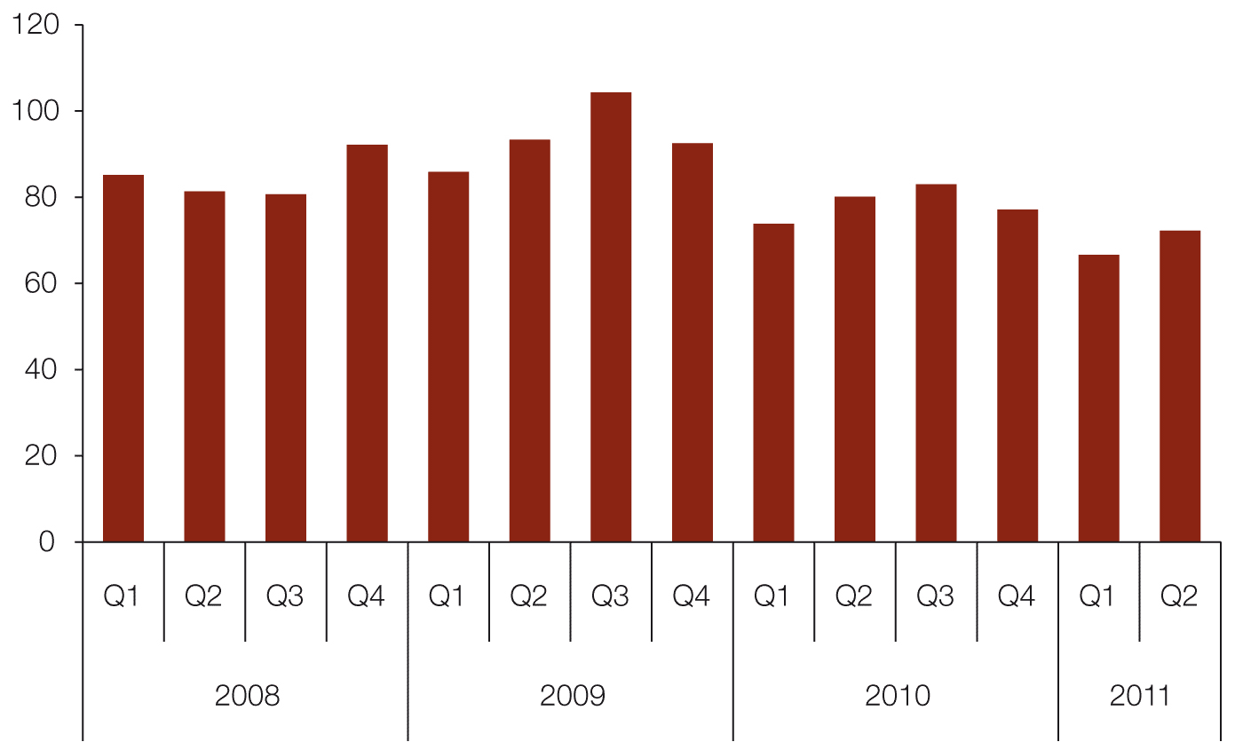
Source: RBA 2011, Financial stability review September 2011, RBA, Sydney.
Notes: Excludes repayments due to sales and refinancing. Includes interest offset accounts. Scheduled payments include interest and principle.

Data for securitised loans (collected by ratings agencies and not publicly available) show higher rates of arrears and a sharper spike in 2009, although they have fallen back since then. But there is some evidence that securitised loans are not representative of the wider market. More specialist non-bank lenders have operated in this market (at least prior to the GFC). They may have been more heavily focused on riskier market segments than more traditional on–balance sheet lenders, and therefore have seen rather different results.
The Fujitsu Mortgage stress report assesses the extent of mortgage stress from a monthly survey of 2000 out of a broader sample of 26,000 statistically representative households. It covers the entire mortgage market rather than focusing on stress for those on lower incomes as do the National Housing Supply Council and National Affordable Housing Agreement measures. It shows a small deterioration in recent times, broadly in line with the RBA data above.
In the Fujitsu report, households are defined as being under mortgage stress if their answers to the survey questions confirm that they are experiencing particular difficulties. The questions include whether they are up to date with their repayments, have recently had to delay repayments, have cut down on other spending or have had to borrow through credit cards or personal loans to meet mortgage repayments. The survey is not restricted by income level. The data are not cross-checked or audited but represent households’ self-assessments of their own situation.
The Fujitsu measure shows that, having fallen following a significant increase in 2008 during the GFC, the number of households facing a degree of mortgage stress has edged a little higher recently. The survey also shows that groups on lower incomes and/or tighter budgets unsurprisingly face greater pressures.
The reasons behind the increase in mortgage stress over the 10 months to January 2011 related to higher costs: both higher interest rates affecting mortgage payments and an increase in the wider cost of living (as illustrated in Figure 5.5).
Renters
As well as the various measures of affordability for potential or actual home owners, there are also indicators from the rental market. Markets overlap, so trends in one tenure type will also have an impact elsewhere, although the lags can be considerable. For example, greater levels of rental stress reduce the ability of these households to save for a deposit on a home. House prices affect rental yields, which in turn can affect investors’ willingness to purchase and make available rental properties. This section looks at some of the metrics directly reflecting the experiences of renters.
Figure 5.10 Rental and income growth (annual change), 2001–2011
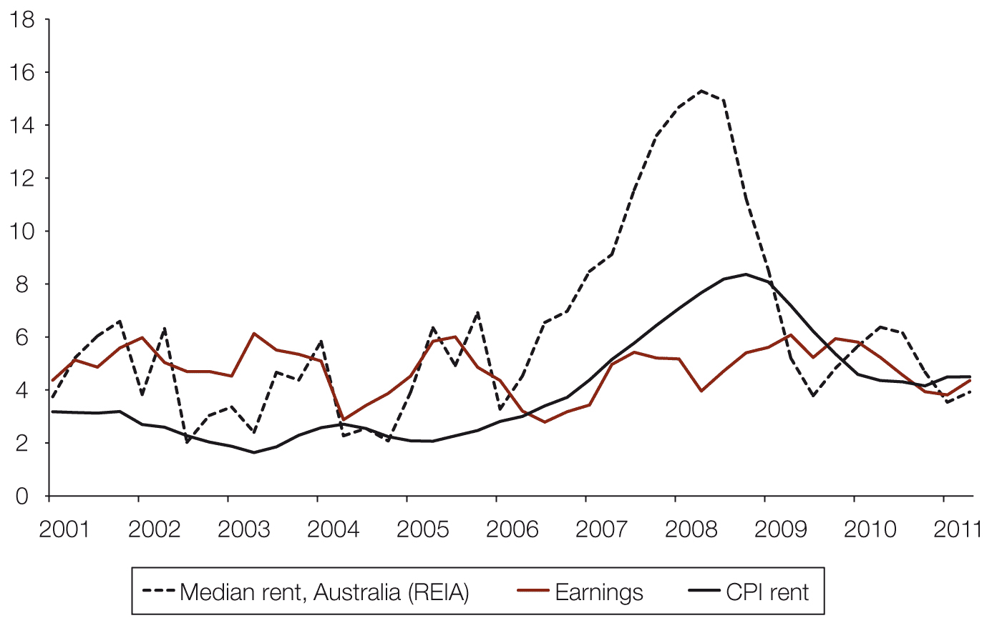
Source: ABS 2011, Average weekly earnings, Australia, May 2011, cat. no. 6302.0, ABS, Canberra; —, Consumer prices index, Australia, June 2011, cat. no. 6401.0, ABS, Canberra; REIA June 2011, Quarterly median rents on three-bedroom houses.

The tightness in the housing market showed up in increasing rents across the country, with the rise consistently outstripping income growth in recent years, although this did reverse in the early part of 2011. The Real Estate Institute of Australia (REIA) reports that median rents across Australia rose by 85 per cent from the beginning of 2001 to the end of 2010, compared to an increase in average weekly earnings of just under 60 per cent over the same period.
The rent component of the CPI shows a more modest increase over the same period; this is because it is a slightly wider measure. It includes a component from the public housing sector (where rents are often fixed as a proportion of tenants’ income) as well as private-sector input from real estate agents. The inclusion of public-sector rents (which account for approximately 20 per cent of the total rental sector) are likely to lead to some understatement of the rate of growth compared to the private sector.
It is not just the direct cost that reflects pressures in the rental market. Vacancy rates are also a potentially good measure of the sector being under pressure. Most of the major metropolitan markets have seen a fall in rental vacancy rates in recent years. There are differences across the markets, and REIA reported a small rise in vacancy rates towards the end of 2010 and into early 2011 in Sydney, Melbourne, Hobart and Darwin. There was a small decline in Brisbane, Adelaide, Perth and Canberra.
Figure 5.11 Rental vacancy rates (percentages), Sydney, Melbourne, Brisbane, Adelaide, four-quarter averages, 1980–2011
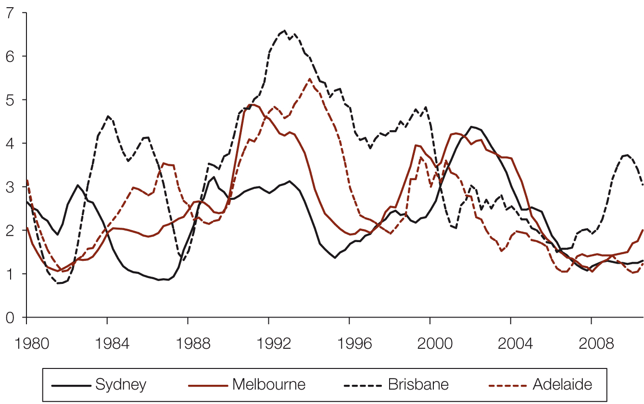
Source: REIA June 2011, Quarterly median rents on three-bedroom houses.

Figure 5.12 Rental vacancy rates (percentage), Perth, Hobart, Darwin, Canberra, four-quarter averages, 1980–2011
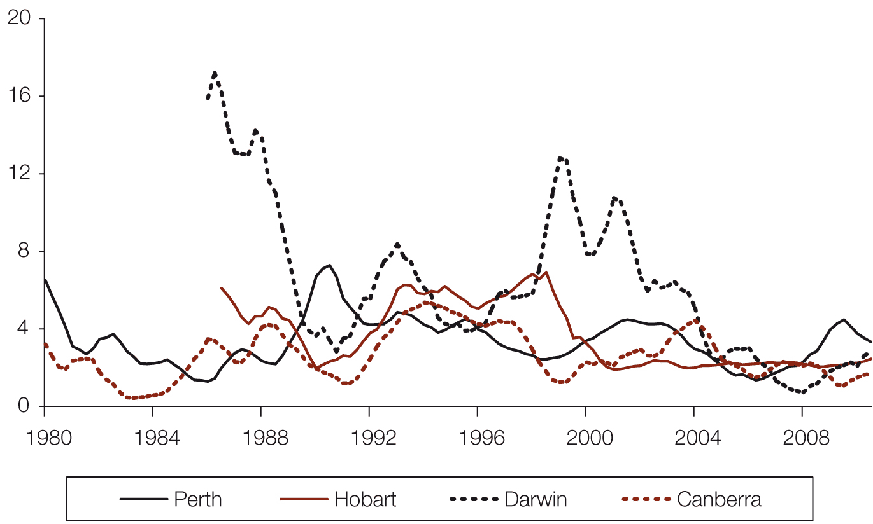
Source: REIA June 2011, Quarterly median rents on three-bedroom houses.

Data gathered by SQM Research show a rather more stable picture of late, with little change in Melbourne and a small rise in Sydney. A vacancy rate of around 3 per cent is generally considered typical for when the rental market is in equilibrium, as there needs to be some ‘slack’ for households to move between homes. SQM reported a national rate of 1.9 per cent in July 2011, so even with the increase in the REIA vacancy rates in some cities, the 2011 rate was still below 3 per cent across the country. According to SQM, in July 2011 the vacancy rate was 2.8 per cent in Melbourne, 2 per cent in Brisbane, 1.6 per cent in Adelaide and Sydney, 1.2 per cent in Perth, 1.1 per cent in Darwin, 1.0 per cent in Hobart and 0.7 per cent in Canberra, suggesting that the market remains tight. It is difficult to reconcile the REIA and SQM information on rental vacancy rates.
Rental trends within states/territories and cities
The rent payable on a property is recorded when a rental bond is lodged with each state or territory rental tenancy authority. State housing departments publish this information at different levels of aggregation. The Council has analysed these data from New South Wales, Victoria and Brisbane (the Queensland data are not aggregated in the same way) in order to determine the median rent paid in various submarkets in each jurisdiction. It should be emphasised that these data sets only record the rent on newly leased properties (and only properties where a rental bond is taken), so cannot account for changes in rents for existing tenants. However, as the rental market (at least in aggregate) tends to have a steady turnover, and certainly a greater one than the owner-occupied sector, these measures will give a strong indication of underlying trends.
The figures provide evidence of varying trends across submarkets. Across Sydney, rents for two-bedroom flats have increased by 70 per cent over the decade to June 2011, a slightly higher increase than for three-bedroom houses (67 per cent), attributable in large part to differences in their locations. This is a faster rate of increase than was seen for either type of dwelling across the rest of the state (64 per cent and 65 per cent, respectively). By way of comparison, average earnings in New South Wales have increased by 50 per cent over the same period.
Figure 5.13 Median weekly rents ($) by area and property type, Sydney, 1990–2011
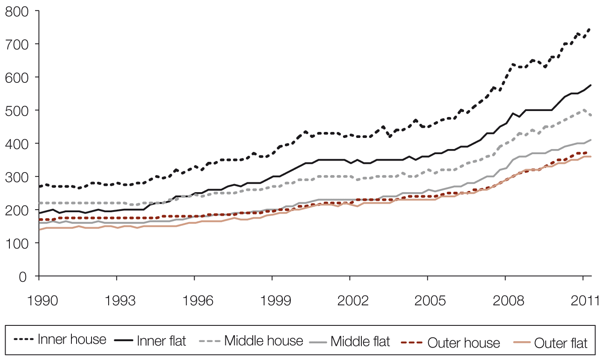
Source: Housing NSW.
Notes: Data are based on median rent paid by type of property in each ‘ring’ of Sydney. Data are not adjusted for inflation. ‘Flat’ refers to a two-bedroom flat. ‘House’ refers to a three-bedroom house.

However, it is within the various Sydney markets that the largest differences in increases in rents are found (see Figure 5.13). The median rent on two-bedroom flats rose by 64 per cent across the ‘inner ring’ of Sydney areas, by 78 per cent in the middle ring and by 71 per cent in the outer ring over the 10 years to June 2011. This may reflect more rental flats becoming available in the middle ring, many of them newly built and typically of higher quality and specifications than existing stock, so tending to rent out at higher rates. For three-bedroom houses, the largest rise was seen in the inner ring (79 per cent), with a 67 per cent rise in the middle and a 63 per cent rise in the outer ring. This is likely to be due to the greater scarcity and higher desirability of houses nearer to the city centre. Rents remain considerably higher in locations nearer the city for all types of property.
Victoria has also experienced very different trends in rents between its capital city and the rest of the state (see Figure 5.14). In Melbourne, rents for two-bedroom flats increased by 80 per cent over the 10 years to the end of March 2011 (end-June data was not available at the time of writing), while rents for three-bedroom houses increased by 68 per cent. Outside Melbourne the opposite was true: rents for two-bedroom flats saw a rise of 66 per cent, while rents for three-bedroom houses rose by 76 per cent. Earnings across all of Victoria have risen by 57 per cent over the past decade.
Figure 5.14 Median weekly rents ($) by area and property type, Victoria, 1999–2011
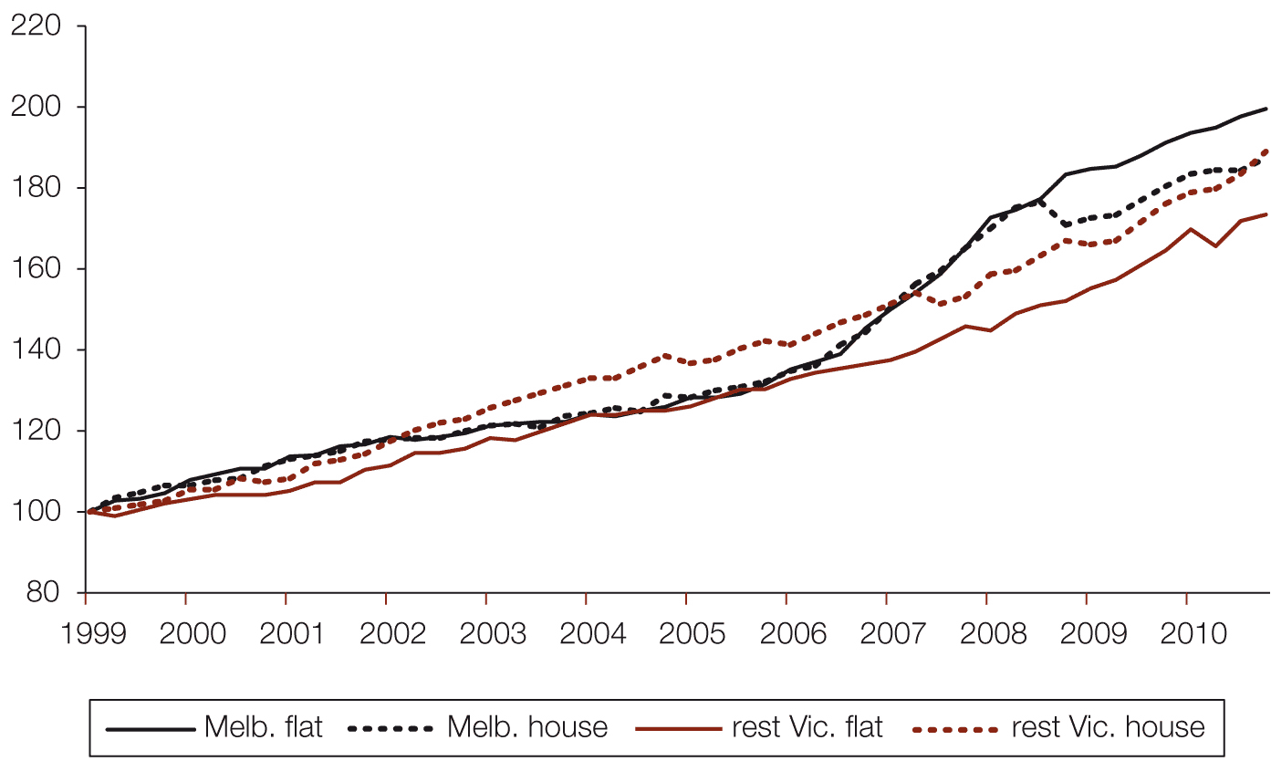
Source: Department of Human Services, Victoria.
Notes: Data set to second quarter 1999 base (Q2 1999 = 100). Data are not adjusted for inflation. ‘Flat’ refers to a two-bedroom flat. ‘House’ refers to a three-bedroom house.

Within Melbourne, the north-western area has seen the fastest rental growth for two-bedroom flats, at around 107 per cent, while southern Melbourne has seen a 97 per cent rise. As with Sydney, the inner city saw more modest growth, of 79 per cent. For three-bedroom houses, the outer east (86 per cent) and the inner city (85 per cent) saw the fastest rates of increase.
Brisbane has seen rather faster rates of rental growth than have Melbourne or Sydney over the past 10 years. For the city as a whole, rents on two-bedroom flats have risen by 117 per cent, while there has been a 100 per cent increase in rents on three-bedroom houses (see Figure 5.15). But there has also been a faster rate of income growth in Queensland than in New South Wales or Victoria. Average earnings across Queensland rose by 66 per cent over the decade. The north of the city has seen the fastest increase in rents, with 113 per cent rises in rents on both flats and houses for the inner north, and a 119 per cent rise in rents on flats in the outer north.
Figure 5.15 Rental growth (percentage), Brisbane, by region, 2001 to 2011
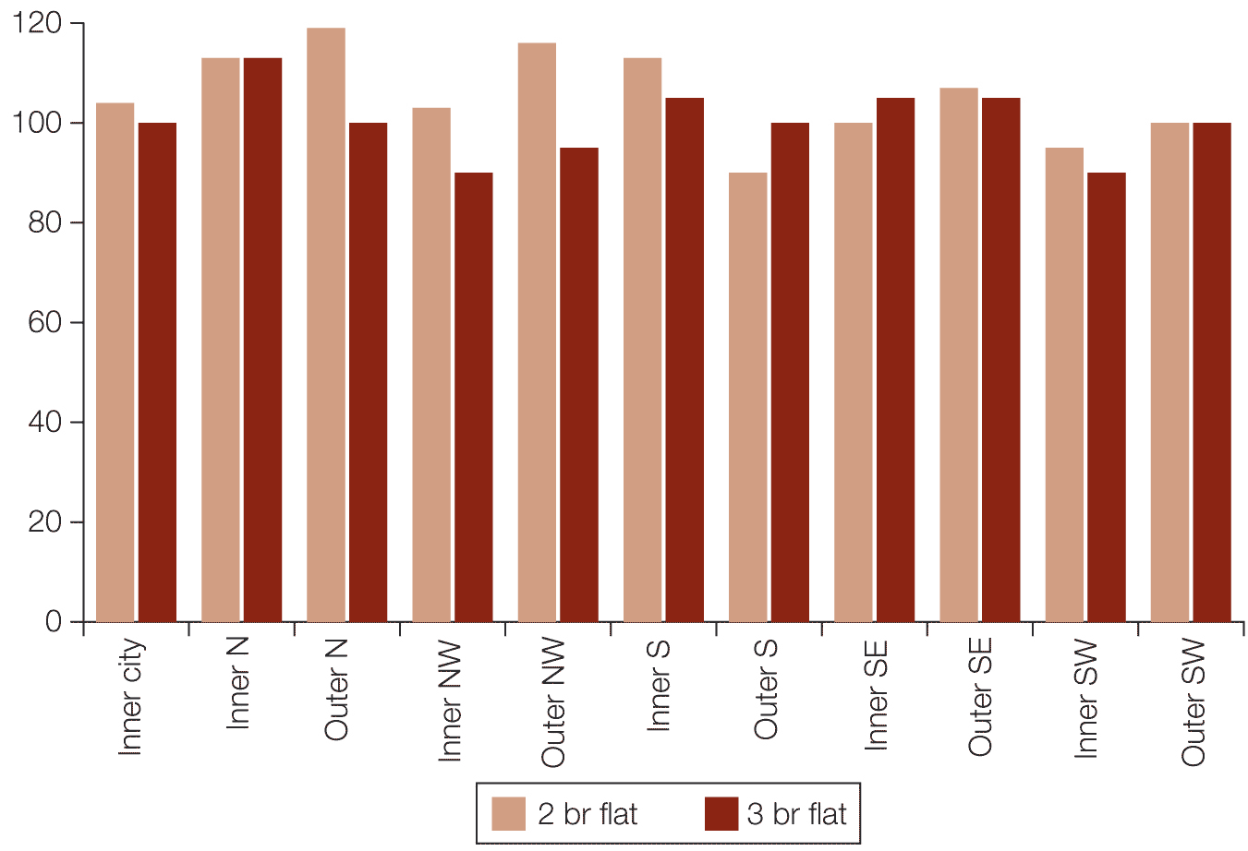
Source: Queensland Rental Tenancy Authority.
Notes: Data reflect median rent paid by type of property in each area of Brisbane. Data are in nominal terms, not adjusted for inflation.

National Housing Supply Council measures
Using the same methodology as for owner-occupiers and data from the 2007–08 Survey of Income and Housing, the Council’s 2010 report found that 41 per cent of lower-income renters (those at or below the 40th percentile of the income distribution scale) in the private rental market paid more than 30 per cent of their income in rent, after Commonwealth Rent Assistance (CRA) was deducted, in 2007–08. If CRA is excluded, this measure rises to over 70 per cent.
The 2010 report also noted a shortage of available dwellings at the lower end of the rental market in 2007–08. While there were 1,410,000 private rental dwellings across the country that were affordable to the 814,000 private renters with incomes below the 40th percentile, 1,089,000 of these were occupied by households in higher income percentiles – representing a shortfall of 493,000 properties affordable and available to those with incomes in the lowest two quintiles.
The National Affordable Housing Agreement on the private rental market
Performance data on the National Affordable Housing Agreement (NAHA) also covered the ability of households to rent (both private and social) housing that meets their needs. Progress is measured by the incidence of rental stress among low-income households. The data on stress in the private rental market have not been updated since the 2007–08 NAHA report. Using the same criterion as that used to identify low-income households under mortgage stress as described earlier, 37.2 per cent of low-income renter households were found to be in rental stress across the country.
Rental stress was higher in the private rental market. Almost half (47.5 per cent) of low-income households renting privately were found to be in rental stress at the time of the report. Those in the public rental sector were far less likely to be under stress, which is unsurprising given that income-related rents predominate in public housing.

Table 5.3 Percentages of low-income households in rental stress
 | NSW | Vic | Qld | SA | WA | Tas | NT | ACT | Australia
All (2007–08) | 45.7 | 33.8 | 37.4 | 25.9 | 28.9 | 22.7 | 29.7 | 35.9 | 37.2
Private renters (2007–08) | 57.0 | 42.2 | 45.6 | 41.8 | 37.6 | 41.2 | 41.3 | 39.6 | 47.5
Public renters (2009–10) | 0.1 | 3.9 | 0.0 | 1.7 | 1.1 | 0.2 | 5.9 | 0.9 | 1.3
Source: COAG Reform Council 2009, National Affordable Housing Agreement: Performance report for 2009–10, COAG Reform Council, Sydney, available at www.coagreformcouncil.gov.au.

Whereas existing owners are likely to have benefited from lower interest rates since the 2007–08 NAHA report, with improvement in the share of homes that are affordable to lower-income households (see earlier in this chapter) and a likely fall in mortgage stress (both due to lower mortgage rates), renters are unlikely to have seen a similar fall in rental stress.
Commonwealth Rent Assistance
Commonwealth Rent Assistance (CRA) is a non-taxable income supplement paid to qualifying households in the private rental market. It is part of the social security safety net aimed at assisting low- and moderate-income households with housing costs. As at June 2010 there were more than 1.1 million individuals and families receiving CRA.
To be eligible, a person must first qualify either for an income support payment (such as the Age Pension or Newstart Allowance) or more than the base rate of Family Tax Benefit Part A. He or she must also pay rent above a specific minimum amount (called the rent threshold). CRA is paid at a rate of 75 cents for every dollar of rent paid above the rent threshold, up to a specified maximum amount – which is currently $116.40 per fortnight for a single person with no children.
This maximum amount of CRA is indexed to the CPI in March and September each year. This rate of increase has not kept up with increases in rent over time. From June 2003 to June 2010, average rents paid by CRA recipients increased by $73 per fortnight in real terms, while average CRA payments increased by only $7 per fortnight in real terms over the same period. The proportion of recipients paying enough rent to be eligible for the maximum rate of CRA has increased over that period.
Individuals and families who receive CRA are required to provide current rental receipts or current lease agreements to Centrelink to verify the amount of rent they pay. Data from June 2008 and June 2010 for Australia as a whole show a 13 per cent increase in rents paid by those receiving CRA over the two years. This is broadly in line with the rent component in the CPI and the REIA measure both increasing by 12 per cent. Western Australia and Northern Territory saw the largest increases over this period.
Table 5.4 Mean fortnightly rent paid by income units receiving rental assistance ($), years ending June 2010 and June 2008
 | NSW | Vic | Qld | SA | WA | Tas | NT | ACT | Australia
2008 | 355 | 325 | 373 | 315 | 352 | 307 | 365 | 383 | 348
2010 | 400 | 366 | 415 | 353 | 407 | 344 | 431 | 432 | 392
Source: ABS 2009, Australian social trends, Dec 2009, cat. no. 4102.0, ABS, Canberra; — 2010, Australian social trends, Dec 2010, cat. no. 4102.0, ABS, Canberra.
Notes: Data presented are current prices in specified year. No adjustment has been made for inflation.
The Tenants Union of Victoria (TUV) produces a private rental affordability study that looks at low-income households, including those receiving CRA and other social security payments, and compares the rent they pay to the benchmark of 30 per cent of income. Of the seven types of households studied across the capital cities in March 2011, all were found to be in rental stress, except couples earning average weekly earnings in Adelaide, Brisbane, Hobart and Perth. All other types of households (four types of single-person household and three types of couple households on various types of government support) were considered to be in ‘poverty’. However, the methodology does assume the same incomes across the entire country; while this is true of most Centrelink payments, it is not true of average income measures.
A separate TUV study found that median real weekly rents had grown across Australian capital cities from $164 per week in 1995 to $232 in 2009. This was based on analysis of REIA and ABS data. It also found that the maximum level of CRA would have covered 26.8 per cent of median rent for singles or couples with more than two children in 1995 but 21.8 per cent in 2009. The proportion of rent covered by CRA fell across all the major cities. It covered the smallest share of median rent in Darwin and Canberra. Subsequent increases in rents, CRA and incomes of CRA-eligible tenants suggest that this share is unlikely to have improved by 2011.
Comparison with international housing markets
The various measures described in this chapter aim to show how housing affordability has changed in Australia in recent history. In addition to this, a number of studies have been undertaken by international bodies that compare the Australia market to others around the world, in order to determine whether housing in Australia is ‘less affordable’ than elsewhere. Most focus on whether prices are sustainable at current levels.
A range of such studies assert that the Australian housing market is relatively expensive. However, there is little agreement on whether prices are overvalued. A 2010 OECD report described Australian house prices as “until now … driven by fundamentals”, but was wary of the “risk of speculative behaviour”. It advised that “consideration should be given to developing prudential measures that could be implemented to dampen future exuberance in house prices and lending”.
On the other hand, the International Monetary Fund (IMF) has changed its assessment in a series of reports. Its view has moved from prices being overvalued by up to 20 per cent to there being no significant evidence of overvaluation. Its most recent estimates point to a more modest overvaluation of 5 to 10 per cent. To a large extent the variation in these estimates depends on the specification of the econometric models used, and highlights the difficulty of separating structural and cyclical determinants of house prices.
Meanwhile, The Economist has rated Australian house prices as “the most overvalued in the world”. This was based on the ratio of rents to dwelling prices being more than 56 per cent above its long-term average, a greater disparity than in any other country. However, the publication did note some mitigating factors for the apparent degree of overvaluation, including financial liberalisation and the commodities boom leading to a “step change” in price levels. The rent-to-price ratio suggests a far more modest degree of overvaluation, at 12 per cent above the average of the past decade.
However, the Council believes that most of these international studies tend to overlook several factors peculiar to the Australian market that distort direct comparisons. Most are based on simple average house price–to-income ratios, which ignore several significant factors that contribute to higher prices in Australia.
Cities with more than one million inhabitants tend to have higher house prices relative to income, and Australia has a higher proportion of its population in major cities (particularly Sydney and Melbourne) than the majority of other economies. These studies also do not take into account the balance between supply and demand – the most obvious contrast being with countries such as the US, Ireland and Spain, where significant excess supply is placing downward pressure on prices. These comparisons also make little attempt to account for the different mix of housing stock in Australia compared to elsewhere. Australian homes tend to be larger, on average, than their international counterparts. In addition, several Australian cities rank very highly on international ‘liveability’ comparisons, which are likely to affect the price households are willing to pay to live there.
Conclusions and future work
Most affordability indicators have deteriorated since the 2010 State of Supply Report. Households in the private rental and ownership markets (particularly more recent entrants) and those looking to get into the market face increasing pressures, with most measures of housing affordability stretched compared to historic readings. However, there are signs that the rate of deterioration has slowed, possibly due to certain constraints, particularly how much households can, or are willing to, borrow.
No single measure can fully encapsulate housing affordability. But affordability in Australia is clearly stretched, and has deteriorated in recent years. By any measure, housing costs in the major cities are high. Prices in Sydney and Melbourne are especially high relative to the incomes of many living there.
The number of households experiencing difficulty in keeping up with their mortgage repayments is fairly low but increasing, and this trend is likely to continue if interest rates rise further (although this now seems unlikely in the immediate future) and the cost of many household utilities continue to increase. However, relatively strong economic performance, a robust labour market and many households being ‘ahead’ on their mortgage repayments should offset this to some extent.
While the rate of deterioration has eased, the difficulties encountered by those looking to enter the market may still have longer-term implications. Potential first-home buyers may spend longer in the private rental market (leading to a tighter rental market), stay in the parental home longer, share housing (reversing the long-term trend of declining numbers of people per household) and end up living in units and apartments rather than houses due to price and location. This raises questions over whether the stock is available to meet the population’s aspirations. As noted earlier in this report, a recent study by the Grattan Institute found that there are shortages of semi-detached homes and apartments in the middle and outer areas of both Melbourne and Sydney, when compared to the type of housing those surveyed said they would choose to live in, given current price and income constraints.
The effects of strained affordability will be felt most acutely at the lower end of the private market and in increased demand for public housing. The Council questions whether the long history of tackling affordability through preferential tax treatment and grants to the broad occupier sector is effective without increasing the supply of affordable housing. A more targeted approach that stimulates demand for new dwellings, and therefore increases housing supply, could provide part of the solution.

Chapter 6 Conclusions
The key findings of the 2011 State of Supply Report are summarised in the executive summary and at the beginning and end of each chapter. They are not repeated here. Instead, these conclusions outline some of the implications of the report.
The Council’s updated estimates and projections of demand, supply and the balance between them collectively show that the issues highlighted in the two previous reports remain. While the housing market has weakened over the past year, the Council does not believe that this means that the accumulated ‘gap’ between underlying demand and supply has somehow disappeared or even eased.
Essentially, there is no reason to expect the housing shortage to eliminate market cycles. All markets experience stronger and weaker times. What has perhaps disguised this in recent years (at least until the global financial crisis struck) was that the housing market was also adjusting to structural changes in the credit markets. Financial deregulation, resulting particularly in greater availability of mortgage credit and lower mortgage interest rates, has meant that higher house prices relative to incomes are more sustainable than they were in the past. The rise in prices has been exacerbated by the emerging housing shortage. The long-term adjustment in credit availability is now likely to have run its course. While there was some tightening of credit during the global financial crisis (especially for developers), and there is increased global sensitivity to the dangers of sub-prime lending and financing speculative development projects in oversupplied markets, these phenomena were far less prevalent in Australia than elsewhere, and will be even less likely for some time to come.
Despite this apparent easing of pressure in the market, demographic trends and the current and historic rates of house building point to a widening in the ‘housing shortfall’. This is not solely evident in the owner-occupier market. With social housing building rates lagging well behind growth in demand in this sector, and little sign of any easing in rents at the lower end of the market, the problem is likely to be more acute for less wealthy households. In addition, lower-income households tend to spend a larger share of their income on ‘essentials’, such as food and fuel, the costs of which have increased by more than overall inflation and, in many cases, their incomes over recent years.
While there has been some slowing in the rate of underlying demand growth since the 2010 report was published, the short-term outlook for delivery of new homes has also fallen. The current rate of new home building is exceptionally low. So the gap between supply and demand is likely to widen by more than indicated by the Council’s medium scenario projections over the next couple of years.
It is important to consider the implications of the worsening shortage beyond what is happening in the current market. Growth of housing demand relative to housing supply implies lower living standards, or at least a slowing in the rate of improvement experienced in Australia over recent years. The household projections are based on assumptions that recent trends in household formation will continue. If these trends are constrained by a lack of supply, household size will be higher than those assumed in the projections and than those households would otherwise choose. The effect on living standards and household formation will not be uniform.
Increased household sizes will have social consequences beyond the housing market. The effects are likely to be felt most further down the socioeconomic spectrum, and particularly in terms of pressure on the social housing sector. Lower-income groups’ ability to access the private market is already a significant issue.
A sustained housing shortage is increasingly likely to affect more affluent households. It is likely that adult children will stay in the parental home longer and form their own households later in life. Meanwhile, the share of households in home ownership is likely to fall as fewer younger households form and/or become owners.
Part of the solution may be to increase the size and functionality of the existing housing stock through additions and renovations. Some have argued in any event that Australia ‘over-consumes’ housing; that is, that many households occupy homes beyond their needs. However, this is unlikely to change at the higher end of the market, and those lower down will have less opportunity to alleviate their situation.
While there have been some signs of improving affordability due to the market weakness, most measures still show that housing is relatively ‘unaffordable’ in Australia. History shows that subsidising home ownership, especially among first-home buyers, appears to have had little effect in reducing these pressures. The Council favours measures that focus on increasing supply, particularly at the more affordable end of the market.
The Council has highlighted a number of areas for further research over the coming two years. Such research will help to improve understanding of some of the more detailed issues relating to the housing shortage. The areas are as follows.
- Immigrant demand for housing among both permanent and temporary migrants
- The capacity and sustainability of the building industry
- The effects of the ageing population on the types of housing that will be required in future
- How government policy affects housing supply
- A more detailed review of regional, including provincial town and city, submarkets across all tenures, and how these interact with one another and with regions’ economic and social development
- Greater understanding of housing supply and demand in urban areas, including growth on urban fringes
- Market and social responses to the deterioration in housing affordability over the past decade
Underpinning much of this work will be the understanding that tackling the housing shortage is not simply about increasing the number of homes being built. It is also important to build the right types of homes in the right places. Housing is a large part of wider communities, and producing the right types and mixes of homes can contribute to developing sustainable communities that work for the population at large.
The Council will continue to focus on the underlying imbalance between housing demand and supply. It will also seek to improve the methodology and data underlying this report to inform government, industry and the wider population of the key challenges and opportunities facing the housing sector.

Appendix 1: Terms of reference
Rationale
The Australian Government is concerned to improve housing affordability for home buyers and renters. The government recognises that better information on supply and demand at local, regional, state and national levels could play a valuable role in improving affordability by guiding policy, practice and market behaviour. The government has established the National Housing Supply Council (the Council) to aggregate and assess data on housing supply and demand and to report to the Minister for Sustainability, Environment, Water, Population and Communities on its findings.
The Council of Australian Governments (COAG) supports the establishment of the Council and has agreed to the establishment of a Working Group of state, territory and government officials to ensure data needed by the Council are supplied to it.
Through its various agencies, the government has considerable information on the demand side – notably demographic, immigration and household income and expenditure data – as well as some supply-side information – such as Australian Bureau of Statistics data on housing approvals and commencements and Australian Institute of Health and Welfare data on social housing and responses to homelessness. States and territories know about the state of land supply, zoning and planning frameworks, and about residential infrastructure requirements and financing. The Council will access and assess these and other data to analyse the balance between demand and supply and help governments at all levels to address housing affordability in an effective and sustainable way. To the extent feasible, the Council will undertake this analysis at both aggregate and disaggregate level.
Role of the National Housing Supply Council
The Council will provide forecasts, analysis and policy advice to the Minister for Sustainability, Environment, Water, Population and Communities and publish an annual State of Supply Report on the adequacy of land supply and construction activity to meet demand and improve affordability over a 20-year forecast period. The Council will:
- adopt consistent national standards in measuring and assessing the supply of land and housing and their relationship with housing demand and affordability
- provide a detailed assessment of trends in land availability, construction activity and housing affordability
- identify possible ways of ameliorating obstacles and otherwise improving the supply response
- advise on research findings and desirable additional research on housing demand, supply and affordability at regional, state and national levels.
Accordingly, the Council’s State of Supply Report will provide consistent data on trends and forecasts of housing demand and supply at national, state and territory and local scales. The report will incorporate assessments of, among other things:
- demographic factors influencing demand such as growth and structure of households, immigration rates and patterns, and the movement of households between cities, regions, state and territories
- economic factors (cyclical and structural) influencing demand, supply and affordability such as the growth and distribution of household incomes, relative returns from investment in housing, the availability and cost of finance for developers and consumers, business and consumer confidence, and the cost, availability and productivity of land, labour and materials
- development control arrangements – planning and zoning, development assessment, building approval processes, building standards and related market practices – affecting the release of land, development activity and redevelopment potential, including with respect to the variety of different types, sizes, densities and prices of housing
- infrastructure provision and financing
- factors influencing or inhibiting industry innovation in housing and community-building product
- practices and output in the public and not-for-profit housing sectors and at the low-cost end of the private rental and home purchase markets.
In considering these matters, the Council will focus particularly on the factors affecting the supply and affordability of housing for families and other households in the lower half of the income distribution as well as on the adequacy of, and movement in cost of, housing supply generally.
In considering housing affordability and factors making housing more or less affordable, the Council will consider the immediate and long-run price of housing relative to household incomes. Accordingly, it will attempt to address house and land prices, residential rents, interest rates and other recurrent costs (including of utilities, transport costs and other matters affecting the ‘sustainability’ of housing in various locations).
The Minister for Sustainability, Environment, Water, Population and Communities may request specific advice from the Council.
Modus operandi
The Council is supported by a budget determined by the Minister and a Secretariat in the Australian Government Department of Department of Sustainability, Environment, Water, Population and Communities (DSEWPaC) as well as by the Housing Data Working Group and the presence at all Council meetings of senior ex-officio representatives of the Australian Treasury and DSEWPaC.
The Council aims to develop and maintain strong relationships with representatives of the building and development industries, planning and development control agencies, key policy agencies and other key interest groups. It also aims to develop strong working relationships with data and research bodies, including the Australian Bureau of Statistics, the Australian Institute of Health and Welfare and the Australian Housing and Urban Research Institute.
The Council aims to meet four times per year at times designed to set the agenda and work program for the annual State of Supply Report, monitor and guide progress, assist with analysis and the development of findings, consider policy and practice implications and authorise the final report.
As far as is practically possible, the Council will meet in a variety of locations to facilitate the development of strong relations with and the engagement of key interested parties.
Council reports will be presented to the Minister and subsequently published on the internet.
Minutes of meetings will be maintained recording a summary of key discussion points, agreed decisions and actions. Progress reports including the Minutes will be provided to the Minister after each meeting.
The State of Supply Report will include:
- an assessment of the current balance between housing demand and supply
- likely trends in demand, supply, affordability and their underlying drivers
- an assessment of major inhibitors and contributors to better balance housing supply and affordability.
Additional issues will be covered where relevant.
Members of the National Housing Supply Council
The Council comprises a Chair plus eleven Members. Appointments to the Council are made by the Minister for Sustainability, Environment, Water, Population and Communities in consultation with the Treasurer. The Chair is appointed for up to three years and Members for two years. The Minister, in consultation with the Chair, will elect a deputy Chair. The Chair and Members will be appointed as individuals and not as a representative of organisations or businesses.
The Chair is responsible for convening and chairing the Council meetings and presenting the annual State of Supply Report to the Minister for Sustainability, Environment, Water, Population and Communities.
Members will be appointed for their individual capacity and expertise in an area relevant to the housing industry as set out below. Members are responsible for attending meetings and contributing to the work of the Council by offering insight and guidance based on their expertise.
Sector representation sought in the membership of the council encompasses the housing, property and building and construction industry, planning and development, social welfare and community housing, banking and finance, and housing research.
Current Members of the Council are:
Dr Owen Donald, Chair Former Director, Housing Victoria; former CEO, Australian Housing and Urban Research Institute
Mr Saul Eslake, deputy Chair Director, Productivity Growth, Grattan Institute; Advisor, PricewaterhouseCoopers’ economic practice
Ms Janet Buhagiar Director, Social Policy, NT Government
Ms Dyan Currie National President, Planning Institute of Australia
Ms Sue Holliday Managing Director, Strategies for Change Pty Ltd
Professor Graeme Hugo Australian Research Council Professorial Fellow, University of Adelaide
Mr Mark Hunter CEO Residential, Stockland
Mr Simon Norris General Manager, Clarendon Homes Queensland
Ms Mary Patetsos Chair, SA Local Government Grants Commission
Mr Nigel Satterley AM Managing Director, Satterley Property Group
Ms Ruth Spielman Executive Officer, National Growth Areas Alliance
Dr Judy Yates Honorary Associate Professor, University of Sydney
In addition, the following senior Australian Government officers attend Council meetings:
Malcolm Thompson Deputy Secretary, DSEWPaC, ex-officio participant observer
Catherine Skippington First Assistant Secretary, DSEWPaC, ex-officio participant observer
Angela Woo Principal Advisor, Treasury, ex-officio participant observer
Support to the Council in developing this report was provided by James Tregurtha, Paul Samter, Ilse Wurst, Grey Robertson, Mark Harry, Julia Graczyk, Caryn Scott, Anthony Krieg, Leanne McGrath and Megan Barker.

Appendix 2: Demand
The methodology behind the Council’s projections for underlying demand is set out below. There has been a minor change to the methodology with respect to the settlement patterns of migrants since the 2010 report, although the impact on the results is not significant. This appendix presents detailed results of the projections and compares them with the methodology used by the Australian Bureau of Statistics (ABS) to calculate its household projections.
Council’s household projections methodology
The Council’s projections employ an innovative approach to projection of housing demand at a sub-national level. The methodology is detailed in McDonald, Kippen and Temple (2006). A short overview of the approach was provided in a previous report published on the Council’s website (McDonald and Temple, 2008). That previous report also contains an analysis of changes in the household situation of Australians between the 1991, 1996, 2001 and 2006 Censuses of Population and Housing. As there have been no further Census results published since (a Census was held in 2011 but the results are yet to be published), there are no new data available to update these trends.
Houses, or more precisely dwellings, are occupied by households. Therefore, the projection of housing demand is equivalent to the projection of the number of future households. All of the Council’s published underlying demand figures for the years following 2006 are essentially estimates based on the likelihood of households forming and changing. Actual household numbers, types and sizes are collected in the five-yearly Australian Census of Population and Housing. When the 2011 Census data become available (starting from mid-2012) the Council’s household estimates may prove to have over- or under-estimated these figures, as may all post-2006 population estimates. The ABS household projections are compared to the Council’s in the following section.
To project future households, for any given locality, we begin with the population of individuals described simultaneously by sex, single-year of age and individual household classification type (HCT). This population table is obtained from successive Censuses, in this case from the 2001 and 2006 Censuses. For these projections, we assume that the household classification type transition probabilities by age, sex and locality remain the same throughout the projection period as they were in the period 2001-–06. Each household is tagged with the characteristics of a ‘household reference person’. Individuals projected to be living in non-private dwellings (NPD) remain as individuals classified by sex, age and location.
The initial household types and sizes (but not numbers) implicit in these projections are consistent with households (by household type and age of reference person) observed at the 2006 Census corrected for undercount and changes in population up to 30 June 2009. As the projections progress through time, household types and sizes change because of changes in the age distribution of the population (including the effects of migration) and the cumulative effects of the household transition probabilities. The household transition probabilities (specific to age, sex and region) are assumed to remain unchanged from those that applied in the 2001–2006 intercensal period. The types and sizes of initial households are partly a product of the reconciliation of housing needs and housing supply in 2006. But in the Council’s calculations of the housing gap, the number of ‘initial households’ is the number of households in 2001, which is where we commence the assessment of undersupply/oversupply. No such reconciliation between demand and supply is made as these projections of housing needs move forward through time. However, such a reconciliation necessarily will occur as long as almost all persons are living in a private or non-private dwelling.
The projection methodology requires an assumption about the state and territory distribution of net overseas migration (NOM) to Australia. Compared to the previous (2010 report) projections, these projections assume that higher percentages of NOM will go to Queensland and Western Australia. To compensate, lower percentages are assumed for New South Wales, South Australia, Tasmania and the Northern Territory. The new assumptions are based on trends evident from the latest ABS data and the high demand for labour in the resource-rich states.
Table A2.1 displays the state split shares for the migration scenarios used in the 2011 report projections. Table A2.2 displays the same splits, but for the migration scenarios used previously in the 2010 report projections. The sub-state splits remain consistent between the 2010 and 2011 projections. That is, the way in which migration is split between capital city and rest of state has remained at the existing propensities.
Table A2.1 State splits for share of NOM (%), 2011 report
 | NSW | Vic | Qld | SA | WA | Tas | NT | ACT
2009 | 30.47 | 26.34 | 19.97 | 5.57 | 15.28 | 0.67 | 0.61 | 1.08 | 100
2010 | 30.57 | 26.34 | 20.28 | 5.33 | 15.58 | 0.67 | 0.52 | 0.70 | 100
2011–30 | 30.76 | 26.34 | 20.26 | 5.18 | 15.57 | 0.67 | 0.52 | 0.70 | 100
Source: McDonald and Temple 2011, Projections of housing demand in Australia, 2009–2039, narrative report, Canberra.

Table A2.2 State splits for share of NOM (%), 2010 report
 | NSW | Vic | Qld | SA | WA | Tas | NT | ACT
2008 | 31.1 | 26.5 | 18.9 | 7.2 | 14.4 | 0.7 | 0.7 | 0.5 | 100
2009 | 31.2 | 26.5 | 18.9 | 7.0 | 14.4 | 0.8 | 0.7 | 0.5 | 100
2010 | 31.3 | 26.5 | 19.0 | 6.7 | 14.5 | 0.8 | 0.6 | 0.6 | 100
2011–30 | 31.5 | 26.5 | 19.0 | 6.5 | 14.5 | 0.8 | 0.6 | 0.6 | 100
Source: McDonald and Temple 2011, Projections of housing demand in Australia, 2009–2039, narrative report, Canberra.
The resulting levels of annual net migration for regions (international and internal) are shown in Table A2.3. The levels are assumed not to change across the period 2011–30. As the only varying parameter across the projections, the levels of annual NOM are the central cause of variation in the results between the scenarios. The low migration scenario in this table is 100,000 people a year, 20,000 lower than the scenario published in the body of the text and later in this appendix.
Table A2.3 Levels of annual net migration (ANM) for regions (international and internal)
Region | Scenario | ANM
NSW capital city | Low | –4,492
 | Medium | 19,114
 | High | 39,770
NSW balance of state | Low | 15,256
 | Medium | 16,261
 | High | 17,140
Vic capital city | Low | 13,914
 | Medium | 33,845
 | High | 51,285
Vic balance of state | Low | 6,427
 | Medium | 7,568
 | High | 8,567
Qld capital city | Low | 15,548
 | Medium | 25,186
 | High | 33,619
Qld balance of state | Low | 32,210
 | Medium | 38,779
 | High | 44,526
SE Qld | Low | 38,785
 | Medium | 51,947
 | High | 63,463
SA capital city | Low | 432
 | Medium | 4,217
 | High | 7,530
SA balance of state | Low | 1,744
 | Medium | 2,099
 | High | 2,409
WA capital city | Low | 13,993
 | Medium | 25,187
 | High | 34,982
WA balance of state | Low | 4,074
 | Medium | 5,333
 | High | 6,435
Tas capital city | Low | 392
 | Medium | 705
 | High | 980
Tas balance of state | Low | –219
 | Medium | 5
 | High | 202
NT | Low | 23
 | Medium | 441
 | High | 807
ACT | Low | 700
 | Medium | 1,260
 | High | 1,750
Source: McDonald and Temple 2011, Projections of housing demand in Australia, 2009–2039, narrative report, Canberra.
Because the different assumptions about international migration do not have much impact on the growth of annual net migration for the balances of each state, the growth rates of households do not vary much across the scenarios in the balances of each state.
The different migration assumptions largely impact on upon the growth of total households. There is little differential effect of the three migration assumptions on the relative growth of the different types of households. This is because migrants are assumed to have the same household formation patterns as the rest of the population.
Comparison of the Council’s method with the ABS household projections
Household projections provide an estimate of the future total number of households and the distribution among different household types, based on a range of assumptions. The State of Supply Report uses household projections to measure future underlying housing demand.
Actual numbers of households and the distribution among types are available only from Census data, with the most recent available data being for 2006. The next Census results, from August 2011, will be published in mid-2012. Household projections use Census data as an important input.
There are a number of methods used to produce household projections. Two main methods used are the propensity method used by the ABS, and the net transitions probability method used by Australian Demographic and Social Research Institute demographers Professor Peter McDonald and Dr Jeromey Temple. The State of Supply Report uses the McDonald and Temple household projections to measure underlying demand.
ABS household projections
The ABS compiles household projections every five years, following each Census of Population and Housing. These projections cover a 25-year period starting from the Census year, and are generally released three years following the most recent Census. The current projections are the Household and Family Projections, Australia, 2006 to 2031 (cat. no. 3236.0), released in June 2010.
The ABS household projections are produced using a propensity methodology. This method identifies propensities (proportions) from the Census for people to be in different types of living arrangement. The trends observed in propensities over the past four Censuses are assumed to continue into the future, and are applied to a projected population. Numbers of households and families are then derived from the projected living arrangements of the population.
The Series B projections from Household and Family Projections, Australia, 2006 to 2101 are used as the future population (number of people) of Australia – forecasts for the number of households are then derived from this. The assumptions that underpin the Series B population are:
- the total fertility rate for Australia declining to 1.8 babies per woman in 2021, and remaining constant thereafter
- life expectancy at birth reaching 85.0 years for males and 88.0 years for females by 2056, and remaining constant thereafter
- net overseas migration remaining constant at 180,000 people per year throughout the projection period
- net interstate migration increasing in some states and territories, and declining in others.
The ABS household projections use the ABS Series B population projection as the future population of Australia. Given this, differences in the different ABS household projection series reflect changes in living arrangements only. A full explanation of the projection methodology is contained in the ABS publication.
The Council’s household projections
McDonald and Temple have produced three sets of household projections for the Council. The first projections were commissioned for the 2008 State of Supply Report (released in 2009), and covered the period 2008–2028. The second set of projections (2009–2029) appeared in the 2010 State of Supply Report and covered the period 2009–2029. The projections presented in this report cover the period 2010–2030.
These housing demand projections are produced using a net transition probability methodology. This method involves the creation of a matrix of probabilities that an individual aged x in a particular household type changes their household type by age x+1. The projections are based on three possible future scenarios that reflect different assumptions about future net overseas migration (NOM) (low = 120,000; medium = 180,000; high = 250,000). The medium level is that assumed in the 2008 official ABS population projections, the 2009 Intergenerational Report from the Department of the Treasury, and the Department of Immigration and Citizenships forecasts to 2012. The fertility and mortality assumptions used are the same as the ABS Series B population projections. These assumptions are shown in Table A2.4.

Table A2.4 Assumptions underpinning the Council’s household projections
Input | Assumption
Fertility | Age-specific fertility rates were assumed to be the same as those in the ABS Series B projections from the 2008 official projections of population.
Mortality | Mortality assumptions are the same as those in the 2008 Series B projections of the ABS.
International migration | Three assumptions are used that constitute the three scenarios: net overseas migration equal to 100,000, 180,000 and 250,000 people per year, respectively.
Internal migration | Assumed levels are taken from the 2008 ABS projections of population.
Dwelling type | The 2006 Census distributions of dwelling type by region, type of household and age of the reference person were assumed to remain constant throughout the projection period.
Tenure type | The 2006 Census distributions of tenure type by region, dwelling type, type of household and age of the reference person were assumed to remain constant throughout the projection period.
Source: McDonald and Temple 2008, Narrative Report - Projections of Housing Demand in Australia, 2006-2021, Canberra. Available at www.nhsc.org.au.

A full explanation of the methodology used to produce the Council projections is included in McDonald, Kippen and Temple (2006) and in McDonald and Temple (2008). McDonald and Temple (2008) also contains an examination of changes in the household living arrangements of Australians between the 1991, 1996, 2001 and 2006 Censuses.
The ABS projects lower numbers of households than the Council projections (as prepared by McDonald and Temple and presented in this report). According to the ABS Series II (household) projections, there were 8.4 million households in 2010, compared with 8.7 million households estimated (for the medium household growth scenario) in this report. The ABS projects that the number of households will grow by 3.0 million households (36.2 per cent) to 11.4 million by 2030, while, from the higher starting point in 2010, this report projects growth of 3.3 million households (37.3 per cent) to 12.0 million households in 2030. Table A2.5 shows a comparison of the Council’s projections (medium household growth) and the ABS household projections (Series II) for the period 2010–2030.
Table A2.5 NHSC and ABS household projections – NHSC medium household growth and ABS Series II: annual increase in number of households and total households, 30 June 2010 – 30 June 2030
 | NHSC projections  (households) |  |  |  | ABS projections  (households)
 | Medium household growth series |  |  |  | ABS Series II
Period | Annual increase | Total underlying demand | % growth |  | Annual increase | Total number of households | % growth
2010 | – | 8,746,600 | – |  | – | 8,394,980 | –
2011 | 162,600 | 8,909,200 | 1.9 |  | 160,495 | 8,555,475 | 1.9
2012 | 164,200 | 9,073,400 | 1.8 |  | 155,296 | 8,710,771 | 1.8
2013 | 165,100 | 9,238,500 | 1.8 |  | 155,847 | 8,866,618 | 1.8
2014 | 164,800 | 9,403,200 | 1.8 |  | 156,964 | 9,023,582 | 1.8
2015 | 164,800 | 9,568,100 | 1.8 |  | 159,335 | 9,182,917 | 1.8
2016 | 164,900 | 9,733,000 | 1.7 |  | 159,111 | 9,342,028 | 1.7
2017 | 164,800 | 9,897,800 | 1.7 |  | 156,154 | 9,498,182 | 1.7
2018 | 164,900 | 10,062,800 | 1.6 |  | 155,223 | 9,653,405 | 1.7
2019 | 164,500 | 10,227,200 | 1.6 |  | 155,391 | 9,808,796 | 1.6
2020 | 163,500 | 10,390,800 | 1.6 |  | 156,261 | 9,965,057 | 1.6
2021 | 162,500 | 10,553,200 | 1.6 |  | 154,803 | 10,119,860 | 1.6
2022 | 162,500 | 10,715,700 | 1.5 |  | 150,399 | 10,270,259 | 1.5
2023 | 161,900 | 10,877,600 | 1.4 |  | 148,809 | 10,419,068 | 1.5
2024 | 161,700 | 11,039,400 | 1.4 |  | 148,118 | 10,567,186 | 1.5
2025 | 162,600 | 11,202,000 | 1.4 |  | 148,119 | 10,715,305 | 1.5
2026 | 164,400 | 11,366,300 | 1.4 |  | 147,893 | 10,863,198 | 1.5
2027 | 164,100 | 11,530,400 | 1.3 |  | 145,682 | 11,008,880 | 1.4
2028 | 162,200 | 11,692,700 | 1.3 |  | 144,620 | 11,153,500 | 1.4
2029 | 160,200 | 11,852,900 | 1.3 |  | 142,119 | 11,295,619 | 1.4
2030 | 158,600 | 12,011,500 | 1.2 |  | 140,855 | 11,436,474 | 1.3
2020–30 | 3,264,900 | 12,011,500 | 37.3 |  | 3,041,494 | 11,436,474 | 36.2
Source: National Housing Supply Council projections based on McDonald and Temple low, medium and high household growth scenarios. ABS 2010, Household and family projections, Australia, 2006 to 2031, cat. no. 3236.0, ABS, Canberra.
Notes: The NHSC medium household growth series is the main projection series used in the report. Figures are projected from estimated resident population (ERP) as at 30 June 2009.
The annual increase for NHSC projections does not add up to the 2010–2030 total due to rounding.
The annual percentage changes are not intended to add to total percentage change for the period 2010–2030.
The ABS data appear as published in Household and Family Projections, Australia, 2006 to 2031 (cat. no. 3236.0).

The differences in the number of households projected in this report compared to the ABS projections are largely due to the differences in the base-year projection. The Council’s projection for 2010 is 8.7 million households, while the ABS projects 8.4 million households. The base-year projection is higher for Council projections (McDonald and Temple) than the ABS projections because it uses the June 2009 estimated resident population (ERP) as the population base for the projections. Using the 2009 ERP figure means that the Council projections incorporate the higher levels of migration and the higher levels of fertility that have been realised in recent years. These are not incorporated in the ABS projections.
References
ABS 2010, Household and family projections, Australia, 2006 to 2031, cat. no. 3236.0, ABS, Canberra.
McDonald, P, Kippen, R and Temple, J 2006, ‘Net transition probabilities: an approach to subnational level projections of households and housing demand based on Census data’, Population, Space and Place 12, pp. 479–495.
McDonald, P and Temple, J 2008, Projections of housing demand in Australia, 2006–2021, narrative report prepared for the National Housing Supply Council.
Household projections
The methodology used to produce Council’s demand projections, including the change in the assumptions in the propensities of migrants, is explained in the previous section. This section presents the detailed projections through to 2030.
The scenarios presented in the tables are: a low household growth scenario based on an assumption of low net overseas migration (120,000 people per year); a medium growth scenario based 180,000 people per year; and a high growth scenario based on 250,000 people per year.
Table A2.6 Underlying demand projections based on low, medium and high household growth: annual increase in underlying demand and total underlying demand projections, 2010–2030
 | Annual increase in underlying demand |  |  |  | Total underlying demand
 | Projection series |  |  |  | Projection series
 | Low | Medium | High |  | Low | Medium | High
 | household | household | household |  | household | household | household
Year | growth | growth | growth |  | growth | growth | growth
2010 | 135,900 | 159,200 | 186,300 |  | 8,723,300 | 8,746,600 | 8,773,700
2011 | 139,100 | 162,600 | 190,100 |  | 8,862,400 | 8,909,200 | 8,963,800
2012 | 140,300 | 164,200 | 192,100 |  | 9,002,700 | 9,073,400 | 9,155,900
2013 | 140,900 | 165,100 | 193,300 |  | 9,143,600 | 9,238,500 | 9,349,200
2014 | 140,200 | 164,800 | 193,300 |  | 9,283,800 | 9,403,200 | 9,542,500
2015 | 140,000 | 164,800 | 193,800 |  | 9,423,900 | 9,568,100 | 9,736,300
2016 | 139,800 | 164,900 | 194,200 |  | 9,563,700 | 9,733,000 | 9,930,500
2017 | 139,500 | 164,800 | 194,400 |  | 9,703,200 | 9,897,800 | 10,124,900
2018 | 139,300 | 164,900 | 194,800 |  | 9,842,500 | 10,062,800 | 10,319,700
2019 | 138,600 | 164,500 | 194,600 |  | 9,981,100 | 10,227,200 | 10,514,300
2020 | 137,400 | 163,500 | 194,000 |  | 10,118,500 | 10,390,800 | 10,708,300
2021 | 136,200 | 162,500 | 193,200 |  | 10,254,700 | 10,553,200 | 10,901,500
2022 | 135,900 | 162,500 | 193,500 |  | 10,390,600 | 10,715,700 | 11,095,000
2023 | 135,100 | 161,900 | 193,100 |  | 10,525,700 | 10,877,600 | 11,288,100
2024 | 134,700 | 161,700 | 193,200 |  | 10,660,400 | 11,039,400 | 11,481,300
2025 | 135,400 | 162,600 | 194,400 |  | 10,795,800 | 11,202,000 | 11,675,700
2026 | 136,800 | 164,400 | 196,500 |  | 10,932,600 | 11,366,300 | 11,872,200
2027 | 136,300 | 164,100 | 196,500 |  | 11,068,900 | 11,530,400 | 12,068,700
2028 | 134,200 | 162,200 | 194,900 |  | 11,203,100 | 11,692,700 | 12,263,600
2029 | 132,000 | 160,200 | 193,100 |  | 11,335,100 | 11,852,900 | 12,456,700
2030 | 130,200 | 158,600 | 191,800 |  | 11,465,400 | 12,011,500 | 12,648,500
Source: National Housing Supply Council projections based on McDonald and Temple low, medium and high household growth scenarios.
Notes: Shaded area depicts the main projection series used in the report. Figures are projected from ERP as at 30 June 2009. Figures are rounded to the nearest hundred.

Table A2.7 Projections of underlying demand based on low household growth, by state and territory, 2009–2030
Year | NSW | Vic | Qld | SA | WA | Tas | NT | ACT | Australia
2009 | 2,762,800 | 2,121,900 | 1,715,500 | 673,000 | 887,700 | 208,300 | 79,800 | 138,300 | 8,587,400
2010 | 2,796,000 | 2,154,000 | 1,753,900 | 679,200 | 907,400 | 210,700 | 81,600 | 140,600 | 8,723,300
2011 | 2,830,900 | 2,186,500 | 1,793,300 | 685,800 | 927,000 | 212,900 | 83,100 | 142,800 | 8,862,400
2012 | 2,866,100 | 2,219,400 | 1,833,200 | 692,300 | 946,700 | 215,200 | 84,800 | 145,000 | 9,002,700
2013 | 2,901,500 | 2,252,400 | 1,873,400 | 698,700 | 966,400 | 217,600 | 86,400 | 147,200 | 9,143,600
2014 | 2,936,500 | 2,285,200 | 1,913,900 | 705,200 | 985,900 | 219,800 | 87,900 | 149,300 | 9,283,800
2015 | 2,971,300 | 2,317,900 | 1,954,600 | 711,600 | 1,005,400 | 222,000 | 89,500 | 151,500 | 9,423,900
2016 | 3,006,000 | 2,350,500 | 1,995,400 | 718,000 | 1,024,800 | 224,200 | 91,000 | 153,600 | 9,563,700
2017 | 3,040,500 | 2,382,800 | 2,036,500 | 724,500 | 1,044,200 | 226,400 | 92,600 | 155,700 | 9,703,200
2018 | 3,075,100 | 2,415,000 | 2,077,700 | 730,800 | 1,063,400 | 228,500 | 94,100 | 157,800 | 9,842,500
2019 | 3,109,200 | 2,447,000 | 2,119,100 | 737,100 | 1,082,600 | 230,600 | 95,700 | 159,800 | 9,981,100
2020 | 3,142,900 | 2,478,600 | 2,160,400 | 743,300 | 1,101,700 | 232,600 | 97,200 | 161,800 | 10,118,500
2021 | 3,176,400 | 2,509,800 | 2,201,400 | 749,400 | 1,120,700 | 234,600 | 98,600 | 163,800 | 10,254,700
2022 | 3,209,800 | 2,540,900 | 2,242,600 | 755,400 | 1,139,600 | 236,500 | 100,100 | 165,700 | 10,390,600
2023 | 3,242,800 | 2,571,700 | 2,283,900 | 761,300 | 1,158,600 | 238,300 | 101,500 | 167,600 | 10,525,700
2024 | 3,275,400 | 2,602,700 | 2,324,700 | 767,200 | 1,177,700 | 240,200 | 102,900 | 169,500 | 10,660,400
2025 | 3,307,700 | 2,633,900 | 2,366,200 | 773,100 | 1,196,900 | 242,100 | 104,500 | 171,300 | 10,795,800
2026 | 3,340,300 | 2,665,400 | 2,408,200 | 779,000 | 1,216,300 | 244,000 | 106,100 | 173,200 | 10,932,600
2027 | 3,372,400 | 2,696,900 | 2,450,600 | 784,700 | 1,235,700 | 245,800 | 107,700 | 175,100 | 11,068,900
2028 | 3,404,000 | 2,728,000 | 2,492,400 | 790,300 | 1,254,700 | 247,400 | 109,300 | 176,900 | 11,203,100
2029 | 3,434,900 | 2,758,700 | 2,533,900 | 795,500 | 1,273,600 | 249,000 | 110,700 | 178,700 | 11,335,100
2030 | 3,465,100 | 2,789,100 | 2,575,100 | 800,600 | 1,292,300 | 250,400 | 112,100 | 180,500 | 11,465,400
Source: National Housing Supply Council estimates based on McDonald and Temple low household growth scenario.
Notes: Figures are projected from ERP as at 30 June 2009. Figures are rounded to the nearest hundred. Numbers may not sum to totals due to rounding.

Table A2.8 Projections of underlying demand based on medium household growth, by state and territory, 2009–2030
Year | NSW | Vic | Qld | SA | WA | Tas | NT | ACT | Australia
2009 | 2,762,800 | 2,121,900 | 1,715,500 | 673,000 | 887,700 | 208,300 | 79,800 | 138,300 | 8,587,400
2010 | 2,803,000 | 2,160,100 | 1,758,500 | 680,700 | 911,000 | 210,800 | 81,700 | 140,900 | 8,746,600
2011 | 2,844,900 | 2,198,900 | 1,802,600 | 688,600 | 934,300 | 213,300 | 83,400 | 143,200 | 8,909,200
2012 | 2,887,400 | 2,238,000 | 1,847,400 | 696,400 | 957,800 | 215,800 | 85,100 | 145,600 | 9,073,400
2013 | 2,930,000 | 2,277,400 | 1,892,500 | 704,200 | 981,300 | 218,300 | 86,800 | 147,900 | 9,238,500
2014 | 2,972,500 | 2,316,600 | 1,938,000 | 712,000 | 1,004,700 | 220,700 | 88,500 | 150,300 | 9,403,200
2015 | 3,014,800 | 2,355,900 | 1,983,700 | 719,800 | 1,028,000 | 223,100 | 90,200 | 152,600 | 9,568,100
2016 | 3,057,100 | 2,395,100 | 2,029,500 | 727,600 | 1,051,400 | 225,500 | 91,900 | 154,900 | 9,733,000
2017 | 3,099,200 | 2,434,100 | 2,075,800 | 735,400 | 1,074,800 | 227,800 | 93,500 | 157,200 | 9,897,800
2018 | 3,141,600 | 2,473,000 | 2,122,200 | 743,200 | 1,098,000 | 230,100 | 95,200 | 159,500 | 10,062,800
2019 | 3,183,600 | 2,511,800 | 2,168,800 | 750,900 | 1,121,200 | 232,400 | 96,900 | 161,700 | 10,227,200
2020 | 3,225,200 | 2,550,100 | 2,215,300 | 758,500 | 1,144,500 | 234,600 | 98,500 | 163,900 | 10,390,800
2021 | 3,266,700 | 2,588,300 | 2,261,700 | 766,100 | 1,167,600 | 236,800 | 100,100 | 166,100 | 10,553,200
2022 | 3,308,200 | 2,626,300 | 2,308,300 | 773,600 | 1,190,600 | 238,900 | 101,700 | 168,200 | 10,715,700
2023 | 3,349,300 | 2,664,100 | 2,355,000 | 780,900 | 1,213,800 | 240,900 | 103,200 | 170,200 | 10,877,600
2024 | 3,390,200 | 2,702,200 | 2,401,300 | 788,300 | 1,237,200 | 243,000 | 104,800 | 172,300 | 11,039,400
2025 | 3,430,800 | 2,740,600 | 2,448,200 | 795,700 | 1,260,600 | 245,100 | 106,500 | 174,400 | 11,202,000
2026 | 3,471,800 | 2,779,300 | 2,495,900 | 803,100 | 1,284,400 | 247,200 | 108,300 | 176,400 | 11,366,300
2027 | 3,512,400 | 2,818,000 | 2,543,900 | 810,300 | 1,308,000 | 249,200 | 110,100 | 178,500 | 11,530,400
2028 | 3,552,600 | 2,856,500 | 2,591,400 | 817,400 | 1,331,500 | 251,000 | 111,700 | 180,600 | 11,692,700
2029 | 3,592,100 | 2,894,600 | 2,638,600 | 824,100 | 1,354,800 | 252,800 | 113,400 | 182,600 | 11,852,900
2030 | 3,631,000 | 2,932,300 | 2,685,600 | 830,700 | 1,377,900 | 254,500 | 114,900 | 184,600 | 12,011,500
Source: National Housing Supply Council estimates based on McDonald and Temple medium household growth scenario.
Notes: Figures are projected from ERP as at 30 June 2009. Figures are rounded to the nearest hundred. Numbers may not sum to totals due to rounding.

Table A2.9 Projections of underlying demand based on high household growth, by state and territory, 2009–2030
Year | NSW | Vic | Qld | SA | WA | Tas | NT | ACT | Australia
2009 | 2,762,800 | 2,121,900 | 1,715,500 | 673,000 | 887,700 | 208,300 | 79,800 | 138,300 | 8,587,400
2010 | 2,811,100 | 2,167,200 | 1,763,900 | 682,300 | 915,200 | 211,000 | 81,800 | 141,200 | 8,773,700
2011 | 2,861,300 | 2,213,200 | 1,813,600 | 691,800 | 942,900 | 213,700 | 83,700 | 143,700 | 8,963,800
2012 | 2,912,100 | 2,259,700 | 1,864,000 | 701,200 | 970,700 | 216,400 | 85,500 | 146,300 | 9,155,900
2013 | 2,963,300 | 2,306,500 | 1,914,800 | 710,600 | 998,600 | 219,100 | 87,400 | 148,900 | 9,349,200
2014 | 3,014,400 | 2,353,300 | 1,966,000 | 720,000 | 1,026,500 | 221,700 | 89,200 | 151,400 | 9,542,500
2015 | 3,065,500 | 2,400,100 | 2,017,600 | 729,300 | 1,054,500 | 224,300 | 91,100 | 153,900 | 9,736,300
2016 | 3,116,600 | 2,447,100 | 2,069,300 | 738,800 | 1,082,500 | 226,900 | 92,800 | 156,400 | 9,930,500
2017 | 3,167,700 | 2,493,800 | 2,121,600 | 748,300 | 1,110,400 | 229,500 | 94,600 | 159,000 | 10,124,900
2018 | 3,219,100 | 2,540,600 | 2,174,000 | 757,700 | 1,138,400 | 232,000 | 96,500 | 161,500 | 10,319,700
2019 | 3,270,300 | 2,587,300 | 2,226,700 | 767,000 | 1,166,300 | 234,500 | 98,300 | 163,900 | 10,514,300
2020 | 3,321,200 | 2,633,600 | 2,279,500 | 776,300 | 1,194,300 | 237,000 | 100,100 | 166,300 | 10,708,300
2021 | 3,372,000 | 2,679,800 | 2,332,000 | 785,600 | 1,222,300 | 239,300 | 101,800 | 168,700 | 10,901,500
2022 | 3,422,900 | 2,726,000 | 2,384,900 | 794,800 | 1,250,100 | 241,700 | 103,500 | 171,000 | 11,095,000
2023 | 3,473,600 | 2,771,900 | 2,438,000 | 803,800 | 1,278,200 | 243,900 | 105,300 | 173,300 | 11,288,100
2024 | 3,524,100 | 2,818,300 | 2,490,600 | 812,900 | 1,306,500 | 246,200 | 107,000 | 175,700 | 11,481,300
2025 | 3,574,400 | 2,864,900 | 2,544,000 | 822,000 | 1,334,900 | 248,600 | 108,900 | 178,000 | 11,675,700
2026 | 3,625,100 | 2,912,100 | 2,598,100 | 831,200 | 1,363,700 | 250,900 | 110,900 | 180,200 | 11,872,200
2027 | 3,675,600 | 2,959,300 | 2,652,700 | 840,200 | 1,392,400 | 253,100 | 112,800 | 182,600 | 12,068,700
2028 | 3,725,800 | 3,006,300 | 2,706,900 | 848,900 | 1,421,000 | 255,200 | 114,600 | 184,900 | 12,263,600
2029 | 3,775,400 | 3,053,000 | 2,760,700 | 857,500 | 1,449,400 | 257,200 | 116,400 | 187,100 | 12,456,700
2030 | 3,824,500 | 3,099,400 | 2,814,400 | 865,800 | 1,477,700 | 259,200 | 118,100 | 189,300 | 12,648,500
Source: National Housing Supply Council estimates based on McDonald and Temple high household growth scenario.
Notes: Figures are rounded to the nearest hundred. Numbers may not sum to totals due to this rounding.

Table A2.10 Additional households by region for dwelling structure (medium growth scenario) (’000), 2010–2030
 | Dwelling structure
Region | Separate house | Semi-detached | Flat | Other | Total
NSW | 729.1 | 36.1 | 45.3 | 17.5 | 828.0
Vic | 589.8 | 71.0 | 102.7 | 8.7 | 772.3
Qld | 743.1 | 65.5 | 96.1 | 22.4 | 927.1
SA | 120.3 | 15.6 | 12.5 | 1.6 | 150.0
WA | 371.5 | 49.3 | 37.6 | 8.4 | 466.9
Tas | 37.1 | 2.1 | 3.8 | 0.6 | 43.6
NT | 23.1 | 3.4 | 4.7 | 1.9 | 33.2
ACT | 34.8 | 5.0 | 3.8 | 0.2 | 43.7
Total | 2,648.7 | 248.1 | 306.6 | 61.5 | 3,264.9
Source: National Housing Supply Council estimates based on McDonald and Temple medium household growth scenario.
Notes: Figures are rounded to the nearest hundred. Numbers may not sum to totals due to this rounding. The model assumes that the dwelling and tenure preferences of each cohort of the population (by age, household type and location) for the 20 years to 2030 will be the same as that cohort’s proportional use of each dwelling and tenure type in 2006.
Please note: Numbers published in table A2.10 on page 164 of the State of Supply Report 2011 hard copy are incorrect. This table A2.10 contains the correct figures.

Appendix 3: Supply
Projections and estimates based on dwelling completions
The methodology used to produce the Council’s low, medium and high projections is described in Chapter 3. The detailed explanation below is essentially the same as that included in the 2010 report. The sole change has been to include an estimate for conversions (which add modestly to housing supply) and the short-term forecasts based on building approval applications (described in the Chapter 3). Updated supply pipeline data have been provided by the states and territories where available.
In preparing its supply projections, the Council adopted different approaches for dwelling supply and land supply. For dwellings, estimates were based on the trend in dwelling production since July 1980, while for land supply, estimates were derived from information on capital city land supply for residential development (see Figure A3.1). The short-term completion projections, based on building approvals, are described in full in chapter 3.
Figure A3.1 Summary of supply-based estimates and projections
 | Supply projection type |  |  |  |  |  |  | Description |  |  | Current status and future development
 |  | 1 | Planning activity based |  |  |  |  | Jurisdiction data provided where available  National estimates of land release |  |  | Current data vary significantly between states and territories in availability and consistency  Work with Data Sub-Group to produce comparable data for each state- and territory-based data on land supply
 |  | 2 | Construction activity based |  | 2a | New supply (gross) |  | Projected trend in completions and conversions |  |  | More detailed state- and territory-based projections for 2010 and 2011 reports
 |  |  |  |  | 2b | New supply (net) |  | Projected trend in completions and conversions less demolitions |  |  | Improved demolition estimates for 2010 and 2011 reports
 |  |  |  |  |  |  |  |  |  |  | Further develop data on demolitions for projections for second and future reports
 |  | 3 | Short-term projections based on building approvals |  |  |  |  | Forecast completions based on recent approvals for state/territory by dwelling type |  |  | Further develop model for more accurate short-term forecasting and include conversions and demolitions

New supply (gross)
The supply projections of construction activity are based on extrapolating the trend line for ABS dwellings completions plus conversions data (the new element in the 2011 report) over the period 1 July 1980 to 30 June 2010. The medium supply projections are based on the trend in building completions from July 1980 to 2010. The trend was projected for each state and territory.
Up to and including December 1997, the ABS reported building conversions as part of a category called ‘conversions, etc’. This category included dwellings created by:
- alterations and additions to residential buildings
- conversion of non-residential buildings to residential buildings (i.e. ‘conversions’)
- construction of non-residential buildings.
From the January 1998 issue onwards, the three components of ‘conversions, etc’ have been reported separately.
In the 2011 State of Supply Report, the number in the second category (conversions of non-residential buildings to residential buildings) has been added to completions. The projections taken from these new supply figures are higher than those published in the previous State of Supply Reports. This reduces the ‘gap’ each year and therefore the cumulative gap since 2001 – see Chapter 4 and Appendix 4.
A low supply trend was estimated using the lowest level of completions plus conversions in each state and territory as identified using a moving average annual calculation from the ABS quarterly data from July 1980 to 2010. This low level of completions was expressed as a proportion of the average completion rate for the jurisdiction and applied to its trend projection. The low supply projection reflects a situation where construction of private dwellings is severely constrained in a ‘realistic’ way (this level of completions, relative to trend, has happened at one stage in the past 30 years).
A high supply trend was estimated using the highest level of completions plus conversions in each state and territory, as identified using a moving average annual calculation from the ABS quarterly data from July 1980 to 2010. This high level of completions was expressed as a proportion of the average completion rate for the jurisdiction and applied to its trend projection. The high supply projection reflects a situation where construction of private dwellings is significantly above average and represents a high level of output that is commensurate with what has actually happened, over a four-quarter period at one stage in the past 30 years. Sustaining such an increase over the next 20 years would require significant expansion of the residential development and construction industry and/or major improvements in the productivity of labour and capital.
New supply (net) – adjusting supply estimates for demolition loss
To adjust new supply for loss due to demolition of existing stock a net measure of new supply has been calculated. In the 2008 report, the gross completions data were adjusted for the estimated demolition rate in each jurisdiction based on the difference in the increases in dwellings between the 2001 and 2006 Censuses compared with the total new dwelling completions over that period.
For the 2010 report, the Council revised its estimates of the demolition rates. This same methodology is used in the 2011 report. The revisions are based on development of the Census-based methodology used in the 2008 report and also incorporate state and territory government provided estimates where available from Data Sub-Group (DSG) members. The demolition rates are shown in Table 3.2 in Chapter 3.
For New South Wales, Western Australia, Tasmania and Northern Territory, the revised estimates of dwelling demolition rates are based on the revised Census methodology (see next section for details).
For Victoria, South Australia and ACT, the revised estimates of dwelling demolition rates were based on data provided by DSG members.
For Queensland, the demolition rates used in the 2008 report were also used in the 2010 and 2011 reports (see next section for details).
In the 2008 report, to adjust the dwelling supply estimates and projections for loss in existing occupied stock due to demolitions, a proxy demolition rate was calculated for Australia and each state and territory based on the difference in the total dwelling counts (occupied and unoccupied) between the 2001 and 2006 Censuses and the number of completions reported for the same period (see Table A2 of the 2008 report).
For the 2010 and 2011 reports, where no DSG demolition rate is available a revised Census-based methodology was used as follows. In the 2008 report, the total dwelling counts were used. This included ‘other dwellings’ in the Census data (i.e. caravans, cabins, houseboats, improvised homes, tents, sleepers out, and houses or flats attached to a shop, office, etc.). These dwellings, however, are not counted in the ABS building activity completions data. For the 2010 and 2011 reports, the estimate of the demolition rate is based on isolating the number of separate houses, semi-detached, row or terrace houses, townhouses and flats, units apartments, and excluding ‘other dwellings’ from the Census data set. These details are shown in Table A3.1. In Table A3.2 the annual state/territory completions have been constrained to national data, while the completions adjusted for demolitions data used the sum of the eight states/territories in place of adjusted actual data.
A major issue in using ABS Census and building completions data to derive demolitions is the assumption that these two data sets are able to be compared and that the data are of sufficient quality to ensure that the calculations produce valid results. The negative result for Queensland illustrates that there may be significant differences in what the two data sets measure with the subsequent calculations producing unreliable results. For Queensland, the Council decided that the demolition rates used in the 2008 report would also be used in the 2010 and 2011 reports. However, for the jurisdictions where there were alternate data available from the DSG (Victoria, South Australia and Australian Capital Territory), the revised method and the DSG data are of similar values. See Table 3.2 in Chapter 3 for actual demolition rates used in the calculation in this report.

Table A3.1 Details of the revised demolition methodology
 | NSW | Vic | Qld | SA | WA | Tas | NT | ACT
Completions
2001–2006 | 201,139 | 206,091 | 180,559 | 47,174 | 94,731 | 10,897 | 5,044 | 11,276
Census point in time excluding other dwellings
2001 | 2,503,575 | 1,878,076 | 1,423,596 | 633,362 | 748,448 | 203,717 | 62,363 | 120,434
2006 | 2,688,114 | 2,066,130 | 1,614,349 | 671,915 | 829,526 | 213,881 | 66,333 | 131,044
Census difference
2001–2006 | 184,539 | 188,054 | 190,753 | 38,553 | 81,078 | 10,164 | 3,970 | 10,610
Five-year demolitions
2001–2006 | 16,600 | 18,037 | –10,194 | 8,621 | 13,653 | 733 | 1,074 | 666
One-year demolitions (average)
2001–2006 | 3,320 | 3,607 | –2,039 | 1,724 | 2,731 | 147 | 215 | 133
2001–2006 per year
Demolition rate | 8.25% | 8.75% | –5.65% | 18.27% | 14.41% | 6.73% | 21.29% | 5.91%  94.09%
Adjustment factor | 91.75% | 91.25% | 105.65% | 81.73% | 85.59% | 93.27% | 78.71%
Sources: ABS 2008, Building activity, Australia, June 2008, cat. no. 8752.0, ABS, Canberra, 2008; ABS, 2006 Census Tables, Australia, ‘Dwelling Structure by Occupied/Unoccupied Dwellings, Time Series Statistic (1996, 2001, 2006 Census Years)’, cat. no. 2068.0, ABS, Canberra, 2007.
Note: The revised methodology calculates demolitions as the marginal difference between two large stock estimates for 2001 and 2006, both of which are known to be under estimates, and for which the underestimation varies between these two points in time. Very small inaccuracies in these large stock estimates can therefore result in very large relative errors in the measured differences between them. Dwellings for which the structure is not stated are excluded from the calculation but are very likely to be in-scope private dwellings. In addition, missed dwellings in the Census will also have an impact on measured difference. The negative figures presented for Queensland reflect these statistical anomalies in the methodology used.

Changes of trajectory in supply projections
The Council’s projections of dwelling completions, presented in Tables A3.2 – A3.11 and the body of the report, nationally and for each state and territory, are based on historical trends (1980-2010) in building completions. It does not project forward recent changes of trajectory – they may or may not be sustained; experience since 1980 shows that all jurisdictions have experienced considerable variation in annual construction activity. If there has been a significant recent change of trajectory in dwelling production, and that recent change continues over the projection period, the change in housing supply will be very different from that suggested by historical trends. In NSW, for instance, the projections indicate that the rate of addition to housing supply will trend slightly downwards in line with actual experience since 1980 (see Chapter 3, Figure 3.2). However, it is evident that a sustained increase in the rate of production (or a further downturn in the rate of household growth) would be needed to avoid substantial deterioration in the balance between supply and underlying demand.
The updated detailed results of the low, medium and high projections are presented in Tables A3.2–3.11.
Table A3.2 Projections of dwelling completions plus conversions and net completions (adjusted for demolitions), 2010–2030
Year | Historical low rate projection (a) | Medium trend projection (b) | Historical high rate projection (c) | Historical low rate production adjusted for demolition rate | Medium trend projection adjusted for demolition rate | Historical high rate projection adjusted for demolition rate
2011 | 127,400 | 155,200 | 188,400 | 117,400 | 143,000 | 173,500
2012 | 128,000 | 156,000 | 189,200 | 117,900 | 143,700 | 174,400
2013 | 128,600 | 156,700 | 190,100 | 118,500 | 144,400 | 175,200
2014 | 129,200 | 157,400 | 191,000 | 119,000 | 145,000 | 176,000
2015 | 129,700 | 158,100 | 191,800 | 119,600 | 145,700 | 176,800
2016 | 130,300 | 158,800 | 192,700 | 120,100 | 146,400 | 177,600
2017 | 130,900 | 159,500 | 193,600 | 120,600 | 147,000 | 178,400
2018 | 131,500 | 160,200 | 194,400 | 121,200 | 147,700 | 179,200
2019 | 132,100 | 161,000 | 195,300 | 121,700 | 148,300 | 180,000
2020 | 132,700 | 161,700 | 196,200 | 122,300 | 149,000 | 180,800
2021 | 133,300 | 162,400 | 197,000 | 122,800 | 149,700 | 181,600
2022 | 133,800 | 163,100 | 197,900 | 123,300 | 150,300 | 182,400
2023 | 134,400 | 163,800 | 198,800 | 123,900 | 151,000 | 183,200
2024 | 135,000 | 164,500 | 199,600 | 124,400 | 151,700 | 184,000
2025 | 135,600 | 165,200 | 200,500 | 125,000 | 152,300 | 184,800
2026 | 136,200 | 166,000 | 201,400 | 125,500 | 153,000 | 185,600
2027 | 136,800 | 166,700 | 202,200 | 126,100 | 153,600 | 186,400
2028 | 137,400 | 167,400 | 203,100 | 126,600 | 154,300 | 187,200
2029 | 137,900 | 168,100 | 204,000 | 127,100 | 155,000 | 188,000
2030 | 138,500 | 168,800 | 204,800 | 127,700 | 155,600 | 188,800
Source: Projections are based on trend data for dwelling completions plus conversions from ABS, Building activity, Australia, December 2010, cat. No. 8752.0, ABS, Canberra, 2011.
Notes: Shaded area depicts the main projection used in Chapter 3. Figures are rounded to the nearest hundred.
(a) A level of dwelling completions (and conversions) at a rate similar to the minimum historic annual level of completions over the period 1 July 1980 to 30 June 2010.
(b) Average long-term growth in dwelling completions (and conversions) based on the trend over the period 1 July 1980 to 30 June 2010.
(c) A level of dwelling completions (and conversions) at a rate similar to the maximum historic annual level of completions over the period 1 July 1980 to 30 June 2010.
Table A3.3 Low trend projection of dwelling completions plus conversions, by state and territory, 2011–2030
Year | NSW | Vic | Qld | SA | WA | Tas | NT | ACT | Australia
2011 | 25,300 | 27,800 | 24,700 | 5,400 | 16,100 | 1,000 | 500 | 1,300 | 127,400
2012 | 25,200 | 28,200 | 24,900 | 5,400 | 16,300 | 1,000 | 500 | 1,300 | 128,000
2013 | 25,000 | 28,500 | 25,000 | 5,400 | 16,500 | 1,000 | 500 | 1,300 | 128,600
2014 | 24,900 | 28,900 | 25,100 | 5,400 | 16,600 | 1,000 | 400 | 1,300 | 129,200
2015 | 24,700 | 29,200 | 25,300 | 5,400 | 16,800 | 1,000 | 400 | 1,300 | 129,700
2016 | 24,600 | 29,600 | 25,400 | 5,400 | 17,000 | 900 | 400 | 1,300 | 130,300
2017 | 24,500 | 29,900 | 25,600 | 5,400 | 17,200 | 900 | 400 | 1,300 | 130,900
2018 | 24,300 | 30,300 | 25,700 | 5,400 | 17,300 | 900 | 400 | 1,300 | 131,500
2019 | 24,200 | 30,600 | 25,800 | 5,500 | 17,500 | 900 | 400 | 1,300 | 132,100
2020 | 24,000 | 31,000 | 26,000 | 5,500 | 17,700 | 900 | 400 | 1,300 | 132,700
2021 | 23,900 | 31,400 | 26,100 | 5,500 | 17,900 | 800 | 400 | 1,300 | 133,300
2022 | 23,800 | 31,700 | 26,300 | 5,500 | 18,000 | 800 | 300 | 1,300 | 133,800
2023 | 23,600 | 32,100 | 26,400 | 5,500 | 18,200 | 800 | 300 | 1,300 | 134,400
2024 | 23,500 | 32,400 | 26,600 | 5,500 | 18,400 | 800 | 300 | 1,300 | 135,000
2025 | 23,300 | 32,800 | 26,700 | 5,500 | 18,500 | 800 | 300 | 1,300 | 135,600
2026 | 23,200 | 33,100 | 26,800 | 5,500 | 18,700 | 700 | 300 | 1,300 | 136,200
2027 | 23,100 | 33,500 | 27,000 | 5,500 | 18,900 | 700 | 300 | 1,300 | 136,800
2028 | 22,900 | 33,800 | 27,100 | 5,500 | 19,100 | 700 | 300 | 1,300 | 137,400
2029 | 22,800 | 34,200 | 27,300 | 5,500 | 19,200 | 700 | 300 | 1,300 | 137,900
2030 | 22,600 | 34,600 | 27,400 | 5,500 | 19,400 | 700 | 200 | 1,300 | 138,500
Source: Projections are based on trend data for dwelling completions from ABS, Building activity Australia, June 2010, cat. no. 8752.0, ABS, Canberra, 2010.
Notes: The low trend projection for each state and territory is based on the lowest dwelling completion rate for four consecutive quarters during the period 1 July 1980 to 30 June 2010. The Australian-level projection is based on the same approach but uses national data and as a result the sum of all states and territories for a year will not necessarily add up to the Australian total. In some states and territories dwelling completions are projected to decline over the period 2011 to 2030. This reflects the timing of peaks and troughs over the 1980 to 2010 period chosen as the basis of the trend projection calculations. Had a different timeframe been chosen, projections may have shown a different trend. Figures are rounded to the nearest hundred.
Table A3.4 Medium trend projection of dwelling completions plus conversions, by state and territory, 2011–2030
Year | NSW | Vic | Qld | SA | WA | Tas | NT | ACT | Australia
2011 | 36,700 | 42,700 | 38,200 | 9,800 | 22,200 | 2,100 | 1,000 | 2,500 | 155,200
2012 | 36,500 | 43,200 | 38,500 | 9,800 | 22,400 | 2,100 | 1,000 | 2,400 | 156,000
2013 | 36,300 | 43,700 | 38,700 | 9,800 | 22,600 | 2,100 | 1,000 | 2,400 | 156,700
2014 | 36,100 | 44,300 | 38,900 | 9,900 | 22,900 | 2,000 | 1,000 | 2,400 | 157,400
2015 | 35,900 | 44,800 | 39,100 | 9,900 | 23,100 | 2,000 | 900 | 2,400 | 158,100
2016 | 35,700 | 45,300 | 39,300 | 9,900 | 23,300 | 1,900 | 900 | 2,400 | 158,800
2017 | 35,500 | 45,900 | 39,500 | 9,900 | 23,600 | 1,900 | 900 | 2,400 | 159,500
2018 | 35,300 | 46,400 | 39,700 | 9,900 | 23,800 | 1,800 | 800 | 2,400 | 160,200
2019 | 35,100 | 47,000 | 39,900 | 9,900 | 24,000 | 1,800 | 800 | 2,400 | 161,000
2020 | 34,800 | 47,500 | 40,200 | 9,900 | 24,300 | 1,800 | 800 | 2,400 | 161,700
2021 | 34,600 | 48,000 | 40,400 | 10,000 | 24,500 | 1,700 | 800 | 2,400 | 162,400
2022 | 34,400 | 48,600 | 40,600 | 10,000 | 24,700 | 1,700 | 700 | 2,400 | 163,100
2023 | 34,200 | 49,100 | 40,800 | 10,000 | 25,000 | 1,600 | 700 | 2,400 | 163,800
2024 | 34,000 | 49,600 | 41,000 | 10,000 | 25,200 | 1,600 | 700 | 2,400 | 164,500
2025 | 33,800 | 50,200 | 41,200 | 10,000 | 25,400 | 1,600 | 700 | 2,400 | 165,200
2026 | 33,600 | 50,700 | 41,400 | 10,000 | 25,700 | 1,500 | 600 | 2,400 | 166,000
2027 | 33,400 | 51,200 | 41,600 | 10,100 | 25,900 | 1,500 | 600 | 2,400 | 166,700
2028 | 33,200 | 51,800 | 41,900 | 10,100 | 26,100 | 1,400 | 600 | 2,400 | 167,400
2029 | 33,000 | 52,300 | 42,100 | 10,100 | 26,400 | 1,400 | 500 | 2,400 | 168,100
2030 | 32,800 | 52,900 | 42,300 | 10,100 | 26,600 | 1,300 | 500 | 2,300 | 168,800
Source: Projections are based on trend data for dwelling completions from ABS, Building activity Australia, June 2010, cat. no. 8752.0, ABS, Canberra, 2010.
Notes: In some states and territories dwelling completions are projected to decline over the period 2011 to 2030. This reflects the timing of peaks and troughs over the 1980 to 2010 period chosen as the basis of the trend projection calculations. Had a different timeframe been chosen, projections may have shown a different trend. Figures are rounded to the nearest hundred.
Table A3.5 High trend projection of dwelling completions plus conversions, by state and territory, 2011–2030
Year | NSW | Vic | Qld | SA | WA | Tas | NT | ACT | Australia
2011 | 50,800 | 57,000 | 56,000 | 14,000 | 32,900 | 3,000 | 1,700 | 4,000 | 188,400
2012 | 50,500 | 57,700 | 56,300 | 14,000 | 33,200 | 3,000 | 1,700 | 4,000 | 189,200
2013 | 50,200 | 58,500 | 56,700 | 14,000 | 33,600 | 2,900 | 1,600 | 4,000 | 190,100
2014 | 49,900 | 59,200 | 57,000 | 14,100 | 33,900 | 2,900 | 1,600 | 4,000 | 191,000
2015 | 49,600 | 59,900 | 57,300 | 14,100 | 34,300 | 2,800 | 1,500 | 4,000 | 191,800
2016 | 49,400 | 60,700 | 57,600 | 14,100 | 34,600 | 2,700 | 1,500 | 4,000 | 192,700
2017 | 49,100 | 61,400 | 57,900 | 14,100 | 35,000 | 2,700 | 1,400 | 4,000 | 193,600
2018 | 48,800 | 62,100 | 58,300 | 14,200 | 35,300 | 2,600 | 1,400 | 4,000 | 194,400
2019 | 48,500 | 62,900 | 58,600 | 14,200 | 35,700 | 2,600 | 1,300 | 4,000 | 195,300
2020 | 48,200 | 63,600 | 58,900 | 14,200 | 36,000 | 2,500 | 1,300 | 4,000 | 196,200
2021 | 47,900 | 64,300 | 59,200 | 14,200 | 36,400 | 2,400 | 1,300 | 4,000 | 197,000
2022 | 47,700 | 65,000 | 59,600 | 14,300 | 36,700 | 2,400 | 1,200 | 4,000 | 197,900
2023 | 47,400 | 65,800 | 59,900 | 14,300 | 37,100 | 2,300 | 1,200 | 3,900 | 198,800
2024 | 47,100 | 66,500 | 60,200 | 14,300 | 37,400 | 2,300 | 1,100 | 3,900 | 199,600
2025 | 46,800 | 67,200 | 60,500 | 14,300 | 37,800 | 2,200 | 1,100 | 3,900 | 200,500
2026 | 46,500 | 68,000 | 60,800 | 14,300 | 38,100 | 2,200 | 1,000 | 3,900 | 201,400
2027 | 46,300 | 68,700 | 61,200 | 14,400 | 38,500 | 2,100 | 1,000 | 3,900 | 202,200
2028 | 46,000 | 69,400 | 61,500 | 14,400 | 38,900 | 2,000 | 900 | 3,900 | 203,100
2029 | 45,700 | 70,100 | 61,800 | 14,400 | 39,200 | 2,000 | 900 | 3,900 | 204,000
2030 | 45,400 | 70,900 | 62,100 | 14,400 | 39,600 | 1,900 | 800 | 3,900 | 204,800
Source: Projections are based on trend data for dwelling completions from ABS, Building Activity Australia, June 2010, cat. no. 8752.0, ABS, Canberra, 2010.
Notes: The high trend projection for each state and territory is based on the highest dwelling completion rate for four consecutive quarters during the period 1 July 1980 to 30 June 2010. The Australian level projection is based on the same approach but uses national data and as a result the sum of all states and territories for a year will not necessarily add up to the Australian total. In some states and territories dwelling completions are projected to decline over the period 2011 to 2030. This reflects the timing of peaks and troughs over the 1980 to 2010 period chosen as the basis of the trend projection calculations. Had a different timeframe been chosen, projections may have shown a different trend. Figures are rounded to the nearest hundred.
Table A3.6 Low trend projection of dwelling completions plus conversions, adjusted for demolitions (net completions) by state and territory, 2011–2030
Year | NSW | Vic | Qld | SA | WA | Tas | NT | ACT | Australia
2011 | 28,900 | 32,200 | 30,300 | 5,400 | 17,200 | 1,200 | 500 | 1,600 | 117,400
2012 | 28,800 | 32,600 | 30,500 | 5,400 | 17,400 | 1,200 | 500 | 1,600 | 117,900
2013 | 28,600 | 33,000 | 30,700 | 5,400 | 17,600 | 1,200 | 400 | 1,600 | 118,500
2014 | 28,400 | 33,400 | 30,800 | 5,400 | 17,700 | 1,100 | 400 | 1,600 | 119,000
2015 | 28,300 | 33,800 | 31,000 | 5,400 | 17,900 | 1,100 | 400 | 1,600 | 119,600
2016 | 28,100 | 34,200 | 31,200 | 5,400 | 18,100 | 1,100 | 400 | 1,600 | 120,100
2017 | 27,900 | 34,600 | 31,300 | 5,400 | 18,300 | 1,100 | 400 | 1,600 | 120,600
2018 | 27,800 | 35,000 | 31,500 | 5,400 | 18,500 | 1,000 | 400 | 1,600 | 121,200
2019 | 27,600 | 35,400 | 31,700 | 5,400 | 18,600 | 1,000 | 400 | 1,600 | 121,700
2020 | 27,400 | 35,800 | 31,800 | 5,400 | 18,800 | 1,000 | 400 | 1,600 | 122,300
2021 | 27,200 | 36,200 | 32,000 | 5,400 | 19,000 | 1,000 | 300 | 1,600 | 122,800
2022 | 27,100 | 36,600 | 32,200 | 5,500 | 19,200 | 900 | 300 | 1,600 | 123,300
2023 | 26,900 | 37,000 | 32,300 | 5,500 | 19,300 | 900 | 300 | 1,600 | 123,900
2024 | 26,700 | 37,400 | 32,500 | 5,500 | 19,500 | 900 | 300 | 1,600 | 124,400
2025 | 26,600 | 37,800 | 32,600 | 5,500 | 19,700 | 900 | 300 | 1,600 | 125,000
2026 | 26,400 | 38,200 | 32,800 | 5,500 | 19,900 | 900 | 300 | 1,600 | 125,500
2027 | 26,200 | 38,600 | 33,000 | 5,500 | 20,100 | 800 | 300 | 1,600 | 126,100
2028 | 26,100 | 39,000 | 33,100 | 5,500 | 20,200 | 800 | 300 | 1,600 | 126,600
2029 | 25,900 | 39,400 | 33,300 | 5,500 | 20,400 | 800 | 200 | 1,500 | 127,100
2030 | 25,700 | 39,800 | 33,500 | 5,500 | 20,600 | 800 | 200 | 1,500 | 127,700
Source: Projections are based on trend data for dwelling completions from ABS, Building Activity Australia, December 2010, cat. no. 8752.0, ABS, Canberra, 2011, adjusted for National Housing Supply Council estimates of demolitions (net completions).
Notes: The low trend projection for each state and territory is based on the lowest dwelling completion rate for four consecutive quarters during the period 1 July 1980 to 30 June 2010. The Australian-level projection is based on the same approach but uses national data and as a result the sum of all states and territories for a year will not necessarily add up to the Australian total. In some states and territories dwelling completions are projected to decline over the period 2011 to 2030. This reflects the timing of peaks and troughs over the 1980 to 2010 period chosen as the basis of the trend projection calculations. Had a different timeframe been chosen, projections may have shown a different trend. Figures are rounded to the nearest hundred.
Table A3.7 Medium trend projection of dwelling completions plus conversions, adjusted for demolitions (net completions), by state and territory, 2011–2030
Year | NSW | Vic | Qld | SA | WA | Tas | NT | ACT | Australia
2011 | 33,700 | 39,700 | 37,700 | 7,900 | 19,000 | 2,000 | 800 | 2,400 | 143,000
2012 | 33,500 | 40,200 | 37,900 | 7,900 | 19,200 | 2,000 | 800 | 2,400 | 143,700
2013 | 33,300 | 40,700 | 38,100 | 7,900 | 19,400 | 1,900 | 800 | 2,400 | 144,400
2014 | 33,100 | 41,200 | 38,300 | 7,900 | 19,600 | 1,900 | 800 | 2,400 | 145,000
2015 | 32,900 | 41,700 | 38,500 | 7,900 | 19,800 | 1,800 | 700 | 2,300 | 145,700
2016 | 32,700 | 42,200 | 38,700 | 7,900 | 20,000 | 1,800 | 700 | 2,300 | 146,400
2017 | 32,500 | 42,600 | 38,900 | 7,900 | 20,200 | 1,800 | 700 | 2,300 | 147,000
2018 | 32,400 | 43,100 | 39,100 | 7,900 | 20,400 | 1,700 | 700 | 2,300 | 147,700
2019 | 32,200 | 43,600 | 39,300 | 8,000 | 20,600 | 1,700 | 600 | 2,300 | 148,300
2020 | 32,000 | 44,100 | 39,600 | 8,000 | 20,800 | 1,600 | 600 | 2,300 | 149,000
2021 | 31,800 | 44,600 | 39,800 | 8,000 | 21,000 | 1,600 | 600 | 2,300 | 149,700
2022 | 31,600 | 45,100 | 40,000 | 8,000 | 21,200 | 1,600 | 600 | 2,300 | 150,300
2023 | 31,400 | 45,600 | 40,200 | 8,000 | 21,400 | 1,500 | 600 | 2,300 | 151,000
2024 | 31,200 | 46,100 | 40,400 | 8,000 | 21,600 | 1,500 | 500 | 2,300 | 151,700
2025 | 31,000 | 46,600 | 40,600 | 8,000 | 21,800 | 1,400 | 500 | 2,300 | 152,300
2026 | 30,800 | 47,100 | 40,800 | 8,000 | 22,000 | 1,400 | 500 | 2,300 | 153,000
2027 | 30,600 | 47,600 | 41,000 | 8,100 | 22,200 | 1,400 | 500 | 2,300 | 153,600
2028 | 30,400 | 48,100 | 41,200 | 8,100 | 22,400 | 1,300 | 500 | 2,300 | 154,300
2029 | 30,300 | 48,600 | 41,400 | 8,100 | 22,600 | 1,300 | 400 | 2,300 | 155,000
2030 | 30,100 | 49,100 | 41,600 | 8,100 | 22,800 | 1,300 | 400 | 2,300 | 155,600
Source: Projections are based on trend data for dwelling completions from ABS, Building activity Australia, June 2010, cat. no. 8752.0, ABS, Canberra, 2011, adjusted for National Housing Supply Council estimates of demolitions (net completions).
Notes: In some states and territories dwelling completions are projected to decline over the period 2011 to 2030. This reflects the timing of peaks and troughs over the 1980 to 2010 period chosen as the basis of the trend projection calculations. Had a different timeframe been chosen, projections may have shown a different trend. Figures are rounded to the nearest hundred.
Table A3.8 High trend projection of dwelling completions plus conversions, adjusted for demolitions (net completions), by state and territory, 2011–2030
Year | NSW | Vic | Qld | SA | WA | Tas | NT | ACT | Australia
2011 | 40,000 | 45,500 | 47,400 | 9,600 | 24,100 | 2,400 | 1,100 | 3,400 | 173,500
2012 | 39,700 | 46,100 | 47,600 | 9,600 | 24,400 | 2,400 | 1,100 | 3,400 | 174,400
2013 | 39,500 | 46,700 | 47,900 | 9,700 | 24,700 | 2,300 | 1,100 | 3,300 | 175,200
2014 | 39,300 | 47,200 | 48,200 | 9,700 | 24,900 | 2,300 | 1,100 | 3,300 | 176,000
2015 | 39,100 | 47,800 | 48,400 | 9,700 | 25,200 | 2,200 | 1,000 | 3,300 | 176,800
2016 | 38,800 | 48,400 | 48,700 | 9,700 | 25,400 | 2,200 | 1,000 | 3,300 | 177,600
2017 | 38,600 | 49,000 | 49,000 | 9,700 | 25,700 | 2,100 | 1,000 | 3,300 | 178,400
2018 | 38,400 | 49,500 | 49,200 | 9,700 | 25,900 | 2,100 | 900 | 3,300 | 179,200
2019 | 38,200 | 50,100 | 49,500 | 9,700 | 26,200 | 2,100 | 900 | 3,300 | 180,000
2020 | 37,900 | 50,700 | 49,800 | 9,800 | 26,500 | 2,000 | 900 | 3,300 | 180,800
2021 | 37,700 | 51,300 | 50,000 | 9,800 | 26,700 | 2,000 | 800 | 3,300 | 181,600
2022 | 37,500 | 51,800 | 50,300 | 9,800 | 27,000 | 1,900 | 800 | 3,300 | 182,400
2023 | 37,300 | 52,400 | 50,600 | 9,800 | 27,200 | 1,900 | 800 | 3,300 | 183,200
2024 | 37,100 | 53,000 | 50,800 | 9,800 | 27,500 | 1,800 | 800 | 3,300 | 184,000
2025 | 36,800 | 53,600 | 51,100 | 9,800 | 27,700 | 1,800 | 700 | 3,300 | 184,800
2026 | 36,600 | 54,100 | 51,400 | 9,900 | 28,000 | 1,700 | 700 | 3,200 | 185,600
2027 | 36,400 | 54,700 | 51,600 | 9,900 | 28,200 | 1,700 | 700 | 3,200 | 186,400
2028 | 36,200 | 55,300 | 51,900 | 9,900 | 28,500 | 1,600 | 600 | 3,200 | 187,200
2029 | 35,900 | 55,900 | 52,200 | 9,900 | 28,800 | 1,600 | 600 | 3,200 | 188,000
2030 | 35,700 | 56,500 | 52,400 | 9,900 | 29,000 | 1,500 | 600 | 3,200 | 188,800
Source: Projections are based on trend data for dwelling completions from ABS, Building activity Australia, June 2010, cat. no. 8752.0, ABS, Canberra, 2011, adjusted for National Housing Supply Council estimates of demolitions (net completions).
Notes: The high trend projection for each state and territory is based on the highest dwelling completion rate for four consecutive quarters during the period 1 July 1980 to 30 June 2010. The Australian level projection is based on the same approach but uses national data and as a result the sum of all states and territories for a year will not necessarily add up to the Australian total. In some states and territories dwelling completions are projected to decline over the period 2011 to 2030. This reflects the timing of peaks and troughs over the 1980 to 2010 period chosen as the basis of the trend projection calculations. Had a different timeframe been chosen, projections may have shown a different trend. Figures are rounded to the nearest hundred.
Table A3.9 Low trend projection of gross completions, 2011–2030
Year | Houses | Semi-detached row or terrace houses, town houses | Flats, units or apartments | Australia (a)
2011 | 88,600 | 15,500 | 23,400 | 127,400
2012 | 88,900 | 15,300 | 23,800 | 128,000
2013 | 89,200 | 15,100 | 24,300 | 128,600
2014 | 89,500 | 14,900 | 24,800 | 129,200
2015 | 89,800 | 14,700 | 25,300 | 129,700
2016 | 90,100 | 14,500 | 25,700 | 130,300
2017 | 90,500 | 14,300 | 26,200 | 130,900
2018 | 90,800 | 14,100 | 26,700 | 131,500
2019 | 91,100 | 13,900 | 27,200 | 132,100
2020 | 91,400 | 13,600 | 27,700 | 132,700
2021 | 91,700 | 13,400 | 28,200 | 133,300
2022 | 92,000 | 13,200 | 28,700 | 133,800
2023 | 92,300 | 13,000 | 29,200 | 134,400
2024 | 92,600 | 12,800 | 29,700 | 135,000
2025 | 92,900 | 12,500 | 30,200 | 135,600
2026 | 93,200 | 12,300 | 30,700 | 136,200
2027 | 93,500 | 12,100 | 31,200 | 136,800
2028 | 93,800 | 11,800 | 31,700 | 137,400
2029 | 94,100 | 11,600 | 32,300 | 137,900
2030 | 94,400 | 11,400 | 32,800 | 138,500
Source: Projections are based on trend data for dwelling completions from the ABS, Building activity, Australia, March 2011, cat. no. 8752.0, ABS, Canberra, 2011.
Notes: The low trend projection for each state and territory is based on the lowest dwelling completion rate for four consecutive quarters during the period 1 July 1995 to 30 June 2010. The data in this table are the sum of the state and territory projections and will not necessarily add up to the Australian total.
(a) Includes other dwellings not otherwise included in this table. Figures are rounded to the nearest hundred.
Table A3.10 Medium trend projection of gross completions, 2011–2030
Year | Houses | Semi-detached row or terrace houses, town houses | Flats, units or apartments | Australia (a)
2011 | 107,900 | 18,800 | 28,500 | 155,200
2012 | 108,300 | 18,600 | 29,100 | 156,000
2013 | 108,700 | 18,400 | 29,600 | 156,700
2014 | 109,100 | 18,100 | 30,200 | 157,400
2015 | 109,500 | 17,900 | 30,800 | 158,100
2016 | 109,900 | 17,600 | 31,400 | 158,800
2017 | 110,200 | 17,400 | 32,000 | 159,500
2018 | 110,600 | 17,100 | 32,500 | 160,200
2019 | 111,000 | 16,900 | 33,100 | 161,000
2020 | 111,400 | 16,600 | 33,700 | 161,700
2021 | 111,700 | 16,400 | 34,300 | 162,400
2022 | 112,100 | 16,100 | 35,000 | 163,100
2023 | 112,500 | 15,800 | 35,600 | 163,800
2024 | 112,900 | 15,600 | 36,200 | 164,500
2025 | 113,200 | 15,300 | 36,800 | 165,200
2026 | 113,600 | 15,000 | 37,400 | 166,000
2027 | 114,000 | 14,700 | 38,000 | 166,700
2028 | 114,400 | 14,400 | 38,700 | 167,400
2029 | 114,700 | 14,200 | 39,300 | 168,100
2030 | 115,100 | 13,900 | 40,000 | 168,800
Source: Projections are based on trend data for dwelling completions from the ABS, Building activity, Australia, March 2011, cat. no. 8752.0, ABS, Canberra, 2011.
Notes: Figures are rounded to the nearest hundred.
(a) Includes other dwellings not otherwise included in this table.
Table A3.11 High trend projection of gross completions, 2011–2030
Year | Houses | Semi-detached row or terrace houses, town houses | Flats, units or apartments | Australia (a)
2011 | 131,000 | 22,900 | 34,600 | 188,400
2012 | 131,400 | 22,600 | 35,300 | 189,200
2013 | 131,900 | 22,300 | 35,900 | 190,100
2014 | 132,400 | 22,000 | 36,600 | 191,000
2015 | 132,800 | 21,700 | 37,300 | 191,800
2016 | 133,300 | 21,400 | 38,100 | 192,700
2017 | 133,800 | 21,100 | 38,800 | 193,600
2018 | 134,200 | 20,800 | 39,500 | 194,400
2019 | 134,700 | 20,500 | 40,200 | 195,300
2020 | 135,100 | 20,200 | 40,900 | 196,200
2021 | 135,600 | 19,800 | 41,700 | 197,000
2022 | 136,000 | 19,500 | 42,400 | 197,900
2023 | 136,500 | 19,200 | 43,200 | 198,800
2024 | 137,000 | 18,900 | 43,900 | 199,600
2025 | 137,400 | 18,500 | 44,600 | 200,500
2026 | 137,900 | 18,200 | 45,400 | 201,400
2027 | 138,300 | 17,900 | 46,200 | 202,200
2028 | 138,800 | 17,500 | 46,900 | 203,100
2029 | 139,200 | 17,200 | 47,700 | 204,000
2030 | 139,600 | 16,800 | 48,500 | 204,800
Source: Projections are based on trend data for dwelling completions from the ABS, Building activity, Australia, March 2011, cat. no. 8752.0, ABS, Canberra, 2011.
Notes: The high trend projection for each state and territory is based on the highest dwelling completion rate for four consecutive quarters during the period 1 July 1995 to 30 June 2010. The data in this table are the sum of the state and territory projections and will not necessarily add up to the Australian total. Figures are rounded to the nearest hundred.
(a) Includes other dwellings not otherwise included in this table.

Projections and estimate of land/dwelling supply pipeline
The framework for collecting data on the land/dwelling supply pipeline was developed for the 2010 report. The methodology described below has not changed, with new figures being provided where available for the 2011 report.
For both the 2010 and 2011 reports, a framework for collecting data relating to the land/dwelling supply pipeline was agreed by the Council. Specifications were developed by the DSG during 2009. The 2011 report presents the data from state and territory planning agencies as well as Council estimates of national data based on the range of jurisdiction data provided. These data are contained in Tables 3.10, 3.11 and A3.16 to A3.22. While most state and territory planning agencies were able to provide some data for the 2011 report, it is recognised that these data are not directly comparable across all jurisdictions due to a range of data-related issues discussed below. Development and standardisation of measures of land supply will be the focus of further work.
The data on land supply vary between states and territories in terms of the coverage of the data and how they are defined. While each jurisdiction produces information on the amount of land supply at various stages in the supply pipeline, there are underlying differences in the way the data are produced that need to be resolved. For example, different jurisdictions report the estimates of available land in terms of hectares available, dwelling yield or total years of potential supply. Further, while some jurisdictions measure the total amount available, others measure new supply since the previous reporting period.
The methodology used in this report to provide a national estimate of potential land supply, accompanied by a set of relevant state and territory data, cannot take account of the full range of planning activity under way in each jurisdiction. It is dependent on the translation of planning activity into production forecasts by the relevant agencies and their provision to the Council in accordance with the above-mentioned framework.
The following sections provide notes supplied by DSG members to assist in interpreting the standard set of data used in the report. To provide a broader jurisdiction-specific understanding of land and dwelling supply, readers are advised to refer to the relevant planning agency website. Table A3.12 provides references to the relevant reports and websites containing state land supply information.
Table A3.12 Information on relevant state and territory government land supply projections
NSW | Department of Planning 2009, 2007–08 Metropolitan Development Program Report, Department of Planning, Sydney, available at www.planning.nsw.gov.au
Vic | Department of Planning and Community Development 2010, Urban Development Program Annual Report 2010 (unpublished data), DPCD, Melbourne, available at  www.dpcd.vic.gov.au
Qld | Queensland Treasury, Office of Economic and Statistical Research 2009, Residential Land Development Activity Profile, Queensland Treasury, Office of Economic and Statistical Research, Broadhectare study, South-east Queensland, Queensland Treasury, available at www.oesr.qld.gov.au/pifu
SA | Department of Planning and Local Government 2010, The 30-Year Plan for Greater Adelaide, available at www.dplg.sa.gov.au/plan4adelaide
WA | Department of Planning and Infrastructure 2010, Land Development Program State Lot Activity, December Quarter 2009, Western Australian Planning Commission, Perth, available at www.planning.wa.gov.au
ACT | Chief Minister’s Department 2009, Indicative Residential Land Release Program 2009-10 to 2013-14, available at www.cmd.act.gov.au

The greenfield supply pipeline
The greenfield supply pipeline data contained in the 2011 report use data provided by the relevant state and territory government planning agencies through their DSG member. Where data have not been provided for individual states and territories in some tables, a grouped estimate of the activity for these jurisdictions has been undertaken by the Council to create an Australian-level estimate based on the 2009 distribution of dwelling completions between jurisdictions. The assumption that supply pipeline data from responding jurisdictions can be used to estimate national data infers some homogeneity between states and territories in pipeline activity. As this is unlikely to hold true in all situations, care should be used in interpreting the national estimates based on this approach.
Also, at each stage of the supply pipeline, there may be differences in the processes and procedures used between jurisdictions. As a result, it is important to understand the methodology used in each jurisdiction to provide the data presented in this section of the report and note the limitations of the data. To assist the reader in doing this, a general overview of the approach and data sources used in each state and territory that provided data follows. This information should be used along with the detailed notes provided for each table to interpret the data. Definitions of the terms used are provided in the glossary and general issues are summarised below.
In particular, in interpreting land supply information, it is important to note that the growth pattern of each capital city is affected by different patterns of development, including a different reliance on growth on the urban fringe. For example, in the Sydney Region, greenfield land is not the main source of dwelling supply as most new houses are built in established areas (historically around 70 per cent). For South-east Queensland, the figure is around 50 per cent (see Tables A3.18 and A3.20).

Table A3.13 Comparison of the key steps in the land supply process in six jurisdictions, based on the Council’s generic supply pipeline for major greenfield development
Stage | NSW (Sydney) | Vic (Melbourne) | Qld (South-east Queensland) | SA (Adelaide and environs) | WA (Perth and Peel) | NT (Darwin)
1 Future urban | Strategic planning – Future urban areas comprise structure plan areas (the Growth Centres and North Wyong structure plan area) and existing Metropolitan Development Program (MDP) release areas on the fringes of Sydney and in the Central Coast. They are identified in the long term strategic plans adopted by State Government and reviewed every five years: The Metropolitan Plan for Sydney to 2036, released in Dec 2010, and Central Coast Regional Strategy, 2008.  Note: Structure planning is a non-statutory process which precedes rezoning. It is undertaken in consultation with the community and identifies potential yield and provides an indicative layout. | Urban Growth Boundary (UGB) is redrawn and Urban Growth Zone (UGZ) is identified. Gazetted by the Victorian Government. Seek to have 20 to 25 years of land supply in growth areas in Melbourne. Conduct a biennial audit of land supply in growth areas to ensure adequate supply exists. Preparation of high level Growth Corridor Plans once land included in UGB. | Urban footprint in SEQ Region Plan intended to accommodate growth to 2031 (i.e. over 20 years). Reviewed 5 yearly. Any extension based on demand and broadhectare suitability assessment. | Intent is for 15 years supply of land and a further 10 years identified. Greater Adelaide Plan 2036 (released February 2010) identifies 7–8 years.  Urban boundary last modified in 2007. | Draft spatial plan to 2036 and supporting sub-regional plans proposed to identify urban growth areas. Land confirmed by statutory Region Scheme zonings. Estimated region schemes holding 18–20 years supply.  Reviewed irregularly at present. | Future development zonings identified via NT Planning Scheme and reviewed on an ‘as needs’ basis. Land release to developers by the Crown follows, with development timeframes.
2 and 3 Specific Use Zoning and Structure Planning (may be a different process outside metropolitan centres) | MDP Step 2 Rezoning – detailed statutory process that leads to the gazettal of an environmental planning instrument. The process is based on detailed layout planning, environmental considerations and infrastructure provision. This step may be undertaken by State and/or local government.  Note: Rezoning is preceded by MDP Step 1 Release and followed by MDP Step 3 servicing. | Precinct structure planning undertaken by Growth Areas Authority with local councils, infrastructure providers and land owners / developers. Zoning occurs at the same time. | The SEQ Regional Plan 2009–2031 identifies Development Areas within the Urban Footprint which can be delivered through local planning schemes, structure plans under the ‘planning partnerships’ section of the Sustainable Planning Act 2009, or development applications. Planning may be initiated and led by councils, developers or the state government as appropriate. | If land is zoned urban then Development Plan amendment is lodged together with a structure plan. For rural land, structure plan and zoning proposal are to be lodged, and are to be consistent with Greater Adelaide Plan. | Local Planning Scheme zonings are required to zone land (usually urban development) to be consistent with Region Scheme, and in specified time frame.  Structure planning usually follows as separate step but some potential to apply local zonings via structure plan. | Government may require developer to undertake structure planning or more recently will transfer land with structure plan in place.
4 Development/sub division approval | MDP Step 4 Subdivision – applications in the system and approvals granted by local government. | Development approval issued by local government after referral to servicing, etc. agencies. | Development approval issued by local government after referral to servicing, etc. agencies. | Development approval issued by local government after referral to servicing, etc. agencies. | Subdivision approval issued by state Government after referral to servicing, etc. agencies. | Development approval issued by territory Government after referral to servicing, etc. agencies.
5 Civil Works and Issue of Title | MDP Step 5 – Vacant subdivided lots available for sale to builders and home purchasers following construction and registration of title. | Construction of subdivision and installation of infrastructure services.  Titles issued on satisfactory completion of works. | Construction of subdivision and installation of infrastructure services.  Titles issued on satisfactory completion of works.  Grouped dwelling titles separate from single residential titles. | Construction of subdivision and installation of infrastructure services.  Titles issued on satisfactory completion of works.  Grouped dwelling titles separate from single residential titles. | Construction of subdivision and installation of infrastructure services.  Titles issued on satisfactory completion of works. Grouped dwelling titles separate from single residential titles. | Construction of subdivision and installation of infrastructure services.  Titles issued on satisfactory completion of works. Future development zonings must be normalised (to residential or other specific zonings) before titles are issued. Grouped dwelling titles separate from single residential titles.
6 Building approval and completion | Net dwelling completions (adjusted for demolitions) based on Sydney Water connections in the Sydney Metropolitan Area and council records in the Central Coast. | ABS dwelling approvals based on 4 classes in Functional Building Classification (FBC). | ABS dwelling approvals based on 4 classes in FBC. | ABS dwelling approvals based on 4 classes in FBC. | ABS dwelling approvals based on 4 classes in FBC. | ABS dwelling approvals based on 4 classes in FBC.
Note: Some Urban Growth Boundaries may extend beyond current city metropolitan boundaries.

The range of data collected for the 2011 report
The four major areas of land/dwelling supply data provided by DSG members were:
A Land/dwelling supply data for greenfield areas
B Average time taken to reach each stage of the greenfield supply pipeline
C Land/dwelling supply data for infill areas
D Forecasts of expected dwelling yields from land supply (greenfield and infill).
These data areas are outlined below. More detailed information is provided in the National Housing Supply Council Land and Dwelling Supply Pipeline Data Collection Guide, 2009 available on the Council’s website (www.nhsc.org.au).
A Land/dwelling supply data for greenfield areas
Table A3.14 Key data areas of the land/dwelling supply pipeline for greenfield areas
Supply pipeline stage | National data items
1 Future urban | 1a Amount of land identified for future urban use  1b Potential dwelling yield from land identified for future urban use  1c Estimates of number of years supply of land
2/3 Specific use zoning/structure planning | 2 Number of potential lots (and /or dwellings) with specific use zoning based and structure planning
4 Development/subdivision approval | 3 Lots/ Potential dwellings approved for residential use
5 Civil works & issue of title | 4 Total residential dwelling titles
6 Building approval | 5 Building applications approved

Land in the supply pipeline at 30 June is only counted once against the current stage it has reached. The data provided at each stage exclude land at other stages in the pipeline. For example, land designated for development (Stage 4) excludes land that is included in structure planning (Stage 3).
Table A3.15 indicates, in general terms, the initiators of activity in the land/dwelling supply pipeline for greenfield areas. The initiators of each stage in the process vary. Some stages are initiated by the relevant regulatory agency, others by the landowner/developer. Responsibility varies between states and territories and more information can be obtained from the planning agency websites shown in Table A3.12.
Table A3.15 Initiators of activity in the land/dwelling supply pipeline for greenfield areas
Supply pipeline stage | Initiator  (in general terms – may differ for each state)
1 Future Urban | State as regulatory agency
2 Specific Use Zoning | Studies and initiation by landowner/developer
3 Structure planning | Initiation by landowner/developer
4 Development / subdivision approval | Subject to initiation by landowner/developer
5 Civil works & issue of title | Initiation by landowner/developer
6 Building approval | Initiation by landowner/developer/builder

B Average time taken to reach each stage of the greenfield supply pipeline
These data measure the average time taken for new greenfield land to be developed. They measure the average time taken to reach each stage of the pipeline identified in Table A3.14.
C Land/dwelling supply data for infill areas
The Council has not developed a pipeline timeframe for infill development, although an indicative outline can be found in table 3.9. The greenfield pipeline is not relevant for infill due to the range of different starting points for infill activity.
These data report infill activity in terms of sites where building approval has been issued but where building has not yet commenced. This is collected for the following categories:
- large projects (50+ dwellings)
- medium projects (11–49 dwellings)
- small projects (10 or fewer dwellings).
D Forecasts of expected dwelling yields from land supply (greenfield and infill)
For the 2010 and 2011 reports, capital city–level forecasts provided by the relevant state or territory have been published in Table 3.10. The approach provides expected dwelling supply in terms of the number of future dwelling completions from current land and building supply pipeline activity. This approach to projecting expected dwelling yields from land supply is based on previous and current conversion rates rather than a ‘land potential’ measure (such as assuming the number of dwellings identified in the initial planning documentation at Stage 2/3 are all achieved). The timing of future dwelling supply is provided for the following categories:
- Two years or less – the period from 1 July 2010 to 30 June 2012
- More than two to five years – the period from 1 July 2012 to 30 June 2015
- More than five to 10 years – the period from 1 July 2015 to 30 June 2020
- More than 10 years – the period from 1 July 2020.
While estimates have been produced, the Council stresses that projections beyond two years are speculative given uncertainty about the actual conversion of land to marketable lots as well as potential dwelling yield. In addition, most jurisdictions report difficulty in providing data on redevelopment areas with an individual dwelling yield of less than 10 net additional dwellings. Note that for each jurisdiction estimated dwelling yields and hectares of land have been rounded to the nearest hundred.
Jurisdiction-specific land and dwelling supply data notes, definitions and methodological issues
The following notes on land and dwelling supply pipeline information are based on information provided by the DSG members.
Notes on New South Wales (NSW) data
In December 2010, the then state government released its Metropolitan Plan for Sydney to 2036. The current government has not formally stated its position on the plan. The 30-year plan seeks to contain Sydney’s urban footprint and provide a more networked and accessible city. The published plan identifies the number of additional dwellings required over the period and distributes them between 10 subregions and the Central Coast. At least 70 per cent of additional dwellings are planned for established areas. The Growth Centres and existing MDP release areas (future urban land) have sufficient capacity to provide for the remainder of housing in greenfield locations for the period to 2036 under current policy settings. A study by the Centre of International Economics into alternative growth paths for Sydney indicates the split between infill and fringe development has the greatest net benefits to society.
Future urban land in the Sydney Region refers to the total of all greenfield land set aside for urban expansion and may therefore include land that has been rezoned, subdivided or with approval to build but where the dwelling is not completed. In total this land is equivalent to more than 35 years’ supply, based on the annualised greenfield housing target for the Sydney Region.
The extent of future urban land for the Sydney Region is mapped in the Metropolitan Plan and Central Coast Strategy, copies of which are available at:
- http://metroplansydney.nsw.gov.au
- http://www.planning.nsw.gov.au/StrategicPlanning/Regionalstrategies/CentralCoastRegion/tabid/186/language/en-US/Default.aspx.
In New South Wales, greenfield land does not enter the supply pipeline until it has been ‘released’ by the state government. This is a decision of government to commence the land conversion process and ensure the orderly roll-out of land with infrastructure. In 2006, the then state government adopted a land supply benchmark equivalent to 15 years’ supply of released land, measured as all released land without a completed dwelling. Stocks currently exceed this benchmark.
Stocks of zoned land, measured as all zoned land without a completed dwelling, also exceed the state government’s adopted land supply benchmark of eight years’ supply. The average time to rezoned land gazetted in 2008–09 was three years and three months. Plans may be prepared by local or state government. The average time taken for state government to rezone land was two years and two months.
Zoning in NSW should not be confused with structure planning, which is a non-statutory consultative process used to determine the yield and broad configuration of major growth sectors, such as the Growth Centres: each the size of a small city. Structure planning in NSW is therefore a strategic planning process which precedes land supply.
The state government has primary responsibility for the early stages of the land supply process; release, rezoning and servicing with trunk water and waste water infrastructure. Servicing is monitored as a separate step in the land supply process in NSW, although it may occur concurrently with rezoning.
In NSW the last two steps of the land supply process are subdivision application/approval, equivalent to Step 4, and vacant subdivided lots available for sale, equivalent to Step 5. The development industry is the key driver of these steps. The take-up of zoned and serviced land is low for a number of reasons including the stage in the property cycle, the high cost of raw land, cheaper houses in established areas and localised demand.
Dwelling production is monitored and reported separately from land supply (Step 6). NSW has access to site-specific information on net dwelling completions (adjusted for demolitions) from Sydney Water connections and therefore does not rely on ABS building approvals.
Forecasts of dwelling production for greenfield release areas and established areas are for likely production of additional dwellings (net, not gross) in the future based on a range of data sources and annual consultations with Sydney Water, councils and developers. A 30-year annual time series of dwelling completions enables comparisons with historic production rates. More specifically:
In greenfield areas forecasts are for MDP release areas and do not include locations that have a structure plan but have not been released by government. A detailed audit is undertaken of zoned and serviced release areas which examines for every englobo parcel of land the potential, DA status and development project production rate. The forecast for other release areas is based on the timing of zoning and servicing and take up rates based on historical analysis, land fragmentation and ownership. Extensive developer surveys provide site specific information on more than 80 per cent of zoned and serviced land in the pipeline. An annual workshop is conducted with greenfield developers to verify greenfield forecasts.
In established areas large active development sites, most with potential for more than 50 dwellings, are tracked through their various stages from pre-DA, DA approval, construction and completion. Data are sourced from publicly available information, regular council liaison and developer surveys. These sites accounts for about half of the production each year in established areas. The status of small sites is not tracked on an individual basis. The forecasts also take into account capacity in existing zones, geocoded historical dwelling completions, dwelling approvals and trend analysis. The MDP currently has a project for geocoding all dwelling approvals.
Dwelling production in the Sydney Region is forecast to increase over the next 10 years. Forecasts are not produced beyond this period due to increasing uncertainties beyond that time.
Notes on Victorian data
The Urban Growth Boundary was extended in 2010, which included an additional approximately 43,700 hectares of land of which approximately 25,400 hectares was zoned Urban Growth Zone. The Growth Corridor Plan for the area is being prepared.
The following provides a guide to some of the issues and characteristics of the planning pipeline in Victoria as it has changed significantly over the last few years since the introduction of Precinct Structure Planning (PSP) processes.
Planning process and timings in Victoria Planning
1 Pre-planning stage: Looks at broad constraints, native vegetation, etc., and covers broad areas that may cover many individual Precinct Structure Plans (PSPs)
1–3 PSP (Precinct Structure Planning) process: In general, this process takes around two years, although this depends on when the start of the process is taken to be as there is the pre- planning stage. Once work is done, PSP goes on exhibition, then if required a planning panel meets to consider submissions on the proposed PSP and associated Planning Scheme Amendment – PSP approved.
4 Development subdivision plans/land construction: Usually takes three to six months to complete. This stage can be commenced at the same time as the end of the PSP process. It can be ready on approval of the PSP.
5 Residential titles: Can happen effectively immediately following lot certification, but most developments are staged so they happen in stages as the land is being sold.
6 Building permit: Generally takes three to six months; however, staging and owner’s/developer’s willingness to construct immediately will vary this up to several years. For display homes, permits are able to be issued early.
The zoning process for new greenfield land is:
1 Rural land gets rezoned to UGZ (Urban Growth Zone) but rural uses are still the only allowable uses (in general - there can be exceptions for construction a display village or other uses). A Growth Corridor Plan is prepared for the area.
2 The PSP process commences - determining the uses for the land in the PSP area that is now zoned UGZ.
3 A series of schedules are applied once the PSP process is completed leading to these UGZ1, UGZ2, UGZ3, etc., designations. The land is still zoned UGZ but the urban uses can now be progressed.
4 Construction of homes or industrial buildings commences and final zonings of Residential, Industrial and Business applied.
A Land/dwelling supply data for greenfield areas
For Victoria, dwelling yield is equal to lot yield for anticipated supply as Victoria assumes one-for-one construction. Multi-unit developments will increase the dwellings yield if they occur.
Estimated years of supply figures are not officially released Victorian Government data.
Data available are year-ending and quarter-ending 30 June. The year-ending 30 June data have been used in the report tables.
Data are from the Residential Land Bulletin.
B Land/dwelling supply – average time taken to reach each stage in land supply pipeline
Victoria notes that a key issue is that the time take to complete a task is different to the delay in time for a stage to be completed. Large areas of land may be ready to develop from a planning perspective but work may be delayed up to several years due to reasons including such as market forces, infrastructure timing and other projects being undertaken by particular developers.
C Supply of land/dwellings – infill
These data are sourced from raw Building Commission data. These are estimates based on the best available data and the final numbers are broadly in line with dwelling construction numbers for Melbourne. The ‘Small projects’ number does not include dwellings on greenfield land.
D Forecasts and timing of expected dwelling supply
For Melbourne, the data are for proposed dwelling project commencements rather than completions as these better line up with UDP data. The small project number is purely a subtraction of UDP identified projects from VIF 2011 projected demand (unpublished).
Total is anticipated demand under VIF 2011 (state population projections). Demolitions are as projected under VIF 2011.
Victoria is aware that ‘normal’ supply in Melbourne each year has resulted in around 12,000 Greenfield dwellings, 10,000 major redevelopment dwellings and 8,000 infill dwellings.
Notes on Queensland data
Scope and source of data
The Queensland data provided for the report are based on the boundary of South-east Queensland (SEQ), as defined for the purpose of the SEQ Regional Plan 2009–2031. The Queensland Department of Infrastructure and Planning’s ‘existing urban area’ (EUA) boundary has been used to define infill, with greenfield as the balance of the area, for the purpose of the data provided.
The EUA is a special-purpose statistical area that has been created for the purpose of the SEQ Regional Plan to spatially define and measure residential infill development. It is made up of 2006 Census Collection Districts that are wholly or mostly existing urban development, but includes some areas of remnant broadhectare land.
The Queensland Government produces a report called the broadhectare study, which measures future residential land supply – according to the Regional Plan Development Areas, local government planning scheme zonings and residential development approvals – on parcels greater than 2500 m². The dwelling yields shown in this study that are located outside the EUA have been identified as greenfield. A sub-set of the greenfield land that equates to ‘future urban’ has been defined using the ‘local and regional development areas’ of the Regional Plan. These include Ripley Valley, Greater Flagstone and Yarrabilba. They will account for a significant contribution to the regional dwelling targets and include substantial areas effectively not yet zoned for the intended residential use.
In 2009 the then Queensland Department of Infrastructure and Planning commenced a residential infill and redevelopment monitoring program capturing multiple dwelling development proposals within the EUA, providing data for infill dwelling potential. This program now resides within Queensland Treasury.
Queensland Treasury’s urban development monitoring program was the source for data reported in parts A and D. Information to support the time periods estimated in Part B was obtained from the Department of Local Government and Planning’s (DLGP) Development Activity Monitoring Performance Program (DAMPP), the Urban Development Institute of Australia (QLD) and Queensland Treasury’s Uncompleted Lots Monitoring Program.
The data provided need to be considered in the context of the following respective explanatory notes. Estimated dwelling yields and hectares have been rounded to the nearest hundred.
Part A Supply of land/dwellings – stages in the greenfield land supply pipeline
The dwellings supply data provided are the ‘estimated dwelling yield’ rather than the lot yield. This data take into account both detached and attached residential developments.
Stage 1 These data are derived from the expected dwelling yields identified in the SEQ Broadhectare Study Edition 6, 2009 where the land is located within the SEQ Regional Plan 2009–2031 ‘local and regional development areas’. This study was released in 2009, and the following should be noted regarding the June and December Quarter 2010 figures.
The data have had subdivisional activity (i.e. broadhectare parcels now under 2500m² removed for both the June and December quarters of 2010.)
The data use expected dwelling yields, which adjust theoretical dwelling yields to allow for assumed probability of development by 2031. The assumed probability of development varies by local government area based on assumed ownership, land fragmentation, parcel size and existing use.
Residential land supply has increased as a result of additional land identified by the Urban Land Development Authority (ULDA) in the ‘Local and Regional Development areas’.
Stage 2/3 These figures represent expected dwelling yields from the updated SEQ Broadhectare Study 6 where located outside the EUA, minus the dwelling yields identified in 1 above (areas taken to be not yet zoned for urban residential use) and 4 below (areas approved for subdivision which have not yet received survey plan certification.
Stage 4 These figures identify those lots located outside the EUA that had received subdivision approval but not yet received survey plan certification at the respective dates. The latter step is required for and precedes the actual issue or registration of title, usually by a number of weeks, but is a close proxy for the requested measurement.
Stage 5 No data are reported here because the information is not available at an individual parcel level for building approvals and demolitions.
Stage 6 Information could not be supplied for this measure as building commencements data are not available at the required geography level.
Part B Supply of land/dwellings – average time taken to reach each stage in the greenfield land supply pipeline
1 In Queensland there are two main processes by which land can transition from being allocated as ‘future urban’ to being effectively ‘zoned’ for residential and associated uses. These are a planning scheme amendment, usually associated with the preparation of a structure plan and/or master plans, and a preliminary approval which overrides the planning scheme. The former is generally managed by the local government and the latter results from a development application initiated by a developer. These different processes, together with the varying circumstances of different localities, have resulted in a broad range of timeframes taken for the transition. The identified average of two years is an ‘of the order of’ estimate only. This is based on advice provided by the Urban Development Institute of Australia (UDIA) Queensland in 2011.
2 The time reported is the estimated average time taken to obtain a reconfiguring a lot (subdivision) approval for a proposal of 50 or more lots. This is the conceptual approval for the subdivision which needs to be followed by approval of the associated engineering works before the lots can be constructed and registered. This is based on the advice from the DLGP DAMPP program.
3 This is B1 plus B2.
4 This is the median time taken from the date the Reconfigure a Lot (RAL) approval is granted to the date it receives certification by the relevant local government. This is based on projects that are more than 50 lots in size and certified by local government within the past two years.
5 This is B3 plus B4.
6 This is the median time between the date the lot is registered with the Department of Environment and Resource Management (DERM) and the date a dwelling approval is granted by the local government, based on individual dwelling approvals in the six months ending December 2010.
7 This is B5 plus B6.
Part C Supply of land/dwellings – infill
No data have been provided for this part due to the lack of dwelling commencements data at relevant project sizes or appropriate levels of geography.
Part D Forecasts and timing of expected dwelling supply
1 The figures reported are the expected dwelling yield from lots that are likely to be registered during the identified periods (for outside the EUA, i.e. greenfield areas only). The information is based on the SEQ Broadhectare Study Edition 6, which has been updated for lot registrations as at 30 June 2010 and 31 December 2010. In this report the total dwelling yield has been discounted to allow for a propensity of development rate. This adjustment results in a realistic outcome as opposed to a theoretical figure for dwellings.
2–5 These are numbers of new dwellings based on development permits and other approvals for ‘multiple dwellings’, i.e. where there is to be more than one dwelling on a land parcel, as at 30 June 2010 and 31 December 2010 (for inside the EUA, i.e. infill areas only). To determine the number of dwelling completions a series of assumptions were applied to the approvals data:
20 per cent of dwellings in large projects will be constructed within zero to two years; 80 per cent will be constructed in two to five years.
40 per cent of dwellings in medium projects will be constructed within zero to two years; 60 per cent will be constructed in two to five years.
80 per cent of dwellings in small projects will be constructed within zero to two years; 20 per cent will be constructed in two to five years.
A 10 per cent attrition rate has been applied to the overall infill dwelling yield for multiple dwellings. This is based on the assessment that some larger projects may not proceed and this would have a greater impact on dwelling numbers.
6 This is D1 plus D5.
7 Insufficient data are available at this stage to estimate dwelling demolitions during the relevant periods.
It should be noted that additional infill dwelling supply will come from detached dwellings on remnant greenfield land within the existing urban area. It is estimated that as at 30 June 2010 remnant greenfield land will yield approximately 4,900 detached dwellings and at 31 December 2010, remnant greenfield land is expected to yield approximately 4,850 detached dwellings.
Notes on Western Australian data
In relation to Stage 6 Building Approval and Completion, the DSG representative from Western Australia has advised that semi-detached dwellings are likely to have been undercounted in the ABS Census.
The data provided by the DSG are presented in the following tables.
Table A3.16 Amount of greenfield land identified at Stage 1 future urban at
30 June 2010
 | Sydney | Melbourne | South-east | Adelaide | Perth | Canberra
 | (a) | (b) | Queensland | (c) | (d)
Total hectares | 33,000 | 6,124 | 17,400 | 7,192 | 11,478 | n.a.
Estimated total dwelling yield | 163,000 | 71,844 | 179,100 | 63,000 | 172,170 | 24,500
Potential lots | n.a. | 71,844 | n.a. | 63,000 | 143,475 | 24,500
Estimated of number of years supply of land | 35 | 5 | 40 | n.a. | 13 | 14
Estimated average time taken for land to complete Stage 1 | 3 years 2 months | 2–3 years | 2 years | 1–3 years | 0.5–2 years | 4 years
Source: National Housing Supply Council estimates and data supplied from state and territory planning agencies.
Notes: Data are not directly comparable between individual states and territories due to differences in the way the data are collected and categorised.
a) New South Wales
Data relate to NET or additional dwellings.
Data relate to the Sydney Region, which comprises Sydney Metropolitan Area and the Central Coast.
Land supply is generally measured in terms of dwelling potential rather than hectares or lots.
The Metropolitan Development Program (MDP) land supply process steps most closely matching the National Housing Supply Council stage has been selected for reporting purposes. It is noted that there is no step corresponding to MDP Step 1 Release and Step 3 Servicing.
Years supply relates to total of future urban and zoned land calculated on annualised greenfield housing target under the Metropolitan Plan for Sydney to 2036 of 6,630 additional dwellings.
In NSW, dwelling completions are monitored rather than building approvals. ABS Census Collection Districts do not align with MDP greenfield release areas.
Source: Metropolitan Plan for Sydney (estimate only) and 2010/2011 Land Audit (unpublished).
(b) Victoria
These data are derived from the 2010 Urban Development Program (unpublished). Dwelling yield equals lot yield for anticipated supply as Victoria assumes one for one construction. Multi-unit developments will increase the dwellings yield if they occur. The pre-planning stage looks at broad constraints, native vegetation, etc., and covers broad areas that may cover many individual precinct structure plans. The data do not include additional land supply resultant from the Urban Growth Boundary shift in July 2010, which substantially increases the supply of future residential land.
(c) South Australia
There has been a substantial increase in the supply of future urban land in the Greater Adelaide Region as a result of the 30-Year plan for Greater Adelaide (released February 2010). The data relate to the Greater Adelaide Region, which includes both the Adelaide and Outer Adelaide Statistical Divisions (excluding Kangaroo Island and Murray Bridge).
(d) Western Australia
Refers to land that is zoned as ‘Urban Deferred’ in either the Metropolitan Region Scheme or the Peel Region Scheme and is undeveloped. On average 880 hectares of undeveloped land is consumed for urban use each year. Dwelling yields from future lot production are estimated on 12 dwellings per urban zoned hectare based on current development densities. However, planning policy is aiming to achieve closer to 15 dwellings per urban-zoned hectare.
Table A3.17 Amount of greenfield land at Stage 2 and/or 3: Zoned for residential (specific use zoning) and/or structure planning, as at 30 June 2010
 | Sydney (a) | Melbourne (b) | South-east Queensland (c) | Adelaide (d) | Perth  (e) | Canberra | Total of six jurisdictions
Potential lots | n.a. | 93,004 | n.a. | 31,535 | 197,690 | n.a. | 321,199
Estimated dwelling yield | 70,000 | 93,004 | 127,000 | 31,535 | 237,228 | 31,640 | 557,842
Total hectares | 6,100 | 8,672 | 22,800 | 4,611 | 19,769 | n.a. | n.a.
Estimated average time taken to move from Stage 2/3 to Stage 4 | 5 months | 3–6 months | 11 months | 6–12 months | 6–12 months | 2 years | –
Source: National Housing Supply Council estimates and data supplied from state and territory planning agencies.
Notes: Data are not directly comparable between individual states and territories due to differences in the way the data are collected and categorised.
(a) New South Wales
The MDP land supply process step most closely matching the National Housing Supply Council stage has been selected for reporting purposes. It is noted that there is no step corresponding to MDP Step 3 Servicing.
The MDP does not report land supply by hectares as it is not considered a useful measure of housing supply by New South Wales.
Years supply is calculated based on average dwelling production since 1992–93 when the current pattern of greenfield development commenced with the north-west sector.
Growth sectors/structure plan areas identified for urban growth to 2031 in the Metropolitan Strategy and Central Coast Regional Strategy. Other sectors have been identified for growth beyond this time but are not reflected in data.
In NSW, the MDP reports stock levels by dwelling potential of land rather than lots.
Source: Zoned MDP release area (excluding MDP Step 4 & Step 5). Rezoning may be by local or state government. Servicing stage (trunk and lead in water and waste water infrastructure) is separately monitored in NSW.
(b) Victoria
The Urban Development Program (UDP) land supply process most closely matching the National Housing Supply Council stage has been selected for reporting purposes.
(c) Queensland
These figures represent expected dwelling yields from the respective broadhectare studies where located outside the existing urban area, minus the dwelling yields identified in 1 above (areas taken as not yet zoned for urban residential use) and 4 below (areas approved for subdivision which have not yet received survey plan certification).
(d) South Australia
Based on June 2010 broadacre land supply analysis undertaken by the Department for Planning and Local Govt. The data relate to the Greater Adelaide Region, which includes both the Adelaide and Outer Adelaide Statistical Divisions (excluding Kangaroo Island and Murray Bridge).
(e) Western Australia
Refers to land that is zoned as ‘Urban’ in either the Metropolitan Region Scheme or the Peel Region Scheme and is undeveloped. On average 880 hectares of undeveloped land is consumed for urban use each year. Dwelling yields from future lot production are estimated on 12 dwellings per urban-zoned hectare based on current development densities, however, planning policy is aiming to achieve closer to 15 dwellings per urban-zoned hectare. The apparent significant reduction in land from 9,336 ha to 7,506 ha is due to a refinement in the classification of ‘non-residential’ zonings and does not reflect actual consumption of land.

Table A3.18 Greenfield land at Stage 4 that has received development/subdivision approval, as at 30 June 2010
 | Sydney  (a) | Melbourne  (b) | South-east Queensland  (c) | Adelaide  (d) | Perth  (e) | Canberra | Total of six  jurisdictions
Estimated dwelling yield | 14,500 | 43,041 | 37,300 | 12,171 | 52,217 | 11,769 | 147,120
Potential Lots | n.a. | n.a. | 37,300 | 12,171 | 43,514 | n.a. | n.a.
For land identified as at 30 June 2010 estimated average time taken to move from Stage 4 to Stage 5 | 1 year 3 months | 0–18 months | 2 years | 0.5–3 years | 1–4 years | 2 years | ..

Source: National Housing Supply Council estimates and data supplied from state and territory planning agencies.
Notes: Data are not directly comparable between individual states and territories due to differences in the way the data are collected and categorised.
(a) New South Wales
The Metropolitan Development Program (MDP) land supply process step most closely matching the National Housing Supply Council stage has been selected for reporting purposes. It is noted that there is no step corresponding to Metropolitan Development Program Step 3 Servicing.
The Metropolitan Development Program does not report land supply by hectares as it is not considered a useful measure of housing supply by New South Wales.
Years supply is calculated based on average dwelling production since 1992–93 when the current pattern of greenfield development commenced with the north-west sector.
Source: MDP Zoned and Serviced Audit DA Approved (excluding MDP Step 5 vacant subdivided land). In NSW, new subdivision of zoned and serviced land is monitored by an annual audit and consultation undertaken with councils on progress of applications relating to the land.
(b) Victoria
Data are not based on a point in time but relate to year-ending and quarter-ending 30 June.
Dwelling yield = lot yield for anticipated supply as Victoria assumes one for one construction. Source data are ‘Residential Lots in subdivision plans submitted to councils’ data from the Residential Land Bulletin.
For growth areas development subdivision plans/ land construction take three to six months to complete(certified plans = statement of compliance) and can be commenced concurrent with the end of the Precinct Structure Planning (PSP) process so technically can be ready on approval of the PSP.
(c) Queensland
These figures identify those lots located outside the existing urban area that had received subdivision approval but not yet received plan certification at the respective dates. The latter step is required for and precedes the actual issue or registration of title, usually by a number of weeks, but is a close proxy for the requested measurement.
(d) South Australia
Broadacre under a residential plan of division (which may or may not proceed).
Table A3.19 Greenfield land at Stage 5 for which residential title has been issued but not yet given, as at 30 June 2010
 | Sydney  (a) | Melbourne  (b) | South-east Queensland  (c) | Adelaide  (d) | Perth  (e) | Canberra
Estimated dwelling yield | 2,750 | n.a. | n.a. | n.a. | 30,474 | 3,703
Lots | 2,750 | 31,541 | n.a. | 4,413 | 25,395 | n.a.
Estimated average time taken to move through Stage 5 | n.a. | 3–6  months | 8  months | 1–3  months | 2–3 months | 1 year
Source: National Housing Supply Council estimates and data supplied from state and territory planning agencies.
Notes: Data are not directly comparable between individual states and territories due to differences in the way the data are collected and categorised.
(a) New South Wales
The Metropolitan Development Program (MDP) land supply process step most closely matching the National Housing Supply Council stage has been selected for reporting purposes. It is noted that there is no National Housing Supply Council step directly corresponding to Metropolitan Development Program Step 3 Servicing.
The Metropolitan Development Program does not report land supply by hectares as it is not considered a useful measure of housing supply by New South Wales.
Years supply is calculated based on average dwelling production since 1992–93 when the current pattern of greenfield development commenced with the north-west sector.
Source: Step 5 Dwelling potential of vacant subdivided land. In NSW, subdivided vacant land is monitored by an annual audit and consultation with councils and Sydney Water. Development approval may have been issued for the dwelling(s) but work not commenced.
(b) Victoria
Data are not based on a point in time but relates to year-ending and quarter-ending 30 June. Dwelling yield equals lot yield for anticipated supply as Victoria assumes one for one construction. Source data are ‘Certification of Residential Lots’ data from the Residential Land Bulletin. Residential titles can happen effectively immediately following lot certification but most developments happen in stages as the land is being sold.
(c) Queensland
No data are reported here because the information is not available at an individual parcel level for building approvals and demolitions.
(d) South Australia
Based on final plans lodged with the Land Titles Office once land division development is completed, for development applications greater than ten lots (assuming one dwelling per lot).
(e) Western Australia
All data are for the Perth Metropolitan Region plus Mandurah and Murray. Note that the year-ending and quarter-ending figures are identical by definition as both figures represent the stock of lots as at 30 June.

Table A3.20 Greenfield land at Stage 6 for which building approval has been issued but where building has not yet commenced, as at 30 June 2010
 | Sydney (a) | Melbourne (b) | South-east Queensland (c) | Adelaide (d) | Perth | Canberra
Number of dwellings | n.a. | n.a. | n.a. | n.a. | 2,745 | 400
Potential lots | n.a. | 28,741 | n.a. | n.a. | n.a. | n.a.
Source: National Housing Supply Council estimates and data supplied from state and territory planning agencies.
Notes: Data are not directly comparable between individual states and territories due to differences in the way the data are collected and categorised.
(a) New South Wales
In NSW net dwelling completions are monitored rather than building approvals.
(b) Victoria
Source data are ‘Residential Lots Released’ from the Residential Land Bulletin. Building permits in growth areas generally take three to six months. Staging and market conditions may lead to lags of up to several years.
(c) Queensland
Information could not be supplied for this measure as building commencements data are not available at the required geographic level.
(d) South Australia
Not collected – quarterly data from the Australian Bureau of Statistics used to inform about the level of building approvals.

Table A3.21 Estimates of the average time taken to reach each stage in the greenfield land supply pipeline
 |  | NSW (a) | Vic (b) | Qld (c) | SA (d) | WA | ACT
B1 | For land identified in Stage 2/3 as at 30 June 2010, estimated time taken to move from Stage 1 to Stage 2/3 | 3 years 2 months | 2 years | 2 years | 1–3 years | 0.5–2 years | 4 years
B2 | For land identified in Stage 4 as at 30 June 2010, estimated time taken to move from Stage 2/3 to Stage 4 | 5 months | 3–6 months | 11 months | 6–12 months | 6–12 months | 2 years
B3 | For land identified in Stage 4 as at 30 June 2010, estimated time taken to move from Stage 1 to Stage 4 | 3 years 8 months | 2–3.5 years | 2 years 11 months | 1.5–4 years | 1–2.5 years | 6 years
B4 | For land identified in Stage 5 as at 30 June 2010, estimated time taken to move from Stage 4 to Stage 5 | 1 year 3 months | 0–18 months | 2 years | 0.5–3 years | 1–4 years | 2 years
B5 | For land identified in Stage 5 as at 30 June 2010, estimated time taken to move from Stage 1 to Stage 5 | 4 years 11 months | 2–5 years | 4 years 11 months | 21–84 months | 4–8 years | 8 years
B6 | For land identified in Stage 6 as at 30 June 2010, estimated time taken to move from 5 to Stage 6 | n.a. | 3–6 months | 8 months | 1–3 months | 2–3 months | 1 year
B7 | For land identified in Stage 6 as at 30 June 2010, estimated time taken to move from 1 to Stage 6 | n.a. | 3– 5 years | 5 years 7 months | n.a. | 4–8 years | 9 years
Source: National Housing Supply Council estimates and data supplied from state and territory planning agencies.
Notes: Data are not directly comparable between individual states and territories due to differences in the way the data are collected and categorised.
(a) New South Wales
B1 This is the average rezoning time measured from the date of commencement of the rezoning process of an MDP release area to the date of gazettal under an environmental planning instrument.
B2 This is the average time taken for greenfield local governments in the Sydney Region to process development applications for subdivision only and may include some applications in established areas.
B4 This is an estimate of the average time taken for granting of subdivision approval in Sydney greenfield locations to registration of new title based on an expert opinion.
B5 This represents the total of BI, B2 and B4.
B6 and B7 In NSW, net dwelling completions are monitored rather than building approvals
(b) Victoria
The pre-planning stage looks at broad constraints, native vegetation, etc., and covers broad areas that may cover many individual Precinct Structure Plans (PSPs). For Growth Areas Stage 2–3 Precinct Structure Planning the process in general takes two to three years. There is also the pre-planning stage.
For growth areas development subdivision plans/ land construction take three to six months to complete and can be commenced concurrent with the end of the PSP process.
Residential titles can be available immediately following lot certification but most developments are staged. Building permits in growth areas generally take three to six months. Again staging and market conditions may lead to lags of up to several years.
(c) Queensland
B1 In Queensland there are two main processes by which land can transition from being allocated as ‘future urban’ to being effectively ‘zoned’ for residential and associated uses. These include a planning scheme amendment, usually associated with the preparation of a structure plan and/or master plans, and a preliminary approval which overrides the planning scheme. The former is generally managed by the local government and the latter results from a development application initiated by a developer. These different processes, together with the varying circumstances of different localities, have resulted in a broad range of times taken for the transition. The identified average of two years is an ‘of the order of’ estimate only. This is based on advice provided by the Urban Development Institute of Australia Qld in 2011.
B2 The time reported is the estimated average time taken to obtain subdivision approval for developments of 50 or more lots. This is the conceptual approval for the subdivision which needs to be followed by approval of the associated engineering works before the lots can be constructed and registered. This is based on the advice from the DLGP DAMPP program..
B3 Equal to B1 plus B2.
B4 This is the median time taken from the date the reconfiguring a lot approval is granted to the date it receives certification by the relevant local government. This is based on projects that are over 50 lots in size and certified by local government within the last two years.
B5 Equal to B3 plus B4.
B6 This is the median time between the date the lot is registered with the Department of Environment and Resource Management and the date a dwelling approval is granted by the local government, based on individual dwelling approvals in the 6 months ending December 2010.
B7 Equal to B5 plus B6.
(d) South Australia
Data for South Australia taken from 2010 State of Supply Report as updated data are not available.
B1 Time taken depends on the size and complexity of the site, housing demand, etc.
B3 The majority of subdivision approvals will occur within 12 months.
B5 Time taken depends on the developer completing the land division and lodging paperwork with the Land Titles Office.
B7 It is extremely difficult to supply this information with any degree of accuracy.

Table A3.22 Estimates of short-term infill dwelling^{(a)} supply, as at
30 June 2010
 | Sydney  (b) | Melbourne  (c) | Perth | Canberra
Number of dwellings
Large projects  (50+ dwellings) | 29,500 | 3,512 | 497 | 200
Medium projects  (11 to 49 dwellings) | n.a. | 3,366 | 794 | 80
Small projects  (10 or less dwellings) | n.a. | 9,456 | 804 | 20
Total number of dwellings | n.a. | 16,334 | 2,095 | 300
Source: National Housing Supply Council estimates and data supplied from state and territory planning agencies.
Notes: (a) Infill sites for which building approval has been issued (equivalent to Stage 6 of the greenfield pipeline) but where building has not yet commenced.
(b) Data relate to infill sites for which development consent has been granted but where the dwelling has not been completed. Data relate to NET or additional dwellings.
Source: MDP Major Sites database and MDP09/10(unpublished). The MDP has commenced a project to geocode all dwelling approvals. Data to June 2010 are estimates and subject to verification.
(c) Data for Melbourne taken from 2010 State of Supply Report, as no updated data are available.

Appendix 4: Demand–supply balance
The methodology used to calculate the housing gap is described in Chapter 4. The method assumes equilibrium at 30 June 2001 across Australia and is determined each year thereafter by adding the number of households that would be formed from the ABS and McDonald and Temple estimates and subtracting the number of dwellings available to meet supply each year (completions plus conversions, less demolitions and unoccupied dwellings). The underlying methodology has not changed since 2010. The difference in the gap estimates up to 2009, compared to the 2010 report, is due to the inclusion of conversions and the revised estimate of the number of households at 30 June 2009.
Steps in the derivation of underlying demand and dwelling supply are as follows:
- Step 1 Establish population estimates (Chapter 2 and Appendix 2)
- Step 2 Establish conversions of people to households (Chapter 2 and Appendix 2)
- Step 3 Produce annual household estimates; assume 2001 = equilibrium
- Step 4 Produce underlying demand (Chapter 2 and Appendix 2)
- Step 5 Produce annual dwelling production estimates, including conversions – adjust gross for demolitions and for selected categories of vacancy, e.g. holiday homes (Chapter 3 and Appendix 3)
- Step 6 Derive gap estimates (Chapter 4 and Appendix 4).
- Underlying demand, in households, is the actual estimated resident population (ERP) divided by household size estimates for each year. The household size estimates are based on:
- ERP for 2001 to 2006
- McDonald and Temple projections for 2008, 2009 and 2010
- interpolation of the two for 2007.
Table A4.1 shows the aggregate Australia wide estimates of the gap. Table A4.2 shows the estimated change in the gap by states and territories since 2002. Table A4.3 shows projected gap by state/territory over the next 20 years.
Table A4.1 Projected demand–supply gap using medium household growth and medium supply projections (number of dwellings), 2010–2030
Year ended 30 June | Medium household growth | Adjusted net medium supply growth (a) | Annual growth in gap between underlying demand and adjusted net supply | Cumulative gap
Number of dwellings
2010 | n.a. | n.a. | n.a. | 186,800
2011 | 162,600 | 134,600 | 28,000 | 214,700
2012 | 164,200 | 135,300 | 28,900 | 243,700
2013 | 165,100 | 135,900 | 29,200 | 272,800
2014 | 164,800 | 136,500 | 28,300 | 301,100
2015 | 164,800 | 137,100 | 27,700 | 328,800
2016 | 164,900 | 137,800 | 27,100 | 355,900
2017 | 164,800 | 138,400 | 26,400 | 382,400
2018 | 164,900 | 139,000 | 25,900 | 408,300
2019 | 164,500 | 139,600 | 24,900 | 433,100
2020 | 163,500 | 140,300 | 23,200 | 456,400
2021 | 162,500 | 140,900 | 21,600 | 478,000
2022 | 162,500 | 141,500 | 21,000 | 499,000
2023 | 161,900 | 142,100 | 19,800 | 518,700
2024 | 161,700 | 142,800 | 18,900 | 537,700
2025 | 162,600 | 143,400 | 19,200 | 556,900
2026 | 164,400 | 144,000 | 20,400 | 577,300
2027 | 164,100 | 144,600 | 19,500 | 596,700
2028 | 162,200 | 145,300 | 16,900 | 613,700
2029 | 160,200 | 145,900 | 14,300 | 628,100
2030 | 158,600 | 146,500 | 12,100 | 640,200
Source: National Housing Supply Council projections based on McDonald and Temple medium household growth scenario; National Housing Supply Council projections based on trends in dwelling completions net of demolitions; National Housing Supply Council estimate of demand–supply gap in 2010; for full details see Chapter 4 and Appendices 2 and 3.
Notes: Figures rounded to the nearest hundred.
(a) Adjusted net medium supply growth (which includes conversions) is additional supply less estimated demolitions, with resulting net production discounted by 5.9 per cent to account for dwellings unavailable to meet underlying demand.
‘n.a.’ is not applicable.

Table A4.2 Change in the gap since 2001, based on the difference between underlying demand and supply adjusted for demolitions and unoccupied dwellings (’000 dwellings), by state and territory, 2001–2010
 | NSW | Vic | Qld | SA | WA | Tas | NT | ACT | Australia
2001 | 0.0 | 0.0 | 0.0 | 0.0 | 0.0 | 0.0 | 0.0 | 0.0 | 0.0
2002 | 5.9 | 1.0 | 10.6 | 1.7 | 0.9 | 0.9 | –0.4 | –0.1 | 20.4
2003 | 4.4 | –3.7 | 20.1 | 2.0 | 1.2 | 1.6 | –0.8 | –0.4 | 24.6
2004 | 4.1 | –9.5 | 24.8 | 1.6 | 1.9 | 1.9 | –0.7 | –0.8 | 23.2
2005 | 4.5 | –17.0 | 26.8 | 0.3 | 2.6 | 1.8 | –0.4 | –0.7 | 17.9
2006 | 11.3 | –23.7 | 29.6 | –1.2 | 1.4 | 1.6 | –0.1 | –1.0 | 17.9
2007 | 17.6 | –10.7 | 35.4 | –2.7 | 5.2 | 0.6 | 3.4 | –0.4 | 48.3
2008 | 23.0 | 3.3 | 37.5 | –5.2 | 12.4 | –0.2 | 8.0 | –0.8 | 78.0
2009 | 56.8 | 19.8 | 51.5 | –2.8 | 23.5 | 0.3 | 9.5 | –0.1 | 158.5
2010 | 73.7 | 17.6 | 61.9 | –4.5 | 28.0 | 0.4 | 10.3 | –0.6 | 186.8
Source: National Housing Supply Council projections based on McDonald and Temple medium household growth scenario; National Housing Supply Council projections based on trends in dwelling completions.
Table A4.3 Projected demand–supply gap using medium household growth and medium supply projections (’000 dwellings), by state and territory, 2010–2030
 | NSW | Vic | Qld | SA | WA | Tas | NT | ACT
2010 | 73.7 | 17.6 | 61.9 | –4.5 | 28.0 | 0.4 | 10.3 | –0.6
2011 | 83.9 | 19.2 | 70.5 | –4.0 | 33.3 | 1.1 | 11.2 | –0.6
2012 | 94.7 | 20.8 | 79.5 | –3.6 | 38.6 | 1.7 | 12.2 | –0.5
2013 | 105.9 | 22.1 | 88.7 | –3.1 | 43.7 | 2.5 | 13.1 | –0.4
2014 | 117.1 | 22.7 | 97.9 | –2.7 | 48.6 | 3.2 | 14.1 | –0.4
2015 | 128.3 | 22.9 | 107.3 | –2.3 | 53.2 | 3.9 | 15.2 | –0.4
2016 | 139.7 | 22.7 | 116.6 | –1.9 | 57.7 | 4.7 | 16.1 | –0.3
2017 | 151.2 | 21.7 | 126.0 | –1.5 | 61.9 | 5.4 | 17.1 | –0.3
2018 | 162.9 | 20.1 | 135.5 | –1.2 | 65.9 | 6.2 | 18.2 | –0.3
2019 | 174.6 | 18.0 | 144.9 | –0.9 | 69.6 | 6.9 | 19.2 | –0.3
2020 | 186.1 | 15.0 | 154.1 | –0.8 | 73.2 | 7.6 | 20.3 | –0.4
2021 | 197.5 | 11.3 | 162.9 | –0.7 | 76.5 | 8.3 | 21.2 | –0.5
2022 | 209.2 | 7.0 | 171.8 | –0.6 | 79.5 | 9.0 | 22.3 | –0.6
2023 | 220.7 | 2.1 | 180.6 | –0.8 | 82.4 | 9.7 | 23.3 | –0.8
2024 | 232.2 | –3.1 | 188.7 | –0.9 | 85.3 | 10.4 | 24.4 | –0.9
2025 | 243.5 | –8.4 | 197.3 | –1.0 | 88.2 | 11.1 | 25.6 | –1.1
2026 | 255.4 | –13.9 | 206.4 | –1.2 | 91.1 | 12.0 | 27.0 | –1.3
2027 | 267.1 | –19.8 | 215.6 | –1.5 | 93.7 | 12.7 | 28.2 | –1.4
2028 | 278.5 | –26.5 | 224.2 | –2.0 | 96.0 | 13.4 | 29.5 | –1.6
2029 | 289.5 | –34.0 | 232.3 | –2.8 | 97.9 | 14.0 | 30.7 | –1.7
2030 | 300.0 | –42.2 | 239.9 | –3.8 | 99.5 | 14.5 | 31.9 | –2.0
Source: National Housing Supply Council estimates based on McDonald and Temple medium household growth scenario; National Housing Supply Council estimates based on trends in dwelling completions net of demolitions adjusted for vacant dwellings; National Housing Supply Council estimate of demand–supply gap in 2010; for full details see Chapter 4 and Appendices 2 and 3.
Note: States and territories do not sum to national figures after 2010, as they use state- or territory-specific adjustments for unoccupied dwellings.

Table A4.4 Average number of people per household, by state and territory
 | NSW | Vic | Qld | SA | WA | Tas | NT | ACT | Australia
2001 | 2.7 | 2.6 | 2.6 | 2.5 | 2.6 | 2.5 | 3.1 | 2.7 | 2.6
2002 | 2.7 | 2.6 | 2.6 | 2.5 | 2.6 | 2.4 | 3.1 | 2.6 | 2.6
2003 | 2.6 | 2.6 | 2.6 | 2.4 | 2.6 | 2.4 | 3.1 | 2.6 | 2.6
2004 | 2.6 | 2.6 | 2.6 | 2.4 | 2.6 | 2.4 | 3.1 | 2.6 | 2.6
2005 | 2.6 | 2.6 | 2.6 | 2.4 | 2.6 | 2.4 | 3.1 | 2.6 | 2.6
2006 | 2.7 | 2.7 | 2.7 | 2.5 | 2.7 | 2.5 | 3.3 | 2.6 | 2.7
2007 | 2.7 | 2.7 | 2.7 | 2.5 | 2.7 | 2.5 | 3.3 | 2.6 | 2.7
2008 | 2.6 | 2.6 | 2.6 | 2.4 | 2.5 | 2.4 | 2.8 | 2.6 | 2.6
2009 | 2.6 | 2.6 | 2.6 | 2.4 | 2.5 | 2.4 | 2.8 | 2.5 | 2.6
2010 | 2.6 | 2.6 | 2.6 | 2.4 | 2.5 | 2.4 | 2.8 | 2.5 | 2.5
Source: ABS 2004, Household and family projections, 2001 to 2026, cat. no. 3236.0, ABS, Canberra.

Gross dwelling supply is based on dwelling completions plus conversions from the ABS for each state (Table A4.6). This is adjusted by the state/territory proxy demolition rate to give completions net of demolitions (Table A4.7).
Some dwellings are assumed to be left unoccupied. The proportion unoccupied is the average unoccupied rate from 1996, 2001 and 2006 Censuses, discounted by the proportion of unoccupied dwellings for which the reason given in the 1976 and 1986 Censuses was ‘usual resident absent’ prorated to exclude ‘not stated’ and ‘other’ (Table A4.8). This gives an indication of the proportion of dwellings that would not be available to meet underlying demand, such as those required for turnover in the market and second or holiday homes.
After adjustment for demolitions and unoccupied dwellings, around 82 per cent of dwellings constructed in the year to 30 June 2010 were available to meet the increase in underlying demand (Table A4.9).
Table A4.5 Change in underlying demand (’000 households), by state and territory
 | NSW | Vic | Qld | SA | WA | Tas | NT | ACT | Australia
2002 | 37.1 | 33.5 | 40.2 | 7.4 | 15.5 | 2.1 | 0.5 | 1.8 | 138.1
2003 | 36.5 | 33.3 | 41.6 | 7.3 | 15.9 | 2.3 | 0.6 | 2.1 | 139.7
2004 | 37.5 | 31.7 | 40.3 | 7.2 | 16.4 | 2.2 | 0.9 | 2.1 | 138.3
2005 | 38.7 | 29.9 | 39.0 | 7.1 | 17.1 | 2.2 | 1.2 | 2.0 | 137.1
2006 | 38.5 | 29.9 | 39.3 | 7.0 | 17.2 | 2.2 | 1.2 | 2.0 | 137.4
2007 | 32.7 | 47.0 | 42.4 | 6.6 | 24.8 | 1.1 | 4.6 | 2.9 | 162.1
2008 | 28.9 | 46.6 | 39.7 | 6.4 | 26.8 | 1.6 | 5.4 | 1.9 | 157.4
2009 | 58.1 | 52.7 | 50.4 | 11.0 | 29.8 | 2.8 | 2.6 | 3.2 | 210.6
2010 | 40.2 | 38.1 | 42.9 | 7.6 | 23.3 | 2.5 | 1.9 | 2.6 | 159.2
Source: National Housing Supply Council estimates of underlying demand for dwellings since June 2001.
Table A4.6 Supply growth (’000 dwellings), by state and territory
 | NSW | Vic | Qld | SA | WA | Tas | NT | ACT | Australia
2002 | 36.1 | 37.4 | 31.8 | 7.6 | 17.9 | 1.4 | 1.2 | 2.0 | 135.5
2003 | 43.9 | 43.5 | 34.4 | 9.3 | 19.3 | 2.0 | 1.3 | 2.5 | 156.2
2004 | 43.7 | 43.1 | 38.2 | 10.2 | 19.5 | 2.3 | 1.1 | 2.7 | 160.7
2005 | 44.3 | 42.9 | 39.8 | 11.2 | 20.1 | 2.7 | 1.2 | 2.0 | 164.1
2006 | 36.5 | 42.1 | 39.3 | 11.3 | 22.7 | 2.8 | 1.2 | 2.5 | 158.5
2007 | 30.5 | 39.0 | 39.3 | 10.8 | 25.9 | 2.6 | 1.5 | 2.5 | 152.1
2008 | 27.2 | 37.4 | 40.4 | 11.9 | 24.2 | 2.8 | 1.1 | 2.4 | 147.3
2009 | 28.2 | 41.5 | 39.1 | 11.5 | 23.1 | 2.8 | 1.4 | 2.6 | 150.1
2010 | 26.8 | 46.3 | 35.0 | 12.6 | 23.3 | 2.8 | 1.5 | 3.3 | 151.5
Source: National Housing Supply Council projections of underlying demand; National Housing Supply Council projections of dwelling completions including conversions from non-private dwellings to private dwellings.

Table A4.7 Supply growth, net of demolitions (’000 dwellings), by state and territory
 | NSW | Vic | Qld | SA | WA | Tas | NT | ACT | Australia
2002 | 33.1 | 34.8 | 31.4 | 6.1 | 15.4 | 1.3 | 1.0 | 2.0 | 124.9
2003 | 40.3 | 40.5 | 33.9 | 7.4 | 16.5 | 1.8 | 1.0 | 2.4 | 143.9
2004 | 40.1 | 40.1 | 37.6 | 8.1 | 16.7 | 2.1 | 0.8 | 2.6 | 148.2
2005 | 40.6 | 39.8 | 39.2 | 8.9 | 17.2 | 2.5 | 1.0 | 2.0 | 151.2
2006 | 33.5 | 39.2 | 38.7 | 9.1 | 19.4 | 2.6 | 1.0 | 2.4 | 145.9
2007 | 27.9 | 36.3 | 38.7 | 8.7 | 22.2 | 2.4 | 1.1 | 2.4 | 139.8
2008 | 24.9 | 34.8 | 39.8 | 9.5 | 20.7 | 2.6 | 0.9 | 2.4 | 135.5
2009 | 25.8 | 38.6 | 38.5 | 9.2 | 19.8 | 2.6 | 1.1 | 2.5 | 138.1
2010 | 24.6 | 43.0 | 34.4 | 10.1 | 19.9 | 2.6 | 1.2 | 3.2 | 139.0
Source: National Housing Supply Council projections of underlying demand; National Housing Supply Council projections of dwelling completions including conversions from non-private dwellings to private dwellings, net of demolitions.
Table A4.8 Adjustment for unoccupied dwellings where the reason unoccupied was not ‘usual resident absent’ (per cent), by state and territory
 | NSW | Vic | Qld | SA | WA | Tas | NT | ACT | Australia
Unoccupied | 9.1 | 10.0 | 9.0 | 9.9 | 10.2 | 12.9 | 8.4 | 6.3 | 9.5
Resident absent | 38.4 | 37.0 | 38.1 | 35.1 | 48.2 | 30.1 | 36.7 | 53.6 | 38.4
Unoccupied (adjusted) | 5.6 | 6.3 | 5.6 | 6.4 | 5.3 | 9.0 | 5.3 | 2.9 | 5.9
Occupied (adjusted) | 94.4 | 93.7 | 94.4 | 93.6 | 94.7 | 91.0 | 94.7 | 97.1 | 94.1
Source: Derived from ABS, 2006 Census Tables, ‘Dwelling structure by occupied/unoccupied dwellings’, 1996, 2001, 2006, cat. no. 2068.0, ABS, Canberra, 2007; ABS, 1976 Census, ‘Table 61: Unoccupied private dwellings by reason unoccupied (section of state)’, cat. no. 2104.0, ABS, Canberra, 1979; ABS, 1986 Census, ‘Table C80: Reason private dwelling unoccupied by section of state: unoccupied private dwellings’, cat. no. 2102.0, ABS, Canberra, 1988.

Table A4.9 Supply growth, net of demolitions, with allowance for unoccupied dwellings excluding ‘usual resident absent’ (’000 dwellings), by state and territory
 | NSW | Vic | Qld | SA | WA | Tas | NT | ACT | Australia
2002 | 31.2 | 32.6 | 29.6 | 5.7 | 14.5 | 1.2 | 0.9 | 1.9 | 117.7
2003 | 38.0 | 37.9 | 32.0 | 7.0 | 15.6 | 1.7 | 1.0 | 2.3 | 135.5
2004 | 37.8 | 37.6 | 35.5 | 7.6 | 15.8 | 1.9 | 0.8 | 2.5 | 139.6
2005 | 38.3 | 37.3 | 37.0 | 8.4 | 16.3 | 2.3 | 0.9 | 1.9 | 142.5
2006 | 31.6 | 36.7 | 36.6 | 8.5 | 18.4 | 2.4 | 0.9 | 2.3 | 137.4
2007 | 26.4 | 34.0 | 36.6 | 8.1 | 21.0 | 2.2 | 1.1 | 2.3 | 131.7
2008 | 23.5 | 32.6 | 37.6 | 8.9 | 19.6 | 2.3 | 0.8 | 2.3 | 127.6
2009 | 24.4 | 36.2 | 36.4 | 8.6 | 18.7 | 2.4 | 1.0 | 2.4 | 130.1
2010 | 23.2 | 40.3 | 32.5 | 9.4 | 18.9 | 2.4 | 1.1 | 3.1 | 131.0
Source: National Housing Supply Council estimates.

Major data limitations
The major data limitations identified in producing the 2011 report are outlined in Table A4.10.
Table A4.10 Major data limitations identified in producing the 2011 State of Supply Report
Data area
Demand projections | Issue: Projections relate only to underlying demand.
 | Approach used: The projections used in the report do not attempt to allow for non-demographic factors that contribute to effective demand.
Dwelling supply data | Issue: There are no official data on the annual number of demolitions.
 | Approach used: The Council’s methodology was based on estimates using Census dwelling counts and dwelling completions data supplemented by DSG data where available.
Dwelling supply data | Issue: There are no national data that separately identify current production of infill and greenfield land and dwellings.
 | Approach used: The Council was unable to provide nationally consistent data on infill and greenfield supply activity.
Demand–supply gap definition | Issue: There is no standard methodology for measuring the gap between supply and demand.
 | Approach: The methodology is described in Chapter 4 and other approaches cited may produce different estimates of a gap.

Glossary
Australian Bureau of Statistics (ABS)
The ABS provides statistics on a wide range of economic, industry, environment and energy, people and regional matters, covering government, business and the community in general.
Australian Office of Financial Management (AOFM)
The AOFM is a specialist Australian Government agency responsible for management of Australian Government debt. It also manages the Government’s cash balances and invests in financial assets.
affordable housing
Housing that is affordable for households on low to moderate incomes, when housing costs are low enough to enable the household to meet other basic long-term living costs. For example, housing costs should be less than 30 per cent of household income for occupants in the bottom 40 per cent of household incomes.
average household size
The average number of people per household in a given area.
betterment levy
A charge that recognises the uplift in land values created by the scope of the development permitted on a particular site.
broadhectare site
See greenfield site.
brownfield site
A development site typically surrounded by existing built-up areas.
Census
The Census of Population and Housing, carried out every five years by the Australian Bureau of Statistics. It aims to accurately measure the number of people in Australia on Census night, and to gather information on their key characteristics and the dwellings in which they live. Census 2006 is the most recent Australian Census for which data is available (a Census was conducted in 2011 but the results are yet to be published).
collection district
The smallest geographical area defined by the ABS, used for the collection of Census information. In urban areas, there is an average of 225 dwellings in each collection district. In rural areas, the numbers of dwellings per collection district declines as population densities decrease. Collection districts are defined for each Census and are only current at Census time. They cover, in aggregate, the whole of Australia without gaps or overlaps.
Commonwealth Rent Assistance (CRA)
A non-taxable Commonwealth Government supplementary payment added on to the benefit or family payment of people who rent in the private rental market above applicable rent thresholds.
Commonwealth State Housing Agreement (CSHA)
A multilateral agreement between the Commonwealth Government and each state and territory. It was replaced by the National Affordable Housing Agreement (NAHA) in January 2009.
community housing
Housing that is managed and sometimes owned by a not-for-profit community organisation.
Consumer Price Index (CPI)
An Australian Bureau of Statistics measure of price change based on a set basket of goods and services.
conversion
Conversions are additional dwellings created by alterations or additions to residential buildings; conversions of non-residential buildings to residential buildings; or construction of non-residential buildings. Throughout this report conversions are taken to be from non-residential buildings to residential buildings – specifically those that add to housing supply but are not counted as a housing ‘completion’.
Council
See National Housing Supply Council.
Council of Australian Governments (COAG)
The peak intergovernmental forum in Australia, comprising the Prime Minister, state premiers, territory chief ministers and the president of the Australian Local Government Association. COAG’s role is to initiate, develop and monitor the implementation of policy reforms that are of national significance and require cooperative action by all levels of government.
crisis accommodation
Short-term accommodation for people who are experiencing or are at risk of homelessness, including refuges and shelters.
Continuous Survey of Australian Migrants (CSAM)
A survey conducted by the Department of Immigration and Citizenship of recent migrants to Australia. Conducted in 2009 and intended to be a continuing survey that will allow cross-sectional data to be analysed over time.
Data Sub-Group (DSG)
A group of Commonwealth, state and territory government officials established to provide the Council with information on potential land supply and demand.
deposit gap
The amount by which the dwelling price exceeds the amount that a household can borrow.
Development Assessment Forum (DAF)
A partnership between government, industry and professional organisations to streamline development assessments and cut red tape without sacrificing the quality of the decision making. The forum’s membership includes the three spheres of government (Commonwealth, state and territory, and local), the development industry and related professional associations.
developer contribution
Usually a payment or in-kind work required by state and local governments to contribute toward the provision or upgrade of infrastructure.
DIAC
Australian Government Department of Immigration and Citizenship.
dual occupancy
The development of two dwellings on one allotment of land. Dual occupancy may consist of two dwellings attached to one another (attached dual occupancy) or two separate unattached dwellings (detached dual occupancy).
dwelling approval
Permission to commence construction of a building, such as a building permit issued by local government authorities and other principal certifying authorities, contract let or day labour work authorised by Commonwealth, state/territory, semi-government and local government authorities, or major building approval in areas not subject to normal administrative approval, e.g. building on remote mine sites.
dwelling commencement
A building is commenced when the first physical building activity has been performed on site in the form of materials fixed in place and/or labour expended (this includes site preparation but excludes delivery of building materials, the drawing of plans and specifications and the construction of non-building infrastructures, such as roads).
dwelling completion
A building is completed when building activity has progressed to the stage where the building can fulfil its intended function.
dwelling under construction
A dwelling is regarded as being under construction at the end of a period if it has been commenced but has not been completed, and work on it has not been abandoned.
dwelling unit
A self-contained suite of rooms, including cooking and bathing facilities, intended for long-term residential use. Units (whether self-contained or not) within buildings offering institutional care, such as hospitals, or temporary accommodation, such as motels, hostels and holiday apartments, are not defined as dwelling units. The value of units of this type is included in the appropriate category of non-residential building.
effective demand
The quantity of housing that owner-occupiers, investors and renters are able and willing to buy or rent in the housing market.
efficient vacancy rate
A vacancy rate that indicates sufficient turnover of rental properties to accommodate demand from renters. It is generally acknowledged to be 3 per cent of rental stock.
equivalised disposal income
Equivalence scales devised to make adjustments to the actual incomes of households in a way that enables analysis of the relative wellbeing of households of different size and composition. For example, it would be expected that a household comprising two people would normally need more income than a one-person household if the two households are to enjoy the same standard of living.
FaHCSIA
Australian Government Department of Families, Housing, Community Services and Indigenous Affairs.
financial deregulation
A process that occurred from the mid-1980s with the aim of releasing the previous extensive controls on the financial sector in the interests of promoting competition in and flexibility of the finance industry.
first-home buyer
A person or couple purchasing their first home in Australia.
First Home Owner Grant (FHOG)
A Commonwealth Government scheme introduced in 2000 giving a lump-sum grant to first-home buyers to offset the introduction of the Goods and Services Tax (GST).
First Home Owners Boost (FHOB)
A scheme established by the Commonwealth Government from October 2008-December 2009 providing eligible first-home buyers with additional grants of up to $14,000 to purchase their first home.
flat, unit or apartment
A dwelling not having its own private grounds and usually sharing a common entrance, foyer or stairwell.
greenfield site
Former agricultural or undeveloped natural land on the periphery of towns and cities that has been rezoned for urban development.
Henry Review
A review into Australia’s future tax system commissioned by the Commonwealth Government and chaired by Dr Ken Henry, then Secretary to the Treasury. The final report was released in May 2010.
homelessness
A person is homeless if he or she does not have access to adequate housing that is safe and secure. People who are homeless fall into three broad groups; that is, those who are:
sleeping rough (living on the streets)
living in temporary accommodation, such as crisis accommodation or with friends or relatives
staying in boarding houses or caravan parks with no secure lease and no private facilities.
house
A house is a detached building primarily used for long-term residential purposes. It consists of one dwelling unit. For instance, a detached ‘granny flat’ or a detached dwelling unit (e.g. a caretaker’s residence) associated with a non-residential building would be defined as a house. The term ‘house’ also includes cottages, bungalows and rectories.
household
The household is the basic unit of analysis in this publication. A household consists of one or more persons, at least one of whom is at least 15 years of age, usually resident in the same private dwelling. The people in a household may or may not be related. They must live wholly within one dwelling.
household growth scenario
A projection scenario of household growth based on (among other factors) the projected rate of net overseas migration.
household reference person
A term used by the ABS to mean the household member whose relationship with all other members of the household identifies the composition of the household in a way that is relevant to family formation.
Housing Affordability Fund (HAF)
A Commonwealth Government scheme that commenced on 1 July 2008 investing $450 million over five years in infrastructure linked to housing developments.
Housing Industry Association (HIA)
A peak body representing the building, renovating and land development industries, covering residential house and land development and refurbishment, commercial building, manufacture and supply of building products, and financing of property development.
housing infrastructure
Infrastructure such as the supply of safe drinking water and effective sewerage systems.
housing stress
The condition of households (in the bottom 40 per cent of income distribution) paying more than 30 per cent of their gross income on mortgage or rental repayments.
housing submarket
An independent subset of a larger housing market. For example, the rental apartment market, smaller units on the urban fringe, medium density housing, aged persons housing and first home buyers.
income support
Commonwealth Government pensions, allowances, supplementary payments, family payments or housing assistance.
independent living
A living arrangement that maximises independence and self-determination for older people living in a community rather than in a medical facility.
infill site
A housing development site within an existing urban area (as opposed to greenfield site).
Intergenerational Report
A 2010 Report undertaken by Treasury to focus on the implications of demographic change for economic growth and assess the financial implications of continuing current policies and trends over the next four decades.
interstate migration
The movement of people between states and territories.
land identified for future urban use
Stage 1 of the generic greenfield supply pipeline. Greenfield land identified as ‘future urban’ from new land release areas. New land release areas refer to the strategic identification and designation by a state or territory planning agency that a parcel of land or an area may have urban development potential.
land with specific residential use zoning and structure planning
Stage 2 of the generic greenfield supply pipeline. Rezoning of land refers to the gazettal of rezoning/material change of use. Development/structure plan refers to preparation of a development plan or structure plan that comprises more detailed site planning for the land.
lot
A tract or parcel of land owned or meant to be owned by one or more owner(s). A lot has defined boundaries (or borders) which are documented, but the boundaries need not be shown on the land itself. Developers divide a large tract of land into lots to make a subdivision out of it.
low-income household
A household with income in the bottom 20 per cent of all household income distribution.
lower-income household
A household with income in the bottom 40 per cent of all household income distribution.
Longitudinal Survey of Immigrants to Australia (LSIA)
A survey conducted by the (then) Department of Immigration and Multicultural and Indigenous Affairs. The survey was first conducted on immigrants around six months after arrival and again around 12 months later.
medium-density housing
A term used to describe residential developments that are at higher densities than standard low-density (or ‘broadhectare’) suburban subdivisions, but not so high that they might be regarded as high-density housing. It is generally defined as more than one dwelling on an ordinary house block, or any form of attached housing such as townhouses or apartments.
migration
The movement of people from one area to another. This movement may take place within a city or region, between different states (interstate migration) or between different countries (overseas migration).
multi-unit development
Development that involves building three or more residential buildings on a single lot.
National Affordable Housing Agreement (NAHA)
The National Affordable Housing Agreement replaced the Commonwealth State Housing Agreement and the Supported Accommodation Assistance Program Agreement in 2009. The NAHA encompasses housing and homelessness assistance provided at all levels of government (Commonwealth, state and territory, and local).
National Housing Supply Council (NHSC)
The National Housing Supply Council was appointed by the Treasurer and the Minister for Housing and announced by the Prime Minister in May 2008. The Council provides projections, advice and analysis of trends in demand and land availability to measure and assess the supply of land and housing and its relationship with demand to assist the government in assessing adequacy of supply and future needs for up to 20 years.
National Rental Affordability Scheme (NRAS)
A Commonwealth Government scheme that commenced on 1 July 2008, providing annual incentives to institutional investors and other eligible bodies for 10 years to create 50,000 new affordable rental properties rented to low-income and moderate-income families at 20 per cent below market rents.
negative gearing
A taxation arrangement applicable when costs exceed investment income, under which the loss may be deducted from other taxable income.
net overseas migration (NOM)
A figure calculated from incoming and outgoing passenger movements at Australian ports maintained by the Department of Immigration and Citizenship. A person must have been in Australia for 12 of the previous 16 months to be counted.
net transition probability approach
A statistical approach that projects probable change in household types at the national and sub-national levels.
new residential dwelling titles issued
Stage 5 of the generic greenfield supply pipeline. This stage usually commences with the commissioning of engineering designs for the civil construction of the subdivision and the provision of services. The completion and certification of the construction works by approval agencies is usually a condition preceding the issue of titles to the new residential lots.
non-private dwelling (NPD)
A non-private dwelling is a residential dwelling with accommodation that is not included in the Census of Population and Housing list of private dwelling categories. NPDs are classified according to their function. They include hotels, motels, guest houses, jails, religious and charitable institutions, military establishments, hospitals and other communal dwellings. Where this type of accommodation includes self-contained units (as provided by hotels, motels, homes for the elderly and guest houses), the units are enumerated as part of the NPD. Complexes such as retirement villages, which have a combination of self-contained units, hostel and/or nursing home accommodation, are enumerated as NPDs.
not-for-profit sector
Community organisations providing a broad range of social services, including in relation to homelessness, education, health, conservation and recreation.
older household
A household in which the reference person is aged 65 or over.
‘other dwelling’ unit commencements and completions
For other residential building (not houses), the statistics presented in this report relate to the number of dwelling units in such buildings (and not the number of buildings). For example, if a new building with 25 apartments is commenced, then 25 is included in the number of dwelling unit commencements under ‘new other residential building’. Residential building activity involving a number of residential buildings of the same type of building and which are being built on the same site are sometimes grouped. Thus, when a project involving the construction of, say, a group of 10 houses is commenced in the sense that work has started on the first one or two houses, then all 10 houses may be counted as commencements in the statistics. Conversely, it is not until the tenth house is completed that all 10 houses are included in the number of dwelling unit completions.
other residential building
A building other than a house primarily used for long-term residential purposes and which contains (or has attached to it) more than one dwelling unit (e.g. blocks of flats, home units, attached townhouses, villa units, terrace houses, semi-detached houses, maisonettes, duplexes, apartment buildings, etc.).
overcrowding
In the housing context, overcrowding occurs when two or more additional bedrooms are required to meet the national standard. The standard used by the Council is that as measured by the Canadian National Occupancy Standard.
owner-occupier household
A household in which at least one member owns the dwelling in which they reside, either with or without a mortgage on that dwelling.
planning permit
A legal document that allows a certain use or development to occur on a particular parcel of land, usually subject to certain conditions. A planning permit ensures that: land uses are appropriately located; buildings and land uses do not conflict with each other; the character of an area is not detrimentally affected; development will not detrimentally affect the environment; places of heritage significance are not detrimentally altered or demolished. A planning permit should not be confused with a building permit. A building permit is certification that a building or alteration to a building meets the minimum standard of construction specified in building regulations.
planning scheme
The single instrument of planning control for any area which sets out policies and provisions for the use, development and protection of land. Usually the planning scheme is a statutory document and each municipality in the state or territory is covered by one.
positive externality
An economic term used to describe a positive effect associated with market activity, such as the proximity to shops and services that comes with development. Externalities can also be negative, e.g. increases in road traffic.
potential dwelling yield
The number of residences that can be added to an existing site or produced in a new housing development.
private dwelling
Defined in the Census as a house, flat, part of a house, or even a room, but can also be a house attached to, or rooms above, a shop or office, an occupied caravan in a caravan park, a boat in a marina, a houseboat or a tent if it is standing on its own block of land. A caravan situated on a residential allotment is also classed as a private dwelling.
Productivity Commission
The Commonwealth Government’s independent research and advisory body on a range of economic, social and environmental issues affecting the welfare of Australians.
public housing
Housing, other than employee housing, that is funded and provided by government directly.
quintile
A proportion of a set of data that has been ranked and divided into five groups, each of which contains an equal number of data items. When people (or any other units) are ranked from the lowest to the highest on the basis of some characteristic such as their household income, they can then be divided into equal-sized groups. When the population is divided into five equal-sized groups, the groups are called quintiles.
redevelopment site
A parcel of land that is being redeveloped from its current urban use (e.g. industrial, commercial or residential) into residential dwellings.
rental yield
Annual rental income as a proportion of the dwelling value.
Reserve Bank of Australia (RBA)
The Reserve Bank of Australia is Australia’s central bank. It conducts monetary policy, works to maintain a strong financial system and issues the nation’s currency.
residential title
Residential title refers to:
the land title that is registered under a Torrens system of registration-the certificate of title for the land, or
the last instrument by which title to the land and dwelling was conveyed.
second home
Often referred to as a holiday home, a second home is a dwelling that is owned by, but not the principal residence of, an individual.
semi-detached, row or terrace house, townhouse
A dwelling having its own private grounds with no other dwellings above or below but attached to an adjacent dwelling.
SEWPaC
Australian Government Department of Sustainability, Environment, Water, Population and Communities.
sleeping rough
See homelessness.
social housing
Rental housing that is provided and/or managed by government or non-government organisations, including public and community housing.
statutory planning
The basic instrument for statutory planning is a planning scheme, which consists of maps and an ordinance containing planning provisions. It includes the preparation and implementation of planning provisions relating to the use and development of land.
strategic planning
Strategic planning is the research and formulation of policies or strategies to implement goals and objectives relating to particular land uses or areas. Strategic planning also involves monitoring and evaluating the implications of the provisions on land use and development.
subdivision
The fragmentation of rural land or rezoning of other land for the purpose of housing development.
supply pipeline stage
A specific stage in the preparation of land and dwellings to add to the supply of dwellings. There are two general types of supply pipeline: greenfield and infill. Greenfield and infill supply pipeline stages vary between states and territories, as discussed in Appendix 3.
tenure type
The nature of a person’s or social group’s legal right to occupy a dwelling. Tenure types include owner (fully owned or being purchased/ with mortgage), renter (private housing or public housing/community housing), rent free, life tenure scheme, shared equity or rent/buy scheme. The category ‘other’ includes being occupied rent free and being occupied under a life-tenure scheme.
under construction
A building is regarded as being under construction at the end of a period if it has been commenced but has not been completed, and work on it has not been abandoned.
underlying demand
The need for housing based on the number of households in the population, rather than the demand actually expressed in the market (effective demand).
Urban Development Institute of Australia (UDIA)
A federation of five state associations that aims to promote the urban development industry.
urban fringe
Housing on the urban fringe is geographically distanced from the inner-city area and adjacent to non-urban land

The UK’s Barker Review of Housing Supply (2004) (www.barkerreview.org.uk) found that “poor supply responsiveness is also one of the factors which has resulted in marked volatility in UK house prices”. It is worth noting that this conclusion came before the even more volatile environment of the run-up to and fall-out from the global financial crisis.
Minutes of the Monetary Policy Meeting of the Reserve Bank Board, 6 September 2011, available at www.rba.gov.au/monetary-policy/rba-board-minutes/2011.
A Street, April 2011, A house or a home? Finding value in Australian residential property, Institute of Actuaries of Australia. The estimates of yields, rental growth are mortgage rates are representative of current trends. The calculations allows for rental expenses of 1.8 per cent growing at 3 per cent per annum, stamp duty of 4 per cent and selling costs of 2 per cent. However, they do not account for potential tax deduction for depreciation of construction costs, land tax or the cost of renovations.
See Australian Office of Financial Management website, www.aofm.gov.au/content/rmbs.asp.Full details available at www.aofm.gov.au/content/notices/02_2011.asp.
Wholesale lenders provide funds to borrowers through a retail intermediary, which may then also be responsible for the ongoing relationship with the borrower. They almost exclusively comprise of securitisation vehicles (typically special purpose trusts), established to issue mortgage backed securities.
‘Low-documentation’ loans are those where a borrower is not required to provide proof of income to the lender for loan approval. In some cases this might cover self-employed borrowers or those whose income is based on irregular bonuses or incentives. It can be difficult for these borrowers to provide evidence of a regular level of income, and they will self-certify their income. They will typically pay a premium on their mortgage interest rate.
Ric Battellino, 26 May 2011, ‘Recent financial developments’ (address to Annual Stockbrokers Conference, Sydney), Reserve Bank of Australia, available at www.rba.gov.au/speeches.
ABS 2009, Information paper: Census of Population and Housing – nature and content 2011, cat. no. 2008.0, ABS, Canberra.
ABS 2010, Household and family projections, Australia, 2006 to 2031, cat. no. 3236.0, ABS, Canberra.
For the full range of factors previously outlined by the Council as influencing demand, supply and affordability, see NHSC 2010, State of Supply Report (p. 5, Figure 1.1), available at http://nhsc.org.au/state_of_supply/2009_ssr_rpt/default.html1.
Hugo 2005, Implications of demographic change for future housing need in Australia: housing demand, University of Adelaide.
Hugo, op. cit.
ABS 2006, Census of Population and Housing: time series community profiles, ABS, Canberra.
ABS 2011, Household income and income distribution 2009–10, cat. no. 6523.0, p. 20, ABS, Canberra.
ABS 2010, Year Book Australia 2009–2010, cat. no. 1301.0, ABS, Canberra.
ABS 2001, ‘Future living arrangements’ in Australian social trends, 2001, cat. no. 4102.0, ABS, Canberra, pp. 51–54; —2007, education and training summary tables in Australian social trends, 2007, cat. no. 4102.0, ABS, Canberra.
ABS 2010, Marriages and divorces, Australia, 2009, cat. no. 3310.0, ABS, Canberra.
ABS 2009, Marriages and divorces, Australia, 2008, cat. no. 3310.0, ABS, Canberra.
Australian Institute of Family Studies October 2010, Families then and now: 1980–2010, AIFS, Melbourne.
ABS 2009, Deaths, Australia, 2009, cat. no. 3302.0, p. 40, ABS, Canberra.
Treasury 2010, Intergenerational Report 3, available at www.treasury.gov.au/igr.
Details of the methodology can be found in McDonald and Temple 2008, Projections of housing demand in Australia, 2006–2021, narrative report, available at nhsc.org.au/research.html. Further findings used in this report come from McDonald and Temple 2011, Projections of housing demand in Australia, 2009–2039, narrative report, also available at www.nhsc.org.au/research.html.
Department of Immigration and Citizenship 2011, The outlook for net overseas migration, July 2011, p. 15, DIAC, Canberra, available at www.immi.gov.au/media/publications/statistics.
Kukoc K, 2011, Integrity and other challenges in a sustainable migration program and Australia’s skill needs, speech to the 5th annual CPD Immigration Law Conference, March 2011, available at www.immi.gov.au/about/speeches-pres.
ABS 2011, Australian demographic statistics, December 2010, cat. no. 3101.0, ABS, Canberra.
ABS 2011, Australian demographic statistics, December 2010, cat. no. 3101.0, ABS, Canberra.
ABS 2011, Australian demographic statistics, December 2010, cat. no. 3101.0, ABS, Canberra.
For further discussion see McDonald and Temple 2011, Projections of housing demand in Australia, 2009–2039, narrative report, available at www.nhsc.org.au/research.html.
McDonald and Temple 2011, Projections of housing demand in Australia, 2009–2039, narrative report, available at www.nhsc.org.au/research.html.
National Economics, ALGA 2010, State of the regions 2010–11, pp. 10–11, available at www.alga.asn.au/policy/regdev/sor.
McDonald and Temple 2011, Projections of housing demand in Australia, 2009–2039, narrative report.
Judd B, Olsberg D, Quinn J, Groenhart L and Demirbilek O 2010, Dwelling, land and neighbourhood use by older home owners, Australian Housing and Urban Research Institute Final Report No. 144, AHURI, Canberra.
Deloitte Access Economics 2011, The housing aspirations of new settlers to Australia, available at www.nhsc.org.au.
Deloitte Access Economics 2011, The housing aspirations of new settlers to Australia, pp. 35–36, available at www.nhsc.org.au.
Deloitte Access Economics 2011, The housing aspirations of new settlers to Australia, p. 21, available at www.nhsc.org.au.
More information on the NRAS is available at www.environment.gov.au/housing/nras/index.html
See www.environment.gov.au/about/nras-reports/pubs/nras-performance-report-sep2011.pdf p.3
More information is available at www.environment.gov.au/housing/haf/index.html
Australian Government Department of Education, Employment and Workplace Relations, Skills shortages in the construction industry, June 2011.
Australian Government Skills Info, Construction industry report, June 2011.
Source: www.skillsinfo.gov.au/skills/IndustryReportsCharts/EmploymentGrowth/ accessed 20/07/2011
Available at www.skillsinfo.gov.au/skills/IndustryReportsCharts/EmploymentGrowth/
Available at Skills info website www.skillsinfo.gov.au/skills/IndustryReportsCharts/WorkforceAgeing/
Kelly, J-F, Weidmann, B, and Walsh, M, (2011) The housing we’d choose, Grattan Institute, Melbourne.
KPMG (2011), Barriers to Financing Infill Property Developments: Supplementary Report, Queensland Government.
Kelly, J-F, Weidmann, B, and Walsh, M, (2011) The housing we’d choose, Grattan Institute, Melbourne.
HIA-Colorbond Steel Housing 100, available at economics.hia.com.au
Braddick et al. 2011, Australian housing snapshot, ANZ Property Research, Melbourne, available at www.anz.com/corporate/research/australian-industry-economics/australian-property-outlook.
A critique of the methodology comes from Wilkinson A (2011), Alternative Analysis of the Australian Housing Shortage, in a paper presented at State of Australian Cities Conference, University of Melbourne, 1 December 2011. The paper offers three main counter arguments to the NHSC’s findings: – that the shortage can be overcome by a relatively minor adjustment in average occupancy; – that the NHSC’s estimate of demand ignores significant excess capacity of the existing housing stock and the role of higher prices in reducing real (rather than underlying) demand. – that level of new dwelling construction as both the cause of high house prices currently, and the solution to the prospect of future worsening affordability, is somewhat overstated.
National Centre for Social and Economic Modelling July 2011, The great Australian dream – just a dream? University of Canberra, Canberra, available at www.canberra.edu.au/centres/natsem.
ABS 2011, Household income and income distribution, Australia, 2009–10, Table 1, cat no 6523.0, ABS, Canberra.
Bloxham, P, McGregor, D and Rankin, E 2010, ‘Housing turnover and first-home buyers’, RBA Quarterly Bulletin, June, available at www.rba.gov.au.
Available at http://economics.hia.com.au/publications/hia_cba_affordability_report.aspx. In calculating the index, only the major costs of home ownership are considered: namely, house price and monthly mortgage payments. Dwelling prices used are medians of those financed by the Commonwealth Bank. It is assumed that direct housing costs should not be greater than 30 per cent of a household’s income. A buyer is assumed to borrow 90 per cent of the property’s value on a 25-year variable-interest-rate capital-repayment mortgage. The interest rate is taken from the RBA’s lending rate data. Income data is from the ABS Average weekly earnings report (cat. no. 6302.0), which provides an estimate of the average full-time (ordinary-time) weekly earnings for an adult (age 21 or over). The affordability index (It) is calculated as follows. It = Yt/Y*t × 100 where Yt = average household disposable income Y*t = qualifying average household disposable income
Bankwest 2011, Third annual First time buyer deposit report, available at www.bankwest.com.au.
Bankwest 2011, Third Key worker housing affordability report, available at www.bankwest.com.au.
COAG Reform Council 2009, National Affordable Housing Agreement: Performance Report for 2009–10, p. 3, COAG Reform Council, Sydney, available at www.coagreformcouncil.gov.au.
The calculations in this report assume that the interest rate is the standard variable rate (as reported by the RBA) averaged out over the year, that the household has provided a deposit of 10 per cent of the purchase price, and that the loan is for a 25-year period. Low-income households are classified as those with equivalised disposable household income around the 40th percentile (where the first percentile has the lowest income). This has been changed from the 30th percentile used in the 2008–09 report and historic data have been restated. The maximum affordable home price for low-income households is calculated by: identifying all households in the 39th, 40th and 41st percentiles of equivalised disposable household income (the three-percentile range is used to reduce the risk of anomalous results which could arise from relying on only one percentile); finding, among households in this range, the median gross household income; and determining the maximum amount that a household could spend on a home purchase without repayments exceeding 30 per cent of this gross income figure. Moderate-income households are classified as those with equivalised disposable household income around the 60th percentile. The affordable home price for moderate-income households is determined using the same steps as above, but for households in the 59th, 60th and 61st percentiles of equivalised disposable household income.
The rationale for this definition of housing stress is set out in a range of publications produced by the Australian Housing and Research Institute (AHURI) on housing affordability for lower-income Australians, available at www.ahuri.edu.au.
Data and analysis from RBA 2011, Financial stability review, September 2011, RBA, Sydney.
Ric Battellino, 26 May 2011, ‘Recent financial developments’ (address to Annual Stockbrokers Conference, Sydney), Reserve Bank of Australia, available at www.rba.gov.au/speeches.
Securitised loans are loans that are packaged up after origination and sold on, so the outstanding mortgages will not always sit on the balance sheets of the originating lender.
Fujitsu 2011, Mortgage stress report: Mortgage Stress-O-Meter update, February 2011.
Available at www.sqmresearch.com.au/terms_vacancy.php.
ABS 2011, Average weekly earnings, Australia, May 2011, cat. no. 6302.0, ABS, Canberra.
ABS 2011, Average weekly earnings, Australia, May 2011, cat. no. 6302.0, ABS, Canberra.
ABS 2011, Average weekly earnings, Australia, May 2011, cat. no. 6302.0, ABS, Canberra.
Those at or below the 40th income percentile paying more than 30 per cent of their gross household income in housing costs.
Applicable from 20 March to 19 September 2011.
FaHCSIA 2011, unpublished analysis of CRA administrative data.
Tenants Union of Victoria 2011, National Rental Affordability Bulletin, March, available at www.tuv.org.au.
Tenants Union of Victoria 2010, Falling behind: the growing gap between rent and rent assistance 1995–2009.
OECD Economic and Development Review Committee November 2010, OECD Economic surveys: Australia, November 2010, p. 6, available at www.oecd.org.
Tumbarello, P and Wang, S December 2010, What drives house prices in Australia? A cross-country approach, IMF Working Paper WP/10/291, available at www.imf.org.
‘Australia’s house prices: iron, coal, bricks and mortar’, The Economist, 4 March 2011, available at www.economist.com/blogs/freeexchange.
Kelly, J-F, Weidmann, B and Walsh, M 2011, The housing we’d choose, Grattan Institute, Melbourne, available at www.grattan.edu.au.
Urban Development Program 2010 - unpublished data.

