Natural Disaster Insurance Review

Inquiry into flood insurance and related matters
June 2011

Executive Summary and Questions

Executive summary

Purpose and nature of the Review
Following the series of storms, floods and cyclones that affected many parts of Queensland and some parts of Victoria in late 2010 and early 2011, the Assistant Treasurer, the Hon Bill Shorten MP, announced on 4 March 2011 the Natural Disaster Insurance Review.
It was not these extreme weather events themselves that stimulated the Review, for the insurance industry has demonstrated, in these events and others such as the Victorian bushfires in February 2009 and the hailstorms in Melbourne and Perth in March 2010, that it has the financial capacity and other resources needed to respond effectively to such events.
It was the absence of flood insurance for many policyholders, particularly in Brisbane and Ipswich, that was the primary stimulus to the Review.
The fact that all home insurance policies cover storm damage but many do not cover flood, allied with the insurance industry’s distinction between the two, which is seen as arcane and confusing by many, has led to a community backlash against insurers and considerable distress, financial loss and disillusionment for many insured homeowners.
The theme of the Review, arising from the flood problem and the full terms of reference of the Review (see Appendix 1), is the availability and affordability of insurance offered by the private insurance market, with particular reference to flood and other natural disasters. This acknowledges that the insurance industry cannot solve the flood insurance problem on its own.
There is a good explanation as to why insurers have difficulty in offering flood cover. It is illustrated by the following figure.
Figure 1: What is the flood insurance problem?
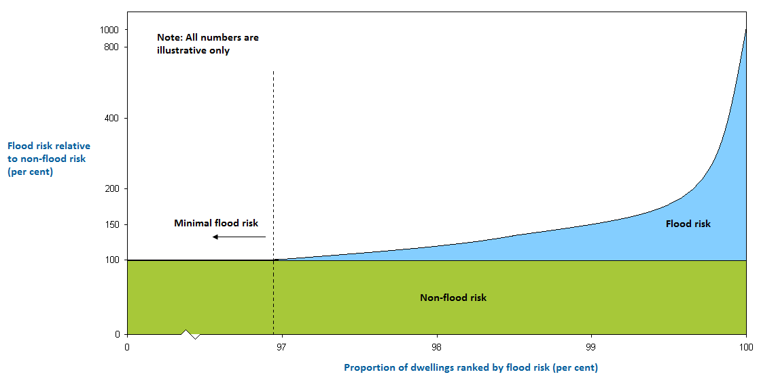
There are probably only about 50,000 homes subject to high flood risk, less than one per cent of Australia’s estimated 6.2 million homes, but if their insurance included flood cover, their premiums would reflect the high risk indicated by the curve on the right of Figure 1. There are probably a further three to six per cent of properties subject to modest flood risk.
In undertaking the Review, the Panel has considered possible new arrangements for flood insurance for homes. It also explores whether any such arrangements ought to be extended to home contents, strata title and other residential properties, and small business.
The Panel has also looked at whether there are any insurance issues related to other natural disasters. They are bushfire, cyclone and earthquake (usually covered as standard in insurance policies) and also actions of the sea and landslide.
Other matters considered by the Review Panel, in the context of availability and affordability, include non-insurance and under-insurance, consumer understanding and dispute resolution, flood risk measurement and mitigation, and some aspects of government funding of natural disaster relief and recovery. The Issues Paper examines all of these matters, explains them in various levels of detail, and poses a set of questions about each of them.

Flood insurance for homes — a way forward
The Review Panel has identified two alternative models of flood insurance for the future: that flood cover be provided automatically as part of home insurance, just as it provides cover automatically for bushfire and storm; or that flood cover be provided automatically but that homeowners be able to ’opt out’ and have home insurance that includes cover for other causes of damage but not flood. The other main possibility is to retain the status quo whereby insurers remain free to offer full, partial or nil flood cover for home insurance and homeowners are free to decide whether or not to include flood cover in their home insurance policies.
Under the first model, Automatic Flood Cover, all disputes about whether water damage is caused by flood or storm would be eliminated. Flood cover would then be in place at the same level as bushfire and storm cover for every insured home. Some homeowners, however, would face significant increases in insurance premiums under such a model unless these homeowners were given some form of assistance to enable them to continue to insure their homes. Such an arrangement would benefit the homeowners themselves, but the broader community would also benefit from extending flood cover to more homes.
Under the second model, Automatic Flood Cover with Opt Out, the take-up of flood insurance would undoubtedly be greater than under the status quo but would still remain limited. Disputes over whether water damage arose from flood or storm could also still occur for policyholders who opt out of flood cover.
Both models require three steps to give some form of assistance to owners of homes exposed to high flood risk so that their premiums become affordable:
- identifying the homes with high flood risk;
- providing discounts to some or all of these home owners; and
- funding these discounts.
Each of these steps requires careful and extensive consideration.
Distinguishing the homes with high flood risk from those with modest flood risk introduces the idea of a high-risk threshold. Two suggestions are put forward:
- an engineering threshold: the threshold is determined by flood mapping and related techniques, using for example a 1 in 100 annual return interval and perhaps also taking account of the design and construction of each house.
This approach relies on engineering techniques and the threshold is set independently of the insurance industry.
- a price threshold: the threshold is specified as an insurance premium relative to a non-flood insurance premium, for example 140 per cent or 150 per cent of the non-flood premium, and if no insurer is willing to offer a lower premium, the home owner would be eligible for a discounted premium.
This kind of threshold could be referred to as an insurance market solution to the threshold question.
The essential argument for introducing discounts is firstly the desirability and importance of solving the flood insurance availability and affordability problem, and secondly the benefit that can accrue to the broader community from a wide take-up of flood insurance. Insurance helps both individuals and communities recover from disasters, it encourages mitigation by the homeowner which also benefits the community, and it reduces the impost on charitable donors or taxpayers.
Under both systems, there is of course a need to maintain the integrity of the total system for the high-risk homes, that is, those where the flood risk is beyond the threshold. The key stakeholders (homeowners, insurers, councils and governments) all need to have a vested interest in order to avoid moral hazard and to maintain incentives for good risk management, including flood mitigation. The full details of the threshold mechanism and the associated premium discount and funding arrangements would need to meet the test of system integrity.
To devise a full insurance system for high flood-risk homes requires not only a high-risk threshold mechanism but also:
- a central vehicle of some kind, referred to in the Paper as the Flood Insurance Pool. It is shown schematically below. The Pool itself could be a form of mutual with insurers as participants, or it could operate as a reinsurer.
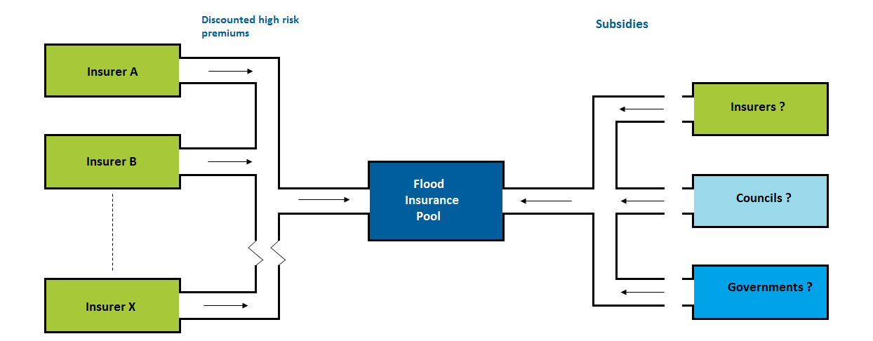
- a pricing regime: for example the price could be set at say 150 per cent of the non-flood premium (as a flat rate for all homes beyond the threshold) or, on a more risk-oriented basis, 150 per cent plus say 10 per cent or 20 per cent of the cost of flood cover beyond 150 per cent.
The discount is then the difference between the full risk-based price and the discounted price charged to the homeowner.
Note that the full risk-based price is assessed by the Flood Insurance Pool.
- eligibility criteria: which homes with high flood risk are eligible for premium discounts? It can be argued, for example, that future new homes with high flood risk should not be eligible for discounts.
- an insurance underwriting regime: for example under an engineering threshold, insurers would be obliged to accept homes beyond the high-risk threshold at the specified discounted price; under a price threshold, if no insurer were willing to offer a premium below the threshold price (of say 150 per cent), insurers would be obliged to accept homes at the specified discounted price.
- a mechanism for funding the discounts: there are several ways to deal with the discounted premiums. For example, the flood portion only of the risk could be transferred to the Pool or the whole risk could be transferred, with a suitable premium also transferred to the Pool. It is suggested that, for transfer of flood risk only, the whole flood premium plus 25 per cent of the non-flood premium would go to the Pool or, for transfer of the whole risk, 90 per cent of the whole premium would go to the Pool. The insurer shortfall implicit in the percentages, the 25 per cent and the 10 per cent respectively, are intended as incentives on insurers to accept as many homeowners as possible to their own account rather than cede them to the Flood Insurance Pool.
Another possible approach is for the whole risk to be retained by the insurer, with the insurer receiving a contribution or subsidy from the Pool to meet the cost of the discount.
- a source of funding for the discounts: the discounts have to be funded and therefore need to be subsidised by someone. The main possible sources of subsidies are governments, councils and insurers. In these cases, the subsidies would ultimately be met by, respectively, taxpayers, ratepayers or policyholders.
In considering an insurance system for high flood-risk homes, the reader’s attention is drawn to the existence of ‘residual market’ schemes known as Fair Access to Insurance Requirements (FAIR) Plans in many states in the United States. These plans, which cater for various kinds of hard to place and high risk homes, have a generic similarity to the type of insurance system for homes with high flood risk that is described in this Issues Paper. These plans are a rich source of ideas and experiences around pricing, funding, governance and risk mitigation. The Review Panel will be examining these systems further, including their successes and failures, as part of the next stage of this Review.

Other issues
Structuring an insurance system for homes with high flood risk is the key focus of the Review. As is evident from the above, it is an undertaking that involves important and in some respects difficult conceptual, technical and practical matters. Their resolution will take extensive analysis, investigation and debate following release of the Issues Paper.
However, there is a range of related issues that also need to be worked through in order to enhance the role that insurance can play in mitigating the costs of natural disasters. The Issues Paper poses a series of questions around each of them.
These questions are recorded in the addendum to this Executive Summary, for convenience both in understanding the scope of the issues being considered by the Review Panel and in framing submissions in response to this Paper.

Submissions
The Review Panel encourages all interested parties to examine the questions posed. Submissions are invited accordingly in response to this Issues Paper

The Natural Disaster Insurance Review Panel
Mr John Trowbridge (Chairman)
Mr John Berrill
Mr Jim Minto

Addendum to the Executive Summary

Questions contained in the Issues Paper

Chapter 2 — Home insurance cover for flood
Are there any other models besides Automatic Flood Cover and Automatic Flood Cover with Opt Out, supported in either case by a high flood-risk discount and funding arrangement, that could materially improve the availability and affordability of flood cover within home insurance policies?

Chapter 3 — Identifying the homes with high flood risk
How practical is the implementation of each of an engineering threshold and a price threshold?
What are the requirements for each to operate successfully?
What are the relative merits of these two approaches?
Are there any other concepts that might be applied to establish a high-risk threshold?

Chapter 4 — A high-risk flood insurance system
If the Automatic Flood Cover model or the Automatic Flood Cover with Opt Out model is introduced:
- what premium formulae and premium discounts would be appropriate for homes with high flood risk?
- what are the relative merits of the different possible ways of operating the Flood Insurance Pool in relation to transfer of risks and premiums from insurers to the Pool?
How might the Flood Insurance Pool be structured regarding its legal existence, capital, financial modus operandi and governance?
What resources and what level of access to flood mapping and related information would be needed by the Pool in order to carry out its full pricing responsibilities for the high flood-risk threshold and high flood-risk homes?
In the interests of a competitive market for home insurance with flood cover, how would the Pool need to operate in the field of flood risk measurement to maintain low barriers of entry to smaller insurers?
Which parts of the community (some or all taxpayers, ratepayers or policyholders) should ultimately fund the premium discounts and how should the subsidies be allocated?
What eligibility criteria would be the most equitable and the most effective for owners of high flood-risk homes?

Chapter 5 — Flood cover for contents insurance
If the Automatic Flood Cover model or the Automatic Flood Cover with Opt Out model is introduced for home insurance, to what extent should the flood cover in home policies be reflected in contents insurance, for each of owner occupiers and renters?
What practical issues could arise if home insurance policies were required to include Automatic Flood Cover but contents insurance policies were not required to include Automatic Flood Cover?

Chapter 6 — Flood cover for strata title and other residential property
If the Automatic Flood Cover model or the Automatic Flood Cover with Opt Out model is introduced for homes:
- How far should these arrangements apply to strata title properties?
- How far should these arrangements apply to company title properties?
- How far should these arrangements apply to mixed use strata properties (residential and commercial)?
- How far should these arrangements apply to retirement villages and aged care facilities?
- How far should these arrangements apply to caravans and mobile homes?
What would be the implications of these arrangements for bodies corporate, their members and insurers?

Chapter 7 — Flood cover for small business insurance
What, if any, are the impediments for the insurance industry in providing flood insurance for small business?
If new arrangements for flood cover for home insurance are introduced, is there a case for introducing similar arrangements for small business? And if not, what could be done to improve the affordability of flood insurance for small business?
What options are there to improve the take-up of flood insurance by small businesses?
Is there a case for any form of regulation or any other government intervention to reduce the current high levels of non-insurance by small business?
Is there a demand for insurers to extend the scope of cover for business interruption insurance? If so, what initiatives could be taken by the insurance industry and the small business community to meet this demand?
If no new arrangements are introduced for small business insurance or the Automatic Flood Cover with Opt Out model is introduced, should there be a standard definition of flood to apply to small business insurance?

Chapter 8 — Natural disasters other than flood
If new arrangements are put in place for flood cover by the Automatic Flood Cover model or the Automatic Flood Cover with Opt Out model, is there a case for extending the scope of cover to landslide and actions of the sea?
What, if any, are the impediments to the insurance industry in providing automatic cover for actions of the sea and landslide for home insurance policies?
How might these impediments be overcome?

Chapter 9 — Measuring flood risk
What are the merits of developing a single national standard for flood mapping in Australia?
What, if any, impediments are there in doing so?
Who would be best placed to develop such a standard?
Who should bear responsibility for producing and maintaining relevant flood maps? Who should fund this activity?
To what extent do land use decisions take flood risk into account?
What, if any, are the potential impediments to councils making flood maps publicly available in a way similar to the Brisbane City Council?
To what extent is the lack of consistency and availability of flood maps limiting the insurance industry’s ability to offer flood insurance?
To what degree is not having a single source for flood maps an impediment to national consistency, both in terms of how maps are developed and how they are used?

Chapter 10 — Risk mitigation and insurance
How have the building codes that have been developed in response to cyclones affected the underwriting and pricing practices of insurers and reinsurers?
How much weight can be given by insurers to flood mitigation measures in areas subject to flood risk?
To what extent are responses to the recommendations of the Victorian Bushfires Royal Commission expected to reduce bushfire risk in Victoria? How are these responses being reflected by insurers in their pricing of home insurance?
To what extent are insurers able and willing to undertake repair and reconstruction of a home following a natural disaster so that it incorporates enhancements to improve resilience before formal changes to building standards?
To what extent should decisions on these matters require the agreement of the homeowner?

Chapter 11 — Non-insurance of homes: should home insurance be compulsory?
Given the high rates of voluntary take up of home insurance, the historical right not to insure and the significant changes to the legislative framework and administrative infrastructure that would be required, is there nevertheless a case for making home insurance compulsory?
Are the data that suggest four per cent of owner occupiers do not hold home insurance reflective of the overall level of non-insurance of homes across Australia, taking into account other classes of residential property owners such as strata title property owners, investors, and owners of holiday homes?

Chapter 12 — Under-insurance of homes
To what extent would the substitution of replacement cover for sum insured cover eliminate the under-insurance of homes?
To what extent does sum insured cover plus ‘top up’ address the under-insurance of homes?
What are the relative merits of replacement cover and sum insured cover with a ‘top up’?
Whatever form(s) of cover is to be preferred, should insurers be encouraged to offer it or should it be mandated that they offer it?
If under-insurance of homes is to be minimised, should homeowners be able to purchase replacement cover only or sum insured cover with ‘top up’ only, or either? Or are there other possibilities?
In the event of total loss of a home, is there a case for changing the practices of insurers around cash settlements and other policies on rebuilding?
What arrangements could be put in place to minimise the possibility of disputes if a cash settlement is offered under a replacement cover policy?
What factors should be considered in determining whether homeowners should have the right to reject a cash settlement in favour of their insurer arranging rebuilding or repairing?

Chapter 13 — Non-insurance and under-insurance of contents
To what extent is the level of non-insurance for contents of concern to the community or to governments?
To what extent is the level of under-insurance for contents of concern to the community or to governments?
Should measures to improve affordability of contents insurance be considered?
What measures could be implemented to improve affordability?
If premium discounts are to be offered for homes with high flood risk should they also be offered for contents insurance?

Chapter 14 — The role of lending institutions
What level of responsibility do lending institutions have toward themselves and toward their home mortgage customers for:
- the purchase of insurance;
- the scope of insurance cover, and in particular whether it includes flood cover;
- the quantum of insurance; and
- the continuity of insurance during the life of the mortgage?

Chapter 15 — Consumer awareness of risk and insurance
What measures could improve consumer understanding of their insurance cover, particularly if purchased over the telephone?
How would consumers benefit from being provided with personal advice that takes account of the insurer’s assessment of the consumer’s risk?
What are the benefits for consumers being provided with scaled advice? What, if any, are the impediments for insurers and insurance brokers providing it?
Is there a particular need for unfair contracts laws to protect policyholders in natural disaster insurance?

Chapter 16 —Processing of Claims
What have been the causes of delays in processing claims other than delays caused by the need to determine whether damage was caused by storm or flood?
In cases of delayed claims processing and settlement:
- how adequate and appropriate is the nature of communication between insured and insurer?
- how adequate are the clarity and frequency of updates from insurers on the progress of the claims?
- should the insurer initiate the communication or should the onus rest with the claimant?
Should there be a time limit for decisions to be made on insurance claims arising from natural disasters? If so, how long should it be and should it be imposed by statute or under a voluntary code of practice?

Chapter 17 — Resolution of claims disputes
Should there be a mandatory time limit for insurers to respond to disputes following a natural disaster and, if so, how long should it be and should it be regulated through the industry Code of Practice or legislated?
Is there a case for improved monitoring and transparency of insurers’ internal dispute resolution processes?
What, if any, changes are needed to the responsibilities of insurers and policyholders during the dispute resolution process?
How can policyholders’ access to information during the dispute resolution process be improved with regard to reasons for decisions, documents relied upon in decision making and independent legal advice?
What can be done to improve the integrity of insurers’ internal dispute resolution processes including full disclosure of any multi-tiered dispute resolution, adequate decision making powers for dispute resolution personnel and structural separation from claims personnel?
Should consumers have access to independent legal advice in rejected insurance claims, particularly in natural disasters? If so, from whom and how should it be funded?
When a claim is not resolved because of a dispute between broker and insurer, what legislative and other steps could be taken to protect the client's interests by obliging broker and insurer to act together in the first instance to resolve the client’s claim, and then to embark separately on their own dispute over liability?

Chapter 18 — Funding public infrastructure
Would there be benefits to the States in equity and effectiveness if the NDRRA funding formula were to apply to expenditure gross of reinsurance recoveries rather than net of reinsurance recoveries?
What, if any, are the impediments to this approach?

Chapter 19 — International comparisons
Are there particular lessons to be learned from international schemes, whether featured in Appendix 4 or not, that should be considered in evaluating different models for application in Australia?

