Lifting the professional, ethical and education standards in the
financial services industry
Consultation on recommendations of the Parliamentary Joint Committee on Corporations and Financial Services’ inquiry into proposals to lift the professional, ethical and education standards in the financial services industry

March 2015

Consultation Process
REQUEST FOR FEEDBACK AND COMMENTS
Interested parties are invited to lodge written submissions on the issues raised in this paper by Thursday, 7 May 2015.
All information (including name and address details) contained in submissions will be made available to the public on the Treasury website unless you indicate that you would like all or part of your submission to remain in confidence. Automatically generated confidentiality statements in emails do not suffice for this purpose. Respondents who would like part of their submission to remain in confidence should provide this information marked as such in a separate attachment. A request made under the Freedom of Information Act 1982 for access to a submission marked confidential will be determined in accordance with that Act.
Submissions should include the name of your organisation (or your name if the submission is made as an individual) and contact details for the submission, including an email address and contact telephone number where available. While submissions may be lodged electronically or by post, electronic lodgement is strongly preferred. For accessibility reasons, please email responses in a Word or RTF format. An additional PDF version may also be submitted.

Closing date for submissions: Thursday, 7 May 2015
Email: ProfessionalStandards@treasury.gov.au
Address written submissions to :
Financial Services Unit
Financial System and Services Division
Markets Group
The Treasury
Langton Crescent
Parkes ACT 2600
Enquiries: Enquiries can initially be directed to Jongsok Oh (02) 6263 4435
The proposals outlined in this paper have not received Government approval and are obviously not yet law. As a consequence, this paper is merely a guide as to how the proposals might operate.

Section 1. Introduction
- Two important inquiries—the Parliamentary Joint Committee on Corporations and Financial Services’ inquiry into proposals to lift the professional, ethical and education standards in the financial services industry (PJC) and the Financial System Inquiry (FSI)—have both presented their recommendations to Government.
- These inquiries found that the current regulatory arrangements regarding professional standards are no longer sufficient to ensure high quality consumer outcomes and to maintain public confidence in the financial services industry.
- Following a number of high-profile advice and product failures, public confidence in the sector has been shaken.
- The Future of Financial Advice (FOFA) legislation was introduced to improve the trust and confidence of Australian retail investors in the financial advice sector. Efforts to finalise remaining technical amendments to FOFA are underway, and will give greater certainty to both consumers and the industry.
- The establishment of an industry-wide register of financial advisers is another significant development. The adviser register will enable consumers, employers and the Australian Securities and Investments Commission (ASIC) to verify the credentials of financial advisers.
- A number of major financial institutions have recently voluntarily announced that they have, or intend to, increased education standards for their advisers.
- The Government is seeking to build on this momentum to develop a framework to increase the professional, ethical and education standards applied to financial advisers. This framework should include:
- how standards will be lifted and maintained at a specified minimum level;
- how minimum standards will be monitored and enforced; and
- mechanisms for the ongoing professionalisation of the industry.
- The framework should encompass core knowledge and skills relevant to all financial advisers. It should also be flexible, with appropriate scope to accommodate advisers who provide advice on specific — or a limited range of — financial products, and allow opportunity for advisers to broaden their skills in order to move within the industry. The framework should also take into account the diversity of advice situations, including for individuals providing non-mainstream financial product advice, such as independent expert reports and actuarial services to retail clients.
- This framework will need to be developed in line with the Government’s commitment to reducing the cost of unnecessary or inefficient regulation imposed on individuals, business and community organisations by at least $1 billion a year.
- The PJC report outlines a comprehensive model to increase the professional standards of advisers, involving a co-regulatory approach where Government, professional associations, industry and academia all work in partnership. This model provides the basis for consultation.
- The Government is undertaking a period of consultation to seek views on the core elements of the PJC model, importantly including how these elements should be implemented.

1.1 The PJC model
- The PJC model focusses on individuals providing financial advice on Tier 1 financial products. Tier 1 financial products include products such as life insurance, shares, superannuation and managed investment schemes. Tier 1 financial products can be contrasted to Tier 2 financial products which are generally simpler in nature. Tier 2 financial products include general insurance products, consumer credit insurance, and basic deposit products.
- Under the PJC model, a financial adviser must be registered to provide financial advice. To be registered, the financial adviser must:
- be a member of a Professional Standards Councils (PSC) approved professional association;
- be degree qualified;
- complete a professional year;
- pass a registration exam; and
- undertake ongoing professional development.
- The PJC model requires approved professional associations to establish an independent, professional standards-setting body called the Financial Professionals' Education Council (FPEC) that will be controlled and funded by professional associations which have been approved by the PSC.
- Under the PJC model, professional association membership is mandatory, and the role of a professional association is to:
- advise ASIC when an adviser has passed the registration exam and completed their professional year;
- advise ASIC if an adviser is no longer suitable to be registered;
- manage members' professional year and continuing professional development;
- establish a code of ethics for member advisers; and
- fund, control and be represented on the FPEC.

1.2 Invitation to consult
- This paper invites consultation on Recommendations 4, 5, 7, 8, 9, 10, 11, 12 and 13 of the PJC report.
- Recommendations similar to 1, 2, 3 and 6 of the PJC report were also made by the FSI and are being addressed through the consultation process related to that inquiry. Recommendation 14 of the PJC report relates to the timing of implementation and is addressed in general in Section 9 of this consultation paper.
- The key elements of the PJC model are outlined in Diagram 1 (including references to the relevant section of this consultation paper). The diagram in Attachment B outlines the roles and responsibilities of various parties in the PJC model.

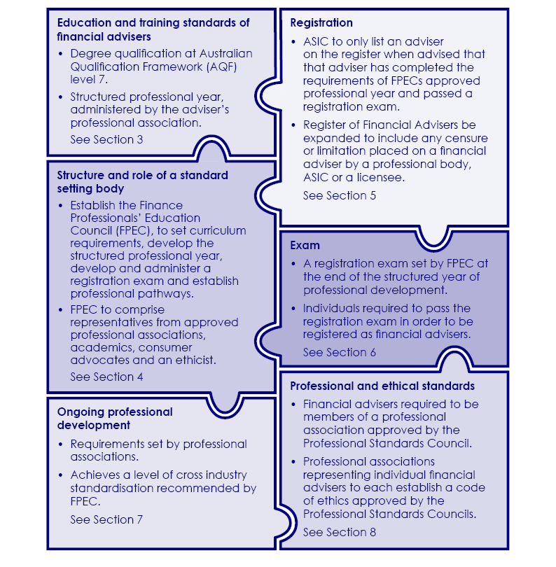
Diagram 1: Key components of the PJC model

Feedback sought — the PJC model
The introduction of the model recommended by the PJC would represent a substantial change to the current regulatory environment for financial advisers.

Question 1.1
What impact would the introduction of the PJC model have on the structure of the financial advice industry?

The PJC model would apply equally to advisers working in different size firms and under different licensee structures.

Question 1.2
What are the practical implications of the PJC model applying to advisers from all sizes and types of firms?

Under the PJC model, ASIC, licensees, the PSC, FPEC and the professional associations will have a role in raising standards and ensuring these are met on an ongoing basis.

Question 1.3
Are the lines of responsibility clear under the PJC model?

Section 2. Key aspects of the current regulatory framework
- Much of the current regulatory framework has its origins in the recommendations made by the 1997 Financial System Inquiry, known as the Wallis inquiry, and the Corporate Law Economic Reform Program (CLERP) Paper No. 6.
- Individuals who provide financial product advice to retail clients in Australia are regulated by a two stage licensing and authorisation regime set out in the Corporations Act 2001 (the Corporations Act).
- A person who carries on a financial services business must obtain and maintain an Australian Financial Services (AFS) Licence with ASIC. This person is referred to as a financial services licensee (licensee).
- A person carries on a financial services business if they provide financial product advice. Financial product advice is a recommendation or a statement of opinion, or a report of either of those things, that is provided with the intention of influencing a person’s decision in relation to a financial product. The AFS licencing regime covers those providing advice on Tier 1 and Tier 2 products.
- Financial product advice is classified into two categories. 'Personal advice' is advice which takes into account the personal financial circumstances of the client. Any other financial product advice that does not take into account the client’s personal circumstances is termed 'general advice’.
- Individuals may provide financial product advice in a range of circumstances. They may be licensees themselves; or directors or employees of licensees. Alternatively, they may be non-director/non-employee representatives of licensees — these individuals are referred to as ‘authorised representatives’.
- In certain circumstances, an authorised representative can ‘sub-authorise’ another authorised representative to act on behalf of the licensee (see Diagram 2).

Diagram 2: Current regulatory arrangements
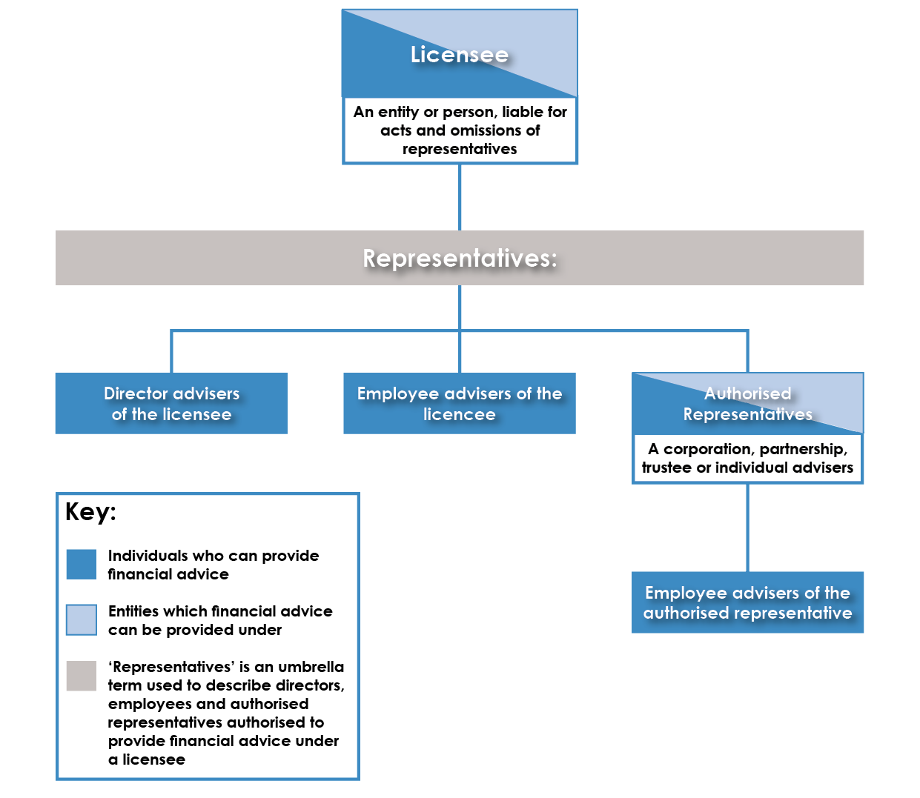
- ‘Representative’ is the overarching term used to describe authorised representatives, director representatives and employee representatives (including those that operate under a related body corporate of the licensee) and any other person acting on behalf of the licensee, that provide financial services under a licence.
- Licensees are responsible for the day-to-day supervision of their representatives. The Corporations Act requires licensees to comply with the conditions on their AFS licence as imposed by ASIC, maintain competence to provide the financial services covered by their licence, and ensure that their representatives are adequately trained and competent to provide those financial services.
- Regulatory Guide 146 Licensing: Training of financial product advisers (RG 146) sets out ASIC’s guidance on the minimum training standards for financial advisers and how advisers can meet these training standards. RG 146 establishes education and training requirements, but does not include an ethics component, nor does it specify minimum continuous professional development and experience requirements.

Feedback sought — current regulatory framework
Under the current regulatory arrangements, the legal obligation to ensure advisers meet the relevant training and competency standards falls on licensees. ASIC is responsible for ensuring that licensees comply with the conditions of their AFS licence.
Under the PJC model, responsibility for meeting (and ensuring compliance with) training and competency standards is expanded to individual advisers and professional associations.

Question 2.1
What are the practical implications of this overlapping of responsibilities? Would this shift have flow-on implications for other provisions in the Corporations Act, or any other parts of the licensing regime?

Question 2.2
Should licensees maintain a legal obligation to ensure advisers meet relevant training and competency standards?

Section 3. Education and training standards of financial advisers

3.1 Education standards
- Under the PJC model, the mandatory minimum educational standard for financial advisers providing advice on Tier 1 products would be increased to a degree qualification at AQF level seven (Bachelor Degree) (Recommendation 7).
- The FSI also recommended that the minimum standard for those advising on Tier 1 products should include a relevant tertiary degree.
- Under current arrangements, training courses meet standards if they have been assessed by an authorised assessor as meeting ASIC’s knowledge and skill requirements to the relevant educational level (specified in RG 146). The role of authorised assessor can be performed by registered training organisations; self-accrediting organisations; or a professional or industry association relevant to the financial services industry that has been accredited by ASIC.
- Some financial advisers, such as stockbrokers, and those who advise on tax matters, currently have to comply with sector-specific laws and regulatory bodies.

3.2 Training standards
- The PJC model requires the introduction of a structured professional year that enables professional associations (in accordance with the requirements established by FPEC and in cooperation with the licensee) to conduct both mentoring and assessment of competence in a range of specified areas (Recommendation 10). Ongoing professional development is discussed in Section 7 of this consultation paper.
- The formal assessment of this professional year would be complemented by an exam set by FPEC, conducted at the end of the professional year. The exam is discussed in Section 6 of this consultation paper.
- The PJC model then binds the successful completion of this year to the registration process. Successful completion of an exam would become a prerequisite for the professional association to make the recommendation to ASIC that a financial adviser be listed on the ASIC register of financial advisers (Recommendation 8). The registration process is discussed in Section 5 of this consultation paper.

Feedback sought — education and training standards of financial advisers

Question 3.1
How would the PJC model interact with existing regulatory regimes for specific types of advisers, for example stockbrokers and tax advisers?

Under the PJC model, financial advisers providing personal advice on Tier 1 products would be required to hold a relevant Bachelor Degree.

Question 3.2
Is holding a relevant Bachelor Degree the appropriate minimum education requirement? What is a “relevant” Bachelor Degree? Would this requirement limit the ability of other degree-qualified individuals to become financial advisers?

Question 3.3
What are the practical implications of requiring advisers to hold a relevant Bachelor Degree?

Under the PJC model, financial advisers providing personal advice on Tier 1 products would be required to undertake a professional year and ongoing professional development.

Question 3.4
What are the practical implications of requiring new advisers to undertake a structured professional year at the outset of their careers as financial advisers, as a way to develop on-the-job skills?

Section 4. Structure and role of a standard-setting body
- The PJC model involves establishing an independent body —FPEC — to set and monitor the educational framework that applies to financial advisers (Recommendation 10). FPEC would set core subjects to be undertaken, and on advice from the constituent professional associations, set sector specific subjects for different types of financial advice. FPEC would also set, maintain and accredit the qualifications and continuing professional development standards that are to apply to financial advisers (Recommendation 10).
- The PJC recommends establishing FPEC as in its view, limited progress has been made to improve the training standards of financial advisers under the current regulatory framework and since previous inquiries presented their findings.
- The PJC considered that having multiple bodies administering the educational requirements for financial advisers (as per current arrangements) is not in the best interests of consumers.
- The PJC’s FPEC is based on the “Financial Planning Education Council” established by the Financial Planning Association of Australia in 2011 which is industry-funded and comprises academics and industry professionals.
- The PJC recommends that FPEC:
- be controlled and funded by professional associations which have been approved by the PSC;
- comprise a representative from each approved professional association, an agreed number of academics, at least one consumer advocate, preferably two who represent different sectors, and an ethicist;
- receive advice from ASIC about local and international trends and best practices to inform ongoing curriculum review;
- set curriculum requirements at AQF level seven standard for core subjects and sector specific subjects (e.g. self-managed superannuation fund services, financial advice, insurance/risk or markets);
- develop a standardised framework and standard for the professional year to be administered by the professional associations;
- develop and administer, through an external, independent invigilator, a registration exam at the end of the professional year; and
- establish and maintain the professional pathway for financial advisers, including recognised prior learning provisions and continuing professional development.
- Under the PJC model, a key role for FPEC is to determine Recognition of Prior Learning (RPL) criteria so as to provide existing advisers a transition pathway to be compliant with the new education standards. For further information on transitional arrangements, see Section 9 of this consultation paper.
- As FPEC is to be funded by industry, it would effectively be a self-regulating body.

Feedback sought — structure and role of a standard-setting body
The PJC model would establish an independent FPEC as the central body to set education standards, professional year requirements, registration exam content and ongoing professional development requirements.
Under the PJC’s recommendations, FPEC would be funded by approved professional associations and would comprise representatives from those associations, academics, consumer advocates and an ethicist.

Question 4.1
What are the practical implications of FPEC performing this role? For example:
- how would FPEC interact with regulators and government agencies, such as ASIC, and education bodies?
- would FPEC need to be supported by legislation in order to perform its role?
- is the recommended FPEC membership appropriate?

Question 4.2
Are there alternative arrangements that would be more appropriate or effective?

Section 5. Registration
- Under the PJC model, to be registered, a financial adviser must be listed on ASIC’s register of financial advisers (the Register).

Register of financial advisers
ASIC is currently establishing the Register. Prior to the introduction of the Register, licensees were not required to provide ASIC with certain information on director or employee representatives that operate under their licence. Licensees were however required to lodge certain information about their authorised representatives with ASIC, which was maintained on a separate register.
Consequently, there was no register that provided information to consumers, the financial advice industry, or ASIC regarding employee and director representatives of licensees.
The Register will contain information on all individuals who provide personal advice on Tier 1 financial products to retail clients under an AFS licence. This will enable consumers to verify that their individual adviser is appropriately authorised to provide advice and to find out more information about the adviser before receiving financial advice.
From March 2015, the Register will display:
- each adviser's name, unique individual registration number and status;
- the year each adviser began advising, and each adviser’s five year advising history;
- each adviser's current financial services licensee and authorised representative (if applicable), and a direct link to the business names associated with these entities;
- what product areas the adviser can provide advice on;
- any bans, disqualifications or enforceable undertakings; and
- where applicable, each person that controls the financial services licensee.
From May 2015, the Register will also display:
- up to five of each adviser’s training courses and qualifications (as determined by licensees); and
- up to five of each adviser’s professional association memberships (as determined by licensees).
- Under the PJC model, to be listed on the Register, an adviser must:
- have met the education and training requirements (be degree qualified and have completed a professional year);
- have passed a registration exam;
- be undertaking ongoing professional development; and
- be a member of a PSC-approved professional association.
- The professional association of which the adviser is a member would then notify ASIC that the adviser has completed all the requirements.
- The current function of the Register is to provide a reference point for consumers, employers and ASIC itself to verify the credentials of financial advisers.
- The PJC model recommends that the current function of the Register be modified so that being listed on the Register becomes a requirement to practice as a financial adviser.
- This represents a partial shift in the regulatory regime, where the obligation to comply partly moves from the licensee to the individual adviser.
- The PJC also recommends expanding the Register to:
- record any higher qualification awarded by a professional body to the adviser;
- include any censure or limitation placed on a financial adviser by a professional body, ASIC or a licensee; and
- highlight where a professional association has suspended or revoked an adviser’s membership, and so the adviser is no longer authorised to provide financial advice.
- These recommendations are aimed at ensuring only suitably qualified and competent financial advisers are allowed to provide financial advice.
- A related PJC recommendation is to bring forward legislation to protect the titles 'financial adviser' and 'financial planner' and require that to be eligible to use the title 'financial adviser', an individual must be registered as a financial adviser (Recommendation 4).
- This recommendation is also intended to assist consumers to better understand the nature of the information and advice they are receiving, and that only suitably qualified people can legally provide financial (personal) advice. Protection of titles is a key part of separating professional and non-professional roles, and of placing higher value in being a professional.

Feedback sought — registration
Under the PJC model, individuals must be listed on the Register in order to practice.

Question 5.1
What are the practical implications of requiring individuals to be registered in order to provide financial advice?

Question 5.2
Should it be the role of professional associations to notify ASIC that all requirements have been met for an adviser’s registration, and of factors which affect their subsequent fitness for registration?

The PJC recommends that, in addition to the information currently required to be listed on the Register, an adviser’s completion of the relevant education requirements, professional year and registration exam, and their professional association membership, higher qualifications and any censure or ASIC action, also be listed.

Question 5.3
What are the practical implications of having these criteria listed on a public adviser register?

Question 5.4
Are there alternative or additional criteria that should be listed on the Register?

The current Register requires licensees to provide information to ASIC about individual advisers. Under the PJC model this responsibility would be shifted to professional associations.

Question 5.5

What are the practical implications of having professional associations perform this role? For example, are professional associations sufficiently resourced and how would they interact with ASIC in relation to these requirements? Does this approach dilute the responsibility of licensees?

Question 5.6

Is legislative protection of the titles ‘financial adviser’ and ‘financial planner’ necessary?

Section 6. Exam
- The PJC model would introduce a registration exam at the end of the structured year of professional development (Recommendations 5 and 8). Candidates would need to pass this exam, along with meeting other requirements, in order to be placed on the Register and hence be able to provide personal financial advice on Tier 1 products.
- The exam, to be developed by FPEC, would assess theoretical and applied knowledge and be independently supervised, with FPEC selecting and monitoring the work of external invigilators. FPEC would also establish a policy on the setting and conduct of the exam, including re-examination options.
- An exam would be an objective way to ensure all financial advisers have the requisite training and knowledge to perform their duties to a reasonable minimum standard. It could also be a central part of the transitional arrangements for existing advisers, along with a process of Recognised Prior Learning. For further information on transitional arrangements, see Section 9 of this consultation paper.
- The FSI did not recommend a national exam for advisers, but noted that an exam could be considered if issues in adviser competency persist.

Feedback sought — exam
The PJC model introduces a registration exam at the end of the structured year of professional development.

Question 6.1
Do you consider a registration exam should be a component of a framework to improve professional standards? Should the exam apply to both existing and new advisers?

Question 6.2
What are the practical implications of the use of a registration exam?

Question 6.3
What content should be covered in the exam?

Question 6.4
Is FPEC the appropriate body to set the exam? Who should be responsible for invigilating the exam? Who should be responsible for marking the exams?

Section 7. Ongoing professional development
- Recommendation 9 of the PJC model requires mandatory ongoing professional development for financial advisers that:
- is set by their professional association in accordance with PSC standards; and
- achieves a level of cross-industry standardisation recommended by FPEC.
- The approved professional associations will have the responsibility to develop the ongoing professional development opportunities available to and expected of their members. While professional associations must administer an appropriate level of continuing professional development to meet the PSC requirements, each association is expected to work with FPEC to achieve a level of cross-industry standardisation.

Feedback sought — ongoing professional development
The PJC model requires mandatory ongoing professional development for financial advisers.

Question 7.1
What are the practical implications of the proposed ongoing professional development requirements?

Question 7.2
Are professional associations well-placed to administer ongoing professional development requirements?

Section 8. Professional and ethical standards

8.1 Codes of ethics
- Codes of ethics are one mechanism by which a profession can raise standards and hold themselves to account, and can complement other measures. Such codes include both a set of requirements and the commitment of the members of the profession to conform to, and uphold, the rules stipulated in the code.
- Promoting an ethical culture and ethical behaviour is a core part of professionalisation. The FSI recommended ethical requirements be part of ongoing professional development.
- The PJC’s view is that there needs to be a change in the drivers of behaviour in the financial advice industry. To set this new benchmark, the PJC recommends that professional associations be required to establish codes of ethics which are compliant with the requirements of a Professional Standards Scheme under the PSC (Recommendation 11).

8.2 Role of the PSC
- The PSC occupies a pivotal role in the PJC model through its power to approve professional associations.
- The PJC recognised that its model envisages an expanded role for the PSC, and noted that the PSC may require additional resources to perform at this level.
- Under the PJC model, financial sector professional associations that wish to have representation on FPEC and be able to make recommendations to ASIC regarding registration of financial advisers, are required to establish PSC approved Professional Standards Schemes within three years (Recommendation 12).
- Professional Standards Schemes are legal instruments that cap the occupational liability of professionals who take part in an association’s scheme if a court upholds a claim against them. In return, members must raise their professional standards and hold insurance (or assets) up to the level of the applicable cap. The liability caps exist to maintain affordable levels of professional indemnity insurance, as well as to improve professional standards and consumer protection. The principle is to reduce liability through better risk management.
- In assessing a professional association's application for a Professional Standards Scheme, the PSC considers:
- an analysis of the proposed scheme (prepared by the PSC's Secretariat);
- independent actuarial analysis of the members' liabilities; and
- material received from public consultation.
- Applying for a scheme is an intensive process that takes most associations around 12 months. Professional associations must: ensure that their members are able to improve their risk management practices; have appropriate continuing professional education requirements; and have complaints and disciplinary mechanisms in place.

8.3 Role of professional associations
- Under the PJC model, every financial adviser would be required to be a member of a professional association approved by the PSC (Recommendation 13). This also means that all financial advisers will be working under the auspices of at least one compliant code of ethics.
- Once approved by the PSC, the professional association would advise ASIC regarding the fitness for registration of its individual members, based on the requirements outlined in Section 5 of this consultation paper. The approved professional association would also advise ASIC on the continuing fitness for registration of individual advisers based on their achievement of mandatory ongoing professional development and compliance with the code of ethics. The approved professional association will be directly responsible for setting the benchmark expected of its members, and for holding them to account.
- Under the current regulatory regime, there is no requirement to be a member of a professional association, thus a large number of advisers are not currently members of an association.

Feedback sought — professional and ethical standards

Code of ethics
The PJC recommended that professional associations be required to establish codes of ethics that are approved by the PSC.

Question 8.1

What are the practical implications of having each professional association create its own code of ethics? For example, what are the implications of having multiple codes as opposed to a single code?

Question 8.2

What are the practical implications of requiring that a code of ethics be approved by the PSC? Are there alternative approaches that would be more appropriate or effective?

Role of the PSC

The PJC model uses the PSC as a key mechanism to drive continuing improvements in the professional standards of the financial advice industry. Under the PJC model, a professional association will need to have schemes approved by the PSC in order for its members to be registered as financial advisers, and for the association to be a member of FPEC.

Question 8.3

Is the PSC the appropriate body to drive improvements in professional standards in this industry? Are there alternative arrangements that would be more appropriate or effective?

Question 8.4

What are the practical implications of having the PSC perform this role? For example, how would the PSC interact with ASIC?

Question 8.5

What are the practical implications of requiring professional associations to hold a PSC-approved scheme?

Approval of a scheme under the PSC has previously meant capped liability for participants.

Question 8.6

Is it appropriate that liability in relation to financial advice/services be limited at this time? Is limitation of liability a necessary element for the operation of the PJC model?

Question 8.7

What are the practical implications of capping liability? For example, what changes to Commonwealth and/or state and territory legislation would be required?

Question 8.8

Would an alternative arrangement, under which a scheme’s approval would not limit liability, be practicable?

Role of professional associations

Question 8.9

What are the practical implications of mandating membership of a professional association? Are there implications arising from the increased responsibility on professional associations rather than on the licensee?

Section 9. Other issues for consideration

Advice on Tier 2 products
- The PJC model considers individuals providing personal advice on Tier 1 financial products, but not Tier 2 financial products. ASIC would continue to set and enforce the minimum standards required for advice related to Tier 2 products.

Transitional arrangements
- The PJC reports notes that a variety of transitional arrangements may be needed for financial advisers who are at different stages of their careers, including for people changing careers.
- The pool of existing advisers is significant. The PJC was of the view that even if existing advisers do not hold formal tertiary qualifications, years of practice have equipped many of them with the knowledge and experience to provide effective and ethical advice to consumers.
- The PJC report considered that structured and consistent assessment of existing advisers and people changing careers is central to maintaining the integrity of the profession. As such, FPEC would play a key role in determining Recognised Prior Learning criteria and in developing transitional pathways.

Timing and interim arrangements
- Recommendation 14 of the PJC report sets out a timeframe for implementing all of the recommendations. This timeline was developed with the view that swift and decisive action is required to raise the professional, ethical and education standards of financial advisers.

Table 1: Recommendation 14 of the PJC report
Transitional arrangement and timeframes | Date
Provisional registration (available to existing financial advisers from the implementation of the proposed government register until 1 Jan 2019 to address the goal of transparency) | Mar 2015
Finance Professionals’ Education Council (FPEC) established | 1 Jul 2015
FPEC releases AQF-7 education standards for core and professional stream subjects | Jun 2016
Establishment of codes of ethics compliant with Professional Standards Scheme guidelines | Jul 2016
FPEC approved AQF-7 courses available to commence | Jan 2017
FPEC releases recognised prior learning framework (dealing with existing advisers and undergraduates who commence AQF-7 courses prior to Feb 2017) | Jul 2016
FPEC releases professional year requirements including a recognised prior learning framework for existing advisers | Jul 2016
Professional associations operating under PSC Professional Standards Schemes | 1 Jan 2017
Target date for existing financial advisers to qualify for full registration | 1 Jan 2018
Cut-off date for full registration – provisional registration no longer available | 1 Jan 2019

- The PJC model involves deferral of key policy considerations and frameworks to FPEC. This will have implications for timing, and interim arrangements may be needed whilst the proposed FPEC is being established and becomes operational.

Feedback sought — other issues for consideration

Advice on tier 2 products

Question 9.1

How could the PJC model interact with the existing Tier 2 adviser training and competency requirements?

Transitional arrangements

Question 9.2

Do you consider FPEC to be the best entity to determine transitional arrangements for existing advisers and advisers wishing to move within the industry?

Question 9.3
Do you consider Recognised Prior Learning a suitable transitional arrangement for existing advisers?

Question 9.4
What is an appropriate timeframe over which existing advisers should transition to the new system?

Question 9.5

Are there any alternative transitional arrangements that would be more appropriate or effective, for either new or existing advisers?

Timing
The PJC recommended an implementation timeline that would see FPEC establish education standards by June 2016, professional associations operating under a PSC approved scheme by 1 January 2017 and all advisers (new and existing) to be fully registered by 1 January 2019.

Question 9.6

Are there any particular elements of the PJC model that present timing challenges?

Question 9.7

What timing or phasing would most effectively balance the recognised need to raise standards and competency in the short-term against practicalities of implementing a new model to raise standards of new and existing advisers over the longer term?

Attachment A — Regulation impact

Current industry arrangements and impact of any changes
The Australian Government Guide to Regulation requires that every policy option be carefully assessed, its likely impact costed and a range of viable alternatives considered in a transparent and accountable way against the default position of no new regulation. In line with this, every policy proposal designed to introduce or abolish regulation must be accompanied by an Australian Government Regulation Impact Statement, or RIS.
A RIS must contain an overview of likely impacts, an outline of regulatory costs and cost offsets and analysis of the likely regulatory impact and a formal cost–benefit analysis of various policy options.
Consistent with these requirements, a RIS considering different policy options for increasing the professional standards of financial advisers would be undertaken prior to a policy position being agreed by Government.

Feedback sought – Regulation impact
To help inform the RIS process, which will consider a range of policy options (one of which would likely be the introduction of the PJC model), we are seeking information on the current structure and education of the industry.

Question 1

How many/what proportion of financial advisers are likely to be affected by the introduction of a new professional standards framework (such as that proposed by the PJC)? If you are a licensee, how many/what proportion of your advisers would likely be affected?

Question 2

What proportion of financial advisers working in the industry are typically new entrants (for example, graduates and those coming from other professions) versus existing advisers who have been in the industry for a number of years? If you are a licensee, what proportion of your advisers are new entrants (versus existing advisers)?

Question 3

What is the typical education level of financial advisers? If you are a licensee, what proportion of your advisers hold a relevant tertiary degree?

Question 4

What proportion of advisers are currently members of a professional association(s)? If you are a licensee, what proportion of your advisers are members of a professional association(s)?

The PJC model would represent a substantial change to current requirements.

Question 5:

What are the likely costs (labour and non-labour costs) associated with the various elements of the PJC model? These costs could include, for example, the direct costs to:
- individual financial advisers;
- professional associations; and
- licensees.

Are costs likely to vary between different size advice firms, different professional associations, etc? If so, how?

The RIS will canvass various options and models for raising professional standards.

Question 6:

Are there alternative options (other than the PJC model) which would provide an enhanced cost-benefit outcome?

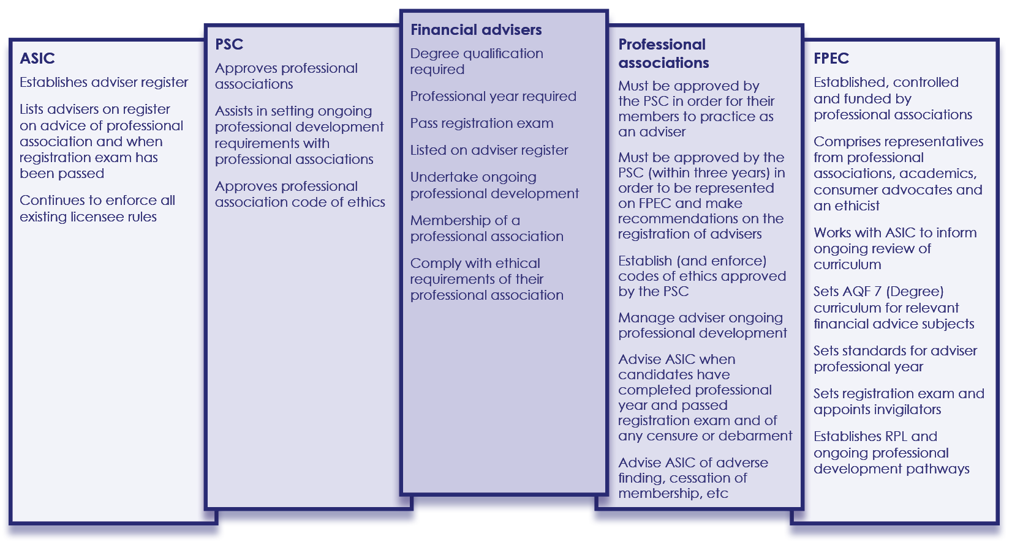
Attachment B — roles and responsibilities under the PJC model

Parliamentary Joint Committee on Corporations and Financial Services, Inquiry into proposals to lift the professional, ethical and education standards in the financial services industry, December 2014, available at www.aph.gov.au.
Financial System Inquiry, Final Report, November 2014, available at www.fsi.gov.au.
ASIC divides products into Tier 1 and Tier 2 in Table 3 of Regulatory Guide 146 Licensing: Training of financial product advisers.
See www.psc.gov.au for further information on the Professional Standards Councils.
To see the recommendations in full, see pages xiii-xvi of the PJC report, available at www.aph.gov.au, and pages xxii-xxviii of the FSI Final Report, available at www.fsi.gov.au.
The Financial System Inquiry 1996 (Wallis) final report is available at www.fsi.gov.au/publications, and the CLERP Paper No. 6 is available at www.archive.treasury.gov.au.
Section 766B, Corporations Act 2001.
Section 912A, Corporations Act 2001.
Stockbrokers who are market participants and hold AFS licences are also subject to market integrity rules set out in ASIC Market Integrity Rules (ASX Market) 2010.
Advisers who provide tax advice are also regulated by the Tax Practitioners Board, and must also comply with requirements under the Tax Agent Services Act 2009.
Parliamentary Joint Committee on Corporations and Financial Service, Inquiry into Financial Products and Services in Australia, November 2009.
See www.asic.gov.au/for-finance-professionals/afs-licensees/financial-advisers-register for more information on the Register.
Parliamentary Joint Committee on Corporations and Financial Services, Inquiry into proposals to lift the professional, ethical and education standards in the financial services industry, December 2014, p.70. Report available at www.aph.gov.au.
Further information is available on the Professional Standards Councils website, www.psc.gov.au.
Parliamentary Joint Committee on Corporations and Financial Services, Inquiry into proposals to lift the professional, ethical and education standards in the financial services industry, December 2014, pp.55-56. Report available at www.aph.gov.au.
As at 10 May 2013, there were 51,147 authorised representatives of AFS licensees providing financial services advice in Australia (ASIC answers to questions on notice, 22 April (received 13 May 2013), Schedule 2 of the Corporations Amendment (Simple Corporate Bonds and Other Measures) Bill 2013).
Parliamentary Joint Committee on Corporations and Financial Services, Inquiry into proposals to lift the professional, ethical and education standards in the financial services industry, December 2014, pp.55-56. Report available at www.aph.gov.au.

