THE HYDROGEN HIGHWAY
The Proposal
We are seeking your support for a trial of hydrogen powered higher productivity heavy vehicle(s) operating between Perth and Port Hedland in Western Australia.
The Project Outline
The Hydrogen Highway will become the first network of roads in Australia equipped with hydrogen refilling stations, allowing the use of hydrogen fuel cell electric vehicles. The Hydrogen Highway will focus on heavy transport, helping to introduce zero emission transport, lower cost fuel, and eventually, a more secure national fuel supply, reducing the need for Australia to import diesel. Phase 1 of the project will run along Highway 95 from Perth to Port Hedland, linking the state capital with the Pilbara region. The subsequent stages will lead to an expansion of the Hydrogen Highway across the State and then in collaboration with other initiatives across Australia. Each refuelling stop will include tourist, accommodation, food and recreation facilities, and all refuelling stations will have separate bays to also accommodate passenger vehicles equipped with plug-in charging facilities for battery electric vehicles.
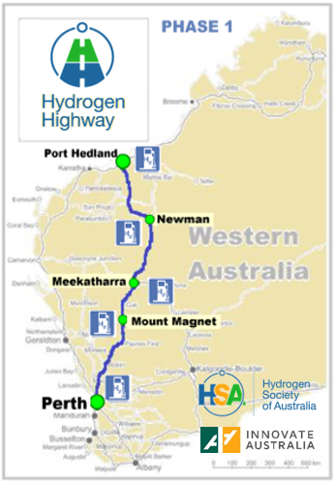
Hydrogen: A Clean and Efficient Power Source
Hydrogen as a power source has a wide range of benefits over traditional fuels. This includes:
- it is a much cleaner energy power source - it has zero pollution if made from renewables;
- it has 236 times greater energy output per kilogram than a battery;
- unlike electric batteries, increasing the range of a hydrogen powered vehicle does not require a commensurate increase in vehicle structure and mass;
- it can be made anywhere;
- it can help to address critical fuel supply issues in Australia;
- it has the potential to act as a catalyst for the development of new industries and technologies in Australia; and
- it is much cheaper than diesel.

A Natural Advantage for Western Australia
There are a number of advantages from initiating this project in WA:
- the state has existing expertise in working with hydrogen gas contained within its workforce and tertiary institutions;
- companies in WA have developed a hydrogen conversion kit for heavy vehicles;
- geographically there are long distances to travel making it well suited to taking full advantage of this technology;
- it will contribute to the diversification of the state’s fuel supplies;
- hydrogen refilling stations can be placed at tourist hubs; and
- it will help to create new industries and additional jobs, in particular in regional areas in Northern Australia;
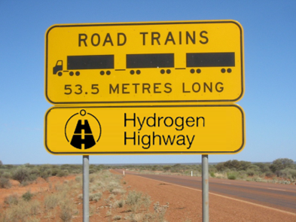
Opportunity to be a World Leader
The heavy vehicle industry in Western Australia operates the largest on-road vehicle combinations in the world, and in some of the harshest conditions. Combining these operating conditions with our natural advantage provides a realistic opportunity to be a world leader.
The Imperative for Change
We are in a unique position to profit from a once in a lifetime confluence of technological innovations and global market shifts – the beginning of hydrogen-powered heavy haulage.
Western Australia relies on its road transport industry to support the state economy and its communities, including those in remote locations. The road transport industry currently depends on diesel. The state consumes over 25% of Australia’s diesel usage, yet currently holds stores of less than 17 days of diesel, which is well below the internationally mandated 90 days. Given the increasing uncertainty in our region, action must be taken to find alternative secure fuel sources in order to mitigate the risk.
The Trial
It is proposed to conduct a trial of a hydrogen powered heavy vehicle(s) from Perth to Port Hedland. The trial vehicle would be a higher productivity vehicle to help offset the operating costs incurred by the trial company.
Funding
Funding of $496,800 excl GST is required and is being sought from the Commonwealth Government to develop the business case and prepare the project planning for the trial.
Funding for the operational trial will be separate and will be confirmed during the resource planning phase of the project.
The project would begin in March 2019 and the final report would be due by the end of June 2019.
Scope of work
The Scope of Work is detailed below:
- complete the initial Business Case for the Hydrogen Highway;
- complete the financial model;
- interact with the relevant stakeholders;
- identify hard dollar funding commitments and in-kind contributions from the private sector;
- report regularly to stakeholders;
- prepare initial scenario planning;
- prepare initial demand modelling;
- prepare initial operational modelling;
- prepare the initial project plan; and
- prepare the initial resource plan.

Project Leadership and Management
This project is a joint initiative of Innovate Australia, Regional Development Australia (Perth), the Hydrogen Society of Australia, the Western Roads Federation, and their partners. The project was conceived of, and will be led by, Innovate Australia, who will also drive the fundraising for the trial in collaboration with RDA Perth.
A working group will be established from the project partners (and including the Commonwealth government) to oversee the project. The working group will finalise the terms of reference for the project, which will be advertised publicly to allow the best possible response to deliver on the terms of reference. The working group will undertake a clear and transparent process to decide on the best proposal. A project manager will be appointed to manage the selected proponent(s) and report back to the working group within a specified reporting framework.
Project Supporters and Stakeholders
The following organisations are actively involved as supporters of the project:
- Innovate Australia
- Hydrogen Society of Australia
- Regional Development Australia
- Western Roads Federation
- Freight and Logistics Council of WA

Other organisations that have expressed an interest to be involved include:

- Fortescue Minerals Group (FMG)
- Department of Transport, Western Australia
- Main Roads Western Australia
- ATCO
- SAP
- Calibre
- Hazer Group
- Curtin University
- Fremantle Port Authority

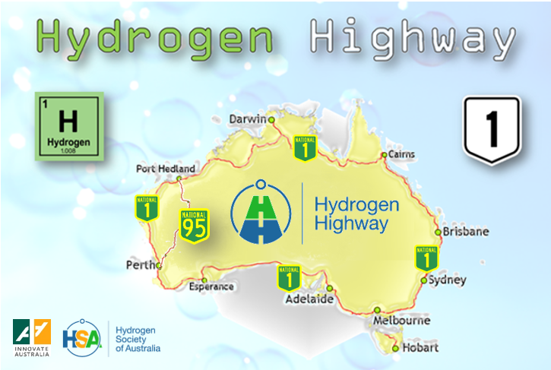

Our request
We seek the support of the Commonwealth Government, both as active participants and as project funding contributors in the amount of $496,800 excl GST.

Innovate Australia was established in 2014 to encourage, assist and proactively promote Australian innovation. The organisation works with industry to bring about and encourage innovation, to showcase innovation, and to develop innovative programs and innovation networks. It is a not for profit, independent facilitator with a wide national footprint. More information is provided at https://innovateaustralia.org/.

