Tracking mergers in Australia using worker flows

Prepared by Competition Review Taskforce[1]

|  |
| --- |
| Key points   * Regulators and researchers only have partial visibility of mergers and acquisitions in Australia. * We develop the first mergers database for Australia using administrative data, which gives a more complete picture of mergers and acquisitions. * This new mergers database can be linked with other administrative datasets, allowing researchers to examine the impact of mergers on wages, productivity, market share and other outcomes. * Preliminary results indicate there are around 1,000 to 1,500 mergers annually with larger firms tending to acquire smaller firms. * We find activity by larger firms increased over time and is most common in manufacturing, retail, professional services and health and social services. * The Competition Review Taskforce is currently looking at incorporating administrative ownership data to this methodology and exploring how merger activity influences economic outcomes across industries. |

# Introduction

Businesses in Australia inform regulators of mergers and acquisitions if certain conditions are met. For example, firms notify the Australian Consumer and Competition Commission (ACCC) if a merger may result in a substantial lessening of competition. Firms proposing to merge can also voluntarily seek the ACCC’s view either through an informal pre-assessment or a voluntary formal authorisation process. Through these channels, the ACCC has considered 330 mergers each year on average over the past 10 years. As a result of this reporting regime, regulators and researchers have only partial visibility of mergers occurring in Australia.

This incomplete view of business activity hinders policy making and research. For example, there has been no economy-wide evaluation of the effects of mergers and acquisitions on workers, competition, and productivity. This makes it harder to form an evidence-base to both inform policy and to help influence stakeholders.

The Competition Review seeks to address these gaps by building the first mergers database for Australia using administrative data. This work combines two approaches:

* Tracking worker movements to identify mergers where the target firm was absorbed into the acquirer.
* Integrating administrative data to capture mergers when ownership changes.

This Competition Review Research Note presents preliminary results from the first of these approaches, alongside information on the methodology.

# Methodology

## Worker flow filters

Figure 1 below presents a summary of the steps in creating the worker flow mergers and acquisition database. We adopt approaches used in the academic literature for overseas jurisdictions that use worker flows to infer mergers.

We start with Treasury’s Labour Market Tracker (LMT) database, which uses administrative data on business (BLADE) and people (PLIDA) to link all employees to their employers in Australia over the period 2000–2020.

We then identify all worker transitions (that is, when a worker moves employers) and apply the following rules: we keep all movements where a worker was at a new firm in year t and t+1 but not at t-1; and where workers are at a new firm in year t+1 but not in t-1.

To focus on mergers, rather than normal job transitions, we require 50 per cent or more of all employees in a target firm to move to the acquiring firm within the year. We also remove cases where target firms have fewer than 10 employees to limit the possibility that we pick up movements of a handful of workers in job transitions unrelated to mergers.

Lastly, we remove corporate restructures, where both acquiring and target firms belong to the same Enterprise Group (EG). An EG in BLADE is a group of businesses that are usually part of a wholly-owned or otherwise controlled group, such as a consolidated group.

## Firm level filters

Figure 2 presents a summary of additional firm-level filters used to further isolate the case of mergers. Firstly, we attempt to remove phoenix firms by requiring that the acquiring firm must have existed in t-1. A firm may phoenix when it ceases operations under one ABN and restarts under another, without a substantial change to its workforce. This can also occur for other reasons, such as change in business type (for example, going from partnership to company).

Figure 1: Tracking labour movements between firms

|  |  |  |  |  |
| --- | --- | --- | --- | --- |
| Start with Treasury’s Labour Market Tracker | Isolate movements | Worker movement rules | Remove small firms/minority movements | Remove corporate restructures |
|  |  |  |  |  |
| This lists every job a person held in a year. | Isolate cases where workers are with one employer in one year and another employer in the next year. | Keep if workers at new firm in t and t+1 but not in t-1. For example: in new firm in 2011 and 2012 but not in 2010.  Keep if workers at new firm t+1 but not in t-1. For example: in new firm in 2012 but not in 2010. We don’t care where they were in 2011. | Remove where <50% of workers move, and where target firms have <10 employees. | Remove cases where target and acquiring firm are part of the same EG. |

## Adding back special purpose vehicles and joint ventures

Requiring that firms must exist in t-1 potentially removes mergers that are implemented by way of a new special purpose vehicle (SPV), or where two firms merge into a new entity. We address the latter by adding back in cases where two firms appear to be acquired by one new firm. Further work will address the use of SPVs, potentially by requiring that the EG existed in t-1, not the ABN, as SPVs are primarily used by large entities for complex/large acquisitions.

Figure 2: Firm-level filters

|  |  |
| --- | --- |
| Remove phoenix firms | Add in new ventures |
|  |  |
| Require that acquiring firm must have existed in t-1 unless linked to EG. | Allow for acquiring firms not to exist in t-1 as long as new firm has workers from 2 or more ABNs. |

# Results and discussion

## Summary of preliminary results

Figure 3 presents results using three different filters: the full sample, which is likely to capture all activity, but include a number of false positives; the sample removing phoenixes, which removes some false positives but may miss some activity; and the version adding back joint ventures, which should miss less activity. All show a similar pattern, with activity tending to be higher during the 2000s before dipping in the early 2010s.[2] Over the 2010s identified merger and acquisition activity increased.

## Benchmarking using merger trackers

Our lower bound estimates suggest there were around 1,000 mergers each year from 2003–2018. This compares to around 1,500 per year in private sector datasets (Bloomberg and Refinitiv). While it is difficult to compare these numbers at this stage given our measure excludes mergers where ownership changed but the target firm remained intact, it does suggest our data has substantial coverage.

## Understanding the nature of the mergers

Unlike private sector merger trackers, our data allow us to examine a larger number of characteristics of the acquiring and target firms, as well as tracking outcomes before and after the merger, due to the linkage with administrative data. For example, we can view the size of businesses in the transaction as measured by their employment or turnover, and therefore analyse the relative size of acquirers and targets (which is useful in assessing possible thresholds for mandatory reporting). We can also incorporate information on the intellectual property (IP) holdings of firms, which is relevant in thinking about the costs and benefits of acquisitions. And, we can track outcomes for workers and firms by geographic location before and after the merger activity to better understand the effects of the merger.

To demonstrate, Figures 4 and 5 decompose acquisitions based on the size of the acquirer and target firm. We can see that most target firms are medium-sized businesses, while acquisitions are disproportionately made by very large firms (who account for less than 1 per cent of the universe of firms). Merger activity by very large firms increased over the 2010s. Target firms are more likely to have a trademark or patent compared to an average firm, highlighting the purchase of IP as a motivator to mergers. Finally, activity is more frequent in manufacturing, retail, professional services and health and social services sectors.

Figure 3: Number of mergers using different filters

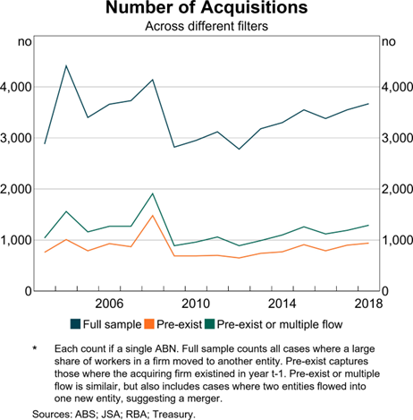

Note: Each count if a single ABN. Full sample counts all cases where a large share of workers in a firm moved to another entity. Pre-exist captures those where the acquiring firm existed in year t-1. Pre-exist or multiple flow is similar, but also includes cases where two entities flowed into one new entity, suggesting a merger.

Sources: ABS; RBA; Treasury.

Figure 4: Acquirers by employment size

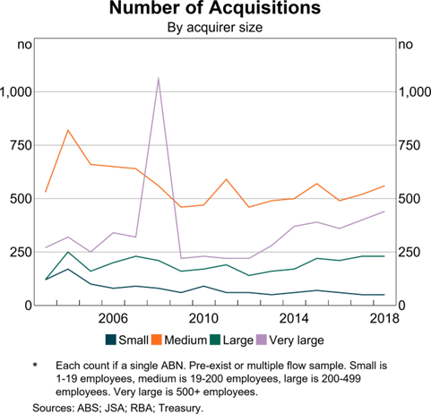

Note: Each count if a single ABN. Pre-exist or multiple flow sample. Small is 1–19 employees, medium in 19–200 employees, large is 200–499 employees. Very large is 500+ employees.

Sources: ABS; RBA; Treasury.

# Conclusion and future work

While the results presented are a first-cut and will continue to be refined, they demonstrate the potential value in developing a mergers database using administrative data. Further work will continue to refine the methodology, incorporating feedback from regulators and other experts, and conduct analysis around the nature and effect of mergers. Finally, the Competition Review Taskforce is liaising with the Australian Securities and Investment Commission to obtain data to track ownership changes to capture a broader range of merger activity.

1. In collaboration with Jonathan Hambur (RBA), David Hansell (ANU) and Nu Nu Win (ANU).
2. The 2008 spike reflects a sharp increase in activity in the healthcare sector.