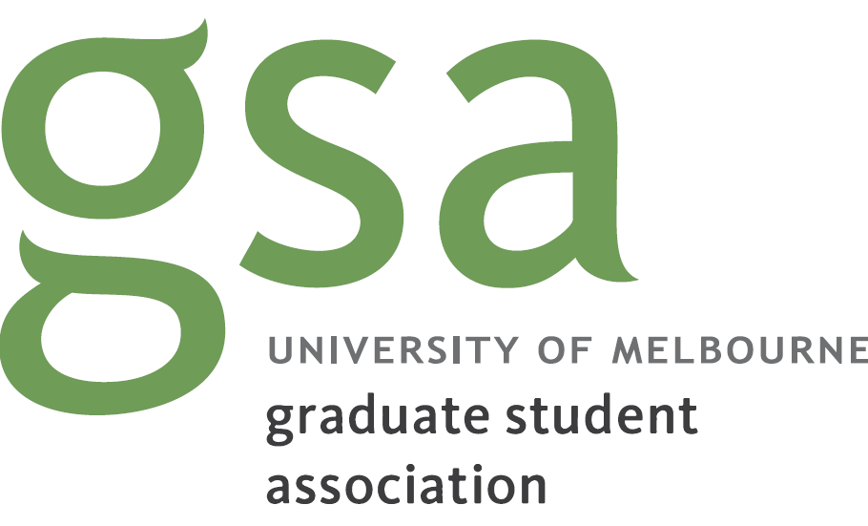

2020-21 Pre-budget submission

University of Melbourne Graduate Student Association

January 2020

Introduction
The great economic, social, and environmental challenges facing Australia this century require a supported research workforce and an educated population. Public investment in research and higher education must be urgently increased so we can meet the demands of the future. As students move through higher education, they must be supported to complete their studies so they can contribute more to our society.
Higher education is also crucial to the current Australian economy. International education is the nation’s largest services export and third largest export overall. In order to safeguard the reputation of Australian education, the Government must continue to ensure Australia remains a desirable study destination.
The Graduate Student Association (GSA) is an independent student association representing over 34,000 graduate students at the University of Melbourne. We provide students with representation, events, training and support.
We thank the Treasury for the opportunity to provide a submission on what we believe should be prioritised in the Government’s 2020/21 Budget. In this submission, we recommend that the Government adopts the following budgetary measures:
- Increase public investment in university research and teaching
- Expand study payment eligibility to all postgraduate students
- Address the cost of childcare for low income earners
- Tackle climate change with more ambitious carbon reduction and renewable energy targets

Increasing public investment in the knowledge economy
Educating the next generation of workers and supporting innovation are an investment in the nation’s future. Public investment in universities stimulates the economy through increased taxation revenue paid by those with a higher education as well as through flow-on productivity effects. The current budget provides the Government with an opportunity to prioritise research investment.
Cuts to university funding in successive Budgets and Mid-Year Economic and Fiscal Outlooks have caused public investment in higher education, as a share of GDP, to fall over time. Universities are only able to deliver education and research for the benefit of all through the receipt of public funds. Currently, Government funding comprises 31% of the University of Melbourne’s income. The University has already suffered due to funding cuts and is highly vulnerable to further reductions in public funding. Insufficient funding is problematic both on a local university level as well as on a national scale.
The Federal Government must increase their contribution to education and research in universities to ensure that Australia remains one of the world’s top knowledge economies.
At GSA, we support increased public funding for university research and services. We recommend that the Government increases its investment into education and research, including through granting stipends to research students who do not currently have one.

Expanding income support to all postgraduate courses
Students should have the financial support to succeed in their studies, complete their qualifications and go on a career that utilises their education.
Domestic undergraduate students are entitled to access income support payments such as Youth Allowance and Austudy, however, this support does not exist for postgraduate students. Many full-time postgraduate coursework students are ineligible for study payments through the social services system, regardless of income level of the student. This is because eligibility is determined by course rather than financial need: a small subset of postgraduate degrees is deemed eligible for income support according a list published by the Department of Social Services each year. At the University of Melbourne, only 36% of Masters-level courses are eligible for Youth Allowance or Austudy. This means that many full-time students in demanding postgraduate courses must shift their focus to part-time work in order to keep a roof over their head and food on the table.
We recommend that the Government expands study payment eligibility to all Masters-level courses. This would alleviate some financial stress from students and facilitate higher course completion rates.

Increasing the childcare subsidy for students
Access to affordable childcare would enable students with young children to complete and succeed in their studies. One in four full-time students between 25 and 44 years of age has at least one child under fifteen years of age. Without access to childcare, students with young children who lack adequate family support are less able to attend classes, spend time on assessments, and be present in their departments. The cost of childcare is unregulated, with the average daily cost in the Melbourne city being $148.67.
Presently, all Australian citizens have access to the Government Child Care Subsidy, with the level of subsidy scaling with income. The Child Care Subsidy, following its introduction in 2008, has improved women’s participation in the workforce. The highest rate of subsidy, for families earning less than $68,163 annually, is 85% of their childcare fees up to a cap of $11.98 per hour ($95.84 per day). However, childcare is unaffordable for many students even after the subsidy is applied. This is largely due to the subsidy cap, which greatly underestimates the actual cost of childcare.
In order to amplify the impact of the Child Care Subsidy to those who need it most, we recommend that the Government creates a higher level of subsidy those on low incomes, and investigates regulating childcare fees.

Addressing climate change
International education is part of the cultural framework of Australian universities and provides the funding needed for universities to conduct research and teaching. At the University of Melbourne, 42% of enrolments (equivalent full-time) are international students, a percentage that is increasing each year, with tuition fees for international students bringing almost one billion dollars of income per annually.
However, the international education sector is vulnerable to reputational damage due to perceptions of Australia being unsafe. The size of Australia’s education export is threatened by prospective international students’ fears over the recent devastating bushfires. This has been recognised by the Government with the recent allocation of $5 million to advertise Australia overseas as a safe education destination. As bushfire seasons grow longer and harsher due to climate change, this will become an ongoing challenge.
We call on the Government to set policies to drastically reduce national carbon emissions and invest in renewable energy sources for the future. Actions to prevent further climate change are urgently needed in order to maintain Australia as a safe place to live, work and study.

Department of Education and Training 2018, Research snapshot – Export income to Australia from international education activity in 2017, accessed from <https://internationaleducation.gov.au/research/Research-Snapshots/Documents/Export%20Income%20CY%202017.pdf>
Deloitte Access Economics 2016, Estimating the public and private benefits of higher education, accessed from <https://docs.education.gov.au/system/files/doc/other/dae-det_benefits_of_higher_education_final_report.pdf>
Universities Australia 2019, 2019-20 Pre-budget submission, accessed from <https://www.universitiesaustralia.edu.au/wp-content/uploads/2019/05/190116-UA-Pre-Budget-Submission-2019-2020_FINAL.pdf>
University of Melbourne 2019, 2018 annual report, accessed from <https://about.unimelb.edu.au/__data/assets/pdf_file/0030/89544/2018-Annual-Report.pdf>
Council of Australian Postgraduate Associations 2018, Income support for domestic postgraduates in Australia: Discussion paper, accessed from from <http://www.capa.edu.au/wp-content/uploads/2018/10/Income-support-discussion-paper-October-2018.docx>
Norton, A, and Cherastidtham, I 2018, University attrition: What helps and what hinders university completion?, Grattan Institute, accessed from <https://grattan.edu.au/wp-content/uploads/2018/04/University-attrition-background.pdf>
Care for Kids, Child care costs calculator, accessed from <https://www.careforkids.com.au/home/childcarecosts>
Norton, A, and Cherastidtham, I 2018, Mapping Australian higher education 2018, Grattan Institute, accessed from <https://grattan.edu.au/wp-content/uploads/2018/09/907-Mapping-Australian-higher-education-2018.pdf>
University of Melbourne 2019, 2018 annual report, accessed from <https://about.unimelb.edu.au/__data/assets/pdf_file/0030/89544/2018-Annual-Report.pdf>
Press Office of the Hon. Scott Morrison MP 2020, Rebuilding Australian tourism, accessed from <https://www.pm.gov.au/media/rebuilding-australian-tourism>

